Is the Technological Advancements Towards Image and Video Creation Ruining our Ability to Recall Memory from the Past?

Kyle Lannigan – P144659

Photography in the Arts

Word count - 4848

Anna Lewis

In a world where we are now able to create stunning images and movies right from our pockets using camera phones, almost everything that you experience day to day can be recorded. With the technological advancements made in the digital imaging department over the last few years, higher quality videos and pictures are available instantaneously in the palm of our hand. Each year the quality of the images getting better and more lifelike. Not only are these images for you to see, you can upload them online for friends, family and even people you have never met. Sites such as Facebook and Twitter have been staple sharing sites through the last decade, and with the newer apps like Snapchat and Instagram taking image sharing to the next level.
Photographs can have a ‘counter-memory’ this has been talked about by Roland Barthes in Camera Lucida. This idea of ‘counter-memory’ paired with the technological improvements is interesting, where more and more photographs/videos are being taken, less of the information is retained within the brain. After all, the photograph is widely known as a piece of evidence that has happened, captured in the presence of the lens, a fragment of time held in place, making us contemplate about the past. Even the Eastman Kodak Company Stated “[Kodak] enables the fortunate possessor to go back by the light of his own fireplace to scenes which would otherwise fade from the memory and be lost” (Batchen, 2004)
With new technology comes a new way to live through our lives, what this text will question and hopefully find some resolution for is how the technology of the 21st century is changing how we recall information or if in fact there are benefits towards photographing instead of being in the moment.

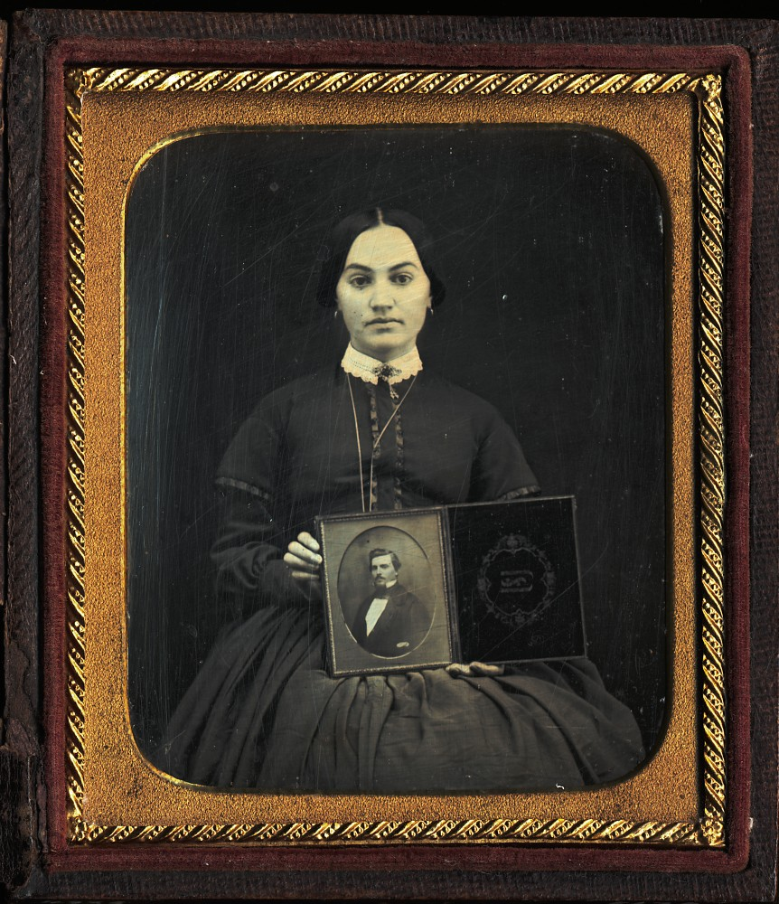
With the invention of the first stable photographic image, the daguerreotype from 1839, has been used as a catalyst for our memory. At this early stage of photography, stable images were valuable as they had extortionate costs. This meaning that if a family were to have a photograph taken it would have been for a loss of a loved one. During the late 18th century and the early 19th century, there was an influx of portraits that involved both the living presence and that of the dead which are presented in the daguerreotype case. The main subject of the image would have their eyes fixed on the daguerreotype, in an endless gaze, seeming to be lost in one’s thoughts. This had been captured in a variety of ways. Take this image of the woman holding a photograph of a male figure. She is still lost in a concentrated gaze but looking directly at the lens of the camera. Is she aware of the viewer looking back at her, or is it her mind that she is wandering through, looking for these memories of a long-lost figure? It’s as if the female wants to be ‘remembered as remembering’ while holding up the photograph in direct view of the camera as a form of reminiscences. Although does photography hold a good function in the way that we remember things? (Batchen, 2004)
Figure 1 - Woman Holding a Daguerreotype

To be able to answer questions in regard to recollecting memories, the type or nature of the memory needs to be established. The form of memory that will be talked about in this text needs to be established. There are many forms of memory, and ways that you retrieve the information. The type of memory that this text focuses on will be the Episodic Memory, the part of your neurological pathway within the hippocampus that remembers your life’s events and experiences, these being called the autobiographical events.
Autobiographical memories are complex mental representations of the self in the past. Memories are constructed from different types of autobiographical knowledge by a complex retrieval process controlled by the working self. (Conway, 2002)
We can then recall these events at any point in our lives, remembering the places, times, individual’s and feeling the respected emotion. Usually, the whole aspect of the memory is remembered, not just the facts about the event itself.
When we want to remember times of a loved one, photographs can help prompt them. We have all looked through our family albums and seen a picture of a past loved one, the photograph will help us remember the fine details in how they look, but that’s it. A photograph only allows you to remember a person in a limited sense, not remembering them how they could be remembered.
The photograph does not really prompt you to remember people the way you might otherwise remember them – the way they moved, the manner of their speech, the sound of their voice, that lift of an eyebrow when they made a joke, their smell, the rasp of their skin on yours, the emotions they stirred (Batchen, 2004, p. 15)
Photographs can only retain a certain amount of information, so using images to fully remember friends and family has potential to make you forget what the person was actually like, in terms of their personality. When thinking about your childhood memories, is it your memories that you are remembering or are they snapshots from photos you have been shown growing up? Its as if photography is taking our memories and limiting them to a one dimensional visual plain. For example Roland Barthes, the French cultural critic has written about the relationship between both memory and photography “not only is the Photograph never, in essence, a memory… but it actually blocks memory, quickly becomes a counter-memory” (Barthes, 1981, p. 91) Barthes is saying that looking at old photographs suspended in time, replaces the immediate emotional experiences of our involuntary memory (the emotional responses often triggered by sounds and smells) with the frozen image that is set within the past.
Barthes suggests that photography only dumbs down the thrill of finding these memories with the “dull certainties” of a past time. In Barthes writings memory is much more than a visual awareness, the challenge would be to create photography as a visual equivalent of taste and smell, bringing something you can feel as well as see. During 1927, German critic Siegfried Kracauer voices his mistrust with photography itself. He states for a memory to be retained it needs to be personally significant to the individual, and what is significant would not be able to be reproduced. Photography, on the other hand, records what is spatial. He describes photography as being able to record “too much information to function as memory.” (Batchen, 2004, p. 16) Memory has a distinctive selective, almost blurred outline and is subjective to the individual, saying that memory is as detailed as it is precise is wrong.
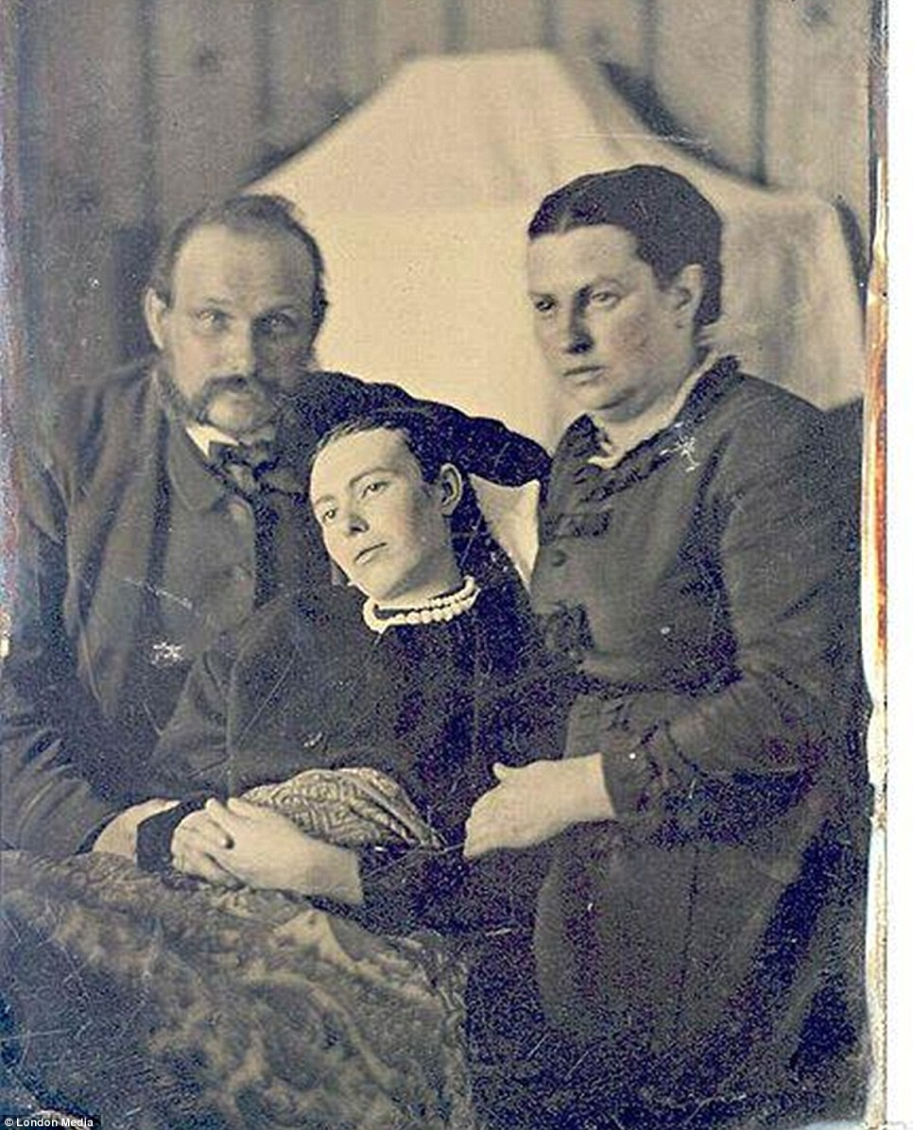
Similar to the previous example of the lady within the daguerreotype morning her lose, the Victorian Era of death photography or Memento mori, a Latin term that reads ‘'remember you must die’ was becoming more and more successful. This practice would include taking photographs of the recently deceased, not only by helping loved ones grieving but often enough these images would be the only visual remembrance these families would have and would be among the highest possessions. Early representations of the deceased were typically close up shots of the face with the body in a coffin, dressed in their most formal of an outfit. After some time, the photographers started trying new ways to represent the departed by placing them in ‘more natural’ positions. There are examples that have siblings resting on the arm of their passed away family members (they are posed as if they are actually sleeping), positioned with their head propped up resting on their hand and even using special devices to have the dead stood up, they are particularly surreal.
Figure 2 - Family Portrait with Deceased Family Member

While examining through these now morbid images, you can generally decipher who the late family member is, by how well they are in focus. As it is taken in the Victorian era, the photography practice is still in its early stages meaning that the exposure times are relatively slow. This results with the body of the deceased being in focus more than their living counterparts around them, creating ghostly figures. It’s this small detail that separates the living from the dead, a constant reminder that its impossible to bring back the past. The living family members, however, are needed to keep rigid throughout the entirety of the image’s exposure, up towards a minute. This often means stripping them of their personality and their expressions to hold body and facial expressions that are easier to keep unnaturally still. “Those pictures were, for the most part, pretty formal,” says Diane Waggoner.
With the technological advancements during the late 18th century led by the Eastman Kodak Company, photography started to become more accessible with the general public. In 1888 George Eastman founded the Kodak camera with the first available flexible, transparent film base and within a year the first perfected roll of film was commercially available. Kodak’s slogan at the time was “You press the button, we do the rest” which was on their advertisements at the time, allowing its consumers to send in the rolls of film to be developed by the company itself, leading the ‘snapshot’ culture, a word only used to describe a gun shot with little to no aim. This accessibility to the masses meant they could start to produce their own family albums. Accordingly, with the rise of the snapshot image and its affordable nature, the formal photographic portraits of the daguerreotype began to die out. This marked a historic moment where for the first time people were able to capture every moment possible, a process once confined to a studio space, can now be explored in the sunshine by the general public.
Figure 3 - The Kodak Eastman Co. Advertisement
During these times, people began shooting everything they could for example, riding bicycles, playing football, trying to capture the exact moment a bird would take flight. With this new form of media available, people began trying new and exciting things. Some people turned to the new media to produce jokes, their head sticking through a newspaper, playing on the “Breaking news” pun. Although this was an influential time for the photographic process, the careful nature of the daguerreotype was lost. As each camera offered 100 shots before needing to be sent back to Kodak, the way people experimented talking images changed. People came less careful with the images they would take, trying different angles, different locations and more natural body poses. It was as if they were stretching off their body’s after being confined to such a limited space before.
Part of the freedom came from surplus. When you had 100 possible snaps in your camera, each picture became less precious—so people could experiment with odd angles and ideas. (Thompson, 2017)
With this new found freedom and rapid development of cheaper and more effective ways to produce a stable image, photography experienced a large influx of amateur photographers. The idea of having an event ‘snapshotted’ changed the way people would behave in front of the camera. During events that previously would not have been photographed, people would be aware of their appearance and so would altar it in order to look good in their own photographs. As Kodak embraced the amateur photographer a large selection of images during this time were made for personal reasons, whether it be for birthdays, holidays or simple family-outings. It also changed the conventions of photography, and what photography was.
Suddenly people had to deal with the fact that someone on the beach or in a public park might have a camera, and that person might actually include you within the frame of a photo. You had to look nice. You had to act responsibly. “It was not only changing your attitude toward photography, but toward the thing itself that you were photographing, says Brian Wallis, former chief curator at the International Center of Photography. So you had to stage a dinner, and stage a birthday party. (Mitnick, 2017, p. 277)
With the continued rise of Kodak, and the change in the dynamics with photography. Family’s started creating albums with all their precious images from trips to the beach, picnics, day trips and birthday party’s. These albums became private for the family that created it, whether the album follows the growth of children, or by documenting a time period or representing a wedding. These albums would have the physical images that Kodak sent back to you after sending off the camera to be reset. These books became family’s pride and joy, something physical they can pass down to their kids. However, these albums got curated by the family’s themselves, most of the time only remembering the most favourable memory’s, not the negativity that could go on behind closed doors. These could be the arguments, disagreements and fighting between siblings and other members within the family. Its as if we are trying to forget these hard and difficult times, but just like the good times you learn from the bad just as much, evolving yourself personally in the way that you are bettering yourself as a person. It would be quite rude to forget what made you into you today.
Continuing on into the digital age, where smartphones and other technological devices have become an integral part of our society. These smart devices are changing the way we live today, being able to act as phonebooks, maps, daily planners, calculators and much more. As a result of this people stopped remembering certain information, and began relying on the smartphone to do so for them.
Another significant change is the fact that a camera phone is more often at the reach of its owner than a traditional camera. Therefore, people have a camera in situations where previously they did not. Examples of this are utilitarian uses of the camera, such as taking a photo of the bus schedule to store a copy of it on the phone. (Vilma Lehtinen, 2015)

Also with the invention of the internet and its continuation to increase in size, came the creation of social media sites such as Facebook, Instagram and Twitter. These platforms allow you and your family and friends can keep in touch wherever you are, also to share experiences whether it be uploading a photo of a picnic, or announcing you are now in a relationship. The creation of the smartphone also gave an increase in the amount of digital images being uploaded on a daily basis, as the cameras on the phones got better, we wanted to share more with the world. The Phone Camera quickly became the most accessible camera of the 21st centenary, even being called “the snapshot camera of today” by celebrity portrait photographer Annie Leibovitz on Brian Williams' Rock Centre. As of 2016 there were around 300 million photographs being uploaded onto Facebook every day. (Noyes, 2017) That is a massive amount of information being digitalized, and every time the image is placed online it is reproduced to hundreds if not, thousands of people. This reproducing of the photographic image makes it lose its ‘Aura’ because the authentic nature of the image has now ceased to exist. Just like a significant personal memory, it’s a feeling that can’t become reproduced.
The aura is an effect of a work of art being uniquely present in time and space. It is connected to the idea of authenticity. A reproduced artwork is never fully present. If there is no original, it is never fully present anywhere. Authenticity cannot be reproduced, and disappears when everything is reproduced. (Robinson, 2013)
With this flood of images being shared online, there could be a possibility that these images will forever be embedded within its respected webpage, untouched and in the same quality that you left it thirty years ago. However, it could be the opposite. If you were to use a website to host the images of your children growing up on, and that site crashes or goes down that’s your life’s photos gone, lost in a void. The same goes with the digital device images that are stored on items such as a hard drive, as soon as you lose the original file, the photographs are gone indefinitely.

Instagram is another main image sharing site where the user uploads images to a timeline that can be accessed anytime they please. After all, snapshots are a documentation of a moment that happened in front of the lens, and Instagram is the archive they are kept in. People like to capture unexpected or extraordinary life events.
“Experiences beyond everyday life (extraordinary experiences) lead people to take photos. For example, seeing exceptional landscapes, traffic accidents, rare animals, or famous people.” (Vilma Lehtinen, 2015)
It is almost an automatic response to grab a camera in an exciting moment, and the Instagram culture of creating the best post to gain the most likes often means retaking the same shot until you get the perfect one, leading towards the throwaway culture of the digital image.
A thing of the past, the snapshot gives way to the digital image captured on a cell phone, deleted to clear storage space for more temporary pictures. The act now repeats a contemporary gesture: affirming the surface of things alone. (Greenough, 2012)
This throwaway nature of the digital snapshot seems to have reduced the photographic image to just that, an image. Nothing more or less, what what once considered to be a significant object to have in the 18th century has now turned into a file you can delete to make room for a more impressive images. Photographs people are taking mean less to them, the personal significance of a single snapshot can’t bring forth the same emotional feeling that one would get if they were remembering the event for all it was without photographic aid.
“The process of image-making has shifted mainly to post-production image editing, … This means we are less aware in the moment that we are taking and capturing the image. We become distanced from the object and events we are photographing.” (BROOK, 2013)

Equally important is how easily digital images can be edited in modern times, creating a completely different image and equivalently changing how the image is read. Commonly users on social media sites add filters to create more aesthetic looking images or crop out certain parts to create an illusion for the viewers of the images, creating a false reality. This false reality being created could trick your brain into thinking that was the actually memory, with a possibility of altering it. There was a study conducted on this exact situation, using false images to create fake memories. A study group of 20 subjects were exposed to doctored images of themselves as children edited into fake childhood memories, over three interviews and guided imagery instructions the subjects were asked if they could recall/construct the false memory.
we exposed 20 subjects to a false childhood event via a fake photograph and imagery instructions. Over three interviews, subjects thought about a photograph showing them on a hot air balloon ride and tried to recall the event by using guided-imagery exercises. (Kimberley A. Wade, 2002)
Figure 4 - Images used to create 'False Memories' in Wades experiment
Just like how Instagram users are using subtle editing techniques to make their posts look more interesting for other users, it creates a flawed impression. Within the research experiment they found that 50% of the subjects believed that they had flown on a hot air balloon in their early life, even when they had not. The clause that the team came up with is as follows:
We speculate that the doctored photograph was accepted as authoritative evidence that the false event had occurred and in doing so, “planted the seed” of a false memory. It is also possible that the seeming authenticity of the photograph prompted the subjects to search their memory for event-consistent information. (Kimberley A. Wade, 2002)
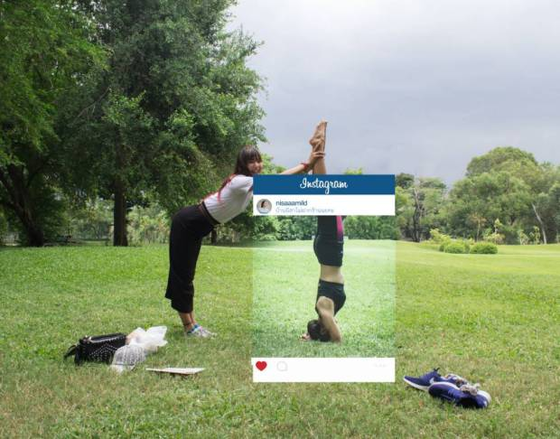
Thailand-based photographer, Chompoo Baritone has also commented on the Instagram images that are edited in a way to make it look they live a more exciting life, by creating a series of humorous photographic prints by including what is happening around the framed Instagram post that the users cleverly hide.
Figure 5 - Chompoo Baritone
Furthermore, there has been a comprehensive study focusing on whether using digital imaging as a form of remembrance helps us retain more memory than if we were to just observe. The study was conducted by Linda A. Henkel, who is a professor in Psychology at the Fairfield University. The study that she organised was called “Point-and-Shoot Memories: The Influence of Taking Photos on Memory for a Museum Tour”. The study revolved around the idea of observing various objects around the Bellarmine Museum of Art, these included paintings, pottery, sculptures and jewels. Henkel writes that photographing the objects could help with the recollection of information as the photographer would have to, frame, focus and shoot, these actions taking time and careful planning. Having a more active part in observing the object could help this recall of information.
“On the one hand, photographing objects could have positive effects on memory because it may focus one’s attention and, hence, increase the memorability of the scene. In addition, photographing an object is a more active process than observing it,” (Henkel, 2013)
Then, secondly, the act of taking a photo could have an impaired effect on the amount of information retained as the subject’s attention is taken away from the scene in a form of multitasking, just like driving or walking while texting. The study had 2 groups and it consisted of 2 separate experiments visiting 30 objects around the museum. The first experiment had half the subjects just observe the items with no external help on recalling the name or details of specific object, the other half of the group were allowed to take digital images of the full object in frame.
“Experiment 1, participants’ memory for objects they photographed was compared with their memory for objects they viewed but did not photograph” (Henkel, 2013)
The second Experiment split the group into three, where there would be a photographing group and an observing group, but the third group were expected to take at least 6 seconds to angle the camera and focus on some detailed part of the art object. This variation was added to see if the focusing and zooming into the object would “address the question of whether focusing on one specified part draws attention to the object in a way that photographing the object as a whole does not.” (Henkel, 2013)
What the two experiments concluded was that the groups that photographed the objects around the museum, had a counterproductive effect on the ability to recall names of the art work as well as the details.
The findings from these two experiments show that photographing objects on a museum tour had a detrimental effect on memory of the objects. When participants took photos of whole objects after viewing them, they remembered fewer objects and remembered fewer details about the objects and the objects’ locations than when they only observed the objects without photographing them. (Henkel, 2013)
Even after all the groups had equal time to view the objects, and the photographing groups taking extra seconds to capture the image they still had a harder time recollecting. This could be because the photographing group start to dismiss the intrinsic memory of the object and start relying on the cameras memory to remember instead. Although the group that focused and zoomed into details of the art, their reconnection of the object did increase overall.
their subsequent recognition and detail memory accuracy was not impaired, and, in fact, their memory for features that were not zoomed in on was just as high as their memory for features that were zoomed in on. This finding highlights key differences between people’s memory and the camera’s “memory” and suggests that the additional attentional and cognitive processes engaged by this focused activity can eliminate the photo-taking-impairment effect (Henkel, 2013).
So the results from the experiments have brought up some evidence that both photographs can definitely impair the memory of details about objects or the recalling of information. However, the more engaged the photographer Is with the event/object (planning, angling, focusing on certain points) the more information you are able to recall. The idea of the snapshot, a quick unplanned photograph has the possibility to impair one’s memory.
Bathes once wrote that photography is “a message without a code” (Barthes, 1977), implying the analogue photograph is a analagon. An object that is a perfect replica of the real, without the need to be decoded. Now with the invent of the digital image, the statement that photography is a message that hasn’t got a code is obsolete. Each image you capture is a string of data, its own language, which has been decoded by the appropriate software/device to create the representation. As the research into this topic has demonstrated that over the course of history, photography has changed in the way that we treat the photographic image. Photographs once were an object that were cherished by the family’s that owned them, now digital images are getting taken that never leave from the storage of the device they were taken on, hoping to be viewed again, or don’t seem that they are of any importance at the time and then are deleted. With the research that has gone into how photography changes how we recall information, its evident that we are using photography as a substitute for some mental function. Which is detrimental for us as we end up remembering less details over all.
“Now that images are on a screen, they’re sort of ‘forever young’, and it becomes difficult to realise that there are many things that connect us to the past in terms of basic human emotions. These become more difficult to tease out when
everything looks contemporary.” (Hostetler, 2016)
Not only does photography limit us to the amount of detail we can reminisce about, it can also alter the memory altogether to create a false memory. With the accessibility of photo manipulating software, digital images can be altered for better viewing pleasure, but in the long term, this altered image could become how you remember the event.
I have also noticed that our memories are in fact becoming more digitalized with social media sites such as ‘Facebook’, where it notifies you personally that you have memories to look back on. These could be photos from a birthday party a year ago, or even a status saying how stressful your day was 7 years ago. What we are doing in our lives now, we get reminded a few years down the line through the screen of our computer. This leads onto another point, our memory isn’t made to be able to recall information to a precise accuracy, its fragmented, so we ourselves have to find the connecting stories and details. This form of the digital memory for me terrifying, we are teaching ourselves that we don’t need to remember points in our life because we can be reminded further down the line.
It also raises questions about what digital technology is going to advance to in the near future, especially with the rise in virtual reality tech in the last three years alone. Recently the increase of more affordable drones are coming to the market, giving photographers a new tool to create work with. Photographs that once were only to be taken from a helicopter, can now be taken from the ground using a live feed from the drone itself. Black Mirror the television series have touched upon this subject in the episode "The Entire History of You", set in the future where the ability to get implants that record everything you see and hear is possible, with the ability to re-watch any moment of your life personally or shared with family or friends.
“Ultimately — or at the limit — in order to see a photograph well, it is best to look away or close your eyes. 'The necessary condition for an image is sight,'Janouch told Kafka; and Kafka smiled and replied: 'We photograph things in order to drive them out of our minds. My stories are a way of shutting my eyes.” (Barthes, 1981)
Finishing on this quote from Camera Lucida. From all the research that has gone into this text. The way that I now look at photography has changed, it’s a powerful medium that can be devastating to our own powers of retention. Altering and changing the way we once perceived the world, it is a problem that’s going to continue to grow. As for now personally for me, photography isn’t going to be a way to store memories, there are more thrills trying to uncover fragments from the past that I had the experience of being fully immersed in.

Figure Table

Figure 1 - Anon. Ca. 1850. Woman seated, holding full plate daguerreotype portrait of a man Available at: http://www.helenakaminski.com/subdomain/wetplate/?attachment_id=10 3
Figure 2 - Anon. Ca. 1900. Living parents with their deceased daughter. Available at: https://hathawaysofhaworth.wordpress.com/2012/11/29/in-deepest-mourning-victorian-mourning-part-one-the-deceased/post-mortum-photo-2/ 6
Figure 3 - Kodak eastman Co. Ca. 1888. The Kodak Eastman Co. Advertisement. Available at: https://en.wikipedia.org/wiki/You_Press_the_Button,_We_Do_the_Rest 7
Figure 4 - Kimberly Wade. CA. 2013. Images used to create 'False Memories' in Wades experiment. Available at: http://www.bbc.co.uk/news/science-environment-24286258 12
Figure 5 - Chompoo Baritone. CA 2015. The Truth Behind Instagram. Available at: https://www.boredpanda.com/truth-behind-instagram-photos-cropping-chompoo-baritone/ 13

Bibliography
Barthes, R., 1977. The Photographic Message. In: S. Heath, ed. Image-Music-Text. london: Fontana Press, pp. 15-32.
Barthes, R., 1981. Camera Lucida: Reflections on Photography. 1st Edition ed. New York : Hill and Wang.
Batchen, G., 2004. Forget Me Not, Photography & Remembrance. 1st Edition ed. New York: Princeton Architectural Press.
BROOK, P., 2013. TO MAKE BETTER PHOTOS, YOU’VE GOT TO THROW THEM AWAY. [Online]
Available at: https://www.wired.com/2013/07/dispose-magazine/
[Accessed 28 11 2017].
Cadava, E., 1997. Words Of Light. 1st Edition ed. UK: Princeton University Press.
Conway, M., 2002. International Encyclopedia of the Social & Behavioral Sciences, Durham: University of Durham.
Greenough, S., 2012. The Art of the American Snapshot: 1888-1978,. [Online]
Available at: http://www.ronslate.com/art_american_snapshot_1888_1978_sarah_greenough_and_diane_waggoner_princeton_university_press
[Accessed 29 10 2017].
Henkel, L. A., 2013. Point-and-Shoot Memories: The Influence of Taking Photos on Memory for a Museum Tour. Psychological Science , December, 25(N/A), p. 396–402.
Hostetler, L., 2016. A matter of memory : photography as object in the digital age. 1st ed. New York: George Eastman Museum.
Kimberley A. Wade, M. G., 2002. A picture is worth a thousand lies: Using false photographs to create false childhood memories. Psychonomic Bulletin & Review, 9(3), p. 597–603.
Kodak, n/a. MILESTONES. [Online]
Available at: https://www.kodak.com/GB/en//corp/aboutus/heritage/milestones/default.htm
[Accessed 20 11 2017].
Kuhn, A., 2006. Locating Memory: Photographic Acts. 1st Edition ed. New York: Berghahn Books.
Mitnick, K., 2017. The Art of Invisibility. 1st Edition ed. New York: Hachette Book Group.
Noyes, D., 2017. The Top 20 Valuable Facebook Statistics. [Online]
Available at: https://zephoria.com/top-15-valuable-facebook-statistics/
[Accessed 20 10 2017].
Risto Sarvas, A. L. V. L. J. N. S. V., 2017. Snapshot Media: “Kodak Culture” in the 21st Century. [Online]
Available at: https://www.researchgate.net/profile/Vilma_Lehtinen/publication/242274302_Snapshot_Media_Kodak_Culture_in_the_21_st_Century/links/55bb471c08ae9289a0929f13/Snapshot-Media-Kodak-Culture-in-the-21-st-Century.pdf
[Accessed 20 11 2017].
Robinson, A., 2013. An A to Z of Theory | Walter Benjamin: Art, Aura and Authenticity. [Online]
Available at: https://ceasefiremagazine.co.uk/walter-benjamin-art-aura-authenticity/
[Accessed 3 11 2017].
Sutton, D., 2009. Photography, Cinema, Memory. 1st Edition ed. London: University of Minnesota Press.
Thompson, C., 2017. The Invention of the “Snapshot” Changed the Way We Viewed the World. [Online]
Available at: https://www.smithsonianmag.com/innovation/invention-snapshot-changed-way-we-viewed-world-180952435/
[Accessed 20 11 1027].
Vilma Lehtinen, J. N. S. V., 2015. Snapshot Media: "Kodak Culture" in the 21 st Century, Helsinki: ResearchGAte.
Zimmermann, K. A., 2014. Memory Definition & Types of Memory. [Online]
Available at: http://www.human-memory.net
[Accessed 22 11 2017].

