Marketing Fundamentals

Assessment 2: Marketing Fundamentals Analysis and Evaluation

LCBB4004

Karolina Kwiecien
ID: 2113036

10/01/2022

Executive Summary
The study is mainly based on the marketing process, where M&S has been taken to demonstrate properly. SWOT analysis, PESTLE analysis has been highlighted to develop the internal and external process of the organisation. Besides, marketing mix (4ps), porter's five force models are also highlighted to develop the report quality very well.
Table of Contents
Task-1: Internal and External analysis of the company 5
Introduction 5
Definition of the marketing 5
Identifying the main stages in the marketing process 5
Identifying the Macro-environment for the organisation 7
Relating the Porters five force model with the company 9
Analysing the SWOT analysis of the company 11
Relating the STP analysis with the organisation 12
Identifying the marketing mix element 13
Conclusion 14
Recommendation 14
Reference List 15

Task-1: Internal and External analysis of the company

Introduction
Marketing is the part of activity that is mainly undertaken by the companies to perfectly promote the selling and buying of the company’s products or services. The study is mainly based on the marketing process that needs to be analysed through developing the different approaches. Marks and Spencer have taken. Identification of marketing aspects within the organisation, important stages of the marketing process are the main focusing points that are highlighted in this study to demonstrate and understand the fundamental approaches of the marketing process within the organisation. Besides, Porter's five force model, SWOT analysis and Pestle analysis are taking part in this study to evaluate the selected company’s marketing process within the UK marketplace. STP analysis is another part that is discussed in this report to demonstrate the company’s positions within the retail industry.

Definition of the marketing
Marketing is the basic activity that identifies itself as an organisation’s vehicle to create better decisions making practices in marketing areas. It is the activity that is undertaken by a company to promote services and products of the company. According to Matikiti et al., (2018), marketing factors are identified as four stages such as monopolistic competition, proper competition, monopoly and oligopoly. It is mainly increasing awareness through enhancing the preferences of services and products. Packing, placements, advertising and pricing are the essential segments of marketing, which help to develop the product or services qualities of the organisation. The UK based multinational retail industry Marks & Spencer uses marketing strategies to develop the marketing process within the organisation (Statista.com, 2021). The marketing process mainly discovers the selected areas that mainly help to influence the organisation’s growth process.

Identifying the main stages in the marketing process
Marketing processes for an organisation are part of a sequential process that is mainly divided into the five basic stages such as, planning, programming, strategising, capturing and engaging. These all need to be considered as phases, which mainly identify the superior values to enhance the customer process successfully. Consequently, as assisted by Utakaeva (2020), the author stated that marketing’s other divisions are divided into four stages, which is indenting the life cycle of products. The stages are named as Growth, introduction, decline and maturity and these stages enhance the marketing growth process successfully. This four-stage oriented concept is part of the management system that mainly influences the marketing process through determining the price reduction process. According to Gladka and Fedorova (2019), planning is the initial stage of marketing that mainly increases or decreases the marketing size of the organisation through understanding the product and marketing process. Situational analysis, strategy implementation, objectives and controls are the main focusing stages of the marketing process that mainly influence the planning process of the organisation.
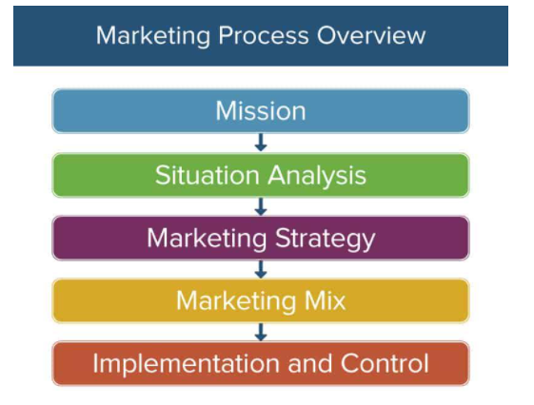
Figure 1: Stages of marketing process
(Source: to Gladka and Fedorova, 2019)
Situational analysis is the method of collection process of marketing, which mainly analyses the external and internal factors within the organisation. Project growth and assessing the competitors are the parts of situational analysis within the organisation. Strategy implementation is another stage of the marketing process that mainly makes better communication approaches through developing contingency plans (Olson et al., 2018). Objectives mainly help to achieve the marketing goals and they also enhance the performance of the organisation through determining the controlling aspects. Marks and Spencer is a renowned retail industry, which uses these marketing stages to develop the marketing process for its products and services (Edwardlowe.org, 2021). Different types of strategies and objectives are developed by the company through determining the controlling aspects of products or services such as, targeting markets, market researching process and so on.

Identifying the Macro-environment for the organisation
PESTLE analysis
Factors | Impacts
Political | - Stability in political aspect  - Superior economic policies are available for business persons (Eacea.ec.europa.eu, 2021)  - The UK government depends upon parliament (Greatbritishmag.co.uk, 2021)  - Import and export activity is developed  - Easy to exchange the foreign currencies
Economical | - Approx 6.76% growth of GDP rate after pandemic (Ons.gov.uk, 2021)  - Sixth-largest developed country worldwide  - Around 4.6% unemployment rate availability (Statista.com, 2021)  - Approx, 20% tax rate availability in the UK (Statista.com, 2021)
Social | - High buying habits availability among UK people  - Approx 67.6 million population availability (History.org.uk, 2021)  - Cultural attitude available among UK people  - Like to live with better lifestyles (Studying-in-uk.org, 2021)
Technological | - Taking 2nd highest-ranking across the world (Accountingweb.co.uk, 2020)  - Thriving tech sector obtain-ability  - High-level of transportation and connectivity across the country (Statista.com, 2021)  - Better internet and artificial intelligence are available
Legal | - Industry safety-oriented legislation available  - Antitrust and common law available (uk.practicallaw.thomsonreuters.com, 2021)  - Employment oriented laws are available (uk.practicallaw.thomsonreuters.com, 2021)
Environmental | - Poor effects for climate change  - Water shortage issue (Worldtravelguide.net, 2021)  - Reducing carbon emission usage  - Soil contamination problem availability (Worldtravelguide.net, 2021)
Table 1: PESTLE analysis of Marks and Spencer
(Source: Created by author)
Analysis
In the above table, six factors are identified that mainly help to understand whether the selected organisation can expand their business in the UK marketplace or not. Besides, as per the political analysis of the UK, it has been seen that political stability is available that mainly influences the business process effectively. Besides, Superior economic policies are available for business persons and better import and export activity, easily exchanging the foreign currency are the main focusing aspects that help to expand the business process within the organisation. Apart from this, 6.76% growth of GDP rate, 4.6% unemployment rate and the Sixth-largest developed country as worldwide are the economical aspect of the UK that are also better for the organisation to expand and explore the business process. High buying habits of UK people, 67.6 million population and cultural attitudes are the social aspect that mainly identifies the huge number of customers that can easily be increased in the UK marketplace.
The 2nd highest ranking in the technology department, Thriving tech sector availability and better transportation level also highlighted that the UK has better technology than other places. Different employment and industry-related laws are available in the UK, which is also better for the UK industries. However, the climate change and water shortage issues, Soil contamination problems are creating problems for the development and explanation process of companies. Thus, after evaluation, it can be stated that Marks and Spencer’s easily develop and expand their business in the UK marketplace because of better technology, social, economical, political aspects.
Advantages and disadvantages factors over organisation
It is a simple oriented framework and it enhances the strategic thinking process of organisation. Besides, Political, social and economical factors are identified from this PESTLE analysis, which mainly counted as advantages for the organisation (Mihailova, 2020). On the other hand, environmental factor can be counted as disadvantage because poor environmental process is faced by whole UK. The factors help to understand the wide-oriented business environments (Christodoulou and Cullinane, 2019).

Relating the Porter five force model with the company
Porter's five forces are the part of business analysis that identifies the model of industries. According to Ferdinand and Tresyanto (2020), Supplier power, Competitive rivalry, Buyer power, Threat of new entry and Threat of substitution are the five basic steps that mainly analyse the competitive position within the marketplace. Marks and Spencer’s competitive advantages are identified in this study to understand the company’s profitability level Such as,
The bargaining of Supplier power (Low)
Supplier power is the degree of control that influences the prices through available resources. Suppliers can achieve the most power while companies are depending upon them and cannot switch to the other suppliers. The supplier power of Marks and Spencer is low because massive customers are connected with them and make huge turnover (corporate.marksandspencer.com, 2021).
Threat of substitution (High)
A Threat of substitutes is the availability of products that can easily be purchased by the customers from others. Threats of substitutes are high, while rival companies are given better products. Marks and Spencer has high threats of substitutes because more competitors are available in the UK marketplace that can reduce product demands.
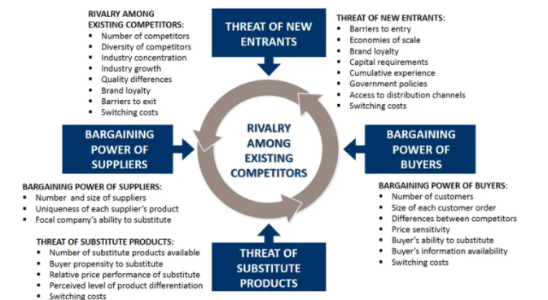
Figure 2: Porter’s five force
(Source: Aithal, 2017)
Competitive rivalry (High)
Competitive rivalry is the identifying competition with the firms, which have existed from earlier days. Interesting rivalry can create a limited profit level through increasing advertising expenditures (Bruijl, 2018). The competitive rivalry is high in M&S because other organisations are entering into the markets with products, whose quality is totally similar to the M&S (corporate.marksandspencer.com, 2021).
Bargaining of Buyer power (High)
Bargaining power of the buyer is identifying the customers of the company, who want a better quality product with minimum price. M&S bargaining power of buyers is high because customers are attracted to classical products with a profitable budget. Competitors are trying to focus on customers while maintaining their demands.
Threat of new entry (Low)
Threats in new entrance are the huge competition with the existing companies in the new marketplace and customers (Slee et al., 2020). However, threats of new entrants in M&S is low because the company has strong brand value and has a set to make successful chain oriented stores internationally.
Advantages and disadvantages factors over organisation
Porter five forces are helps to understand the factors of the organisations and Profitability and decision making process also can be determined through this Model (Kabeyi, 2018). Besides, better bargaining power of supply and better threats of new entrance process are help to develop the business process within the organisation (Mukherjee, 2018). On the other hand, high bargaining powers of buyer and competition revelry make disadvantages for the organisation because these factors reduce the company’s strategic alliances effectively.

Analysing the SWOT analysis of the company
Strength | Weakness
- Clear and high brand image (Statista.com, 2021)  - Better innovation and diversification availability  - 9,166.9 billion dollars in annual revenue (Statista.com, 2021)  - 220 personally owned and approx 300 franchises available across the world (Marksandspencer.in, 2021) | - Poor supply chaining scalability (corporate.marksandspencer.com, 2021)  - Poor penetrating process used in international market
Opportunity | Threats
- Huge market demands  - New segments are opening on a daily basis (corporate.marksandspencer.com, 2021)  - Huge customers are attracted to products | - Huge competitions are available in market  - Created impact on logistic costing process (Marksandspencer.in, 2021)
Table 2: SWOT analysis of M&S
(Source: Created by author)
Analysis
From the above table, it can be seen that clear and high brand images are present in the M&S company, which can minimise the weakness of poor supply chain scalability within the organisation. On the other hand, better innovation and diversification availability, 220 personally owned and approx 300 franchises availability across the world can easily reduce the weakness of Poor penetrating process used in international markets within the organisation. On the other hand, huge market demands and new segments opening process reduce the threats on the logistic costing process. Huge customer demands enhance the competition level of companies.

Relating the STP analysis with the organisation
Segmentation
Segmentation is the process that allows the seller to demand product needs and the customer's paying abilities also can be determined through analysing this aspect. Geographic, psychographic, demographic and behaviour are the four types of segmentation that can be analysed through lifestyles, ages and genders and other aspects. Different strategies are used in this type of segmentation and differentiate it through understanding their different company’s aspects (Bae et al., 2021). M&S used demographic segmentation to select their targeted customers for their products (Corporate.marksandspencer.com, 2021). The company tries to open their new branches by determining different segmentation strategies within the organisation.
Targeting
Targeting is the essential part of STP analysis that mainly helps to understand the business expansion process within the marketplace. Targeting the audience is the main focusing aspect that can enhance the company process through developing better strategies. The organisation M&S used a demographic segmentation process and from this aspect, it can be identified that the organisation targeted the particular customer's age. The organisation is targeting the 30 plus age group-oriented people, who have a high-income group (corporate.marksandspencer.com, 2021). From this aspect, it can be stated that the organisation segmented and targeted the customers through determining the product value process.
Position
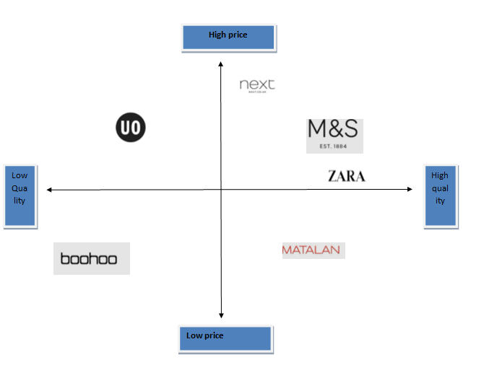
Figure 3: Positioning map of M&S
(Source: As influenced by Bae et al., 2021)
From this aspect, it can be stated that the organisation is positioned at a high price and high-quality section that mainly identifies the marketplace position of their product in the particular marketplace.

Identifying the marketing mix element
4ps of marketing mix
Product
Product is important in the marketing mix that mainly connects the company with its customers. M&S mainly sells high-quality products for their customers and develop innovation process on their product also.
Price
Price is another segmentation of the marketing mix process, which mainly identifying the values exchange of their products., The M&S company started their cloth oriented product from 100 dollars (corporate.marksandspencer.com, 2021).
Place
Place mainly identifies the competitive strategies through determining the brand positioning. The company has 220 personally owned branches and approx 300 franchises across the world, which helps to understand the strong brand process in front of customers.
Promotion
Promotions mainly spread product-oriented information in different places. The M&S used social media platforms to spread their brand information in the UK marketplace (Statista.com, 2021).

Conclusion
In this study, marketing analysis is the main focusing aspect, where marketing mix, SWOT analysis, PESTLE analysis has been highlighted to develop the M&S business process. After evaluating the models and frameworks it can be stated that the marketing analysis is the most important aspect to develop the business process within the marketplace.

Recommendation
- Documenting the market planning process is an important strategy that needs to be used to develop the marketing process within the M&S organisation effectively (Vasović et al., 2018).
- Using CRM technology is another essential key that needs to be used to develop marketing strategies within the organisation.

Reference List
Accountingweb.co.uk , (2020). UK PEST: Technological Factors. Available at: https://www.accountingweb.co.uk/community/industry-insights/uk-pest-technological-factors [Accessed on: 28/11/2021]
Aithal, P.S., (2017). ABCD Analysis as Research Methodology in Company Case Studies. International Journal of Management, Technology, and Social Sciences (IJMTS), 2(2), pp.40-54.
Bae, K., Cho, J. and Yoo, B.J., 2021. A Study on Establishment of AI Development Strategy for Ground Operations innovation Applying PEST-7S-SWOT. Journal of the Korea Academia-Industrial cooperation Society, 22(6), pp.67-74.
Bruijl, G.H.T., (2018). The relevance of Porter's five forces in today's innovative and changing business environment. Available at SSRN 3192207.
Christodoulou, A. and Cullinane, K., (2019). Identifying the main opportunities and challenges from the implementation of a port energy management system: A SWOT/PESTLE analysis. Sustainability, 11(21), p.6046.
Corporate.marksandspencer.com , (2021). M&S IS A BRITISH VALUE FOR MONEY RETAILER . Available at: https://corporate.marksandspencer.com/msar2021/m-and-s_ar21_strategic_210602.pdf [Accessed on: 28/11/2021]
corporate.marksandspencer.com, (2021). Annual report of M&S. Available at: https://corporate.marksandspencer.com/annualreport [Accessed on: 28/11/2021]
corporate.marksandspencer.com, (2021). M&S sustainability. Available at: https://corporate.marksandspencer.com/sustainability [Accessed on: 28/11/2021]
corporate.marksandspencer.com, (2021).Official Website of M&S in UK. Available at: https://corporate.marksandspencer.com/aboutus [Accessed on: 28/11/2021]
Eacea.ec.europa.eu, (2021). Political, Social and Economic Background and Trends of UK. Available at: https://eacea.ec.europa.eu/national-policies/eurydice/content/political-social-and-economic-background-and-trends-93_en [Accessed on: 28/11/2021]
Edwardlowe.org , (2021). “How to Expand Your Business Through New Market Development” . Available at: https://edwardlowe.org/how-to-expand-your-business-through-new-market-development-3/ [Accessed on: 28/11/2021]
Ferdinand, D.Y.Y. and Tresyanto, C.A., (2020). Marketing Strategy Using Porters Five Force Model Approach: A Case Study At The Culinary Center In Sidoarjo Regency. International Journal of Business and Management Invention (IJBMI), 9(11), pp.44-48.
Gladka, O. and Fedorova, V., (2019). Defining personnel marketing strategies. Business: Theory and Practice, 20, pp.146-157.
Greatbritishmag.co.uk, (2021). How the British political system works. Available at: https://greatbritishmag.co.uk/uk-culture/how-the-british-political-system-works/ [Accessed on: 28/11/2021]
History.org.uk, (2021). Social Structure of UK. Available at: https://www.history.org.uk/student/module/4536/overview-of-elizabeth-i/4543/social-structure [Accessed on: 28/11/2021]
Kabeyi, M.J.B., (2018). Michael porter’s five competitive forces and generetic strategies, market segmentation strategy and case study of competition in global smartphone manufacturing industry. IJAR, 4(10), pp.39-45.
Marksandspencer.in, (2021). Marks and Spencer’s website. Available at: https://www.marksandspencer.in/?&utm_source=google&utm_medium=search&utm_campaign=9897984394&adgroupid=100463569156&utm_content=565849828928&utm_term=%2Bmarks%20%2Bspencer&gclid=CjwKCAiAhreNBhAYEiwAFGGKPJdl7iy27TT_TguVJpscDySR_lo3SoLiocS7oF6OAEceliCvkhVZTRoCvf4QAvD_BwE&gclsrc=aw.ds [Accessed on: 28/11/2021]
Matikiti, R., Mpinganjira, M. and Roberts-Lombard, M., (2018). Application of the technology acceptance model and the technology–organisation–environment model to examine social media marketing use in the South African tourism industry. South African Journal of Information Management, 20(1), pp.1-12.
Mihailova, M., (2020). The state of agriculture in Bulgaria–PESTLE analysis. Bulgarian Journal of Agricultural Science, 26(5), pp.935-943.
Mukherjee, I., (2018). Applying Porter’s Five Force Framework in Emerging Markets—Issues and Recommendations. In Strategic Marketing Issues in Emerging Markets (pp. 307-316). Springer, Singapore.
Olson, E.M., Slater, S.F., Hult, G.T.M. and Olson, K.M., (2018). The application of human resource management policies within the marketing organization: The impact on business and marketing strategy implementation. Industrial Marketing Management, 69, pp.62-73.
Ons.gov.uk, (2021). Five facts about... The UK service sector . Available at: https://www.ons.gov.uk/economy/economicoutputandproductivity/output/articles/fivefactsabouttheukservicesector/2016-09-29 [Accessed on: 28/11/2021]
Slee, A., McKeaveney, C., Adamson, G., Davenport, A., Farrington, K., Fouque, D., Kalanter-Zadeh, K., Mallett, J., Maxwell, A.P., Mullan, R. and Noble, H., (2020). Estimating the prevalence of muscle wasting, weakness, and sarcopenia in hemodialysis patients. Journal of Renal Nutrition, 30(4), pp.313-321.
Statista.com, (2021). Statistics about Technology & Telecommunications in United Kingdom. Available at: https://www.statista.com/map/europe/united-kingdom/technology-telecommunications [Accessed on: 28/11/2021]
Statista.com, (2021). Marks and Spencer - Statistics & Facts . Available at: https://www.statista.com/topics/3707/marks-and-spencer/ [Accessed on: 28/11/2021]
Statista.com, (2021). Revenue of Marks & Spencer worldwide from 2010 to 2021. Available at: https://www.statista.com/statistics/413349/group-revenue-marks-and-spencer-mands/ [Accessed on: 28/11/2021]
Statista.com, (2021). The UK economy - statistics & facts . Available at: https://www.statista.com/topics/6500/the-british-economy/#:~:text=The%20gross%20domestic%20product%20of,fallout%20of%20the%20Coronavirus%20pandemic
Studying-in-uk.org, (2021). British Culture and Social Norms . Available at: https://www.studying-in-uk.org/british-culture-and-social-norms/ [Accessed on: 28/11/2021]
uk.practicallaw.thomsonreuters.com, (2021). Legal systems in the UK (England and Wales): overview . Available at: https://uk.practicallaw.thomsonreuters.com/5-636-2498?transitionType=Default&contextData=(sc.Default) [Accessed on: 28/11/2021]
Utakaeva, I.H., (2020), November. Agent-based approach to modeling the process of viral marketing. In Journal of Physics: Conference Series (Vol. 1661, No. 1, p. 012088). IOP Publishing.
Vasović, D., Nikolić, V. and Mušicki, S., 2018. ANALYSES OF THE SPECIFICS OF EDUCATION FOR THE RESOURCES PROTECTION WITHIN THE CIVIL AND MILITARY EDUCATION SYSTEM. The authors are responsible for the professional and linguistic accuracy of their papers., p.13.
Worldtravelguide.net, (2021). England weather, climate and geography. Available at: https://www.worldtravelguide.net/guides/europe/united-kingdom/england/weather-climate-geography/ [Accessed on: 28/11/2021]

