Sarah Ali 2119052
BMIH6007
Philippa Fitzgerald
Assignment: Feasibility Plan For International Meeting

Link: https://uowtsd-my.sharepoint.com/:v:/g/personal/2119052_student_uwtsd_ac_uk/EVPHl0z3FV1FtCVjRfKC2GkBRXiYpwSFbKCSw_Lcn_MZRw?referrer=Teams.TEAMS-ELECTRON&referrerScenario=MeetingChicletGetLink.view.view

Title: Love Dairy and Veg

1.
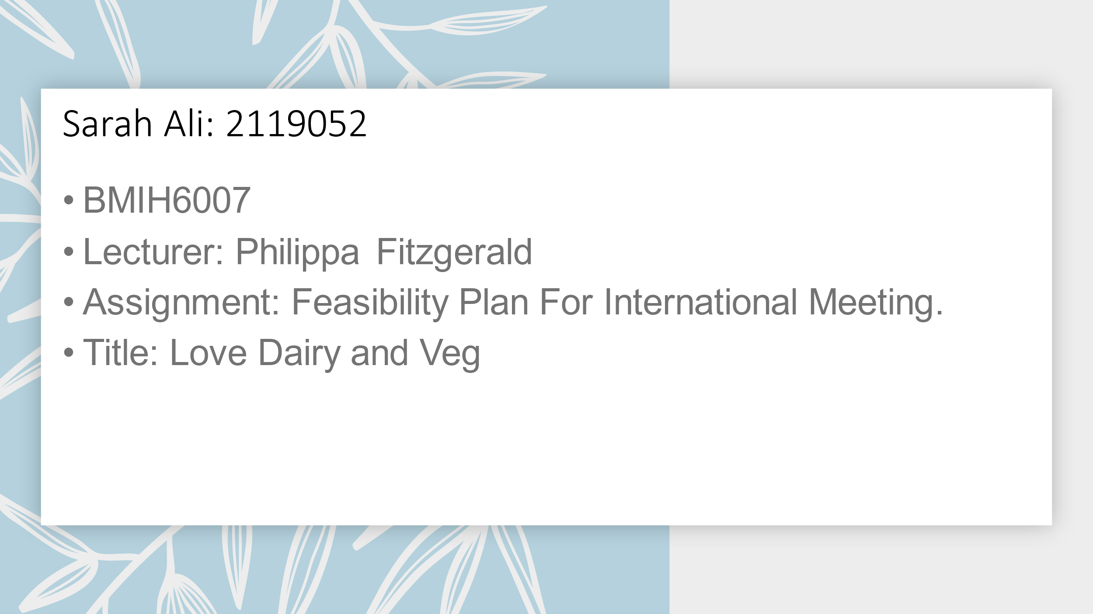

2.

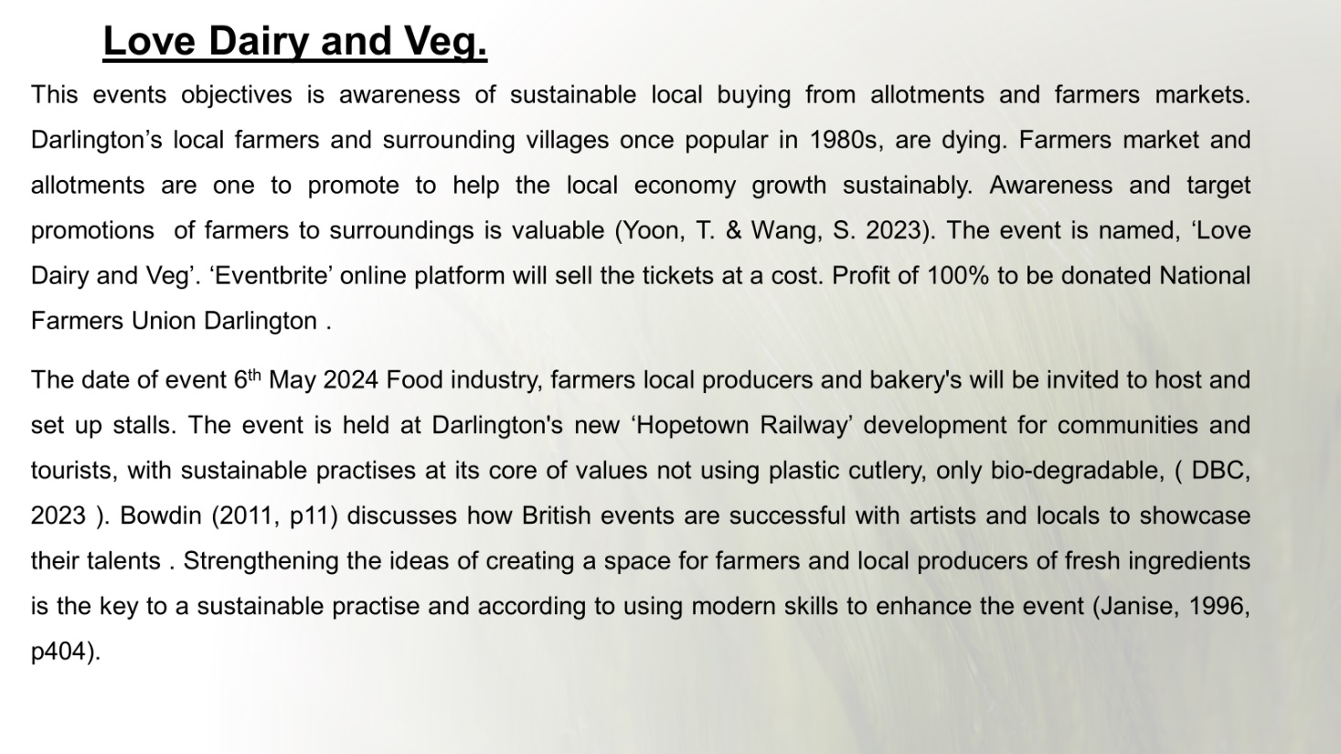

3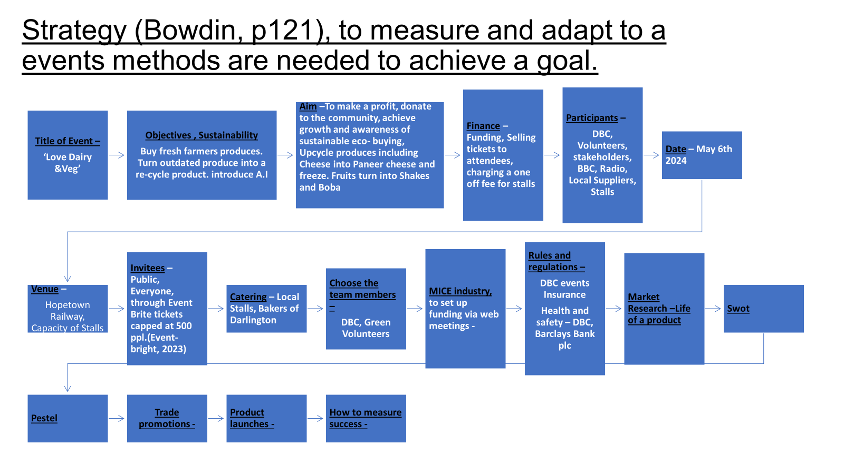.

4.
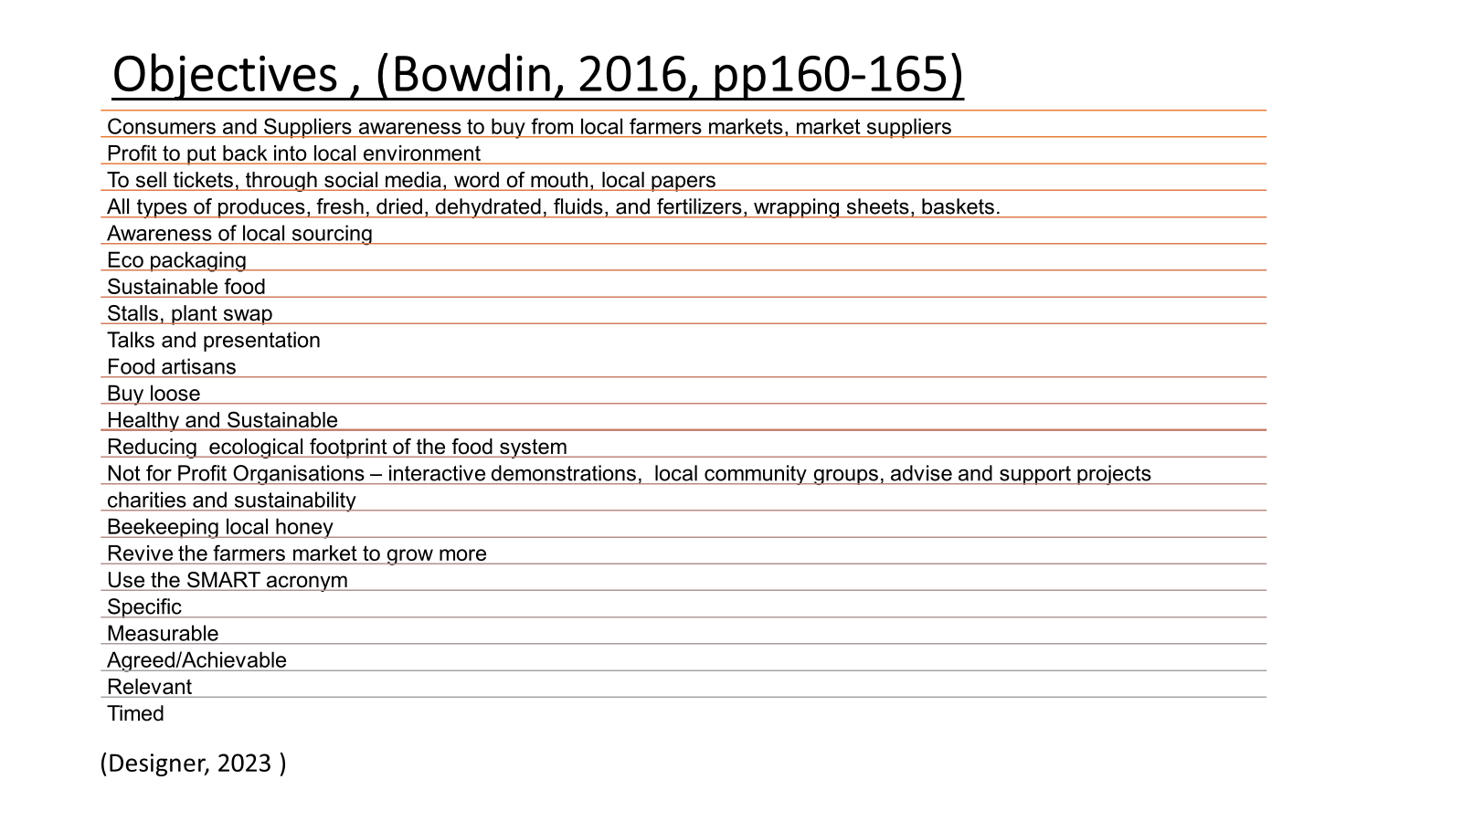

5.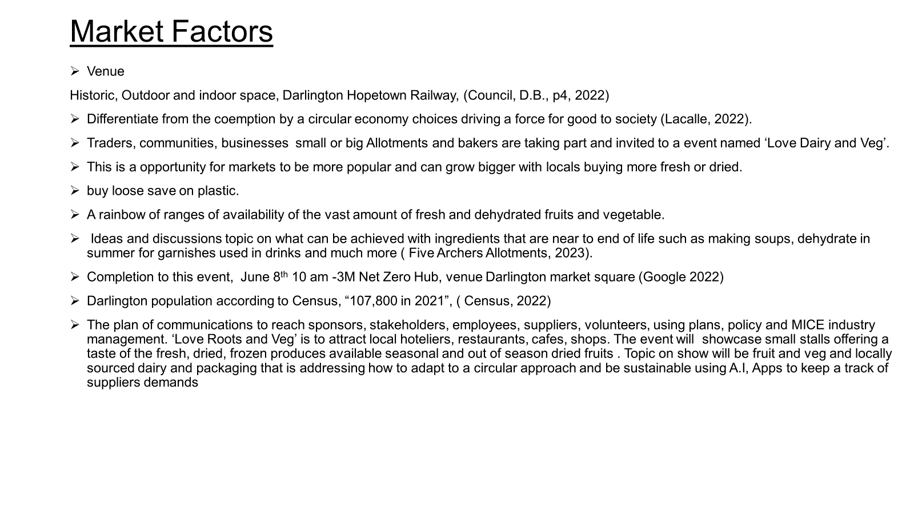

6.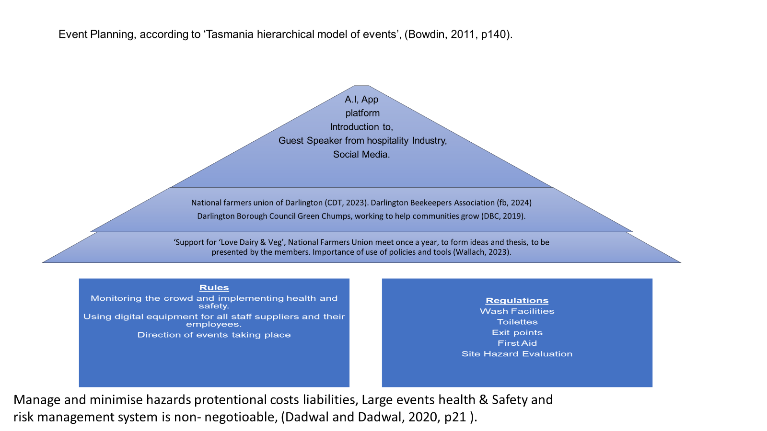

7.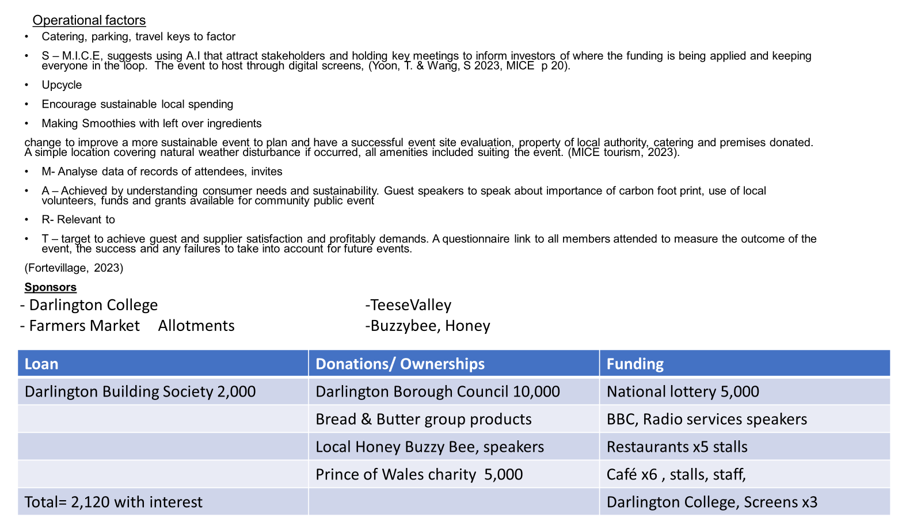

8.
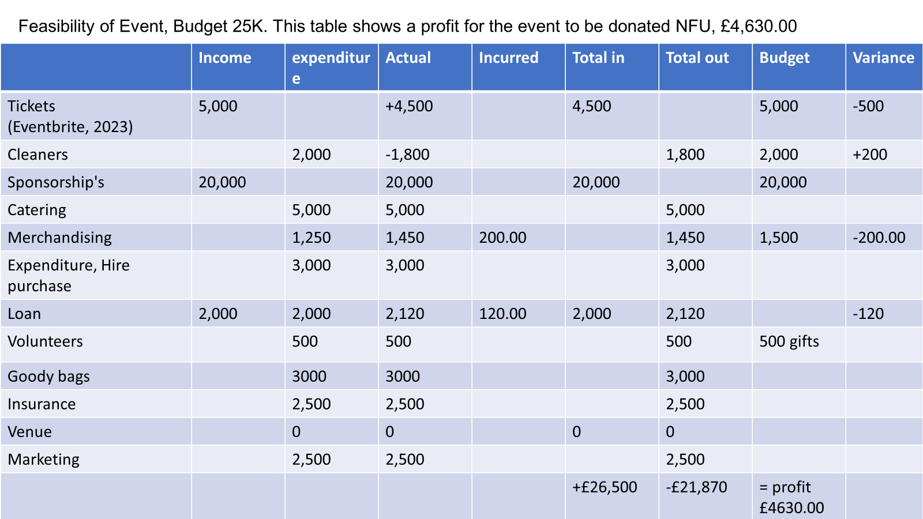

9.
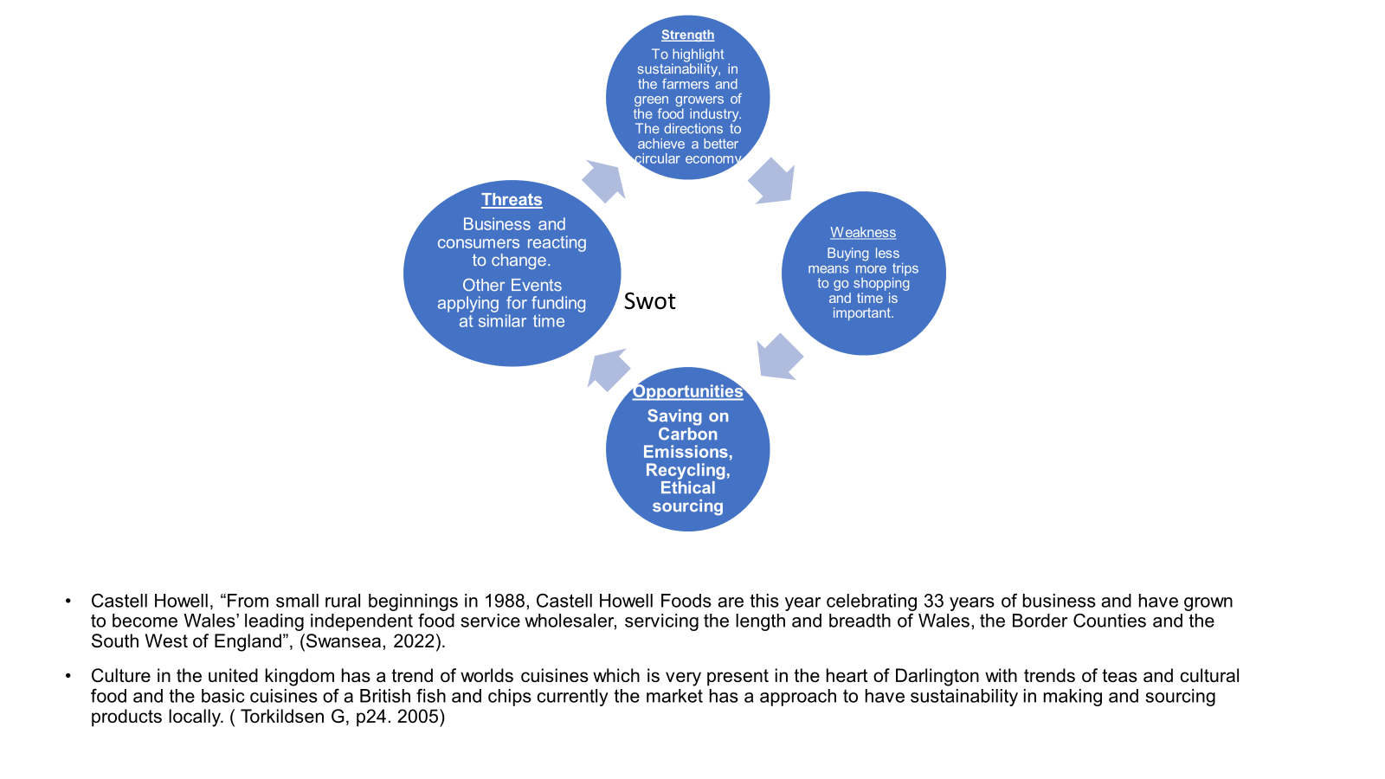

10.
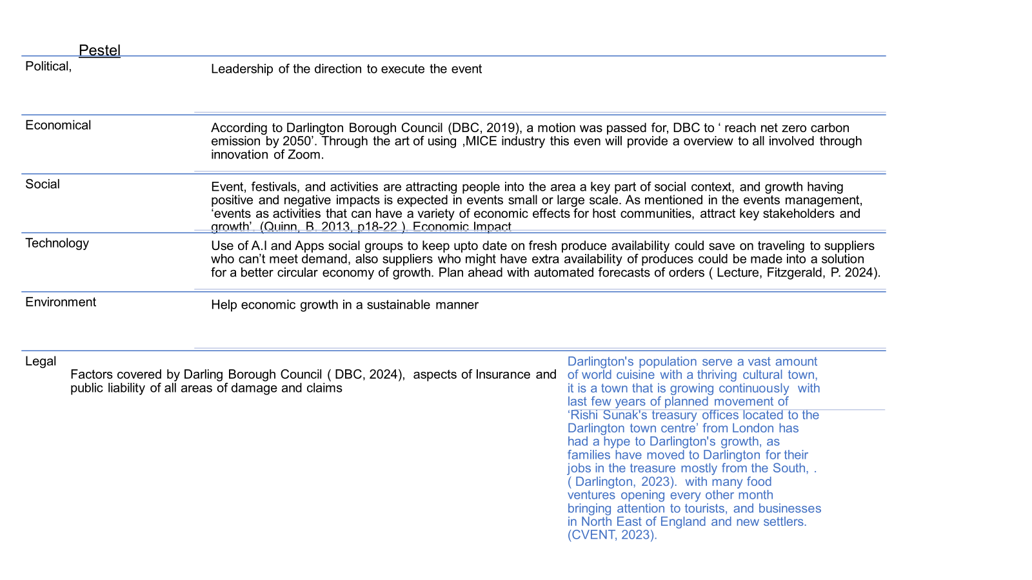

11.
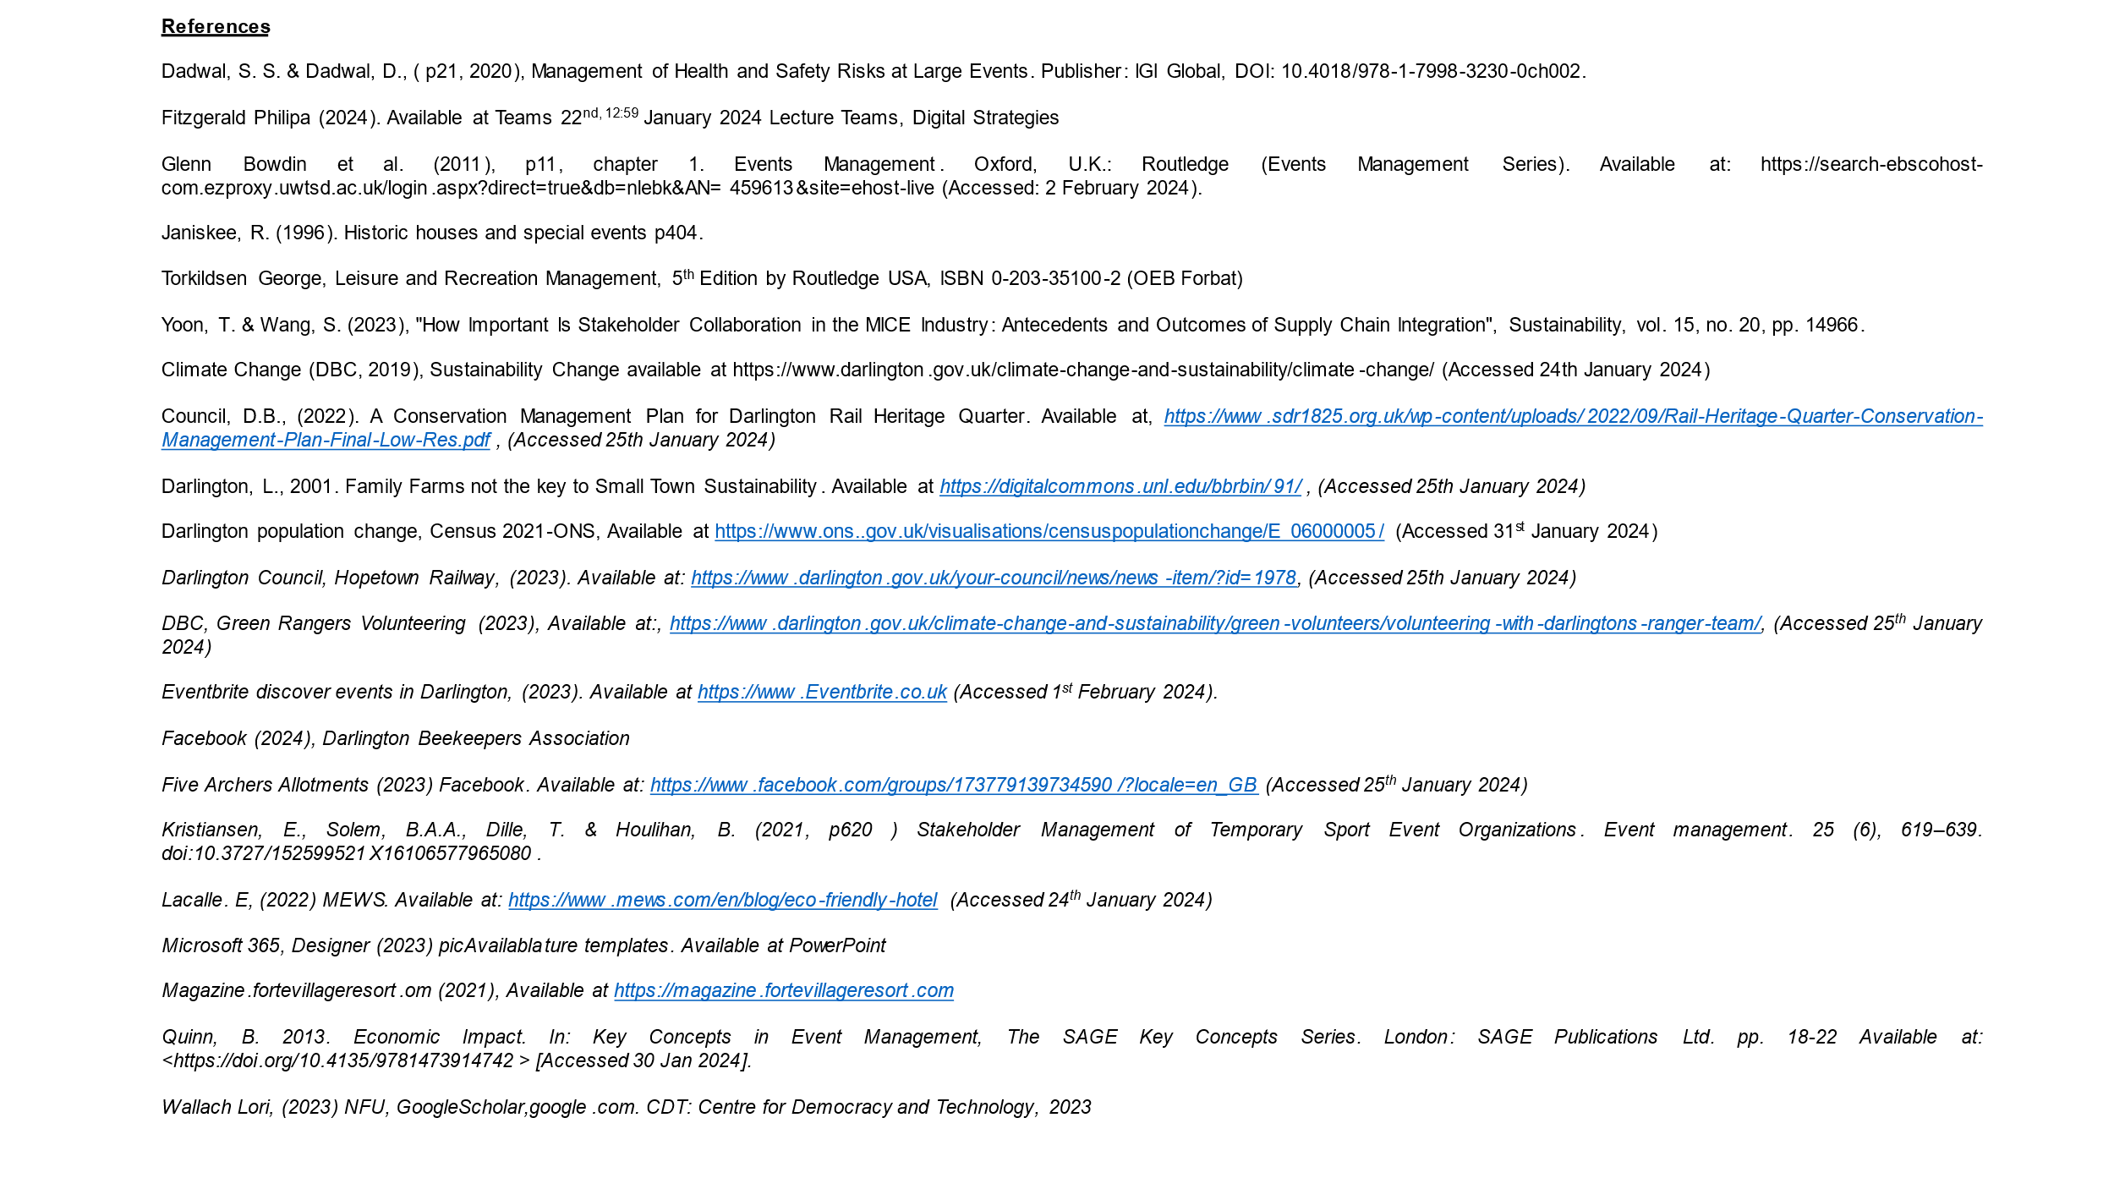

References

Dadwal, S. S. & Dadwal, D., (p21, 2020). Management of Health and Safety Risks at Large Events, Publisher: IGI Global, DOI: 10.4018/978-1-7998-3230-0ch002.
Fitzgerald Philipa (2024). Available at Teams 22nd, 12:59 January 2024 Lecture Teams, Digital Strategies.
Glenn Bowdin et al. (2011), p11, chapter 1. Events Management. Oxford, U.K.: Routledge (Events Management Series). Available at: https://search-ebscohost-com.ezproxy.uwtsd.ac.uk/login.aspx?direct=true&db=nlebk&AN=459613&site=ehost-live (Accessed: 2 February 2024).
Kristiansen, E., Solem, B.A.A., Dille, T. & Houlihan, B. (2021, p620 ) Stakeholder Management of Temporary Sport Event Organizations. Event management. 25 (6), 619–639. doi:10.3727/152599521X16106577965080.
Janiskee, R. (1996). Historic houses and special events p404.
Torkildsen George, Leisure and Recreation Management, 5th Edition by Routledge USA, ISBN 0-203-35100-2 (OEB Forbat)
Yoon, T. & Wang, S. (2023), "How Important Is Stakeholder Collaboration in the MICE Industry: Antecedents and Outcomes of Supply Chain Integration", Sustainability, vol. 15, no. 20, pp. 14966.
Climate Change (DBC, 2019), Sustainability Change available at https://www.darlington.gov.uk/climate-change-and-sustainability/climate-change/ (Accessed 24th January 2024).
Council, D.B., (2022). A Conservation Management Plan for Darlington Rail Heritage Quarter. Available at, https://www.sdr1825.org.uk/wp-content/uploads/2022/09/Rail-Heritage-Quarter-Conservation-Management-Plan-Final-Low-Res.pdf. (Accessed 25th January 2024).
Darlington, L., 2001. Family Farms not the key to Small Town Sustainability. Available at https://digitalcommons.unl.edu/bbrbin/91/ , (Accessed 25th January 2024).
Darlington population change, Census 2021-ONS, Available at https://www.ons..gov.uk/visualisations/censuspopulationchange/E06000005/ (Accessed 31st January 2024).
Darlington Council, Hopetown Railway, (2023). Available at: https://www.darlington.gov.uk/your-council/news/news-item/?id=1978, (Accessed 25th January 2024).
DBC, Green Rangers Volunteering (2023), Available at:, https://www.darlington.gov.uk/climate-change-and-sustainability/green-volunteers/volunteering-with-darlingtons-ranger-team/, (Accessed 25th January 2024).
Eventbrite discover events in Darlington, (2023). Available at https://www.Eventbrite.co.uk (Accessed 1st February 2024).
Facebook (2024), Darlington Beekeepers Association
Five Archers Allotments (2023) Facebook. Available at: https://www.facebook.com/groups/173779139734590/?locale=en_GB (Accessed 25th January 2024).
Lacalle. E, (2022) MEWS. Available at: https://www.mews.com/en/blog/eco-friendly-hotel (Accessed 24th January 2024).
Microsoft 365, Designer (2023) picAvailablature templates. Available at PowerPoint
Magazine.fortevillageresort.om (2021), Available at https://magazine.fortevillageresort.com. (Accessed 1st February 2024).
Quinn, B. 2013. Economic Impact. In: Key Concepts in Event Management, The SAGE Key Concepts Series. London: SAGE Publications Ltd. pp. 18-22 Available at: <https://doi.org/10.4135/9781473914742> [Accessed 30 Jan 2024].
Wallach Lori, (2023) NFU, GoogleScholar,google.com. CDT: Centre for Democracy and Technology, 2023

