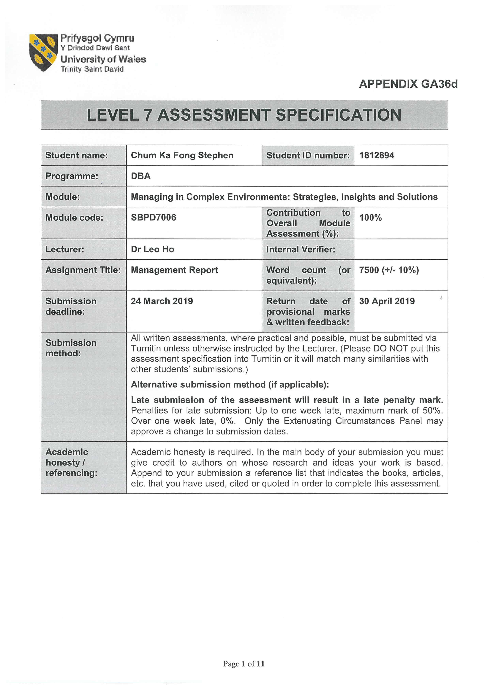
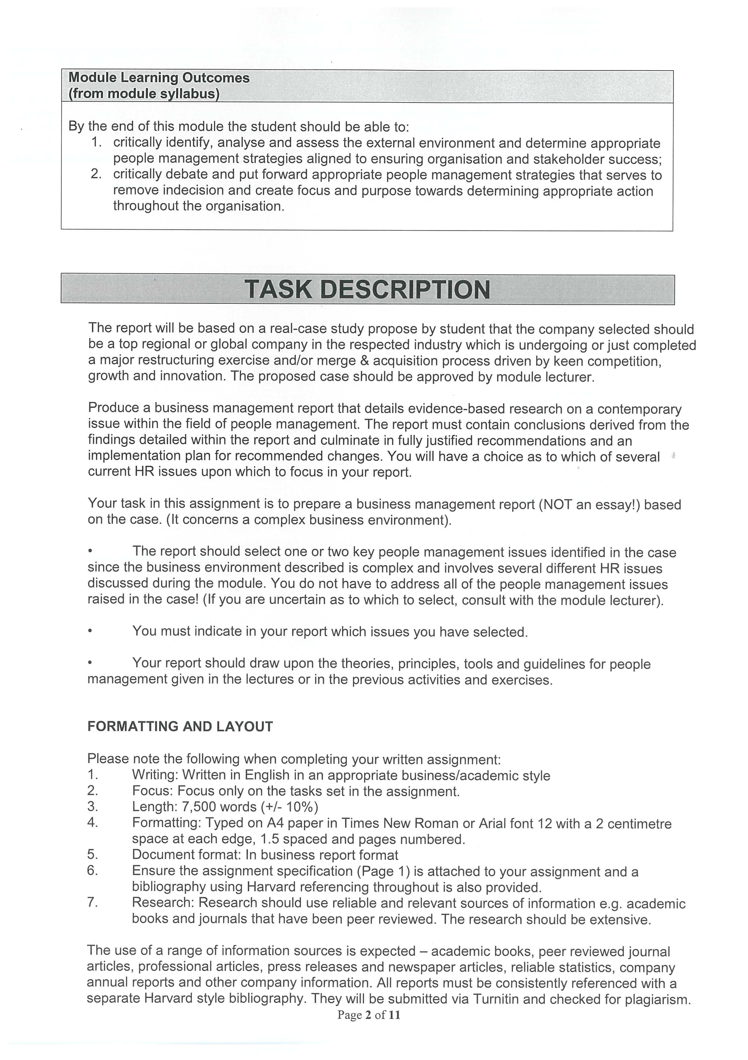
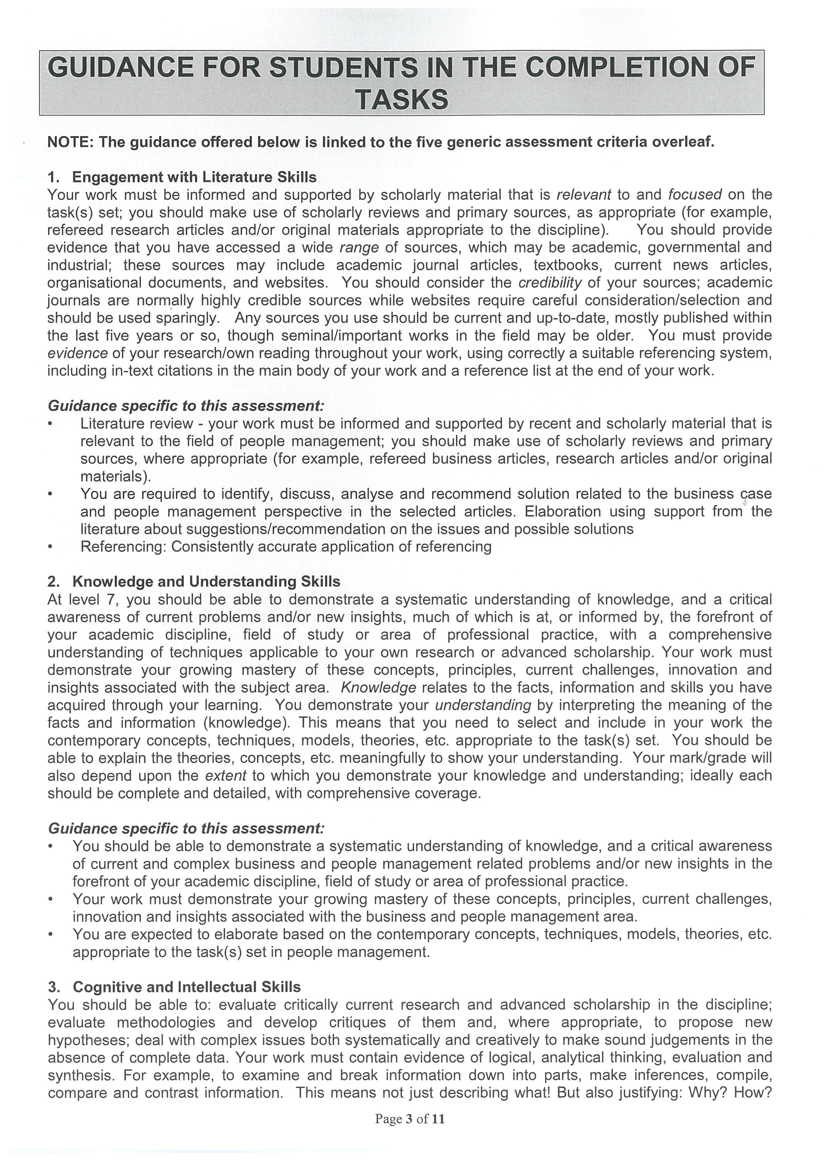
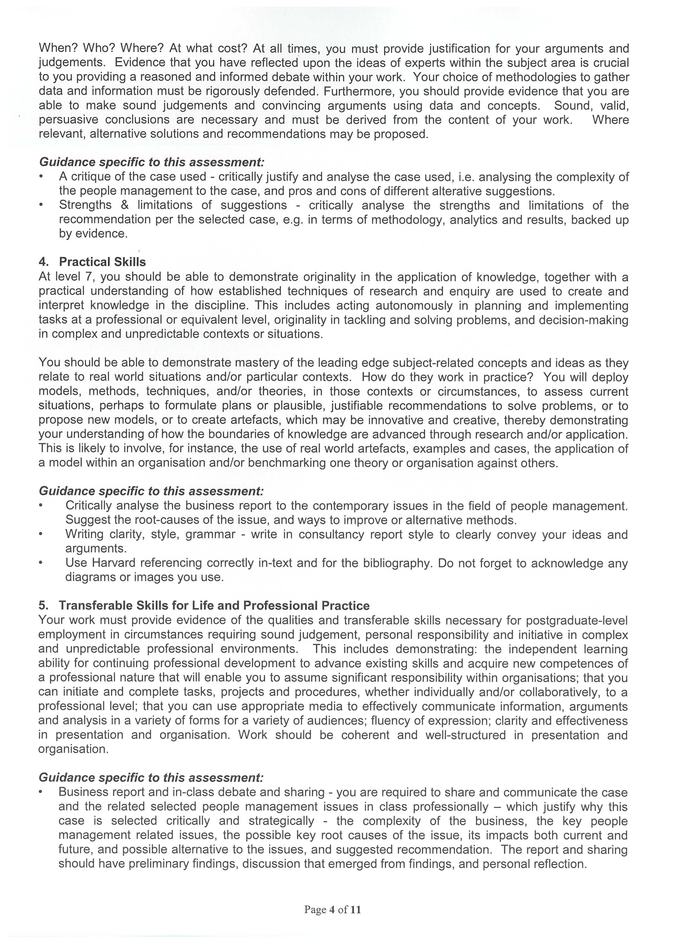
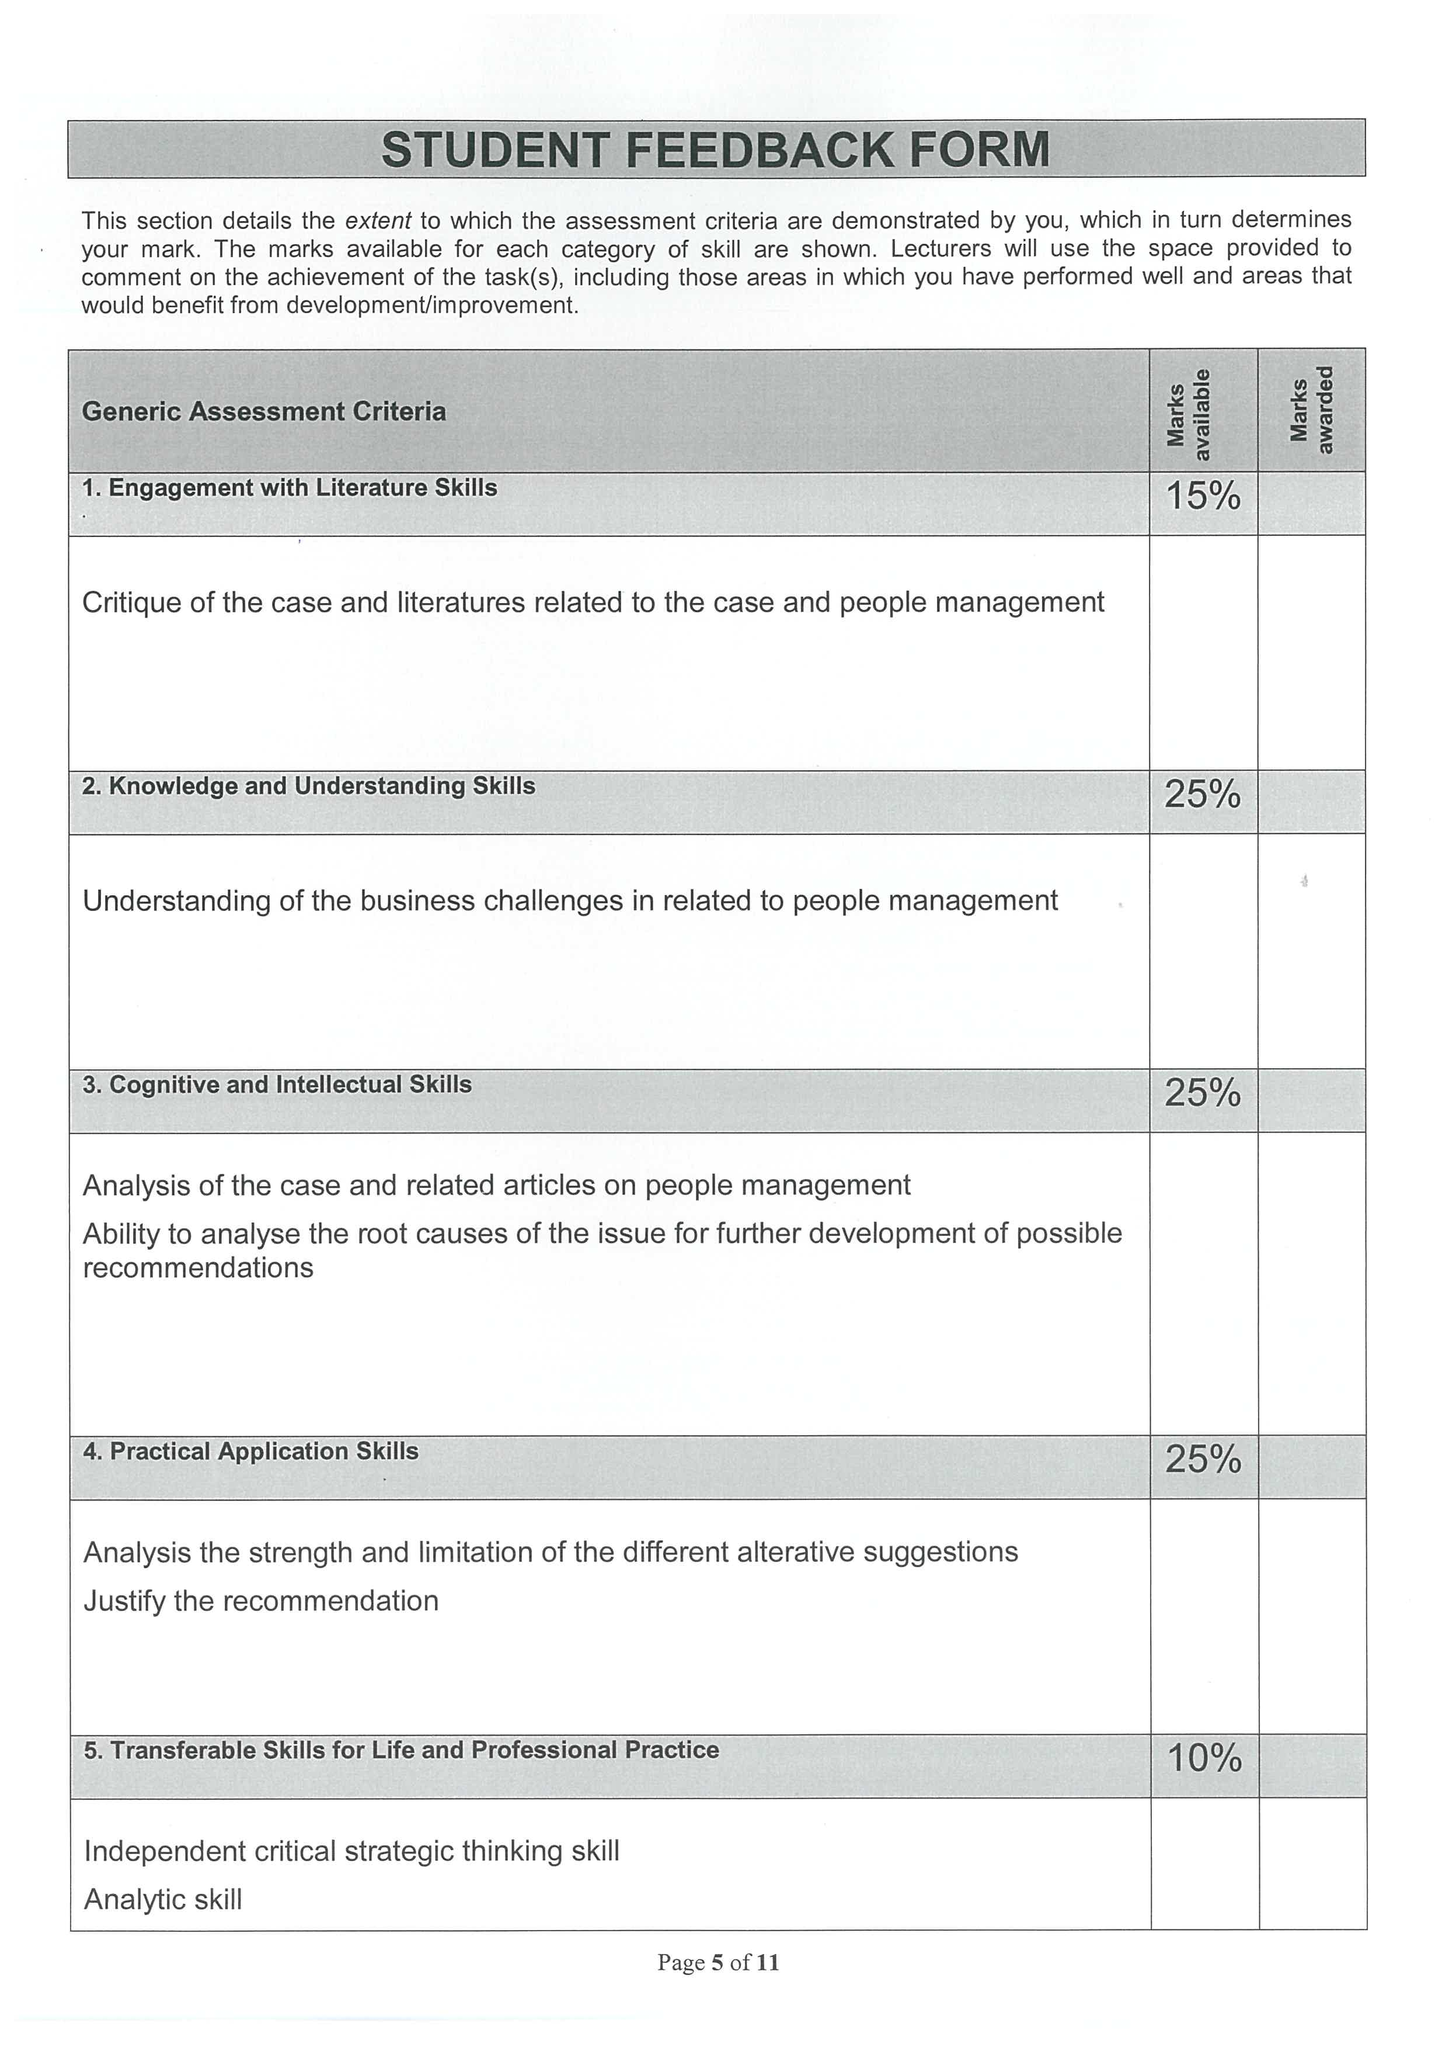


Table of Contents

Page
1) Executive Summary 8
2) Introduction 8
3) Background 9
  - Company Background of KazOil 9
  - 1st Merger & Acquisition Situation 9
  - 2nd Merger & Acquisition Situation 11
4) Merger & Acquisition Trend Analysis 12
  - China Economic Performance 12
  - Merger & Acquisition Trend of China 12
5) Literature Review 14
  - Kahn’s Personal Engagement Model 14
  - Saks’ Employee Engagement Model 15
  - Anitha’s Employee Engagement Model 16
  - Hofstded’s Culture Difference Model 17
6) Problems Identification and Issues Analysis 20
7) Recommendations 22
8) Conclusions 26
9) References 27

Title
KazOil’s Merge & Acquisition Experience: Recommendations for Policies Implementation to Improve Employee Engagement

Executive Summary
KazOil was a stated-run cooperative producing oil in Kazakhstan with 5,000 employees and after two different merger and acquisitions by Canadian company and Chinese company respectively, it encountered serious employee engagement problem because of total differences in culture. In order to identify the problem and find out corresponding suggestions, three employee engagement models and one cultural difference model have been discussed in this report and finally the employee engagement one of Anitha and Hofstede’s Cultural Difference Model have been used to analyse the situation. For the recommendations, it is suggested that both short-term plan and long-term plan should be formulated in order to continuously improve the employee engagement situation in KazOil. For short-term plan, it mainly focuses on corrective actions with immediate and mid-way effects on management, job designing, resources allocation, communication and decision-making process while for the long-term plan, it mainly focuses on sustainability of employee engagement by introducing the concept of Cultural Intelligence (CQ) and incorporated engagement culture in the whole company in order to improve and sustain KazOil’s business growth.

Introduction
This is a business management report concerning the recommendations that KazOil can implement in order to improve the employee engagement after the merge and acquisition taken place. KazOil had experienced two merge and acquisition incidents, one was by Canadian company while another one was by Chinese company. Because of the culture difference, there were many people management issues and problems happened when comparing of two like leadership, motivation, coaching, delegation, conflict management, communication, employee engagement, etc. This report is trying to analyse and evaluate the problem of employee engagement that KazOil encountered in order to find out some recommendations to implement and improve the employee engagement from the perspective of culture difference.
Background
Company Background of KazOil
According to the case written by Minbaeva and Muratbekova-Touron (2016), KazOil was a stated-run cooperative producing oil in Kazakhstan with 5,000 employees. After the power of Soviet disintegrated in 1990s, the dominant centralized planned economy of Kazakhstan also collapsed which gave Kazakhstan opportunity to introduce certain degree of western democratic systems in the fields of both political as well as economical into the country. Because of the plenty and abundant amount of natural resources especially in oil, Kazakhstan soon after enjoyed a sustainable economic growth after independence. Starting from 2000, Kazakhstan exceeded most other countries with 10% average annual economic growth rate while the natural resources reserve of the country was also estimated to be third largest among other natural resources supply countries in the world. All the above-mentioned favourable conditions led KazOil became one of the most important oil producers and suppliers in the world.
Nevertheless, the operation of KazOil was not so efficiency and effective at all. Because of highly protection by the government before the dissolution of Soviet system, KazOil tended to have high degree of bureaucracy and centralized structure. Besides, employees of KazOil were also expected to only follow those norms including ultimately respect of top management, high uncertainty avoidance and only pay attention on those short-term issues. What’s more, technology and the internal operational system of the company were outdated while communication between top and bottom was not encouraged at all owing to the distance kept between management and staff. Because of this, management didn’t pay much attention on employees’ development or training, and decision-making process was basically top-downed by top management without much more inputs from the lower level of employees.

1st Merger & Acquisition Situation
The state-owned situation of KazOil was ended when the Kazakhstan government sold it to a Canadian company, Hydrocarbons Ltd., for US$120 million. With immediate additional capital and advanced technological support after the acquisition from the Canadian headquarter, KazOil gained some huge successes in business performance. Based on the descriptions of Minbaeva and Muratbekova-Touron (2016), KazOil could increase its natural resources reserve by 10% more after one year from the acquisition and also obtain 20 additional new successful oil wells with 100% ownership and exploration licenses. For those unsuccessful drilling cases, KazOil could also gather some valuable data and run them with the improved analysis system installed for carry on study and future development. The Canadian headquarter also helped to set up some future goals and executed them effectively in order to sustain the long-term value of return for the investors (e.g. Actively exploring the export opportunity for their crude oil and refined products to China as well as Central Asia markets). Apart from business direction retuning, the headquarter also implemented some effective policy changes internally which could minimize the negative effects of uncertainty arising from the acquisition including keeping all existing KazOil’s staff for at least three years, reducing all unnecessary cost and capital expenditures, providing formal general training programmes for all employees, as well as conducting an all-rounded evaluation of safety measurement with specific programmes supported. Not only offering localized training programmes, most of the employees also gained the opportunities to go to Canada to participate the advanced training programmes relating to safety, management skills and field operations, as well as team building activities and social events, etc. For better communication, the human resources department of the headquarter not only organized some English language courses but also hired some instructors to organize some seminars talking about the Canadian culture and invited KazOil employees, their families, relatives and friends to join to make sure that they could have better understanding about the company directions and wills of top management. Besides, the new top management also coached their employees whenever necessary and encouraged them to discuss and feedback openly, and actively take their own initiatives. A new set of human resources policies relating to recruitment, job contents and performance appraisals were also prepared and implemented after strategic decision-making process from HR department in order to increase the morale of the employees of whole organisation. All local managerial executives also gained the chance to involve in the KazOil’s talent succession programme with the intention to enhance their career achievements. KazOil’s staff considered that all these policy changes and implementations were positive and care about their interests and so tended to work harder to present their acceptances for the new top management. They all commented that Canadian management was professional with open lines of communication and unifying to the company philosophy “To build employees’ confidence, broaden employees’ business perspective and increase employees’ job satisfaction” while in short, KazOil’s staff believed that they “had an impact” in the company (Minbaeva and Muratbekova-Touron, 2016, p. 7). They also believed that the model implemented by the Canadian top management was one of the successful acquisition cases by western countries.

2nd Merger & Acquisition Situation
Nevertheless, this positive working environment was suddenly changed after Hydrocarbons Ltd., agreed and confirmed to sell KazOil to Chinese company, China Petrol, for US$4.2 billion which was the largest acquisition project taken place by a Chinese company at that time. One of the main purposes for this takeover was trying to design and build the 3,000-kilometer-long Sino-Kazakhstan oil pipeline in order to guarantee the reliable supply of oil. Basically, this objective was remarkable and full of vision to achieve. However, the managerial style that Chinese management brought in was totally different from Canadian one and unsuitable to situation just after the acquisition. Even though the Chinese management maintained those existing employees, but they also transferred KazOil 30 managers from Chinese headquarter to monitor the new implemented managerial system. The new managerial system included a high degree of bureaucracy and hierarchy, many new strict directive rules, procedures and practices, a comprehensive centralized decision-making system, re-allocating all resources subjectively and inefficiency, etc. Instead of care about the employees’ needs and developments, Chinese top management focused little attention on KazOil’s employees’ interests and the only way they were used to retain those staff was boosting the bonus at the beginning stage of takeover. Because of high degree of bureaucracy and hierarchy, the top-downed decisions from top management were slow and spent a lot of time from the top to the bottom, with lack of transparency and not much input and mutually communication while they were made (even some organized Chinese language courses were available but they were only for selected group of staff which in fact created some barriers in communication). The overall situation was just like shifting backwards to the Soviet management system when it state-owned by Kazakhstan government. As a result, those international staff of KazOil resigned and left soon after the acquisition while for the local managers, especially those high skilled ones, also considered Chinese top management was “non-professional” and would likely to “slow down their own career” (Minbaeva and Muratbekova-Touron, 2016, p. 8) in the sense that they also would not stay in the company long. As a Head of Corporate Finance of KazOil as well as one of the local top management in the company, Mr. Nurlan Ospanov believed that employee engagement obviously was a big problem for KazOil’s existing situation since talent people definitely was a valuable asset for KazOil’s future development and success.

Merger & Acquisition Trend Analysis
China Economic Performance
The case of KazOil’s 2nd acquisition by Chinese company is one of the typical examples that China going aboard to enlarge its political and economic impacts internationally in the global stage through the means of overseas investment or even merge and acquisition. The economic reforms of China had started since 1978 and over the past 25 years, China’s economy grew rapidly (Holz, 2008). If measuring in terms of real gross domestic product (real GDP), the annual average growth rate was 9.6% (Morrison, 2018, p. 5) from less than US$150 billion in 1978 to around US$8,300 billion in 2012 (Purdy, 2013). Up to 2017 and after enjoying more than 30 years explosive growth in economy, China has made its own as the world largest one of economic growth with around US$23 trillion (Amadeo, 2019) and become the 2nd largest economy in the world today (Eckart, 2016). One of the main reasons for this substantial increase in GDP was huge increase of trade between China and other countries all over the world especially with United States (US). According to the information provided by Morrison (2018, p. 1), total trade between China and US increased from US$5 billion in 1980 to around estimated US$640 billion in 2017 while China was the largest trading partner and the 3rd largest export country of US, as well as US’s largest source of import right now. In 2009, China had already replaced Germany to become the largest trade exporter and the 2nd largest trade importer in the world while 3 years after this, China had finally replaced US to become the largest trading economy in the world (Morrison, 2018, p. 21). Owing to all these aggressive trade transactions and practices to support the rapid economic growth, PricewaterhouseCoopers (PWC) also predicted that China would become the biggest economy in the world by 2020 (Wearden, 2010).

Merger & Acquisition Trend of China
An extensive trade practices also benefited to China government to accumulate its own massive foreign exchange reserves. Together with a sustainable high rate of savings by stated-owned enterprises (SOEs), as well as productivity gains and improvement due to resources reallocation, all these also supported the economic reforms and growth which allowed and encouraged the outflows of foreign direct investment (FDI) of the SOEs (Morrison, 2018, p. 7). Only in 2014 alone, China had become the 2nd largest country to provide FDI in the world with US$116 billion in total (Eckart, 2016) and while in 2016, Chinese companies had also spent around US$230 billion in “outbound” merger and acquisition (M&A) issues around the world (Cogman, Gao and Leung, 2017). Through the FDI outflows exercises, SOEs could obtain those valuable natural resources like oil and minerals, technologies, management skills, international relationships (to support its rapid economic growth), and have the opportunity to develop their own internationally recognized products and brands in order to gain the competitive advantages globally and setup their multinational positions with production and R&D operations all over the world (Morrison, 2018, p. 18-19).
Some examples of outbound M&A by Chinese companies were typical and representative including China National Chemical Corp. (Chemchina, which is one of the largest industrial companies in Asia) acquired Pirelli (the 5th largest tire manufacturer in the world) for technology and production know-how learning which was also the largest acquisition transaction of Chinese company in Italy (Stiekema, 2015); Yili Industrial Group acquired Fauji Foods for new production technology and operational experience (Anjum, 2018); Lenovo acquired IBM’s ThinkPad and x86 enterprise server divisions, as well as Motorola Mobility for stretch its power in global mobile business (Backaler, 2015); Dalian Wanda acquired AMC Entertainment for US$2.6 billion in US and Sunseeker yachts in UK (Backaler, 2015); Anbang Insurance Group acquired a New York City historic Hotel, Waldorf Astoria, for US$2 billion while Shuanghui International acquired Smithfield Foods for US$4.7 billion which brought out a lot of issues for politicians and economists in US to discuss about (Backaler, 2015); Bain Capital Partners and Huawei Technology acquired 3Com for US$2.2 billion in order to allow them to stretch both parties’ power into Silicon Valley (Flynn and Bradsher, 2007); China Xiwang Foodstuffs acquired Kerr Investment Holding Corporation of Canada with the purpose to brand-built the company into the high-end health food market segment (Xinhua, 2016); Zhejiang Geely Holding Group acquired Volvo from Ford Motor to expand its market share in the world (Nicholsom, 2010); China Jianyin Investment acquired SGD Pharma such that it could have the opportunity to enter into the high technological pharmacy industry (Love, 2016), etc. All the above-mentioned acquisitions were only some of the highlights that Chinese companies or SOEs invested directly into foreign countries all these years. By executing the outflows of FDI like the case of “The Acquisition Experiences of KazOil” mentioned above, companies intended to move back the usual natural resources and energy, technology, industrial knowledge, research & development (R&D), chemical innovation and consumer insight information into China in order to boost up the economic growth of China again. Besides, it also helped to support both political and financial environment of China required during this economic reforms’ situation, as well as enhanced the political and economic influences internationally for China (Shepard, 2016).

Literature Review
Referring to the KazOil case, Mr. Nurlan Ospanov realized that the acquisition taken place by his Chinese headquarter right now really raised some people management issues especially in the field of employee engagement. According to Kahn’s definition, personal engagement was defined as “the harnessing of organisation members’ selves to their work roles” with further explained that “in engagement, people employ and express themselves physically, cognitively, and emotionally during role performances” (Kahn, 1990, p. 694). Anitha also defined employee engagement as “the level of commitment and involvement an employee has towards their organisation and its values” (Anitha, 2014, p. 308). Riding on what Kahn’s mentioned above, Saks also interpreted “engagement means to be psychologically present when occupying and performing an organisational role” (Saks, 2006, p. 601).

Kahn’s Personal Engagement Model
Based on the model of Kahn (1990, pp. 703-717), there were three psychological conditions determined whether a person was being engaged to the organisation: Psychological Meaningfulness, Psychological Safety and Psychological Availability.
Psychological Meaningfulness referred to work elements which encouraged or discouraged a person to engage and was a feeling a person received on his or her investment return in terms of physical, cognitive or emotional energy. People tended to feel meaningfulness when they felt they were useful and valuable in their positions if they were capable to give something to others as well as capable to receive during their work. There were three factors affecting Psychological Meaningfulness: Task Characteristics, Role Characteristics and Work Interactions and based on the study of Kahn, if people could participate in the work which was well-defined, challenging, creative and with certain amount of change (Task Characteristics), while their role identities of this work were implicitly to be assumed, valuable and capable to influence others in the organisation (Role Characteristics), and their performances finally could involve rewarding interpersonal interactions with both inside and outside of the organisation (Work Interactions), then their Psychological Meaningfulness in their work would be more and hence, more engaged on their work as well as their organisations.
Psychological Safety referred to the feeling a person received when he or she didn’t feel fears from the negative impact on his or her self-image, status, position or career. People tended to feel safe if they were in the trust environment which were clear enough, predictable and consistent. There were four factors affecting Psychological Safety: Interpersonal Relationships, Group and Intergroup Dynamics, Management Style and Process and Organisational Norms and based on the study of Kahn, if people were free to try without fear and could receive supportive, trust and constructive criticisms even failure from peer groups and management (Interpersonal Relationships and Management Style and Process), while their work were with good impact on group dynamic within the organisation, and their performances in their positions were clearly and aligned with organisational norms (Organisational Norms), then they would psychologically feel more safe in their work and hence, more engaged on what they were doing in the organisation.
Psychological Availability referred to the feeling a person had on his or her physical, emotional and psychological resources for engaging to the work as well as organisation and in short, it referred to the measurement of how people were ready for the engagement. Based on the study of Kahn, there were four factors affecting Psychological Availability: Physical Energy (whether people had enough energy for their engagements), Emotional Energy (whether people were emotional ready for their engagements), Insecurity (whether people felt secure about their work and positions) and Outside Life (whether people’s outside lives distracted them from their engagements). The higher the Psychological Availability that people were, the higher the personal engagement that they would be towards their work and organisations.
In short, based on the ideas and development from Kahn, people tended to more engage to the organisation when the environment and condition allowed them to feel more psychological meaningfulness as well as psychological safety, while they were also in more psychological available situation.

Saks’ Employee Engagement Model
Besides Kahn, Saks also looked at those factors affecting employee engagement in more precise perspective and hence, developed his own model accordingly. Based on the model of Saks (2006, pp. 604-606), there were totally six factors affecting employee engagement: Job Characteristics, Perceived Organisational Support, Perceived Supervisor Support, Rewards and Recognition, Procedural Justice and Distributive Justice.
Job or Task Characteristics mentioned that people tended to more engage in their work when the work contents were challenging with variety, allowed them to apply or learn different skills, as well as provided them the chance to make significant contribution to the organisation.
Similar to what Kahn mentioned in his point of Interpersonal Relationships and Management Style and Process, Perceived Organisational and Supervisor Support referred to situation when people were free to try without fear of negative consequences since they could receive care, trust, as well as supportive and constructive criticisms from organisation (named as POS) and direct supervisors (named as PSS) and it claimed that people tended to more engage to the organisation and supervisors if they could receive more support from both parties in return.
Rewards and Recognition referred to benefit perceptions that people could gain from their roles and it claimed that if those rewards and recognitions could align with the perceptions people thought about from their roles and paid directly by the organisation, then they tended to have higher engagement to the organisation.
Procedural Justice and Distributive Justice referred to whether people in the organisation felt the rewards distribution and the procedures applied to allocate those rewards were predictable and consistent. This was the concept of fairness relating to how to distribute the rewards to the people involved and higher perceptions of justice generally led higher levels of engagement.
To summarize this, people tended to more engage to the organisation when they were participating in core and important, creative with variety work, receiving rewards and recognition through some fair, predictable and consistent means with fruitful supports from the organisation as well as from their supervisors.

Anitha’s Employee Engagement Model
Anitha concluded and consolidated both models from the above-mentioned two scholars and developed her own one. Based on the model of Anitha (2014, pp. 310-313), there were seven factors affecting employee engagement, which mainly inspired by those six factors from Saks’ model, and each of them could refer to those three psychological factors of Kahn’s model: Work Environment, Leadership, Team and Co-worker Relationship, Training and Career Development, Compensation or Remuneration, Organisational Policies and Procedures and Workplace Wellbeing. Based on the study of Anitha, Working Environment not only referred to physical conditions but also referred to psychological feeling of employees about the feedbacks from others, communication encouragement, new skill set development, etc. (Anitha, 2014, p. 311). Leadership referred to the effectiveness of leadership as well as its corresponding style like the degree of transparency, balance information processing, internal moral standard setup and sustainability, etc. (Anitha, 2014, p. 311). Team and Co-worker Relationship referred to the degree of trusty, open and supportive team environment (encouraging to try something new without fear of failure) and maintenance of interpersonal relationships which both contributed important influence on Psychological Meaningfulness of Kahn’s model (Anitha, 2014, p. 311). Training and Career Development referred to the performance improvement and growth of employees, as well as their development plans by providing them suitable training opportunities (Anitha, 2014, p. 312). Compensation or Remuneration not only referred to financial and non-financial means, but also referred to some psychological feeling of employees like recognitions from the organisation for their contributions (Anitha, 2014, p. 312). Organisational Policies and Procedures referred to the fairness and the flexibility of work arrangements in order to balance employees’ work and personal life (Anitha, 2014, p. 312). Finally, Workplace Wellbeing referred to perceived support of the organisation from senior management for employees’ interests (Anitha, 2014, pp. 312-313). It was crystal clear that the aspired and supportive working environment with both physical and emotionally safe, which encouraged people to emotionally communicate with each other, with the opportunity to learn openly and train up and develop people themselves, as well as with clear, consistent, predictable and transparency policies and procedures in compensation and remuneration would definitely promote higher engagement level of employees. This could increase the morale of the employees and hence, boost up the productivity of work assigned as well as improve the performance of jobs.
In this report, in considering the factor of comprehensiveness, we will provide our suggestions later based on the contents of this model.
Referring to the case, there was an inferior change of employee engagement from 1st merger and acquisition to 2nd merger and acquisition. One of the main reasons for that happened due to two different companies being involved were actually with total differences in culture which led the management style on how to engage those members in the organisation changing. When talking about culture difference issues, a model of Hofstede can be used to illustrate:

Hofstede’s Culture Difference Model
According to the article written by Hofstede (2011), there are totally six dimensions of Hofstede’s culture difference model: Power Distance (PD), Uncertainty Avoidance (UA), Individualism-collectivist, Masculinity-femininity, Long-term Orientation-short-term Orientation and Indulgence-restraint (Hofstede, 2011, p. 8).
Power Distance referred to “degree to which members of a society accept as legitimate that power in institutions and organisations are unequally distributed” (Gouveia and Ros, 2000, p. 26) which also related to the human inequality issue (Hofstede, 2011, p. 8). Based on what further elaboration of Hofstede about Power Distance dimension (PD), less powerful employees in the organisation tended to accept the situation of unequal distribution of power and when the organisation or society with Large Power Distribution, elderly tended to receive most respect while hierarchy also implied existence of inequality and subordinates or bottom level of employees expected to be told what they need to do instead of to be trained for how they think (Hofstede, 2011, p. 10). According to what Signorini, Wiesemes and Murphy’s mentioned (2009, p. 254), China’s culture or even those in Asian countries is basically with a large power distance (LPD) while western countries tend to be with small power distance (SPD).
Uncertainty Avoidance (UA) referred to “degree to which members of a society are uncomfortable with uncertainty and ambiguity” (Gouveia and Ros, 2000, p. 26) which also related to level of stress when dealing with unknown future (Hofstede, 2011, p. 8). Hofstede further explained that under this, people normally tried to avoid any uncertainty by strictly rules, regulations and codes of conduct (Hofstede, 2011, p. 10) and when group of people with Strong Uncertainty Avoidance, they generally tended to have higher stress and anxiety for any change and uncertainty (as such, tended to avoid), and also considered differences within the group would be dangerous to them. People also emotionally needed rules and regulations to structure and clarify the situation and employees would stay in the job and the organisation even disliked (Hofstede, 2011, p. 10). Based on the study of Hofstede, East and Central European countries tend to have strong UA while English speaking countries or Chinese culture countries tend to have relatively weak UA (Hofstede, 2011, p. 11).
Individualism-collectivist related to individuals’ integration into specific group of people (Hofstede, 2011, p. 8) and was the dimension to show whether that individual care about themselves as well as their closet relations (Gouveia and Ros, 2000, p. 26). Hofstede further explained Collectivism that people tended to have stress and always seek for belonging within the group while in-group harmony should be maintained (Hofstede, 2011, p. 11). The purpose or the first priority of training or learning was for how to do instead of how to learn in this kind of group culture and relationship (Hofstede, 2011, p. 11). Collectivism tend to be developed in less developed and Eastern countries including China while Individualism tend to be developed in developed and Western countries.
Masculinity-femininity referred to the preference of an individual for heroism, accomplishment, material success against those for relationship, weak attentive and quality of life (Gouveia and Ros, 2000, p. 26). Hofstede further described male within the group with Masculinity culture tended to be more assertive and ambitious for strong than female. Working should be considered much more important than family while men normally considered to have dominant position within the group. Based on the classification of Hofstede, Masculinity is high in Japan and those speaking German while moderately high in western countries and some Asian countries including China (Hofstede, 2011, p. 13).
Long-term Orientation-short-term Orientation related to the option that people focused on their efforts for past and present or for future (Hofstede, 2011, p. 8). People with culture of Short-term Orientation (STO) normally respected and heavily focused on their traditions, “preservation of face” (or in other words, be proud of their own countries) and tried their best to fulfil obligations of the society (Signorini, Wiesemes and Murphy, 2009, p. 257) while for Long-term Orientation (LTO), people considered that their most important incidents would be happened in the future and tradition could be adaptable to change based on different situations. People normally kept learning from other countries and had general practices to save their resources for future usage (Hofstede, 2011, p. 15). Countries with LTO are East Asian countries including China, as well as those in Eastern and Central Europe while those with STO are Western countries (Hofstede, 2011, p. 15).
Indulgence-restraint related to satisfaction gained from the control of basic desires of people or life enjoyment (Hofstede, 2011, p. 8). Indulgence preference allowed relatively free gratifications of enjoying life and having fun and hence, the control of personal life, freedom of speech, leisure in life were considered relatively more important than others (Hofstede, 2011, p. 16). In contrast, restraint preference would more focus on the control of gratifications relating to needs and regulates by strictly norms of the society and hence, those important elements like personal life enjoyment, freedom of speech, leisure would be considered less important than the ordering of the society. Based on the study of Hofstede, Western countries tend to have indulgence preference while Eastern Europe as well as Asia tend to have restraint preference (Hofstede, 2011, p. 16).
In short, Asian countries like China is restraint preference and tend to have high PD and LTO but low individualism, as well as moderately high in masculinity and relatively weak UA. On the other hand, Western countries are indulgence preference and tend to have high STO and individualism but low PD, as well as also moderately high in masculinity and relatively weak UA (Shi, X. and Wang, J., 2011, p. 15).
Because of the authority and simplicity consideration, we will provide our suggestions later based on the contents of this model in this report.

Problems Identification and Issues Analysis
Referring to the case, KazOil did experience some positive changes within the organisation after the 1st merger and acquisition by a Canadian company. From the financial performance perspective, first of all, the immediate additional capital and advanced technological support brought in after the acquisition really helped and further improved the company business performance which reinforced KazOil’s dominant position of natural resources supply in its own country, Kazakhstan, as well as further enhanced the positive impacts on the international stage in natural resources supply of the world (e.g. Natural resources reserve increased, 20 additional new oil wells with exploration licenses obtained, new export opportunity exploring to sell their products to China and Central Asia, etc.). This could more or less increase the morale of employees towards the new Canadian headquarter. Internally, new management set up some future goals and executed some new policies effectively in order to re-state the vision of the company and the direction of management clearly without vague. They also tried to minimize the negative effects arising from uncertainty due to acquisition by keeping all existing staff for at least three years and reducing all unnecessary cost and capital expenditure. All these could positively affect the Organisational Policies factor, Leadership factor and Workplace Wellbeing factor in the model of Anitha, as well as the Psychological Safety feeling and Psychological Availability in terms of security feeling of Kahn’s model and fit to relatively high Uncertainty Avoidance culture characteristics stated in Hofstede’s model by reducing uncertain risks. Besides, new management also provided some formal training and evaluation programmes, either locally or internationally, in the fields of safety measurement, field operations and management skills in order to improve the job performance of the employees. These could also bring positive impacts on the factors of Training and Career Development, Work Environment in terms of skills improvement and development and Workplace Wellbeing (perceived support from management) of Anitha’s model, as well as further improve the Psychological Meaningfulness and Safety feeling mentioned in Kahn’s model. Furthermore, new Canadian headquarter also organized regularly team building activities, social events and Canadian culture seminars in order to let KazOil employees understand more about the company direction and wills of management, as well as to increase the bonding of the team and fulfil their social needs. All these could enlarge the positive impacts on the factors of Working Environment, Leadership and Team and Co-working Relationship of Anitha’s model, as well as increase the feeling of Psychological Meaningfulness and Safety in Kahn’s model. Finally, the Canadian management also arranged some English language courses and established and maintained the openly discussion, communication and feedback internal culture through systematic and specific coaching in the sense that employees owned their initiatives, authorities as well as responsibilities for what they did in their roles of work. These could bring positive effects on the factors of Working Environment, Team and Co-worker Relationship and Training and Career Development of Anitha’s model, as well as further benefit to the feeling of Psychological Meaningfulness and Safety in Kahn’s model and shorten the degree of Power Distance dimension in order to increase the efficiency of work. By introducing talent succession programmes into the organisation, employees clearly knew and understood their roles in future in the organisation and how company recognized them by their contributions for future compensations and career developments. As such, employees believed that new management valued about them for their contributions as well as cared about their interests.
Nevertheless, the 2nd merger and acquisition by a Chinese company brought totally different case to KazOil in which the management direction was contradictory in comparing with the 1st one. After the acquisition, even though the Chinese management maintained those existing staff, but they also transferred 30 managers into KazOil for management system monitoring. Because of the culture and management style differences since the existing staff had already adapted somehow the western culture and the management style implemented by Canadian company, they felt upset and anxiety about the situation in the organisation. This brought a negative impact on the factors of Working Environment, Compensation and Workplace Wellbeing of Anitha’s model as well as on Psychological Safety and Availability in terms of insecurity because of the uncertainty increasing. Besides, the new Chinese management also implemented high degree of bureaucracy and hierarchy of management making the decision-making process slower than before and set up many strict and directive rules, procedures and practices which negatively affect the factors of Working Environment, Team and Co-worker Relationship and Organisation Policies of Anitha’s model, as well as Psychological Safety in Kahn’s model and enlarged the degree of Power Distance dimension which may affect the efficiency of work finally. This centralized decision-making practice also led the resources re-allocating in a subjective and inefficiency way, too. Furthermore, a lot of communication barriers created, due to lack of transparency and different language with little chance to understand (not many Chinese language courses arranged for staff), obviously affected the factors of Work Environment, Leadership and Team and Co-worker Relationship of Anitha’s model negatively. The factors of Psychological Safety and Availability in terms of emotional energy also changed and were not ready at all since right now, communication was one- way top-downed from management to middle and lower level of employees. After all, employees felt management paid little attention on their interests right now which made them think that the new Chinese management was “non-professional” and “slowing down their career” (Minbaeva and Muratbekova-Touron, 2016, p. 8) and hence, encouraged employees the intention to leave KazOil. As one of the local top management in KazOil, Mr. Nurlan Ospanov needed to find out how to increase the level of employee engagement again and tried to suggest some recommendations to Chinese headquarter in order to retain talent people for KazOil’s future development and success.

Recommendations
In order to improve the employee engagement of KazOil, it is suggested that a short-term planning as well as long-term planning should be formulated respectively. For the short-term planning, the main objective is to find out those unsatisfactory areas of employee engagement currently encountered and try to correct them accordingly in order to minimize the will of the intention to leave of the employees. For the long-term one, the main focus will be how to sustain or even continuously improve the employee engagement within the organisation in order to improve the job performance as well as business performance as a whole. Based on the opinions of Mann, A. and Harter, J. written in their article in 2016, a-three-year road map for the period of plan was reasonably recommended (Mann, A. and Harter, J., 2016, p. 4).
Before preparing any short-term plan, first of all, it is recommended that the situation of culture difference existed right now in KazOil should be clearly evaluated. In order to do this, the culture distance index similar to the one developed by Kogut and Singh in 1988 can be introduced and used as the measurement standard (Venaik, S. and Brewer, P., 2008, p. 7) which allows the management to compare what and how differences in culture between Chinese, western one (adapted by KazOil existing staff already) or even somehow mixing with the original Kazakhstan one. Since this concept may be difficult for the management to execute if done by the management themselves as it may involve some subjective judgments and certain amount of academic research experience, asking and hiring some academic institutions like universities or other professional parties in this field can be one of the options for them to choose from. After getting a picture of the culture difference in KazOil, the new management can implement some changes in the operation in order to fit to the style of existing culture in the short-term plan in order to reinforce the employee engagement, efficiency and effectiveness of the operation again. Referring to the article of Stankiewicz, J. and Moczulska, M. (2012, pp. 80-83), for example, if the existing culture of KazOil finally found out is like western one with relatively low level of Uncertainty Avoidance and Power Distance, as well as with Short-term Orientation, Indulgence and Individualism, then creative and interesting tasks will more likely help to increase the employee engagement since this type of work can provide autonomy, challenge, freedom, independence and respect to them with sufficient reward. Even those routine works cannot provide similar functions of all these, management in fact can still create them by organizing some ad-hoc projects, which are aligning to the business direction of KazOil (finding out through some analysis using strategic management tools like SWOT), in order to achieve similar objective (Stankiewicz, J. and Moczulska, M., 2012, p. 81).
After clarifying the situation, KazOil can also hire some professional organisations which specialized in studying the field of employee engagement (e.g. Gallup Group, Tower Perrin, Kingston Engagement Consortium, etc.) in order to help them to conduct some assessments to measure the existing degree of employee engagement level, as well as set up and formulate the short-term and long-term plan based on the result for KazOil (Brad Shuck et al., 2011, p. 316). For example, inspired by the information stated in the article written by Sorenson (2013), the modified Q¹² of the Gallup Group can be used which designed with the purpose to uncover those elements or factors affecting the employee engagement and business performance in KazOil (Sorenson, S., 2013, p. 1). Furthermore, this specialized and professional party can also prepare and provide some guidelines for KazOil to follow in this employee engagement project, with reference to some results gathered qualitatively from focus group, so that the concept can be continued and sustainable within KazOil in order to increase the level of employee engagement (Brad Shuck et al., 2011, p. 317; Mann, A. and Harter, J., 2016, pp. 3-4). Firstly, KazOil management should consider that the engagement idea need to be integrated into KazOil’s human capital strategy in the sense that all leaders and senior management should be accountable to follow up the implementation of the programme once kick-off and the leadership commitment and involvement as well as communication strategies should also be integrated all the way through with the concept development and implementation in KazOil (Mann, A. and Harter, J., 2016, p. 3). This can somehow help to improve the factor of Workplace Wellbeing of Anitha’s model and increase the Psychological Safety in terms of interpersonal relationship of Kahn’s model, as well as lower the degree of uncertainty. What’s more, Mann, A. and Harter, J. (2016, p. 4) also mentioned that employee engagement should be the performance management result, after work expectation clarifying by which employees with the intention to identify what they need to do, and encouragement of positive co-worker relationship (Mann, A. and Harter, J., 2016, p. 4). As such, people in the organisation with the programme implementing like KazOil should be capable to do what they do best because of the strengths demonstrating well. This can also help to improve all three psychological factors (Meaningfulness, Safety and Availability) of Kahn’s model by improving the Work Environment, enhancing the Team and Co-worker Relationship, providing suitable Training and Career Development and increasing the Compensation in terms of recognition described in the model of Anitha.
After framework and guidelines development for employee engagement, some operational policies and changes can also be implemented in KazOil. According to the information stating in the article of Jordao, R.V., Souza, A.A. and Avelar, E.A. (2014, p. 543), a Management Control System (MCS) can be introduced in order to promote business success by encouraging the concept of employee engagement into the management process in the sense that both employees and senior management can achieve their individual as well as managerial objectives by re-focusing them through the system. By transforming employee’s individual goals into the managerial and operational purpose, together with ongoing correction of operational errors and continuous mutual communication for the policies and guidelines setting up, all members in KazOil can get involved in the development processes which can somehow improve the Psychological Meaningfulness and Safety factors in the Kahn’s model and at the same time, also improve the factors of Work Environment, Leadership, Team and Co-worker Relationship as well as Organisational Policies in the model of Anitha. After all, one of the main purposes of implementing this system is trying to transform the situation of “Culture Assimilation” (new Chinese management dominant) to “Cultural Blending” and finally into the situation of “Cultural Plurality” (two cultures integrated but still capable to deliver better performance result) by keeping high level of employee engagement (Jordao, R.V., Souza, A.A. and Avelar, E.A., 2014, p. 544).
Besides the introduction and implementation of MCS, KazOil can also have some other changes in operation in order to increase the level of employee engagement. As mentioned earlier, job redesign like offering the employees some creative and interesting tasks or some fun and challenging ad-hoc projects can somehow use as one of the ways for this kind of purpose. By doing this, it can provide autonomy, challenge, freedom, independence and respect to the employees of KazOil with sufficient reward and hence, foster the Psychological Meaningfulness factor of Kahn’s model in terms of Task Characteristics, Role Characteristics and Work Interactions. When redesigning the jobs for employees, it should also need to pay attention that the new roles of the work only create minimum level of cognitive, emotional and physical pressure for the employees (May et al., 2004, p. 33). Besides, those employees being reallocated for particular roles of work should be carefully and properly selected, or in another words: Placing right employees in right places to do some right things, in order to enhance the Psychological Meaningfulness factor of Kahn’s model again (May et al., 2004, p. 33), as well as improve the factor of Work Environment in the model of Anitha. This may most likely achieve through one-on-one sharing or meeting organized by human resources department in order to find out the strengths, weaknesses, preferences, ways of thinking and doing of those employees, or through the initiative selection processes with some key stakeholders to well-define the knowledges, skills, abilities of each position needed to have, as well as the mission, vision and important value of KazOil in order to set up the measurement standard of each position in the organisation (Brad Shuck et al., 2011, p. 317).
Another aspect that KazOil can consider for increasing employee engagement level is by improving the relationships between the Chinese management and the existing employees. By establishing a mutual supportive and trustworthy relationship, it can improve the working atmosphere in the organisation, encourage and promote employees to solve their own work-related problems, improve or even help the employees to develop their new skills for future development, as well as setup and demonstrate the consistent internal moral and integrity standard for the employees to follow (May et al., 2004, p. 33). There are mainly two ways to achieve this objective: encouraging open communication and involving employees in decision-making process (Roll et al., 2015, p. 19). By implement these two policies, it more or less can improve current inferior employee engagement situation of KazOil because it can reduce the negative impact coming from uncertainty due to job insecurity. It also can increase the transparency of leadership and policies running in the organisation. Referring to the case, one of the communication barriers leading misunderstanding and miscommunication in KazOil right now is language difference and so it is highly recommended that Chinese language courses should be further expanded and available to all level of staff including their families, relatives and friends while Chinese headquarter should also conduct some seminars regularly in order to let employees understand the Chinese culture and what is going on in Chinese headquarter. This can definitely improve both factors of the Psychological Safety and Availability in terms of insecurity and emotional energy of Kahn’s model, as well as the factors of Work Environment, Leadership and Team and Co-worker Relationship of Anitha’s model.
For a long-term plan, it is recommended that KazOil can introduce the concept of Cultural Intelligence (CQ) which is referring to “a person’s capability for successful adaption to new cultural settings, that is, for unfamiliar setting attributable to cultural context” (Deng, L. and Gibson, P., 2008, p. 183). CQ is also made up by the components of “individual’s difference, characteristics and cultural environment” (Deng, L. and Gibson, P., 2008, p. 183) with the purpose to measure the degree of person to adapt to the unfamiliar cultural environment. Instead of setup a specific role, every employee in KazOil is recommended to have this concept in their mind set in order to allow them to keep on dealing different cultural situations and changes. In order to achieve this, regular development training, either locally in Kazakhstan or internationally in China headquarter or some other foreign countries, should be organized. It can start with Cultural or even Change Awareness, Motivational Cultural Adaption, Adaptive Behavioural Skills Development and Effective Communication and Language Development and Usage (Deng, L. and Gibson, P., 2008, pp. 187-192). By implementing this concept and corresponding arrangement related in KazOil, it can allow all stakeholders to start to deal with the employee engagement issue from the fundamental stage by nurturing, planting and establishing this idea in all employees’ minds in KazOil, to in-depth situation by finally creating a culture of engagement which is incorporating with daily operational workflow, every business change and new initiative whenever happened, resource allocation and human capital strategy so as to make sure that employees are doing what they do best and keeping this concept top of their mind for KazOil’s positive business and organisation performances in the future (Mann, A. and Harter, J., 2016, p. 4).

Conclusions
As mentioned in the Recommendation part, professional parties justified that a-three-year road map for employee engagement planning is reasonably for implementation. The main objective of the short-term plan is trying to identify the problem from the perspective of cultural difference and the existing employee engagement situation of KazOil through some objective and professional third parties. Then, after receiving those guidelines suggested by professional parties and determining the direction through the framework setup, KazOil can start the corrective actions for the current inferior situation of employee engagement accordingly. Besides, it is also recommended that some additional concepts like Management Control System (MCS), job redesigning, resources (including human capital) reallocation with the purpose of employee engagement improvement, relationship improvement from top to the bottom, open communication encouragement and decision-making process involvement should also be introduced into the organisation to foster the improvement of employee engagement situation. For long-term plan, it is suggested that the concept of Cultural Intelligence (CQ) should be developed in order to create a culture of engagement in the whole company, from the top to the bottom, which is incorporating to every business activity of KazOil in order to improve and sustain their business growths. In a nutshell, human resources or talent is a valuable asset which every organisation should be focused and emphasized to maintain and develop.

References
Amadeo, K. (2019) ‘China’s economic growth, its causes, pros, cons, and future’, The Balance, 4th February. Available at: https://www.thebalance.com/china-s-economic-growth-cause-pros-cons-future-3305478 (Accessed 1st March 2019).
Anitha, J. (2014) ‘Determinants of employee engagement and their impact on employee performance’, International Journal of Productivity and Performance Management, 63(3), pp. 308-323.
Anjum, D. (2018) ‘A Chinese company ready to acquire 51% stake in Fauji Foods’, Research Snipers News, 31st July. Available at: https://www.researchsnipers.com/a-chinese-company-ready-to-acquire-51-stake-in-fauji-foods/ (Accessed 1st March 2019).
Backaler, J. (2015) ’10 Chinese companies going global in 2015’, Forbes, 14th January. Available at: https://www.forbes.com/sites/joelbackaler/2015/01/14/10-chinese-companies-going-global-in-2015/#664565be62d8 (Accessed 1st March 2019).
Brad Shuck, M. and Rocco, T.S. and Albornoz, C.A. (2011) ‘Exploring employee engagement from the employee perspective: implications for HRD’, Journal of European Industrial Training, 35(4), pp. 300-325.
Cogman, D., Gao, P. and Leung, N. (2017) ‘Making sense of Chinese outbound M&A’, McKinsey&Company, pp. 1-5.
Deng, L. and Gibson, P. (2008) ‘A qualitative evaluation on the role of cultural intelligence in cross-cultural leadership effectiveness’, International Journal of Leadership Studies, 3(2), pp. 181-197.
Eckart, J. (2016) ‘8 things you need to know about China’s economy’, World Economic Forum, 23rd June. Available at: https://www.weforum.org/agenda/2016/06/8-facts-about-chinas-economy/ (Accessed 1st March 2019).
Flynn, L.J. and Bradsher, K. (2007) ‘Bain and Chinese company to acquire 3Com’, The New York Times, 29th September. Available at: https://www.nytimes.com/2007/09/29/technology/29com.html (Accessed 1st March 2019).
Gouveia, V.V. and Ros, M. (2000) ‘Hofstede and Schwartz’s models for classifying individualism at the cultural level: their relation to macro-social and macro-economic variables’, Psicothema, 12(Su1), pp. 25-33.
Hofstede, G. (2011) ‘Dimensionalizing culture: the Hofstede model in context’, Online Readings in Psychology and Culture, 2(1), pp. 1-26.
Holz, C.A. (2008) 'China’s economic growth 1978–2025: what we know today about China’s economic growth tomorrow', EconPapers, pp. 1-52.
Jordao, R.V., Souza, A.A. and Avelar, E.A. (2014) ‘Organisational culture and post-acquisition changes in management control systems: an analysis of a successful Brazilian case’, Journal of Business Research, 67(4), pp. 542-549.
Kahn, W.A. (1990) ‘Psychological conditions of personal engagement and disengagement at work’, Academy of Management Journal, 33(4), pp. 692-724.
Love, Sally. (2016) ‘SGD Pharma in talks to be acquired by Chinese investment company’, Glass International, 17th May. Available at: https://www.glass-international.com/news/view/sgd-pharma-in-talks-to-be-acquired-by-chinese-investment-company (Accessed 1st March 2019).
Mann, A. and Harter, J. (2016) ‘The worldwide employee engagement crisis’, Gallup Business Journal, 7, pp. 1-5.
May, D.R., Gilson, R.L. and Harter, L.M. (2004) ‘The psychological conditions of meaningfulness, safety and availability and the engagement of the human spirit at work’, Journal of Occupational and Organisational Psychology, 77(1), pp. 11-37.
Minbaeva, D. and Muratbekova-Touron, M. (2016) 'The acquisition experiences of Kazoil', Copenhagen Business School, pp. 1-10.
Morrison, W.M. (2018) 'China's economic rise: history, trends, challenges, and implications for the United States', Congressional Research Service Report, pp. 1-49.
Nicholsom, C.V. (2010) ‘Chinese carmaker Geely completes acquisition of Volvo from Ford’, The New York Time, 2nd August. Available at https://www.nytimes.com/2010/08/03/business/global/03volvo.html (Accessed 1st March 2019)
Purdy, M. (2013) 'China's economy, in six charts', Harvard Business Review, 29, pp. 1-7.
Roll, L.C., Siu, O.L., Li, S.Y. and De Witte, H. (2015) ‘Job insecurity: cross-cultural comparison between Germany and China’, Journal of Organisational Effectiveness: People and Performance, 2(1), pp. 36-54.
Saks, A.M. (2006) ‘Antecedents and consequences of employee engagement’, Journal of Managerial Psychology, 21(7), pp. 600-619.
Shepard, W. (2016) ‘China hits record high M&A investments in western firms’, Forbes, 10th September. Available at: https://www.forbes.com/sites/wadeshepard/2016/09/10/from-made-in-china-to-owned-by-china-chinese-enterprises-buying-up-western-companies-at-record-pace/#5f7eb095d879 (Accessed 1st March 2019).
Shi, X. and Wang, J. (2011) ‘Cultural distance between China and US across GLOBE model and Hofstede model’, International Business and Management, 2(1), pp. 11-17.
Signorini, P., Wiesemes, R. and Murphy R. (2009) ‘Developing alternative frameworks for exploring intercultural learning: a critique of Hofstede’s cultural difference model, Teaching in Higher Education, 14(3), pp. 253-265.
Sorenson, S. (2013) ‘How employee engagement drives growth’, Gallup Business Journal, 1(1), pp. 1-4.
Stankiewicz, J. and Moczulska, M. (2012) ‘Cultural conditioning of employees’ engagement’, Management, 16(2), pp. 72-86.
Stiekema, N. (2015) ‘Chinese company acquire Pirelli in a deal for 7.1billion EUR’, Financefeeds, 23rd March. Available at: https://financefeeds.com/chinese-company-acquire-pirelli-in-a-deal-for-7-1-billion-eur/ (Accessed 1st March 2019).
Venaik, S. and Brewer, P. (2008) ‘Contradictions in national culture: Hofstede vs GLOBE’, Academy of International Business 2008 Annual Meeting, pp. 1-27.
Wearden, G. (2010) ‘Chinese economic boom has been 30 years in the making’, The Guardian, 16th August. Available at: https://www.theguardian.com/business/2010/aug/16/chinese-economic-boom (Accessed 1st March 2019).
Xinhua. (2016) ‘Chinese food company acquires Canada’s Kerr, China Daily, 24th September. Available at: http://www.chinadaily.com.cn/business/2016-09/24/content_26884516.htm (Accessed 1st March 2019).

