7/21/2026

Business and Web Management
Module: ACCA5019
Lecturer: Suneth Fernando

URL Web Site: https://www.figma.com/design/p98vbAZY9qYAigsQ4s4MIz/HealthyHarvest?node-id=58-2&t=wFWJ8bSV8NF9ul7i-1
Higor Scaffi Dutra do Nascimento (2413595)
UNIVERSITY TRINITY SAINT DAVID – EAST LONDON.
Contents
Task 2: 3
Introduction 3
HealthyHarvest Website Redesign 4
Responsive Design Implementation 5
Implementation 6
Influence of the Mood Board and Wireframes on the Final Design 6
Mood board: 7
Home Page Wireframes: 8
Home Page Prototype: 9
Shop Page (Wireframe and Prototype) 10
Grocery Boxes (Wireframe and Prototype) 11
Shopping Cart (Wireframe and Prototype) 12
Checkout (Wireframe and Prototype) 13
Conclusion 14
References 15

Task 2: Web Site Report.

Introduction

An effective e-commerce website should provide a user-friendly experience that enables customers to browse products, access information and complete purchases efficiently. As online shopping continues to grow, businesses must ensure their websites are visually appealing, responsive and easy to use across different devices. Research shows that good User Interface (UI) and User Experience (UX) design improve customer satisfaction, increase conversion rates and encourage repeat purchases [1], [6].
This report presents a proposed redesign of the HealthyHarvest website based on an evaluation of its current design and user experience. Although the existing website successfully reflects the company's sustainable values through quality imagery and branding, several areas can be improved, including navigation, product presentation, mobile usability and the checkout process.
The report analyses these issues and proposes practical design solutions supported by current UI/UX research. It also discusses the importance of responsive web design in modern e-commerce before explaining how the mood board, wireframes and high-fidelity prototype were used to develop a more accessible, engaging and user-centred website that supports HealthyHarvest's business objectives.

HealthyHarvest Website Redesign

Following an evaluation of the current HealthyHarvest website, it is evident that the business has established a professional online presence that reflects its commitment to quality, sustainability and healthy living. The website uses high-quality product photography and consistent branding, creating a positive first impression while reinforcing the company's values. However, several aspects of the user experience could be improved to better meet modern e-commerce standards and customer expectations.
One of the main areas requiring improvement is the website's navigation and information architecture. Although the navigation menu is clean, product categories are not immediately visible, requiring users to spend extra time locating products. Research suggests that intuitive navigation reduces cognitive effort and improves usability [3], [10]. To improve the browsing experience, the redesigned website introduces clearer product categories, breadcrumb navigation and predictive search to help users locate products more efficiently.
The homepage also presents an opportunity to improve customer engagement. While the current design includes attractive imagery, the main value proposition is not communicated immediately. The proposed redesign introduces a full-width hero section highlighting HealthyHarvest's commitment to fresh, sustainable food, supported by clear "Shop Now" and "Subscribe & Save" buttons. This stronger visual hierarchy guides users naturally through the page and encourages interaction with important content [2], [4].
Product pages would provide more detailed information, including nutritional values, ingredient sourcing, allergen advice, organic certifications and recipe suggestions. Additional features such as customer reviews, product ratings and "Frequently Bought Together" recommendations would improve transparency, increase customer confidence and encourage higher average order values [5], [7].
The checkout process would also be simplified by reducing unnecessary steps, supporting guest checkout, automatic address validation and multiple payment options. Security badges and delivery information would remain visible throughout the process to reassure customers and reduce shopping cart abandonment [6], [8].
The redesign also adopts a mobile-first approach with larger touch targets, simplified navigation and responsive layouts to improve usability across different devices [1], [8]. Accessibility would be enhanced by improving colour contrast, providing alternative text for images, supporting keyboard navigation and using clear form labels, helping create a more inclusive shopping experience while following recognised accessibility standards [9], [10], [11].
Finally, customer trust would be strengthened through more visible trust signals, including verified customer reviews, secure payment icons, sustainability certifications and clear delivery policies [5], [8].
Overall, the proposed redesign builds on the strengths of the existing website while improving navigation, product presentation, accessibility and the checkout process. These improvements aim to deliver a more intuitive shopping experience that supports customer satisfaction and HealthyHarvest's long-term business objectives.

Responsive Design Implementation

Responsive web design has become essential for modern e-commerce as more consumers browse and purchase products using smartphones and tablets. Rather than maintaining separate desktop and mobile websites, responsive design enables a single interface to adapt automatically to different screen sizes, providing a consistent user experience across devices. Research shows that responsive websites improve usability, customer satisfaction and purchasing behaviour [10].
For HealthyHarvest, responsive design is particularly important because many customers browse grocery products using mobile devices. Although the current website adapts to smaller screens, navigation, product discovery and checkout can be further improved. The proposed redesign adopts a mobile-first approach, ensuring that essential content is prioritised while navigation remains simple and intuitive. This approach improves usability and supports faster, more efficient interactions [11].
The redesign incorporates flexible grid layouts, responsive images and touch-friendly interface elements. Larger buttons, improved spacing and scalable typography increase readability while reducing interaction errors on smaller screens. These improvements also support accessibility by creating a more comfortable browsing experience for all users.
From a business perspective, responsive websites contribute to lower bounce rates, higher customer engagement and improved conversion rates. Mobile-friendly websites are also prioritised by search engines, increasing visibility and attracting more potential customers [12].
Overall, responsive design is a key element of the HealthyHarvest redesign. By applying mobile-first and responsive design principles, the proposed website provides a consistent, accessible and user-friendly shopping experience across desktop, tablet and mobile devices while supporting customer satisfaction and long-term business growth.

Implementation

This section presents the practical implementation of the proposed HealthyHarvest website redesign. The design process was completed in Figma and followed a structured UI/UX approach, beginning with the creation of a mood board, followed by low-fidelity wireframes and a high-fidelity interactive prototype. Each stage contributed to the development of a consistent and user-centred design that reflects HealthyHarvest's sustainable brand identity. The following figures illustrate the evolution of the website from the initial wireframes to the final prototype, demonstrating how the proposed design improves usability, visual consistency and the overall shopping experience across desktop and mobile devices.

Influence of the Mood Board and Wireframes on the Final Design

The mood board played an important role in defining the visual direction of the website. It established the colour palette, typography, imagery and overall style, ensuring that the final design reflected HealthyHarvest's sustainable and organic brand identity. Using the mood board before creating the prototype helped maintain visual consistency across all pages.
The wireframes influenced the overall structure and functionality of the website by defining the layout, navigation and user journey before any visual elements were added. Creating both desktop and mobile wireframes made it easier to organise content, improve usability and ensure that the final prototype provided a responsive and user-friendly experience. Together, the mood board and wireframes formed the foundation of the final high-fidelity prototype, resulting in a consistent, accessible and visually appealing website.

Mood board:
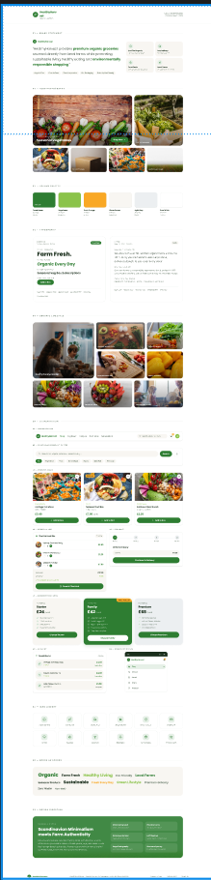
The mood board was created to establish the overall visual identity of the HealthyHarvest website before designing the interface. It combines colours, typography, product imagery and UI inspiration that reflect the brand's focus on organic food, sustainability and simplicity. This provided a clear design direction and ensured consistency throughout the wireframes and the final high-fidelity prototype.

Home Page Wireframes:

The homepage was designed to create a strong first impression while guiding users towards the shopping journey. It includes a promotional banner, simple navigation, a hero section with clear call-to-action buttons, trust indicators and featured product categories. The mobile version reorganises the same content into a vertical layout, ensuring easy navigation and accessibility on smaller screens.
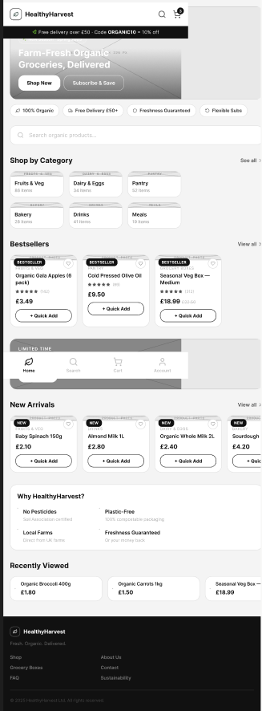
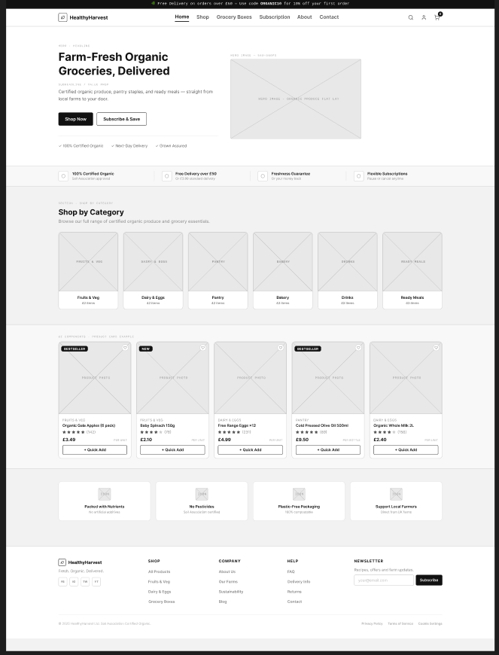

Home Page Prototype:

The homepage prototype was created from the approved wireframe using the visual style defined in the mood board. Natural green colours, simple typography and product images were added to reflect HealthyHarvest's sustainable brand. The page includes clear navigation, featured categories, best-selling products and call-to-action buttons to provide an easy and engaging shopping experience.

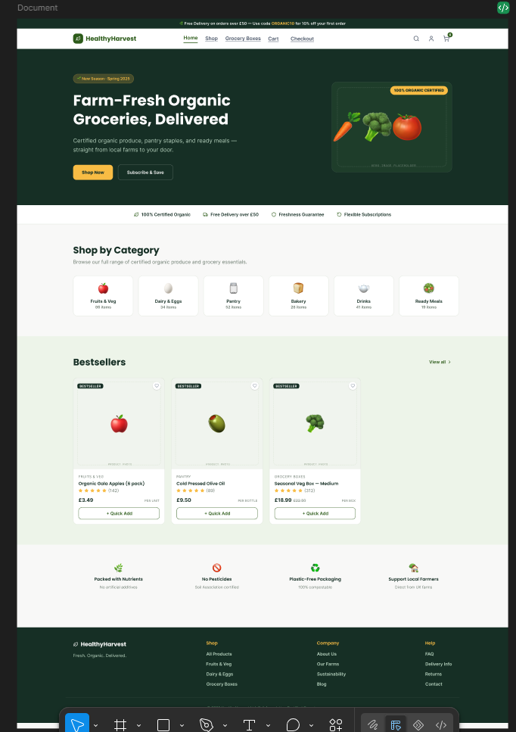

Shop Page (Wireframe and Prototype)

The Shop page was first designed as a wireframe to define the layout, navigation and product organisation. It includes a search bar, category filters and product cards to help users browse products easily. The high-fidelity prototype then applied the colours, typography, icons and product images from the mood board, creating a clean and modern shopping page that reflects HealthyHarvest's sustainable brand while providing a simple and user-friendly shopping experience.
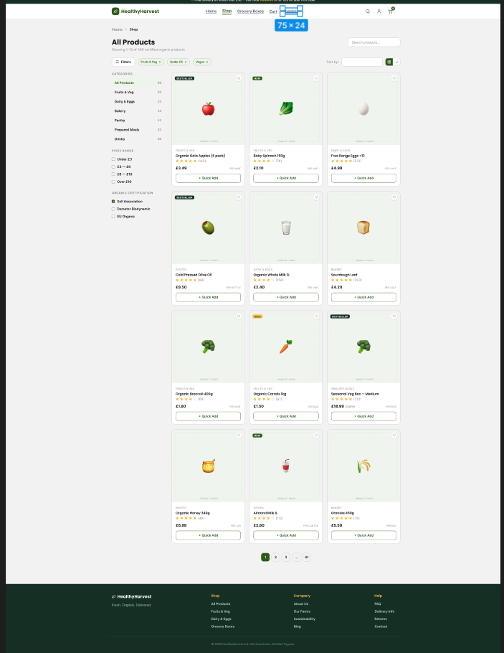
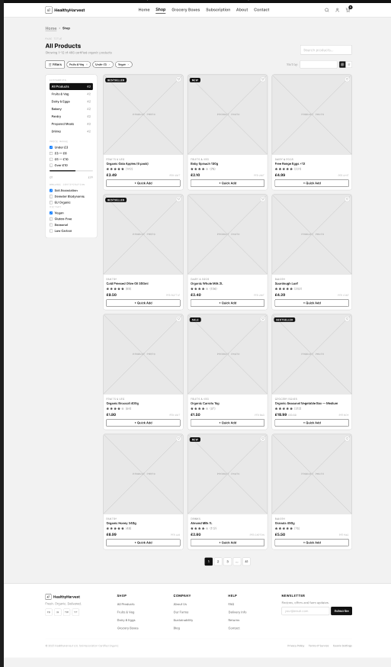

Grocery Boxes (Wireframe and Prototype)

The Grocery Boxes page was first designed as a wireframe to organise the product information and purchasing options in a clear layout. The high-fidelity prototype then added colours, product images and branding from the mood board, creating a clean and informative page that helps users view product details and complete their purchase with confidence.
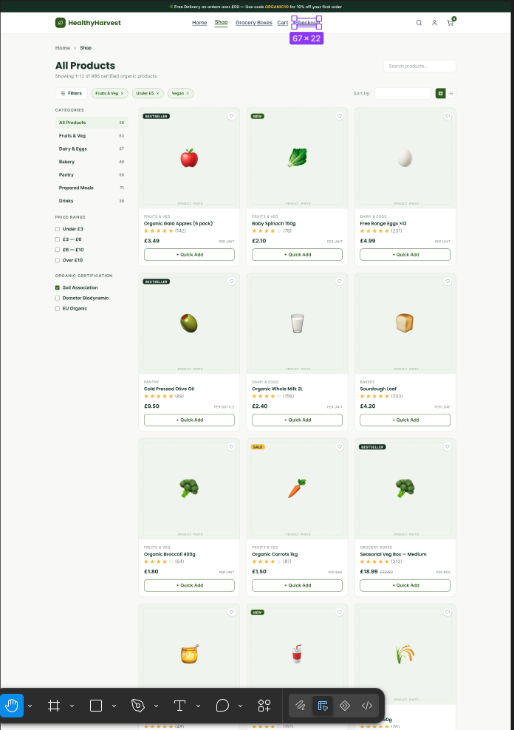
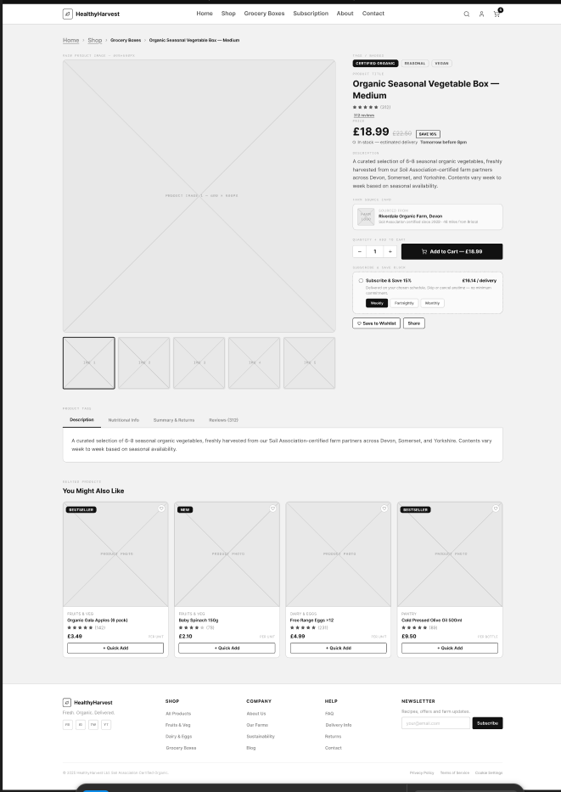

Shopping Cart (Wireframe and Prototype)

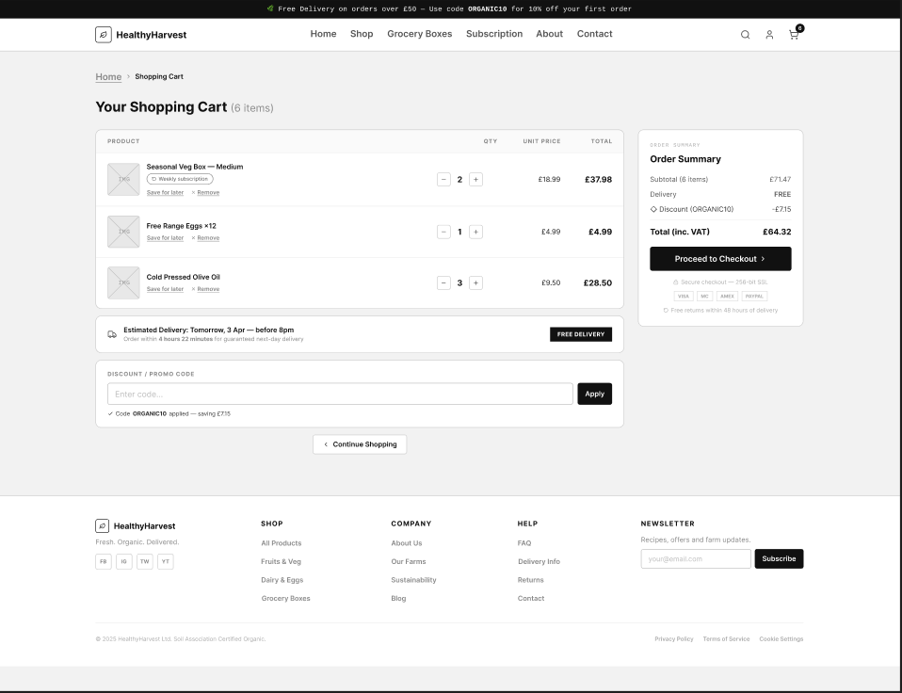
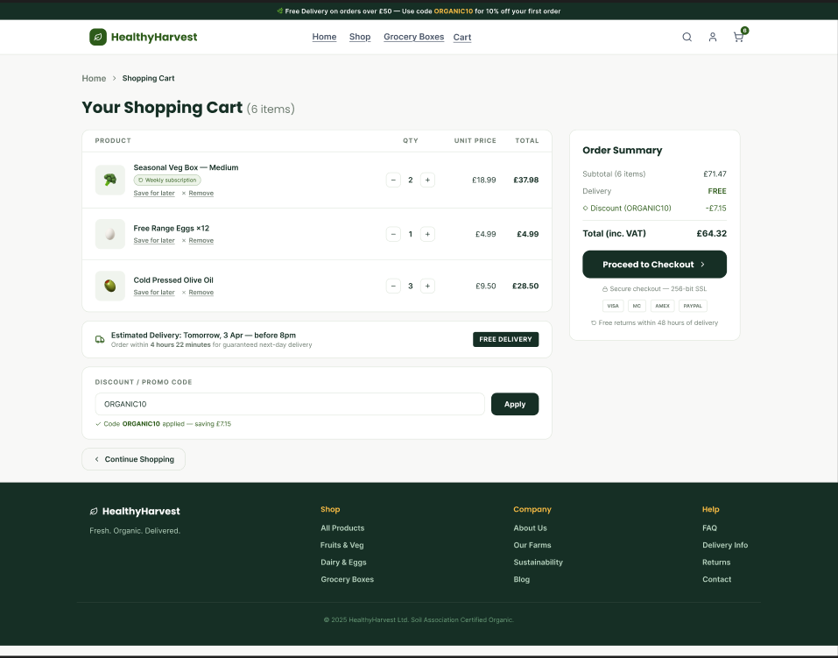
The Shopping Cart page was first designed as a wireframe to organise the selected products, order summary and checkout process in a simple layout. The high-fidelity prototype then applied the visual style from the mood board by adding colours, product images and icons, creating a clear and user-friendly page that allows customers to review their order before proceeding to checkout.

Checkout (Wireframe and Prototype)

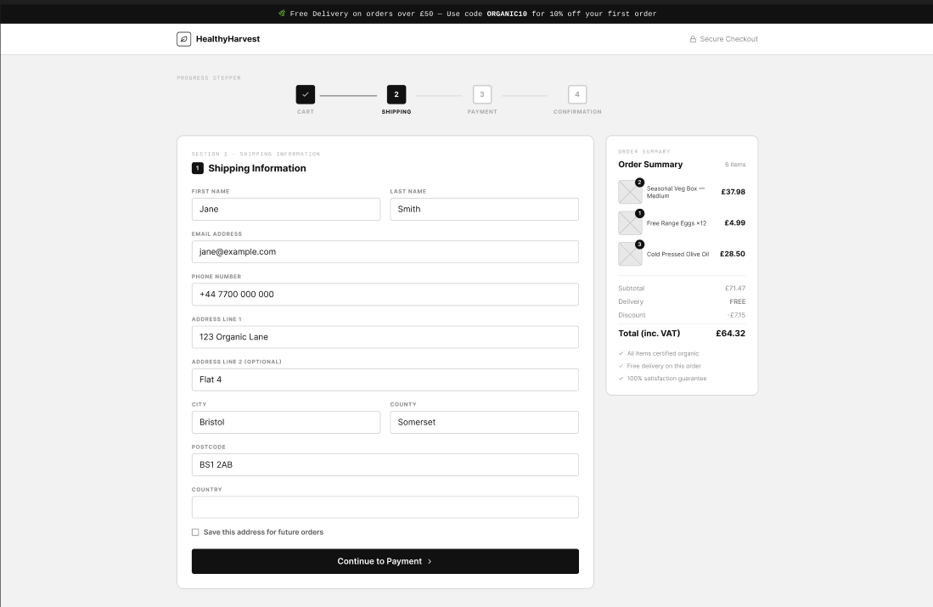
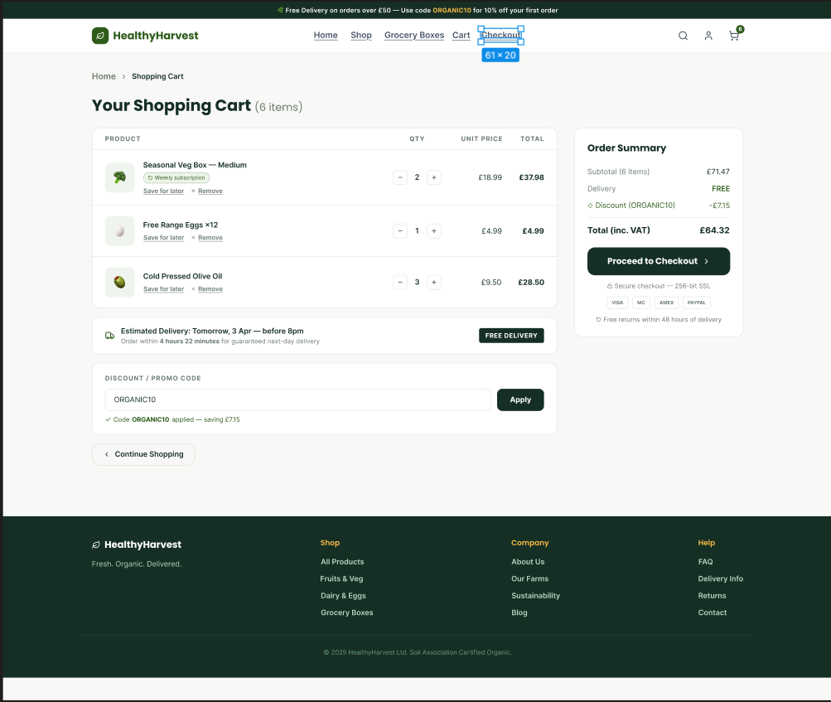
The Checkout page was first designed as a wireframe to organise the payment process and shipping information in a simple and structured layout. The high-fidelity prototype then applied the final colours, typography and interface elements from the mood board, creating a clean and secure checkout experience that helps users complete their purchase quickly and confidently.

Conclusion

The redesign of the HealthyHarvest website demonstrates how a structured UI/UX design process can improve both user experience and business performance. By evaluating the existing website, several opportunities for improvement were identified, including navigation, product presentation, mobile usability, accessibility and the checkout process. Addressing these issues through user-centred design principles resulted in a more intuitive and engaging shopping experience.
The project followed a logical design methodology, beginning with a mood board to establish the visual identity, followed by desktop and mobile wireframes to define the website structure and user journey, before producing a high-fidelity interactive prototype. This approach ensured consistency throughout the design process while supporting responsive and accessible design principles.
Overall, the proposed redesign provides a modern e-commerce solution that reflects HealthyHarvest's sustainable brand while improving usability, customer satisfaction and conversion opportunities. Applying recognised UI/UX principles throughout the project demonstrates how thoughtful design decisions can support both user needs and business objectives, creating a website that is better suited to today's digital shopping environment.

References

[1] J. Nielsen and R. Budiu, Mobile Usability, 2nd ed. Fremont, CA, USA: Nielsen Norman Group, 2023.
[2] D. Norman, The Design of Everyday Things, Revised and Expanded ed. New York, NY, USA: Basic Books, 2013.
[3] J. Nielsen, "10 Usability Heuristics for User Interface Design," Nielsen Norman Group, 2024.
[4] S. Krug, Don't Make Me Think, Revisited: A Common Sense Approach to Web Usability, 3rd ed. Berkeley, CA, USA: New Riders, 2014.
[5] E. M. González, J. H. Meyer and M. P. Toldos, "What women want? How contextual product displays influence women's online shopping behavior," Journal of Business Research, vol. 123, pp. 625-641, 2021.
[6] M. Hoyer, M. Kroschke, B. Schmitt, K. Kraume and V. Shankar, "Transforming the Customer Experience Through New Technologies," Journal of Interactive Marketing, vol. 51, pp. 57-71, 2020.
[7] S. K. Roy, G. Singh, S. Sadeque, P. Harrigan and K. Coussement, "Customer engagement with digitalized interactive platforms in retailing," Journal of Business Research, vol. 164, Article 114001, 2023.
[8] M. M. Marimon, M. Casadesús, G. Mas-Machuca and F. Vall-Llosera, "Managing the Online Customer Experience and Subsequent Consumer Responses Across the Customer Journey: A Review and Future Research Agenda," Electronic Commerce Research and Applications, vol. 58, Article 101242, 2023.
[9] World Wide Web Consortium (W3C), Web Content Accessibility Guidelines (WCAG) 2.2, W3C Recommendation, 2023.
[10] International Organization for Standardization, ISO 9241-210:2019 Ergonomics of Human-System Interaction — Part 210: Human-Centred Design for Interactive Systems, 2nd ed., Geneva, Switzerland: ISO, 2019.
[11] D. M. Ferreira and S. Venturelli, "The Human-Centered Design and the Challenges for Human–Computer Interaction from ISO 9241-210:2019," DAT Journal, vol. 7, no. 4, pp. 99-118, 2022.
[12] M. Ortiz-Escobar, J. Chavarria, N. Schönenberger, A. Hurst, M. Stein, A. Mugeere and M. Rivas Velarde, "Assessing the Implementation of User-Centred Design Standards on Assistive Technology for Persons with Visual Impairments: A Systematic Review," Frontiers in Rehabilitation Sciences, vol. 4, 2023.

