Implementing Six Sigma in Automating Work Processes: A Case Study

  - Transitioning from Printed Work Cards to Electronic Tablets



Contents
Introduction 3
Overview of DSEAR (Dangerous Substances and Explosive Atmospheres Regulation 2002) 4
Overview of Six Sigma 5
History and Evolution 5
The Problem statement. 6
Specific problem statement for project 7
Current Work Process: Printed Work Cards 7
Description of the Existing Process 7
Challenges and Limitations 7
Define Phase 7
Project Charter 8
Goal Statement 8
SIPOC Diagram 8
Voice of the Customer 9
Current Process Mapping. 10
Data Collection Plan 11
Baseline Metrics 11
FMEA (Failure Modes and Effects Analysis) 13
Improve Phase 13
Solution Design 13
Pilot Implementation 14
Cost-Benefit Analysis 14
Updated Process Map 16
Controlling and Planning. 17
SOPs and Training 17
Feedback and Continuous Improvement 18
Conclusion. 19
References 20

Figure 1 Table of DSEAR zonings as per HSE website, showing both Gas and Dust zoning types 4
Figure 2- Table illustrating the project charter and stakeholders. 8
Figure 3 Tabulated results of the SIPOC chart. 9
Figure 4 Tabulated results for CTQ tree 9
Figure 5 fishbone diagram to highlight the main issue of spiralling printing costs 12
Figure 6 FMEA highlights high-priority risks suitable for digital mitigation. 13
Figure 7 Figure of costing layout 15
Figure 8 Figure of before and after potential cost savings calculated 15
Figure 9 Email verification to back up the costings listed 16
Figure 10 tabulated layout of method and repsonible party 17
Figure 11 Image of actual Gteac tablet from IT department supplies to review suitability 17

Introduction
This project applies the Six Sigma DMAIC (Define, Measure, Analyse, Improve, Control) methodology to address inefficiencies and safety risks in DSEAR-regulated ATEX zones by transitioning from paper-based work cards to ATEX-certified digital tablets. The tablet must be suited to the gas type and zoning to which it will be exposed, ensuring compliance with both DSEAR and ATEX regulations (Health and Safety Executive (HSE), 2020). The objective is to enhance safety, improve compliance standards, and significantly boost operational efficiency while utilising a comprehensive range of Six Sigma tools.
Technicians spend non-value-added time completing forms by hand, often leading to documentation errors requiring rework and supervisory intervention. This inefficiency extends the total labor cost per job. By implementing digital tablets, data entry becomes streamlined and standardised, allowing for real-time submission and automated logging, thereby significantly reducing the man-hours previously devoted to administrative tasks.
Furthermore, the improved feedback loop where technicians instantly submit work records and supervisors approve them electronically minimise delays and bottlenecks in workflow processing. Digital systems enable schedulers and supervisors to reallocate time previously spent on document handling towards higher-value planning, compliance assurance, and operational management activities. This reallocation of resources not only increases productivity but also enhances employee engagement, as tedious manual documentation tasks are replaced with efficient digital workflows (George et al., 2005).
Thus, the transition to ATEX-certified digital tablets aligns with both operational excellence goals and Lean Six Sigma principles by simultaneously reducing waste, lowering costs, and improving quality outcomes in high-risk environments.

Overview of DSEAR (Dangerous Substances and Explosive Atmospheres Regulation 2002)

The Dangerous Substances and Explosive Atmospheres Regulations 2002 (DSEAR) protect workers from risks like fires and explosions caused by dangerous substances in the workplace (Health and Safety Executive (HSE), 2020). DSEAR mandates that employers identify and assess explosive atmosphere risks, implement control measures, and classify hazardous areas.
Electrical equipment in these areas must not ignite explosive atmospheres. DSEAR reflects European ATEX directives: ATEX 114 (Directive 2014/34/EU) for equipment and protective systems, and ATEX 153 (Directive 99/92/EC) for minimum health and safety requirements (European Commission, 2020). Equipment in hazardous areas must be ATEX certified if it can ignite through sparks, heat, or static discharge.
ATEX certification ensures equipment is designed and tested to prevent ignition sources under normal and foreseeable abnormal conditions. Equipment is classified into groups and categories based on the type of explosive atmosphere (gas, vapour, dust) and required protection level. For instance, Group II equipment is for non-mining industries, and Categories 1, 2, or 3 indicate safety integrity, with Category 1 suited for the highest risk zones (Zone 0 for gases or Zone 20 for dusts) (Health and Safety Executive (HSE), 2013).

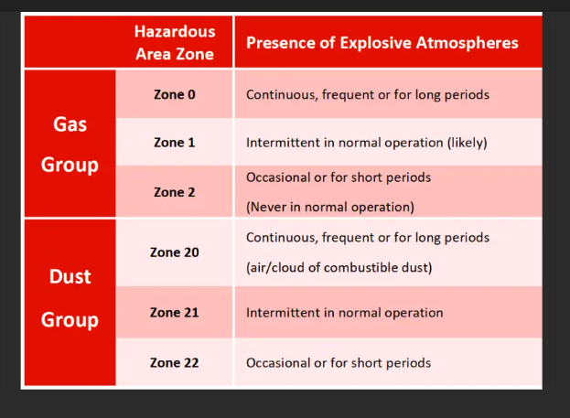
Figure 1 Table of DSEAR zonings as per HSE website, showing both Gas and Dust zoning types

Overview of Six Sigma

History and Evolution
Six Sigma was developed by Bill Smith at Motorola in 1986 (Pyzdek and Keller, 2018). It was originally designed as a set of practices to improve manufacturing processes and eliminate defects. The methodology has since evolved and been adopted across various industries, including healthcare, finance, and information technology (George et al., 2005). Its premise is excellent for identifying issues and using evidence-based calculations and documentation to find the root cause and eradicate the issue. Many asset owners are quick to back a failing system when its ownership is theirs (Pande, Neuman and Cavanagh, 2000).
Key Concepts and Principles
Six Sigma is based on two major methodologies, which are DMAIC (Define, Measure, Analyse, Improve, Control) and DMADV (Define, Measure, Analyse, Design, Verify) (Brue, 2005). These approaches aim to methodically enhance processes and guarantee quality control by emphasising the following aspects.
- Customer Focus:
Understanding and meeting customer needs and expectations.
- Data-Driven Decision Making:
Making decisions based on data and statistical analysis.
- Process Improvement
Identifying and eliminating defects and variations in processes.
- Employee Involvement
Engaging employees at all levels in the improvement process.
- Continuous Improvement
Committing to ongoing improvement and development (Pyzdek and Keller, 2018).

The Problem statement.
A Six Sigma problem statement clearly outlines the issue that a project aims to tackle, emphasising measurable facts over assumptions or opinions. It identifies the difference between the current performance of a process and the target outcome, serving as a basis for improvement efforts. (Pyzdek and Keller, 2018).
The problem statement is critical because it helps ensure all project stakeholders have a shared understanding of the issue. It should clearly articulate the who, what, where, when, and impact of the problem. An effective problem statement includes quantitative data wherever possible, such as defect rates, production delays, or customer complaints, to highlight the scale and seriousness of the issue (Brue, 2005).
In Six Sigma, the problem statement must avoid suggesting solutions or causes prematurely. Instead, it must remain focused purely on describing the symptoms of poor performance. For example, instead of stating, "We need to automate the process," a proper problem statement would be, "The order processing time exceeds the customer expectation of 24 hours in 45% of cases, leading to customer dissatisfaction and an increase in complaints" (George et al., 2005).
A well-constructed problem statement is important during the Define phase of the DMAIC methodology, as it sets the tone for data collection and analysis. Poorly defined problems can lead to wasted resources or ineffective solutions. Therefore, clarity, focus, and evidence-based description are essential features of a strong problem statement (Pande, Neuman and Cavanagh, 2000).
In summary, the Six Sigma problem statement is a factual, focused, and measurable description of a current process issue, essential for guiding the team towards meaningful, data-driven improvements.

Specific problem statement for project

Increasing work efficiency by allowing work orders to be digitally issued and completed via a DSEAR tablet, generating live feedback by on-the-job completion, allowing overall visibility of workflows, and reducing printing costs and man-hour costing of schedulers and technicians.

Current Work Process: Printed Work Cards

Description of the Existing Process
The current work process involves the use of printed work cards, which are manually filled out by employees. These work cards are used to track tasks, monitor progress, and record any issues or defects. The process is time-consuming and prone to errors such as illegible handwriting, lost cards, and delayed data entry without considering the cost and waste.

Challenges and Limitations
- The reliance on printed work cards presents several challenges:
- • Human Error: Data entry mistakes, misplacement, and difficulties in reading handwriting. Cards are subject to harsh environments and contaminants like grease.
- • Time-Consuming: Manual processing of work cards is labour-intensive.
- • Data Delays: Printed information is not readily available for analysis.
- • Resource Intensive: Printing, distributing, and storing cards consume substantial resources.
- Transitioning to electronic tablets offers many benefits:
- • Real-Time Data: Instant access to information facilitates quicker decision-making.
- • Error Reduction: Minimises human errors from manual entry and illegible handwriting.
- • Efficiency: Streamlines processes, saves time, and allows supervisors to plan further ahead, enhancing alignment of work orders.
- • Environmental Impact: Reduces paper usage, supporting sustainability. Shredding costs are often absorbed into overall document control expenses.
- • Data Security: Electronic records are more secure and easier to back up than paper.
- • Damage to Paper Cards: Cards face exposure to harmful chemicals, affecting their durability.

Define Phase
The Define phase establishes the foundation of the project by clearly articulating the problem, objectives, scope, and stakeholders involved. This phase ensures that the project team understands what needs improvement and what success looks like. Several key Six Sigma tools are used in this stage, including the Project Charter, SIPOC diagram, Voice of the Customer (VOC), and Critical to Quality (CTQ) tree.

Project Charter

Below the table shows the project charter for the the reduction in printing costs, it outlines the key stake holders involved.
Element | Description
Project Title | Reducing printing costs while using ATEX-Certified Digital Tablets
Problem Statement | Current reliance on paper-based work cards that are expensive, not economically viable for the environment and illegible due to exposure in certain areas of plant.
Goal Statement | Replace paper-based work cards with ATEX-rated digital tablets to reduce safety incidents, enhance compliance, and improve operational efficiency.
Business Case | Transitioning to digital tablets can reduce errors, improve safety, provide real-time documentation, and align with sustainability and digitalization goals.
Scope | This project covers the work card process in ATEX-rated zones, focusing on hazardous areas where paperwork is currently used and non hazardous areas. The tablets will be used for both areas to stop any confusion.
Timeline | 11 weeks (Define – 1 weeks, Measure – 1 weeks, Analyse – 4 weeks, Improve – 3 weeks, Control – 2 weeks)
Team Members | Green Belt Project Leader, HSE Advisor, Operations Manager, IT Technician, Field Technician, supervisors, planners and schedulers.

Figure 2- Table illustrating the project charter and stakeholders.

Goal Statement
This project aims to implement ATEX-certified digital tablets to replace traditional paper-based work cards in DSEAR-regulated zones. The goal is to reduce costs and increase productivity with a short payback on investment

SIPOC Diagram

A SIPOC diagram is a high-level process mapping tool used in Six Sigma and Lean Six Sigma projects to define and visualise the key elements of a process before work begins on improvement initiatives. SIPOC is an acronym that stands for Suppliers, Inputs, Process, Outputs, and Customers (Pyzdek and Keller, 2018). It provides a structured way to understand how processes function within an organisation, ensuring that all relevant stakeholders have a shared understanding of the critical components involved. The SIPOC DIagarm below is laid out with all key stake holders. This is specific for the current process at Vale.

Suppliers | Inputs | Process | Outputs | Customers
Scheduler | Work packs are planned and ready following pool drop from planners. | 1. Issue work cards  2. Complete tasks 3. Review and sign off | Completed documentation | Operations Team, HSE Auditors
Operators | Instructions, task checklist | Feedback cards live and are on time. | Compliance logs, task completion status | Regulatory Bodies
IT Department | Digital device support and compatibility. |  | Digital records, real-time updates | Internal Management
Figure 3 Tabulated results of the SIPOC chart.

Voice of the Customer
To gather the VOC, interviews were conducted with field technicians, supervisors, HSE advisors, schedulers, planners, and compliance auditors. Key themes included:
- Need for a durable and safe method of data entry in explosive atmospheres.
- Desire for real-time task updates and easier audit preparation.
- Frustration with lost or damaged paper work cards.
- Printed cards do not allow technicians access to technical drawings in the field.
- Preference for tools that reduce administrative workload and documentation errors.
- Documenting issues live and being able to send spare requests to the intended parties.

Critical to Quality (CTQ) Tree
Customer Need | CTQ Requirement | Drivers
Improve safety and efficiency. | Use explosion-proof equipment | 100% of devices must be ATEX-certified for specific zones
Real-time documentation | Digital entry and sync capabilities | <5 min update delay from field to server
Reduce admin workload | Automated data logging | Reduce form fill time
Enhance compliance traceability | Secure digital records | 100% record retention and searchability
Figure 4 Tabulated results for CTQ tree

By establishing these foundational elements, the Define phase creates a structured understanding of the improvement opportunity. With clear project goals, defined metrics, and alignment with customer needs, the project team is well-positioned to move into the Measure phase and gather data on the current state of the process.

Current Process Mapping.
A process map of the current system reveals several steps involved in issuing and completing work cards:
- 1. The scheduler prints a batch of main work cards weekly. In addition, the supervisor issues paper work cards daily in batches and prints ad hoc emergency cards.
- 2. The operator collects the physical card during the daily stand-up briefing meeting.
- 3. The task is performed after the card is issued to the area-specific team leader, who signs it, linking it to any associated permit.
- 4. Upon completing the work task, the operator fills in the card.
- 5. The area team leader signs off on the card, followed by a review and signature from the supervisor.
- 6. The paper card is submitted for filing.
- 7. Data is manually entered into a database, specifically SAP, for traceability and compliance.
This process can be quite slow and may lead to errors or even the loss of important documents. One of the main reasons for this delay is that any work that is identified has to wait before the supervisor can raise notifications.
Another issue is the inefficiency of having to return to workshops to collect materials from raising store orders and looking for technical documentation. With a tablet open to the Vale maintenance network, this can be done on-site. Items can even be photographed and sent to stores for cross-referencing.

Data Collection Plan
We spent a month collecting data from five important areas: the gas plant, kiln, shipping, powder pellet plant, and effluent. Our dedicated team of Electrical and Instrumental Technicians worked closely with us to ensure this measurement was thorough. Having reliable data is essential to kick off a project; without an initial benchmark, it’s challenging to see the improvements we implement.

- Number of paper work cards issued on average per month: 1,370
- Number of cards lost or damaged on average: 18 work order cards 1.3 (%)
- Average form fill time: 10 minutes plus on average 8-10 minutes for signing on with the team leader for the associated plant.
- Documentation error rate: 1.3% (Unable to legibly read who completed on back of card)
- Time from completion to data entry: 0.5 days (average) multiplied by six due to there being six technicians.
- Safety incident reports linked to documentation delay: 0 cases

Baseline Metrics
Using Six Sigma metrics:
- Defects per Unit (DPU) = 18 / 1370 = 0.013
- Defects per Million Opportunities (DPMO) = (0.013 x 1,000,000) / 10 opportunities per card = 1300 DPMO
Although the defects are minor, they aren't the main reason for the change; rather, the cost of materials, time, and printing medium is the crucial factor. It's encouraging to see that people are dedicated and take pride in doing their best work. However, there are still key input variables (kivs) that highlight the necessity for a digitised work system. Environmental factors and carbon footprint from waste and transported printed materials should be considered. Limited time constraints mean that if a job takes longer than expected, it could affect feedback time and delay actual updates in SAP. Additionally, manual data transfer and human error may lead to feedback being recorded against the wrong work order, especially if multiple work order cards are distributed at the start of the day. These factors lead into the generate of root cause analysis and a fish bone diagram.
Root Cause Analysis (Fishbone Diagram)
Main categories:
- People: Incomplete training, inconsistent handwriting
- Process: Manual steps, no real time completion of work tracking.
- Environment: Dirt, dust and harsh chemicals damaging paperwork
- Technology: Lack of digital solutions in the field and duplication of task by inputting the card digitally into SAP later that day.
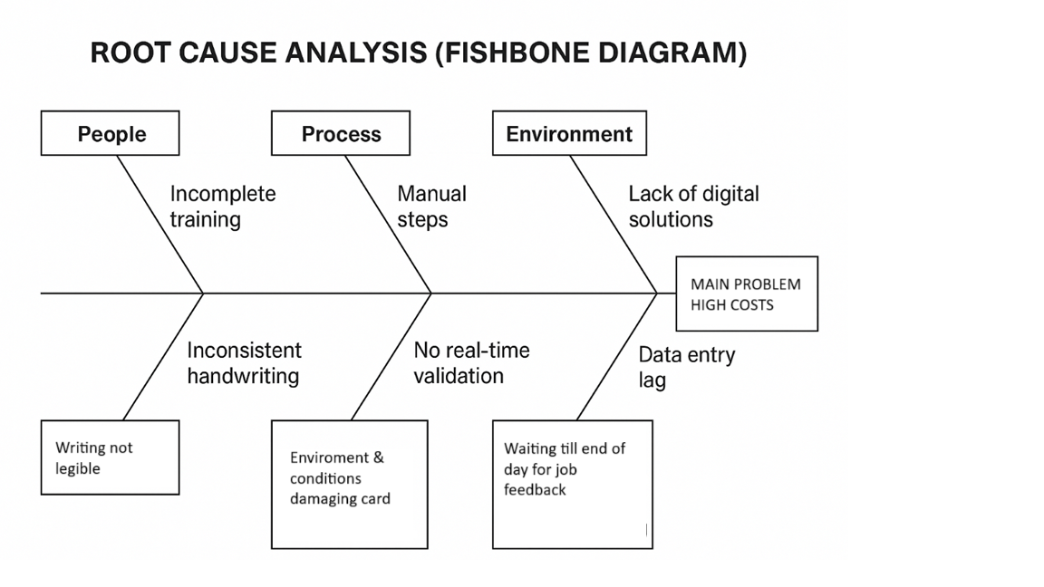
Figure 5 fishbone diagram to highlight the main issue of spiralling printing costs
The problem is large printing cost and late completion of work.
So, it's really important to conduct a five why’s analysis to highlight key issues.
1. Why? The supervisor receives documents late, after all work cards are finished.
2. Why? The operator submits them at the end of their shift, possibly several hours after the card has been approved.
3.Why? The remote digital solution is located a considerable distance from the work site.
4. Why? Currently, the system depends on paper, with digital uploads taking place at the end of the day after printing hundreds of cards from the previous week. This process does not include the emergency cards created outside of regular hours.
5. Why? An initial investment is required to purchase the Getac tablets and provide training.

The five why process connects to another Six Sigma tool known as Pareto analysis. This technique is employed to identify and prioritise the most significant problems or issues within a system or process. It is founded on the Pareto Principle, commonly referred to as the 80/20 Rule, which posits that 80% of outcomes are frequently the result of merely 20% of causes (Juran, 1951). In a business context, this implies that a limited number of issues typically account for the majority of adverse effects, such as defects, delays, or customer complaints. This can not be carried out until the digital system is live and operational.

FMEA (Failure Modes and Effects Analysis)
Failure Mode | Effect | Severity | Occurrence | Detection | RPN
Lost card | Task undocumented | 8 | 6 | 4 | 192
Illegible entries | Miscommunication | 7 | 5 | 5 | 175
Incomplete fields | Audit failure | 6 | 5 | 6 | 180
Figure 6 FMEA highlights high-priority risks suitable for digital mitigation.

Improve Phase
The Improvement phase in Six Sigma is crucial for addressing root causes of issues and implementing solutions for process enhancements. After analysing the causes, the team identifies and prioritises feasible and impactful solutions aligned with project objectives (Pyzdek & Keller, 2018).
This phase involves piloting solutions in a controlled environment to test effectiveness before full implementation. Continuous data collection is vital for evaluating success, using statistical tools like regression analysis or control charts (Pande, Neuman, & Cavanagh, 2000). Data-driven decisions ensure the team scales only the most effective solutions.
Improvement efforts aim to reduce defects and streamline processes by eliminating unnecessary steps and improving resource allocation. Cross-functional collaboration ensures proposed solutions are practical (Brue, 2005). Additionally, risk analysis tools like Failure Mode and Effect Analysis (FMEA) help identify and mitigate potential risks (George et al., 2005).
In summary, the Improvement phase tests and refines solutions, leading to sustainable process improvements and better performance.

Solution Design
The solution design stages must be kept high level and specific. Therefore the Introducing ATEX-rated digital tablets eliminates paperwork and enables
- Digital form completion
- Real-time cloud sync with SAP.
- Tamper-proof recordkeeping
- User authentication and secure login, to prove work completion by the actual individual.
This creates a strong sense of accountability for actions, ensuring that all work is done to the highest possible standards by the technicians carrying out the task.

Pilot Implementation
The pilot needs to span all zones for four weeks, which will enable the resolution of initial issues. Every new system encounters initial difficulties and resistance to change based on individual perspectives. It would require ongoing support.
- Digital work cards issued via tablets
- Operators trained on usage
- Supervisors used dashboards to review entries.
There must be a separate hands-on tools time and an impartial facilitator to ensure that this work improvement is given the best possible opportunity to succeed. The facilitator needs to be impartial. A meeting brief should be recommended where all stakeholders can come together and review both the positive and negative outcomes.

Cost-Benefit Analysis
Costing data has been extracted from the site, the cost of printing, and the hourly pay rates of technicians.
 | Current Asset Number | MONO | Cost | Color | Cost
 | HR Copier | 2848 | £26.23 | 2925 | £227.33
 | Admin Copier | 8460 | £77.92 | 7225 | £561.53
 | Kiln Permit Office | 2702 | £24.89 | 8077 | £627.74
 | OCC health | 2394 | £22.05 | 1161 | £90.23
 | Stores Copier | 1716 | £15.80 | 280 | £21.76
 | Engineering | 32653 | £300.73 | 66565 | £5,173.43
 | Shipping | 212 | £1.95 | 2004 | £155.75
 | PPP | 772 | £7.11 | 3218 | £0.00
 | Costing per printed page |  | £0.01 |  | £0.08
 | Total's for mono and colour |  | £476.68 |  | £6,857.78
 | Site Total for printing |  |  |  | £7,334.46
 | Labour costing
 | 1 technician feeding back for 30 Minutes | £9.87
 | Six technicians per day | £59.22
 | Per week | £296.10
 | Per Month | £1,184.40
 | Per Year Annual cost | £14,212.80
 | Scheduler labour cost
 | Scheduler hourly rate | £23.23
 | One day printing per week | £185.84
 | Monthly printing | £743.36
 | Per year annual cost | £8,920.32
 | TOTAL FOR PRINTING AND LABOUR |  |  |  | £30,467.58
Figure 7 Figure of costing layout

Factor | Paper System (Annual) | Digital System (Annual)
Stationery & storage | £4800 | £1,000
Lost time/admin | £30467.58 | £0,000
Ad hoc printing | £Unknown can't be calculated, unmeasurable due to multy shift patterns and departments | £0,000
Tablet infrastructure cost | £2145.68 each (10 required.) | £21456,000 (Total investment)
Figure 8 Figure of before and after potential cost savings calculated

Payback in less than one year is based on savings from efficiency and safety. According to the provided calculation, the investment in digital tablets alone- excluding printing materials and only considering labour costs- would result in a payback of just over eight and a half months.
Please see the email extract below showing the cost of digital printing, excluding labour, for an annual period. The latest data available was used to generate the calculations mentioned above.

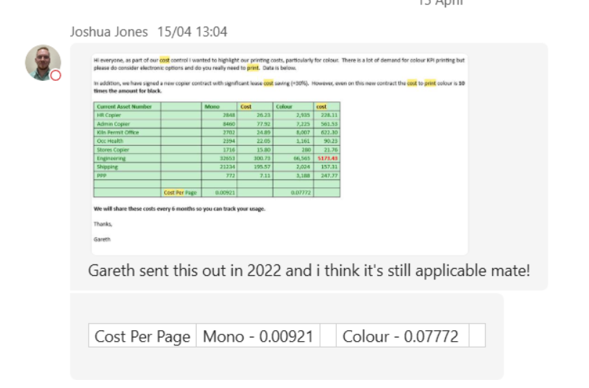
Figure 9 Email verification to back up the costings listed

Updated Process Map

The updated process map now outlines simplistically the new work generation and capture method.
1. A digital work card is issued after planners finalise material preparation and planning.
2. The task is completed onsite once signed off and permits are generated.
3. Technicians input data on their tablets in real time.
4. The supervisor monitors progress online throughout the day and can adjust work strategies if synergies arise or tasks are cancelled.
5. Data is automatically logged into the system when saving SAP work orders, preparing them for the TECO stage (Technical completion of order).
6. Emergency work necessary for safety or to prevent production loss can be tracked in real time, from creation to implementation by the technician.
7. Any issues or findings can be noted in the work order.

Controlling and Planning.

Parameter | Control Method | Responsible Party
System uptime | Daily IT checks | IT Technician
Data accuracy | Weekly audits | Compliance Officer
User compliance | Monthly reviews/training | HSE Manager
Figure 10 tabulated layout of method and repsonible party

SOPs and Training
Standard operating procedures should be established to outline the proper operation and usage of materials. Creating a standard operating procedure is essential because it ensures that everyone adheres to the same operational standards, allowing for consistent replication.
- Device usage whilst using the new Microsoft operating system, Getac DSEAR zone 2 tablet. Stylus at rear.

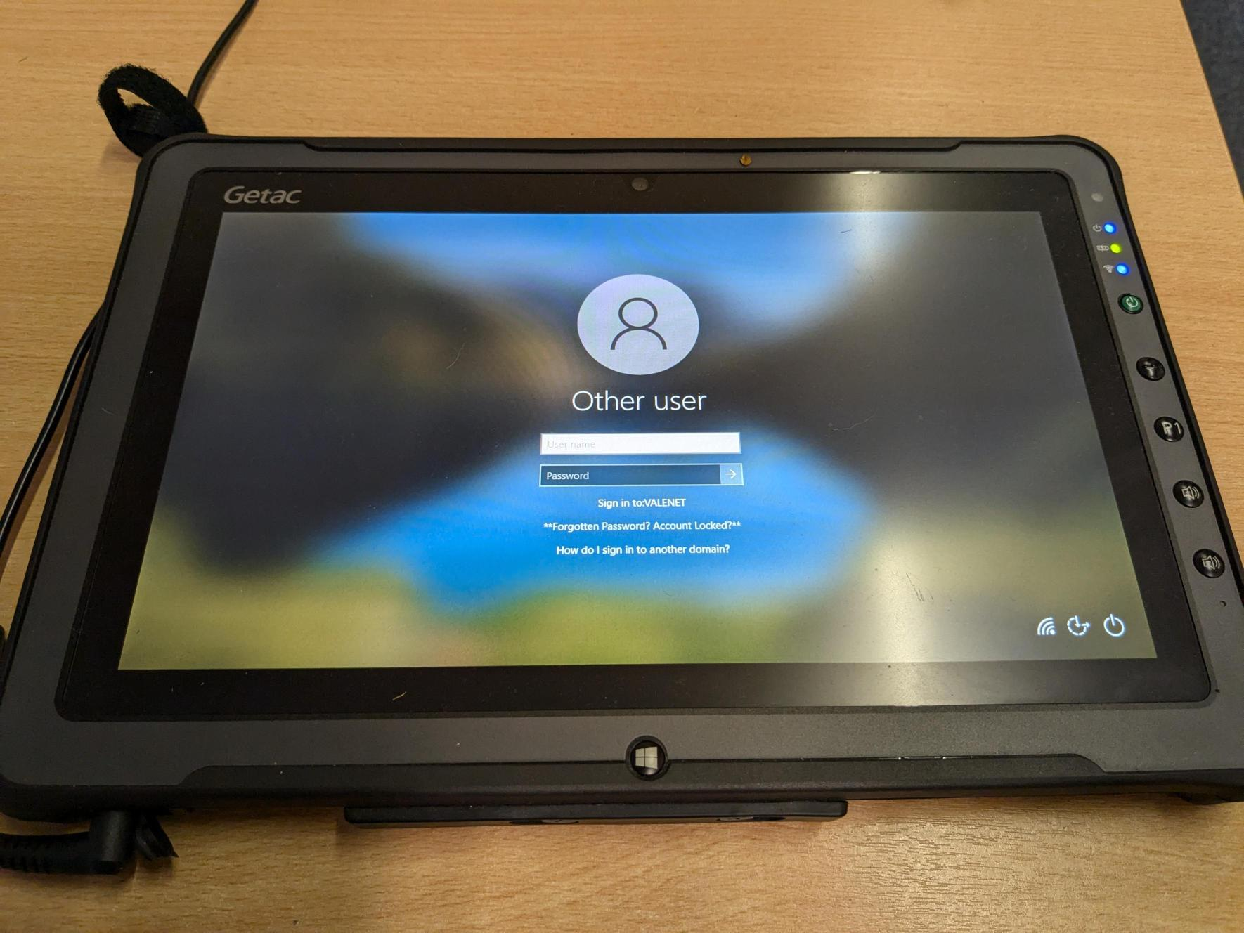
Figure 11 Image of actual Gteac tablet from IT department supplies to review suitability
- Data entry protocols using SAP. All technicians are trained in SAP however a referesh and attachment asset identification would be required. This would be around one hour across all shifts.
- Care and usage of the tablet with docking and data transfer need to be illustrated to all users. The security and retention of intellectual data must be emphasized. Setting passwords will ensure that only authorised personnel can use the tablet.
All operators receive six-month training protocols, and this could be documented and presented during these opportunities.

Feedback and Continuous Improvement
Monthly review meetings are a wonderful opportunity to gather user feedback and update procedures. We recommend involving all stakeholders and rotating technicians to ensure their voices are heard. Additionally, implementing a feedback box in the department would allow technicians to share their thoughts anonymously, so they can freely express their opinions. We understand that some people find it challenging to speak openly, especially when it comes to giving criticism or praise in front of their peers.

Conclusion.

In conclusion, the data collected indicates that the implementation of the digital work order platform represents a promising solution likely to yield substantial benefits and cost reductions for the organisation. The analysis of the current process uncovers inefficiencies and delays attributable to manual systems, contributing to elevated operational costs and diminished productivity. By transitioning to a digital platform, the organisation can optimise workflows, minimise errors, and enhance communication among team members. This transition is expected to result in expedited response times, improved accuracy in work orders, and increased customer satisfaction.
Furthermore, the financial analysis suggests that the digital work order platform constitutes a prudent investment, with a return on investment anticipated within a period of less than nine months. The projected savings stemming from reduced administrative expenses, fewer errors, and improved operational efficiency will counterbalance the initial investment, thereby rendering the platform a financially viable solution. This relatively swift payback period accentuates the financial allure of the project, emphasising that the platform will commence generating value shortly after its implementation.
In summary, the data suggests that the adoption of the digital work order platform constitutes a judicious business decision. With its potential to facilitate substantial cost savings, operational enhancements, and a relatively prompt payback period, it represents a strategic investment poised to foster long-term value for the organisation.

References
Brue, G. (2005) Six Sigma for Managers. 2nd edn. New York: McGraw-Hill.
George, M.L., Rowlands, D., Price, M. and Maxey, J. (2005) The Lean Six Sigma Pocket Toolbook. New York: McGraw-Hill.
Pande, P.S., Neuman, R.P. and Cavanagh, R.R. (2000) The Six Sigma Way: How GE, Motorola, and Other Top Companies Are Honing Their Performance. New York: McGraw-Hill.
Pyzdek, T. and Keller, P.A. (2018) The Six Sigma Handbook. 5th edn. New York: McGraw-Hill Education.
George, M.L., Rowlands, D., Price, M., and Maxey, J. (2005) The Lean Six Sigma Pocket Toolbook: A Quick Reference Guide to 100 Tools for Improving Quality and Speed. New York: McGraw-Hill.

