
Jack Lewis (2011032)

Assignment 2 – Aichi biodiversity tartgets - report
Table of Contents
1 Introduction 1
2 Aichi Biodiversity Targets 1
2.1 COP 15 1
3 Conclusion 3
4 References 4

Table 1 - Montreal Global Biodiversity Framework - 4 Goals (Conservation on Biological Diversity, 2022). 2
Table 2 - Sustainable Development Goals - Key (United Nations, 2022). 3

Figure 1 - The 20 Aichi Biodiversity Targets set by the CBD (Vardon, 2019). 1
Figure 2 - The 23 Targets of the Global Biodiversity Framework. (Future Earth, 2023). 4

Introduction

The Aichi Biodiversity Targets were created in 2011 but ended in 2020 due to not little progress being made towards them. This report will examine the new revised biodiversity targets set out by the United Nations, and documented by Conservation on Biological Diversity, at the Conference of the Parties (COP15) meeting held in Montreal in December 2022. Additionally, the report will explain the need for such targets and how these targets will be implemented, as well as whom the targets will help. Lastly, the report will examine how the new biodiversity targets are being viewed by others, along with how they are welcomed or not so welcomed.

Aichi Biodiversity Targets

The Aichi Biodiversity Targets were previously made up of 20 targets split over 5 separate goals. Figure 1 below shows the 5 separate Aichi overarching goals and where the 20 targets sit within them. These goals had core aims which consisted of educating and understanding, enhancing, and improving biodiversity within areas throughout the world including developing third-world countries.

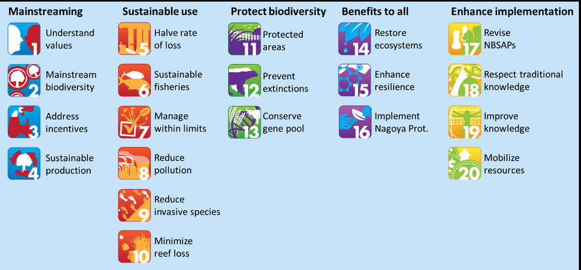
Figure 1 - The 20 Aichi Biodiversity Targets set by the CBD (Vardon, 2019).

However, none of these targets was fully achieved, so this, in turn, forced Conservation on Biological Diversity to create new ones. The new revised targets are made up of 23 targets, split into 4 separate group goals (CGIR, 2023). It is stated by Lai (2021) that the Aichi Biodiversity Targets were originally created by the United Nations Convention on Biological Diversity in 2011, and the idea behind the targets was that it would allow the world’s nations a uniform framework to work off. Further, the idea was this then could be used to help tackle the accelerated biodiversity loss in which the world was, and still is, experiencing. This was clearly stated by United Nations (UN), “Nature’s dangerous decline ‘unprecedented’; Species extinction rates ‘accelerating’” (UN, 2019). This was all in the hope that the conservation efforts carried out worldwide would be more effective and streamlined.

COP 15

The main aim of COP15, as stated by Conservation on Biological Diversity (2022), is to “By 2030: Protect 30% of Earth’s lands, oceans, coastal areas, inland waters; Reduce by $500 billion annual harmful government subsidies; Cut food waste in half.” (Conservation on Biological Diversity, 2022).

There are 4 overarching goals in which the 23 targets sit. All the goals set out below (see table 1) are part of the Montreal Global Biodiversity Framework, along with the 2050 Vision for Biodiversity (Conservation on Biological Diversity, 2022).

Table 1 - Montreal Global Biodiversity Framework - 4 Goals (Conservation on Biological Diversity, 2022).
Goal A | Aims to enhance, restore, and maintain the resilience, connectivity, and integrity of all ecosystems by 2050. Also, by 2050, the goal aims to not only reduce the rate of species loss, but to regain a healthy level of wild species, whilst increasing the genetic diversity within that wild species population.
Goal B | The aim of this goal is to, by 2050, maintain and enhance ecosystems' function and services including areas which are in decline, whilst managing and sustainably using biodiversity.
Goal C | The primary focus of this goal is to help and financially support local communities and indigenous people. In the hope that traditional ways of managing these key areas are protected, and in turn add to the sustainable use of biodiversity and conservation.
Goal D | Similarly, to ‘Goal C’, this goal aims to financially support and supply resources to small and/ or developing countries so that these countries have access to the latest, up-to-date technology and equipment.

Contained within the 4 main goals lie 17 Sustainable Development Goals, which are split throughout each goal as listed below:

Table 2 - Sustainable Development Goals - Key (United Nations, 2022).
Sustainable Development Goals
Goal A | Goal B | Goal C | Goal D

- No Poverty.
- Zero Hunger.
- Good Health and Well-being.
- Quality Education.
- Gender Equality.
- Clean Water and Sanitation.
- Affordable and Clean Energy.
- Decent Work and Economic Growth.
- Industry Innovation and Infrastructure.
- Reduced Inequalities.
- Sustainable Cities and Communities.
- Responsible Consumption and Production.
- Climate Action.
- Life Below Water.
- Life on Land.
- Peace, Justice, and Strong Institutions.
- Partnerships for the Goals.

Figure 2 (below) briefly outlines and captures the 23 Global Biodiversity Targets, where those targets lie within the 4 main goals, and how the 17 Sustainable Development Goals are split over the 4 main overarching goals.

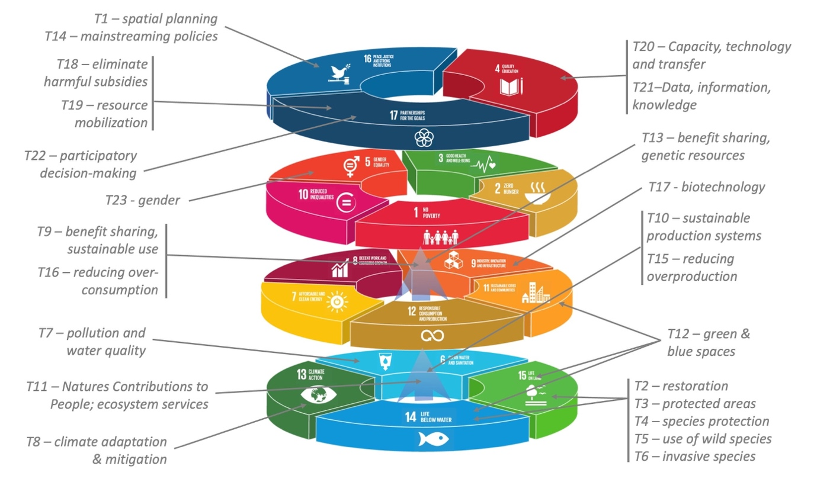
Figure 2 - The 23 Targets of the Global Biodiversity Framework. (Future Earth, 2023).

The new biodiversity targets are not fully welcomed by all. Cuff (2022) believes the new targets are unrealistic, and that they could compromise conservation efforts. Cuff suggests that the 2050 target set by Conservation on Biological Diversity to halt and reverse the loss of biodiversity is unfeasible. Although, on the other hand, Eveleigh (2023) suggests that the new biodiversity targets set out by the UN, are great news for nature and believes that the targets are a conservation milestone in the effort to reverse biodiversity loss.

Evaluation

It could be suggested that the original Aichi targets sparked hope in being able to tackle biodiversity loss. After a review of the original targets, the UN created the new Global Biodiversity Diversity framework, in hope that they will be more effective in the fight. Whilst some have doubt about the targets that have been set, believing that they are unrealistic, others seem to suggest that the aim behind the targets is one of hope and believe that they could be the key to fighting global biodiversity loss. Could these new targets hold up to the task, or will they fall by the wayside like the original Aichi Biodiversity Targets? A possible review of these targets could take place at COP16, which is planned to be held in Turkey in December 2024.

Conclusion

To conclude, the original Aichi Biodiversity targets failed to step up to the mark, but hope continues with the new targets that have been set. The new targets aim to achieve significantly higher in their success, with some having concerns as to whether it is too much to ask, branding them ‘unrealistic’. The new targets aim to protect and enhance global biodiversity in the hope to maintain food, clean water supplies, and health.

References

CGIR. (2023) Nexus Thinking Needed to Implement COP15 Biodiversity Targets. Available at: https://www.cgiar.org/news-events/news/nexus-thinking-needed-to-implement-cop15-biodiversity-targets/ (Accessed: March 14, 2023).

Conservation on Biological Diversity. (2022) COP 15: Nations Adopt Four Goals, 23 Targets for 2030 in Landmark UN Biodiversity Agreement. Available at: https://www.cbd.int/article/cop15-cbd-press-release-final-19dec2022 (Accessed: March 13, 2023).

Cuff, M. (2022) ‘COP15 aims “unrealistic”’, New scientist (1971), 256(3416), p. 1–.

Eveleigh, R. (2023) What is the UN’s 30x30 Biodiversity Target, and How Will the UK Play its Part? Available at: https://www.positive.news/society/what-is-the-uns-30x30-biodiversity-target-and-how-will-the-uk-play-its-part/ (Accessed: March 15, 2023).

Future Earth. (2023) Can the Kumming-Montreal Global Biodiversity Framework Fulfil its Transformative Potential? Available at: https://phys.org/news/2023-02-kunming-montreal-global-biodiversity-framework-fulfill.html (Accessed: March 14, 2023).

Lai, O. (2021) What Are the Aichi Biodiversity Targets? Available at: https://earth.org/what-are-the-aichi-biodiversity-targets/ (Accessed: March 6, 2023).

United Nations. (2019) UN Report: Nature’s Dangerous Decline ‘Unprecedented’; Species Extinction Rate ‘Accelerated’. Available at: https://www.un.org/sustainabledevelopment/blog/2019/05/nature-decline-unprecedented-report/ (Accessed: February 20, 2023).

Vardon, M. (2019) The 20 Aichi Biodiversity Targets set by the CBD. Available at: https://www.researchgate.net/figure/The-20-Aichi-Biodiversity-Targets-set-by-the-CBD_fig2_334067489 (Accessed: March 6, 2023).

