Faiz Khan
KHA16828994
Assignment 2

Contents
Bibliography 2
Introduction 3
Key functions of general Operating Systems 3
Use of CLI commands in a Windows/Mac OS. 4
6
Use of CLI commands in a Linux OS. 6
Use a Batch script in a Windows /Mac Os. 7
Use of Bash Scripts in a Linux OS. 9
Conclusion 11

Bibliography

[1] | B. Bitesize, “Computer systems,” BBC Bitesize, Monday April 2023. [Online]. Available: https://www.bbc.co.uk/bitesize/guides/z7qqmsg/revision/2. [Accessed 03/04/2023 April 2023].
[2] | T. Chakrabarty, “5 Key function of Oprtating System,” Online Class Notes, Friday May 2016. [Online]. Available: https://onlineclassnotes.com/what-are-functions-of-operating-system/. [Accessed 03/04/2023 April 2023].
[3] | T. point, “Operating system - Overview,” Tutorials point, Wednesday April 2023. [Online]. Available: https://www.tutorialspoint.com/operating_system/os_overview.htm. [Accessed 05/04/2023 April 2023].
[4] | I. C. Science, “Role of the operating system,” Isaac Computer Science , Thursday April 2023. [Online]. Available: https://isaaccomputerscience.org/concepts/sys_os_role_of_os?examBoard=all&stage=all. [Accessed 06/04/2023 April 2023].
[5] | W3schools, “What is command line interface,” W3schools, Friday April 2023. [Online]. Available: https://www.w3schools.com/whatis/whatis_cli.asp. [Accessed 07/04/2023 April 2023].
[6] | H. Tutorials, “What is CLI?,” Hostinger Tutorials, Wednesday December 2022. [Online]. Available: https://www.hostinger.co.uk/tutorials/what-is-cli#:~:text=For%20example%2C%20when%20you%20have,do%20automate%20the%20repetition%20easily.&text=Most%20operating%20systems%20today%20prevent,SIP%20(System%20Integrity%20Protection).. [Accessed 08/04/2023 April 2023].
[7] | H. Tutorials, “40 Essential Linux commands that every user should know,” Hostinger Tutorials, Monday April 2023. [Online]. Available: https://www.hostinger.com/tutorials/linux-commands#:~:text=A%20Linux%20command%20is%20a,the%20end%20of%20the%20line.. [Accessed 11/04/2023 April 2023].
[8] | A. Hassan, “What is a Command-Line interface?,” Bulit in, Wednesday March 2023. [Online]. Available: https://builtin.com/software-engineering-perspectives/command-line-interface. [Accessed 15/04/2023 April 2023].
[9] | S. s. a. o. r. concepts, “Shell scripts and other related concepts,” Shell scripts and other related concepts, Wednesday May 2023. [Online]. Available: https://hbctraining.github.io/Intro-to-shell-flipped/lessons/05_shell-scripts_variable.html#:~:text=The%20echo%20command%20is%20used,screen%20or%20to%20a%20file.. [Accessed 10/05/2023 May 2023].
[10] | SS64, “SS64,” SS64, Wednesday May 2023. [Online]. Available: https://ss64.com/nt/set.html#:~:text=The%20%2FP%20switch%20allows%20you,the%20user%20input%20is%20read.. [Accessed 10/05/2023 May 2023].
[11] | PhoenixNap, “Bash elif else statement: A comprehensive tutorial,” PhoenixNap, Sunday May 2023. [Online]. Available: https://phoenixnap.com/kb/bash-if-statement#:~:text=What%20is%20the%20Bash%20if%20Statement%3F&text=Bash%20scripts%20help%20automate%20tasks,making%20process%20during%20a%20program.. [Accessed 14/05/2023 May 2023].
[12] | Schkn, “Bash if else sytax with examples,” Devconnected, Sunday May 2023. [Online]. Available: https://devconnected.com/bash-if-else-syntax-with-examples/#:~:text=then%20%3A%20if%20the%20previous%20condition,%2C%20then%2C%20else%E2%80%9D%20statement.. [Accessed 14/05/2023 May 2023].

Introduction

I have been asked to demonstrate the key functions of the modern general operating system in my assignment. So, I will include the key functions of the operating system, cli commands for Windows and Linux OS. I will also do some batch and bash scripting for Windows and Linux OS which I will be demonstrating with different types of codes.
Its serves as the most basic software layer that manages computer hardware resources and provides a platform for running applications. There have been a lot of evolutions over the time so the recent modern operating system offers a very wide range of functions and capabilities.
From 1960s to 1970s, the modern general operating system has been introduced and later became mor complex and needed a centralized control mechanism.
Recently, the modern operating system has advanced considerably in terms of its functionality, reliability, easiness and user friendliness. So, the above-mentioned list of operating systems provides a range of essential functions.

Key functions of general Operating Systems

The key functions of a general operating system have three main functions. Such as manging the computers resources like central processing unit, disk drive and printers. The second function is establishing a user interface and the third faction is executing and providing services for the application software. The other key functions are the operating system is controlling hardware components like motherboard, CPU ram Heat sink and other components in the system. [1] “As stated by BBC Bitesize they say, when a program is run, it is loaded into memory. The operation system determines how much memory the program requires, and allocates enough pages to hold it and its documents. When the program is closed, the allocated pages are freed up for use by other programs.”
So, this shows when the programs will stop running the allocated pages get freed up for the other tasks. [2] “As stated by Tanmay Chakrabarty he says, the task management program of any operating system takes instruction, analyse it and processes it. Task management uses the power of computer processor and distributes it to various, controls interrupts.”
So, the task manager allows the user to terminate application and processes, adjust the processing priorities that are set to the processor affinity. As this will give the system the best performance to run tasks. Another key function of general operating system is processor management. [3] “As stated by Tutorials point, they say, in multiprogramming environment, the OS decides which process gets the processor when and for how much time. This function is called process scheduling. An operating system does the following activities for processor management.” This shows that the processor management is a function to handle different task that are set in the schedule.
The next thing that is very important in an operating system is security management. This will be like setting a password on the system so it becomes more secure and safe. [4] “As stated by Isaac computer science he says, the operating system supports the security of a device by ensuring that system resources are protracted for unauthorised access. Typically, an operating system will provide the users with the ability to create user accounts so that only authorised users can access the system.” So, this shows that password and logins are very important for better security for any system.

Use of CLI commands in a Windows/Mac OS.

CLI commands are command-lines interface, it is used for a text-based document which is used by the user interface. This command line interface is used to run programs, manage computer files and interact with the computer system. [5] “As stated by W3schools they say, CLI is a command line program that accepts text input to execute operating system functions. In the 1960s, using only computer terminals, this was the only way interact with computers. Today, with graphical user interfaces GUI, most users never use command-line interfaces CLI. However, CLI is still used by software developers and system administrators to configure computers, install software, and access features that are not available in the graphical interface.”
So, this shows that the CLI is still good to use as it can be used to install software and access features that are not available in the graphical interface. So, software developers can install softwares and other programmers in the system. [6] “As stated by Hostinger Tutorials they say, for example, when you have to handle hundreds of files within a folder, CLI enables you to use a single command to do automate the repetition easily. Most operating systems today prevent you from messing up the system’s core process. Windows has system protection and MacOS has Sip system integrity protection.” So, the reason why people should use CLI commands for the windows program is because it allows the user full control over the system. The other reason why a CLI command is good because it can tell the users their system information of what operating system is running on the system and other information about the system. This is a CLI command I made in Windows. This CLI commands is about people’s favourite hobbies. I also put their ages in the program and their names to show what they like to play.
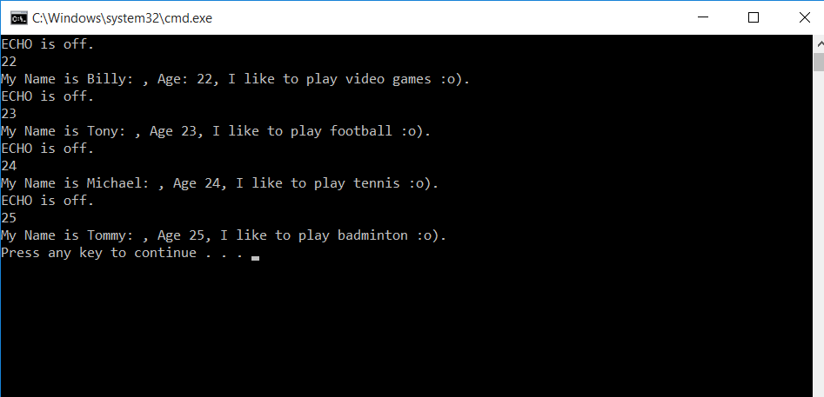

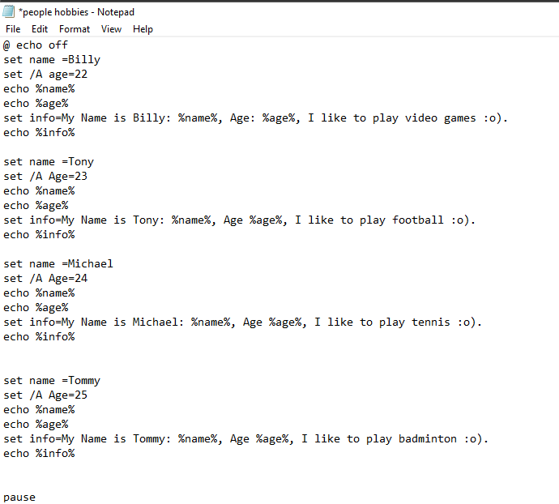

Use of CLI commands in a Linux OS.

The Linux command is a program or service that runs on the CLI. It is a console that interacts with the system by texts and processes. The Linux is a similar command prompt application like on Windows operating system. [7] “As stated by Hostinger Tutorials they say, Linux commands are executed on Terminal by pressing Enter at the end of the line. You can run commands to perform various tasks, from package installation to user management and file manipulation.” So, the Linux command line is similar to the windows but when you would like to install application you would need to use the command line to install the applications.
[8] “As stated by Abdishakur Hassan he says, speed: CLI enables you to execute commands quickly. You can combine multiple commands into a single line of test to run your program. This is much faster navigating though menus with a GUI. Resources: CLI requires fewer computing resources to execute commands than a graphical interface.” So, this shows that CLI commands are much faster to do in Linux as you can download programs and files. Below is a CLI command I made in Linux. It is on creating a user’s login. So, the users will type their names, email addresses and passwords. The program will inform the users their login details.
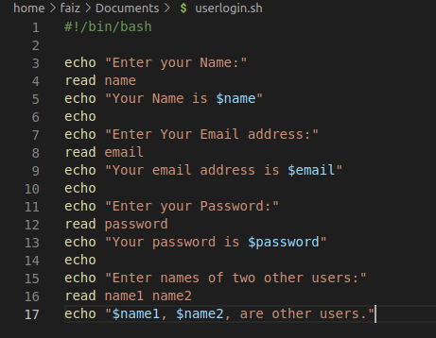
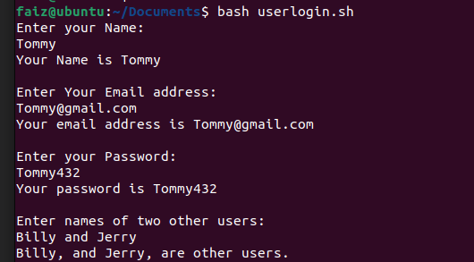

Use a Batch script in a Windows /Mac Os.

I have devised a quiz about famous places and different languages around the world using batch scripting on the Windows. The reason why I chose this is because it would be fun for the users whoever would play the quiz and it would also be beneficial for their general knowledge. The command I used in the batch scripting in windows was Echo. This command will show the user a question in the quiz.
After reading the questions, they can fill in their answer and they will get a message which will say if this is their final answer. The user will be able to select yes or no. So, when the user finally answers the questions, they would get one point if it is correct answer or if it is not, they will get 0 point. When the users have done all the question on the quiz, they will get their final score if they got 10/10, they will win the game if they don’t get this score, the user will get a message saying better luck next time.
[9] “As stated by Hbc Training they say, the echo command is used to display a line of text that is passed in as an argument. This is a bash command that is mostly used in shell scripts to output status to the screen or to a file.” So, in my batch scripting I used a lot of echo commands for the questions and answers in my quiz.
[10] “As stated by SS64 they say, the /p switch allows you to set a variable equal to a line of input entered by the user. The prompt string is displayed before the user input is read.” So, I used the /p command in my program as this will allow the users to fill in their answer for any questions in the quiz.
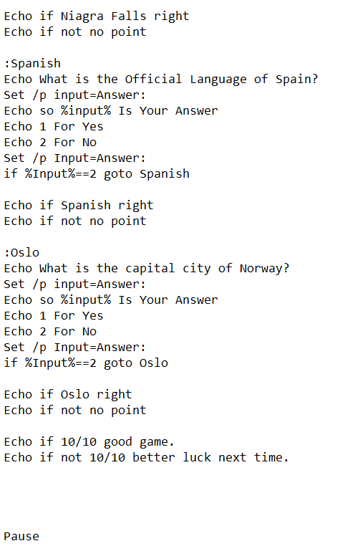
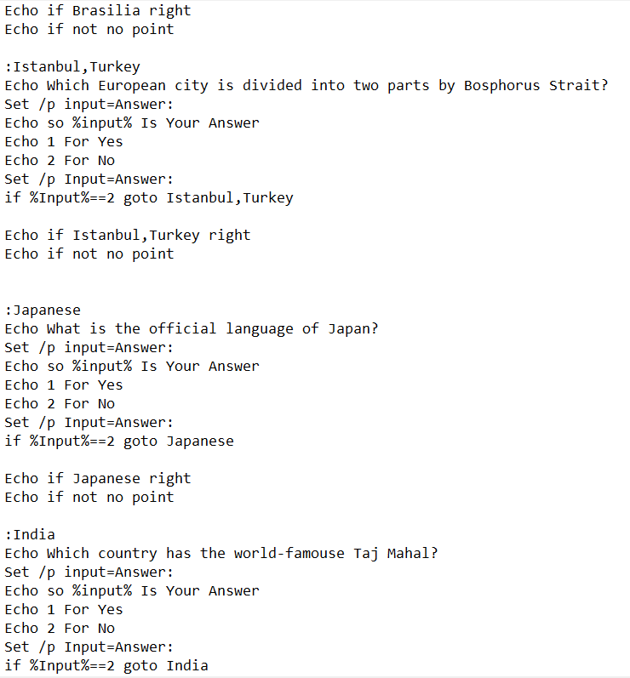

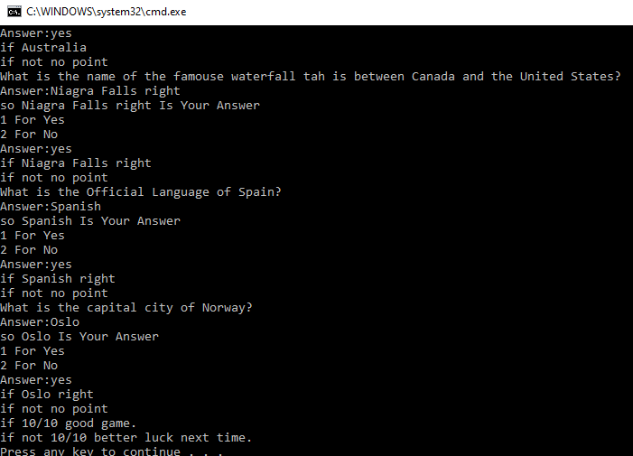

Use of Bash Scripts in a Linux OS.

I used Bash scripting in Linux OS to devise and another quiz. I made this quiz about modern technology and famous people. The reason why I choose to make this game is because I think it would be fun and educational for anybody who would play this quiz. I used if, else, echo, read and then commands statements in bash scripts.
The echo command will let me write a question and then read command will show the text in the quiz. The next command I used in my program was the if, else this common lets me create conditions in the program. Like, if a user gets any answer correct, it will say one point or if the user does a wrong answer, it will show no point for any wrong answer.
“Then command” will let the user show the final result which could be success or failure. So, when the user has played the quiz, the users will get their final scores which should be 5/5 if the user does not get this result, then they get the message, “better luck next time”.
[11] “As stated by Phoenix Nap they say, Bash scripts help automate tasks on your Machine. The if elif else statement in bash scripts allows creating conditional cases and responses to specific code results. The if conditional helps automate a decision-making process during a program.” So, this statement let the program make a decision on the users answer.
[12] “As stated by Schkn he say, then: if the previous condition is true, then execute a specific command;.” So, the “then command” lets the program process if the condition is true or false. It will give the user one of these answers or results.
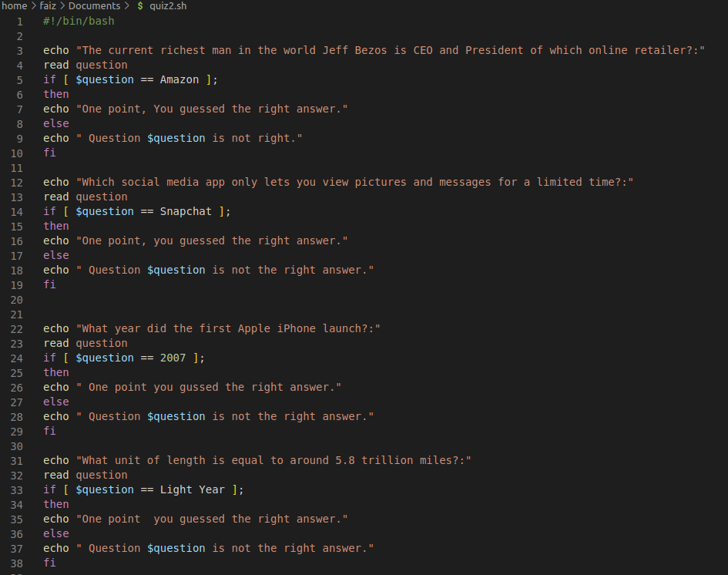

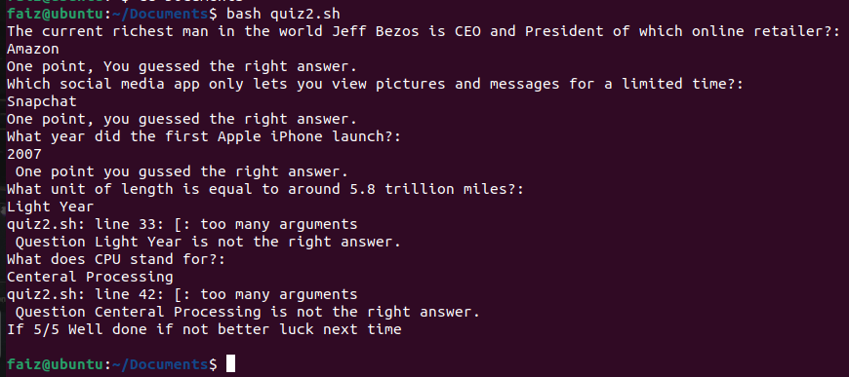

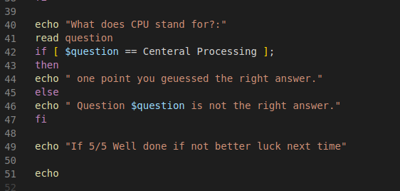

Conclusion

In conclusion cli commands for Windows, Linux OS, Bash and bash for Windows and Linux OS are the most essential and user-friendly commands of functions for the modern general operating system. They provide a range of essential functions to do any basic or advanced tasks.

