Systems Engineering Report
Functionality and design in a household object

Hayden Taylor

05/05/2025

Table of Contents
1 Table of Figures 2
2 Table of Tables 2
3 Introduction 3
4 Requirements Gathering 3
5 Requirements Analysis 5
6 QFD 1 + Explanation 6
7 Concept Generation 8
8 Concept Evaluation 9
9 QFD 2 + Criticality 12
10 Conclusion 15
11 References 15
12 Appendix 16

Table of Figures
Figure 1 - Table showing requirements 3
Figure 2 - Pairwise comparison of requirements 4
Figure 3 - Pairwise comparison of requirements table 5
Figure 4 - Function analysis table 5
Figure 5 - Quality function deployment 1 (QFD1) 6
Figure 6 - QFD1 function importances graph 7
Figure 7 - Function metric table 8
Figure 8 - Function means analysis table and key 9
Figure 9 - concept 1 separate bins 9
Figure 10 - concept 2 sensor bins 10
Figure 11 - concept 3 scanner bins 10
Figure 12 - concept 4 multi bin and scanner 11
Figure 13 - system Pugh table 11
Figure 14 – Quality Function Deployment 2 (QFD 2) 12
Figure 15 - QFD2 feature importance graph 13
Figure 16 - P diagram 14

Table of Tables

Introduction
Systems engineering is a vital part of the planning and designing a system, understanding what it means and how to complete this process effectively. “Systems Engineering is a transdisciplinary and integrative approach to enable the successful realization, use, and retirement of engineered systems, using systems principles and concepts, and scientific, technological, and management methods.” [1] An effective plan of the systems engineering process can allow for developments of systems to allow them to work better and improve the function. The process is used to look at a problem with a system, the requirements of different customers, how the requirements can be met, different solutions, the five failure modes that may occur and whether the adaptations are useful. For this assignment it will look at the household object of a bin and ways to make it easier to recycle and have the correct contents in the correct bins.
Throughout the engineering world developments to technology has meant systems have adapted and improved. When these improvements are invented, the systems engineering plan is undertaken to ensure that it works effectively. One example of this over the years has been the development of cars. The development of cars has come with new technology being added with new modern models. This new technology increases the number of subsystems needed in the modern-day car, these include things like the antilock braking system and cruise control which have developed over the years. [2]
Systems engineering has also had a vital role in the ordnance munitions and explosive world. This was seen in World War 2, where the advancements in technology was introduced to weapons and aircrafts to try and gain that military advantage. World War 2 saw the development of high-performance aircraft, military radar, the proximity fuse, the German V1 and V2 missiles and the atomic bomb. By advancing technology to the military, it made the systems more complex. To ensure they worked correctly the use of systems engineering was taken place to allow for the challenges that were faced.[2]
The history of systems engineering is something that cannot be pinned down to a specific date as there were architects and civil engineers using a form of systems engineering prior to World War 2. For example, the golden gate bridge and the Egyptian pyramids but these products used system engineering techniques that had no theory or science behind them. Then during World War 2 a project manager and a chief engineer oversaw the development of an aircraft where subsystems were required with the advanced technology. Moving into the late 1950s this is where the systems engineering framework evolved as there was major development for missiles and nuclear warheads, which were seen as vital for national survival.[8]
Systems are complicated and can fail. It is thought that the most common accident causality is caused by component failure and planning for failures will prevent accidents. In the book “engineering a safer world” Nancy G Leverson states that this is true for the simple systems but with the newer more complex systems that get built today does not match this statement anymore. The idea is to find a more effective engineering approach to improve the safety and manage the risks more effectively.[9]

Requirements Gathering
The case study that this report covers the changes to a bin to ensure the contents going into the bin is going into the correct sections.
The customer requirements are an important part of the systems engineering process as this identifies what the customer needs from the product that they are using. For this case the customer requires a bin that has multiple sections (rubbish, recycling, compost) and a way of understanding where different contents need to be put. The reason behind these requirements is currently they have no way of identifying what contents go into which bin which is not good for recycling and the environment. In a family home it is important for all the family to understand what products go into which bin and an easy way to identify this is what they need.
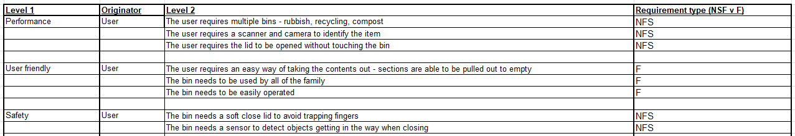
The stakeholder of this product is going to be the main user and the family who will be using it daily but there are other stakeholders which will use it occasionally. This means that ensuring that the product is simple and easy to use by everyone is a vital requirement that needs to be considered in the systems engineering plan.
Figure 1 - Table showing requirements
Figure 1 shows the requirements gathering table which breaks down the customers’ requirements into different sections. This helps for the identification of the requirements and gives each one a heading, for example performance or safety. It is shows if the requirement is a functional subsystem (F) or nonfunctional subsystem (NFS). Functional means that the user must put an input in to do something and nonfunctional means that the system does that itself. This table is easy to follow and helps structure for the rest of the systems engineering methods which will be explained throughout this report.

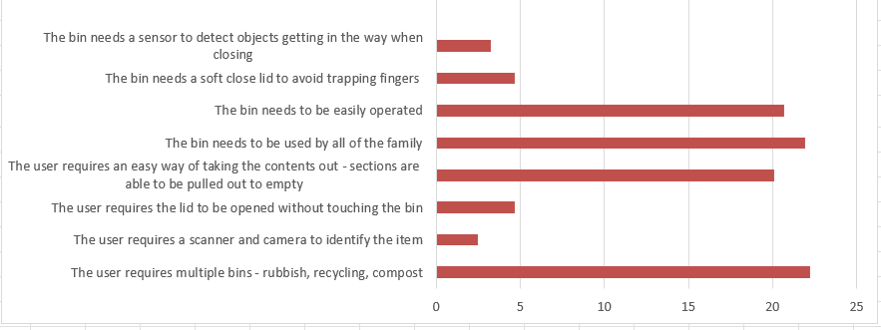
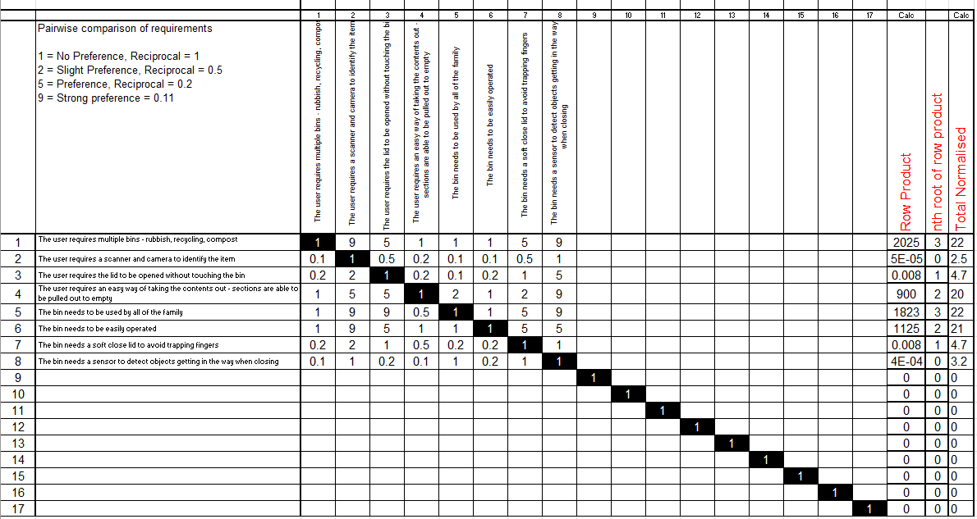
The next part of the systems engineering methods is to compare the customers’ requirements against each other. This can be seen in figure 2. Figure 2 has the requirements across the top and down the side, this part is comparing the different requirements against each other to determine which are more important to the customer. It works by a 1-9 key and the higher the number given the higher preference the customer had. In the opposing box a key of 0-1 was used to show which one was the priority. A high priority example is the user having multiple bins rubbish recycling and compost was a 9 over the bin requires a camera or scanner to identify item. This uses the numbers and puts them into an equation which allows to see the requirements preferences.
Figure 2 - Pairwise comparison of requirements
Figure 3 shows the pairwise comparison of requirements in a table to show which requirements had a bigger preference for all the requirements discussed. By having this information in a table, it is quick and easy to understand which will help the engineer when they get the requirements information as they will be able to identify which requirements are the most important. Therefore, they will be able to prioritise these when designing the product. Figure 3 clearly shows that there are 4 requirements which are the priority which include multiple bins, easily operated, useable by all, easy way of taking contents out. From this table it shows that the user-friendly requirements have the highest need but on the other hand the safety features are less required. This means that when designing the bin product compromises need to be made as all the requirements will be important.
Figure 3 - Pairwise comparison of requirements table

Requirements Analysis
The requirement analysis investigates the functions of the operator and the steps they need complete to ensure the product works with the requirements needed by the operator.
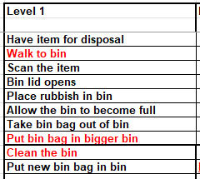
Figure 4 - Function analysis table
Figure 4 shows the functions needed by the operator to work the bin. This uses the requirements needed from the operator to get the desired result. It works by a step-by-step method of how a bin works but also including the developments that will be seen by the scanner system. The sections highlighted in red show the subsystems that were missed and not thought about in the beginning process. This section of the systems engineering process is important to determine how an operator is going to use the product.

QFD 1 + Explanation
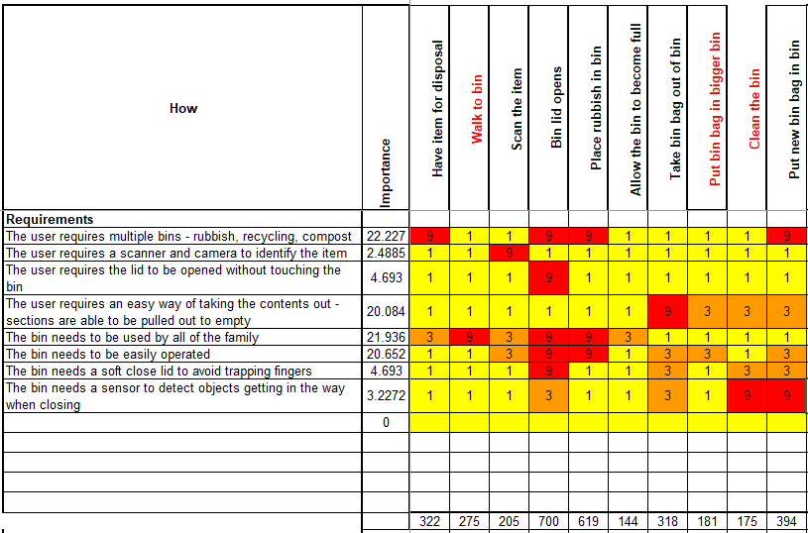
QFD1 stands for quality function deployment 1 and is used to determine and analyse a set of requirements, especially for missing parts and to integrate analysis of requirements and functionality. It also enables for the retention of the customers focus in a structural and traceable way. [3]
Figure 5 - Quality function deployment 1 (QFD1)
Figure 5 shows the customer requirements against the functions of the bin. The table shows the relationship between every requirement to every function, this is shown by the numbering system which I colour coordinated. The strongest relationship can be seemed by the score of 9 and the red boxes, the medium relationship of a 3 and orange and the weakest relationship gets a score of 1 and is yellow.
Using the information of how it works it can be seen which requirements affect each function, this allows for the designer to see where the customer requirements can change and effect the function. From a look at the graph every requirement will affect a different are of the function of a bin. This means that the changes to the bin will change how the customer will function the operation of a bin.
By using QFD1 it shows that the customers requirements are in line with the function of the bin and shows that there was nothing missed in the previous steps of the system engineering plan. Overall QFD1 is a quick and easy way to check the work previously has worked and allows for the progression and going into more detail about the system.
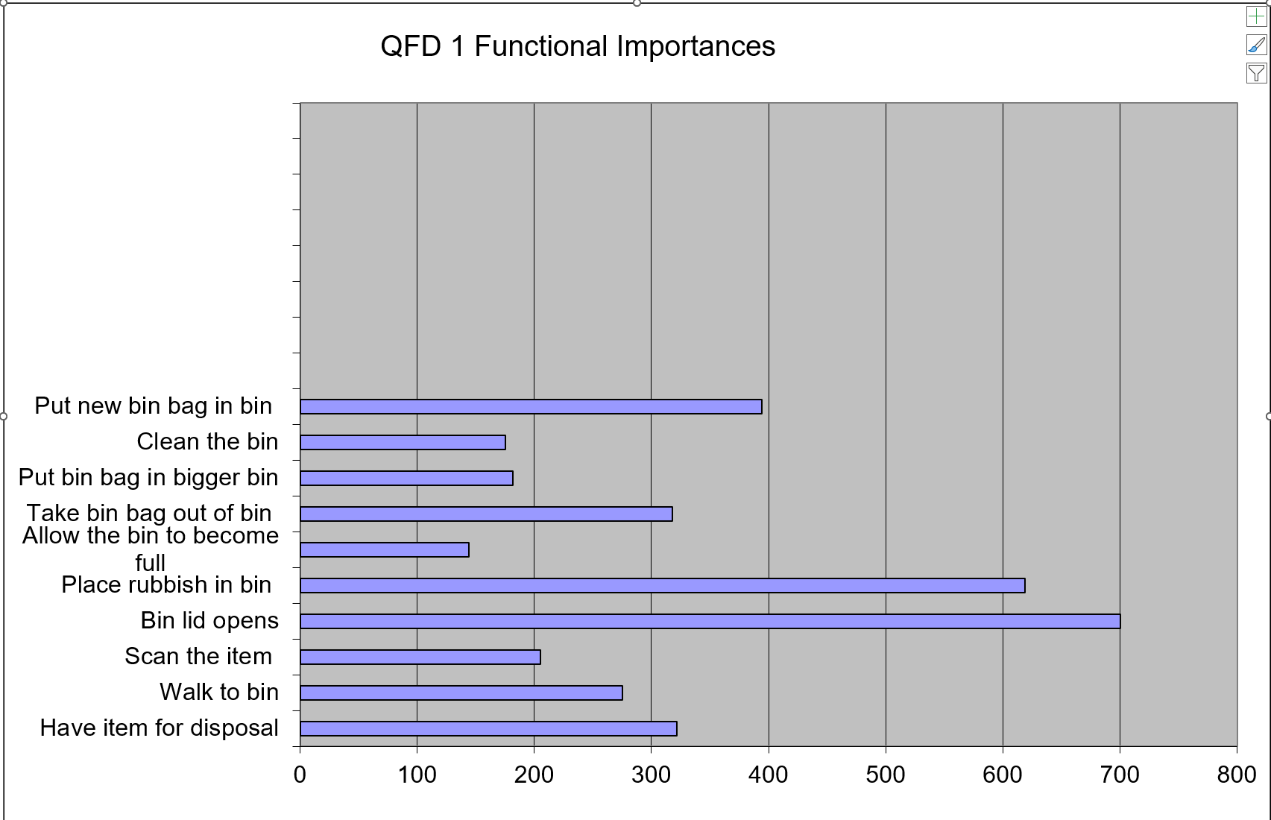
Figure 6 - QFD1 function importances graph
Figure 6 shows the results of QFD1 in a table form. By having this information in a table form it clearly shows which functions had the strongest relationship with the customers requirements. The graph shows that the bin lid opening and the placing rubbish in the bin had the strongest relationship with the requirements. On the other hand, the function of allowing the bin to become full had the lowest relationship with the requirements. It was important to see that each function had a relationship with one or more of the requirements as this shows that all the customers’ needs will affect the functions.
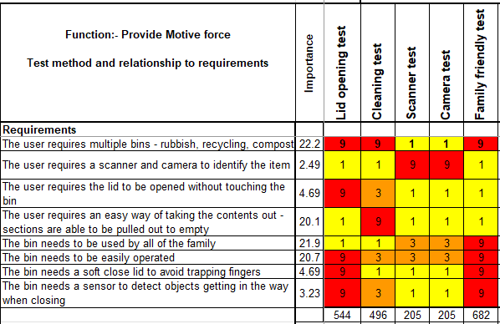
Figure 7 - Function metric table
Figure 7 is the function metric table which involves tests on different functions of the bin compared to the customers requirements. For the customers requirements it is important to have tests to ensure that the product will work and be safe for the purpose. Ensuring that the tests can work effectively it is vital that these two are compared against each other which can be seen in figure 7. It uses the same comparison method as before with the numbering system 9,3 and 1.
The results in figure 7 show that the family friendly test has the biggest relationship with the customers requirements. This shows that ensuring the product can be used by all people no matter age, size or disabilities it is useable for all. The other tests will also be important and that can be seen by the scores; by completing these it ensures the product will complete the tasks needed in line with the customer requirements. Every test in the table has a 9 with one or more of the requirements, this shows that the tests and requirements are linked together.

Concept Generation
Function Means Analysis is a highly structured approach to generating, selecting and documenting system design concepts. The basic idea is to consider the functions that the system performs and identify all the means of achieving that function.[7]
The next part of the report will cover the concept generation and the first part of that is completing a function means analysis table. This investigates the function of the product and the different means, the different ways it can be carried out. This is important to see all the different ways that one product can be made and how different technology can change the way it functions.
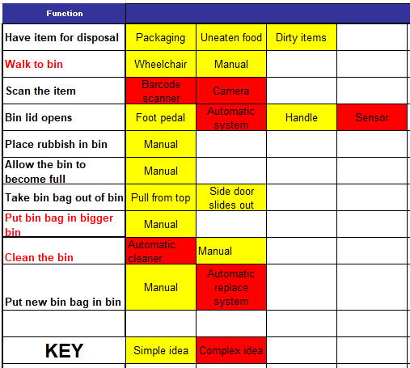
Figure 8 - Function means analysis table and key
Figure 8 shows the function means analysis table of a bin. The key indicates which means are a simple idea and which ones are more complex. Having these colour coded is important to see the differences as more complex ideas are going to be harder to make and therefore can become more expensive when building the product. As seen above it shows that many of the functions have simple means with a couple of complex ideas as well.

Concept Evaluation
In this section there will be 4 examples of different bins, separate bins, scanner bin, sensor bin and multi bin with scanner. Each example of a bin will have their own function means analysis table to show how they would work compared to the function. This will allow for a comparison between each design and how each one will work.
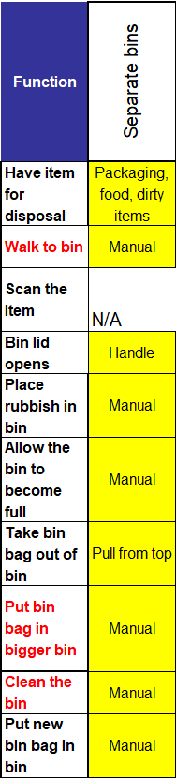
Figure 9 - concept 1 separate bins

The first idea for the bin is to have separate bins. This is the basic idea which can be seen in homes all over the world. There are multiple separate bins for the different types of rubbish which will be labelled or colour coded to help identify, it has a simple handle on the lid to lift manually and to replace the bin liners the user pulls it out from the top. This concept will be cheap and easy to produce as it is already seen all around the world. From the function means analysis graph in figure 9 the yellow means shows that the functions to use this bin use all simple ideas. One issue with this concept is one of the functions it does not apply with the customers’ requirements, this could become a deciding factor when purchasing the product.
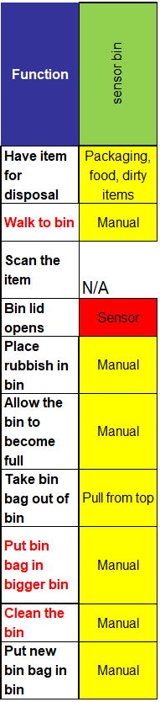
Figure 10 - concept 2 sensor bins
The second concept is a sensor bin which is another simple design but for the lid opening there is a hand sensor at the top. The user will use this by showing the bin their hand and the lid automatically opens to allow for the rubbish to be put in. This concept uses technology on one of the functions and has been seen used before, but it isn’t often that homes contain this product. By having a sensor, it eliminates the user from touching the bin which would contain germs. In figure 10 it shows that the sensor is the only complex idea for this bin which will help with the hygiene around the family home. One issue with this concept is one of the functions it does not apply with the customers’ requirements, this could become a deciding factor when purchasing the product.
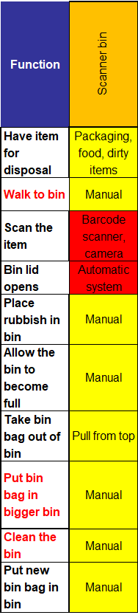
Figure 11 - concept 3 scanner bins
The third concept is scanner bins. The way the scanner bin works is by adding a barcode scanner and camera to the user’s home, they would then scan the item or take a photo, and it will tell the user what type of bin their rubbish needs to go into. By having this adaption, the correct rubbish will go into the correct bins, this promotes the importance of recycling with the whole family. The idea would use a similar scanner to the self-serve checkouts that can be seen in supermarkets, there will be a smaller screen which will indicate the type of bin. The attachment for this would be sperate for the bins and the user would still need to locate the correct bin. In figure 11 it shows the function means analysis graph for the scanner bin, and this shows two of the means being complex.
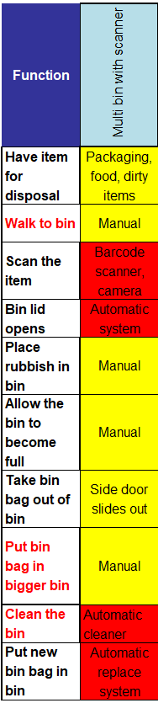
Figure 12 - concept 4 multi bin and scanner
The fourth and final concept is the multi bin with scanner. This is the most complex bin out of the concepts as shown in figure 12. It uses the same scanner system as the scanner bin, but the scanner opens the lid of the item ready for disposal. The bin has multiple sections for all different rubbish and once the disposal item is scanned the lid of the bin opens and the user puts the item in. This eliminates any rubbish going into the wrong bin. Another feature this bin includes is an automatic cleaner and bin bag replacer. When the user pulls out an old full bin bag the bin will close and have a cleaning system that uses disinfectant to kill some of the germs, the bin will still need proper cleaning but by having this quick system it limits the chances of older germs staying in the bin for long periods of time. The replacing bin bag works by having the packet of new bin bags at the bottom where the side of the bin bag get brought up to the top and it is ready to use straight away. In figure 12 it shows the complex ideas that would be added to the system, this means that the product will be expensive, and the technology needed for this will be high. This concept is something that has never been seen before but does meet all the customers’ requirements.
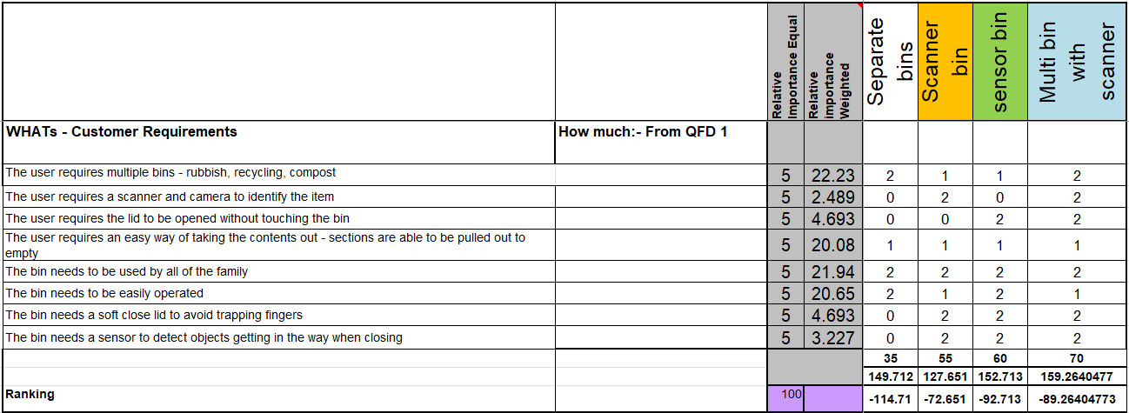
All 4 concepts have their benefits and faults, the most important part is deciding which bin would meet all the customers requirements. Concepts 1 and 2 are the only concepts that don’t comply with all the customers’ requirements and functions whereas concepts 3 and 4 do. Concept 4 includes the most complex ideas, but this may be harder to manufacture and for it to work.
Figure 13 - system Pugh table
The Pugh Matrix (PM) is a type of Matrix Diagram that allows for the comparison of a number of design candidates leading ultimately to which best meets a set of criteria. It also permits a degree of qualitative optimisation of the alternative concepts through the generation of hybrid candidates.[4]
Figure 13 shows the system Pugh matrix for the concepts show earlier. The Pugh matrix has the customers requirements down the side and the four concepts across the top. It works via a numbering system of 0,1 and 2. 0 has not met the customers requirements at all, 1 has met them but there could be adaptations and 2 has fully met the requirements needed. Using a mathematical equation is then ranks each idea compared to the customers requirements. From this information in figure 13 it shows that the multi bin with scanner has the highest score in relation to the requirements, followed closely behind by the scanner and sensor bin which received very similar scores. The lowest score relating to the customer requirements was the separate bin. By looking at the Pugh matrix it shows the only concept with no 0 scores was the multi bin and therefore that would be the best concept for the customer as it achieves everything that the customer requires. In the Pugh matrix it also shows the requirements which are the most important with the score of 21.94 the use by all the family is the most important and all the bins score 2. This shows that all the concepts apply with this customer requirement. By using this method, it allows the designer to work out which concept will be best to produce.

QFD 2 + Criticality
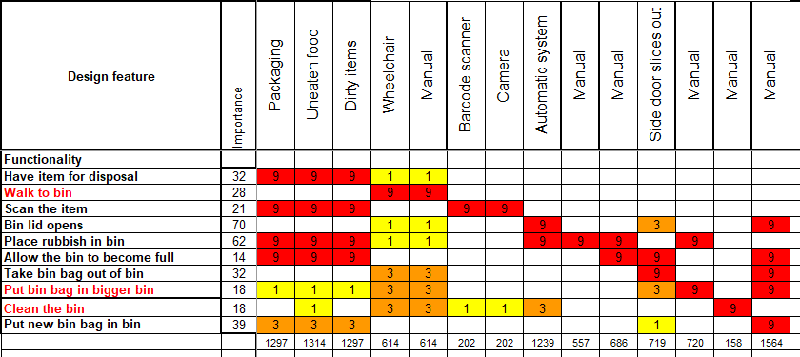
The Level 2 QFD matrix is a used during the Design Development Phase. Using the Level 2 QFD, the team can discover which of the assemblies, systems, sub-systems and components have the most impact on meeting the product design requirements and identify key design characteristics. The information produced from performing a Level 2 QFD is often used as a direct input to the Design Failure Mode and Effects Analysis (DFMEA) process.[5]
Figure 14 – Quality Function Deployment 2 (QFD 2)
QFD 2 works the same way that QFD 1 did but the titles are different. Down the left side of the table, it contains the function and across the top is the design feature. This investigates the way the bin will be manufactured to still meet the function requirements and the features that are needed.
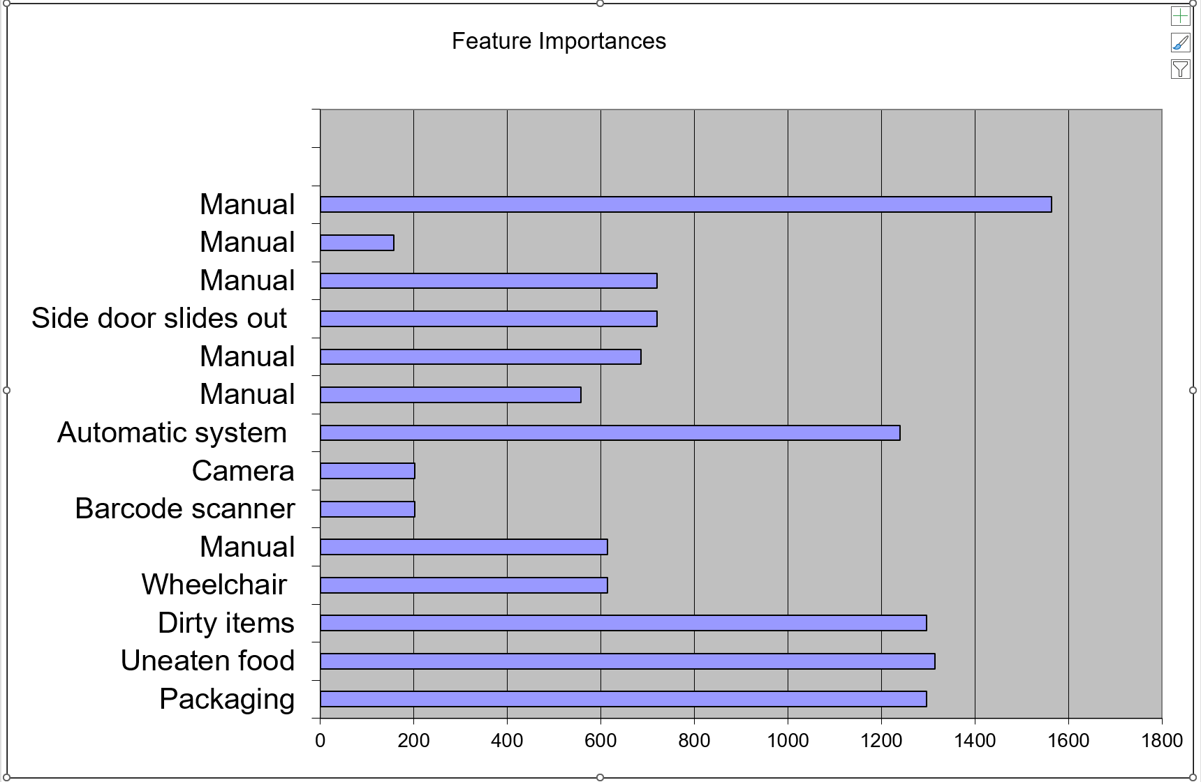
Figure 14 shows the QFD2 table for the bin. It indicates what relationship the function means have with the functionality of the bin. The scoring system is the same as the QFD1, the 9 and red sections indicate a very strong impact, the 3 and orange sections are a medium impact and a 1 is a small impact. By having it laid out in this way it is quick and simple to see which parts have the strongest relationship. The scores for each then get put into an equation and shown in the bottom, the higher the score at the bottom the mor impact they have on each other.
Figure 15 - QFD2 feature importance graph
Figure 15 shows the graph of the results from completing QFD2. This information is placed into a graph to make it easy to understand the features which are important to the system for the manufacturing process. From this graph it shows that there are some features which had a higher score than others. The highest score was the manually putting a new bin bag in with a score of 1564, this indicates that having an easy way of completing this task as important. On the other hand, the lowest scoring was manually cleaning the bin which had a score of 158. Even though the scoring system came out this way does not mean that certain functions can be forgotten about, all the functions are needed for the product to work effectively.
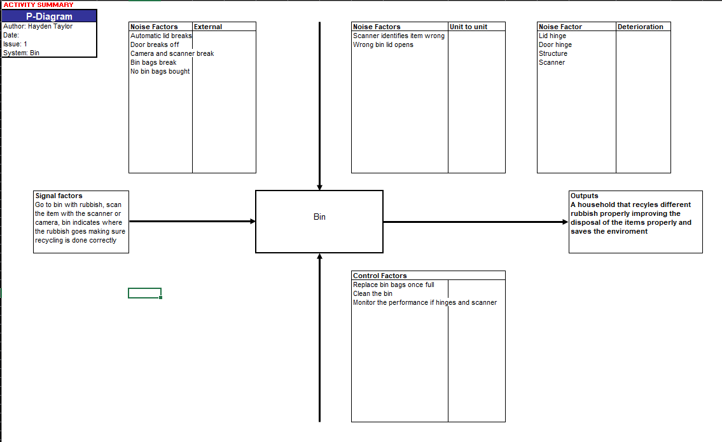
A P-Diagram, or Parameter Diagram, is a useful tool used to determine and document inputs and intended outputs for the item or process under review, along with unintended outputs (sometimes called error states), noise factors, and control factors. Function details, functional requirements, and non-functional requirements may also be documented. Developing a well-defined P-Diagram can provide useful input for the FMEA, including details like Failure Causes, Failure Modes, Effects, Current Controls, and Recommended Actions.[6]
Figure 16 - P diagram
Figure 16 shows the P diagram for the bin. It includes the sections external noise factors, unit to unit noise factors, deterioration noise factors, signal factors, control factors and outputs. By looking into these sections, it indicates the bins supposed input to work, the desired outputs, the failure factors and the control factors. This information is important when moving onto the next section of DFMEA (design failure mode and effects analysis). By looking into that factors that can affect the output of the bin is important so that the product can work effectively and the product that is produced can work perfectly for the customer.
The signal factors of the bin are to have rubbish, go to the bin, scan the item for disposal, the bin identifies item and suggests place for it. By having these signal factors, it indicates how the bin will function with the operator and allows for a household to become better at recycling and organising their rubbish.
The design of the bin includes technology and that can go from so one example of a noise factor is the scanner identifies the item incorrectly, therefore the rubbish will end up in the wrong section of bin. This would be a unit-to-unit noise factor as this may happen to only certain units that get used.
Another noise factor would be the deterioration, this would be seen after a lot of use. The bin lid hinges would be used a lot and therefore may break from constant opening and closing. This is a factor that will be more common after a long period of time in use.
The third noise factor is the external reasons, for example a bin bag breaking and the rubbish contents being everywhere. This is not a factor that would happen because of the bin itself but its important to know that these situations do occur.
The control factors are something that the operator will need to monitor. For example, they need to ensure that the bin bags in use are not overflowing and are replaced once full. This needs to be completed to ensure the bin can use the product how intended.
After looking at all the noise factors the output of the bin can be reviewed and for this product the outcome of a household and family are able to organise rubbish into the different sections ready for disposal is done correctly. This allows for recycling to be done and improve the environment that they live in.

Conclusion
Throughout this report the systems engineering framework was researched and put into use for a household object, a bin. The idea was to develop the bin using systems engineering methods to improve the customers way of using a bin. This started with understanding the customers’ requirements for a bin and knowing ways of improving. This then led onto looking at the functions of a bin and the subfunctions. These were then compared against each other in QFD 1. This allowed to see the importance of the customers’ requirements against the function, making sure they all aligned and would work. This allowed for the product to move on to the function means analysis section where understanding the way the product would work, and the customers’ requirements were compared. This led to the four different concepts and a comparison between them was done to find the best product. QFD 2 then investigated more of the manufacture process and the thoughts into how it could be made to fit every previous requirement was done. The final part was looking into the P diagram where it moved onto more failure factors could be seen which would lead onto DFMEA.
Overall, this report shows an example of how the systems engineering framework is used and how important it is to complete to get the best outcome. By learning these skills, they can now be taken into the workplace, for example a trials conducting officer will work with the lead scientist and a member of the diagnostic team to develop a new explosive trial where the important data will be gathered effectively and safely.

References
[1]H. Sillitto et al., “Systems Engineering and System Definitions AUTHOR TEAM,” 2019. Available: https://www.incose.org/docs/default-source/default-document-library/final_-se-definition.pdf
[2] A. Kossiakoff, Systems engineering : principles and practice. Hoboken, N.J.: Wiley-Interscience, Cop, 2011.
[3]QFD -Quality Function Deployment … a brief guide. (2012). Available at: https://incoseuk.org/Documents/Omega_Guides/Omega_3.pdf [Accessed 28 Apr. 2025].
[4] Burge, S. (2009). The Systems Engineering Tool Box ‘Give us the tools and we will finish the job’ Pugh Matrix (PM). [online] Available at:
https://www.burgehugheswalsh.co.uk/uploaded/1/documents/pugh-matrix-v1.1.pdf.
[5] quality-one (2019). QFD | Quality Function Deployment | Quality-One. [online] Quality-one.com. Available at: https://quality-one.com/qfd/.
[6] Relyence.com. (2025). DFMEA P-Diagrams. [online] Available at: https://relyence.com/help/user-guide/dfmea-p-diagrams.html [Accessed 29 Apr. 2025].
[7] Burge, S. and Churchill, W. (n.d.). The Systems Engineering Tool Box ‘Give us the tools and we will finish the job’. [online] Available at: https://www.burgehugheswalsh.co.uk/Uploaded/1/Documents/FMA-Tool-v1-1.pdf.
[8] www.rose-hulman.edu. (n.d.). 404 | Rose-Hulman. [online] Available at: https://www.rose-hulman.edu/class/cs/csse490-requirements/handouts_490/sh%20hdbk%202.1.pdf.
[9]N. G. Leveson , Engineering a Safer World. MIT Press, 2011. Accessed: Apr. 30, 2025. [Online]. Available: https://www.google.co.uk/books/edition/Engineering_a_Safer_World/fA38DwAAQBAJ?hl=en&gbpv=0

Appendix

