

Student Name :- Vraj A Pandya
Student ID :- 2244599
Programme :- MBA General Management
Module :- Marketing Management
Code :- LCMB7001
Lecturer : Tushara Balendran
Submitted On :- 30 August 2023

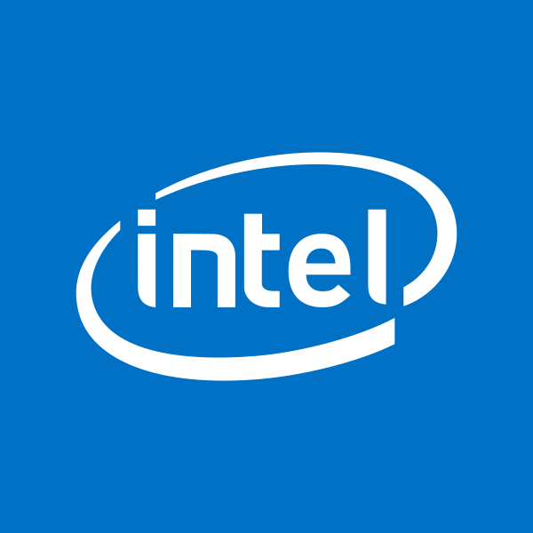
Student name:
Student ID:
Program: MBA- Masters of Business Administration
Module: Marketing Management
Module code: LCMB7001
Assignment: 2
Table of Contents
1. Introduction 3
2. PESTLE analysis of Intel 3
3. Porter’s Five Forces Analysis 5
4. SWOT Analysis of Intel 7
4.1. SWOT analysis 8
4.2. Advantages and Disadvantages of SWOT 10
5. Segmentation, Targeting, and Positioning 10
5.1. Segmentation 10
5.2. Targeting 11
5.3. Positioning 11
6. 4Ps of marketing mix 11
6.1. Product 12
6.2. Price 12
6.3. Place 13
6.4. Promotion 13
7. Recommendation 13
8. Conclusion 14
References 16
Poster presentation 19

1. Introduction
The report examines the Intel organisation, which provides extensive services worldwide to consumers. Intel Corporation develops and designs technological components and products. The organisational portfolio comprises chipsets, microprocessors, conferencing products, communication, networks and graphics (LinkedIn, 2023). The Intel organisation also offers server products, drives of solid state, motherboards, and products of wireless products connectivity. The report discusses PESTLE factors consisting of political, economic, social, technological, legal and environmental elements. Porter's five forces model is applied to state whether the forces are medium, low or high. SWOT analysis is mentioned that determines the strengths, weakness, opportunities and threats of the organisation. The advantages and disadvantages of the model are mentioned in the report. Segmentation, targeting and positioning are mentioned in the report. 4P marketing mix is used to evaluate the marketing factors of Intel company in the U.S. market. Recommendation is applied that determines the strategies incorporated by the organisation to achieve success in the future.

2. PESTLE analysis of Intel
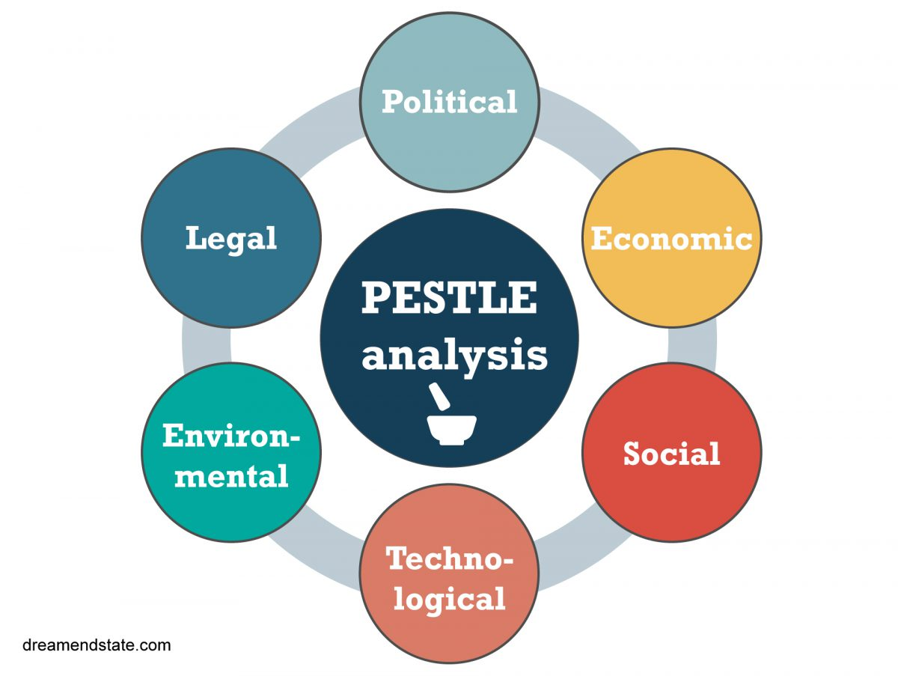
Figure 1: Pestle Analysis
Source: (Paul, 2021)
Analysis of PESTLE signifies a useful tool implemented to deploy while opening a new business and entering a modern market (Paul, 2021).
Political | - Drug policies  Drug policies are the primary concern for the U.S. government (Shondaland, 2022). In October, Joe Biden, president of the U.S., declared that he would issue an executive pardon for every federal offence concerning the use or possession of marijuana (Shondaland, 2023). Intel must follow all the policies executed by the U.S. government. The organisation should notice that none of their employees should use drugs. (unfavourable)  - Gun violence  Gun violence is another challenge in parts of Texas, New York, Illinois, Highland Park, and other communities around the U.S. Intel must take necessary precautions to provide stable protection towards its workforce. (unfavourable)
Economic | - High inflation  The U.S. economy has recovered rapidly from the pandemic, but the bounce-back demand has hampered the supply chain and caused inflation to emerge sharply (Hodge, 2023). The high inflation might impact the products of Intel. Intel might face challenges in raising its prices because of the high inflation rate. (unfavourable)  - Risks ahead  The economic developments will be affected by international factors, including the Russian and Ukraine wars and possible shutdowns in China. Intel may face challenges due to the risks emerging in the market. (unfavourable)
Social | - Wage inequality  Wage inequality is a significant challenge impacting various workforces in the U.S. Inequality has worsened. During 2020, 90% of the bottom received 60.2% of wages, which grew measly by 28.2% (Soken-Huberty, 2022). Intel may provide equal payment towards its employees. (unfavourable)  - Racism  Racism is a social challenge in the U.S. Intel should follow anti-racism activities to protect all its employees from internal and external threats. (unfavourable)
Technological | - Cybersecurity  Technological security has been a challenge in the U.S. (Brown, 2017). Intel should adopt measures to secure its personal information from data leakage and threats. (favourable)  - Connectivity  The United States still has not been connected like other resource countries. Intel must expand its connectivity with other global countries rather than depending on the U.S. (favourable)
Legal | - Social media  Carless usage of social media platforms, including LinkedIn, Twitter and Facebook, can cause violations of federal and state laws (Personnel Today, 2012). Intel should adequately use social media to spread their awareness of the brand and employee recruitment. (favourable)  - Discrimination  Discrimination is a primary concern for U.S. employees. Intel must enforce discrimination laws in their workforce. (unfavourable)
Environmental | - Air pollution  It has been a significant problem in various cities, including large populations (Tsui, 2020). Intel has to be careful in following environmental policies to address such issues. (unfavourable)  - Water pollution  It is another issue that can create a significant issue for Intel. (unfavourable)
Table 1: PESTLE analysis
Source: (Developed by the auhor)

3. Porter’s Five Forces Analysis
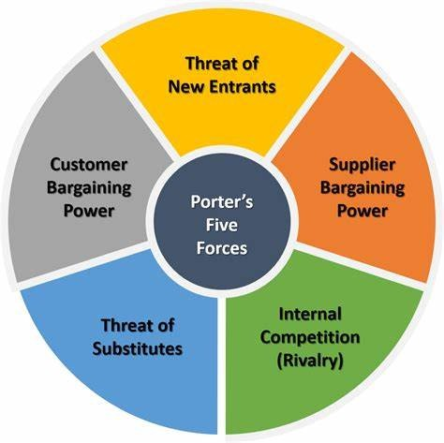
Figure 2: Porter Five forces
Source: (ELRouby, 2023)
The five forces of this model include the threat of substitutes, the power of consumers, the threat of new entrants and rivalry among the competitors (ELRouby, 2023).
The threat of new entrants (low) | As an expert in the semiconductor business, Intel generates optimised operations that suit its strategic objectives (Lombardo, 2017). The organisation uses their technological expertise to maintain and support constant operations. If the entry barrier is high, then there is less chance for companies to enter the market. Modern companies will face challenges to enter into the U.S. market. The low threat of new entrants can cause a significant advantage for Intel to enjoy a sustainable competitive advantage in the U.S. market.
The threat of substitutes (low) | The chips used by Intel are some of the most complex equipment ever produced and need advanced technologies (Inc. 2023). Other companies cannot substitute the chips of Intel. Hence, people feel reliable in using their chipsets instead of using others. Therefore, the threat of substitutes is low because people are more reliably using Intel chipsets.
Bargaining power of consumers (low) | Since many consumers depend on the processor and chipsets of Intel, there is a high switching cost. People will feel compelled to switch because of their low power of bargaining. For several years, Intel was one of the largest chipmakers (Oakley, 2020). The organisation kept creating stable-performing chips compared to chips manufactured by its competitors. The competitive strength of Intel in the U.S. market will help it gain a large number of consumers for its manufactured products.
Bargaining power of suppliers (low) | Intel firmly manages its supply chain to reduce challenges, improve the quality of products, and achieve social and environmental goals (Intel, 2023b). It can be stated that Intel has significant control over its supply chain management. Therefore, suppliers can generate low power on the supply chain of Intel.
Competitive rivalry (moderate) | In the USA market, there is a presence of various companies that are doing effective business in the market. The topmost competitors of Intel firm include NVIDIA, Microsoft and Meta (Zippia, 2023). Due to the presence of competitors, there is a moderate threat to Intel’s ability to operate its business.
Table 2: Porter’s five forces analysis
Source: (Developed by the author)

4. SWOT Analysis of Intel
Strengths | Weakness | Opportunities | Threats
Has a strong relationship with supply chain management. | Has no presence in the mobile market. | Due to good competitive advantage, it will enjoy a sustainable competitive advantage. | Presence of competitors in the U.S. market.
It has an excellent competitive advantage. | Excessive amount of production | Can sell products confidently both in the offline and online Medium. | Changing preferences of consumers.
Massive consumers. | Bad services
Complex chipsets | Lack of diversity
Table 3: SWOT analysis
Source: (Developed by the author)
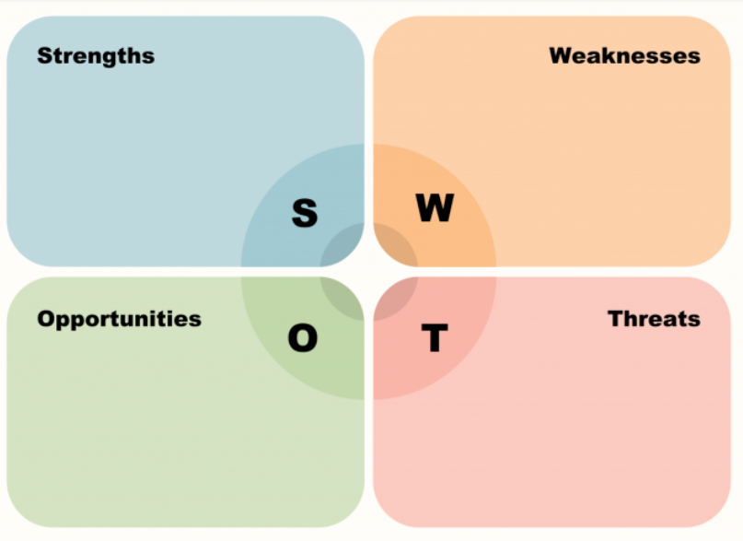
Figure 3: SWOT analysis
Source: (Tannuzzo, 2023)

4.1. SWOT analysis
Strengths:
- Intel has a strong relationship with supply chain management.
Intel manages their supply chain to develop product quality, reduce risk, and improve performance for consumers, suppliers and Intel (Intel, 2023b). On the other hand, it also manages the supply chain to achieve social and environmental goals. Due to its excessive control over the supply chain management, it can quickly sell its products directly towards its consumers. With the help of their supply chain management, industry collaboration, progress and human rights standards, sourcing of responsible minerals, inclusion and supplier diversity are advancing.
- Good competitive advantage
Intel was a well-known chipmaker. It has developed X86 architecture that acts as a basis for microprocessors that developed the central processing unit that went into laptop and desktop computers (Oakley, 2020). Intel's planning of designing and manufacturing chipsets provides competitive strength and significant scale economies.
- Massive consumers
Intel is achieving success by providing its consumers with what they want (Oakley, 2020). Therefore, Intel has a massive base of consumers purchasing their products and services to run their PCS and laptops.
- Complex chipsets
Other companies cannot copy their complex chipsets.
Weakness:
- Has no presence in the mobile market
Intel has targeted this market but initially gave up because mobile devices became the item of choice (Oakley, 2020).
- Excessive amount of production
Excessive amount of production can act as a significant weakness for Intel.
- Bad services
The sales of Intel fell by a quarter during the year (Leibson, 2023).
- Lack of diversity
Due to a lack of diversity in their products, the company faces significant challenges in achieving success in the market.
Opportunities:
- Competitive advantage
Due to their stable competitive advantage, Intel will enjoy concrete success in the market.
- Product sales
Because of a significant base of consumers, Intel can sell their products confidently through both offline and online platforms.
Threats:
- Presence of competitors
The presence of competitors such as NVIDIA, Microsoft, and Meta generates steep competition against Intel.
- Consumer changing preferences
Changing consumer preferences will significantly threaten Intel's operating business in the market.

4.2. Advantages and Disadvantages of SWOT
- Advantage
SWOT analysis is conducted by conducting brainstorming sessions, and the objective is to identify the external and internal factors. SWOT analysis is also stable in gaining valuable information about the business's strengths, weaknesses, threats, and opportunities.
- Disadvantage
It creates a single-dimensional model that categorises all problem attributes in the form of weakness, threat, opportunity and strength (Nordmeyer, 2023).

5. Segmentation, Targeting, and Positioning
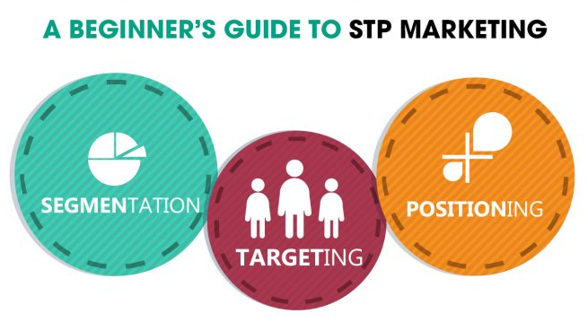
Figure 4: STP marketing
Source: (Martechlive, 2020)

5.1. Segmentation
Demographic segmentation-
- Gender: Both males and females are the organisation's target audience in the market. Intel sells its products primarily towards ODMs and OEMs (CSI Market. 2023).
- Income: The consumers of Intel have recorded a revenue of about 3.15% during 2022. It can be said that both the high-income and middle-income people are the consumers of Intel.
- Age: It can be said that all consumers are purchasing Intel products from both offline and online Mediums.
- Occupation: All people doing any type of work and earning income are the consumers of Intel.
Geographic segmentation-
- In all parts of the USA, the products of Intel are sold to consumers. It can be said that Intel is doing effective business in various parts of the U.S.
Psychographic segmentation-
It can be stated that Intel has targeted consumers who are generally technologically savvy.
Behavioural segmentation-
- It is also found that customers do not require the products of Intel (Oakley, 2020). Therefore, Intel should develop more products to attract several consumers' attention.

5.2. Targeting
Intel uses mass marketing to reach the consumers available around the U.S country. Intel was implementing Eloqua to regulate their marketing automation, but the related system processes had some limitations (Mass Engines, 2023).

5.3. Positioning
It can be stated that Intel might use a differentiation strategy to achieve success in the market. The chipsets used by the organisation are helping the firm to gain a dominant position in the market (Oakley, 2020).

6. 4Ps of marketing mix
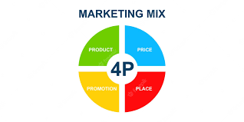
Figure 5: 4P marketing mix
Source: (Freepik, 2023)

6.1. Product
Its chip product has guided the organisation to build a business of a significant scale. The strategy of designing and manufacturing chips has guided them to gain vast economies of scale and competitive strength (Oakley, 2020).
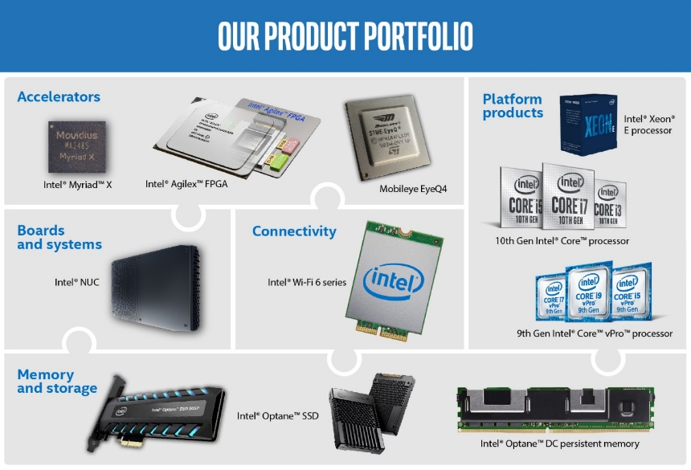
Figure 6: Product portfolio of Intel
Source: (INC, 2023)

6.2. Price
The organisation can push through the pricing within the P.C. business (Oakley, 2020).
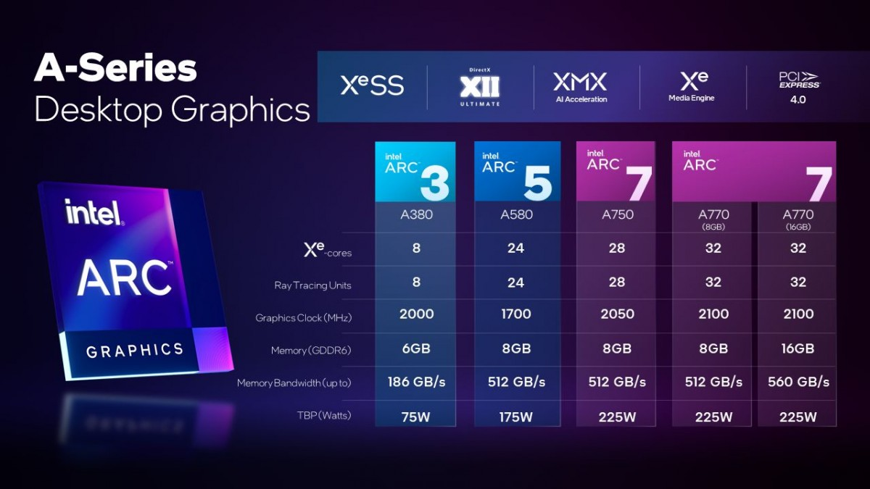
Figure 6: Availability and pricing of Arc A750 launched by Intel
Source: (Prasad, 2023)

6.3. Place
Intel technologies generate a foundation to share, analyse, and collect data from different channels (Intel, 2023a). Intel is also using an omnichannel strategy to reach its consumers.

6.4. Promotion
It can be stated that Intel has promoted its products to consumers in both the offline and online markets. Intel was a dominant manufacturing organisational brand doing business since the 1980s, along with the launch of a microprocessor, including 486, 386 and 286 (Mohammed, 2023). As Intel uses an omnichannel marketing approach, it will successfully promote its products to its consumers.

7. Recommendation
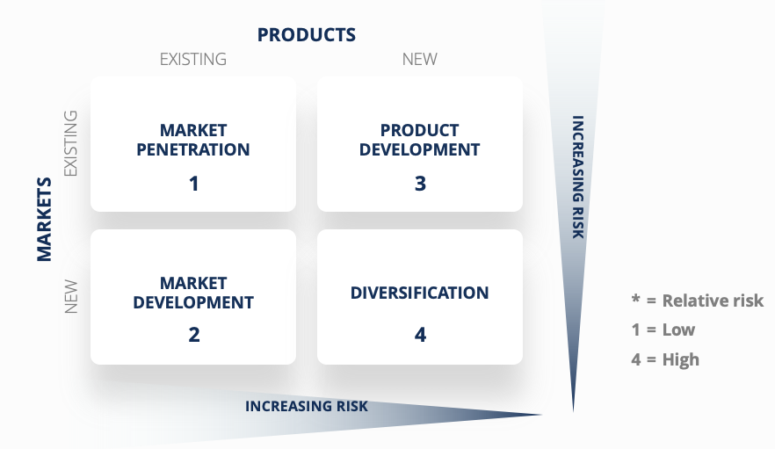

Figure 7: Ansoff matrix
Source: (Corporate Finance Institute, 2023)
- Diversification
The Intel organisation should expand its business while monitoring its competitors in the U.S. market. The organisation should adopt a diversification strategy. The organisation can develop diversification while manufacturing the desired products for the consumers. There is a presence of various companies that are already doing good business in the U.S. market. Therefore, Intel must track the changing preferences of consumers in the U.S. market.
- Product development
The organisation should develop their products according to the choices of customers purchasing technological products. It has been identified that the organisation has faced negative reviews from consumers. Therefore, Intel must operate an effective business while building brand awareness by adopting an omnichannel marketing technique. The organisation should also expand their business towards the mobile market. The organisation needs to build chipsets applicable for manufacturing a mobile phone.

8. Conclusion
Based on the above explanation, it can be concluded that Intel is a thriving organisation in all parts of the world. The firm is located in different parts of the USA. The organisation-built chipsets will be incorporated into PCs and laptops. In the U.S. market, there are presence of competitors that are doing good business in the market. In order to do good business in the market, the firm should track the consumer preferences of consumers and operations of its rival companies in the market.

References
Brown, D., 2017. 5 hot-button technology issues facing the U.S. government. [online] The Enterprisers Project. Available at: <https://enterprisersproject.com/article/2017/2/5-hot-button-technology-issues-facing-us-government> [Accessed 28 Aug. 2023].
Corporate Finance Institute. 2023. Ansoff Matrix. [online] Corporate Finance Institute. Available at: <https://corporatefinanceinstitute.com/resources/management/ansoff-matrix/> [Accessed 28 Aug. 2023].
CSI Market. 2023. Intel Customers by Division and Industry - CSIMarket. [online] Intel Customers by Division and Industry - CSIMarket. Available at: <https://csimarket.com/stocks/markets_glance.php?code=INTC> [Accessed 28 Aug. 2023].
ELRouby, M., 2023. Simplified Strategy for Finance Professionals - Porter’s 5 Forces. [online] Simplified Strategy for Finance Professionals - Porter’s 5 Forces. Available at: <https://www.linkedin.com/pulse/strategy-finance-porters-5-forces-elrouby-acma-cgma-fpac-mba> [Accessed 28 Aug. 2023].
Freepik. 2023. Premium Vector | Marketing mix model - product, place, price and promotion. 4p - business or management strategy. [online] Available at: <https://www.freepik.com/premium-vector/marketing-mix-model-product-place-price-promotion-4p-business-management-strategy_38373577.htm> [Accessed 28 Aug. 2023].
Hodge, A., 2023. The U.S. Economy's Inflation Challenge. [online] IMF. Available at: <https://www.imf.org/en/News/Articles/2022/07/11/CF-US-Economy-Inflation-Challenge> [Accessed 28 Aug. 2023].
INC. 2023. About Intel. [online] Intel Corporation. Available at: <https://www.intc.com/about-intel> [Accessed 28 Aug. 2023].
Intel. 2023a. What Is Omnichannel Retail? [online] Intel. Available at: <https://www.intel.com/content/www/xl/es/retail/omnichannel.html> [Accessed 28 Aug. 2023].
Intel. 2023b. Global Supply Chain and Manufacturer Responsibility | Intel®. [online] Intel. Available at: <https://www.intel.com/content/www/us/en/corporate-responsibility/supply-chain.html> [Accessed 28 Aug. 2023].
Leibson, S., 2023. Bad Times For Intel. Will They Last Forever? [online] Forbes. Available at: <https://www.forbes.com/sites/tiriasresearch/2023/02/02/bad-times-for-intel-will-they-last-forever/> [Accessed 28 Aug. 2023].
LinkedIn. 2023. Intel Corp Company Profile - Intel Corp Overview. [online] Intel Corp Company Profile - Intel Corp Overview - GlobalData. Available at: <https://www.linkedin.com/company/globaldataplc/> [Accessed 28 Aug. 2023].
Lombardo, J., 2017. Intel’s Operations Management Strategy: 10 Decisions, Productivity - Panmore Institute. [online] Panmore Institute. Available at: <https://panmore.com/intel-operations-management-strategy-10-decisions-productivity> [Accessed 28 Aug. 2023].
Martechlive. 2020. A Beginner’s Guide to STP Marketing - martechlive. [online] martechlive. Available at: <https://martechlive.com/stp-marketing/> [Accessed 28 Aug. 2023].
Mass Engines. 2023. Intel - MASS Engines. [online] MASS Engines. Available at: <https://www.massengines.com/success-stories/intel/> [Accessed 28 Aug. 2023].
Mohammed, S., 2023. Branding lessons -How did Intel build a brand around a commodity?-Ingredient Branding. [online] Medium. Available at: <https://shahmm.medium.com/branding-lessons-how-did-intel-build-a-brand-around-a-commodity-d48b29b71621> [Accessed 28 Aug. 2023].
Nordmeyer, B., 2023. Advantages & Disadvantages of SWOT Analysis. [online] Small Business - Chron.com. Available at: <https://smallbusiness.chron.com/advantages-amp-disadvantages-swot-analysis-41398.html> [Accessed 28 Aug. 2023].
Oakley, P., 2020. Has Intel’s competitive advantage gone for good? [online] Has Intel’s competitive advantage gone for good? - Investors’ Chronicle. Available at: <https://www.investorschronicle.co.uk/shares/2020/09/24/has-intel-s-competitive-advantage-gone-for-good/> [Accessed 28 Aug. 2023].
Paul, 2021. PESTLE and mortar your rivals (in a nice, non-lethal way) - Dream End State. [online] Dream End State - Have fun. Try things. Break stuff. Available at: <https://www.dreamendstate.com/2021/01/11/pestle-and-mortar-your-rivals-in-a-nice-non-lethal-way/> [Accessed 28 Aug. 2023].
Personnel Today. 2012. The top 5 legal issues currently facing U.S. employers. [online] Available at: <https://www.personneltoday.com/hr/the-top-5-legal-issues-currently-facing-us-employers/> [Accessed 28 Aug. 2023].
Prasad, 2023. Intel announces pricing and availability for the Arc A750. [online] GSMArena.com. Available at: <https://www.gsmarena.com/intel_announces_pricing_and_availability_for_the_arc_a750-news-56010.php> [Accessed 28 Aug. 2023].
Shondaland, 2022. 7 Political Issues That Deserve More Attention Before the 2022 Midterms. [online] Shondaland. Available at: <https://www.shondaland.com/act/news-politics/a41714243/7-political-issues-that-deserve-more-attention-before-the-2022-midterms/> [Accessed 28 Aug. 2023].
Soken-Huberty, E., 2022. 10 Examples of Social Issues in the U.S. [online] Human Rights Careers. Available at: <https://www.humanrightscareers.com/issues/examples-of-social-issues-in-the-us/> [Accessed 28 Aug. 2023].
Tannuzzo, S., 2023. 3 Easy Steps to Create a SWOT Analysis. [online] BNI. Available at: <https://www.bni.com/the-latest/blog-news/3-easy-steps-to-conduct-a-swot-analysis> [Accessed 28 Aug. 2023].
Tsui, J., 2020. Five Biggest Environmental Issues Affecting the U.S. -- Environmental Protection. [online] Environmental Protection. Available at: <https://eponline.com/articles/2020/02/24/five-biggest-environmental-issues-affecting-the-us.aspx> [Accessed 28 Aug. 2023].
Zippia. 2023. Intel Competitors and Similar Companies - Zippia. [online] Intel Competitors and Similar Companies - Zippia. Available at: <https://www.zippia.com/intel-careers-6055/competitors/> [Accessed 28 Aug. 2023].

Poster presentation

