Student Name: Olinda Rapaso
Module Name: Workplace Culture and its impact on Organisational Efficiency –
Code: BMSK5005

Table of Contents
Introduction: 3
Organizational structure………………………………………………………………………………………………………………......4
Organizational culture……………………………………………………………………………………………………………………….7
Investing in the environment…………………………………………………………………………………………………………….9
SWOT Analysis…………………………………………………………………………………………………………………………………12
PESTLE Analysis……………………………………………………………………………………………………………………………...13
The formal and informal relationship between department and people………………………………………….15
Conclusion: 16

Introduction:
Organizational culture is an important issue for any organization to control the employees as well as organizational rules and regulation. Organizational culture refers to the working environment of an organization. It includes norms, values, ethics and rules and regulation of an organization (Burford, 2009). Every staff of an organization should obey organizational culture to increase efficiency of organization. So the manager and leader of an organization are responsible to set values and ethics, rules and regulation of an organization. It is also responsibility of an employee to obey the organizational culture. The author shows here different issues of an organization regarding working culture and its impact on organizational efficiency. The author here chose Leicester Square Kitchen for understanding organizational working culture.
Leicester House was established in 1670 at West end London, England but after it named Leicester Square Kitchen. Now it is one of the most favourite restaurants in London. It is located in a crowded place, as a result, most of the time tourists visits here. It has a chic setting so that tourists can enjoy exotic and Mexican flavours.

Organizational structure:
According to Burford (2009), Organizational structure defines a hierarchy of staff and management in an organization. It also defines job responsibility of each and every staff and manager of any organization. But the size of business varies the length of hierarchy. Small business has lower length and big business has higher length of hierarchy. Leicester Square Kitchen has followed a hierarchy. Leicester Square Kitchen has a team and they are:
1. Owner
2. Bookkeeper
3. General Manager
4. Assistant manager
5. Kitchen manager and team members
The hierarchy model of Leicester Square Kitchen is drawn below:
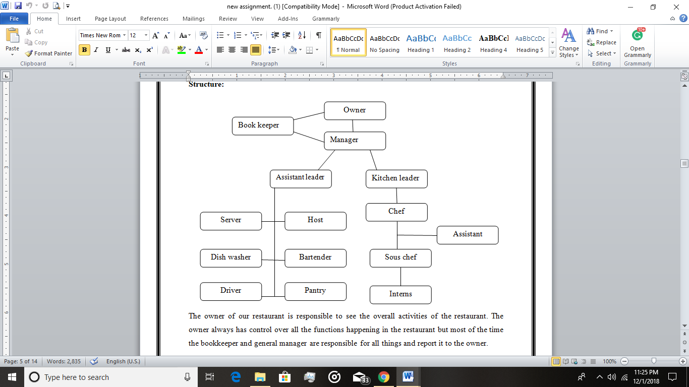
Figure 01: Organizational structure of Leicester Square Kitchen
Source: (Burford, 2009)
Vision: Vision of Leicester Square Kitchen is maintaining sustainable growth of business and providing a higher quality of products.
Mission: Mission statement of Leicester Square Kitchen is “Providing higher quality, getting higher customer satisfaction”.
Owner: Owner of this restaurant has controlled everything in the restaurant. It is responsibility of owner. The owner needs to control all the function is happening in the organization but most of the time bookkeeper and general manager has controlled overall activity of the organization and they report to the owner.
Bookkeeper: Bookkeeper is responsible for recording all economic data. The bookkeeper is also preparing different report for the organization such as cost sheet, income statement, and balance sheet. It helps the manager and owner to take vital decision for the organization (Burford, 2009).
General Manager: The author of this report is playing the role of general manager at Leicester Square Kitchen. General Manager has played an important role in the organization. General Manager needs to do
- The GM is responsible to recruit staff for the organization and train them and helps assist leader and Kitchen leader.
- General Manager is also responsible to maintain a good relation with the customer and maintain a high standard of quality of products.
- Bookkeeper reports to the GM and GM create and monitors the Budget of the restaurant. The GM also finds out that their goal and objectives are achieved or not.
- If an owner creates any new policy than the GM should implement it.
Assistant Manager and Kitchen leader: These two persons are reporting to the GM. The duties of assistant manager are:
- Assistant Manager is responsible for hiring, training and monitoring team member.
- The assistant manager ordered inventory when it is being needed
- Take reviews and suggestion from the customer for ensuring their satisfaction.
The duties of the server are serving foods to the guest and visitors. Under assistant manager drivers, dishwashers and servers are working. Kitchen leader is responsible to train and monitor the chefs working under him.
Organizational culture: Organizational culture refers to the values, norms, beliefs, and attitude of employee of an organization. Organizational culture helps to build organizational structure in restaurant business. The effective culture within the restaurant can create organizational effectiveness.
The manager has always tried to improve the culture of the organization. It helps the organization to strengths the productivity of the restaurant. Being a manager the author understands importance of culture than it brings efficiency; customer satisfaction and employee are working effectively. The author collectively set up norms and values for the restaurant and some of them are mentioned below:
1. All the worker from owner to server should be worked in a team. It helps them to solve any problem quickly.
2. There should not be any communication gap between staff and the author.
3. Serving customer with dignity and integrity without any discrimination of customer.
4. There are not allowed to discriminate worker and every worker should accept and respect each other always.
5. Smoking is not allowed in the restaurant and this rule is for everyone including customer.
6. The success of organization should be celebrated within the organization in various ways.
Staff meeting: The author arranges staff meeting each month so that all the employee can share their problem or ideas and team can solve this problem or take ideas. It also encourages the employee to understand that they are also important for the organization equally as manager or owner. It helps the organization to get new ideas from employee because they are engaging with customer directly so they know the actual demand of customer.
Recipe contest: In the restaurant business all the function are happening by following food and recipe. So the author arranges different recipe competition among chef and worker to get new recipe’s ideas from them. It also helps the organization to increase the skill of employee to make different types of food. These activities create a friendly environment in the workplace as well as increase organizational efficiency. If the internal environment is better than the ultimate restaurant will achieve its goals.
Annual party: This organization always celebrates success, as a result, they arrange annual party every year. In this occasion all the staffs and their family are being invited and some known person. The entire member is enjoying this party and staffs are being honored for their performance in front of their family member and others. It encourages the employee to perform well in an organization.
Uniforms: This organization also maintains a uniform system of the employee. The entire employee should wear uniform appropriately. This uniform also provides restaurant. But uniforms are different from each other. Chef’s uniform is different from server and server is different from employee.
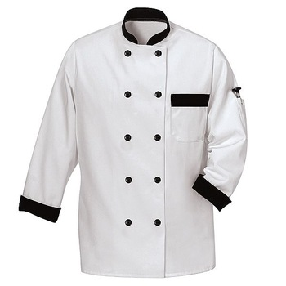
Figure 01: Chef’s dress
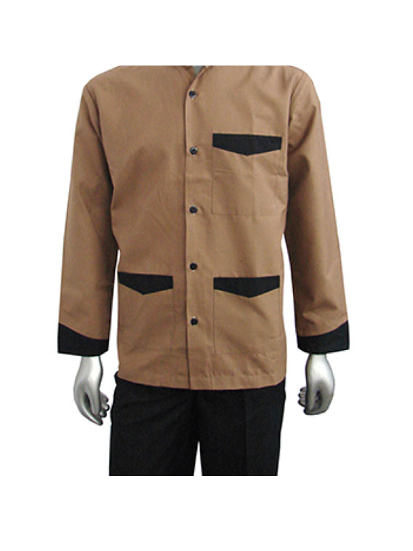
Figure 02: Waiter uniform

Profit-sharing: This organization also share profit with employee. This strategy builds an effective friendly environment for the employee to work hard for increasing profit of the organization. It encourages the employee to increase profit of the organization because of higher the profit higher the commission.
Impact of organizational culture: There is a very strong relationship between organizational culture and overall performance of an organization. If an organization can practice norms and values in a better way than it can add effectiveness to the performance of an organization.
Effective organizational culture can lead an organization effectively. Teamwork in an organization is the most effective system to achieve organizational goal and objectives. The manager of the organization should perform effectively to organize a restaurant business. For example, manager fixes entry and exit time and all the staff should be followed appropriately. The manager is also set delivery time of food. Leicester Square Kitchen sets maximum 30 minutes to deliver food to the customer.
Corporate social responsibility: Corporate social responsibility is another important activity for any organization. It means doing something for society. Because every organization is running a business in society. So they need to do something for the society to survive a long time. Leicester Square Kitchen is also maintained quality of food. They are providing good food and using unhygienic ingredients to make food. It is also a part of corporate social responsibility.
Investing in the environment:
Our restaurant has invested almost $1.5m in starting new meters, LED lighting that is environment-friendly, contribute in managing better management systems, eco refrigeration, water heaters that are more efficient as compared to others, and also improved air-con systems so we could save energy consumption and footprint for future. We have planned that by the end of 2018 we will going to invest about 300,000 to support such initiatives.
Smart measurement: Leicester Square Kitchen is using a smart meter to save electricity, gas and other sources to reduce consumption because these are non-renewable energy. It also saves money.
Training staff: Training staff is also important for an organization to increase the skill of employee. The manager of the organization arranges different types of training program for the staff because of job responsibility varies from one staff to others. Basically Leicester Square Kitchen arranges all practical training session to the chef and server. So they can learn something and use it in Leicester Square Kitchen.
Recycling: It wastage items is also important for an organization as well as the environment. A restaurant can recycle several things.
Food waste: Leicester Square Kitchen is avoiding food waste. The manager of the organization ordered the staff to provide extra food to the street child every night. So they can eat this food. It is a good strategy for management. Sometimes a manager sends this food to the orphan child.
Cocking oil: Leicester Square Kitchen gives cocking oil to the industry so that they can make it reusable.
Funding: Leicester Square Kitchen gives money to a different charitable organization at different times. It is a part of greatness of an organization.

SWOT Analysis: Every business organization has some strengths, weaknesses, opportunities, and threats that are needed to be analyzed properly to survive in the market. This certain organization has also to evaluate such analysis effectively. SWOT analysis of this restaurant is denoted here:
Strengths:
- This restaurant is very popular among the consumers because the restaurant offers a wide range of foods including Mexican good to the consumers.
- The culture of this restaurant is very significant and effective to the consumers.
- This restaurant includes a variety of food items.
- The price of the food items is seemed to be very effective as the consumers seek it reasonable.
- The relationship between the restaurant and the consumers is very friendly.
- The restaurant is very convenient for an effective location.
- The inner decorator is very appealing to the consumers.
- The restaurants have several franchises across the country.
Weaknesses:
- The cooking time that the chefs take is considered very high for the consumers.
- The impatient customers influence profitability as the cooking time is relatively high.
- The consumers have suggested that the restaurant must ensure more healthy foods.
- The restaurant does not serve foods by online orders to the consumers. This is very inconvenient to the consumers at the present time.
Opportunities:
- The restaurant has several branches in several areas and more branches will be opened. As a result, there are ample opportunities for increasing market share.
- The strategies undertaken by the management has the opportunity to open more markets.
- The restaurant has the opportunity of introducing the online delivery food processing system.

Threats:
- There are several restaurants in the state that offer such kind of food items to the consumers.
- Due to take more time to cook the foods, the customers can leave the orders.
- The amount of sales gets influenced by the economic condition of the state.

PESTEL ANALYSIS:
Many analyses are done by the management of the organization in order to get a total overview of the elements of the organization. Macro environment of the organization consists of the political, economic, social, technological, environmental and legal factors. Such analysis is known as PESTEL analysis that is very significant to be evaluated by the organization because to survive in the competitive market, the organization must analyze it properly (McDonald, 2014). The PESTEL analysis of this organization is denoted here:
Political Impact: Political factors are very crucial in the sense because the overall sales and growth of the business are densely affected by such factor. To develop the condition of the business, the stable political situation is much needed. If the political condition of UK is not stable, it will affect the restaurant diversely because such instability will affect the production of farming products (Frost, 1985). The restaurant needs vegetables and other farming products to prepare food items. The unstable political condition will decrease farming production as well as affect the restaurant business. If this happens, the restaurant will lose many customers. As a result, the development of the restaurant business will get hampered.
Economic Impact: The economic factor of the business also influences a lot for the growth of the business. Economic factors are exchange rates, interest rates, living cost, inflation rates, etc. Such factors have a great influence on the development of the business. Sometimes there prevails recession in economy of the state. Then it will affect both negatively and positively (McDonald, 2014). Positively in that sense because the restaurant leaves many staffs and takes staffs at the same payment model with greater skills. However, in most of the cases, the economic recession decreases the sales. The competition in the market also influences the growth of the business. If there prevails higher competition, the organization has to make decisions strategically because any flaw will decline the sales (Cole, 2000).
Social Impact: The social factors of the business environment influence the growth of the business. The social factors are buying power, choice, population, demographics, health, and security, etc. The growth and development of the business are affected by such factors. The attitude of the locals towards the restaurant is very significant because if the consumers have dissatisfaction towards the restaurant, it will affect the overall growth. In UK, consumers prefer organic foods than junk foods now (Cole, 2000). So the restaurant prefers to prepare the organic foods for the consumers as well. Moreover, the restaurant has to prepare and ready the right amount of foods to the consumers as per the demand. This factor is denoted as the population factor. The supply as per the demand should be proper because it will affect the overall sales. The variety of food items also affects the decision of consumers.
Technological Impact: the Business world is being influenced by technological factors a lot. The scenario of the business world is being changed due to technological factors. The assigned restaurant has a great reputation for having superior technological impact. The restaurant has well-furnished website so that the consumers can get an overview of the food items and the restaurant (McDonald, 2014). The consumers also provide opinion regarding various issues in the website so that the restaurant can make necessary adjustments as per the opinions of the consumers. The restaurant also maintains social sites to get touched with the customers. The restaurant gets reviews from the customers properly in this regards. The restaurant has a plan to introduce more technologies so that it will be more convenient for the consumers. In order to attract customers, the restaurant offers Wi-Fi facilities to the consumers so that the consumers can enjoy the time properly by browsing the internet. The restaurant is planning to start the online food delivery system. It will offer a great benefit to the consumers because the customers can get the desired foods easily.
Environmental Impact: Every organization has some environmental factors that influence the growth of the business. The location of the business is a relative factor because effective location paves a positive impact. The change in climate affects the growth of the restaurant business (McDonald, 2014). Environmental factors are known as ecological factors also. The restaurant is very much concerned about the preservation of the environment where it is located. To prepare the foods for the customers, the restaurant has to use various chemicals and ingredients. Again the restaurant keeps in mind not to throw wastes in the environment. The restaurant uses eco-friendly packaging (Cole, 2000). All the wastages are used to throw in the nearest trash bins so that the environment can be protected properly.
Legal Impact: The legal factors influence the restaurant business significantly. In the UK the legal factors are to be considered effective as those factors strictly affect the growth of the business. All the legal documents and licenses have to be properly gathered and maintained. For preparing any new food item, proper certification must be gathered so that the consumers can be valued. In UK, most of the restaurants have to face challenges in choosing the proper location alongside other issues such as industrial issues, residential issue, etc. These issues affect the size and scope of the restaurant. The restaurant structure is also a prominent factor that influences the restaurant business (Cole, 2000).

The formal and informal relationship between department and people: To achieve success from the business, there is no alternative to combine all the departments and the employees. The objectives may be varied from personnel to personnel but the main motive is the same and this is the goal of the organization. All the departments of the organizations are needed to be coordinated (Cole, 2000). The goal of the organization can be achieved if all the departments are working with coordinated efforts. The relationship between the staffs and the departments can be denoted as formal and informal.
Formal relation: Formal relation is the pre-established standards and discipline that are maintained by the staffs with the departments. Formal relation is structured. This relation is generated to maintain proper discipline. The communication process of the organization is maintained systematically by this relation (Frost, 1985).
Informal relation: Informal relation prevails to those organizations where the relationship is not well structured and communication process is done informally. The communication process gets hampered by this relation.
The manager of Leicester Square Kitchen has applied formal relation. This relation has helped the manager to communicate with all the departments and staffs properly. The manager can apply proper strategies for the development of the business.
Organizational culture, ethics, and values: Culture denotes to the overall conditions, rules of behavior, attitude, etc. of the organization. It is the set of principles, beliefs, ethics, etc. of the organization that is strictly maintained to operate the functions. The culture of the organization is a dominant factor that can increase or decrease the values. For Leicester Square Kitchen, the cultural value is very significant for organizational growth. There are several types of culture. These cultures are denoted here:
Task culture: In this type of culture, people are gathered to face tough challenges. The personnel related to solving the issue engage themselves as a team. Thus this culture increased the skill of the teamwork.
Power culture: In this type of culture, the staffs have the scope for having some power from the manager. As a result, the staffs also engage in the decision making process.
Role culture: In this type of culture, the staffs are assigned power and works according to the ability of the staffs. The role of the staffs is specified in this culture.
Person culture: In order to achieve the goal of the organization, the staffs are provided specific duties and responsibilities by the manager.
In this restaurant, the role of culture is followed by the manager. Because the preparation of dishes needs a lot of staffs and there are several phases to prepare the dishes. The staffs are assigned different roles. So, the organizational goal can be achieved properly (Frost, 1985).
Ethics: Ethics is something that forces the organization to operate the functions with the proper values and conscience. Every business organization has some specific ethics that generate the functions of the organization (Frost, 1985). The goal of the organization can be achieved properly if ethics are valued. Ethics develops the morals of the staffs in imparting the functions. Ethics keep the staffs away from doing any wrong activity.
Values: Values are the pre-established marks and activities that the organization sets for the consumers. The success of the organization mostly depends on the proper values that the organization creates for the consumers.
Sustainability: Every business organization wants to get success and survive in the long run. The market is very competitive and for surviving in the competitive market, the organizations must face the sustainable challenges. Sustainable development can be possible if the organization can make proper strategies. The plans and ideas should be furnished properly that can give competitive advantages than rivals. The culture of the organization should be more practical and convenient for the staffs where the staffs can enjoy the scope for making any decision for the organization. This will ensure the proper value of the staffs that can motivate the staffs to give the best results. Leicester Square Kitchen maintains proper cultural values that have ensured the success of the business.
Corporate social responsibility: Corporate social responsibility serves the general purpose of maintaining social cultures. This term avoids the personnel to undertake any unethical activities. The manager of Leicester Square Kitchen maintains corporate social responsibility. The dishes offered to the consumers are ensured higher quality (Frost, 1985).
Beliefs: Belief is something that every organization wants to get from the consumers. This ensures the goal of the organization.
The communication channel for sharing information: To make effective communication, the communication channels have to be properly selected. The ways of communication are here:
Oral communication: This communication implies the verbal sharing of information with each other. This is easy to understand and the result is directed instantly.
Advantages:
- Time-saving.
- Cost effective.
Disadvantages:
- Not useful for formal communication.
- Chances of misleading.
Written communication: The organization often communicates with the staffs and the departments by written documents. It is formal communication and is considered proper way of preserving the validity.
Advantages:
- It is the basis of validity.
- Good relationship is maintained.
Disadvantages:
- Very costly and time killing.
- More space is needed.
The manager of Leicester Square Kitchen uses oral communication process. Because the main product of the organization is food item. So the oral communication system is much effective in this case. There may be arisen some emergency where the oral communication is best suited. So the communication process of Leicester Square Kitchen is in proper manner.
Barriers to effective functioning in the organization: The barriers to effective functioning in an organization are here:
Communication barriers: Organizations often face communication barriers with the staffs that affect the growth of the business.
Skilled labour shortage: If there is lack of skilled staffs, the organization fails challenges to meet the organizational goal.
The inefficiency of employee: The inefficiency of the employees hampers the productivity and the development of the business. The efficiency of the staffs should be increased so that the organization can meet the goal (Cole, 2000).

Conclusion:
The manager of the business organization must think properly to improve the organizational culture because it denotes the functionality of the business. The goal of the organization must be set by the manager according to the established culture. This will help the organization to get the expected result from the business. In this report, the SWOT and PESTEL analysis of Leicester Square Kitchen have been evaluated by the manager. The manager has evaluated such analyses properly. All the factors of the organization have possible best ways for the development of the business. The restaurant has specific ethics, values, beliefs, standards etc. to serve the consumers.

Reference
Alvesson, M., 2012. Understanding Organizational Culture. California: SAGE.
Cole, G.A., 2000. Organizational Behaviour: Theory and Practice. London: Cengage Learning EMEA.
Frost, P.J., 1985. Organizational culture. California : SAGE Publication.
McDonald, G., 2014. Business Ethics. Cambridge: Cambridge University Press.
McIlwraith, A., 2016. Information Security and Employee Behaviour: How to Reduce Risk Through Employee Education, Training and Awareness. Florida: CRC Press.
Schein, E.H., 2010. Organizational Culture and Leadership. New Jersey: John Wiley & Sons.
Shaw, S., 2016. Airline Marketing and Management. london: Routledge.
Thyssen, O., 2009. Business Ethics and Organizational Values: A Systems Theoretical Analysis. New York City: Springer.
Porter, M.E. and Kramer, M.R., 2006. The link between competitive advantage and corporate social responsibility. Harvard business review, 84(12), pp.78-92.
Burford, R., 2009. Description of a view of the falls of Niagara, now exhibiting at the Panorama, Leicester square.

