

Module: Changemakers: Creativity and Value Creation (BMHP5014_LON)

POSTER

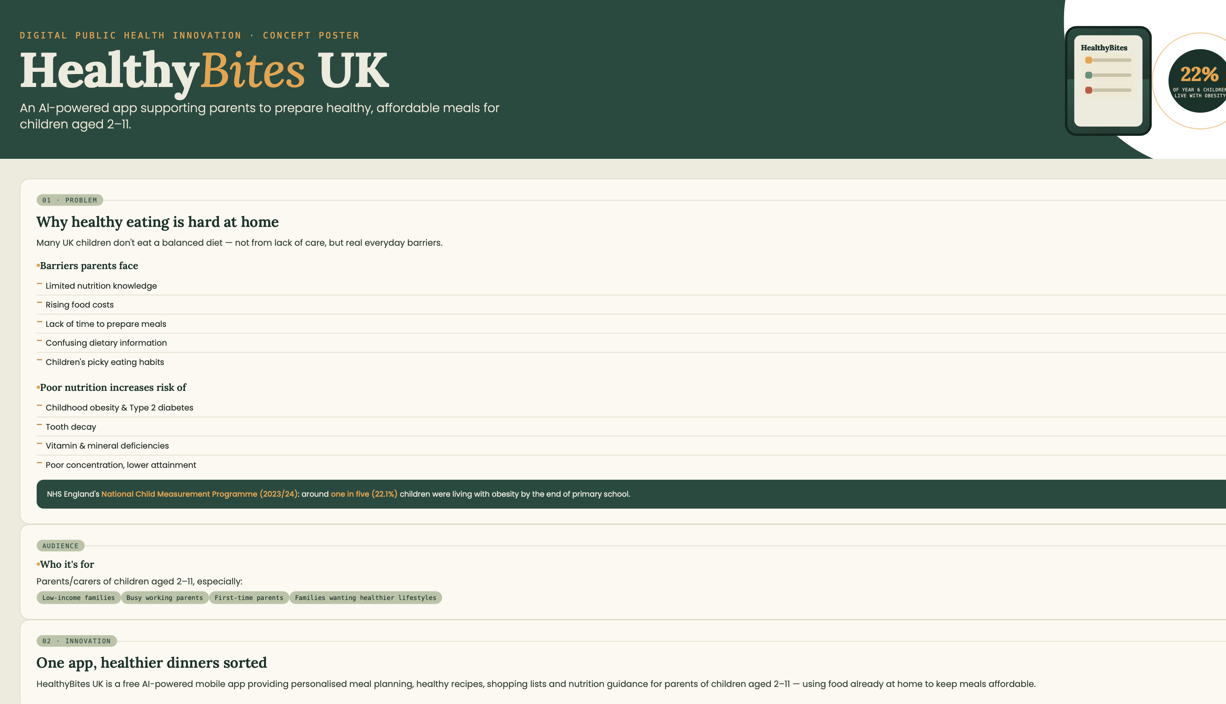
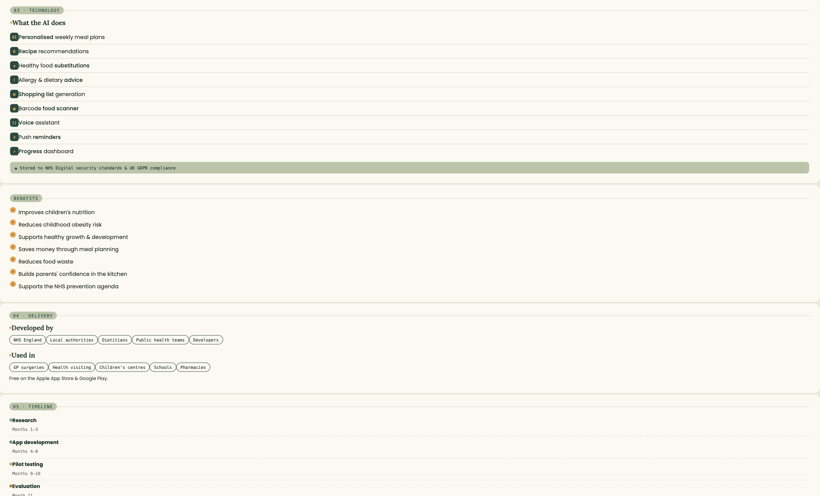
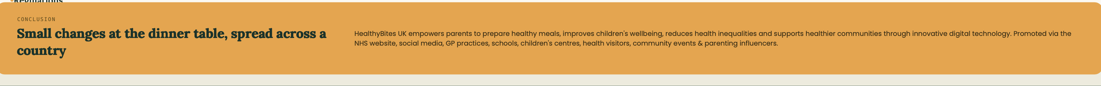

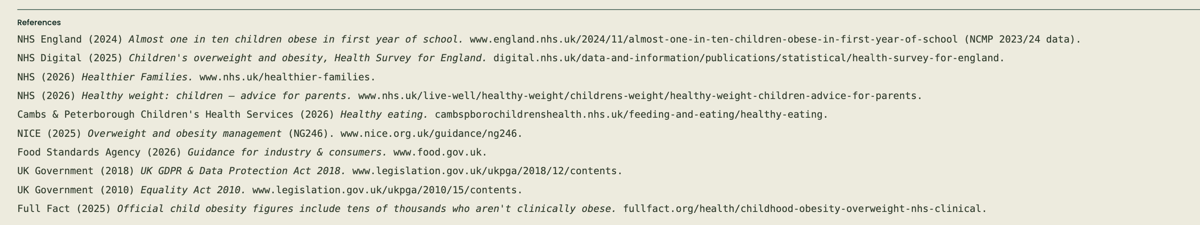

Written Pitch
HealthyBites UK: Supporting Parents to Build Healthier Futures

HealthyBites UK is an innovative artificial intelligence (AI)-powered mobile application designed to support parents and carers in preparing healthy, affordable meals for children aged between two and eleven years. Good nutrition during childhood is essential for healthy growth, brain development, immune function and long-term wellbeing. However, many families across the UK face barriers to preparing healthy meals, including rising food prices, lack of time, limited nutritional knowledge and confusing health information. These challenges contribute to increasing rates of childhood obesity and health inequalities.

The NHS identifies childhood obesity as one of the greatest public health challenges in England. Children living with obesity are more likely to experience physical health conditions including type 2 diabetes, hypertension and cardiovascular disease later in life. They are also at greater risk of experiencing low self-esteem, anxiety and social exclusion. Preventative interventions that support healthy eating within families are therefore essential.

HealthyBites UK addresses these challenges by providing parents with personalised nutritional support through an accessible and user-friendly digital platform. Using artificial intelligence, the application generates weekly meal plans based on the child's age, dietary requirements, allergies, cultural preferences and family budget. Parents receive healthy recipe suggestions using ingredients already available in their homes, helping reduce food waste while encouraging balanced nutrition.

The application also includes an intelligent shopping list generator that identifies affordable supermarket options and healthier alternatives to processed foods. A barcode scanner enables parents to compare food products and understand nutritional information using simple traffic-light labelling. Push notifications provide reminders for meal preparation, hydration and healthy lunchbox ideas, encouraging positive behavioural changes.

One of the most innovative features is the AI nutrition coach, which answers parents' questions about healthy eating using evidence-based advice developed by registered dietitians and aligned with NHS guidance. The application also offers recipes suitable for children with allergies, vegetarian diets and cultural dietary preferences, ensuring inclusivity across diverse communities.

The primary target audience includes parents and carers of children aged between two and eleven years, particularly families living in deprived communities where food insecurity and childhood obesity are more prevalent. Busy working parents, first-time parents and families seeking practical nutritional support will particularly benefit from the application. By improving nutritional knowledge and confidence, HealthyBites UK aims to empower families to make healthier food choices independently.

Implementation would involve collaboration between NHS England, local authorities, public health departments, registered dietitians, software developers and educational settings. The application could be introduced through health visitors, GP practices, schools, children's centres and community pharmacies. Healthcare professionals could recommend the app during routine child development reviews, school health programmes and healthy weight initiatives.

Technology plays a central role in the success of HealthyBites UK. Artificial intelligence allows meal recommendations to adapt continuously according to user preferences, previous meals and nutritional goals. Secure cloud technology enables safe storage of personal information, while encryption and authentication systems protect sensitive data. The application would comply with the UK General Data Protection Regulation (UK GDPR), the Data Protection Act 2018 and NHS Digital standards to ensure confidentiality and cybersecurity.

The development process would follow a structured twelve-month implementation plan. The first three months would involve stakeholder consultation and user research with parents, dietitians and public health professionals. Months four to eight would focus on software development, AI integration and user interface design. Pilot testing would take place during months nine and ten across selected NHS trusts and schools. Feedback collected from users would inform improvements before national rollout during month twelve.

Promotion of HealthyBites UK would involve a comprehensive public health campaign using both digital and community-based approaches. The application would be promoted through NHS websites, GP surgeries, schools, health visitor services, community centres and social media platforms. Partnerships with parenting organisations, supermarkets and children's charities would increase public awareness and encourage widespread adoption. Educational videos, webinars and local healthy eating workshops could further support engagement.

The innovation aligns with several UK policies and professional standards. It supports the NHS Long Term Plan by promoting prevention and reducing health inequalities through early intervention. It contributes to the Government Childhood Obesity Strategy by encouraging healthier dietary behaviours among families. The application also reflects NICE guidance on obesity prevention and behaviour change interventions by providing evidence-based nutritional advice and encouraging sustainable lifestyle improvements. Compliance with the Equality Act 2010 ensures that the application remains accessible and inclusive for diverse populations.

The wider benefits extend beyond improving children's diets. Better nutrition supports cognitive development, educational achievement and emotional wellbeing while reducing long-term demand on NHS services associated with obesity-related illness. Families may also experience financial savings through reduced food waste and improved meal planning. From a societal perspective, investing in preventative digital health innovations such as HealthyBites UK contributes to healthier communities and a more sustainable healthcare system.

In conclusion, HealthyBites UK represents an innovative, evidence-based digital solution that addresses an important public health issue. By combining artificial intelligence, personalised nutritional guidance and accessible technology, the application empowers parents to prepare healthier meals while supporting children's physical and emotional wellbeing. Through partnership with healthcare professionals, schools and community organisations, HealthyBites UK has the potential to improve public health outcomes, reduce inequalities and contribute to healthier future generations.

References

Department of Health and Social Care (2019) Advancing our health: prevention in the 2020s. London: DHSC.
Food Standards Agency (2023) The Eatwell Guide. London: Food Standards Agency.
HM Government (2018) Data Protection Act 2018. London: The Stationery Office.
National Health Service (2023) Advice for parents of healthy-weight children. Available at: https://www.nhs.uk/live-well/healthy-weight/childrens-weight/healthy-weight-children-advice-for-parents/ (Accessed: 29 July 2026).
National Health Service (2025) Eating a balanced diet. Available at: https://www.nhs.uk/live-well/eat-well/how-to-eat-a-balanced-diet/eating-a-balanced-diet/ (Accessed: 29 July 2026).
National Institute for Health and Care Excellence (NICE) (2015) Obesity: identification, assessment and management (CG189). London: NICE.
NHS England (2019) The NHS Long Term Plan. London: NHS England.
NHS England (2025) Childhood obesity. Available at: https://www.nhs.uk (Accessed: 29 July 2026).
Office for Health Improvement and Disparities (2024) Child obesity profile. London: OHID.
UK Government (2010) Equality Act 2010. London: The Stationery Office.

