Constantin Ovidiu Strinu (2321711)



Predicting and Understanding Customer Churn
A Data Mining Analysis of the Online Retail Customer Churn Dataset
Module: ACCA6026 - Data Warehousing & Data Mining Assignment: Component 2 - Data Mining Lecturer: Rajeev Nath
Table of Contents
Introduction 2
1. Purpose and Practice of Data Mining 3
2. Dataset Description and Exploration 3
3. Data Pre-processing and Post-processing 8
4. Sample Runs and Analysis Methods 9
5. Business Recommendation 13
6. Reflective commentary 14
Conclusion 15
References 16

Figure 1 - Dataset attributes 4
Figure 2 - Churn Donut 4
Figure 3 - Churn by Gender 5
Figure 4 - Churn by Promo 5
Figure 5 - Distributions of six key numeric attributes 6
Figure 6 - Boxplots of key behavioural attributes, churned vs retained customers 7
Figure 7 - Correlation matrix of numeric attributes, including Target_Churn 7
Figure 8 - Weighted-average classifier performance, 10-fold cross-validation 10
Figure 9 - Confusion matrices for the three classifiers (10-fold cross-validation) 11
Figure 10 - SimpleKMeans cluster centroids (k=2), rescaled for a common axis 13

Introduction
Customer churn means loss of paying customers either through inactivity or to a competitor and is therefore one of the most immediate revenue threats in online retail since acquiring a replacement customer usually costs much more than keeping an existing one [1]. This case report responds to the Online Retail Customer Churn Dataset, 1,000 customers described by demographic and spending and engagement attributes for churn prediction to help identify behavioural segments that could benefit from targeted retention approaches. The data was analysed in Weka, using 10-fold cross-validation throughout, and results are presented as transparently as possible, including where models did not support the predictive claims a less rigorous analysis might have been tempted to make.

1. Purpose and Practice of Data Mining
Data mining is the application of computational methods to large datasets to identify patterns that can support decision-making, typically as part of the iterative Knowledge Discovery in Databases (KDD) process of selection, pre-processing, transformation, mining, and interpretation [1]. In this context, classification techniques learn from historical customer records to predict an unseen outcome, here whether a customer will churn, while clustering techniques group customers by behavioural similarity without specifying an outcome in advance, which may reveal a segment that a marketing team would not have defined manually.
Both of those apps serve as decision support, rather than as a replacement. Even a moderately predictively strong churn classifier enables a retailer to focus retention spend on customers who are genuinely at risk rather than bothering the entire base, and this is important because even small improvements in retention tend to be disproportionately value-accretive: Reichheld and Sasser's classic finding that a five-percentage-point improvement in retention can drive 25–95% of profit uplift [2] remains the go-to justification for this kind of investment. Segmentation has, in turn, supported differentiated marketing, the ability to tailor the offer, the channel and even the tone of communication to how a customer behaves instead of treating the whole customer base as homogenous. As discussed further in this paper, a large body of published churn-prediction research in related fields such as telecoms verifies that both branches (supervised prediction and unsupervised segmentation) are standard parts of the customer-analytics pipeline, complementary rather than alternative approaches, and that success depends largely on whether the available attributes actually capture behaviour explaining churn for that specific business, answering this question empirically with data from the retailer instead of assuming a yes answer in advance [3].

2. Dataset Description and Exploration
The dataset comprises of 1,000 customers and 15 attributes. Customer_ID is a unique variable followed by ten numeric variables, three nominal variables namely Gender, Email_Opt_In and Promotion_Response along with the binary Target_Churn. There were no missing values or duplicate Customer_IDs found in Weka Explorer, so there was nothing to repair before modelling [4].
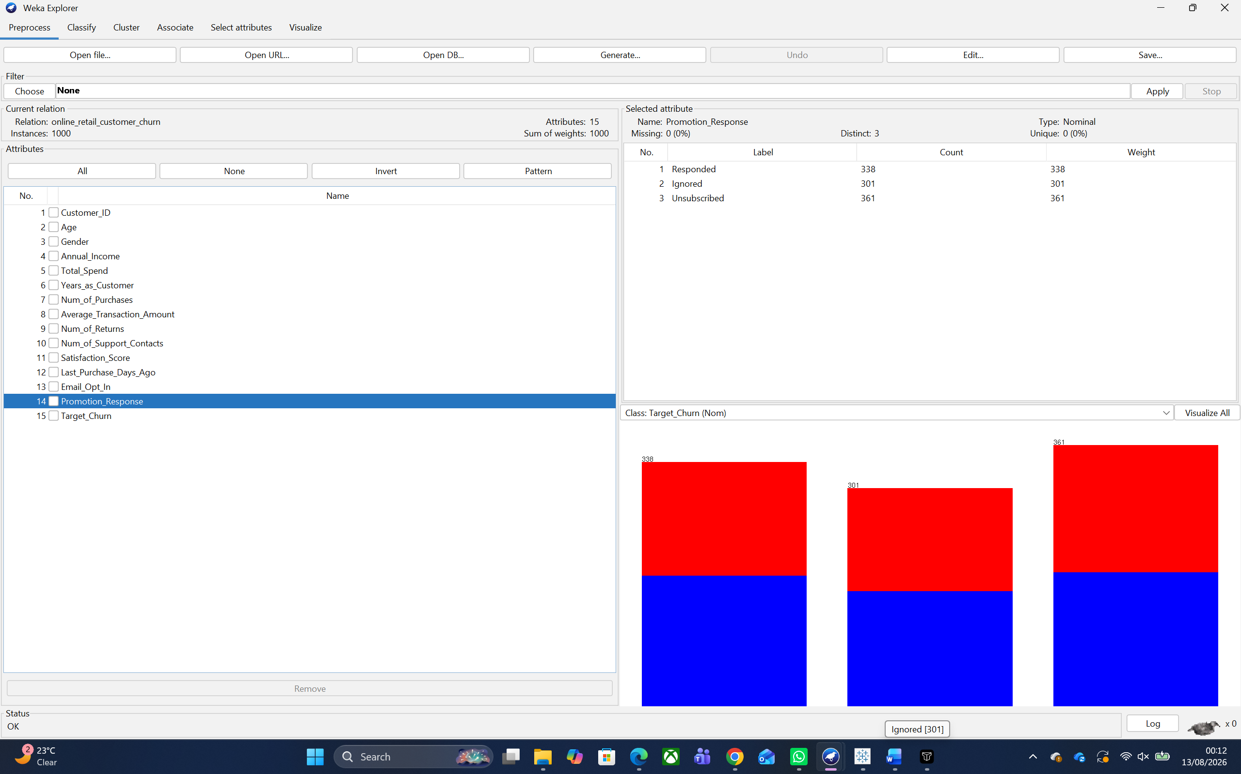
Figure 1 - Dataset attributes
Customers had an age range of 18–69 (mean 43.3), mean annual income £112.0k, and mean total spend £5,081. As shown in Figure 2, the target classes contain almost equal churned and retained class instances (52.6% churned and 47.4% retained). Churn rate does not differ very much as per Gender or Promotion_Response so these variables will have a lower predictive value.
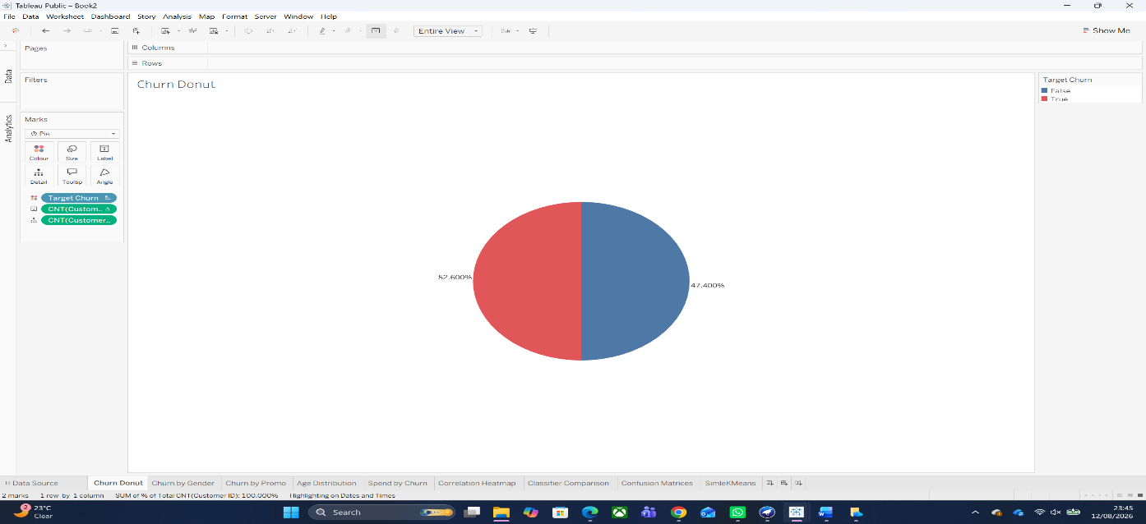
Figure 2 - Churn Donut
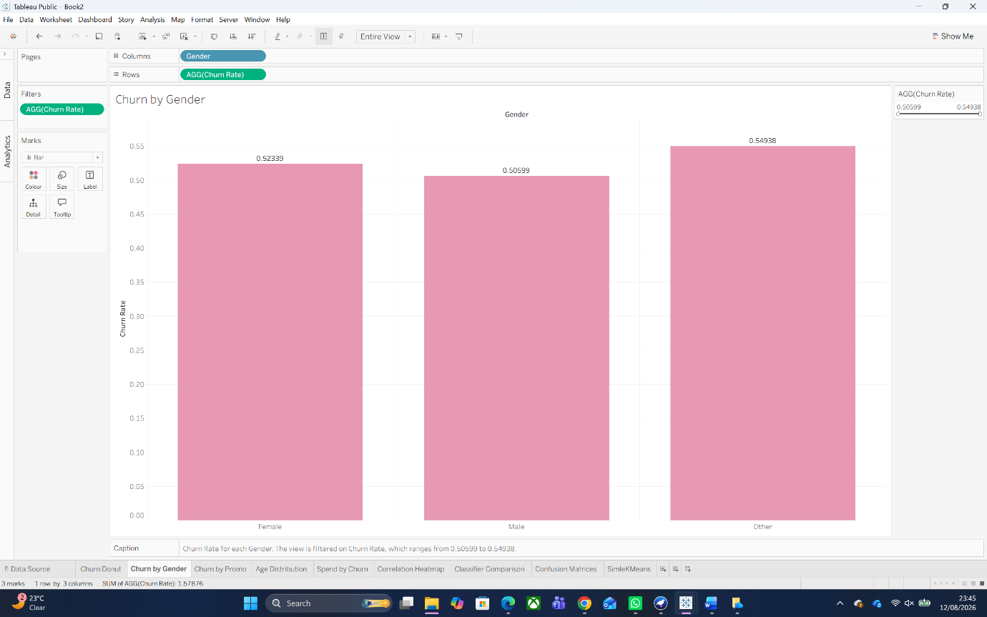
Figure 3 - Churn by Gender
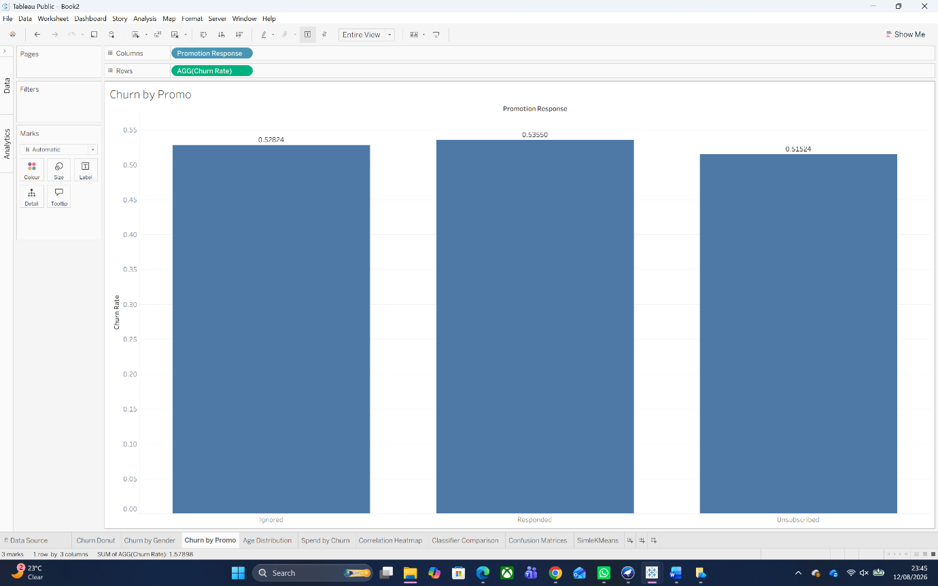
Figure 4 - Churn by Promo
The final main takeaways from the Numeric Attributes graph (Figure 5) are that, almost without exception, its numeric attributes sound like they have been drawn uniformly and more or less evenly across their stated ranges, including Satisfaction_Score, which comprises five coarsely equal bands of customers at a rating between 180–220 each as opposed to clustering around some typical score(s); Such uniformity sits far closer to synthetically generated data than to a highly right-skewed real-world retail population typically observed for spend and recency in particular.
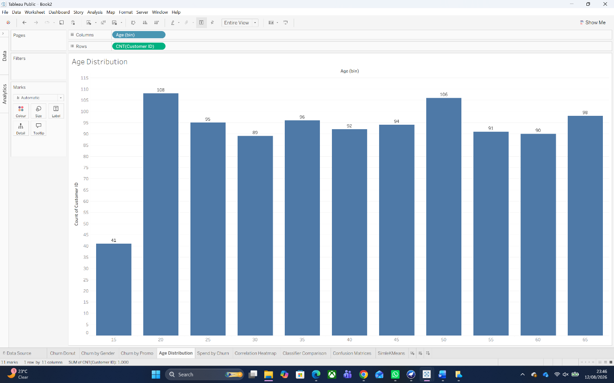
Figure 5 - Distributions of six key numeric attributes
In figure 6, we use boxplots to compare four behavioural variables between churned and retained customers, Total_Spend, Satisfaction_Score, Last_Purchase_Days_Ago, Num_of_Support_Contacts: The median, interquartile range and whiskers are visually almost identical between the two groups on every variable; this foreshadows the classification difficulty explored in section 4.
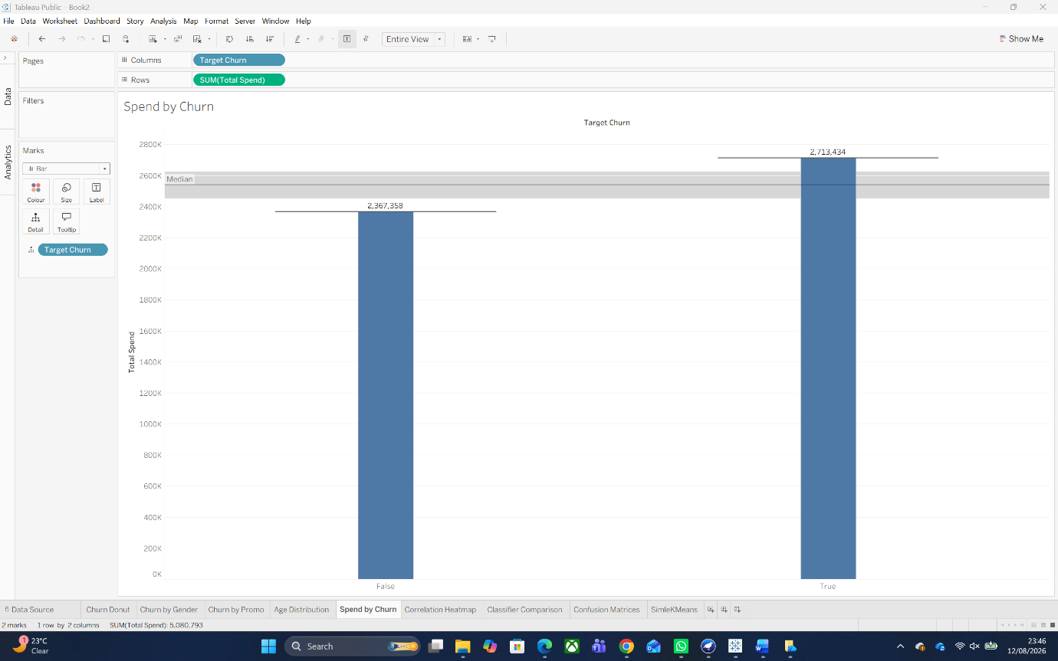
Figure 6 - Boxplots of key behavioural attributes, churned vs retained customers
In the full correlation matrix of these ten numeric attributes, including Target_Churn, we quantitatively substantiated this in Figure 7. Each numeric attribute below indicates that they all share weak correlations with Target_Churn at |0.09| or lower, indicating that no single individual numeric attribute has a meaningful linear relationship with churn. This result sheds light on the large overlap observed in the boxplots and forewarns of the classification confusion discussed in Section 4.
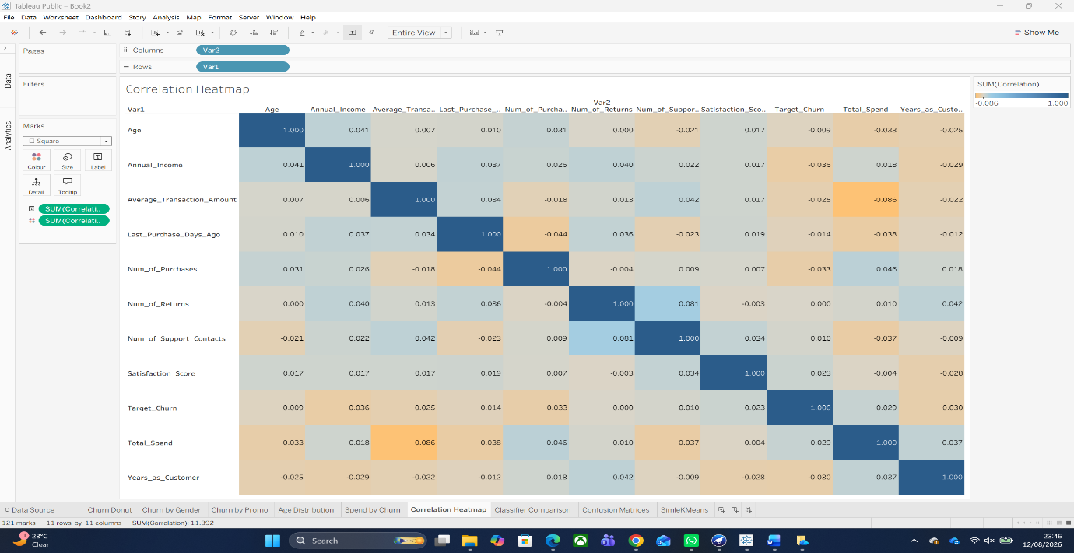
Figure 7 - Correlation matrix of numeric attributes, including Target_Churn
When modelling, good practice necessitates that there be an answer to this question before building a model: is this data, as it has been supplied, able to speak back to the business problem? Thus, the exploration stage answers such a question before it exists. The evidence here is "no" for the task of classification, a conclusion that has been formally evaluated and shown to be correct in 4.

3. Data Pre-processing and Post-processing
Overseeing missing values: none were required. Weka's Preprocess panel confirmed zero nulls across all 1,000 instances, so no imputation, listwise deletion, or missing-indicator flag was necessary (this was verified rather than assumed; undetected missingness would invalidate the cross-validation below), and this cleanliness is itself a further sign of the dataset's synthetic nature (not discussed further until Section 6).
Encoding categorical variables, Gender and Promotion_Response were kept as native Weka nominal attributes since J48 and RandomForest splits on nominal attributes directly without one-hot encoding; a dummy-encoding step performed manually by hand was not necessary for Logistic since Weka's Logistic classifier internally executes its own NominalToBinary transform automatically during training. Email_Opt_In and Target_Churn are kept True/False in source CSV but recoded as Yes/No before export to ARFF for cosmetic clarity of results from the model; this is a transformation which does not affect the learned model. Thus Customer_ID was entirely removed before modelling, being a unique identifier providing no generalisable signal and while the splitting on it by tree-based learners will in practice work to extreme depth, leaving near-unique keys in the training set runs the risk of overfitting split points not based on useful structure but based solely upon row order.
Balancing the dataset: target is only slightly imbalanced (52.6/47.4) and so well within a region typically considered safe without resampling; synthetic oversampling techniques such as SMOTE are recommended specifically for skews far more severe than this, where otherwise a naive classifier could achieve high accuracy simply by predicting the majority class every time [5]. Here, that particular failure mode is not present (the majority class in fact contributes only 52.6% of instances, so always predicting it barely beats chance), hence applying SMOTE would have injected variance into the estimates through synthetic interpolation without addressing a genuine concern and was therefore purposely avoided; see also Section 4, where the 52.6% baseline turns out to matter for a different reason entirely.
Feature selection or engineering: the correlation matrix (Figure 7) was used as the feature-selection tool, and it argued against removing any attribute, since the strongest individual predictor of churn correlates at only 0.09, no attribute could safely be deemed “clearly irrelevant” relative to the others; hence all ten numeric attributes and the two behavioural nominal attributes were retained. We did not add any additional engineered features (ratios, bins, or interaction terms): with every raw attribute already carrying negligible individual signal, a combined feature was judged more likely to overfit on noise than to reveal a genuine interaction. Outlier screening via the boxplots found no extreme values requiring capping; the wide interquartile ranges reflect the dataset's uniform distributions rather than genuine outliers.
Post-processing: Weka's output (confusion matrices, Detailed Accuracy By Class tables, cluster centroid tables) was exported and re-visualised in Tableau as grouped bar charts and heatmaps so that the management audience this report is aimed at could compare classifiers and clusters side by side rather than having to comprehend raw text output, and by doing so model comparison did not depend solely on accuracy: Cohen's Kappa - which corrects for chance agreement which accuracy does not, meaning it proved crucial in interpreting the results below[6]- was calculated automatically by Weka with every run. And finally, those two SimpleKMeans clusters had been translated from numeric centroids into distinct named, plain-language personas (“Responsive Loyalists,” “Quiet High-Spenders”) as a last step of post-processing since just a table of centroid values is not actionable by a retailer manager.

4. Sample Runs and Analysis Methods
In Weka, three classifiers were executed with 10-fold stratified cross-validation (the protocol standard for an estimate of accuracy without a separate holdout [7]) selected to cover three different types of modelling philosophy and used such that a weak result from one could be checked against sufficiently dissimilar mechanisms. J48 (Weka implementation of Quinlan's C4.5) was selected as an interpretable, rule-based baseline that outputs a human-readable tree directly usable by staff without technical expertise [8]. Specifically, logistic regression was selected as a common linear, probabilistic baseline commonly adopted in industry churn scoring because the coefficients are interpretable as odds ratios [9]. This paired RandomForest, Breiman's bagged-tree ensemble method [10], with the assertion that among the three it was most likely to detect any relatively low dimensional non-linear signal the other two would miss, such ensembles of this sort being consistently among the best-tested general-purpose classifiers available, based on large independent benchmark studies [11].
Figures 8 and 9 show the weighted-average statistics output by Weka, and Table 1 collates the same figures alongside the majority-class baseline for a direct comparison.
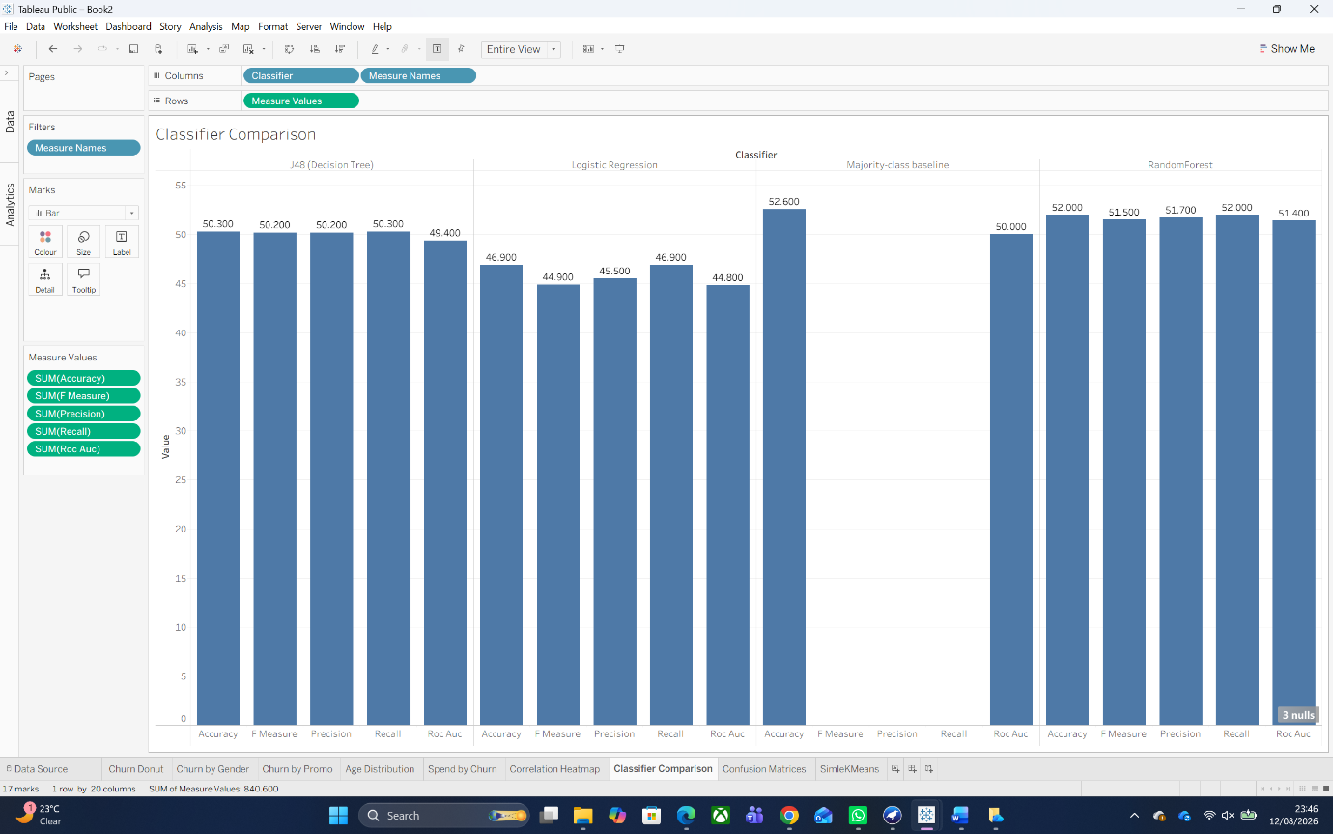
Figure 8 - Weighted-average classifier performance, 10-fold cross-validation

Figure 9 - Confusion matrices for the three classifiers (10-fold cross-validation)
Classifier | Accuracy | Precision | Recall | F-Measure | ROC Area (AUC) | Kappa
Logistic Regression | 46.9% | 0.455 | 0.469 | 0.449 | 0.448 | -0.083
J48 (Decision Tree) | 50.3% | 0.502 | 0.503 | 0.502 | 0.494 | 0.001
RandomForest | 52.0% | 0.517 | 0.520 | 0.515 | 0.514 | 0.030
Majority-class baseline | 52.6% | - | - | - | 0.500 | 0.000
Table 1 - Classifier comparison, 10-fold cross-validation, against the majority-class baseline

Logistic Regression achieved 46.9% accuracy, with a Kappa of −0.083 and ROC Area of 0.448. Its accuracy fell below the 52.6% majority-class baseline, while the near-zero negative Kappa and sub-0.5 ROC Area indicates that the model provides no useful discriminatory ability for churn prediction on this dataset. The measured coefficients help explain this result: the odds ratio for each predictor is clustered a few percentage points from 1.0 (Satisfaction_Score 1.036, Promotion_Response=Unsubscribed 0.965, Num_of_Support_Contacts 1.017) meaning that the model did not identify any quality whose presence moves the odds of churn meaningfully in one direction or another. The J48 classifier achieved 50.3% accuracy (Kappa 0.001, ROC Area 0.494), statistically indistinguishable from chance and analysing the model explains this; its pruned tree still has 148 leaves and 285 nodes for just a thousand training instances and its root split is on Gender, an attribute that Figure 7 showed only barely correlates with churn at ~0.01. This is the sort of textbook symptom of a tree hunting for information gain among noise: J48 has an entropy-based splitting criterion and therefore cannot split with regard to some non-existent signal, so it finds and reports whatever spurious split minimises training-set impurity before failing to generalise, the classic overfitting pattern as reflected in the confusion matrix and echoed by cross-validated Kappa. Of the three classifiers, RandomForest, an ensemble of 100 bagged trees, delivered the strongest performance, unsurprising given its reputation for extracting weak signal from a noisy dataset [11], but at those levels (52.0% accuracy, Kappa 0.030, ROC Area 0.514) it remains a negligible effect size, not a usable model. Crucially, this baseline of predicting “churned” for every customer would score 52.6% accuracy: none of the three trained classifiers even surpassed that trivial baseline. Aggregated with the low-to-no correlations already discovered in Section 2, the honest conclusion is that this feature set does not have useful churn signal, and not that there was something wrong with modelling.
Segmentation used SimpleKMeans with Euclidean distance and k=2 (Weka's default, and a reasonable starting point given the modest instance count), run on the clustering-only ARFF with Target_Churn excluded entirely so the segments reflect behaviour rather than the label being predicted [12]. Gender and Promotion_Response were nominal attributes in the distance calculation, whereas Email_Opt_In was excluded to keep the segmentation focused on spending and engagement rather than a simple binary marketing-consent flag. The 2 resulting segments are shown in figure 10.

Figure 10 - SimpleKMeans cluster centroids (k=2), rescaled for a common axis
Cluster 0 (506 customers,51%), which we have named here "Responsive Loyalists", focuses on an older average customer (47.9 years), higher satisfaction (3.06/5), more recency purchasing (177 days since last order) and a Promotion_Response mode of "Responded". Cluster 1 (494 customers, 49%), “Quiet High-Spenders”, is younger on average (38.5 years) and spends marginally more in total (£5,170 vs £4,993), but reports lower satisfaction (2.89/5), less recent activity (189 days since last order) and a Promotion_Response mode of “Unsubscribed”. Importantly, churn was almost equally split within both clusters (consistent with the finding shown in Figure 2 that churn hardly varies by any single attribute), therefore these clusters should not be interpreted as a churn-risk segmentation; they are however a much more actionable and interpretable output of this analysis than the churn classifiers, since a marketing team can plan separate campaigns targeting each persona even if their actual risk of churning is the same.

5. Business Recommendation
None of the three models perform better than the trivial baseline of assuming every customer is about to churn, meaning no retention system based on this attribute set could be responsibly deployed; in Logistic Regression's case, its negative Kappa means it is actively worse than doing nothing at all — it would directly mis-target retention spend. Hence the first suggestion is to stop automated churn scoring on these attributes and invest in richer behavioural data, browsing & cart-abandonment events, email opens and clicks, competitor price exposure etc., before trying again at classification, given that the current fields (predominantly static demographic or lifetime-aggregate statistics) evidently do not hold whatever it is that gets a customer to leave.
The segmentation results, however, are immediately actionable. The clearest re-engagement opportunity identified through segmentation is the “Quiet High-Spenders (49% of the base, £5,170 average spend, but unsubscribed from marketing), and a re-engagement campaign via a non-email channel–an SMS or on-site offer–targeted specifically to this segment could recover marketing reach to nearly half the customer base currently receiving no promotional contact at all. “Responsive Loyalists” should instead receive a loyalty or referral programme that reinforces already-positive engagement rather than an unnecessary win-back offer. Last but not least, given how weak each individual attribute turned out to be, this budget should be divided up and used as funding for a small A/B-tested retention offer for the random sample of customers selected here, with continued tracking of data, rather than just committing all that expenditure into targeting based on models which this analysis cannot yet support.

6. Reflective commentary
The key takeaway is that a bad predictive data can never be compensated with an improved algorithm. While satisfaction, purchase recency and support contacts seemed at first likely candidates for predicting churn, an exploratory analysis and all three classifiers suggested otherwise.
Baseline comparisons between Logistic Regression, J48 and RandomForest also reiterated the importance of using appropriate baselines. The best performing model was RandomForest, but still not even beating the 52.6% majority-class baseline, which makes a case for looking at accuracy along with Kappa and ROC Area. But SimpleKMeans was still able to discover two meaningful behavioural segments. That thus indicated that simply failing at a prediction task does not mean that the general analysis fails, and that conclusions should be determined by the data.

Conclusion
This analysis aimed to predict churn and segment customers based on behaviour. It succeeded at the second and on the evidence collected could not honestly claim to succeed at the first: three classifiers over three different modelling approaches all agreed on this outcome, none exceeded the trivial majority-class baseline of 52.6%, a real finding about properties of this dataset rather than a failure of method. In comparison, outcome-led analysis with SimpleKMeans clustering yielded two well-defined and actionable customer segments (“Responsive Loyalists” and “Quiet High-Spenders”), the basis for a core finding of this report that retention effort be redirected away from a churn-scoring model which is not yet supported by this data set, toward evidence-based segmentation and A/B-tested offers, while building with higher resolution behavioural data in order to revisit classification.

References
[1] U. Fayyad, G. Piatetsky-Shapiro, and P. Smyth, “From data mining to knowledge discovery in databases,” AI Magazine, vol. 17, no. 3, pp. 37–54, 1996.
[2] F. F. Reichheld and W. E. Sasser Jr., “Zero defections: Quality comes to services,” Harvard Business Review, vol. 68, no. 5, pp. 105–111, 1990.
[3] A. K. Ahmad, A. Jafar, and K. Aljoumaa, “Customer churn prediction in telecom using machine learning in big data platform,” Journal of Big Data, vol. 6, no. 28, 2019.
[4] I. H. Witten, E. Frank, M. A. Hall, and C. J. Pal, Data Mining: Practical Machine Learning Tools and Techniques, 4th ed. Cambridge, MA, USA: Morgan Kaufmann, 2016.
[5] N. V. Chawla, K. W. Bowyer, L. O. Hall, and W. P. Kegelmeyer, “SMOTE: Synthetic minority over-sampling technique,” Journal of Artificial Intelligence Research, vol. 16, pp. 321–357, 2002.
[6] J. Cohen, “A coefficient of agreement for nominal scales,” Educational and Psychological Measurement, vol. 20, no. 1, pp. 37–46, 1960.
[7] R. Kohavi, “A study of cross-validation and bootstrap for accuracy estimation and model selection,” in Proc. 14th Int. Joint Conf. on Artificial Intelligence (IJCAI), 1995, pp. 1137–1143.
[8] J. R. Quinlan, C4.5: Programs for Machine Learning. San Mateo, CA, USA: Morgan Kaufmann, 1993.
[9] D. W. Hosmer Jr., S. Lemeshow, and R. X. Sturdivant, Applied Logistic Regression, 3rd ed. Hoboken, NJ, USA: Wiley, 2013.
[10] L. Breiman, “Random forests,” Machine Learning, vol. 45, no. 1, pp. 5–32, 2001.
[11] M. Fernández-Delgado, E. Cernadas, S. Barro, and D. Amorim, “Do we need hundreds of classifiers to solve real world classification problems?” Journal of Machine Learning Research, vol. 15, pp. 3133–3181, 2014.
[12] A. K. Jain, “Data clustering: 50 years beyond K-means,” Pattern Recognition Letters, vol. 31, no. 8, pp. 651–666, 2010.

