  Define evidence based policing: PROVIDE A COMPREHENSIVE DEFINITION OF EVIDENCE BASED POLICINGAND EXPLAIN ITS KEY PRINCIPLES. HIGHLIGHT HOW THE EVIDENCE BASED APPROACHES DIFFER FROM TRADITIONAL POLICING METHODS. | 2310510  BMCP4000  Tim Nicholas  Evidence Based Policing

In this assignment we will be looking into what evidence-based policing is, how it is used and why it is more beneficial and universal compared to older traditional policing methods. There has been a push for evidence-based policing in recent times due to its effectiveness and the ability to more effectively measure and correlate its data. There is not one single definition of this concept, it generally refers to the strategies, models and tactics the police will use, they are then subject to experiments and research to find out if the tactic or particular strategy actually works. The best evidence uses research methods fit for the questions to be answered.
Bullock et al, (2022) Suggests that the overall goal of policing is to prevent crime, stopping crime before it happens. Problem oriented policing or (POP) as well as (EBP) both conceive research broadly but (EBP) is more associated with experimentation when compared to (POP) the perception is there will be more scientific rigour in terms of (EBP). Evidence Based Policing differs from traditional policing practices or (POP) described as problem-oriented policing and is instead a form of (EBP), suggesting that when (POP) is used properly, it can also reduce the amount of crime, this can be called an evidence-based response to tackling crime problems Bullock, Erol, and Tilley, (2006). The language of problem-oriented policing correlates with that of evidence-based practice, they both have a focus on how effective it is at reducing the problems, when focused on the issues that are of concern to the community in question. (POP) and (EBP) are not the same, whereas (POP) is a model aimed at improving the police as an organisation and is much wider in its scope Bullock, Erol, and Tilley, (2006) (EBP) is based on the best evidence available at the time as said by Sherman, L (1998).
(POP) policing tends to be more problem specific with more emphasis on creativity and policing as a craft and context is very important. (EBP) tends to be a little more generic with universal solutions in mind, higher concentration on the science and evidence Cordner, G (2017). The types of evidence used are primary and secondary, the Healy Library (2023) states primary evidence sources are the immediate accounts on a particular event, from people with a direct connection to it such as; written laws or reports of witnessed events. The Healy Library (2023) defines secondary evidence as one step removed from primary sources. The same topic can be covered but it is added with some interpretation, examples of these sources are; data analysis or articles about a topic by someone not directly involved.
Evidence is what is used for the police when making important decisions, the college of policing (2014) states that to help the police with their decision making and to try and get a more universal approach, it has adopted a single national decision model (NDM). The core of this, is the code of ethics for all decision making, this model encourages police staff to act in accordance which in turn brings into balance threat and risk. (NDM) is a model not built on any bias, at its core is the code of ethics, there is a recognition that police need to be consistent in their decision making and enhancing discretion and judgement. This balances the demand put onto policing services with very limited resources as stated by police professional (2023). Implicit Bias and Policing (2016) finds bias is discrimination towards a particular group, research repeatedly shows discrimination of this type is found across all of policing. Bias can operate outside of our conscious awareness but can still influence us in our decisions and behaviour. There is ongoing research looking into areas such as intergroup contact and adjusting policing policies and updated training.
The (NDM) model created by (ACPO) is more of an update than a replacement of another decision-making model called the conflict management model (CMM) the beauty of (NDM) is it can be used across the board, in any type of situation as said in Interoperability of the National Decision-Making Model (2017). When using (NDM) the first step is to gather information, which moves onto risk assessment and develop a strategy, then it is time to consider the procedures and what you have the power to do, it’s then identifying your options and lastly taking action and reviewing the outcome as shown in the illustration below.

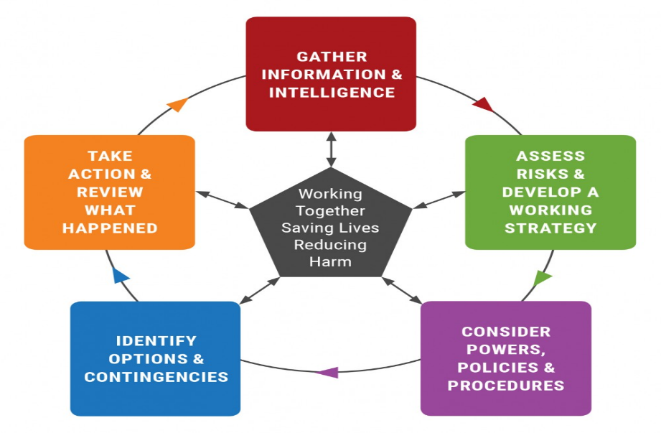

The most valuable part of this process is being able to evaluate the processes being used, also using this research to make better decisions in the future. College of policing (2023) states that research can be used for a better understanding of a particular issue; this works by describing the nature and the cause of the problems and how the changes were implemented. The impact of initiatives are tested with the specific aim of adjusting policing practices, the research is carried out carefully and peer reviewed, keeping in mind the importance of transparency of its methods and conclusions. This is called the (ATLAS) model and is designed specifically for police to question practices, learn and evaluate the existing framework and ideas, it stands for Ask, Test, Learn, Adapt, Share.
Some theories try to explain why crime happens as in the (RAT) or routine activity theory Wickert, C (2020) explains that the likelihood of a crime being committed is higher if the offender is a motivated one and their target looks in any way weak, the situation itself is more in play here than the offender. Cordner, G (2017) backs this with the (PAT) or problem analysis triangle, this provides a way of thinking about recurring crime, the idea assumes that disorder results when (1) likely offenders (2) suitable targets all meet together (3) in a particular area at the same time. This leads on to another tool police can use when assessing the risk by probability or likelihood against the severity of the consequence, using a risk matrix. Boers, D (2023) explains the use of a risk matrix is to have a simple process to assess the risks of a situation across several categories, ranging from low to medium and then high risk. This is a helpful tool when used in a policing context where cost and resources are always limited.

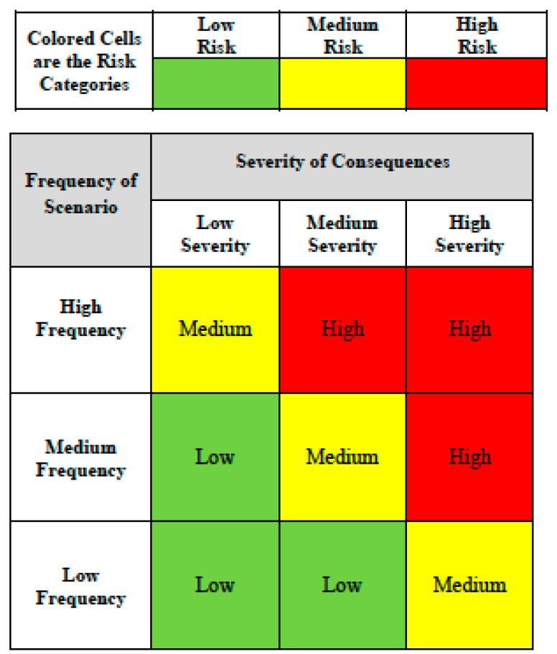
To conclude, both EBP and POP are important to policing, as they contribute to the essential framework that the police follow in order to complete their duties effectively and fairly. However, it is important to note that neither are a means to an end – rather, assist in delivering more favourable outcomes such as using research to enhance predictions of time and locations of crimes, and reducing bias. Despite this, the EBP approach encourages the police force to reflect, and question their practices in order to improve and adapt their practices. Therefore, the EBP approach could be considered the more progressive and useful tool. However, EBP and POP offer elements that aim to improve community relations and crime reduction which are complimentary of each other, and as a result should be utilised in such a way. Evidence is the cornerstone of everything in policing, continual improvement and research can only be a positive.

Bullock, K. Erol, R. Tilley, N Problem-oriented Policing and Partnership. Published2006 https://doi.org/10.4324/9781843926597

Bullock, k. Sidebottom, A. Armitage, R. Matthew, P. Ashby, J. Clemmow, C. Kirby, S. Police perceptions of problem-oriented policing and evidence-based policing: evidence from England and Wales. Pages 775-791 Published online: 08 Mar 2022 https://doi /10.1080/15614263.2022.2046568

Christian, W. Clarke, R. V. Tiley, N. Routine Activity Theory. Handbook of Crime Prevention and Community Safety (pp. 39-70). London: Routledge. URL: https://www.routledgehandbooks.com/doi/10.4324/9781843926146.ch3

Cordner, G. POP and Evidence Based Policing. https://popcenter.asu.edu/sites/default/files/pop_evidence_based_policing_gary_cordner.pdf

East Midlands Police Academic collaboration. Interoperability of the National Decision-Making Model. November 2017 https://www.empac.org.uk/interoperability-national-decision-making-model

Evidence-based policing (2023) https://www.college.police.uk/research/evidence-based-policing-EBP

Healy Library. Police professional https://www.policeprofessional.com/news/acpo-launches-decision-model-for-all-policing/

National Library of medicine. Public Health 2015, doi:10.3390/ijerph120809575

Sherman, W. Evidence-Based Policing https://www.policinginstitute.org/wp content/uploads/2015/06/Sherman-1998-Evidence-Based-Policing.pdf

Spencer, K. Amanda, K. Charbonneau, J. Social and Personality Psychology Compass. Volume 10, Issue 1 p. 50-63 Implicit Bias and Policing. Katherine B. Spencer, Amanda K. Charbonneau, Jack Glaser. published: 08 January 2016 https://doi.org/10.1111/spc3.12210

The Problem Analysis Triangle https://popcenter.asu.edu/content/problem-analysis-triangle-0

