James Holmson

P150037

Project Management

Sue Maw

27/04/2018

Table of Contents
Introduction 1
Risk 1
Project Risks 1
Risk Evaluation Matrix 2
Risk Management 3
Code of Practice 4
Environmental Impact 5
First Order 5
Second Order 6
Third Order 6
Ethical Issues 6
Code of Conduct IEEE/BCS 8
Quality Assurance 9
Conclusion 11
Reference List 12
Bibliography 14
Appendix 16

Table of Figures

Fig 1. The risk evaluation matrix for the Brynamman Cinema project....................2
Fig 2. ICT impacts on the environment [1]…………………………………………….5
Fig 3. The sources of power generated in the UK (2017) [2]………………………..5
Fig 4. Weaver’s [3] Waterfall Model………………………………………………..…10

Introduction
This report analyses three areas that were considered for the project completed for Brynamman Cinema. In the appendix, screenshots of the finished project have been provided including code excerpts.

Risk
Although issues may arise during a project, it is possible to reduce their implications by planning for these situations. Firstly, the potential risks are identified and outlined. Secondly, these are marked onto a ‘Probability Impact Matrix’ which provides a visual overview, as to which risks are most likely to occur and have the most significant impact. Finally, it is discussed how these risks can be managed throughout the timeframe of the project.

Project Risks
Each of the following risks to the project has been given a key R₁ through R₈ which in-turn will be marked onto the grid in the next section.
R₁ – Team member illness.
R₂ – Inadequate knowledge to complete the content of the website.
R₃ – Poor time management, including over or under allocation of time.
R₄ – Typographical errors in the content of the website.
R₅ – Incorrect information published online.
R_{6 –} Attempt to gold plate assignments leading to them overrunning.
R₇ – The loss of files pertaining to the end website.
R₈ – A fault is found on the website after launch.

Risk Evaluation Matrix
Figure 1 presents the likelihood of the risks occurring and the impact upon the project, should they occur. Anything above the tolerance line requires the most attention as these would have to be addressed foremostly.
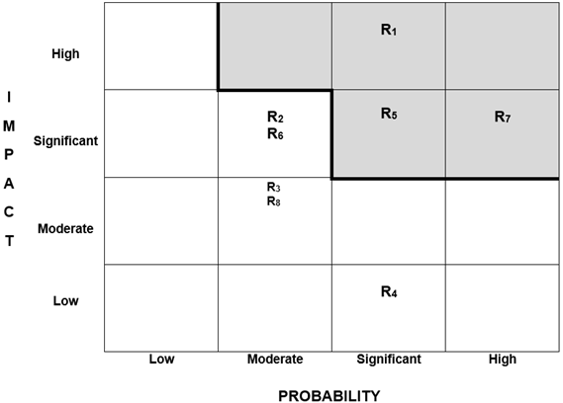
Tolerance Line

Fig 1. The risk evaluation matrix for the Brynamman Cinema project.

Risk Management
This section determines how the probability of the risk occurring was minimised, and how the impact was reduced.
R₁ (Significant, High) – Illness of any kind is impossible to predict, although perhaps during the winter month cold/flu and sickness bugs are more prevalent. For this project, coincidentally the author of the report contracted the flu and was actually incapacitated for over two weeks. Usually, in a group situation, the work could be re-distributed to other team members [4], although this was not possible due to the makeup of the team. Therefore, the alternative solution was to allocate extra time to finish the content, and where necessary days off were used [5].
R₂ (Moderate, Significant) – The lack of technical knowledge could lead to incomplete sections of the website, or sections that are not functioning [4]. Thus, to negate this from occurring, during the planning phase the site was designed not to be unnecessarily complex. Any areas where there was uncertainty were identified early, and the appropriate literature or university lecturers could be consulted to complete the required sections. Doing so meant any additional knowledge could be gain ahead of time, and if necessary the plans could be revised.
R₃ (Moderate, Moderate) – To achieve a balance of one’s time proves a challenge. There is little chance of completing the project by the specified date if underestimating and overestimating could reduce the quality of another assignment. The Project Initiation Document (PID) submitted, did not take into account the amount of time required for the other units. Newton [6] endorses breaking down projects into the individual tasks, and this was followed using a weekly planner and then hours could be allocated against each task. The PID over allocated time for this project, so using this method to realistically re-distribute the time.
R₄ (Significant, Low) – Any errors in spelling or punctuation, have the lowest impact on the business. However, by using Microsoft Word spelling checker and careful proofreading by the author and where possible by friends to provide a second opinion.
R₅ (Significant, Significant) – If information is published online, that is not factually correct this could lead to complaints or poor reviews, which in turn could result in the cinema losing custom. The film's description and so forth will come from the provider. However, if this project were to go live, the showing times would have to be signed off by the management of Brynamman Cinema.
R₆ (Moderate, Significant) – Spending too much time on specific sections of other assignments was a frequent occurrence. Primarily, as learning new skills is achieved through carrying out development work, and there is a desire to achieve the high grades. However,
R₇ (High, Significant) – A hard drive is a weak point of any computer, especially those with mechanical components that have a limited life-span [7]. During the project lifecycle, daily backups were made onto two physical drives including making copies to an external hard drive and USB flash drive, and they were also saved to cloud storage using Dropbox. It was also noted that files could become corrupted from malicious software [7]. Thus, virus protection software was implemented to minimise this threat.
R₈ (Moderate, Moderate) – Comprehensive software testing should reduce the likelihood of this problem occurring [8]. Plans were drawn up ahead of the development, and the tests were performed both during and after the development process.
In summary, the only risk to the project that materialised was illness over the Christmas holidays, fortunately as more than enough time was allocated this had no impact on the project’s completion.

Code of Practice
This section details an investigation into ensuring sustainability throughout the different areas of this project. It is documented that several organisations offer membership for individuals working in the computing industry. The guidelines produced should increase standards of developers and offer assurances to the customer that work they request will be delivered to the standard they require and in a professional manner. Thus, these standards will be analysed to demonstrate how they can assist with any project.

Environmental Impact
This section examines first, second and third order effects to the environment in the context of the case study, and in the table below Shaw et al. [1] classify the positive and negative impacts of each.
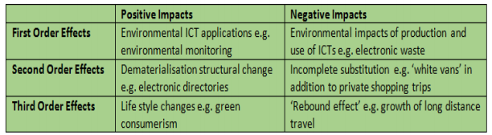
Fig 2. ICT impacts on the environment [1].

First Order
The use of any IT hardware requires power from the national grid, although there is a trend away from using coal and oil in the UK, a large percentage of this power still comes from non-renewable sources. In figure 2 the recent statistics from the Department for Business, Energy & Industrial Strategy are presented by Vaughan [2].
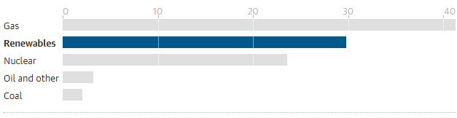
Fig 3. The sources of power generated in the UK (2017) [2].

Consequently, every time a PC is used there is a further burden on these resources. For this project, a laptop was used, and it was noted that these types of computers designed for optimal battery life [9]. Therefore, the settings were adjusted for minimum power consumption which involves reducing brightness and reducing performance [10].

The other immediately apparent problem comes at the end of a PC lifecycle, this is known as electronic waste or e-waste. When a computer is recycled, it is usually transported abroad, and many components are made from materials that are harmful to the environment [11]. However, no new hardware was recommended for this case study, the only consideration is website hosting, which could be implemented using cloud-based services.

Second Order
Conversely, IT can assist with helping the environment, as technology has brought about many changes; particularly to how we communicate. The primary example of this is video conferencing, which cuts down on travel as individuals are not required to be there in person. Shaw et al. [1] estimate that around “21% of the UK’s domestic carbon emissions” comes from work-related travel. Hence it could have a meaningful impact. In addition to this, promotional emails saved the need for printed promotional literature, whereby trees will be saved [12].

Third Order
Any impact made by the case study is hard to quantify for this project. A possible long-term change could be a sharp increase of customers which could affect the village of Brynamman, especially as the road infrastructure and parking are somewhat limited to cope with a massive influx of new customers. However, should attitudes change from staying in and watching services such as Netflix, towards going out to the cinema then it could impact on the amount of electricity used, although it may be offset by the harm to the environment via additional travel. Furthermore, individuals who live further afield may use the cinema itself.

Ethical Issues
The site is mainly factual providing details relating to films shown, although, some may carry warnings regarding the content.
The site built for Brynamman cinema was designed to be accessible to all. Many users have disabilities, but due to assistive technology can still browse the internet. Thus, efforts were made to include these features during the design of the website; including alternative text tags which provide descriptions of any images to individuals who use screen readers. Setting an alt tag for the description of the age image is seen below.
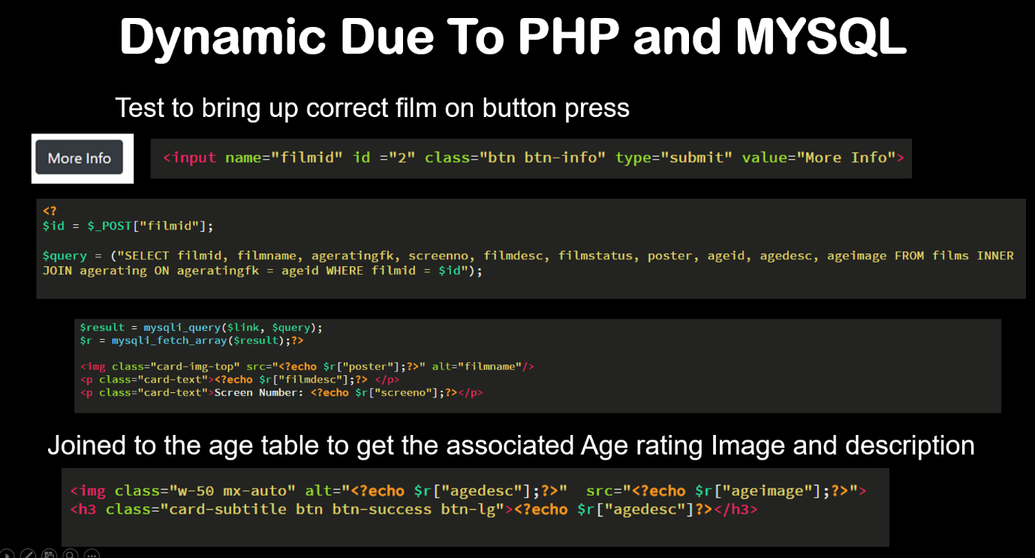
Also, the buttons created for mobile devices seen below span the whole screen, making operating them more accessible for those with limited dexterity [13].
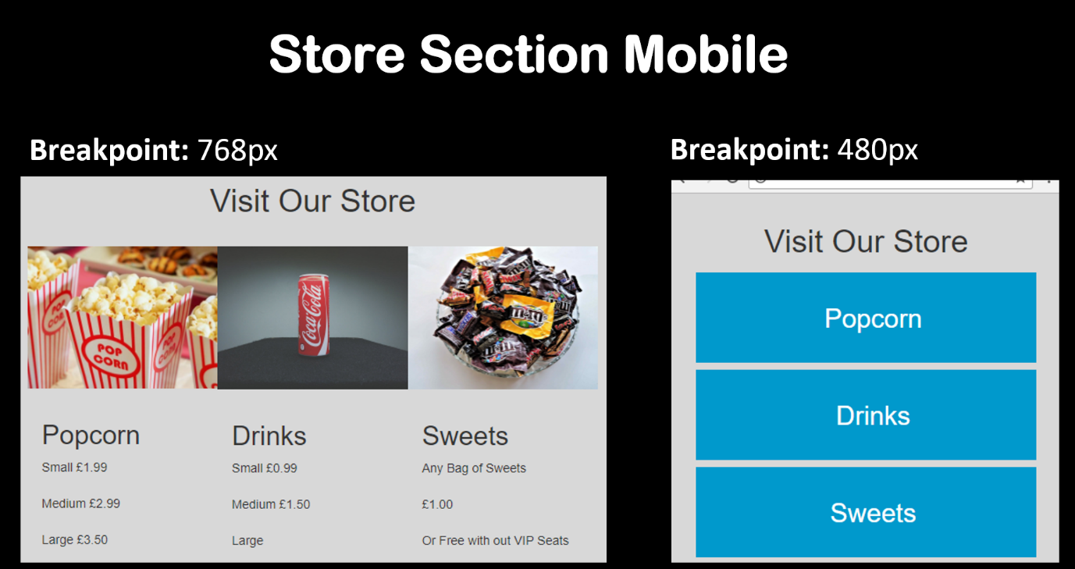
Legal Issues
The issue of using copyright images was raised in the PID. If this was to occur, the owner of the copyright material could take legal action against the Cinema [14]. They could seek the removal of their material and secondly seek to recover funds for their unauthorised usage. To avoid encountering any problems, copyright free images which were downloaded from pexels.com.
Another concern relates to data protection, and as the European Union’s (EU) General Data Protection Regulation (GDPR) comes into effect on 25/05/2018, organisations need to ensure they are compliant [15].
As software developers, we need to be aware how we can safeguard the client. The databases we provided store customer data, and the security systems keep their details safe, to which end the Information Commissioners Office (ico) [16] present the following related principle:
“Appropriate technical and organisational measures shall be taken against unauthorised or unlawful processing of personal data and against accidental loss or destruction of, or damage to, personal data”.
With an initial fine of 10 million euros, a precedent has been set to implement this in work undertaken to safeguard electronic data [15]. Although no data was saved as part of this project, it does have a MYQSL database to return film information. Therefore, it could store customer’s data, for example for the weekly e-mail newsletter currently in operation. Possible solutions were investigated, and two applicable preventive methods include minimising the risk of exposing customer data via an SQL injection attack and hashing customers passwords should the database be compromised [17].

Code of Conduct IEEE/BCS
With rapid growth in the computing sector, there is an ever greater need to ensure professionalism [18]. The British Computer Society (BCS) and the Institute of Electrical and Electronics Engineers (IEEE) are the leading professional organisations relevant to this project. To which end, the following code of conduct from the BCS [19] is discussed regarding this project against each relevant point:
From 1. Public Interest.
- “d) promote equal access to the benefits of IT and seek to promote the inclusion of all sectors in society wherever opportunities arise”.
Website accessibility was covered in the ethics section of this assignment and implemented.
From 2. Professional Competence and Integrity.
- “a) only undertake to do work or provide a service that is within your professional competence”.
- “b) NOT claim any level of competence that you do not possess”.
These points are interlinked, and it was vital not to overestimate one’s skills. Thus, planning made it a lot more likely that the project was achievable, and no claims were made because of this. The alternative solutions of website builders were highlighted and trialled for the cinema, giving them a viable alternative should it not be finished.
- “c) develop your professional knowledge, skills and competence on a continuing basis, maintaining awareness of technological developments, procedures, and standards that are relevant to your field”.
As a university student, this is perhaps the most relevant point. The on-going development is of utmost importance, and the knowledge from lectures and that gained from other sources was used throughout the project life-cycle.
- “d) ensure that you have the knowledge and understanding of Legislation and that you comply with such Legislation, in carrying out your professional responsibilities”.
Again, this point was considered under the legal section of this report, where copyright and data protection laws were analysed.

Quality Assurance
Producing substandard work could harm business in the long term and result in the company having to pay twice to get what was a request. With large, IT projects this section evaluates how the work produced maintained standards throughout.

Quality Metrics
The PID highlighted the need to seek approval from the client, who should confirm the software developed meets their requirements. Weaver [3] informs us that the Waterfall model can offer the necessary assurances with any adjustments being applied before moving onto the next stage. Weaver makes a case for the waterfall Model for students and small-scale projects using this method as it “is easy to build a simple plan around” [3]. He does recognise the drawbacks noting that mismanagement at any stage can result in substandard work being produced.
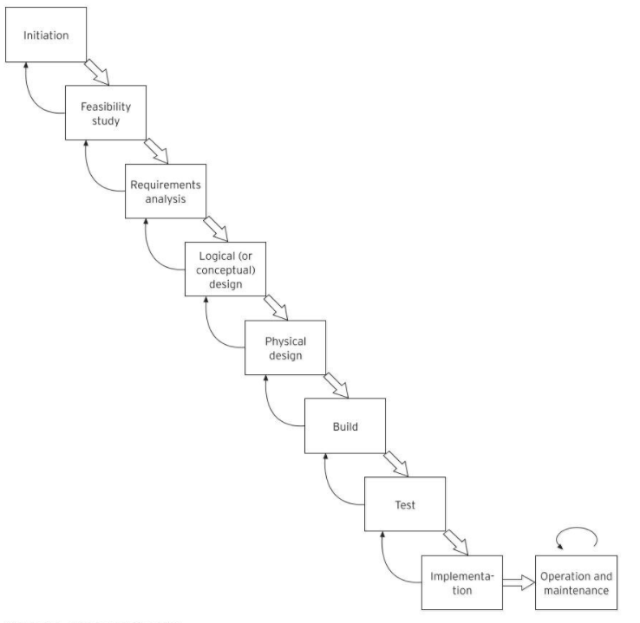
Fig 4. Weaver’s [3] Waterfall Model.

Conclusion
The project manager overcame the potential impact of illness, and also took the necessary actions to negate the impact of the other risks, or in some instances had to accept these may occur. With sustainability of the project, it is difficult to measure its success. Only through questioning customers and monitoring visitor numbers could the impact be quantified. Legal issues are often challenging; however, research into the appropriate legislation can save businesses both time and money. Some of the guidance provided by the BCS may already be adhered to, although it is hoped that such an organisation will increase the level of work produced by all those in the profession. The quality of a project produced at university may well be lower than that produced in the workplace. However, a collaboration between staff themselves assists with fulfilling custom expectations.

Reference List
[1] J. Shaw, A.-L. Kor, and C. Pattinson, “An Evaluation of the Impact of Remote Collaboration Tools on Corporate Sustainability,” in 2016 IEEE 14th Intl Conf on Dependable, Autonomic and Secure Computing, 14th Intl Conf on Pervasive Intelligence and Computing, 2nd Intl Conf on Big Data Intelligence and Computing and Cyber Science and Technology Congress(DASC/PiCom/DataCom/CyberSciTech), 2016, pp. 257–262.
[2] A. Vaughan, “How green is Britain’s record on renewable energy supply?,” 2017. [Online]. Available: https://www.theguardian.com/business/2017/oct/07/how-green-is-britains-low-carbon-energy-supply. [Accessed: 10-Apr-2018].
[3] P. L. Weaver, Success in Your Project: a guide to student system development projects. Financial Times/ Prentice Hall - M.U.A, 2004.
[4] M. S. Dobson and T. Leemann, Creative project management: innovative project options to solve problems on time and under budget. McGraw-Hill USA, 2010.
[5] H. Maylor, Project Management: . Financial Times/ Prentice Hall - M.U.A, 2011.
[6] R. Newton, Project Management Step by Step: How to Plan and Manage a Highly Successful Project. Pearson Education M.U.A., 2016.
[7] Q. Docter and E. Dulaney, CompTIA A+ Complete Study Guide: Exams 220-901 and 220-902, 3rd ed. Sybex, 2015.
[8] D. McLaughlin, Brentt; Pollice Gary; West, Head First Object-Oriented Analysis & Design. O’Reilly, 2006.
[9] “Laptops vs. Desktops: Which Is More Energy-Efficient?,” Direct Energy Business, 2017. [Online]. Available: https://business.directenergy.com/blog/2017/november/laptops-vs-desktops-energy-efficiency. [Accessed: 15-Apr-2018].
[10] L. Xiang, J. Huang, and T. Chen, “Coordinating System Software for Power Savings,” in 2008 Second International Conference on Future Generation Communication and Networking, 2008, pp. 222–225.
[11] G. Lucache, A. Turcanu, D. Lucache, and I. Nuca, “Comparative study of the level of awareness of e-waste management in Romania and Republic of Moldova,” in 2017 International Conference on Electromechanical and Power Systems (SIELMEN), 2017, pp. 431–436.
[12] Amanda, “2,400 Trees Saved Daily,” 2010. [Online]. Available: https://blog.mailchimp.com/earthday2010/. [Accessed: 10-Apr-2018].
[13] J. Duckett, HTML and CSS: Design and Build Websites, 1st ed. John Wiley & Sons, 2011.
[14] “How copyright protects your work.” [Online]. Available: https://www.gov.uk/copyright. [Accessed: 17-Apr-2018].
[15] J. Curtis, “What is GDPR? Everything you need to know before the 2018 deadline,” 2018. [Online]. Available: http://www.itpro.co.uk/it-legislation/27814/what-is-gdpr-everything-you-need-to-know. [Accessed: 16-Apr-2018].
[16] “Data protection principles.” [Online]. Available: https://ico.org.uk/for-organisations/guide-to-data-protection/data-protection-principles/. [Accessed: 17-Apr-2018].
[17] L. Ullman, PHP and MySQL for Dynamic Web Site, 4th ed. Peachpit Press, 2014.
[18] J. B. Thompson, “Future Software Development and Education - A UK View,” in 29th Annual International Computer Software and Applications Conference (COMPSAC’05), vol. 1, pp. 372–372.
[19] “BCS Code of Conduct.” [Online]. Available: https://www.bcs.org/category/6030. [Accessed: 15-Apr-2018].

Bibliography
[1] J. Shaw, A.-L. Kor, and C. Pattinson, “An Evaluation of the Impact of Remote Collaboration Tools on Corporate Sustainability,” in 2016 IEEE 14th Intl Conf on Dependable, Autonomic and Secure Computing, 14th Intl Conf on Pervasive Intelligence and Computing, 2nd Intl Conf on Big Data Intelligence and Computing and Cyber Science and Technology Congress(DASC/PiCom/DataCom/CyberSciTech), 2016, pp. 257–262.
[2] A. Vaughan, “How green is Britain’s record on renewable energy supply?,” 2017. [Online]. Available: https://www.theguardian.com/business/2017/oct/07/how-green-is-britains-low-carbon-energy-supply. [Accessed: 10-Apr-2018].
[3] P. L. Weaver, Success in Your Project: a guide to student system development projects. Financial Times/ Prentice Hall - M.U.A, 2004.
[4] M. S. Dobson and T. Leemann, Creative project management: innovative project options to solve problems on time and under budget. McGraw-Hill USA, 2010.
[5] H. Maylor, Project Management: . Financial Times/ Prentice Hall - M.U.A, 2011.
[6] R. Newton, Project Management Step by Step: How to Plan and Manage a Highly Successful Project. Pearson Education M.U.A., 2016.
[7] Q. Docter and E. Dulaney, CompTIA A+ Complete Study Guide: Exams 220-901 and 220-902, 3rd ed. Sybex, 2015.
[8] D. McLaughlin, Brentt; Pollice Gary; West, Head First Object-Oriented Analysis & Design. O’Reilly, 2006.
[9] “Laptops vs. Desktops: Which Is More Energy-Efficient?,” Direct Energy Business, 2017. [Online]. Available: https://business.directenergy.com/blog/2017/november/laptops-vs-desktops-energy-efficiency. [Accessed: 15-Apr-2018].
[10] L. Xiang, J. Huang, and T. Chen, “Coordinating System Software for Power Savings,” in 2008 Second International Conference on Future Generation Communication and Networking, 2008, pp. 222–225.
[11] G. Lucache, A. Turcanu, D. Lucache, and I. Nuca, “Comparative study of the level of awareness of e-waste management in Romania and Republic of Moldova,” in 2017 International Conference on Electromechanical and Power Systems (SIELMEN), 2017, pp. 431–436.
[12] Amanda, “2,400 Trees Saved Daily,” 2010. [Online]. Available: https://blog.mailchimp.com/earthday2010/. [Accessed: 10-Apr-2018].
[13] J. Duckett, HTML and CSS: Design and Build Websites, 1st ed. John Wiley & Sons, 2011.
[14] “How copyright protects your work.” [Online]. Available: https://www.gov.uk/copyright. [Accessed: 17-Apr-2018].
[15] J. Curtis, “What is GDPR? Everything you need to know before the 2018 deadline,” 2018. [Online]. Available: http://www.itpro.co.uk/it-legislation/27814/what-is-gdpr-everything-you-need-to-know. [Accessed: 16-Apr-2018].
[16] “Data protection principles.” [Online]. Available: https://ico.org.uk/for-organisations/guide-to-data-protection/data-protection-principles/. [Accessed: 17-Apr-2018].
[17] L. Ullman, PHP and MySQL for Dynamic Web Site, 4th ed. Peachpit Press, 2014.
[18] J. B. Thompson, “Future Software Development and Education - A UK View,” in 29th Annual International Computer Software and Applications Conference (COMPSAC’05), vol. 1, pp. 372–372.
[19] “BCS Code of Conduct.” [Online]. Available: https://www.bcs.org/category/6030. [Accessed: 15-Apr-2018].

Appendix
Initial storyboard designs.
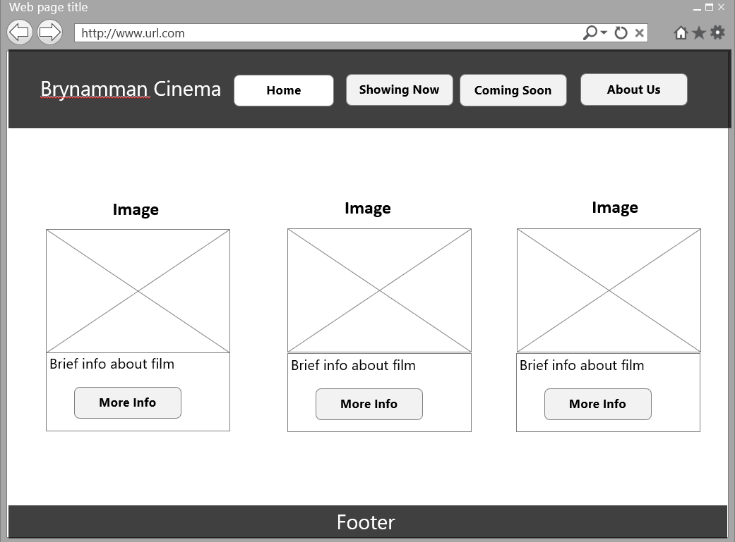
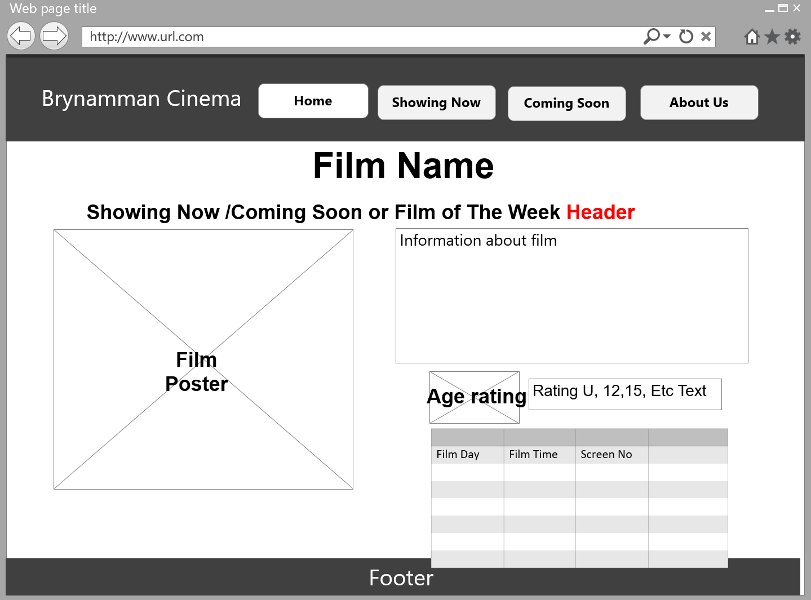
Two navigation bars were created, firstly using HTML CSS, with Media Queries to adjust the bar at the following breakpoints.
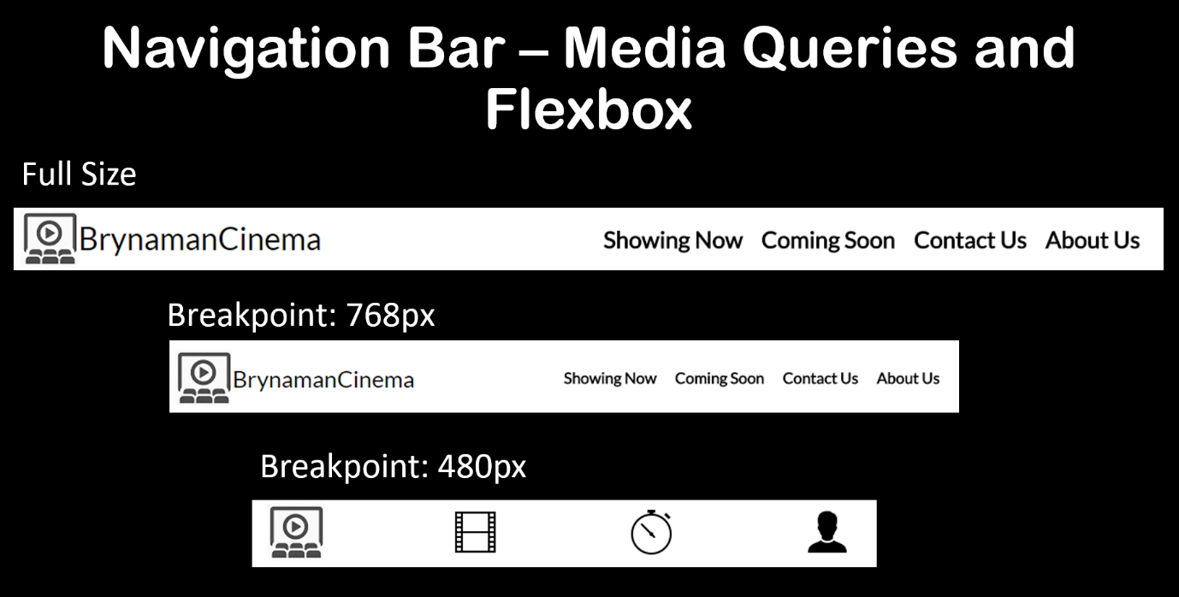
Secondly, is a standard Bootstrap design with an added search bar, where the Hamburger menu has been applied.
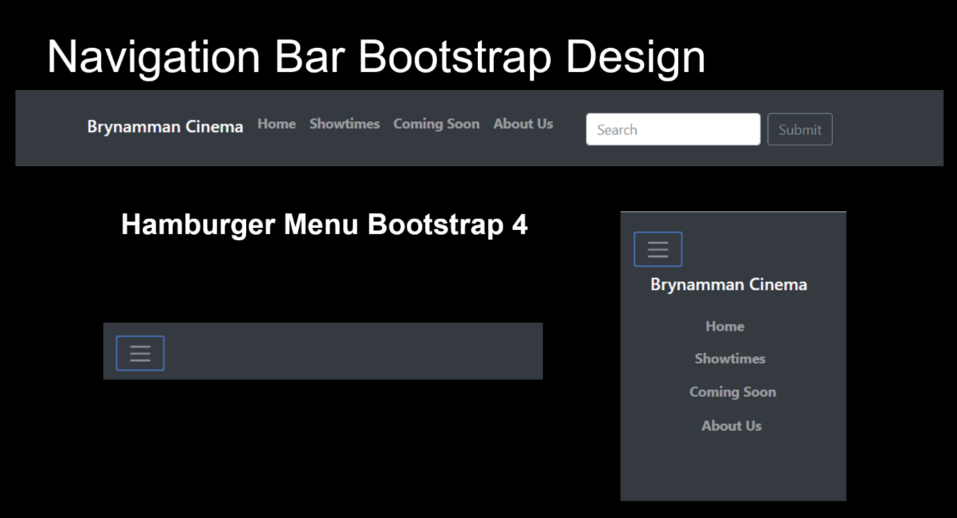

A standard footer was created to be used across all pages using bootstrap red as the background.
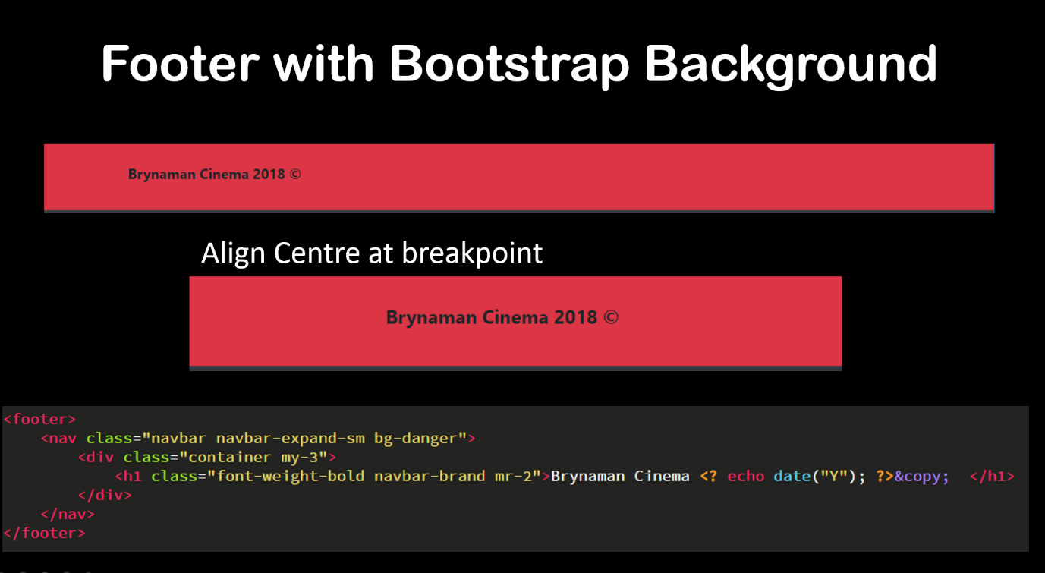
PHP include statement makes maintenance of sections such as the header and footer more straightforward for the developer as adjustments are made in one file. Also, code repetition is significantly reduced, and regarding the titles of the page, a variable is used for every page.
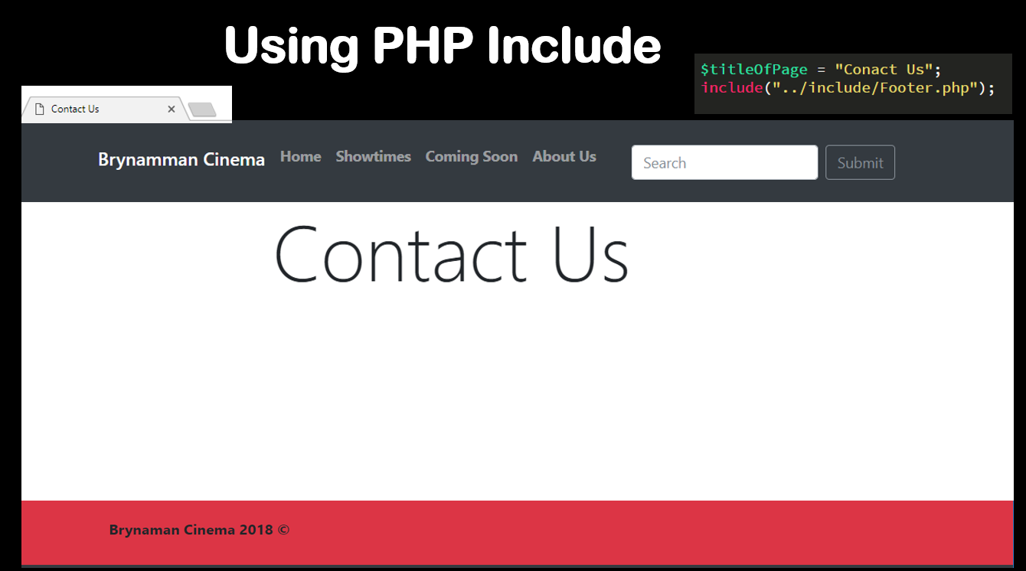

Bootstrap Cards used for the films on the home/coming soon page.
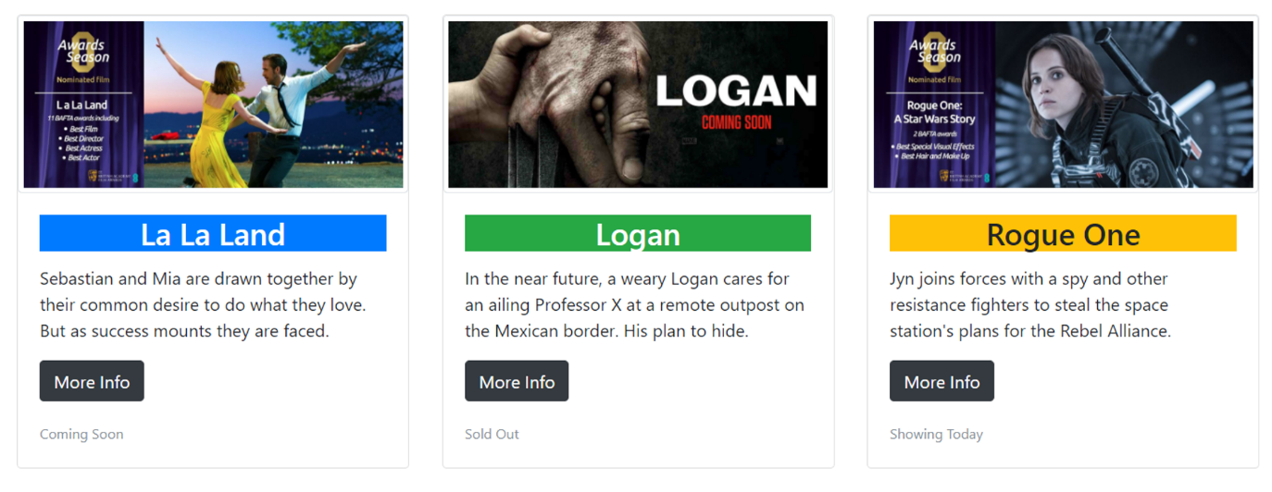
The cards adjust to column view and expand as necessary, clicking the more info button will take the user through to the expanded view.
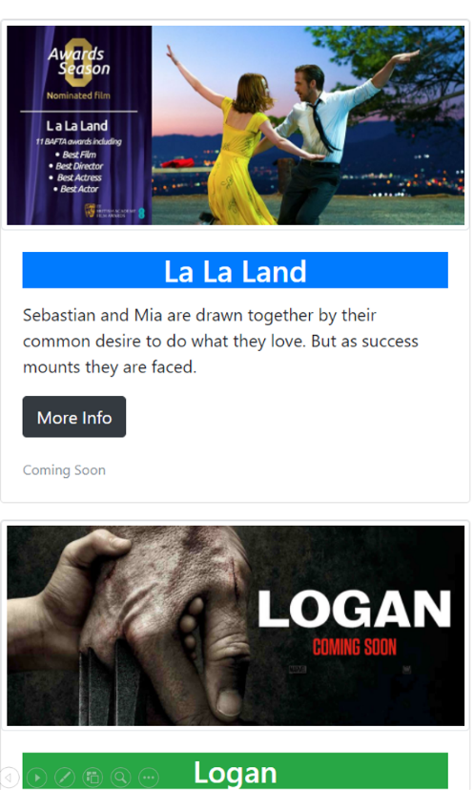

Using Bootstrap cards, buttons and table in the final design.
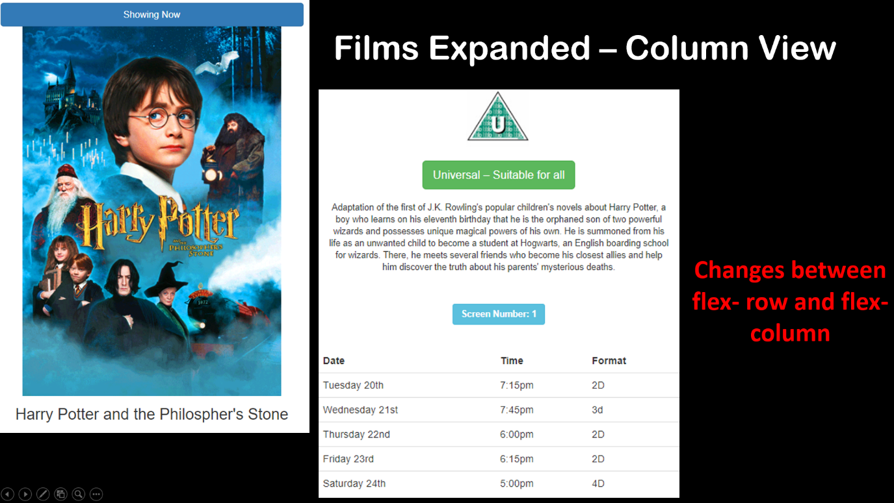
All the information comes from an MYSQL database seen below. Doing so allows for it determine if a blue banner is required for a film that is currently shown or the orange banner for coming soon.
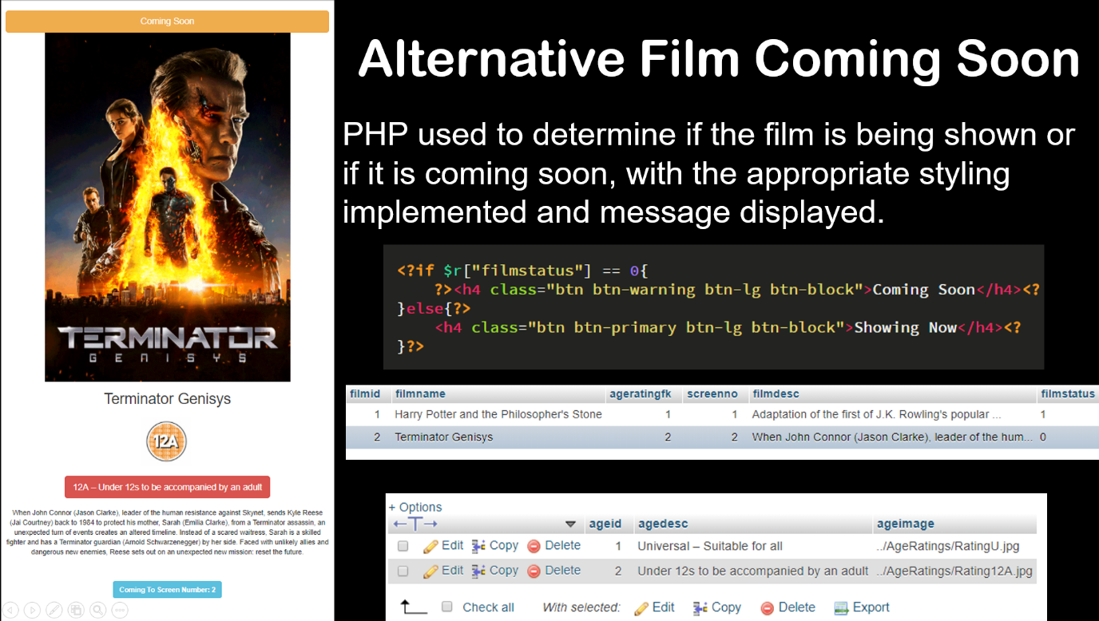

Using PHP means clicking through from the thumbnail film view to the expanded film view can use the same template, without recreated a page for every film. As instead the correct details from the database are applied to the template. Multiple tables can be used as seen here each film links to the film table which is then applied.
Here a standard HTML CSS section is created.
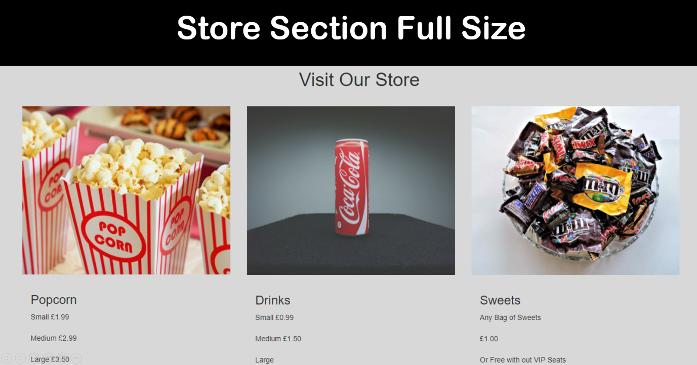

Then spacing is removed from the images at the 768px breakpoint. For the 480px everything is hidden apart from the title of the product, the width is adjusted to fill the screen, and a background colour applied giving buttons should they be required.
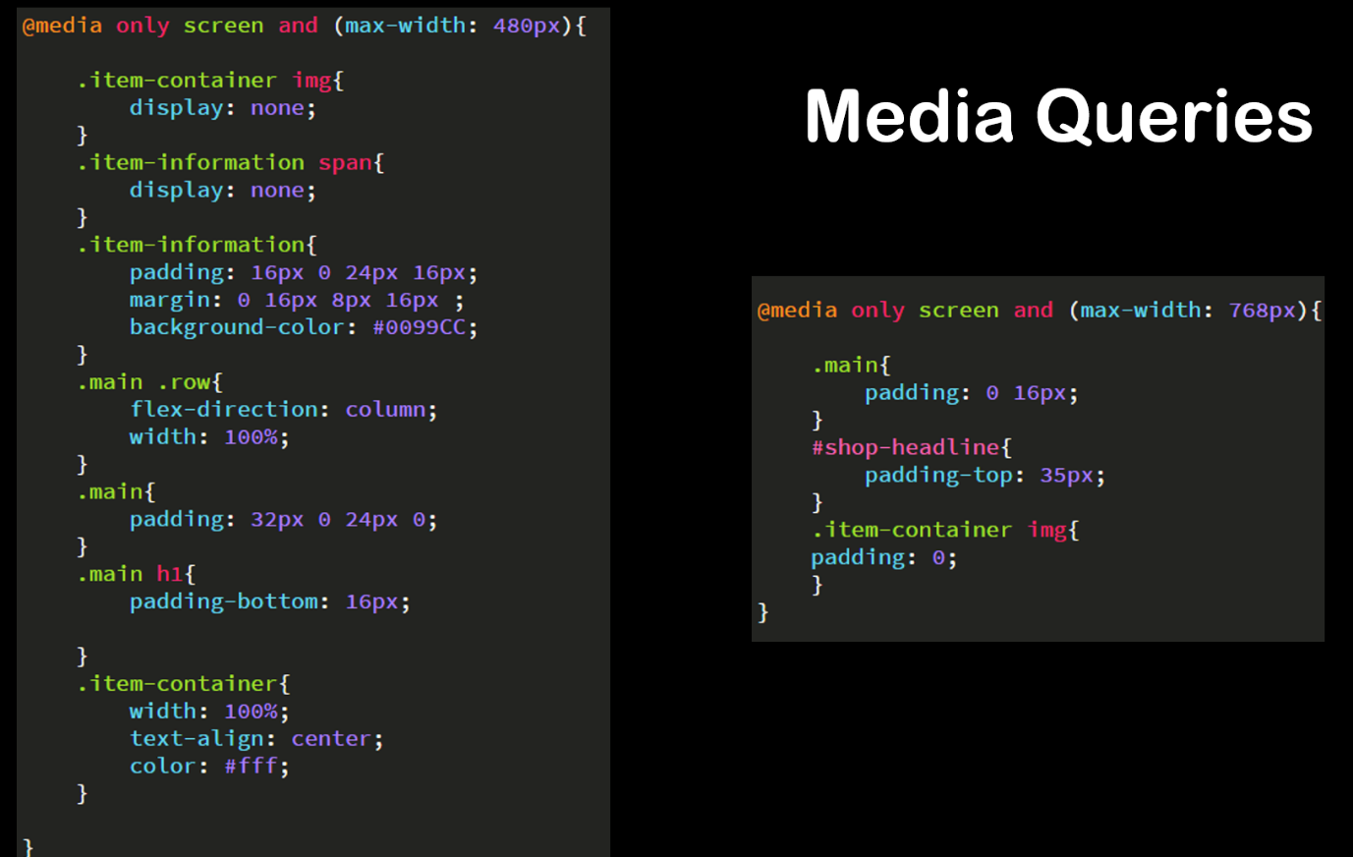

A page created to be displayed, should the site be compromised.
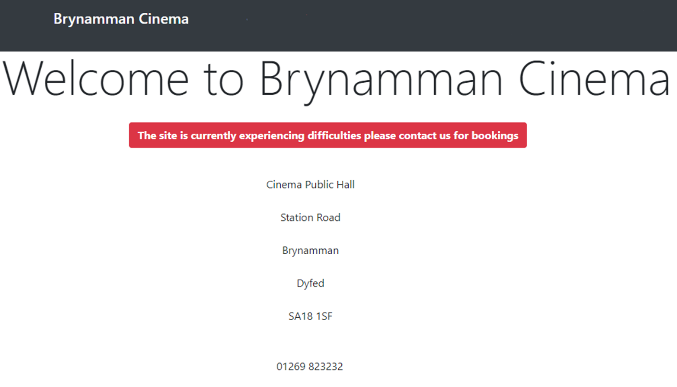

To publish the websites, online users would require admin section to add new films and so forth, the alternatives were explored.


These were subsequently trialled and some example pages created.


