

BA (Hons) Leadership and Management Skills for the Workplace
Module: Developing and Managing Individuals and Teams (LCLM5002)
Assignment Title: Component 2 - Individual Report

Contemporary HR Challenges and Practices at Tesco PLC

Student Name: Hammad Talib
Student Number: 2423857
Lecturer Name: Doreen Nyaa Amundam
Submission Date: 30 March 2026
Word Count: 2041

Contents
Introduction 3
1. Factors influencing HR challenges at Tesco PLC 3
1.1 Meeting technological advancement 3
1.2 Talent acquisition and retention 4
1.3 Diversity, equity and inclusion (DEI) 4
2. Evaluation of contemporary HR practices to address each factor 5
2.1 Practices for technological advancement 5
2.2 Practices for talent acquisition and retention 6
2.3 Practices for DEI 7
3. Critical evaluation: how departmental managers can implement these practices urgently 8
Conclusion 10
Recommendations 10
References 12

Introduction
Tesco PLC is a British multinational retailer, the operating model of which relies on the high-volume and high-quality service provision in stores, online fulfilment and customer contact channels. In this respect, the HR role is a two-fold task in that it is expected to sustain the organization in line with the change brought about by technology whilst safeguarding the quality of services provided, equity and wellbeing of employees. This report evaluates three burning HR considerations to Tesco: (1) addressing technological change, (2) talent acquisition and retention and (3) diversity, equity and inclusion (DEI). It then analyses the current HR practices that can be used to counter every factor and then critically looks at how the departmental managers (store and function-level) can adopt the practices and urgently on a consistent basis. The report is based on the existing literature on the HRM field and uses evidence-based methodology to the workforce planning, performance management and sustainable personnel development.

1. Factors influencing HR challenges at Tesco PLC

1.1 Meeting technological advancement
Automation, Artificial Intelligence-powered decision support, digital customer experiences and operations based on data are changing retail. According to the forecasts made by the World Economic Forum, digitalisation will continue to disrupt employment positions and skills needs (World Economic Forum, 2025). In the case of Tesco, the problem is not in the implementation of new technologies like workforce management systems and online fulfilment platforms. It also has to deal with workforce implications such as role redesign, skills obsolescence and employee issues about monitoring or job security. HR should strike the right balance between operation and human sustainability and make sure that technology supports and results in the work but not in its escalation (Deloitte, 2024). Also, recruit or schedule algorithms run the risk of introducing bias, and ethical control and reskilling pathways need to be established to make it fair and responsible to implement (Raghavan et al., 2020).

1.2 Talent acquisition and retention
The UK retail is confronted with the challenges of constrained labour markets, increased demands on flexibility and wellbeing, and rivalry with logistics and gig labour. The studies on CIPD indicate that there is difficulty in attracting candidates, lowering high turnover and offering viable career opportunities (CIPD, 2024). In the case of Tesco, the customer-facing jobs directly affect the brand experience, thus high turnover means high training expenses, less consistency in services and less supervisory capacity. A solid employee value is the reason behind retention by offering attractive pay, predictable schedules, and up-to-the-job management and professional growth (Armstrong and Taylor, 2023). In the meantime, digital transformation changes necessary capabilities, which requires flexibility and digital confidence. Recruitment, reskilling, and internal progression have to be incorporated in workforce planning instead of excessively depending on outside hiring (Boxall and Purcell, 2022).

1.3 Diversity, equity and inclusion (DEI)
Diversity is a performance and ethical priority as diverse teams can make better decisions and be more innovative when inclusion is a part of their day-to-day management (McKinsey & Company, 2020). Being one of the largest employers in the UK Tesco is the area that is under scrutiny in terms of representation, equal opportunity and fair progression. Although Tesco DEI policies focus on inclusive culture and leadership responsibility (Tesco PLC, 2025b), there are still practical risks, such as discrimination during hiring, inequality of development opportunities and unequal treatment of misconducts. According to ACS (2023), to have inclusive workplaces, there should be the presence of clear policies and plausible procedures. It can also increase inequities when technology is not monitored to be fair through automated systems (Raghavan et al., 2020).
Finally, technology and talent issues are interrelated, and the efficiency of workforce planning and performance systems should not be considered separately, but instead applied as one combined HR initiative (CIPD, 2024; Deloitte, 2024).
Table 1. Summary of the three HR factors and implications for Tesco.
Factor | Key drivers in Tesco context | Risks if unmanaged | Sustainable performance implications
Technological advancement | Automation, AI and digital platforms changing work design and required skills. | Skill gaps; inconsistent system use; perceived surveillance; unfair algorithmic decisions. | Productivity gains offset by lower engagement, safety incidents or service failures.
Talent acquisition & retention | Competition for frontline labour; changing expectations for flexibility and growth. | High turnover; weak service consistency; higher recruitment and training cost. | Stabilised staffing improves service quality, reduces cost and builds leadership pipeline.
DEI | Community-facing workforce; expectations for fairness, representation and respectful culture. | Discrimination risk; unequal progression; reputational harm; reduced trust and retention. | Inclusion supports innovation and engagement, and reduces legal and reputational risk.

2. Evaluation of contemporary HR practices to address each factor

2.1 Practices for technological advancement
The first current practice is to position the adoption of HR technology as a change programme, and not an IT rollout. It implies that workflows are co-designed with end users, and are piloted in selected stores, and that feedback loops are used to eliminate friction. Workforce planning can utilize people analytics to identify areas of skills deficit, absences or turnover hotspots, and learning interventions that are positively associated with improvements to service delivery; nevertheless, the CIPD emphasizes that analytics should be worked out to differentiate between correlation and causation and must have high-quality data governance and ethics (CIPD, 2025). The second one is role-based reskilling where digital micro-learning is applied alongside on-job coaching such that colleagues are able to rely on new systems during the peak trading times. The expectations can also be spelled out in terms of roles like Customer Service Team Leader, as in, ability to use digital scheduling tools, ability to recover customers and coach teams (Armstrong and Taylor, 2023). The fact that training does not eliminate structural pressures is the primary limitation: when there is too little staffing, there is no time to learn, results in paper compliance and not competence. Thus, HR must consider the technology projects in terms of human results (safety, workload, inclusion) and productivity (Deloitte, 2024).

2.2 Practices for talent acquisition and retention
As an attraction tool, employer branding and EVP design are becoming more popular talent management instruments, which portends what the organization will give in exchange of skills and commitment (Reis et al., 2021). Tesco can enhance the effectiveness of EVP by connecting recruitment messages to actual actions: reliability of the working hours, support of wellbeing, career paths and clear pay advancement. The process of selection must utilize both structured interviews and job-related simulations to enhance objectivity and forecast performance, but not the opaque black box-type of assessment that is hard to comprehend by the candidates (Raghavan et al., 2020). In order to retain talent, modern practice is focused on career mobility: internal talent markets, apprenticeships, cross-training are used to mitigate the risk of exit because they provide a position of progression without leaving the company (CIPD, 2024). Tesco mentoring and systemic development programs, which are examples of colleague development initiatives, demonstrate how the large employers can broaden access to progression at scale (Tesco PLC, 2024). The difficulty is that the retention levels vary by segment: the pay might be the most important in the case of new starters, whereas the development and autonomy might be the most significant in the case of more experienced colleagues. Segmenting and leveraging evidence should thus help HR to prevent interventions that apply to everyone (Boxall and Purcell, 2022).

2.3 Practices for DEI
The modern DEI practice is shifting towards awareness training to quantifiable systems: inclusive hiring, fair talent processes and responsibility. Hiring and progression bias can be minimized through the utilization of various shortlists, scoring structure and set criteria (ACAS, 2023). Pay equity reviews and progression analytics will allow identifying trends that disadvantage a group that is being protected or marginalised, but HR should use the data responsibly and do not infringe on privacy of employees (CIPD, 2025). Leadership behaviors are another condition of inclusion: managers require applied communication abilities, resolution of conflicts, and psychologically secure workplaces. The policy on DEI of Tesco is an indicator of commitment at the board level, although its practical implementation into targets, managerial skills and non-conformance will depend (Tesco PLC, 2025b). The most important trade-off is the so-called “initiative overload”: excess DEI campaigns without follow-up operation will break trust. Thus, the DEI must be integrated into the mainstream people processes (recruitment, scheduling, performance reviews and learning) instead of being a discrete program (McKinsey and Company, 2020).
Overall, the most effective way in which a modern HR practice can be implemented is the integration: the change in technology must be supported by reskilling and ethical governance; retention is to be enhanced by plausible EVP and internal mobility; and DEI is to be advanced by providing the fairness in everyday procedures and accountability of the leaders (CIPD, 2024; Deloitte, 2024).

Table 2. Contemporary HR practices mapped to each factor (benefits, limitations and indicative KPIs).
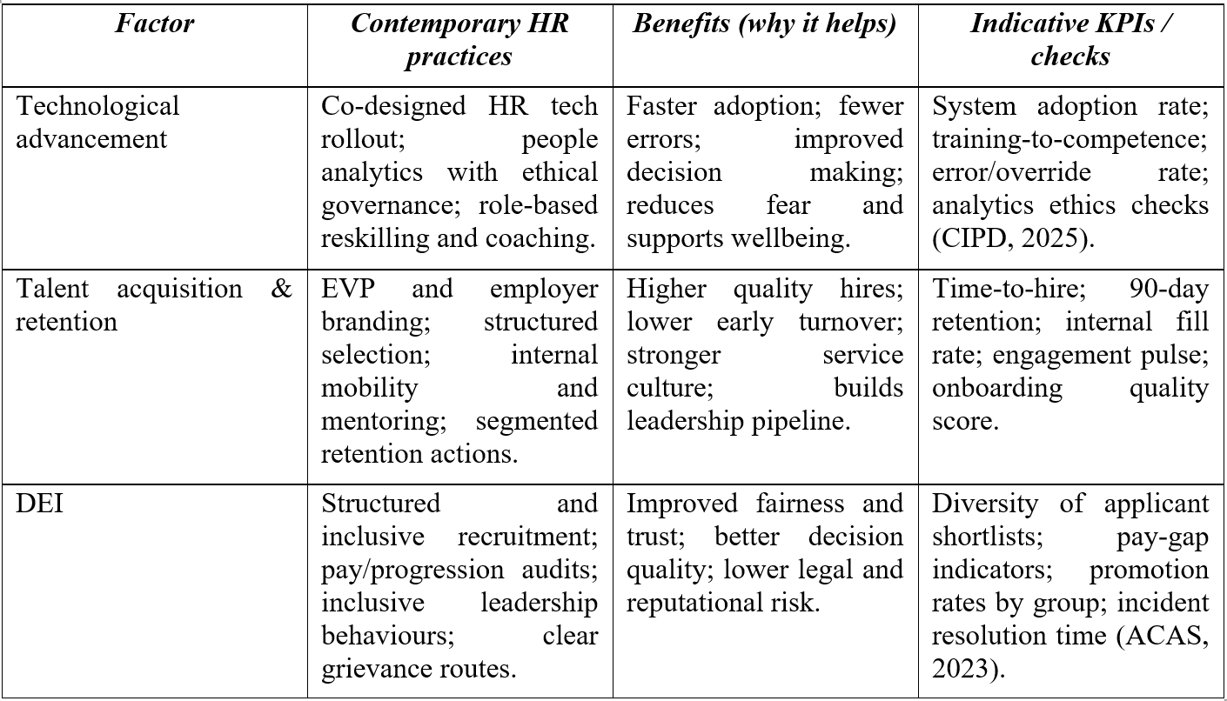

3. Critical evaluation: how departmental managers can implement these practices urgently
The operational (delivery) system of HR strategy is the departmental managers since they are the ones who govern day-to-day scheduling, coaching, conversations on performance and behavioural norms. Urgency may however spur short cuts like recruitment in a hurry or uneven application of policies. The main difficulty is how the change can be implemented within a short period of time but with fairness and trust.
Managers ought to define an effective governance pace between corporate HR priorities and local action. The leading indicators such as vacancy days, early turnover, absence, training completed, service performance and DEI measures such as shortlisting diversity or grievance trend can be tracked using a brief monthly people dashboard reviewed in team meetings. People analytics facilitates decision-making, yet managers also need guidance to comprehend data in a responsible manner and take the action in their control (CIPD, 2025). The urgency can be addressed by using short problem-solving cycles: detecting problems, testing the desired interventions during four to six weeks, measuring the results and testing the successful solutions.
Continuous performance management has to also incorporate the contemporary HR practices. Instead of annual appraisals, the managers need to make use of frequent feedbacks and transparent goals to reaffirm the expectations (CIPD, 2026). As an illustration, the targets of technology adoption can be included in those of individuals, whereas the retention activities should focus on the quality of onboarding, the fairness and development of workloads as well as sales performance.
Manager capability and authority is also required in the implementation. There is a tendency of change initiatives to fail because line managers do not have time, skills, or decision rights (Armstrong and Taylor, 2023). Delivery can be reinforced by the provision of practical toolkits, HR business partner assistance and coachee-guaranteed time. Supervisory competence can be also developed by mentoring arrangements (Tesco PLC, 2024).
Lastly, DEI risks should be actively controlled by managers through the implementation of systematic criteria, the recording of decisions and the solution of conflict in time (ACAS, 2023). The issue of bias is minimized by ensuring the transparency of technology use (Raghavan et al., 2020). These measures increase sustainable performance when they are carried out in a steady and responsible manner (Boxall and Purcell, 2022).
Table 3. Suggested 30-60-90-day manager actions to accelerate implementation.
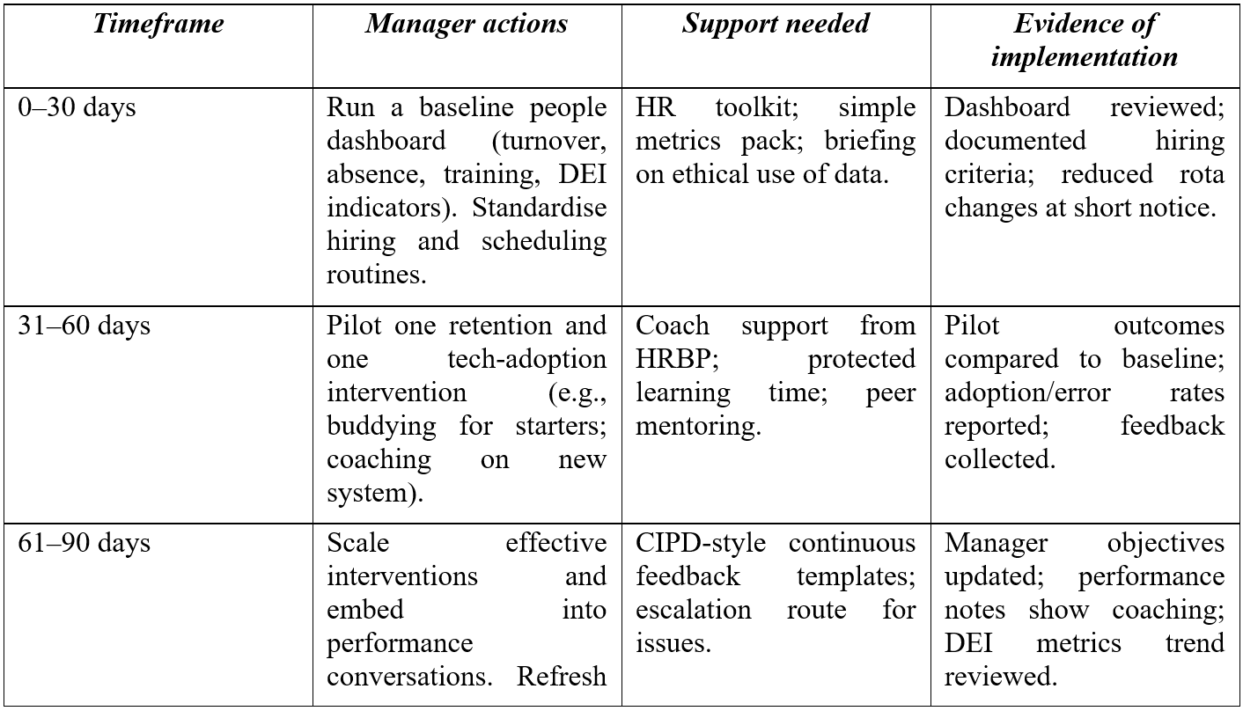

Conclusion
The HR problems of Tesco are influenced by the fast change in technology, competition among frontline talents and increasing demands of fair and inclusive work. There have been indications that the best responses tend to be combined: ethical HR technology and people analytics, a realistic EVP underpinned by internal mobility and development, and DEI being part of core people processes with quantifiable responsibility. The approaches, however, can only provide value when department managers transform them into routine-based activities- through coaching, structured decision making and continuous performance management.

Recommendations
- Technology change (workload, safety and fairness as well as productivity) is scored using a human outcomes scorecard and any algorithmic assessment tool is run with bias/explainability checks (Raghavan et al., 2020).
- Enhance the EVP by Tesco of the customer service jobs, focusing on consistent scheduling, advancement, and mentoring, segmented retention efforts at the time of new employees and with existing workers (Tesco PLC, 2024; Reis et al., 2021).
- Inculcate DEI into the daily management by formal hiring/promotions based on behaviors, early detection of unacceptable behaviors, and a well-established accountability of managers by the performance cycle (ACAS, 2023; CIPD, 2026).

References
ACAS (2023) ‘Making your workplace inclusive’. Available at: https://www.acas.org.uk/improving-equality-diversity-and-inclusion/making-your-workplace-inclusive (Accessed: 3 March 2026).
Armstrong, M., & Taylor, S. (2023). Armstrong's handbook of human resource management practice: A guide to the theory and practice of people management. Kogan Page Publishers.
Boxall, P., & Purcell, J. (2022). Strategy and human resource management. Bloomsbury Publishing.
CIPD (2024) Resourcing and talent planning report 2024. London: Chartered Institute of Personnel and Development. Available at: https://www.cipd.org/globalassets/media/knowledge/knowledge-hub/reports/2024-pdfs/8662-resource-and-talent-planning-2024-report-web.pdf
CIPD (2025) ‘People analytics’. Factsheet. London: Chartered Institute of Personnel and Development. Available at: https://www.cipd.org/en/knowledge/factsheets/analytics-factsheet/ (Accessed: 3 March 2026).
CIPD (2026) ‘Performance management’. Factsheet. London: Chartered Institute of Personnel and Development. Available at: https://www.cipd.org/en/knowledge/factsheets/performance-factsheet/ (Accessed: 3 March 2026).
Deloitte (2024) 2024 Global Human Capital Trends: The Human Factor. Deloitte Insights. Available at: https://www.deloitte.com/ua/en/about/press-room/human-capital-trends.html (Accessed: 3 March 2026).
McKinsey & Company (2020) Diversity wins: How inclusion matters. Available at: https://www.mckinsey.com/featured-insights/diversity-and-inclusion/diversity-wins-how-inclusion-matters (Accessed: 3 March 2026).
Raghavan, M., Barocas, S., Kleinberg, J., & Levy, K. (2020, January). Mitigating bias in algorithmic hiring: Evaluating claims and practices. In Proceedings of the 2020 conference on fairness, accountability, and transparency (pp. 469-481).
Reis, I., Sousa, M. J., & Dionísio, A. (2021). Employer branding as a talent management tool: A systematic literature revision. Sustainability, 13(19), 10698.
Tesco PLC (2024) Our colleagues factsheet 2024. Available at: https://www.tescoplc.com/our-colleagues-factsheet-2024 (Accessed: 3 March 2026).
Tesco PLC (2025a) Annual Report and Financial Statements 2025. Welwyn Garden City: Tesco PLC. Available at: https://www.tescoplc.com/investors/reports-results-and-presentations/annual-report-2025 (Accessed: 3 March 2026).
Tesco PLC (2025b) Board Diversity, Equity and Inclusion Policy (October 2025). Tesco PLC. Available at: https://www.tescoplc.com/media/5o1dc5nq/2025-board-diversity-and-inclusion-policy-final-october-2025.pdf (Accessed: 3 March 2026).
World Economic Forum (2025) The Future of Jobs Report 2025. Geneva: World Economic Forum. Available at: https://reports.weforum.org/docs/WEF_Future_of_Jobs_Report_2025.pdf (Accessed: 3 March 2026).

