Visual Inquiry 1 ADAA5008/C
Report on Site Specificity
How and why is site specific art different to a framed photograph?
Katie Hill
2305365

Site specific art is the form in which a piece of art is created in a certain location. If taken out of that location, it can lose its purpose and meaning. Viewers can interact with these art pieces, creating an experience and atmosphere for all. In comparison to a framed photograph, what we see will still contain its meaning and intention despite the location in which it can be found. In response to the question, I will be looking at the site-specific artworks of The Weather Project, Olafur Eliasson and Vietnam Veterans Memorial, Maya Lin showing how they differ to a framed photograph.

Olafur Eliasson’s, The Weather Project (2003) was a large installation created in the Turbine Hall of Tate Modern in London. Placed at the end of the hall, with the use of hundreds of lamps, a giant artificial sun was created. With the use of fine mist thus creating a foggy atmosphere, “…he wanted to create the illusion of a meteorological event.” (Tate 2003) With this combination, it gave the vision of a sunset or an overcast sky. Mirrors were placed upon the ceiling, in addition, therefore doubling the perception of the installation. With all these elements combined, viewers were encouraged to reflect upon their own relationship with nature. The beaming artificial sun invites the visitors in to take part in the experience where they can lie down, talk, reflect, becoming part of the installation which Eliasson intended for visitors.

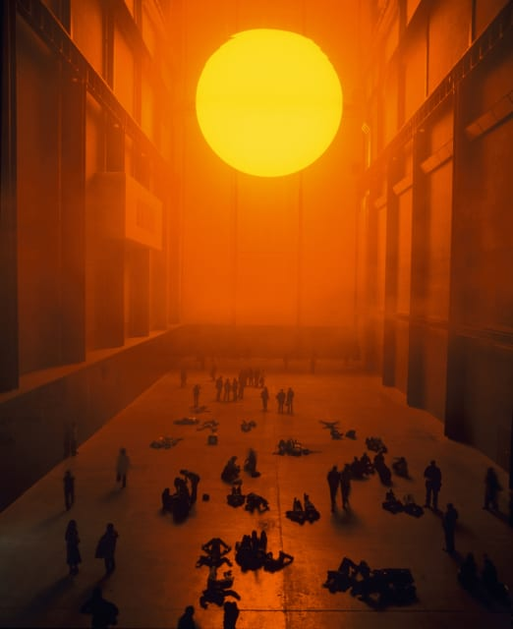

Maya Lin’s, Vietnam Veterans Memorial (1982) is a strong example of site specific located in Washington DC. The black granite walls positioned in a V shape, with the intention of looking like scars left by Vietnam War, display the names of the fallen soldiers. The names in which are seen have been positioned in order of their date of death instead of alphabetically. Lin does this to show the idea of passage of time and “to create a private and personal connection with each viewer to those names.” (Lin, 1982) The memorial doesn’t highlight any aspect of triumph and success as it invites visitors to reflect, heal and think of those lost. Taking into consideration the key facts of the V shape black granite walls and the location between Lincoln Memorial and Washington Monument, if this was to be placed elsewhere, it would lose all emotional meaning and purpose.
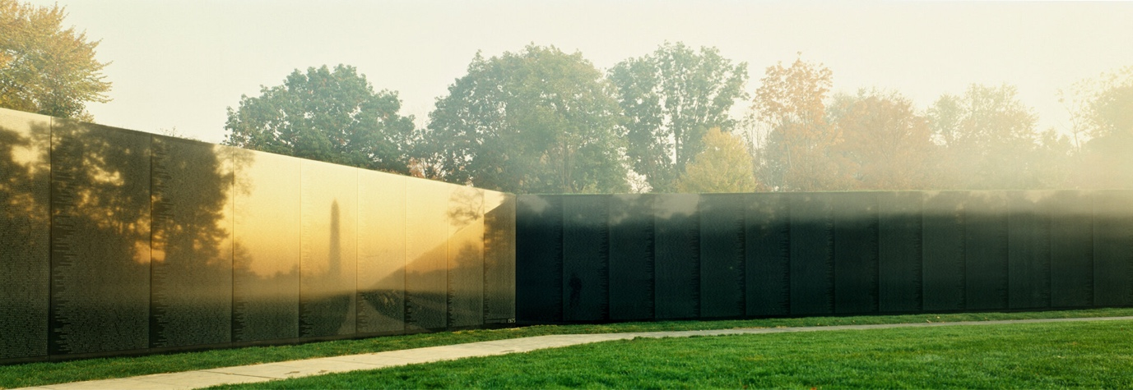

Sharing the common factor of site specific, both installations have their differences in how they have created a different tone in atmosphere. Eliasson’s work creates an uplifting, playful environment, creating a connection between nature and art. This gives visitors a sense of wonder on the environment and how those experiences change our sense on reality. On the other hand, Lin’s work has created a reflective space in which has had a more saddening impact on visitors as they reflect on those lost in the Vietnam War. Looking at Eliasson’s and Lin’s work, their site-specific work highlights the clear difference between site specific and a framed photograph. Although a framed photograph is still able to contain just as much emotion and can be transferred to other locations whilst maintaining its meaning, it does not interact with its environment at all unlike site specific. Visitors have a complete change in experience as site specific allows the viewers to become part of the artwork and engage with it.

To conclude, site specific art is different to a framed photograph, as with support with the work from Eliasson’s, The Weather Project and Lin’s Vietnam Veterans Memorial, a site specific is all about its location and how the meaning behind it will be lost if moved elsewhere. Whereas a framed photograph is still, contained and can still hold its meaning despite its location.

Bibliography

Eliasson, O., 2003. The Weather Project. Olafur Eliasson Studio. Available at: https://olafureliasson.net/exhibition/the-weather-project-2003/ [Accessed 21 October 2024].
Lin, M., 1982. Vietnam Veterans Memorial. Maya Lin Studio. Available at: https://www.mayalinstudio.com/memory-works/vietnam-veterans-memorial [Accessed 21 October 2024].
Tate, 2023. Yes, but why? Olafur Eliasson. Available at: https://www.tate.org.uk/art/artists/olafur-eliasson-5239/yes-but-why-olafur-eliasson [Accessed 21 October 2024].

