Report Case Study: Urban Heights Hotel
Module: Financial Management for the Hotel Industry
Module code: BMIH5007
Student name: Iulia Petronela Ferent
Student ID:2225255
Lecturer: Tristan Hawkins

Contents
1 Introduction 3
2 Scope of the objectives 3
2.1 Trends and Patterns of Urban Height Hotel 3
2.2. Financial performance over the past three years 4
3 Key Reasons for the decline in profitability 6
4 Turnaround strategy 7
5 Financial Projections 8
6 Conclusion 10
7 References 11

Introduction
The Urban Height Hotel with restaurants, bars and event facilities is situated in a metropolitan landscape. Lodgings and tourism plays a vital and significant part in the metropolitan economy in these modern advanced times. The operator's management capacity, the scale and level of the hotel binds with nearby business sectors are referenced to be the general circumstances for choosing the achievement and disappointment of hotel management (Sejati et al., 2018). The hotel administrations are flourishing and giving accommodations to travellers, particularly in computerized contributions which enormously influence the quantity of requests (Wang et al., 2019). However, in recent years, hotels have encountered a decrease in income, inhabitance rates and consumer loyalty. The owner is worried about the future suitability of the business and has enrolled their expertise to evaluate to assess if the business can be rescued through a turnaround strategy. This report may cover the financial performances of Urban Height Hotel in the past three years which will focus on revenue, profitability, liquidity and solvency of the hotel. Moreover, it will also include the reasons for the decline in profitability of the hotel and will also include the strategies to restore the hotel and help the owner gain his reputation.

Scope of the objectives

2.1 Trends and Patterns of Urban Height Hotel
Several variables are impacting the hotel's situation affecting its reputation, customer loyalty and overall success. Being near famous places of interest, business districts or occasions can attract additional visitors. Therefore location plays a significant role in maintaining the hotel's reputation. Simple admittance to public transportation, airports and significant highways is crucial. The security and neatness of the encompassing region can affect the visitor's satisfaction (Qin et al., 2021). Pricing of the Urban Height hotel also plays a major role, they offer competitive pricing as compared to other hotels in the locality and they are offering more money for providing good services and amenities to the customers. They are providing well-trained staff who can offer better assistance and further develop visitor fulfilment (Ball et al., 2024). Moreover, Urban Height Hotel are proficient utilization of innovation for appointments, registrations and visitor administration. Local economy and global trends are also the variables which impact the hotel situation. The financial strength of the area can impact travel patterns and spending power. Worldwide financial patterns can affect the traveller's streams and logical execution (Bhattacharyya and Malik, 2020). By cautiously considering and advancing these factors, Urban Height Hotel can advance its market position, draw in additional visitors and guarantee long-haul achievement (Hastings et al., 2020: Budović et al., 2020).

2.2. Financial performance over the past three years
To analyze the financial performance of Urban Height over the past three years, the report will focus on key aspects such as revenue, expenses, profitability, liquidity and solvency.
Table 1:
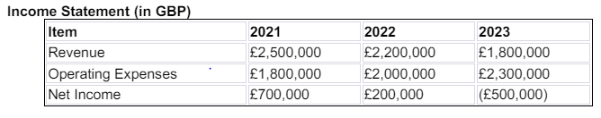
Table 2
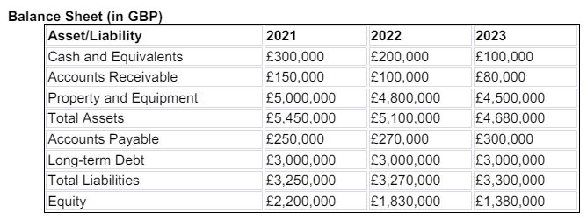
Revenue
According to Table 1, there has been a consistent decline in revenue over the past three years. From 2021 to 2022 revenue decreased by £300,000 which is about a 12% decrease. From 2022 to 2023 revenue further decreased by £400,000 which is about a decrease of 18.2%. Overall there is a decrease of 28% in the revenue from 2021 to 2023.
Operating Expenses
Table 1 shows that operating expenses increased from 2021 to 2023. From 2021 to 2022 expenses increased by £200,000 which is an increase of 11.1%. There is an increase of 15% in the expenses by £300,000 from the year 2021 to 2023. Overall from 2021 to 2023, the operating expenses increased by 27.8% which is a huge margin.
Profitability
Profitability proportions evaluate an organization's capacity to procure benefits from its deals or tasks, balance sheet assets or investor's value. They show how effectively an organization creates benefits and incentives for investors (Matar and Eneizan, 2018). Profitability proportions incorporate edge proportions and return ratios. Analysis of Table 1 shows that there is a sharp decline in the profitability of the Urban Height Hotel. Net income decreased by £500,000 which is about a 71.4% decrease in the year 2021 to 2022. From the year 2022 to 2023, the company incurred a net loss of £500,000. Overall, the net income from 2021 to 2023 decreased by £1,200,000, which is shifting from positive net income to a net loss.
Liquidity
Liquidity refers to the capacity to cover short-term obligations. Solvency, on the other hand, is a company's capacity to pay long-haul commitments. For a firm this will frequently incorporate, having the option to reimburse the interest and head on obligations like securities or long-haul leases (Li et al., 2020). Liquidity has weakened in the past three years at Urban Height Hotel. According to the cash and equivalent analysis from 2021 to 2022 cash and equivalents decreased by about £100,000 which is 33.3%. Cash equivalents further decreased by £100,000 (50% decrease) from the year 2022 to 2023. Overall from 2022 to 2023, there is a decrease of 66.7% decrease in cash and equivalents. Furthermore according to the accounts receivable analysis from 2021 to 2022 accounts receivable decreased by £50,000 which is about a 33.3% decrease, from the year 2022 to 2023 accounts receivable decreased by £20,000 (20% decrease). Overall from the year 2021 to 2023, there is a 46.7% decrease in accounts receivable.
Solvency
Solvency depicts the capacity of the business (or individual) to take care of its monetary commitments. Consequently, the fastest evaluation of an organization’s solvency is its resources short liabilities which is equivalent to its investor’s value (DAHIYAT et al., 2021). So for checking the Urban Height solvency long-term debt, total liabilities analysis and equity analysis were conducted. It was concluded that long-term debt remained constant through the past three years which is about £3,000,000. Whilst total liabilities of the hotel has been slightly increased. From 2021 to 2022 it increased by £20,000 (0.6% increase). From the year 2022 to 2023, total liabilities increased by £30,000 which is about 0.9%. So overall from 2021 to 2023, there is a 1.5% increase in total liabilities. Moreover, equity has decreased in the past three years. From 2021 to 2022 equity decreased by £370,000 (16.8% decrease). Equity decreased by £450,000 which is about a 24.6% decrease from the year 2022 to 2023. The overall rate of equity decrease from 2021 to 2023 was 37.3% (Burhan et al., 2021).

Key Reasons for the decline in profitability
The hotel has confronted critical difficulties throughout recent years, with declining income and expanding costs, prompting a deterioration in the benefits. Liquidity has debilitated extensively, and even though solvency ratios have not deteriorated essentially, the substantial decrease in equity is a concern. The overall financial health proposes the requirement for strategic adjustments to further develop income generation and control costs (Chen et al., 2021). There are several reasons for the decrease in the productivity of the hotel. Such as revenue might be reduced due to market conditions and customer preferences. Economic downturns, diminished consumer spending, or expanded rivalry might have influenced hotel appointments (Alvarez-Ferrer et al., 2018). Changes in client preferences, for example, a shift towards elective accommodations options like Airbnb, might have added to bring down the income of the hotel. An increase in inflation is due to an increase in the expenses of labour and products, including utilities, supplies and support. Also, the increase in daily wages of the labourers and benefits for the employees have increased the expenses of the hotel (Pelaez-Verdet. and Loscertales-Sanchez, 2021).
Shortcomings in overseeing assets, prompting higher functional expenses might be another reason. The reasons for the decline in profit margins might be because of the reduction in revenue. High fixed expenses, for example, contract instalments on property, which stay consistent paying regardless of revenue fluctuations. Inflated costs without enhancements in functional effectiveness can dissolve net revenues (Dimitrić, et al., 2019). Reasons for the decrease in liquidity and solvency of the hotel might be reduced in cash flow. Lower-income and higher costs have likely prompted diminished income, influencing liquidity. Continuous commitments to support long-haul obligations without adequate income age. The decline in the worth of property and gear affects general resource esteem (He et al., 2019). It is concluded that a decrease in revenue, an increase in operational expenses, eroding profit margins and challenging liquidity and solvency are the key reasons for the decline in profitability of hotels. Resolving these issues will require an essential way to deal with improving income, control costs, work on functional efficiencies and oversee liquidity and solvency effectively (Ahmad et al., 2022).

Turnaround strategy
Cost efficiency strategy
Revive the hotel’s financial development and to regain its reputation a good turnout strategy is essential. The strategy mainly focuses on supporting income, controlling expenses, working on functional proficiency and improving their visitor experience. For developing a turnout strategy, Urban Height Hotel needs to foster prompting efforts focusing on specific customer portions like business explorers, families and couples. The requirement for turn-out strategy is not restricted to only firms during financial downturns or outer variables (Igosheva et al., 2024). The reason for turnout execution could be boundless to incorporate the underperformance or fumble of firm methodology by the authority or management structure. It is at the basic point that many organizations in the hospitality business face critical difficulties (Fairley, 2019).
Turnaround can be operational and strategic (Malačič and Malačič, 2016). Operational review ordinally brings about conversations which conversations which address a bunch of activities pointed toward decreasing expenses. These processes are also referred to as recovery, they are not consecutive and may happen at the same time or autonomously (Mulwa, 2017). For the hospitality business, turnaround strategy includes several components such as the Urban Height hotel must develop techniques for generating a profit and reducing cost, must navigate and understand market competition and position, enhance front office tasks, increase food and beverage options and streamline housekeeping operations (Artana and Wiagustini, 2018). For better productivity, the hotel must adopt technologies which are effective across other hospitality businesses (Dimitrios et al., 2020).

Financial Projections
Income Statement
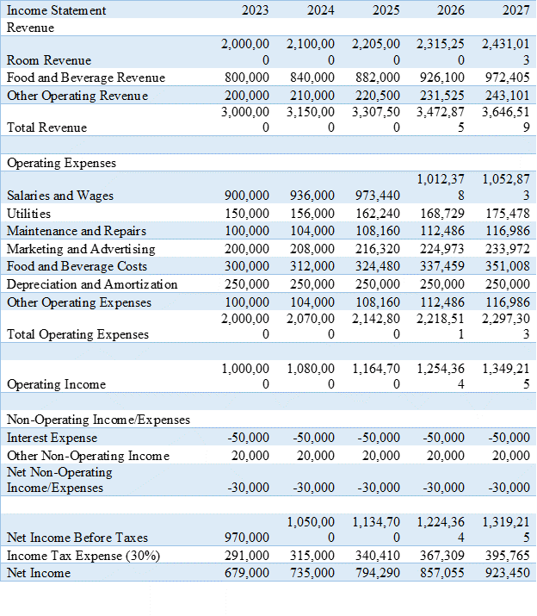

Balance sheet
s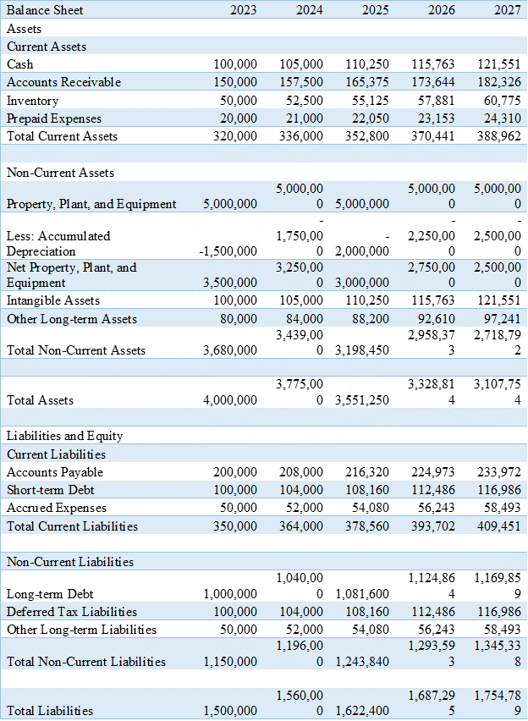

Conclusion
The idea of the corporate procedure and investigation on the segmental in markets is never a simple cycle in any event, for individuals who get by in the field of inn business. Nonetheless, his review offered me a chance to all the more likely comprehend the market portion of the lodging business (Richard, 2017). In this report, the trends and patterns of Urban Height hotels are discussed in detail. The financial performance of the past three years of Urban Height is also discussed. It is concluded that the operational expenses of the hotel have been increased which has reduced the overall revenue of the hotel. The profitability of the hotel has also been slightly decreased from the year 2020 to 2023. Profitability has shifted from positive net income to net loss. Moreover, the liquidity and solvency of the hotel have also decreased in the past three years (Babajee et al., 2020).

References
Ahmad, N., Ullah, Z., AlDhaen, E., Han, H., Ariza-Montes, A. and Vega-Muñoz, A., 2022. Fostering advocacy behavior of employees: A corporate social responsibility perspective from the hospitality sector. Frontiers in Psychology, 13, p.865021.
Alvarez-Ferrer, A., Campa-Planas, F. and Gonzales-Bustos, J.P., 2018. Identification of the key factors for success in the hotel sector. Intangible Capital, 14(1), pp.74-98.
Artana, I.M. and Wiagustini, L.P., 2018. Formulation Process of Turnaround Strategy to Overcome Financial Distress in Pt. Pn. International Journal of Novel Research in Marketing Management and Economics, 5(3), pp.36-45.
Babajee, R.B., Seetanah, B. and Nunkoo, R., 2020. The determinants of hotel financial performance: an intellectual capital perspective. Journal of Hospitality Marketing & Management, 29(8), pp.1008-1026.
Ball, I., Buiter, W., Crompton, J., Detter, D. and Soll, J., 2024. Looking to the Future: The Comprehensive Balance Sheet. In Public Net Worth: Accounting–Government-Democracy (pp. 97-109).
Bhattacharyya, S.S. and Malik, A., 2020. Development of an integrated canvas on turnaround strategy. International Journal of Organizational Analysis, 28(2), pp.523-554.
Budović, A., Ratkaj, I. and Antić, M., 2020. Evolution of urban hotel geography–a case study of Belgrade. Current Issues in Tourism, 23(6), pp.707-722.
Burhan, M., Salam, M.T., Abou Hamdan, O. and Tariq, H., 2021. Crisis management in the hospitality sector SMEs in Pakistan during COVID-19. International Journal of Hospitality Management, 98, p.103037.
Chen, Y., Kumara, E.K. and Sivakumar, V., 2021. Investigation of the finance industry on risk awareness model and digital economic growth. Annals of Operations Research, pp.1-22
DAHIYAT, A.A., Weshah, S.R. and ALDAHIYAT, M., 2021. Liquidity and solvency management and its impact on financial performance: Empirical evidence from Jordan. The Journal of Asian Finance, Economics and Business, 8(5), pp.135-141.
Dimitrić, M., Tomas Žiković, I. and Arbula Blecich, A., 2019. Profitability determinants of hotel companies in selected Mediterranean countries. Economic research-Ekonomska istraživanja, 32(1), pp.1977-1993.
Dixit, S.K., Lee, K.H. and Loo, P.T., 2021. Consumer behavior in hospitality and tourism. In Consumer Behaviour in Hospitality and Tourism (pp. 1-9). Routledge.
Elsharnouby, T.H. and Elbanna, S., 2021. Change or perish: Examining the role of human capital and dynamic marketing capabilities in the hospitality sector. Tourism Management, 82, p.104184.
Fairley, J., 2019. Turnaround Strategies in Destination Marketing Organizations. Tourist Destination Management: Instruments, Products, and Case Studies, pp.227-239.
Filimonau, V., 2021. The prospects of waste management in the hospitality sector post COVID-19. Resources, Conservation and Recycling, 168, p.105272.
Hastings, G., Angus, K., Eadie, D. and Hunt, K., 2020. Selling second best: how infant formula marketing works. Globalization and Health, 16, pp.1-12.
He, P., Qiu, Y., Wang, Y.D., Cobanoglu, C., Ciftci, O. and Liu, Z., 2019. Loss of profit in the hotel industry of the United States due to climate change. Environmental Research Letters, 14(8), p.084022.
Hickel, J., 2021. What does degrowth mean? A few points of clarification. Globalizations, 18(7), pp.1105-1111.
Igosheva, L., Filimonau, V., Ciraulo, M., Ashton, M. and Ermolaev, V.A., 2024. Revisiting the taxonomy of market exit strategies in hotels. International Journal of Hospitality Management, 120, p.103777.
Khanra, S., Dhir, A., Kaur, P. and Joseph, R.P., 2021. Factors influencing the adoption postponement of mobile payment services in the hospitality sector during a pandemic. Journal of Hospitality and Tourism Management, 46, pp.26-39.
Li, K., Musah, M., Kong, Y., Adjei Mensah, I., Antwi, S.K., Bawuah, J., Donkor, M., Coffie, C.P.K. and Andrew Osei, A., 2020. Liquidity and firms’ financial performance nexus: panel evidence from non-financial firms listed on the Ghana Stock Exchange. Sage Open, 10(3), p.2158244020950363.
Malačič, N. and Malačič, I., 2016. Key factors for successful financial and business restructuring with a general corporate restructuring model and Slovenian companies case studies. Inštitut za ekonomska raziskovanja.
Martínez, P., Herrero, Á. and Gómez‐López, R., 2019. Corporate images and customer behavioral intentions in an environmentally certified context: Promoting environmental sustainability in the hospitality industry. Corporate Social Responsibility and Environmental Management, 26(6), pp.1382-1391.
Matar, A. and Eneizan, B., 2018. Determinants of financial performance in the industrial firms: Evidence from Jordan. Asian Journal of Agricultural Extension, Economics & Sociology, 22(1), pp.1-10.
Milasinovic, M., Mitrović, A. and Milojević, S., 2020. Financial performance measuring of a hotel company-case study. Challenges of Tourism and Business Logistics in the 21st Century, 3(1), pp.228-234.
Mitrovic, A., Milašinović, M. and Knežević, S., 2023. The importance of net working capital in the hotel companies’ liquidity assessment. In 1st International Scientific Conference on Economy, Management and Information Technologies–ICEMIT 2023.
Mohamad Said, N.H., Abdull Rahman, N.L., Abd Mutalib, H. and Badri Shah, N.S., 2021. Profitability performance analysis on malaysian hotel industry during covid-19 pandemic. Journal of Academia, 9, pp.84-92.
Mulwa, M., 2017. The Effect Of Turnaround Strategy On The Performance Of Kenya Airways (Doctoral dissertation, University of Nairobi). Dimitrios, B., Christos, P., Ioannis, R. and Vasiliadis, L., 2020. Strategic management in the hotel industry: proposed strategic practices to recover from COVID-19 global crisis. Academic Journal of Interdisciplinary Studies, 9(6), pp.130-130.
Nguyen, L.T.M., Le, D., Vu, K.T. and Tran, T.K., 2023. The role of capital structure management in maintaining the financial stability of hotel firms during the pandemic—A global investigation. International Journal of Hospitality Management, 109, p.103366.
Ntounis, N., Parker, C., Skinner, H., Steadman, C. and Warnaby, G., 2022. Tourism and Hospitality industry resilience during the Covid-19 pandemic: Evidence from England. Current Issues in Tourism, 25(1), pp.46-59.
Pelaez-Verdet, A. and Loscertales-Sanchez, P., 2021. Key ratios for long-term prediction of hotel financial distress and corporate default: Survival analysis for an economic stagnation. Sustainability, 13(3), p.1473.
Qin, Y., Qin, J. and Liu, C., 2021. Spatial-temporal evolution patterns of hotels in China: 1978–2018. International Journal of Contemporary Hospitality Management, 33(6), pp.2194-2218.
Rather, R.A., Tehseen, S., Itoo, M.H. and Parrey, S.H., 2021. Customer brand identification, affective commitment, customer satisfaction, and brand trust as antecedents of customer behavioral intention of loyalty: An empirical study in the hospitality sector. In Consumer behaviour in hospitality and tourism (pp. 44-65). Routledge.
Richard, B., 2017. Hotel chains: survival strategies for a dynamic future. Journal of Tourism Futures, 3(1), pp.56-65.
Sejati, A.W., Rahayu, S., Pigawati, B. and Winarendri, J., 2018. The Ex-Ante Evaluation of Hotel Buildings Height in Airport Area: A Case of Hotel in Kaliwungu, Peri-Urban Area of Semarang. Journal of Architectural Design and Urbanism, 1(1), pp.31-39.
Sikveland, M., Xie, J. and Zhang, D., 2022. Determinants of capital structure in the hospitality industry: Impact of clustering and seasonality on debt and liquidity. International Journal of Hospitality Management, 102, p.103172.
Umrani, W.A., Channa, N.A., Ahmed, U., Syed, J., Pahi, M.H. and Ramayah, T., 2022. The laws of attraction: Role of green human resources, culture and environmental performance in the hospitality sector. International Journal of Hospitality Management, 103, p.103222.
Wang, S., Hung, K. and Huang, W.J., 2019. Motivations for entrepreneurship in the tourism and hospitality sector: A social cognitive theory perspective. International Journal of Hospitality Management, 78, pp.78-88.

