Database Analysis

and Design
  - ACCA4023

Benjamin Powell | 2015305 | 16/04/21
L4 - Introduction to Web and Database Concepts
Contents
Introduction 2
Requirements 2
Database Design 2
Final ERDd 2
References 3
Appendices 4

Introduction

As part of this assignment, I have been tasked with designing, creating, and implementing a database that meets a specified criteria as provided by a client to manage their order across several stores. The client has decided to update from paper-based system to a modern database.

Requirements

Celtic Caters, the client, has requested that the modern solution possess a few essential requirements, they are outlined below:
- The interface should be easy to use and be expandable; the client is looking to use the system for additional uses such as to perform financial audits.
- It should be able to detect duplicate data (for example double bookings) and should provide the user with a warning/pop up.
- All orders should be made using a pre-made query or by using the forms feature.

Database Design

Based on the above requirements as set out by the client, the following documentation was developed to outline the data flow between the key stakeholders. The diagram shows how the data is handled as well as where/what data will be stored at each checkpoint.

Context Diagram
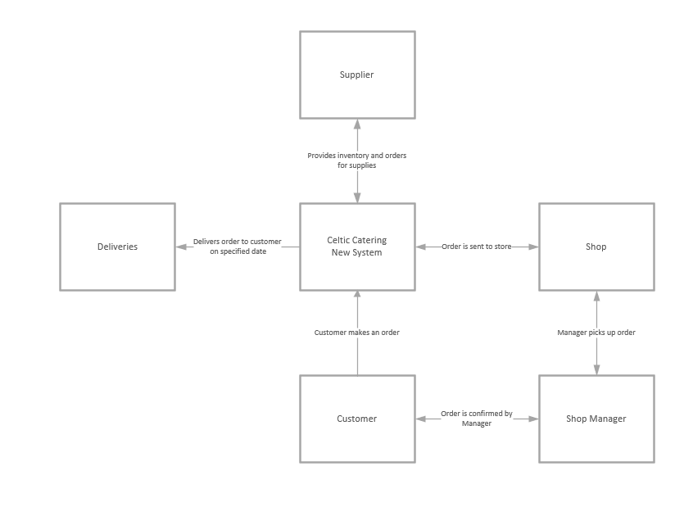

Level 0 Data Flow Diagram
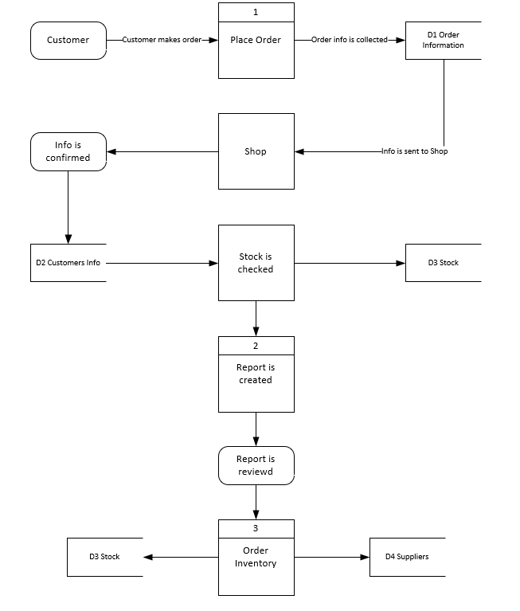

Entity Relationship Diagram

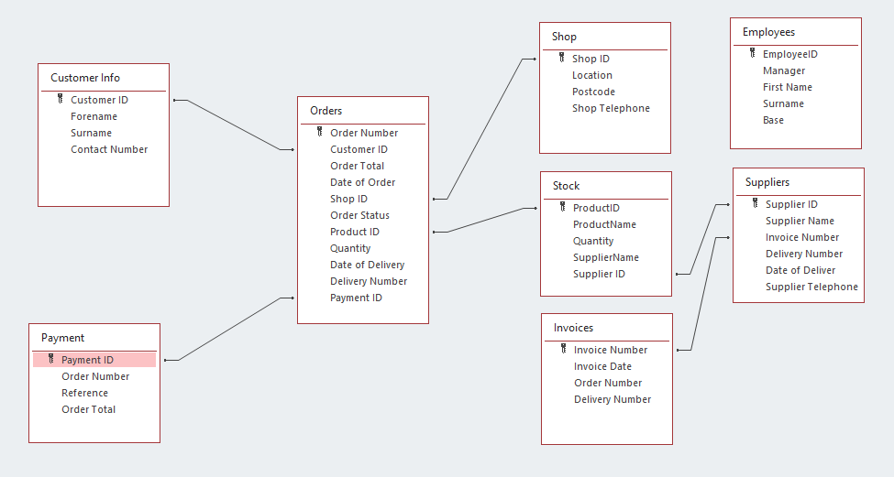

Implementation

The next section will convey how each table within the database has been configured. I have made a note to highlight any errors or issues that have occurred during the development process.

Tables
My database consists of 9 tables as seen below. When creating the tables I have taken the relationships that connect each table into account, as well as attempting to ensure that each comply with 3rd Normalised form to reduce duplication.
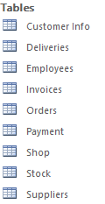
Table 1 – Customer Table
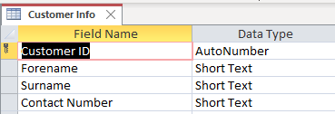
When creating the customer table, I designated Customer ID as the primary key. Fortunately, I was able to deploy a very basic input mask on AutoNumber data types due despite my lack of familiarity with MS Access. The input mask was set to create a customer ID following this basic structure CC100(increment number), an example of this can be seen below:
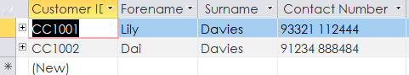

Table 2 – Deliveries
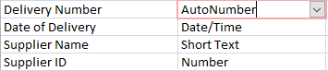
I choose Delivery Number as the primary key for this table as every delivery should have a unique delivery number (or ID).
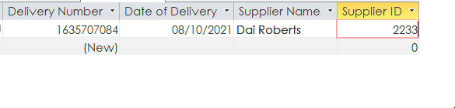
Table 3 - Employees
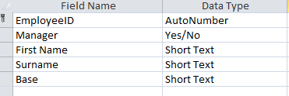
For this table I designated Employee ID as the primary key. I also added a key to denote if the employee is a manager using a Boolean. This was done as an easy identifier to denote a regular employee from that of a manager. In the future this could be denoted by creating separate table for employees and managers.
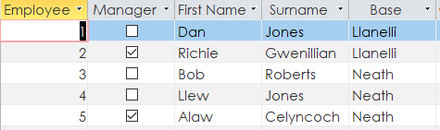

Table 4 – Invoices
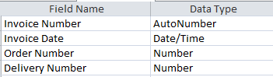
The next table featured in my database was the invoice table. This table featured a number of input masks including some on the Invoice Number and Order Number fields. These can be seen below:
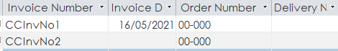

Table 5 – Orders
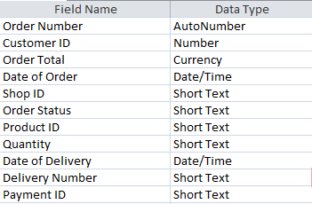
For this table the Order Number field was designated as the Primary Key. Additionally, a number of IDs from a range of table input into the Orders Table. In future I would develop this table to remove obsolete fields in order to ensure that it conforms to the 3rd Normal Form.

Table 6 – Payments
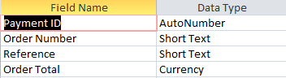
This table was a late addition and will need to be developed further to be of any use to the database. In the meantime, this table should be ignored by the user.


Table 7 – Shop
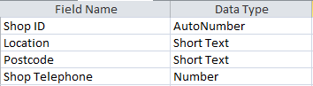
This table uses the Shop ID field as it’s primary Key. This table could be developed further to include Input masks on several fields, specifically Shop ID and Telephone. This can be addressed in a future development of the database.
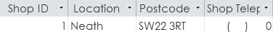

Table 8 – Stock
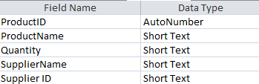
The stock table was configured as shown above with the Product ID designated as the Primary Key.

Table 9 – Suppliers
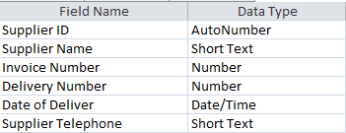
In this table the Supplier ID is the Primary key as each supplier would be outfitted with a unique identifier when logged into the database. This allows the supplier to be identified quickly and avoids confusion with another entity in the database. This table lack input masks on several fields which will be addressed in a future development.
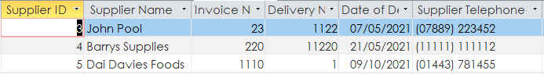

Queries

A basic query was initiated using the query wizard to identify Managers from each location within Celtic Caterers. The output of this query can be found below.
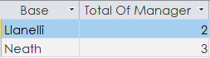
Due to my lack of experience with MS Access I was not able to perform more advanced queries, although I believe this can be rectified with enough practice.

Forms and Interface Concept
Each table has a corresponding form which can be used to create a new entry in each table. Each form possesses two buttons, which can be used to create a new form and to save the current form. An overview of these forms can be found below:
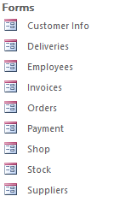
Form 1 – Customer Info
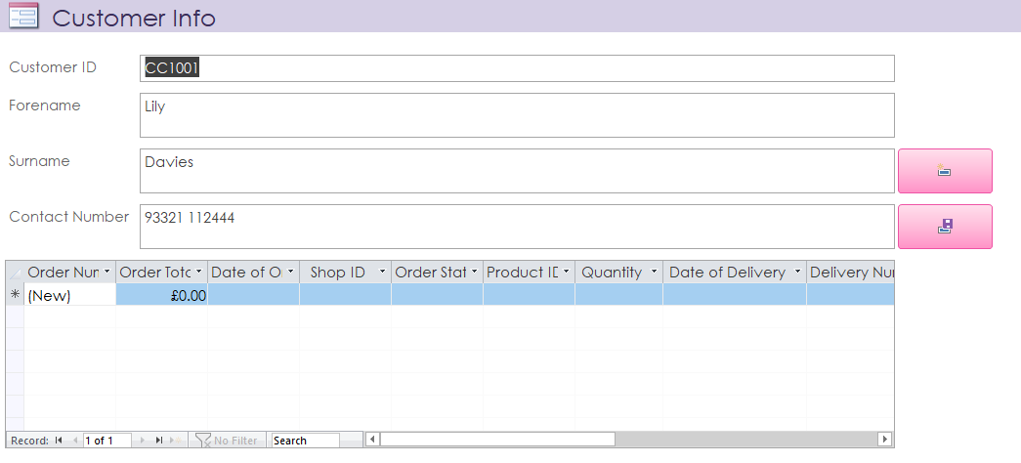
Form 2 – Deliveries
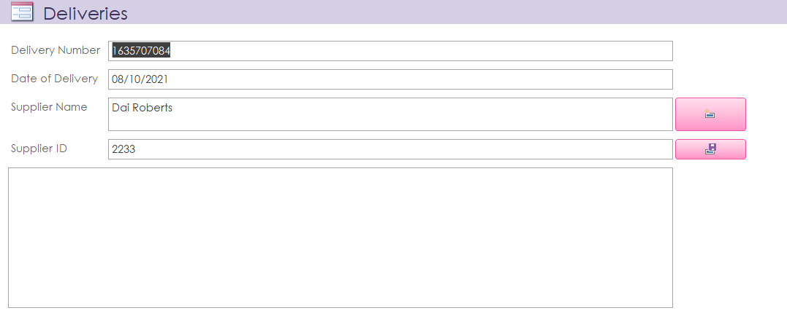
Form 3 – Employees
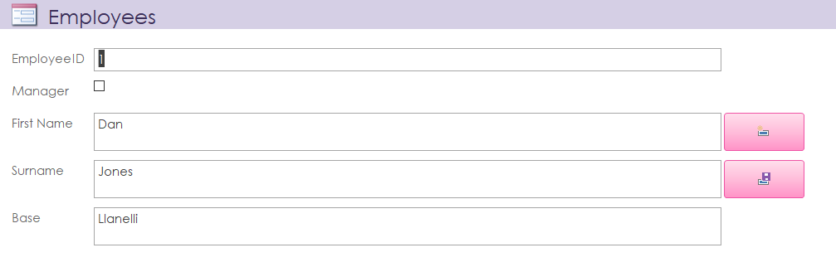
Form 4 – Invoices
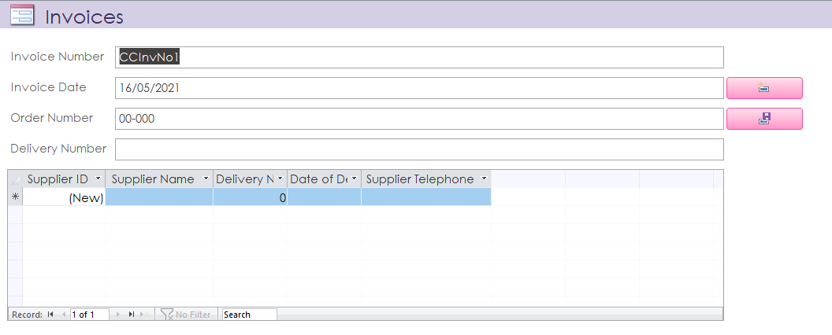
Form 5 – Orders
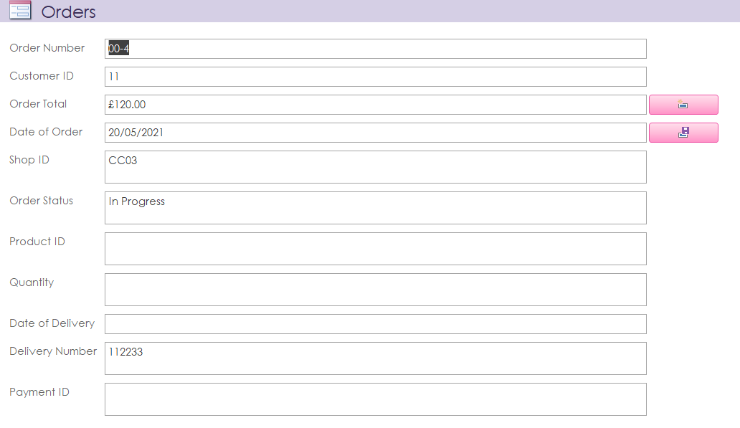
Form 6 - Payment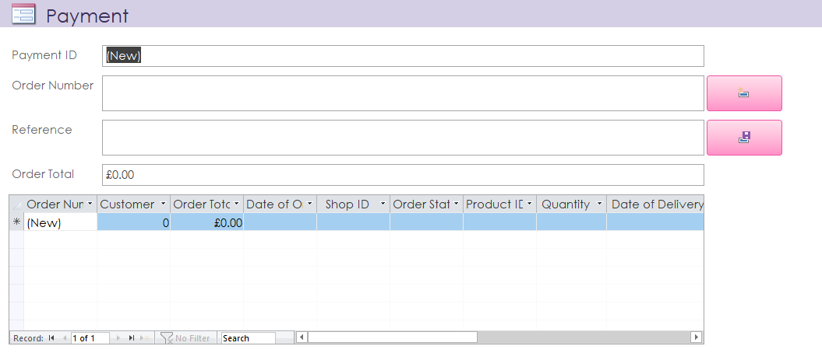
Form 7 - Shop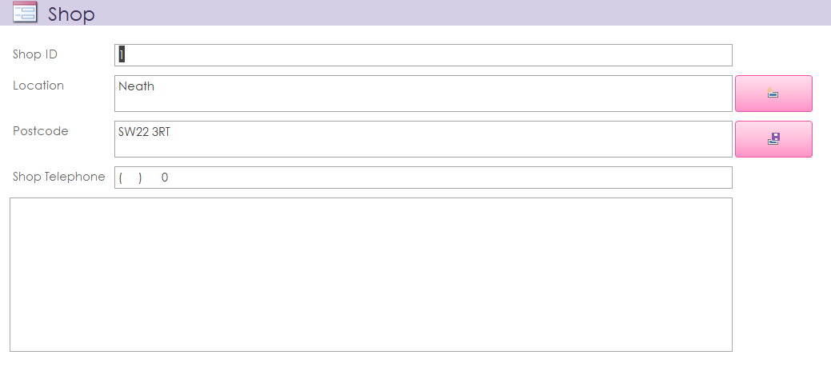
Form 8 – Stock
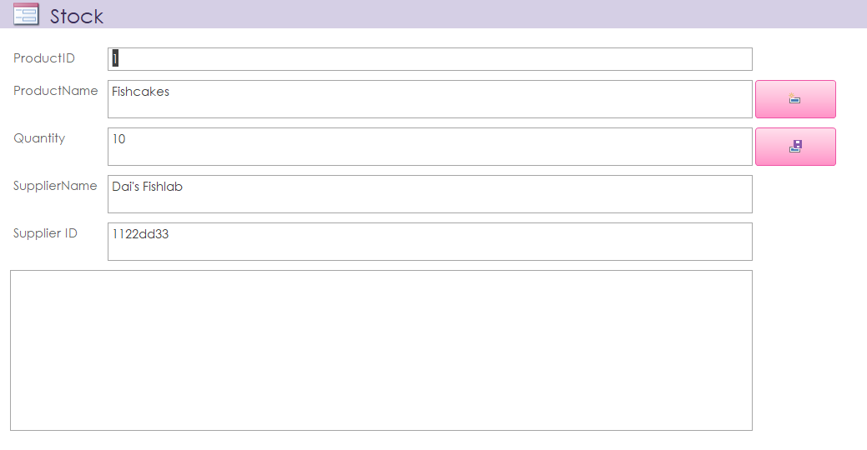
Form 9 – Suppliers
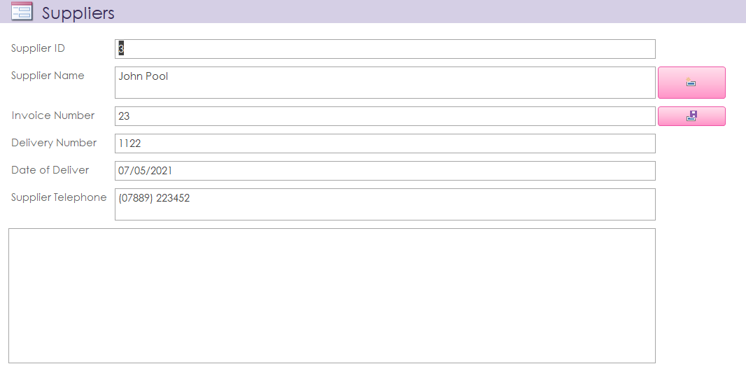
Interface Concept
Unfortunately, I was not able to develop a Form interface for the database, however a concept can be seen below:
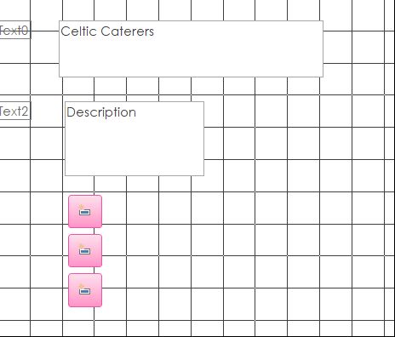

Conclusion
To conclude I was able to develop a very basic database that could be used by the client to fulfil the requirement as outlined in the beginning of this document. However, several issues occurred, mainly out of a lack of experience with the tooling. To develop the database further a greater understanding of MS Access is required, especially around the Queries and Forms.

References
Introduction to Microsoft Access 2016 for Absolute Beginners by Udemy.com:
https://www.udemy.com/course/microsoft-access-2016-for-absolute-beginners/?utm_source=adwords&utm_medium=udemyads&utm_campaign=MicrosoftAccess_v.PROF_la.EN_cc.UK_ti.6712&utm_content=deal4584&utm_term=_._ag_73899888913_._ad_532713167455_._kw__._de_c_._dm__._pl__._ti_dsa-774930040049_._li_9045353_._pd__._&matchtype=b&gclid=Cj0KCQjw_fiLBhDOARIsAF4khR2CjZ2T_5A9a3H9zVd_ZdL1PzqRRvZuSeiKzF6rYdoyv0cubqCp3kEaAmy8EALw_wcB
Basic tasks for an Access desktop database by Micrsoft.com:
https://support.microsoft.com/en-us/office/basic-tasks-for-an-access-desktop-database-5ddb8595-497c-4366-8327-ae79d2abdc9c

