

Callum Doherty

Simulating shape charge liner geometries in 2D and 3D using ABAQUS

UWTSD
Advanced Physics of OME (ACDB5015)

Supervisor: Prof Kelvin Donne
May 2026

Abstract
This report presents the design and analysis of a copper lined and tungsten cased shaped charge using ABAQUS/Explicit. It uses the Lagrangian form to explore the jet velocities and the Eulerian form to express the simulation unconditionally with large peak plastic strain values (560%) present. A flat liner was compared to a rounded liner, for which the flat liner produced a faster (8%) and longer jet. The values obtained were comparable with already agreed ranges. A literature review was also performed on current shape charge physics, and a velocity estimation is calculated using the Gurney equation to compare against the direct values obtained. A limitation present throughout the study is the 250k element limit imposed by ABAQUS but through intelligent mesh design this was made more possible.

Keywords:
Eulerian, Lagrangian, ABAQUS, Jet, Formation, Munroe, Liner, Cone

Table of Contents
Abstract ii
List of Figures v
List of Tables vii
List of Equations viii
1 Introduction 1
1.1 Abaqus modelling 2
1.2 Purpose 2
2 Literature Review and Pre-Decisions 3
2.1 The history of shape charges 3
2.2 Jet Interaction 3
2.3 Gurney energy 4
2.4 Shock physics 4
2.5 Deflagration to detonation transition 5
2.6 Material Models 5
2.7 Computation methods 6
2.8 Shape charge modelling and design research. 6
3 Material Model 8
3.1 Gurney calculation 10
4 Two Dimensional Analysis 11
4.1 Model Dimensions 11
4.2 Mesh strategy 12
4.2.1 Edge seeding and biased mesh direction 13
4.2.2 Element type 14
4.2.3 Complementary mesh boundaries 15
4.2.4 Mesh convergence testing. 16
4.3 Boundary conditions and contact 17
4.4 Results (flat) 19
4.5 Results (circle) 22
4.6 Design selection 24
4.7 Bulk viscosity testing 25
4.8 Calculated Gurney comparison 25
5 Three dimensional analysis 26
5.1 Eulerian and meshing 26
5.2 Volume Fraction Tool 27
5.3 Results (3D) 28
5.3.1 Peak Plastic Strain 28
5.3.2 Detonation propagation to jet formation 29
5.3.3 Shear forces 31
6 Further Discussion 33
6.1 Method limitations 33
6.2 2D and 3D, same design different results 33
6.3 Validation 34
6.4 Directions for further work 34
7 Conclusion 35
References 36

List of Figures
Figure 1: Basic diagram of a shape charge, highlighting its main three sections. 1
Figure 2: Example shape of the jet formed from a copper lined shape charge. 2
Figure 3: ABAQUS Sketch of the rounded liner. 11
Figure 4: ABAQUS sketch of the flat liner. 12
Figure 5: Fully meshed designs. Left is the rounded liner design. Right is the flat liner design. 13
Figure 6: Mesh SAR parameters showing the Element Type for the 2D designs. 15
Figure 7: Rounded liner with element excessively distorting causing interpolation error. 16
Figure 8: Boundary condition set, forcing XSYMM on the axis of symmetry. This is the same for both 2D designs. 17
Figure 9: Contact properties for the 2D designs, showing Tangential and Normal behaviour properties. 18
Figure 10: Field and History Output Request selection for both 2D designs. 18
Figure 11: Flat liner jet tip velocity graph. Uses 30 data points. 19
Figure 12: Flat liner shape charge at 100µs, showing initial jet formation. 20
Figure 13: Flat liner shape charge at 19µs, showing the arrival of the detonation wave. 20
Figure 14: Flat liner shape charge at 50µs, where the detonation wave is seen to be reflected and absorbed by the casing prior to jet formation. 21
Figure 15: Flat liner shape charge at 200µs showing the full jet formation. 21
Figure 16: Rounded liner jet tip velocity graph, uses 20 data points. 22
Figure 17: Rounded liner shape charge at 50µs, showing the formation of the jet from the detonation wave. 23
Figure 18: Rounded liner shape charge at 100µs, showing the initial jet formed, wider than the flat liner version. 23
Figure 19: Rounded liner shape charge at 200µs, final jet formation. 24
Figure 20: Selected nodes for each design. Top picture is the rounded liner; bottom is flat liner. Flat liner has more selectable nodes. 25
Figure 21: Partitioned Eulerian mesh, bottom up in the centre and global sweep on the outside. 27
Figure 22: Eulerian simulation with an updated mesh without redoing the volume fraction. 28
Figure 23: Highest peak plastic strain (%) experienced, suggesting the point at which beading will begin to occur. 28
Figure 24: 3D Eulerian shape charge at 200µs showing beading and final jet formation. 29
Figure 25: 3D Eulerian shape charge at 30µs, showing the initial impact of the detonation wave. 30
Figure 26: 3D Eulerian shape charge at 100µs, showing that the jet has started to form and take shape. 31
Figure 27: 3D Eulerian shape charge at 15, 50, and 100μs (left to right). It shows the S23 shear forces as active, passive, and then active throughout the jet formation. 32

List of Tables
Table 1: Johnson Cook plasticity parameters for copper liner and tungsten casing. 8
Table 2: Mei Gruneisen EOS parameters for copper liner and Tungsten casing. 9
Table 3: Jones Wilkins Lee equation of state parameters for TNT 9
Table 4: Edge seed values for the liner, casing and HE for the 2D parts. 14

List of Equations
(3-1.1) 10
(3-1.2) 10
(3-1.3) 10

Introduction
A shape charge is a military weapon used to concentrate the energy of an explosive to produce a high velocity metal jet, capable of penetrating armoured targets up to a specified depth. The shape charge consists of a casing, filling, and liner, as seen in Figure 1.
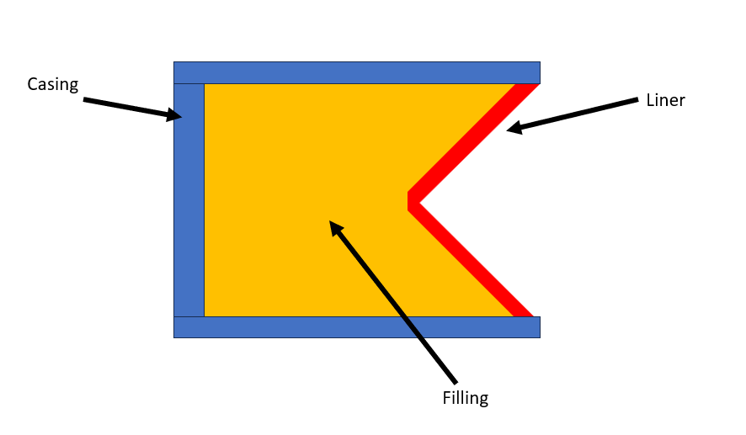
Figure 1: Basic diagram of a shape charge, highlighting its main three sections.
The casing acts as a barrier and holds the filling in place during detonation to allow the pressure to be directed towards the weaker liner material and allow for aiming of the device. The filling is used to provide the energy source to maintain the reaction. The liner is the material which forms a jet and its properties and physical geometry will primarily dictate the power and shape of the formed jet. The jet typically will form a stretched arrowhead or carrot shape, as seen in Figure 2, which is the shape of the copper jet formed in this study.

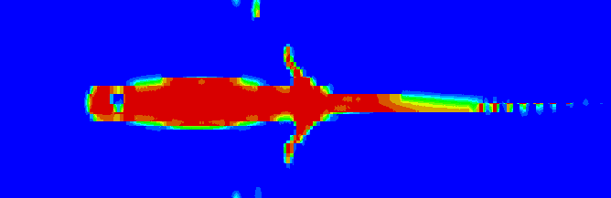
Figure 2: Example shape of the jet formed from a copper lined shape charge.
The jet forms from the immense pressure applied by the detonation wave. The metal liner collapses under this pressure. As the shape charge is symmetrical it cancels out any radial motion and instead compresses it from both sides, squeezing the metal liner forwards at a high velocity [1]. The liner gets extruded into a thin jet while the rest gets dragged along, eventually slowing down the jet and causing a velocity gradient.

Abaqus modelling
Shaped charges are inherently highly dynamic and involve large amounts of plastic deformation. Because these events occur over such a short time scale and involve excessive distortion of materials, they are very difficult to represent using standard finite element methods. ABAQUS/Explicit is a common use for this problem because it is designed to allow for such dynamic events through its explicit time integration.
In shaped charge simulation, the main components are described through elastic plastic material modes. ABAQUS uses hydrodynamic equations of state such as the Jones Wilkins Lee or Mie Gruneisen to provide a numerical description of the large evolving pressure.

Purpose
This report will look at two methods of modelling in ABAQUS, namely the Lagrangian and Eulerian form. It will also cover different liner geometries to see the impact to jet shape and velocity. It further compares the studies and details the problems faced during modelling.

Literature Review and Pre-Decisions

The history of shape charges
Shape charges were first mentioned in 1792 as a mining charge, with German mining engineer Franz Xaver von Baader writing a journal entry advocating for a conical space at the end of a blasting charge in order to increase its explosive effects [2]. The idea used blackpowder, a low explosive which was incapable of producing a sufficient shock wave to produce a true shape charge. It wouldn’t be until 1888 that Charles E Munroe discovered the aptly named Munroe effect, when exploding guncotton against a steel plate produced a penetration that mirrored a cavity in the explosive’s geometry [3]. Later, this would be tested on different shapes and angles with higher explosives, as seen in the issue of Popular Science in 1945 explaining the principles behind conical lined charges such as the Bazooka and Panzerfaust [4].
The underlying physics behind the jet formation was established in 1948 by Birkhoff, for which he derived steady state relations between collapse angle, detonation, and resulting jet and slug velocities from a comprehensive hydrodynamic treatment of a conical liner collapse [5]. Brinkhoff’s theory was later refined by Pugh in 1952 to include an unsteady collapse and axial velocity gradients, the main cause of jet elongation and beading [6]. A widely accepted text is that of Walters, which collates most analytical results with a modern computational inclusion [7].

Jet Interaction
Upon initiation of a shape charge, a detonation wave sweeps across the liner and collapses it onto its axis of symmetry. Only a small amount of the liner (typically 15 to 20%) is squeezed forwards as a high velocity jet, with the remaining material forming a slug. The jet itself has a strong velocity gradient, with tip velocity in copper typically in the range of 7 to 10km/s and tail velocities 1 to 30km/s, as described by Walters. This gradient causes a progressive stretching during flight, causing it to break up into smaller discrete particles. The maximum penetration is then typically obtained at a stand off distance that allows for the stretching to occur without any significant particulation occurring. This is typically measured in charges diameters [8]. Penetration itself is described by application of the Bernoulli equation, in which both the jet and the target can be treated, theoretically, as an inviscid fluid.
As penetration relies on jet length, high density and ductile metals are attractive materials to use in liners, with copper fitting all these categories. The casing material selection is largely driven by its confinement ability, with higher density casings transmitting the peak detonation pressure better, at the cost of both mass of shape charge and expense in manufacture. In this study, tungsten acts as a conservative material capable of strong confinement during jet formation.

Gurney energy
In 1943, Gurney introduced a method for predicting the initial velocity of metal accelerated by a detonating explosive [9]. Gurney assumes that the chemical energy released by detonation is split between the kinetic energy of the liner, casing and expanding detonation products, with a linear velocity distribution. It assumes a terminal velocity is reached, that the velocity is always perpendicular to the metal surface, and that each geometry can be split into infinite rings. Different explosives can be easily characterised by the Gurney constant (√(2E)). For TNT this velocity is approximately 2.43 km/s, as described by Walters. Gurney uses a closed form prediction for different geometries, with the metal mass per unit area and explosive mass per unit area providing a reliable ratio to compare fragmentation effects. Increasing the metal per unit explosive will in turn decrease the velocity, following an inverse square law. For shape charges, a cylindrical Gurney equation is used since each element of the cone is radially driven inwards by the detonation products. The metal per unit explosive ratio varies along the cone height, contributing to the velocity gradient observed to cause jet stretching. Gurney can also yield a radial collapse velocity by treating each annular element of the cone as a unique cylindrical Gurney expression, seen by Walters, as the Gurney velocity for that annular element will be perpendicular to the cone surface.

Shock physics
Compressive shock waves provide discontinuities, leading to a greater pressure and temperature. Rarefactions, on the other hand, are continuous reductions. Detonation waves are a specific type of compressive shock wave in which the leading shock front creates an exothermic reaction in unreacted explosive material immediately behind the travelling wave [10]. The released chemical energy from the reaction sustains the shock at a constant velocity.
The state of a shock wave is expressed by the Rankine-Hugoniot conditions, which expresses the conservation of mass, energy, and momentum across a discontinuity [11]. In a detonating explosive, the shock wave is sustained at the Chapman-Jouget velocity, where the shock wave is travelling at sonic speeds relative to its front. For TNT, this value is 6930 m/s with a pressure of 21 GPa behind the reaction zone, at a given density of 1630 kg/m³ [11].
In ABAQUS, a Jones Wilkins Lee equation of state captures this Chapman Jouget behaviour as an isentropic expansion of detonation products. Material is further simulated by Abaqus to convert from unreacted to reacted as the expansion passes. This means that the reaction zone itself is not directly modelled and helps lower the computational power needed for this simulation which only looks at what happens post detonation.
Once the detonation wave reaches the liner, the pressure propagates the shock wave into the metal. This pressure is regulated by the difference in acoustic impedance between the explosive and liner, a principal idea talked about by Walters. This pressure will be equal at both the casing and the liner interface, however the total work done will be greater for the liner as it has a lower mass per unit area than the casing. The pressure exerted on the casing will be almost constant, whereas the pressure on the liner will change as it deforms and gets squeezed forwards.

Deflagration to detonation transition
Deflagration is a subsonic process in which the burn front propagates with the reaction. Detonation is supersonic shock driven process where shock compresses explosive material and propagates due to the release of energy from the unreacted material to sustain its supersonic wave. Detonation velocities for secondary explosives are typically around 8 km/s, shown by Cooper. For TNT, the deflagration rate is approximately 0.01m/s whereas its detonation wave can travel at around 7000 m/s, also shown by Cooper.
Deflagration to detonation occurs when a deflagrating explosive accumulates enough pressure to accelerate the burn front and cause compression waves to form ahead of it, causing shock to initiate material ahead of the deflagrating front. In ABAQUS, a detonation wave travelling at the Chapman-Jouget velocity is assumed from the instant of initiation.

Material Models
The Johnson cook plasticity model is a widely used description of high strain rate problems [13]. It explains how the metal flows under load. The model expresses stress as a combination of strain hardening, strain rate, and thermal softening and is available for most materials. It is, however, limited as it does not take into account any explicit structural dependence of the material [14].
The strain experienced by a shape charge exceeds several hundred percent as the metal breaks apart. To model this sufficiently a damage model is needed [15], and the Johnson cook damage criteria does this by expressing ductile failure [16]. It tracks the accumulation of damage in deforming elements, increasing in proportion to its plastic strain and failure strain.
The hydrostatic shock response to compression is expressed by the Mie Gruneisen equation of state. It expresses the pressure in a solid as the sum of its reference pressure from its Hugoniot and thermal difference from its internal energy [17].

Computation methods
ABAQUS has two types of solvers: Implicit Newton-Raphson, or Explicit. Implicit solvers are well suited to static problems but fail to converge under large deformations [18]. Explicit solvers integrate equations using a central difference explicit time integration scheme. Nodes are evaluated using a diagonal matrix with linear degrees of freedom, meaning that it requires no matrix factorisation. However, in each solver, the Jacobian matrix is used to calculate rate of change and as it approaches zero the deformation gradient becomes non-definable. In the explicit solver, this means that the integration points within each element produce corrupt stress values. These values will propagate and this is ultimately a failure in modern modelling design.
For simulations such as shape charges the strain rate can rapidly increase, causing elements to become incredibly small, leading to a smaller deformation gradient. This element distortion will then propagate and drives the explicit time step towards zero resulting in element deletion or simulation crash. The explicit formulation, however, is conditionally stable (assuming a perfect mesh) as the time increment must respect the Courant-Friedrichs-Lewy condition, which prevents Abaqus from processing information faster than one local time step, a value that is dependent on the local element size and dilatational wave speed.
The Lagrangian formulation is the standard formulation for finite element analysis. The Lagrangian uses a mesh that is attached to the material, with each node representing a specific point in relation to its prior motion. Otherwise, Eulerian formulations have a fixed mesh which allows material to flow through it and are unconditionally stable under heavy deformation. Recent applications to similar shock problems demonstrate agreement with the use of Eulerian formulations when mesh resolution is adequately fine tuned [19], [20].

Shape charge modelling and design research.
Shape charge modelling is a particularly less researched area due to sensitivity and security restrictions. Software to model such simulations is widely available but the numerical data and values are hard to come by.
Eric et al uses an Explicit ABAQUS model in a pure Eulerian formulation to model copper jet penetration. The work varies the jet and tail velocity gradient and details penetration depths of up to 536mm into rolled homogenous armour. The paper uses explicit numerical analytical with broad parametric sweeps. Eric et al notes that the penetration phase dominates the computational cost in respect to the jet formation and that material property uncertainty is the source of error. This present paper strategically did not use a target to save on computational cost under the guidance of Eric et al.
Zhang and Jin [21] used an Arbitrary Lagrangian Eulerian method with an adaptive mesh for a reusable oil well perforating gun. This work strategically looks at a nonmilitary weapon which uses the same physics behind shape charges, allowing for direct comparisons without the sensitivity barrier. They varied the liner angle and examined the penetration width, casing bulge and burr formation as a direct result. The Arbitrary Lagrangian Eulerian method successfully maintained element quality as the liner collapsed inwards but had a large computational expense. Zhang and Jin found that narrower angles allowed for faster jet formation, and wider angles allowed for a slower jet but wider perforation. They derived a formula to relate penetration width with liner angle, showing it to increase exponentially. The present paper uses this advice and chose a relatively steep angle (62° full angle) to allow for maximum jet velocity at the expense of a narrower penetration width.
Mohd Nor et al [22] used an Explicit Abaqus formulation with Johnson Cook and Mie Gruneisen parameter sets which were also used within this present study. Their Lagrangian simulation suffered from excessive distortion, and to conserve energy they had to delete such elements.
Mobaraki and Vaghefi are the sources used for the Jones Wilkins Lee parameters for TNT. Their analysis of liner geometry reported trends that agreed with Birkhoff and Pugh. Walters and Zukas provided a 7-10km/s copper liner velocity range.

Material Model
The copper and tungsten liner and casing both use a Johnson Cook plasticity model with a Mie Gruneisen equation of state, see Table 1 and Table 2. The high explosive filling, TNT, uses a Jones Wilkins Lee equation of state with the detonation point set to the rear centre of the filling, see Table 3. All metal parameters follow Mohd Nor et al. The TNT parameters follow Mobaraki and Vaghefi.

Table 1: Johnson Cook plasticity parameters for copper liner and tungsten casing.
Parameter | Symbol | Copper | Tungsten | Units
Density | ρ | 8930 | 18200 | Kg/m³
Shear modulus | G | 47.7 | 160 | GPa
Yield stress constant | A | 120 | 2200 | MPa
Strain hardening coefficient | B | 292 | 2920 | MPa
Strain hardening exponent | n | 0.31 | 0.19
Strain-rate coefficient | C | 0.025 | 0.025
Thermal softening exponent | m | 1.09 | 1.09
Melt temperature | T(m) | 1790 | 4520 | K
Reference temperature | T(r) | 293 | 293 | K
Specific heat | C(v) | 383 | 129 | J/Kg K
Failure stress | σ(f) | 1.20 | 1.20 | GPa

Table 2: Mei Gruneisen EOS parameters for copper liner and Tungsten casing.
Parameter | Symbol | Copper | Tungsten | Units
Bulk sound speed | C | 3940 | 4030 | m/s
Hugoniot slope | s₁ | 1.489 | 1.237
Gruneisen | γ₀ | 2.02 | 1.67
First volume correction | a | 0.47 | 0.38

Table 3: Jones Wilkins Lee equation of state parameters for TNT
Parameter | Symbol | Value | Units
Density | ρ | 1630 | Kg/m³
Detonation velocity | V(d) | 6930 | m/s
C-J pressure | P(Cj) | 21.0 | GPa
JWL constant A | A | 373.8 | GPa
JWL constant B | B | 3.747 | GPa
JWL exponent R₁ | R(1) | 4.15
JWL exponent R₂ | R(2) | 0.9
Gruneisen-like coefficient | Ω | 0.35
Detonation energy per unit volume | E(0) | 6.0 | GPa

Gurney calculation
The copper liner has a wall thickness of 14mm (see Section 4.1) and a density of 8930 kg/m³. The copper mass per unit area is calculated to be 125 kg/m² (see Equation 3-1).

$$M= ρt=\left(8930\right)\left(0.014\right)=125.0 kg/m^{2}$$ | (3-1.1)

The explosive filling has a radial thickness of 70mm, at roughly mid cone height, providing an explosive mass per unit area of 114 kg/m² (see Equation 3-1.2).

$$C= ρt=\left(1630\right)\left(0.07\right)=114.1 kg/m^{2}$$ | (3-1.2)

This then provides the local M/C ratio of 1.1. The Gurney constant for TNT is known to be 2.43 km/s, shown by Walters. If we now apply the cylindrical Gurney form, we get a radial collapse velocity of 1.9km/s (see Equation 3-1.3).

$$V={\sqrt{2E} \left[\frac{2M +C}{2C}\right]}^{-1/2}=1.921 km/s$$ | (3-1.3)

This value is indicative of the initial velocity as the liner begins to deform, but does not take into account the velocity gradient, angle of liner, nor anything that happens after the detonation wave passes through the liner.

Two Dimensional Analysis

Model Dimensions
Both models were designed using 3 axisymmetric components, sketched in 2D:
- Copper liner: 31° half angle, 196mm height, 270mm base, 14mm wall thickness, 90mm wide radial flange seated against the casing inner wall.
- Tungsten casing: Closed cylindrical cup, 480mm diameter, 427mm length, and 33mm wall thickness.
- TNT filling: 165mm depth from casing to liner apex.
With the two designs holding such differences:
- Flat apex where the liner terminates at the axis, Figure 4.
- Rounded apex with the same geometry except for the hemispherical filet of 14mm radius at the axis, Figure 3.
The intended design principle was to reduce stress concentrations at the point of jet formation for the rounded apex, and to investigate if the Monroe effect caused the tip of the jet to reflect the outer surface of the cone (rounder apex giving a wider jet).
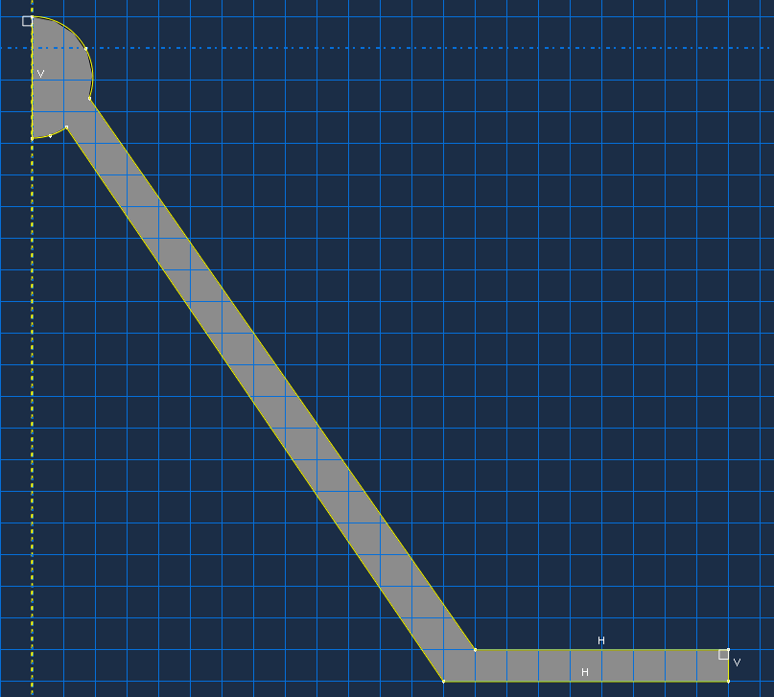
Figure 3: ABAQUS Sketch of the rounded liner.
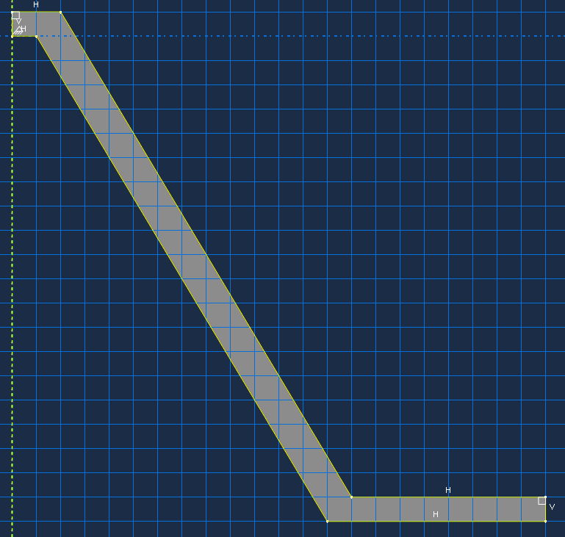
Figure 4: ABAQUS sketch of the flat liner.

Mesh strategy
The global mesh can be seen for both designs below in Figure 5. The meshing of the models took up the majority of the time, as the 250,000 element ceiling imposed a hard to fit upper bound. The final mesh for each design contained between 200,000 and 250,000 nodes, distributed unevenly across the design in accordance with the different deformation regimes experienced by the liner, casing, and explosive.
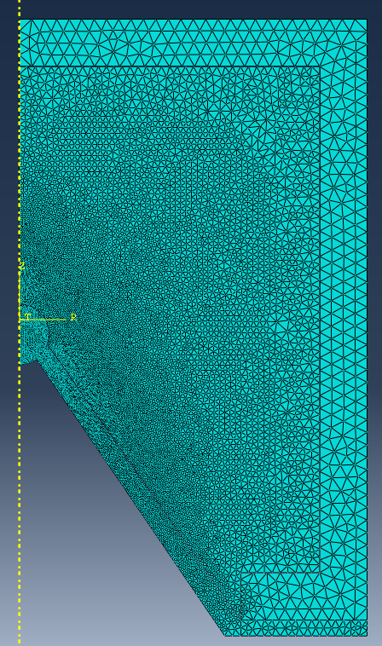 | 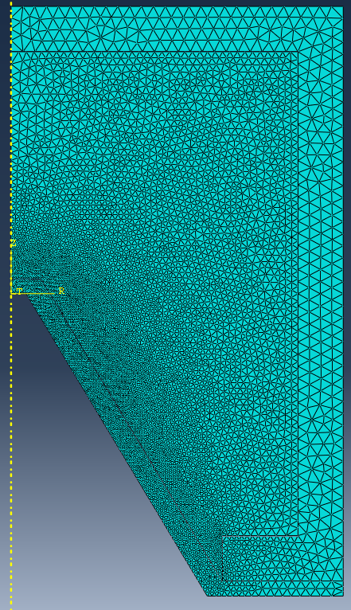
Figure 5: Fully meshed designs. Left is the rounded liner design. Right is the flat liner design.
The meshing decision process used can be summed up as:
- Try global mesh (too coarse)
- Try local mesh (interface boundary errors)
- Try seed mesh (interface boundary errors)
- Try biased seed mesh (runs better)
- Try bottom up mesh (too little time to implement, this tool was only found during the 3D creation process)
For future research a bottom up mesh would provide even finer control over the node sizes and allow for a greater control over the geometry of each node, especially in key areas such as the apex of the cone.

Edge seeding and biased mesh direction
Instead of using a single global element size for each part, the mesh was constructed by assigning element sizes directly to each edge of the parts using ABAQUS edge seeding. This gave finer control over the element distribution and allowed for a graduated element size. The edge seed values can be seen below in Table 4.
Table 4: Edge seed values for the liner, casing and HE for the 2D parts.
Region | Min Element | Max Element | NOTES
Liner | 0.001 | 0.0025 | Finer at the apex and coarser at casing interface
HE | 0.001 | 0.005 | Matched at the liner interface but progressed towards 0.005 at a faster rate once it moved away from liner apex
Casing | Coarse | Coarse | Coarsened deliberately, except for an edge match at the HE and liner interface
The liner bias produced a fine mesh at the immediate jet initiation point, as this will have the highest stress and strain concentrations and incur the largest velocity gradient. This also allowed for the slug to be coarser without compromising the tip, spending less computational time on the parts experiencing less force.
It should be noted that for design B with the circular apex, a mesh size of 0.0015 was used towards the apex, as it allowed a better fit with the circular geometry of the tip.

Element type
Both designs used CAX3 elements (three node linear axisymmetric triangles) with a distortion control of 0.1 and default element deletion settings, see Figure 6.

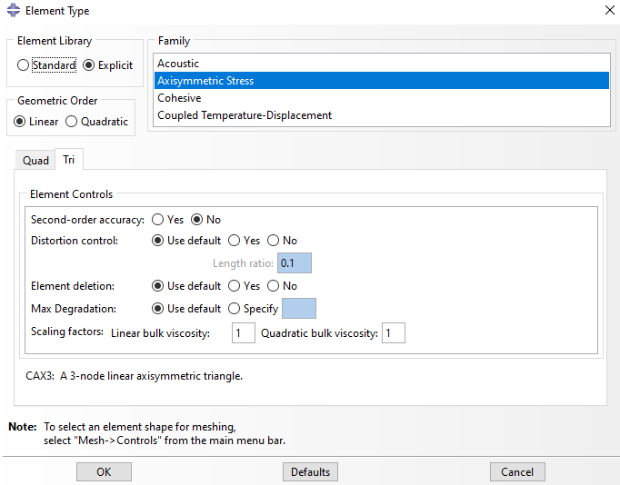
Figure 6: Mesh SAR parameters showing the Element Type for the 2D designs.

Complementary mesh boundaries
Where two parts meet, the element sizes on the interfacing boundary were deliberately matched to avoid large element size jumps. In earlier versions, it was found that without this match the simulation had excessive interpolation errors at the interfaces, causing stress oscillations that crashed the run within a few time steps, as seen in Figure 7.
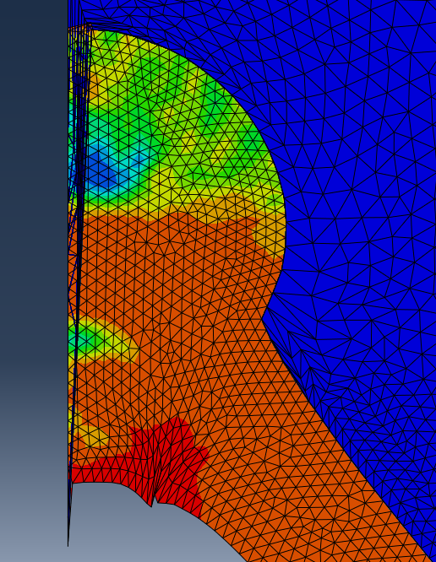
Figure 7: Rounded liner with element excessively distorting causing interpolation error.
The fix was a meticulous matching of the node interfaces so that it could smoothly transition from smaller to larger elements. Particular care was put into preventing a pile up of smaller nodes to happen at the edges, where the nodal flux will naturally be higher. This, in turn, added computational time to the simulation but resulted in a file that did not crash and ran to completion.

Deliberate coarsening of the casing
To help fit the nodal limit and decrease the computational time, a coarser mesh was applied to the casing. This is because it will only experience a moderate elastic plastic deformation. It expanded outward radially by a small amount of its initial dimensions and the peak equivalent plastic strain in the casing was considerably lower than that in other parts. However, as there is an interface between the casing and the liner, it was tough to match this up to a bias ratio that didn’t cause excessive deformation.

Mesh convergence testing.
The mesh for both models had a node range between 200k and 250k, but a proper mesh convergence test was not performed. This is something that should have been performed to justify the node selection. It should be noted that the simulation did run at multiple different node amounts (as the mesh was being tested), but the quantitative output values were not compared and therefore cannot be shown to be insensitive to mesh size.

Boundary conditions and contact
A boundary condition was applied to the nodes at the axis of symmetry for the models, Figure 8. General contact was applied and the domain set to allow interaction between all parts, using hard contact and frictionless behaviour, Figure 9. This is consistent with the hydrodynamic equations used for the strain rates involved. The field output was taken every 1µs and history output every 200 increments, Figure 10.
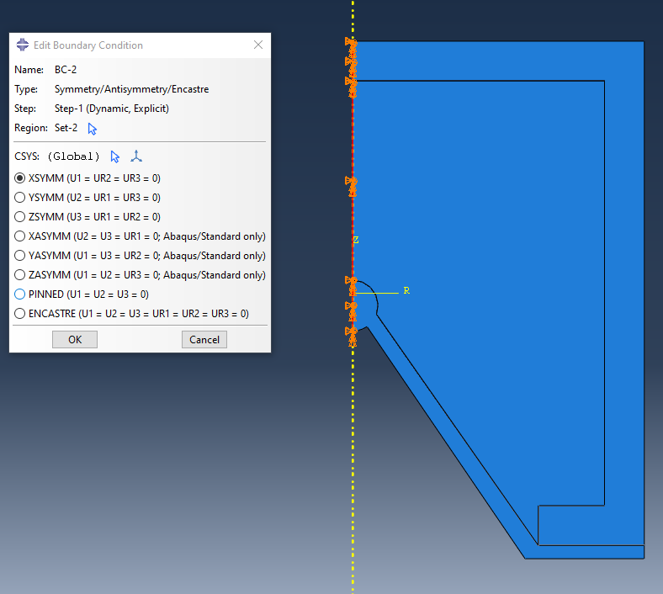
Figure 8: Boundary condition set, forcing XSYMM on the axis of symmetry. This is the same for both 2D designs.
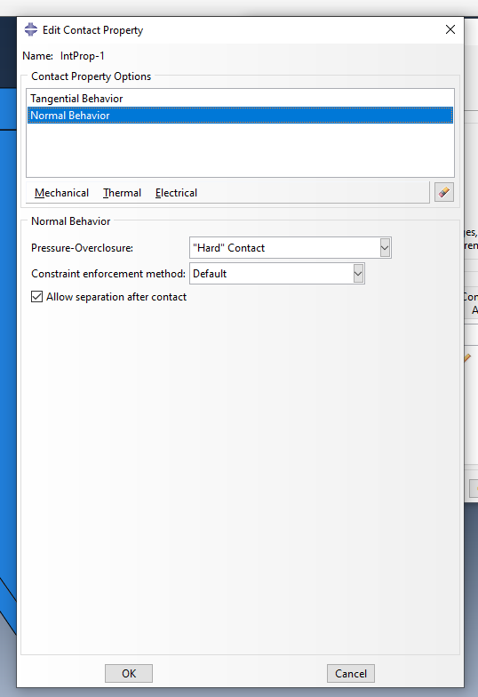 | 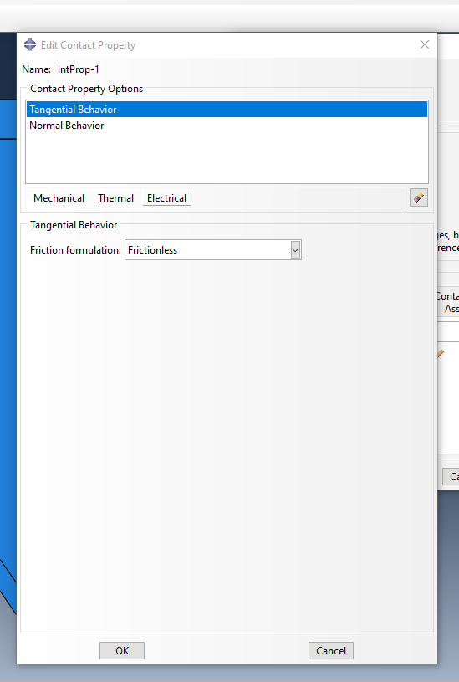
Figure 9: Contact properties for the 2D designs, showing Tangential and Normal behaviour properties.

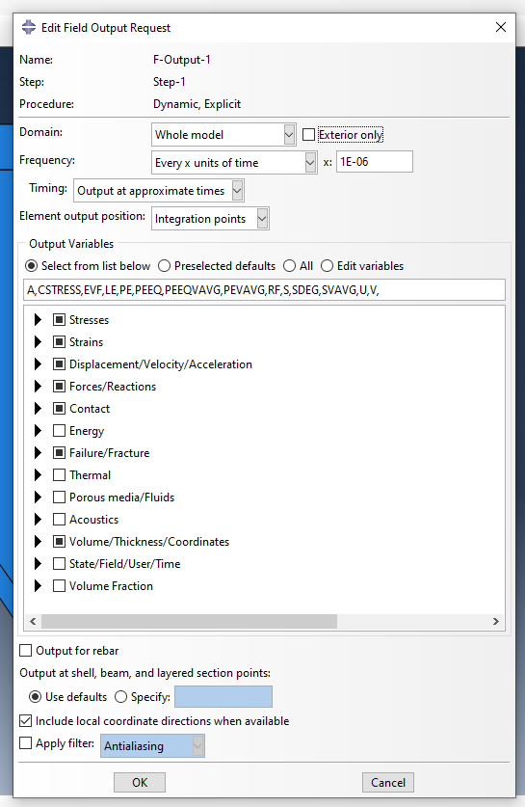 | 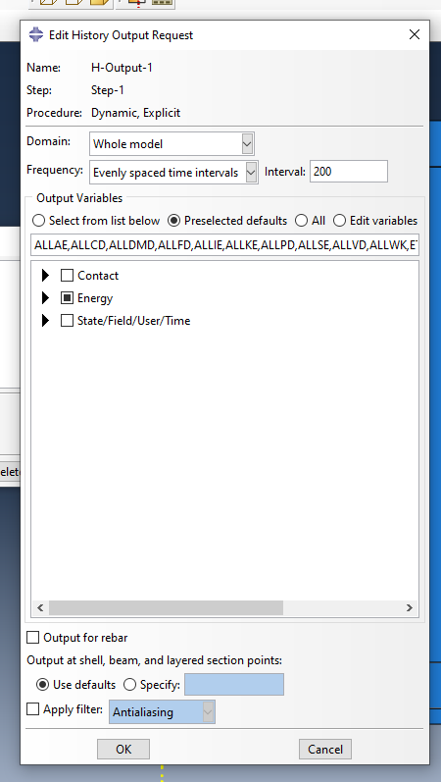
Figure 10: Field and History Output Request selection for both 2D designs.

Results (flat)
The tip of the jet was selected (Figure 20), and the velocity graph was plotted (see Figure 11). Nodes that had excessive distortion were deselected.
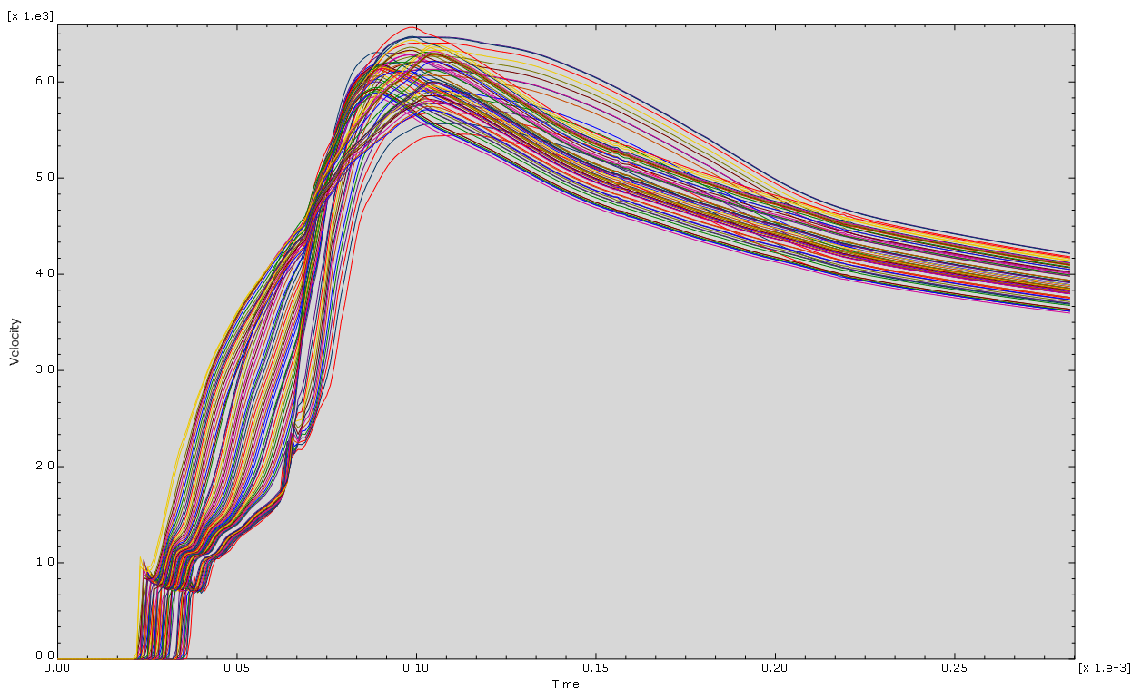
Figure 11: Flat liner jet tip velocity graph. Uses 30 data points.
The flat apex allowed for a well balanced collapse. The detonation wave is shown to have arrived at approximately 30µs (with velocities jumping from zero to 800m/s almost instantaneously), a rapid acceleration then peaks at around 100 µs with velocities of 6500m/s. This also shows a settled velocity gradient spanning from 3500-6000m/s as the jet elongates and is slowed down by the slug. Checking the simulation at 100 µs, the shape charge has already formed a small jet and the incoming slow down by the slug can be seen visually in Figure 12.
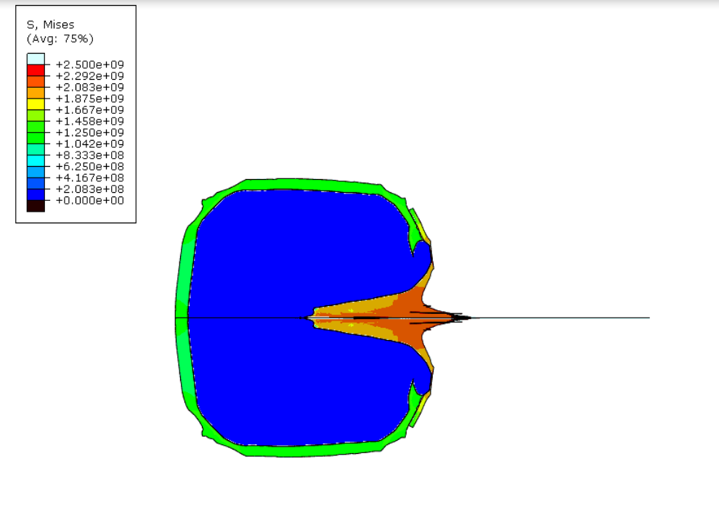
Figure 12: Flat liner shape charge at 100µs, showing initial jet formation.
The pressure wave itself, however, can be seen to have reached the cone apex at 19 µs, providing a max pressure of almost 250 GPA, as seen in Figure 13.
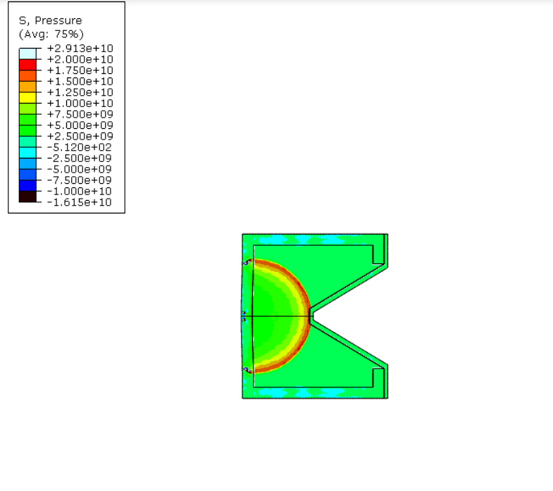
Figure 13: Flat liner shape charge at 19µs, showing the arrival of the detonation wave.
The jet, however, is not yet formed until the shock wave is reflected from the casing and squeezed into the axis of symmetry, forcing the flat apex of the liner to compress and push forwards, See Figure 14. The initial compression of the liner can be seen on the inside edge, which will soon form the jet tip. The solid black line extruding from the centre is a visual bug resulting from excessive distortion of the HE that interface with the liner.
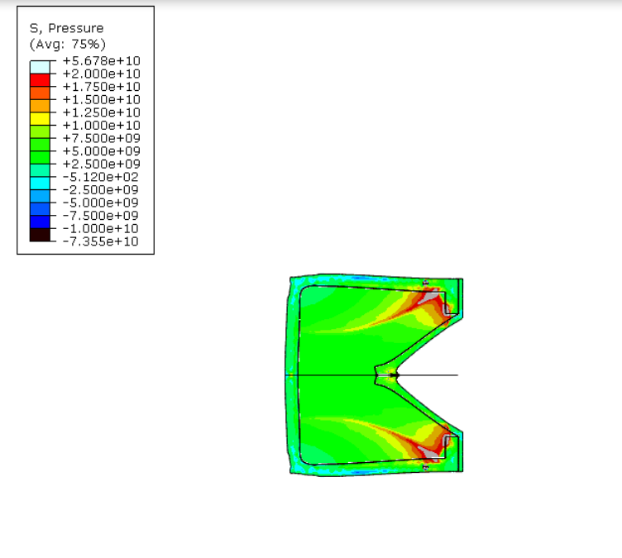
Figure 14: Flat liner shape charge at 50µs, where the detonation wave is seen to be reflected and absorbed by the casing prior to jet formation.
The 200 µs point results in a fully formed jet as seen in Figure 15. The stress is still relatively high within the jet, with it now being slowed down by the metal it initially left behind. The black tip seen in the figure is both a visual bug from element distortion as well as a graphical representation of beading. Furthermore, the case is now fully obturated.
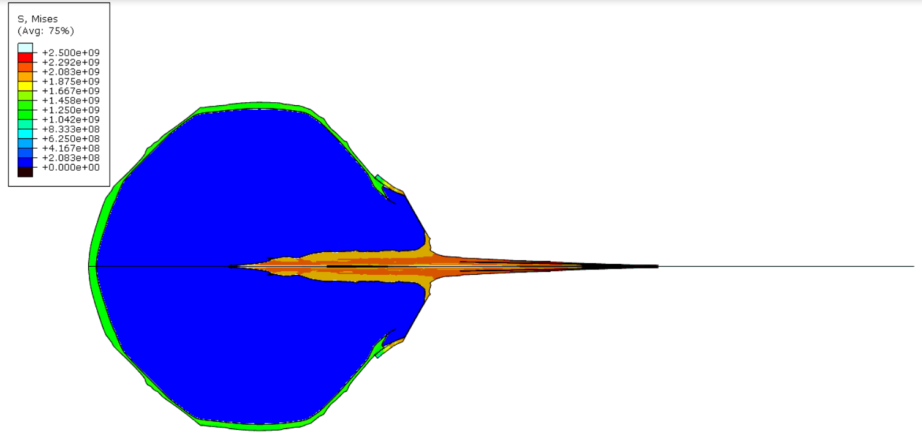
Figure 15: Flat liner shape charge at 200µs showing the full jet formation.

Results (circle)
The rounded apex liner produced a notably different result, Figure 16. The nodes experienced a peak velocity of only 6000m/s (8% lower than the flat apex design), and a notable time and gradient difference between nodes. This is down to the larger gap between the tip of the apex and the bottom, hence the less tight clustering between first contact point (30 µs) and peak velocity point (100 µs). The velocity gradient after reaching its peak velocity to its reduced velocity point is more gradual than the flat design, agreeing that the rounded design reduced the overall difference in slug and tip stress.
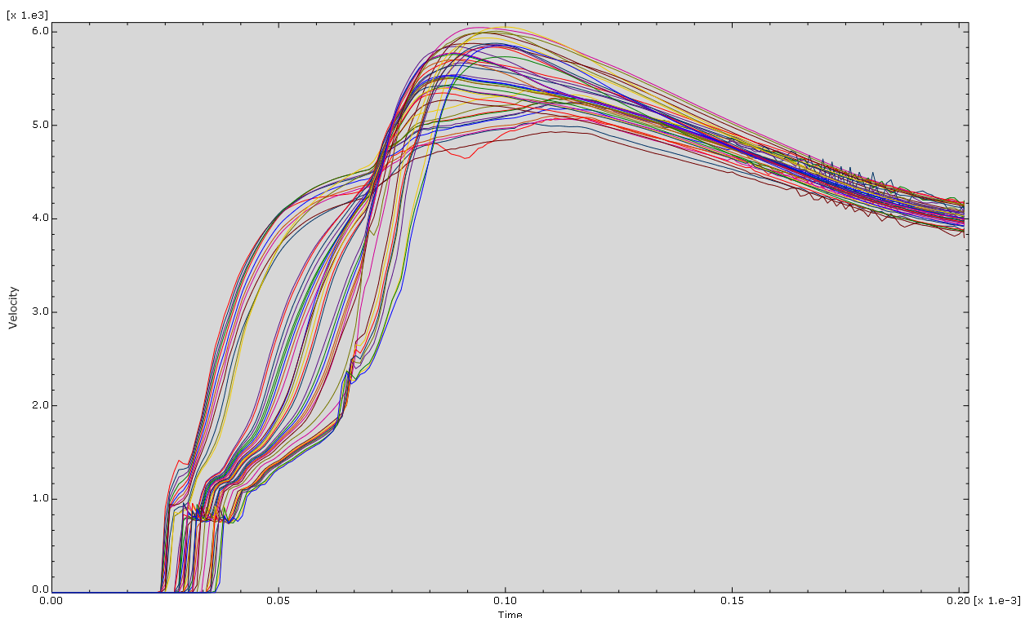
Figure 16: Rounded liner jet tip velocity graph, uses 20 data points.
Similarly to the flat apex design, the case reflects the pressure wave (and absorbs some into the casing and through into the liner), before compressing the tip of the circular apex from all sides and squeezing it forwards into a jet, as seen in Figure 17. The max pressure here is around 250Gpa.
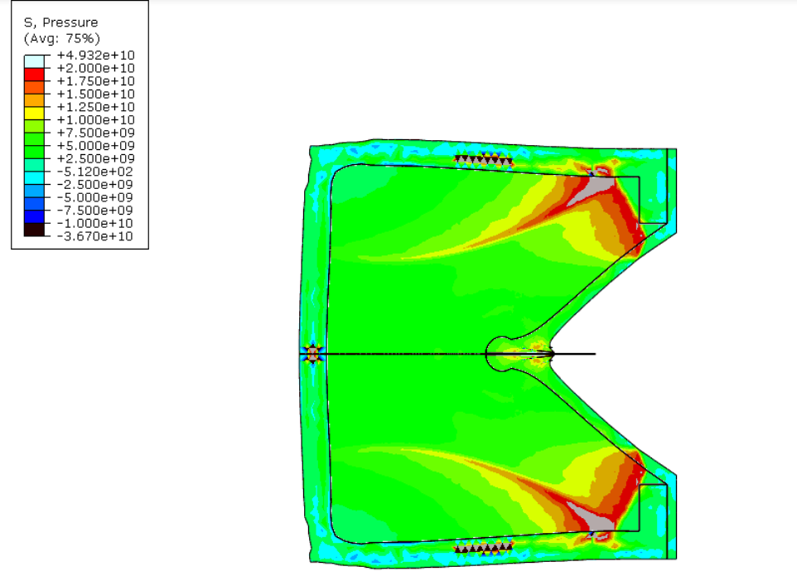
Figure 17: Rounded liner shape charge at 50µs, showing the formation of the jet from the detonation wave.
At the peak velocity point, 100 µs, the shape charge can be seen in Figure 18 to have started its jet formation. The jet itself is slightly wider than that in the flat liner design, which is reflective of the Munroe effect stemming from the circular apex.
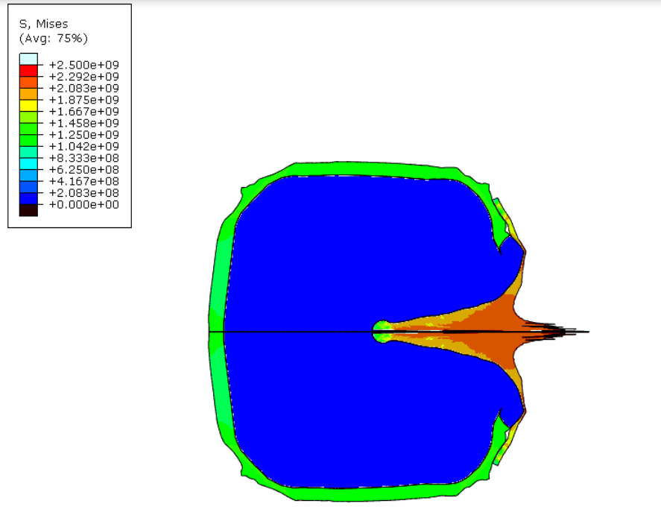
Figure 18: Rounded liner shape charge at 100µs, showing the initial jet formed, wider than the flat liner version.
At the final point, 200 µs, the jet is notably shorter than the flat liner design and has travelled less distance. This design would have a larger perforation into a metal but would need to be closer to its target for effective transfer of energy.
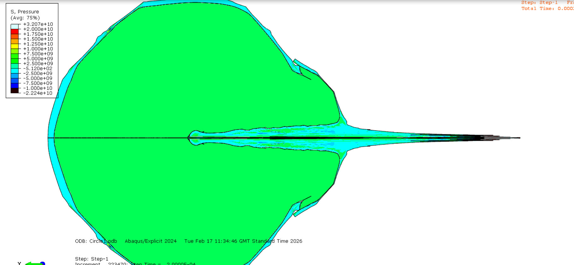
Figure 19: Rounded liner shape charge at 200µs, final jet formation.

Design selection
The flat design was selected to progress to the 3D design as it had a higher tip velocity, greater jet coherence, and had a lower computational cost. The circular liner took 1.47x the explicit increments than the flat liner.
The flat design is seen to have a faster and tighter jet, suggesting that it would be better for thicker armour and can function at greater stand off distances. The round design has a wider jet with a smaller distance and would be better suited to break larger holes in less thick armour.
The selected nodes for the velocity plots can be seen in Figure 20, which also highlights the width of each jet.

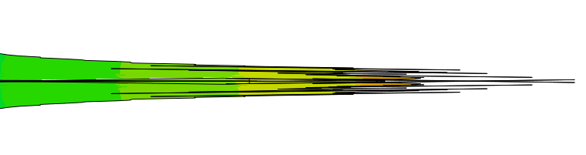
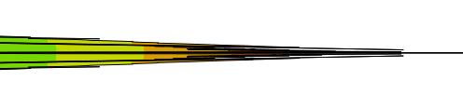
Figure 20: Selected nodes for each design. Top picture is the rounded liner; bottom is flat liner. Flat liner has more selectable nodes.

Bulk viscosity testing
To ease the computational power needed for the circular design, the linear and quadratic bulk viscosity were changed to 1 and 10 respectively (from 0.6 and 1.2 set by default). This allowed the step time to increase locally, providing a larger difference in the rate of change between each step, and ultimately easing the CFL constraints. In principle, this meant that the simulation ran faster but provided a visually smeared jet tip and a less differentiated velocity gradient. As this came at the cost of precision, the viscosity values used for the report were all maintained at the default value.

Calculated Gurney comparison
In section 3.1 a velocity of 1.9km/s was calculated for the conical collapse velocity. In practice, the flat liner achieved around 1.1km/s and the circle liner 1.5km/s (as seen in Figure 11 and Figure 16 at 50 µs). The discrepancy occurs as Gurney theory assumes a particle reaches terminal velocity. The particles at 50 µs will not yet have reached terminal velocity, highlighting how material inertia affects the Gurney equations.

Three dimensional analysis
The same sketch was used for the 3D design as was for the 2D flat liner, except the elements were now revolved through 360° to create a 3D part.
A rectangular Eulerian domain was also drawn, 1.26m by 0.5m and revolved 360°, which was large enough to contain the development of the jet to around 250 µs without any significant boundary interactions. All parts were mashed on instance, with the Eulerian section containing all the material properties for TNT, copper, and tungsten.
The dimensions of the Eulerian originally were larger but were reduced to lower the total node count after meshing (allowing for a finer mesh with lesser or equal total nodes).
The benefit of using the Eulerian method is that it is unconditionally stable for plastic strain rates that would normally exceed the defined limits in Lagrangian simulations. This meant that there was no excessive distortion of elements and that it ran to full completion (200+ µs as compared to only 200 µs for both 2D models).

Eulerian and meshing
Three meshing strategies were used:
- First iteration: A default global swept mesh.
  - This produced a very uniform distribution of elements but was too coarse to see any granularity.
- Second iteration: A fully bottom-up mesh.
  - This worked out very well but was limited by the upper limit of number of elements available.
- Third: A combination of bottom up and global.
  - This was a hybrid of the 1st and 2nd approaches and combined the control of a bottom up mesh with the coarseness and uniformity of a global mesh, see Figure 21.
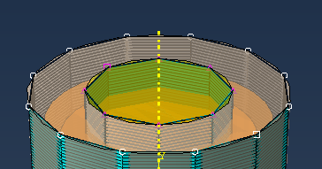
Figure 21: Partitioned Eulerian mesh, bottom up in the centre and global sweep on the outside.
The third approach used an extruded partition which segregated the inner cone with the outer sections. A bottom up extrude mesh was used for the inner partition, and a global mesh was used on the outside. The edges of the partition were local seed meshed to 0.01, with 300 layers of bottom up mesh. The outside partition was locally meshed using a global sweep of 0.05. The outer vertical edge of the cylinder was then seeded to 0.05 to allow for better element geometries.

Volume Fraction Tool
The Eulerian section was then characterised by three unique areas using the discrete volume fraction tool. This combined the Eulerian with the subregions of the shape charge and allowed them to interact with the Eulerian section.
This was a crucial step, and even more important that it is done last in the process. Once this is defined, it applies to the current mesh of the Eulerian, therefore by changing the mesh the Eulerian has to be repartitioned with the volume fraction tool. This is something which was learnt late into the modelling process and was a large source of error throughout. Figure 22 shows how the simulation looks if it is not re applied. The interaction between the materials will not occur as the mesh (space) it was originally applied to no longer exists.
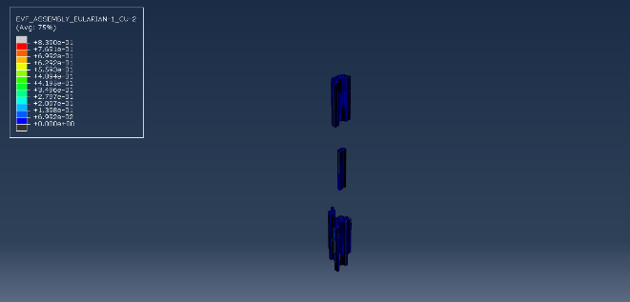
Figure 22: Eulerian simulation with an updated mesh without redoing the volume fraction.

Results (3D)
The 3D Eulerian simulation was utilised primarily to overcome the high plastic elastic forces that a shape charge experiences. Eulerian simulations can simulate such events without any excessive deformation.

Peak Plastic Strain
The Eulerian experienced its highest PEEQ value at the point seen in Figure 23, at 190 µs. This suggests that the slug has caused such a velocity gradient to induce beading at the tip. This also suggests the maximum stand off distance applicable for this design.
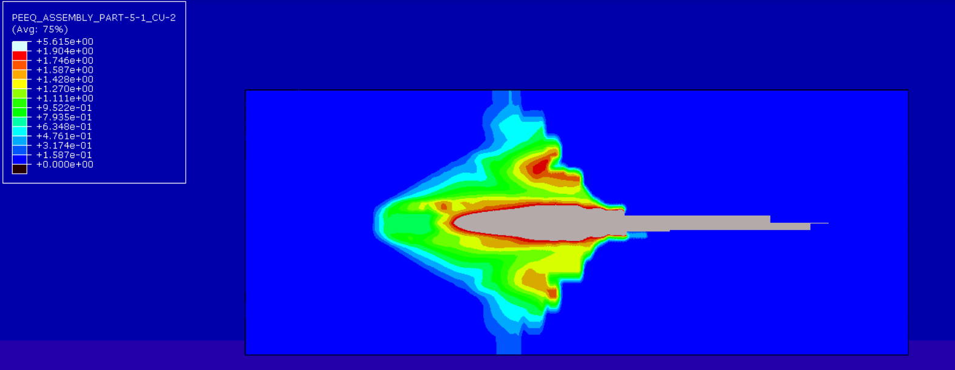
Figure 23: Highest peak plastic strain (%) experienced, suggesting the point at which beading will begin to occur.

Detonation propagation to jet formation
The copper within the Eulerian section, at 200 µs, is seen in Figure 24. The picture is a good representation of beading, which would not be possible to see using a Lagrangian model. The shape of the jet is clearly shown visually, as well as its size. The beading takes place within 3 cone diameters, which is typical for copper liners [23].
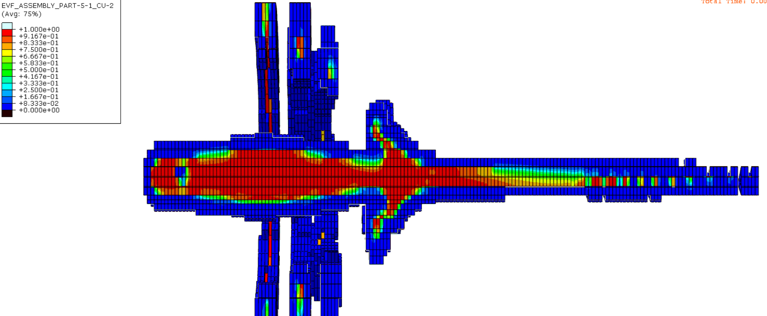
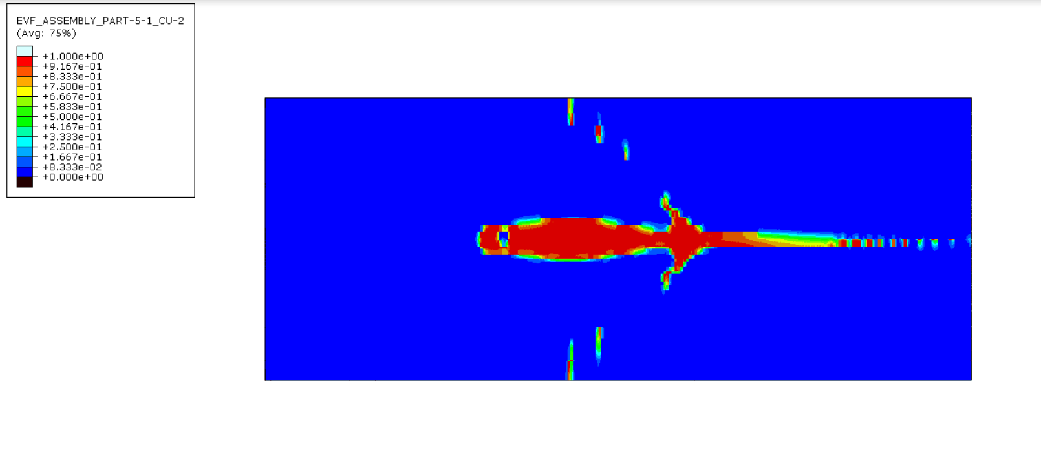
Figure 24: 3D Eulerian shape charge at 200µs showing beading and final jet formation.
Figure 25 shows the copper at the point which the liner experiences a jump in velocity(~30 µs), with a slight conical collapse visual.

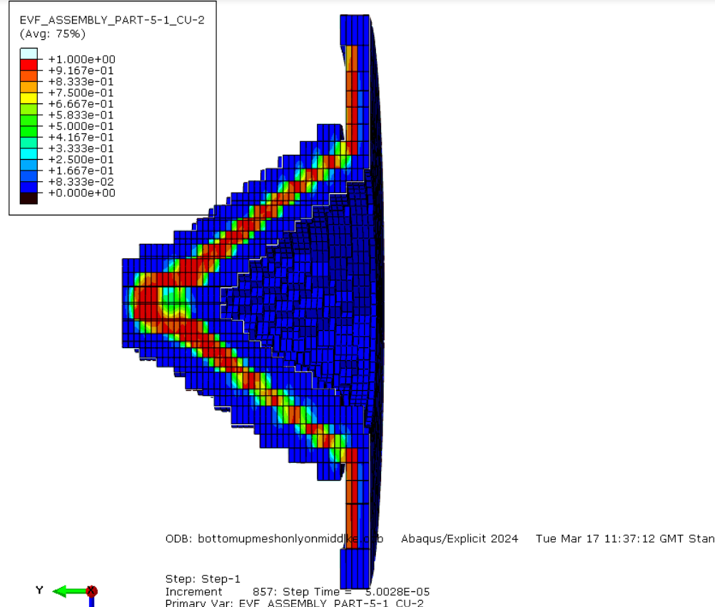
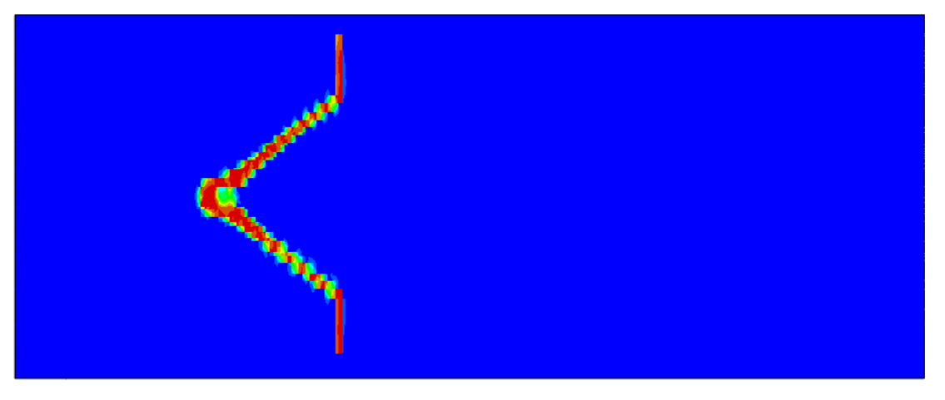
Figure 25: 3D Eulerian shape charge at 30µs, showing the initial impact of the detonation wave.

Figure 26 shows the copper liner at the peak velocity point, 100 µs, where the initial formation of the jet is clearly seen as a result of compression.
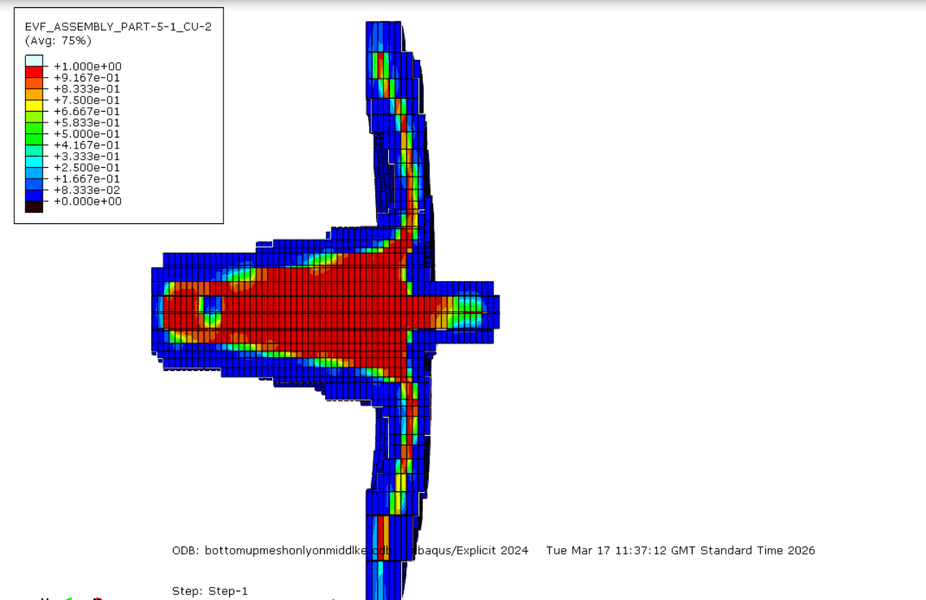
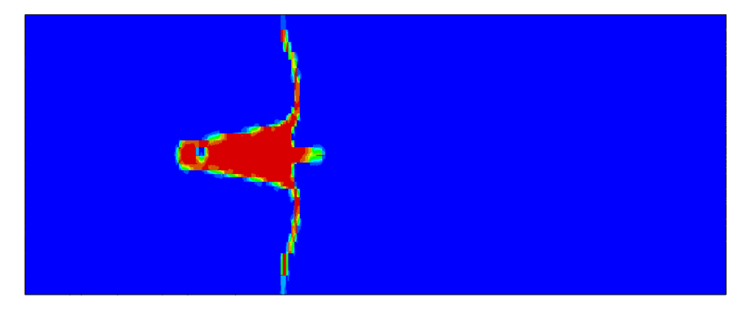
Figure 26: 3D Eulerian shape charge at 100µs, showing that the jet has started to form and take shape.

Shear forces
Interestingly, Figure 27 depicts shear forces that dominate the early stages of shape charge detonation.
- The left picture depicts the point at which the detonation wave first reaches the liner. The detonation wave will drive the metal inwards at an angle not aligned to the original cone wall. This creates a large amount of shear.
- The middle shows the point at which maximum velocity is achieved. The jet is experiencing less strain now as it is primarily experiencing axial stretching with little additional shear. Shear is still happening for the slug and left behind material.
- The right picture shows the shear forces arising again as the jet begins to bead. It stretches under the velocity gradient from the local shear stress of the tip pulling away from trailing material.

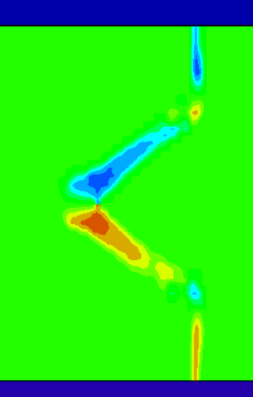 | 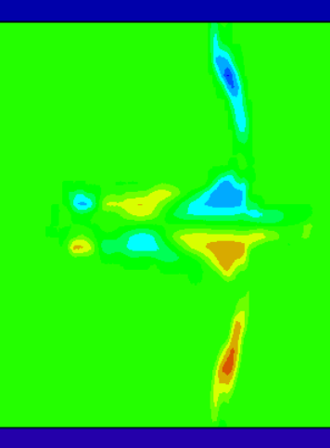 | 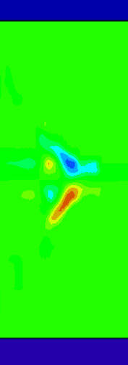
Figure 27: 3D Eulerian shape charge at 15, 50, and 100μs (left to right). It shows the S23 shear forces as active, passive, and then active throughout the jet formation.

Further Discussion

Method limitations
The 250k element limit forced a smaller mesh size than expected. The Eulerian suffered greatly from this as can be seen from the visual pixelation of its jet. The tip of the jet is also only a few elements wide and fails to show how stretched the tip would become. A larger element budget would resolve this.
The Eulerian simulation also directly self-limits itself from the volume fraction averaging used. With this, when the jet tip becomes thin and below the cell size, the velocity drops below the true material velocity as most of the cell will be empty space. SPH would avoid this as its particles carry their own velocity. The SPH method would also allow for a greater amount of particle flux on the jet axis as adjacent particles don’t need to share faces to form valid elements. Some of the early simulations for this report failed due to this exact reason, singular elements deviating from their interfacing boundaries and crashing ABAQUS. However, SPH is computationally more expensive and suffers from its own drawbacks such as tensile instability.

2D and 3D, same design different results
Both the 2D and 3D simulations use the exact same setup (for the flat liner design). The 3D Eulerian, however, has a peak tip velocity that is lower than the 2D Lagrangian. This, principally, is due to the interface diffusion at the tip of the jet, where volume averages fast moving material with slow moving products. The 3D simulation also captures what happens at 560% peak plastic strain, which the 2D simulation simply can not model due to excessive boundary distortion forcing element deletion. Conversely, the 2D model has a much sharper jet morphology and provides velocity histories which the Eulerian formulation cannot provide. The Eulerian required much less time increments to reach 200µs (5556 compared to 152000 for the 2D model), at a 2700% reduction in computational power. This is due to the reduction in element distortion affecting the time step. It should be noted that this does not mean that the simulation ran faster, just that it took less steps to get to that specific point. The Eulerian actually took 2x as long to complete than the Lagranian.
The Eulerian simulation is better for a visual representation of the evolution of the jet, whereas the Lagrangian form shows how the entire shape charge is affected. This, simply, is because the Lagrangian tracks each material point through space and time whereas the Eulerian only records where the cells containing specific material is at each instant.
The best benefit of the Lagrangian form over Eulerian is that Eulerian formulations do not track discrete material nodes and therefore do not produce field output quantities. This makes it less applicable to compare exact figures between models. For comparative studies the 2D Lagrangian form is more suited.

Validation
Despite some differences between the two formulations, the physical conclusions of the two simulations are coherent. Both formulations show a peak jet tip velocity in agreement with known ranges and both show a strong axial velocity gradient. In addition, both show how the jet collapse via shear stress to form beading and that the initial formation is the result of compressive shock. The difference in numerical values between simulations is largely down to formulation specific factors.
For studies focusing on average jet behaviour the 3D Eulerian approach should be used, and for studies looking at the evolution of specific material properties the Lagrangian should be used. The combination of both formulations provides a wholistic and global view of the materials point in space and detailed properties.

Directions for further work
Alternative liner materials with varied density and Hugoniot characteristics would help to explore the wider design space of liner material choice. The cone angle and cone thickness would also map this out and provide greater precision in the width of jets and slugs. Different explosive fillings with new Jones Wilkins Lee parameter sets would also allow for testing with modern higher energy formulations (safely).
In addition, a sensitivity study on the viscosity coefficients would help map a more rigorous speed to quality trade off and help in alleviating computational power.

Conclusion
Both the 2D simulations and the 3D Eulerian simulation produced a shape charge jet in accordance with the analytical theory and data collected over the last 3 centuries. Both 2D simulations had similar jet velocities but differed in size and width. The circular liner produced a wider jet and would be more useful for larger holes in less thick armour. This agrees with the Munroe effect as the circular design would invert the shock wave as it passes through the material. The flat liner had a much longer and thinner jet, ideal for larger stand off distances and for thicker armour penetration. A general observation is that sharp geometric terminations are to be preferred over curved surfaces when the velocity and length of the jet is the primary concern. The beading effect was observed using the Eulerian formulation and is therefore a recommended form to use to verify the maximum distance from a target.
Excessive distortion plagued the study, forcing a better mesh and increasing the computational time taken for each run. This put a time limit on the study, in which it would have liked to have tried other modelling formulations in addition to what has been presented. Another limitation was the 250k element ceiling. The hybrid Eulerian partitioned mesh strategy worked around this and produced quantitative results, but the resolution that a larger element ceiling would produce is incomparable. Further studies should look at varying the parameters of the cone and properties of the materials.

References
[1] C. Poole, “Penetration of a Shaped Charge,” University of Oxford, 2005. Accessed: May 17, 2026. [Online]. Available: https://fileserver-az.core.ac.uk/download/pdf/40087594.pdf
[2] D. Kennedy, “HISTORY OF THE SHAPED CHARGE EFFECT The First 100 Years,” Defense Technology Support Services, Mar. 1990. Available: https://apps.dtic.mil/sti/tr/pdf/ADA220095.pdf
[3] C. E. Munroe, “Wave-like effects produced by the detonation of gun-cotton,” American Journal of Science, vol. s3-36, no. 211, pp. 48–50, Jul. 1888, doi: https://doi.org/10.2475/ajs.s3-36.211.48.
[4] W. Walters, “A Brief History of Shaped Charges,” U.S. Army Research Laboratory, 2008. Available: https://apps.dtic.mil/sti/tr/pdf/ADA497450.pdf
[5] G. Birkhoff, D. P. MacDougall, E. M. Pugh, and S. G. Taylor, “Explosives with Lined Cavities,” Journal of Applied Physics, vol. 19, no. 6, pp. 563–582, Jun. 1948, doi: https://doi.org/10.1063/1.1698173.
[6] E. M. Pugh, R. J. Eichelberger, and N. Rostoker, “Theory of Jet Formation by Charges with Lined Conical Cavities,” Journal of Applied Physics, vol. 23, no. 5, pp. 532–536, May 1952, doi: https://doi.org/10.1063/1.1702246.
[7] W. P. Walters and J. A. Zukas, Fundamentals of shaped charges. New York: Wiley, 1989.
[8] M. Held, “Liners for shaped charges,” JOURNAL OF BATTLEFIELD TECHNOLOGY, vol. 4, Jan. 2001.
[9] R. W. Gurney, “The Initial Velocities of Fragments from Bombs, Shell and Grenades,” Ballistic Research Laboratory, no. Report No. BRL-405, Sep. 1943, doi: https://doi.org/10.21236/ada800105.
[10] P. W. Cooper, Explosives engineering. New York. ; Chichester: John Wiley-Vch, 1997.
[11] P. W. Cooper, Explosives engineering, vol. Chapter “Shock Waves: Rankine Hugoniot Jump Equations.” New York. ; Chichester: John Wiley-Vch, 1997.
[12] B. Mobaraki and M. Vaghefi, “Numerical study of the depth and cross-sectional shape of tunnel under surface explosion,” Tunnelling and Underground Space Technology, vol. 47, pp. 114–122, Mar. 2015, doi: https://doi.org/10.1016/j.tust.2015.01.003.
[13] T. J. Holmquist and G. R. Johnson, “A Computational Constitutive Model for Glass Subjected to Large Strains, High Strain Rates and High Pressures,” Journal of Applied Mechanics, vol. 78, no. 5, 1983, doi: https://doi.org/10.1115/1.4004326.
[14] B. Banerjee, “An evaluation of plastic flow stress models for the simulation of high-temperature and high-strain-rate deformation of metals,” Dec. 2005, doi: https://doi.org/10.13140/RG.2.1.4289.9285.
[15] J. Lemaitre, “A Continuous Damage Mechanics Model for Ductile Fracture,” Journal of Engineering Materials and Technology, vol. 107, no. 1, pp. 83–89, Jan. 1985, doi: https://doi.org/10.1115/1.3225775.
[16] G. R. Johnson and W. H. Cook, “Fracture characteristics of three metals subjected to various strains, strain rates, temperatures and pressures,” Engineering Fracture Mechanics, vol. 21, no. 1, pp. 31–48, Jan. 1985, doi: https://doi.org/10.1016/0013-7944(85)90052-9.
[17] D. Steinberg, Equation of State and Strength Properties of Selected Materials. Lawrence Livermore National Library, 1996.
[18] “Abaqus/CAE User’s Guide,” Dassault Systèmes. Accessed: May 17, 2026. [Online]. Available: https://help.3ds.com/2026/english/DSSIMULIA_Established/SIMAPDFResources/CAE.pdf?contextscope=all
[19] P. Elek, M. Marković, D. Jevtić, and R. Đurović, “Modeling of shaped charge jet penetration depth: Analytical and numerical approach,” Scientific Technical Review, vol. 74, no. 2, pp. 17–22, 2024, doi: https://doi.org/10.5937/oteh2402017e.
[20] G.-S. Yeom, “Numerical Simulation of Conical and Linear-Shaped Charges Using an Eulerian Elasto-Plastic Multi-Material Multi-Phase Flow Model with Detonation,” Materials, vol. 15, no. 5, p. 1700, Feb. 2022, doi: https://doi.org/10.3390/ma15051700.
[21] Z. Zhang and W.-W. Jin, “Finite element modeling of the shaped charge jet and design of the reusable perforating gun,” Petroleum Science, vol. 17, no. 5, pp. 1389–1399, Jun. 2020, doi: https://doi.org/10.1007/s12182-020-00468-4.
[22] Mohd, C. S. Ho, N. Ma’at, and Muhammad Faredzuan Kamarulzaman, “Modelling shock waves in composite materials using generalised orthotropic pressure,” Continuum Mechanics and Thermodynamics, Oct. 2019, doi: https://doi.org/10.1007/s00161-019-00835-6.
[23] M. Ahmed and A. Q. Malik, “A Review of Works on Shaped Charges,” Engineering, Technology & Applied Science Research, vol. 7, no. 5, pp. 2098–2103, Oct. 2017, doi: https://doi.org/10.48084/etasr.1532

