

Assignment Title:
Comprehensive Management of Chronic Mental Health Conditions in the Community

Programme: MSc Public Health and Social Care in Practice
Module Code: LCHS7003
Module Name: Community Care and Management of Longer-term Conditions

Student Name: Dhruvi Mukeshbhai Desai
Student Number: 2534275

Table of Contents
1. Introduction 3
1.1 Relevance and Background 3
1.2 Definition 3
1.3 Prevalence and Burden 3
1.4 Aetiology and Risk Factors 3
2. Impacts of Chronic Mental Health Conditions 4
2.1 Physical Implications 4
2.2 Psychological Implications 5
2.3 Social Implications 5
2.4 Economic Impact 6
3. Theoretical Perspectives and Models 7
3.1 International Model: The Chronic Care Model (CCM) 7
3.2 UK Model: The House of Care Framework 8
3.3 Framework for Improved Outcomes 9
4. Political, Health, and Social Care Agendas 10
4.1 National Agendas (UK) 10
4.2 Implementation of Initiatives globally 11
5. Recommendations for Improvement 12
6. Conclusion 13
References 14

1. Introduction

1.1 Relevance and Background
Different mental health disorders, such as depression is a crucial global health problem. It has been recorded that these conditions have made around 13% of the total disease burden worldwide (World Health Organization, 2023). The information from 2024 of the WHO has revealed that approximately 1 in 8 people throughout the globe is affected with a severe mental disorder (United Nations, 2020).
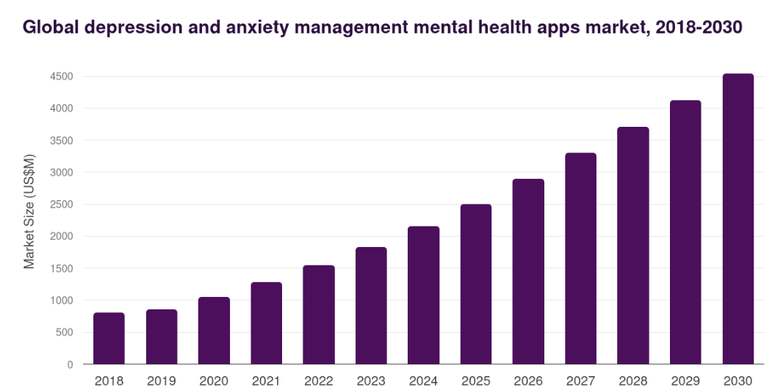
Figure 1: Global rate of depression
(Source: Grandview research, 2025)

1.2 Definition
Clinical depression can be considered as a chronic or relapsing long-term condition (LTC). Around 50% people may be recovered from one stage to experience another, while those who have had three episodes face a 90% chance of further occurrence (Lye et al. 2020).

1.3 Prevalence and Burden
In the UK, approximately 11.3% of adults in England meet the diagnostic criteria for a depressive disorder (Mental Health First Aid Course, 2026). Most stroking fact is that 30% of all primary care consultations for mental health are focused on either depression. The burden of this disorder has impacted the UK in terms of £17 billion annually through lost productivity and increased service utilisation (Mental Health Foundation, 2024). Globally, 1 in 5 men is seen to experience acute depression (World Health Organization, 2025).
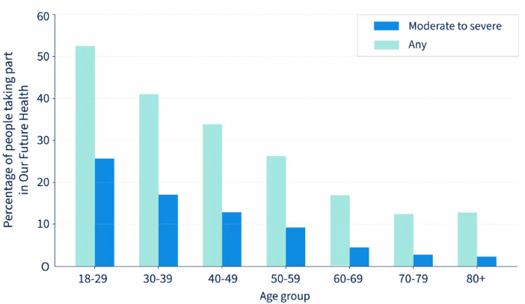
Figure 2: Increasing depression rate in the UK
(Source: Our Future Health, 2025)

1.4 Aetiology and Risk Factors
The aetiology can be analysed by applying the biopsychosocial model, which is helpful to evaluate the health outcomes through the dynamic interaction of biological, psychological, and social factors (Bolton, 2023). The biological factors are based on genetic vulnerabilities and the physiological changes, while the psychological factors are based on expressing symptoms such as sadness or irritability. It is recorded that genetically depression is caused for 30% to 40% cases globally (Cerebral, 2025). Moreover, globally, individuals with a history of severe childhood trauma are 2.6 times more likely to develop chronic, relapsing depression in adulthood. Social determinants play a crucial role in increasing the chance of the onset of illness. As evidence, in England and Wales, male suicide rates due to depression have shown a upward trajectory, peaking at 17.6 deaths per 100,000 in recent years, compared to 5.7 per 100,000 for females (Kirk-Wade, 2025). Lack of community support is a social cause leading to acute depression for 40% individuals in UK. As a support, it is highlighted that the prevalence of mental health disorders is prominent in the major parts of less deprived communities.

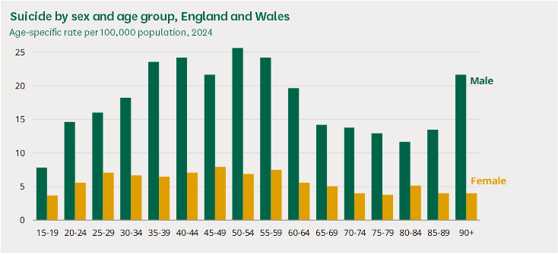
Figure 3: Suicide rates
(Source: Kirk-Wade, 2025)

2. Impacts of Chronic Mental Health Conditions

2.1 Physical Implications
The chronic mental health conditions, specifically depression, show a bidirectional correlation with physical long-term conditions. In this regard, clinical evidence has made it prominent that individuals affected with depression are more prone to have a stroke and 4 times more prone to have a heart attack or develop cardiovascular diseases in comparison with a non-depressed population (Kittanning et al. 2023). On the contrary, the presence of physical illness enhances mental health vulnerability. It is observed that patients affected with physical long-term conditions often two to three times more adaptive to develop depression (Kittanning et al. 2023). While, the individuals affected with three or more conditions may face a seven times increased risk.

2.2 Psychological Implications
As mentioned by Croatian et al. (2025), the psychological impact of mental health disorders can be evaluated as a “Vicious cycle” that often overruns the management of coexisting physical symptoms. It is seen that if an individual undergoes psychological distress, it may lead to reduced capacity for managing symptoms and as a result of this, decreased reliance on medications enhances the risk of onset. In case of conditions such as diabetes, the level of depression may be enhanced due to poorer glycaemic control (Fanelli et al. 2025). This cycle can be impacted by “learned helplessness” and a sense of disempowerment, which may make the patient passive in their own care, viewing their health trajectory as outside of their control.

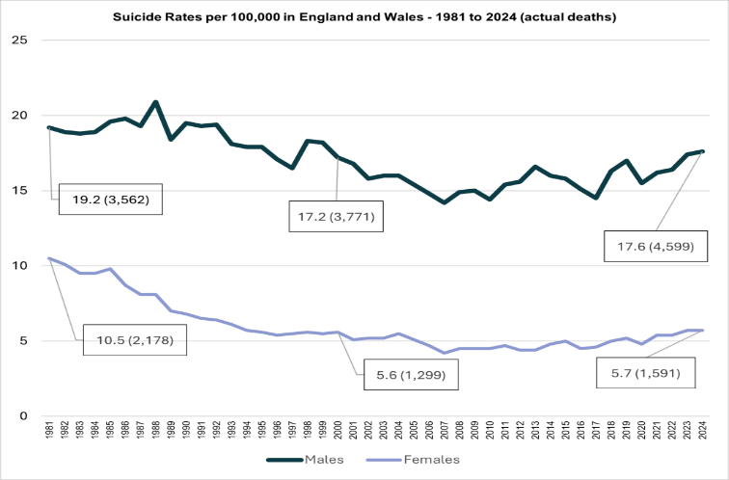
Figure 4: Suicide rates due to depression
(Source: CPRMB Team, 2025)

Social Implications
The social implications of chronic mental illness can be crucial to impact beyond the individual level, affecting the community health as well as the management of immediate support networks. At the individual level, the stigma and taboo surrounding mental health illnesses are pervasive. It is observed that a lack of community support for physical conditions such as cancer may increase the risk of mental depression. In the words of Peçanha et al. (2025), social exclusion is also a prominent reason to increase the risk of depression. As per the information from Chuti Yami et al. (2025), due to the development of general awareness in the UK, over 40% of individuals with chronic mental disorders are seen to state that their condition has reduced their participation in local community events.
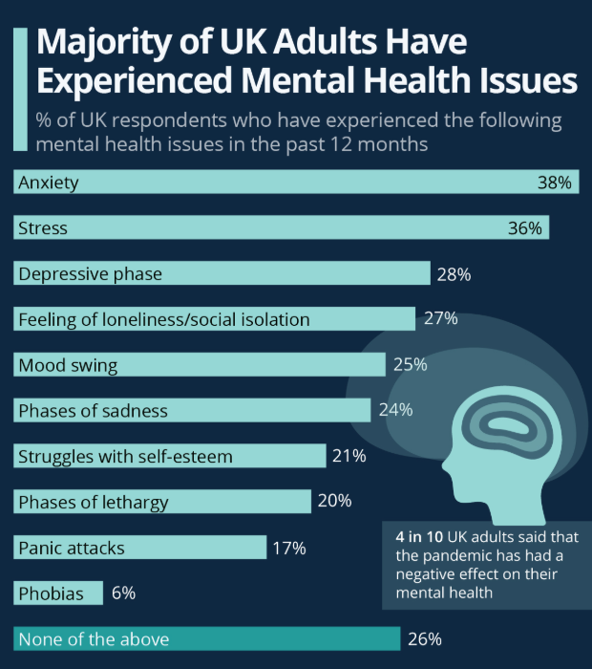
Figure 5: Mental health issues among adults
(Source: Armstrong, 2023)
The informal carer may face a burden in the situation of generating a “carer crisis” if not managed in an active way. Often, they may face an acute level of stress as their own health needs become secondary to the patient and left unrecognised to an extreme point of recognition (Averill et al. 2024). In this regard, the application of the community care model can emphasise resilience development among family members, because it can be helpful to transform them from passive helpers to expert partners in the care team. At the same time, the bereavement support is important clinically for the carers to reduce the risk of morbidity.

2.4 Economic Impact
The economic burden based on mental health conditions in the UK is at an adverse level. It is recorded that depression combined cost the economy £17 billion annually in the UK (ISE, 2023). This is caused due to the reasons such as decreased productivity and high staff turnover in healthcare. Another important aspect is that the cost of treatment of long-term conditions in the UK is based on £7 in every £10 of the total health and social care budget (Department of Health, 2024). It has been recorded that approximately 5% of patients with complex LTCs account for over 75% of unscheduled hospital admissions (Southwark Public Health, 2022). As a result of this, the aspect is clear that the prevalence of mental health disorders is directly or indirectly linked with the overall economic scenario of the country.
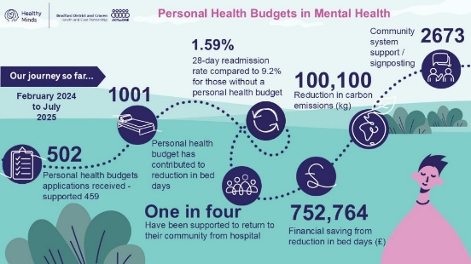
Figure 6: Personal budget for mental health management UK
(Source: Bradford District and Craven Health and Care Partnership, 2025)
Additionally, the mental health disorder is also prominent among the employees who are engaged in a tight schedule and it leads to a loss of £51 billion annually to the UK private sector (Deloitte, 2024). At the same time, a charity named NESTA suggests that implementation of the care model may cause a national savings of £4.4 billion per year (NESTA, 2023), which proves that the severity of mental health conditions is matched by a compelling economic imperative.

3. Theoretical Perspectives and Models

3.1 International Model: The Chronic Care Model (CCM)
The chronic care model (CCM) is most effective in managing long-term mental health conditions. Additionally, it is effective in terms of providing a road map for shifting healthcare from a reactive and acute focus to a proactive and collaborative system (James, 2024). The model has emphasised the fact that clinical outcomes can be enhanced only when the healthcare system acts to address the ongoing needs of the patients by following a patient-centred and evidence-based approach. In case of mental health issues, the CCM principles are applied as the Collaborative Care model (Reist et al. 2022). This model is widely adopted in the UK and USA, showing a two-fold increase in treatment adherence and improved clinical outcomes for depression lasting up to five years.
- Case management
It is exemplified that often a practice nurse or a care coordinator seems responsible while monitoring patients’ condition in LTC through systematic follow-up and aligning different care components.
- Clinical information system
This process is based on using patient registries to find out the high-risk individuals and their current physiological conditions. It needs to ensure that the relapsing conditions, such as depression must not be overlooked between the primary and secondary care processes.
- Decision support
In this regard, the evidence-based NICE guidelines (NICE, 2024) need to be followed for managing daily practice, along with ensuring that primary care staff must receive specialist supervision from psychiatrists to manage complete depression cases.

3.2 UK Model: The House of Care Framework
The House of Care has been adapted as the central metaphor in NHS England’s healthcare plans for handling long-term conditions. This model is effective in supporting the system population approach that critically emphasises an individual with a long-term condition (Sussex et al. 2024). The framework has included four walls highlighting the central core of collaborative personalised care planning.
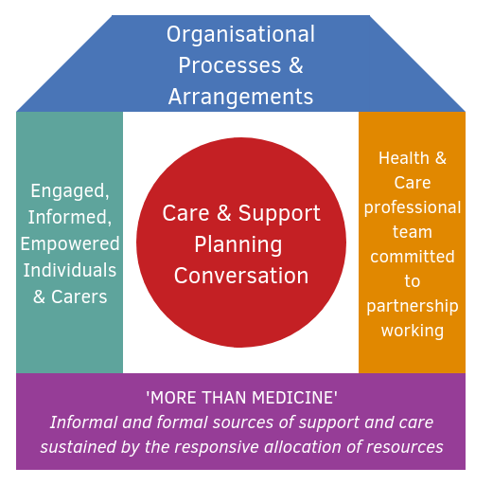
Figure 7: The House of Care
(Source: Health and Social Care Alliance Scotland, 2018)
- Engaged and Informed Patients (Left Wall)
The model is based on making the patients able to manage effective conversations regarding their health conditions. The people affected with depression can be supported effectively through this approach for overcoming “learned helplessness” and passivity by building their skills and confidence to self-manage.
- Committed Health Professionals (Right Wall)
The clinicians need to be partners of care, rather than being diagnoses or treaters. For this purpose, the NHS England provides clinical training to the staff to enable them to address mental health issues while managing the adverse physiological conditions (Health Education England, 2025). It is noted that there are around 160,000 full-time equivalent staff employed in NHS mental health services in England (Rolewicz et al. 2024).
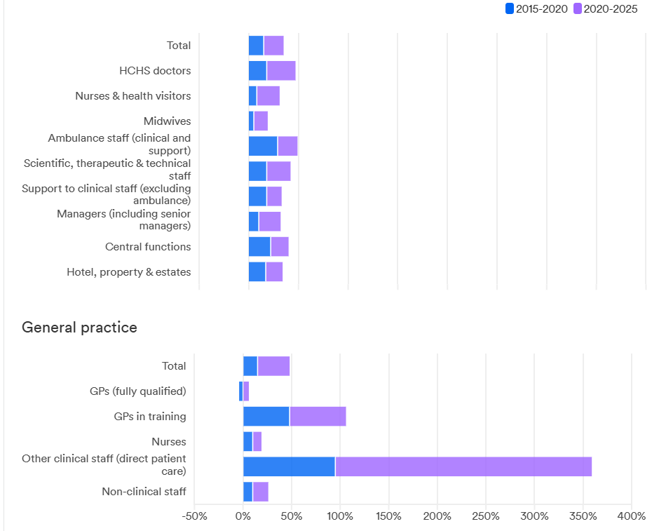
Figure 8: Percentage increase in staff in UK Hospitals since 2015
(Source: Rolewicz et al. 2024)
- Organisational Processes (The Roof)
In order to manage clinical efficiency, effective information technology must be adopted, which can align with the personal goals of the patients, along with a flexible clinical care process provided to them. It will also be effective in supporting the patients with a proper mental health support system.

- Responsive Commissioning (The Base)
Local health authorities and the commissioners need to be active in creating an environment for community-based support through social prescribing, befriending schemes and peer support groups. It will be important to reduce the number of mental health affected individuals from chronic depression.
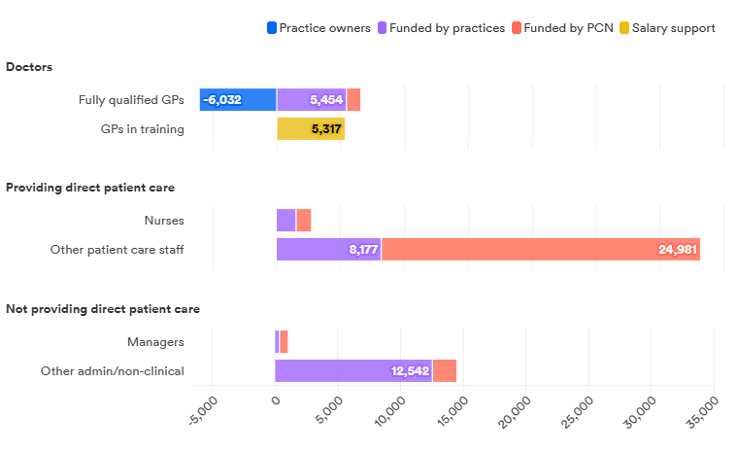
Figure 9: Increases in other staff providing direct patient care driven by funding through primary care networks
(Source: Rolewicz et al. 2024)

3.3 Framework for Improved Outcomes
Based on the above two models, it can be mentioned that both of them are effective in highlighting the process of fragmented care for people with mental health morbidity. Survey evidence shows that individuals with physical long-term conditions are more prone to suffer from depression. First of all, the House of Care is mainly applied in the UK context because it has considered mental and physical health wellbeing as interlinked factors of individual health and wellbeing. On the other hand, the CCM is based on introducing collaborative care into the clinical infrastructure for managing positive mental health conditions through a holistic caregiving approach (Hernandez et al. 2024, August). Therefore, together these two frameworks are based on triple aim, such as improved patient experience (feeling “listened to”), better clinical outcomes (reduced symptoms) and increased system efficiency (fewer emergency admissions).

4. Political, Health, and Social Care Agendas

4.1 National Agendas (UK)
The NHS Long Term Plan highlighted the change of prominent UK healthcare policy by considering “personalised care business as usual” across the entire health and social care system. The agenda of the plan is based on serving around 2.5 million people through effective personalised care and to focus on doubling the figure within a decade. The Primary care Network has involved effective GP practices, serving a population of 30,000 to 50,000 patients (Community Pharmacy England, 2025). Increasing access to the Improving Access to Psychological Therapies program appears helpful to support the intervention for 380,000 people with depression by 2023/24 in the UK (Nuffield Trust, 2024). Moreover, the Improving Access to Psychological Therapies program by NHS was brought to a scale capable of treating over 380,000 individuals with depression annually (Health.org, 2024). In some cases, the community people feel less valued and respected, which ultimately leads to the creation of barriers to access specialist support for long-term management.
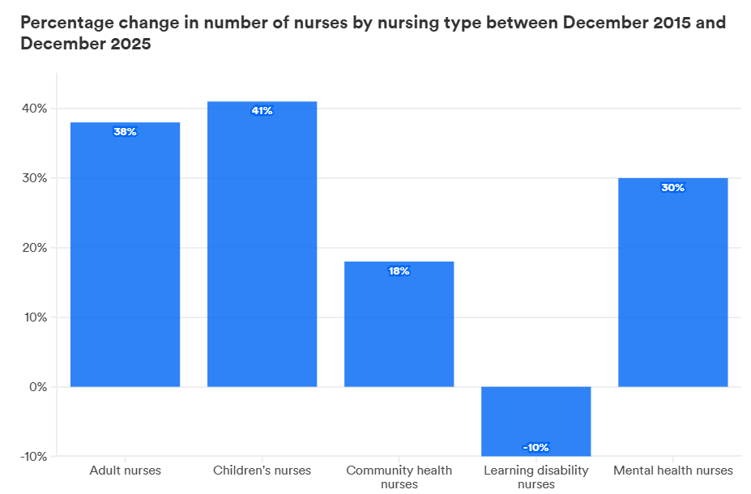
Figure 10: Percentage change in the number of nurses between December 2015 and December 2025
(Source: Rolewicz et al. 2024)
It is recorded that the application of this national agenda is based on developing primary care networks in the UK for managing community care in a positive manner. As a result, it is observed that the plan has developed the intensive primary care network and due to this, 370,000 people with severe mental illness (SMI) annually in the UK are benefited (GOV.UK, 2023). NHS has also introduced the personal health budget plan and it is resulted into development of self-efficacy in 86% cases (NHS England, 2022). On the contrary, the critical fact is based on developing a treatment gap in the same area and for this, around 23% of adults affected with depression are receiving minimal formal treatment (GOV.UK, 2023). The roles have included health and wellbeing coaches and care coordinators, who are further trained to support people with mental health illnesses in the long term.

4.2 Implementation of Initiatives globally
As mentioned by Cooper et al. (2022), one of the prominent implementation strategies, controlling mental health illness is based on social prescribing, which is effective to address the social determinants of mental ill health, such as housing, debt, and loneliness. It is noted that by 2030, the UK government aims to engage more than 1000 Social Prescribing Workers and enable up to 900,000 people to be connected to community assets such as befriending schemes and advice centres. Globally, WHO has implemented Mental Health Gap Action Programme (MH GAP) for low- and middle-income countries to detect, diagnose, and treat chronic depression (WHO, 2023). For instance, this approach appeared helpful to the Sandwell Esteem team in the West Midlands, which is engaged in providing care coordination to individuals to prevent any kind of deterioration and unusual hospital admissions (Thiel et al. 2026). The prominent positive result in this regard shows that social prescribing referrals result in 14% fewer GP appointments and a 12% reduction in A&E attendances (Bu et al. 2026). Additionally, WHO's baseline benchmark targets a 50% increase in service coverage for severe depressive disorders by utilizing digital health tracking apps and community peer networks (WHO, 2023). Another important policy requirement is personalised care and support planning, through which the depressed and anxious individuals can be supported morally and physiologically. Additionally, the application of personal health budget policy for mental health in the UK is developing rapidly and it is reported by 86% of individuals that they are now able to manage their self-efficacy by utilising fund arrangement by the UK government (Fung, 2024). Specific testing is also under experiment for “looked after children”. As evidence, it is seen that 45% of this group face severe mental health issues in comparison with 10% of the general child population. Thus, it is evident through the entire discussion that around 90% of mentally ill people in the UK are under the supervision of primary care and receiving proactive support for long-term recovery.

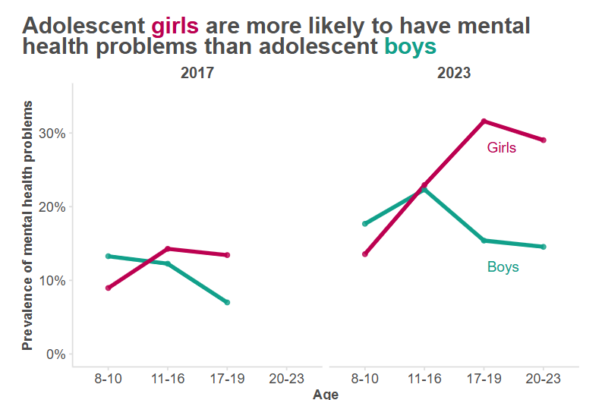
Figure 11: Gender-based mental health conditions
(Source: Education Policy Institute, 2023)

5. Recommendations for Improvement
Person-centred care process
In order to manage the output of chronic mental health conditions, the clinical practices must be based on shifting from the traditional “diagnose and treater” role towards an expert healthcare partner. Additionally, the clinical experts can follow a “what matters to me” approach, which may support to fulfil patients’ goals along with clinical symptoms. This will be helpful to support individuals with chronic depression to overcome helplessness and maintain a positive attitude to manage their plan for long-term growth.
Self-management support
- Conducting health coaching
Introducing clinical coaching skills is suggested to support patients in developing their knowledge, skills, and confidence in managing their own health conditions. For example, it is seen that highly activated patients are showing 19% fewer GP appointments and 38% fewer emergency admissions (Reader. Health, 2025). Subjective recovery rates are seen to develop for the individuals through this technique. Besides, hope, empowerment, self-rated recovery, and overall quality of life are seen to be managed effectively at both immediate post-treatment and longitudinal follow-ups.
- Managing peer support
This strategy will be helpful for the affected individuals in terms of making them more knowledgeable and less isolated. At the same time, this approach is highly cost-effective for handling community health care. As evidence, it is shown that highly depressed individuals use preventative care and community support groups, rather than waiting for an acute mental health crisis treatment (Adu et al. 2024). It results into substantially lower healthcare expenditures compared to inactivated individuals.
End-of-life care
- Introducing integrated narratives
High-quality EOLC can act beyond physical symptom management to treat the whole person. In this care process, the emotional and spiritual needs will also be considered, fulfilling the care plan. The mental health conditions of the patients may develop as they can feel “at peace” by reducing fears, cultural practices, and spiritual beliefs alongside pharmacological interventions for depression.
- GP Coordination
It is obvious that 90% of cases of depression are managed by primary care and hence, the role of GPs is crucial. They will act as a coordinator in multidisciplinary team (MDT) meetings. Application of the Gold Standards Framework (GSF) and QOF incentives (PC2) will be helpful to ensure that patients with depression, who are vulnerable, must receive proactive care by GPs to manage their livelihood effectively.

6. Conclusion
Thus, it can be concluded that the mentioned mental conditions, such as depression, must be denoted as chronic and relapsing long-term conditions. Yet, these can be appeared as for both individuals and the UK economy. It is needless to mention that physical wellbeing can be managed smoothly only when the mental health condition is good and for this purpose, the critical care models such as House of Care have been discussed. In order to showcase the national agendas of the UK, the NHS long-term mental healthcare plan is focused, which mentioned that the roles of clinicians must be based on being expert healthcare partners. Finally, adoption of a proactive and community-based framework becomes necessary to support individuals to manage their recovery and receive dignified and coordinated support from diagnosis through to the end of life.

References
Adu, M.K., da Luz Dias, R., Obuasi-Donkor, G., Ezeanozie, N., Sridharan, S., Morrison, J., Simon, P., Taylor, B., MacKinnon, M., Gossen, S. and Awara, M., 2024. Reducing wait times and avoiding unnecessary use of high-cost mental health services through a Rapid Access and Stabilization Program: protocol for a program evaluation study. BMC Health Services Research, 24(1), p.247. https://link.springer.com/content/pdf/10.1186/s12913-024-10697-7.pdf
Armstrong, M. (2023). Infographic: Majority of UK Adults Have Experienced Mental Health Issues. [online] Statista Daily Data. Available at: https://www.statista.com/chart/25645/uk-mental-health-issue-prevalence-gcs/?srsltid=AfmBOorCbkxXJf55SwDtdxrXx6yzJq24uxVgGKUytHIo0SmcYYBN1B6U [Accessed 28 Jun. 2026].
Averill, P., Bowness, B., Henderson, C. and Sevda Lis, N., 2024. What does ‘safe care ‘mean in the context of community-based mental health services? A qualitative exploration of the perspectives of service users, carers, and healthcare providers in England. BMC Health Services Research, 24(1), p.1053. https://link.springer.com/content/pdf/10.1186/s12913-024-11473-3.pdf
Bolton, D., 2023. A revitalized biopsychosocial model: core theory, research paradigms, and clinical implications. Psychological medicine, 53(16), pp.7504-7511. https://www.cambridge.org/core/services/aop-cambridge-core/content/view/8FC915C01228857ED6B5E123536E8994/S0033291723002660a.pdf/div-class-title-a-revitalized-biopsychosocial-model-core-theory-research-paradigms-and-clinical-implications-div.pdf
Bradford District and Craven Health and Care Partnership. (2025). Pilot on one off personal health budget for mental health - Bradford District and Craven Health and Care Partnership. [online] Available at: https://bdcpartnership.co.uk/strategic-initiatives/healthy-minds-community-mental-health-transformation/pilot-on-one-off-personal-health-budget-for-mental-health/ [Accessed 28 Jun. 2026].
Bu, F., Kurland, J.S., Hayes, D. and Fancourt, D., 2026. Assessing the impact of social prescribing on health service utilisation: Evidence from the UK. media, pp.2026-01. https://www.medrxiv.org/content/10.64898/2026.01.30.26345222.full.pdf
Cerebral (2025). The Genetic Factors of Depression. [Online] Cerebral. Available at: https://cerebral.com/blog/the-genetic-factors-of-depression [Accessed 11 July 2026]
Chuti Yami, M., Cutler, N., Sangun, S., Taekwon, T., Natacha, P., Napa, W., Krai Thaworn, P. and River, J., 2025. Community-engaged mental health and wellbeing initiatives in under-resourced settings: A scoping review of primary studies. Journal of primary care & community health, 16, p.21501319251332723. https://journals.sagepub.com/doi/pdf/10.1177/21501319251332723
Community Pharmacy England. (2025). Primary Care Networks (PCNs) - Community Pharmacy England. [online] Available at: https://cpe.org.uk/lpcs-and-local/local-nhs-structures/primary-care-networks-pcns/ [Accessed 28 Jun. 2026]
Cooper, M., Avery, L., Scott, J., Ashley, K., Jordan, C., Errington, L. and Flynn, D., 2022. Effectiveness and active ingredients of social prescribing interventions targeting mental health: a systematic review. BMJ open, 12(7), p.e060214. https://bmjopen.bmj.com/content/bmjopen/12/7/e060214.full.pdf
Croatian, A., Covases, S., Isaiahs, O., Lupu, L., Avaani, M., and Siafakas, N., 2025, July. Chronic obstructive pulmonary disease and depression—the vicious mental cycle. In Healthcare (Vol. 13, No. 14, p. 1699). MDPI. https://www.mdpi.com/2227-9032/13/14/1699
CPRMB Team (2025). Male suicide combined rates in England and Wales continue to rise (highest this century). [online] Menandboys.org.uk. Available at: https://www.menandboys.org.uk/nce/male-suicide-combined-rates25 [Accessed 28 Jun. 2026].
Deloitte (2024). Poor mental health costs UK employers £51 billion a year for employees | Deloitte UK. [Online] www.deloitte.com. Available at: https://www.deloitte.com/uk/en/about/press-room/poor-mental-health-costs-uk-employers-51-billion-a-year-for-employees.html [Accessed 27 Jun. 2026].
Department of Health (2024). No health without mental health: A cross- government mental health outcomes strategy for people of all ages. [Online] Available at: https://assets.publishing.service.gov.uk/media/5a7cab32e5274a2f304ef5a3/dh_123993.pdf [Accessed 27 Jun. 2026].
Education Policy Institute (2023). Four charts which explain the state of children’s mental health in 2023. [online] Education Policy Institute. Available at: https://epi.org.uk/publications-and-research/four-charts-which-explain-the-state-of-childrens-mental-health-in-2023/ [Accessed 28 Jun. 2026].
Fanelli, G., Raschi, E., Hafez, G., Matura, S., Schiek, C., Poluzzi, E. and Lunghi, C., 2025. The interface of depression and diabetes: treatment considerations. Translational Psychiatry, 15(1), p.22. https://www.nature.com/articles/s41398-025-03234-5.pdf
Fung, S. (2024). Validity of the Brief Resilience Scale and Brief Resilient Coping Scale in a Chinese Sample. International Journal of Environmental Research and Public Health, 17(4), p.1265. https://doi.org/10.3390/ijerph17041265.
GOV.UK (2023). Mental Health and Wellbeing plan: Discussion Paper. [online] GOV.UK. Available at: https://www.gov.uk/government/calls-for-evidence/mental-health-and-wellbeing-plan-discussion-paper-and-call-for-evidence/mental-health-and-wellbeing-plan-discussion-paper [Accessed 28 Jun. 2026].
Grandviewresearch.com. (2025). Depression and Anxiety Management - Mental health apps market outlook. [Online] Available at: https://www.grandviewresearch.com/horizon/statistics/mental-health-apps-market/application/depression-and-anxiety-management/global [Accessed 28 Jun. 2026].
Health and Social Care Alliance Scotland (2018). The House of Care Model. [online] Health and Social Care Alliance Scotland. Available at: https://www.alliance-scotland.org.uk/past-work-and-projects/scotlands-house-of-care/the-house-of-care-model/ [Accessed 28 Jun. 2026].
Health Education England (2025). Mental health. [online] Health Education England. Available at: https://www.hee.nhs.uk/our-work/mental-health [Accessed 28 Jun. 2026].
Health.org (2024). In deprived areas, patients referred for psychological therapy are less likely to receive treatment. [Online] The Health Foundation. Available at: https://www.health.org.uk/features-and-opinion/features/in-deprived-areas-patients-referred-for-psychological-therapy-are [Accessed 11 July 2026]
Hernandez, V., Nasser, L., Do, C. and Lee, W.C., 2024, August. Healing the whole: an international review of the collaborative care model between primary care and psychiatry. In Healthcare (Vol. 12, No. 16, p. 1679). MDPI. https://www.mdpi.com/2227-9032/12/16/1679
ISE (2023). Mental health problems cost the UK economy at least £118 billion a year - new research. [Online] The London School of Economics and Political Science. Available at: https://www.lse.ac.uk/news/latest-news-from-lse/c-mar-22/mental-health-problems-cost-uk-economy-at-least-118-billion-a-year-new-research [Accessed 27 May 2026].
James, J.L., 2024. Effectiveness and Challenges of Integrated Care Models in Managing Mental Health in Chronic Illness and Disability: A Literature Review. Undergraduate Research in Natural and Clinical Science and Technology Journal, pp.1-9. https://urncst.com/index.php/urncst/article/download/780/496
Kirk-Wade, E. (2025). Suicide: Summary of Statistics. Commonslibrary.parliament.uk. [online] Available at: https://commonslibrary.parliament.uk/research-briefings/cbp-7749/ [Accessed 11 July 2026]
Kittanning, C., Maitra, N.S., Qadeer, Y.K., Wang, Z., Fogg, S., Storch, E.A., Celano, C.M., Huffman, J.C., Jha, M., Charney, D.S., and Lavie, C.J., 2023. Association of depression and cardiovascular disease. The American journal of medicine, 136(9), pp.881-895. https://www.amjmed.com/article/S0002-9343(23)00334-0/pdf
Lye, M.S., Tey, Y.Y., Tor, Y.S., Shahabuddin, A.F., Ibrahim, N., Ling, K.H., Stanislas, J., Loh, S.P., Rosli, R., Lokman, K.A., and Badamasi, I.M., 2020. Predictors of recurrence of major depressive disorder. Plops one, 15(3), p.e0230363. https://journals.plos.org/plosone/article/file?id=10.1371/journal.pone.0230363&type=printable
Mental Health Foundation (2024). Mental health problems cost the UK economy at least GBP 118 billion a year. [Online] Mental Health Foundation. Available at: https://www.mentalhealth.org.uk/about-us/news/mental-health-problems-cost-uk-economy-least-gbp-118-billion-year [Accessed 17 Jun. 2026].
Mental health first aid course (2026). Depression Statistics UK: 2026 Facts, Data & Key Insights. [Online] Mentalhealthfirstaidcourse.co.uk. Available at: https://www.mentalhealthfirstaidcourse.co.uk/blog/depression-statistics [Accessed 27 Jun. 2026].
NESTA (2023). Our work in health. [Online] Nesta. Available at: https://www.nesta.org.uk/health/our-work-health/ [Accessed 27 Jun. 2026].
NHS England (2022). NHS England » Personal health budgets. [Online] Www.england.nhs.uk. Available at: https://www.england.nhs.uk/personalisedcare/personal-health-budgets/ [Accessed 11 July 2026]
NICE (2024). Depression in adults: Treatment and Management. [online] www.nice.org.uk. Available at: https://www.nice.org.uk/guidance/ng222 [Accessed 28 Jun. 2026].
Nuffield Trust (2024). Improving Access to Psychological Therapies (IAPT) programme. [Online] The Nuffield Trust. Available at: https://www.nuffieldtrust.org.uk/resource/improving-access-to-psychological-therapies-iapt-programme [Accessed 10 Jun. 2026]
Our Future Health. (2025). Revealed: what our data says about the UK’s mental health. [Online] Available at: https://ourfuturehealth.org.uk/news/2025-mental-health-statistics/ [Accessed 8 Jun. 2026].
Peçanha, A., Silveira, B., Krahe, T.E. and Landeira Fernandez, J., 2025. Can social isolation alleviate symptoms of anxiety and depression disorders?. Frontiers in psychiatry, 16, p.1561916. https://www.frontiersin.org/journals/psychiatry/articles/10.3389/fpsyt.2025.1561916/pdf
Reader. Health (2025). Key points | Reducing emergency admissions. [Online] Health Foundation. Available at: https://reader.health.org.uk/reducing-emergency-admissions/key-points [Accessed 2 Jun. 2026].
Reist, C., Patiala, I., Latimer, J., Raffaelli, S.B., Chiang, M., Eisenberg, D. and Campbell, S., 2022. Collaborative mental health care: A narrative review. Medicine, 101(52), p.e32554. https://journals.lww.com/md-journal/_layouts/15/oaks.journals/downloadpdf.aspx?an=00005792-202212300-00021
Rolewicz, L., Palmer, B. and Labonte, C. (2024). The NHS workforce in numbers. [Online] The Nuffield Trust. Available at: https://www.nuffieldtrust.org.uk/resource/the-nhs-workforce-in-numbers [Accessed 18 Jun. 2026].
Southwark Public Health (2022). Supporting commissioning decisions by assessing the burden of long-term conditions locally. [Online] Available at: https://www.southwark.gov.uk/sites/default/files/2024-10/Long-Term%20Conditions%20JSNA%20Factsheet%202018.pdf [Accessed 27 Jun. 2026].
Sussex, J., Smith, J., Wu, F.M. and Wu, F., 2024. Service innovations for people with multiple long-term conditions: reflections of a rapid evaluation team. Health and Social Care Delivery Research, 12(15), pp.1-76. https://www.journalslibrary.nihr.ac.uk/hsdr/PTRU7108
Thiel, V., Sonola, L., Goodwin, N. and Kodner, D. (2026). Co-ordinated care for people with complex chronic conditions. [online] Available at: https://assets.kingsfund.org.uk/f/256914/x/f6dd3b19b2/esteem_team_august_2013.pdf [Accessed 28 Jun. 2026].
United Nations (2020). Mental Health and Wellbeing | United Nations. [Online] United Nations. Available at: https://www.un.org/en/global-issues/mental-health [Accessed 27 Jun. 2026].
WHO (2023). Mental Health Gap Action Programme (MH GAP). [Online] Www.who.int. Available at: https://www.who.int/teams/mental-health-and-substance-use/treatment-care/mental-health-gap-action-programme [Accessed 11 July 2026].
World Health Organization (2023). Global burden of mental disorders and the need for a comprehensive, coordinated response from health and social sectors at the country level. [Online] Available at: https://apps.who.int/gb/ebwha/pdf_files/EB130/B130_9-en.pdf [Accessed 17 Jun. 2026].
World Health Organization (2025). Depressive disorder (depression). [Online] World Health Organization. Available at: https://www.who.int/news-room/fact-sheets/detail/depression [Accessed 11 July 2026]

