NAME:Isha muskaan
STUDENT ID:2128279
MODULE:Marketing management assessment 2
MODULE CODE: LCMB7001
LECTURER:Tushara Balendran
COURSE:Master’s in business administration
SUBMISSION DATE:12-09-2022

Marketing Management Assessment 2

Table of Contents
Introduction 3
Macro Environment Factors 3
PESTLE Analysis of Tesco 3
Porter Five Forces Model 5
SWOT Analysis 7
Market Segmentation 8
Target Market 9
Positioning of the Company 9
Marketing Mix Strategy 10
Recommendation 11
Conclusion 11
References 12

Introduction
The management related to marketing is regarded as the exchange of services and commodities along wiry several other activities like choosing, planning, and managing the customers as well as the target market. The report will emphasize Tesco which is a famous retail store based in the United Kingdom (Rosnizam et al. 2020). It will focus on analyzing Tesco with the help of the marketing Mix and Porter's five forces and the marketing mix. The focus will also be provided on explaining the market segmentation as well as the positioning. The concentration will be provided on discussing the recommendation about unfavourable factors.

Macro Environment Factors

PESTLE Analysis of Tesco
PESTLE analysis is essential to grasp the position of an organisation in the market and also for comprehending the strengths and potential weaknesses that affect profitability and productivity.
Political: TESCO has been one of the most renowned retail giants in the UK for ages. The company is witnessing a few troubles this year due to some emerging political issues in the country. The company is subjected to a few troubles due to the Brexit issue in the UK, the trade war between China and US, and also because Russia invaded Ukraine (Rosnizam et al. 2020). Apart from this, the escalating tax rates on imports also affect TESCO as it imports many of the goods from East Asia, China, and others.
Economical: Even though TESCO has been able to attain its profitability during the Covid19 pandemic, it is still dealing with some economical issues that are hindering its way to achieving the expected profitability. The supply chain issue during and after the pandemic is responsible for the increasing rate of transportation charges which results in price hikes for the products (Baliyan, 2021). The inflation in 2022 that is caused due to the Russia-Ukraine war has enlarged the problem of unemployment in the country (Dräger et al. 2022). Inflation and unemployment are reducing the purchasing capability of the consumers and as a result, the organisation is being able to attain its profit margin.
Social: Social factors refer to the lifestyle of people, their preferences, demands, boost in population, and others. People are inclining toward brands that can offer them healthy and sustainable products at an affordable price range. TESCO has introduced some healthy food variants in their stores online and offline besides the fast food options. By launching health food items TESCO has been able to maintain its loyal consumer base and has also attracted new customers.
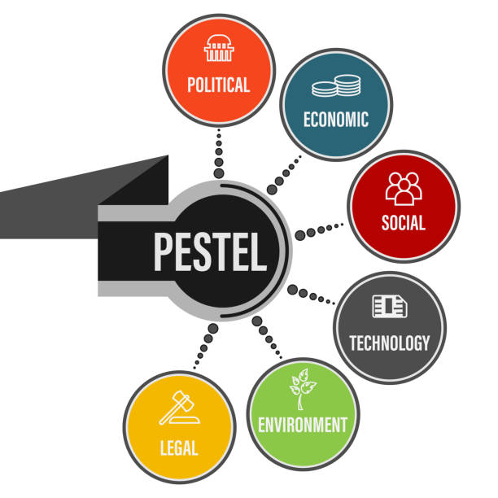
Fig 1: Pestle Analysis
(Source: istockphoto, 2022)
Technological: TESCO has grasped the importance of technology in this era, and has invested strategically in enhancing its technology to satisfy its customers and also for maintaining its data, supply management, research and development, and others.
Environmental: At this crucial stage of several environmental issues, the government has executed some policies for organisations to reduce the amount of pollution on their part. TESCO has implemented some strategies such as collecting single-use plastics from the customers and recycling them, reducing the amount of carbon imprint by using fuel-efficient routes, utilise recyclable sources to produce electricity, and others (Brock et al. 2022).
Legal: TESCO has faced several charges due to discriminating against employees based on age and gender. Several shareholders have complained because of puzzling them while providing information. The TESCO team has to observe the problems and must implement rules to avoid any legal issues which can reduce the reputation of the organisation.

Porter Five Forces Model
Porter's five models are analyzed to examine the impact of five forces which include competitive rivalry, customer power, supplier power, the threat of new entrants, and substitute.
Buyers' power of Tesco: In Tesco customers shop in their stores and online every week. Buyers in the UK are not organized, so they have little bargaining power. As for grocery stores, bargaining power is high due to competitive players on the market that are cheaper than Tesco (Mbaskool, 2022). Therefore, it can be concluded that Tesco needs to lower its product prices in order to increase its profit margins.
Supplier powers of Tesco: Retail stores like Tesco are thus able to switch suppliers easily. In this situation, the retail owners are in control of the negotiations, and they will have the upper hand when determining the price under the agreement. In each store, the same item is available from multiple suppliers (Malik et al. 2021). It allows retailers to purchase products from vendors that offer them the most competitive prices as long as the quality is maintained. As a result, Tesco has weak bargaining power with suppliers.
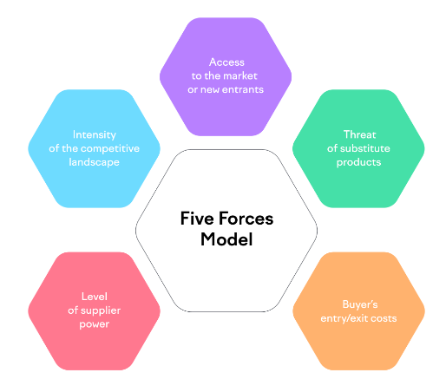
Fig 2: Porter's five forces
(Source: semrush, 2022)
The threat of new entrants in Tesco: Although to compete with Tesco, new entrants will need more knowledge and experience, as well as substantial capital investments. Moreover, the existing players can always find ways to cut costs and increase profits through economies of scale, but they cannot offer bulk discounts on products (Monte, 2021). Since the big players already dominate the distribution channels and supply chains, it will also be difficult for new entrants to enter the market. Thus, it can be concluded that this force poses a weak threat.
The threat of a new substitute: Despite having substitute product Tesco sell products that satisfy customer needs and maintains its position in the market. However, if a company provides similar products as Tesco for temporary customers, they might prefer the alternative. Through this data, it can be determined that the threat is moderate and can be controlled. This is because Tesco has a reputation for offering a wide variety of products, which gives it an edge.
Competitive rivalry of Tesco: The market is dominated by several players such as Sainbury and Walmart. There are very few differences between these established corporations, each with a strong supply chain and logistic network (Hua, 2022). Each company, however, applies different strategies to maintain their position among customers. It can be concluded that intense price wars are more visible between the strongest players. It can be concluded that the threat based on rivalry is high.

SWOT Analysis
Strengths: The biggest strength of Tesco is its leading position in the grocery retail market with annual revenue of 57.8 billion for the year 2021. Additionally, its diversified product range has enabled it to gain the market share of Great Britain with a value of 27.9%. Furthermore, it has gained an international presence with 4673 stores in about 14 global counties (pestleanalysis.com, 2020). It utilizes superficial technological devices that have enabled it to develop an efficient network of supply chains along with an online shopping platform with a 60% growth in sales.
Weaknesses: In 2012, Tesco failed to successfully operate in the US and Japanese markets. Additionally, the company was found guilty of an accounting scandal in 2017. Moreover, the previous year, the operating profit of 2021 declined by 21.3%, that is, 1.7 billion (tescoplc.com, 2022). Other factors like negative publicity, labour exploitation, illegal business practices, and the Clubcard scam have been major weaknesses of Tesco.
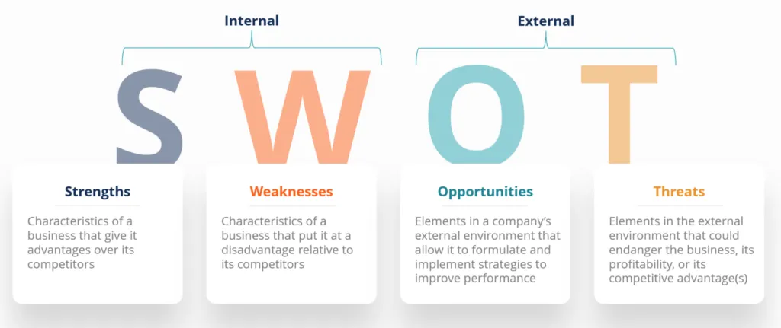
Figure 3: SWOT Analysis
(Source: corporatefinanceinstitute, 2022)
Opportunities: Tesco must focus on grabbing potential opportunities by developing a positive partnership with popular companies. Additionally, by expanding its operations in emerging markets such as Turkey, South Korea, and Indonesia, Tesco can avail of higher profitability. Furthermore, the productivity of the company can be enhanced by initiating its cashless stores in different countries (pestleanalysis.com, 2020). Tesco has initiated a one-hour delivery facility in more than 100 stores which have increased its sales significantly.
Threats: Due to its disrespectful Christmas ad in 2017, Tesco faced negative responses from customers along with misleading information about its fake farm "Woodside Farms". Additionally, the increasing costs are a major threat to the company's financial health with additional expenditures varying from 830 million and 1.18 billion (tescoplc.com, 2022). The arrival of the global pandemic has negatively impacted the supply chain management of the company along with various hygiene investigations carried out against the company.

Market Segmentation
Market segmentation is a massively essential aspect for any business enterprise in order to separate their targeted customers into different sections following their demands and requirements. The market segmentation is divided into different parts such as Geographic, Demographic, Psychographic, and Behavioral. Geographic segmentation refers to segmentation based on country, region, location, demographic refers to age, gender, and others, behavioural refers to the customers' digital shopping pattern, their shopping frequency, and others, and lastly, psychographic defines the segmentation according to the characteristics of a customer, their moral values and others (Badilla, 2022). Segmentation helps organisations in creating customised texts according to choices, habits, location, and other things. Segmentation guides in preparing effective strategies according to different segments to attain the profitability of the organisation.

Target Market
Depending on the market segmentation, it is the responsibility of the organisations to understand their targeted segments. After grasping the requirements of the different segments, the organisations can comprehend their targeted audience (Schlegelmilch, 2022). The management team is responsible to understand the various demands of the target audience according to the segments to implement effective strategies in order to attain their profit margin. Organisations launch products and produce them in vast amounts in compliance with the demands of the targeted customers. Targeting guides organisations in creating productive communication with their customers and also in establishing a robust consumer base.

Positioning of the Company
Tesco focuses on functional positioning which helps the organization in having competitive advantages. This approach has guided the company in expanding the market share and the business ideas that have helped it open many stores in various parts of the world. It is one of the proficient positioning tactics that Tesco has used for gaining advantages followed by meeting the relevant targets (Aiello et al. 2020). It has made the company capable in front of its competitors followed by the creation of favourable possibilities. Another tactic via the multi-segment positioning has helped the organization in targeting buyers with an effective approach for improvisation, not the sales of revenue. This strategy has helped the organization in achieving a consolidated positioning on the international platform.

Marketing Mix Strategy

Fig 4: Marketing Mix
(Source: byjus, 2022)
A marketing mix analysis of Tesco's brand covers the 4Ps of marketing:
Product: It is one of the largest retailers in the UK, offering products in various categories which satisfy customers' preferences. Retail giant Tesco caters to a wide range of needs from consumers across various segments (Tse et al. 2018). There are several brands under Tesco Cares for Baby, Tesco Lotus, Tesco Kipa, F&F Clothing, and Tesco Value.
Price: Tesco takes advantage of economies of scale by implementing a well-organized supply chain and offers low prices on its products. Despite Tesco's low prices, quality is not compromised (Karim et al. 2021). Consumer feedback is regularly taken into account and unnecessary costs are reduced so prices are kept affordable. Accordingly, Tesco adheres to the cost leadership model.
Place: In addition to its 6,900 stores across 15+ countries, the company offers a variety of stores offering a wide variety of products. There are a variety of non-food items sold at Tesco stores along with groceries. Tesco offers four different types of supermarkets: Metro, Express, Extra, and Superstore. With Tesco Extra, customers can complete all their routine shopping under one roof, including groceries and general merchandise.
Promotion: Tesco focuses on themes when it comes to its promotional activities, such as hoarding campaigns, TV advertisements, and charity events. Promotional discounts and offers are also extremely popular, such as buy one get one free (Khanta et al. 2019). Digital marketing is also an important part of the brand's strategy, as it engages with its customers through online advertisements, social media marketing campaigns and many more.

Recommendation
According to the above information, Tesco faces many obstacles and competitors. Developing strategies differently from competitors is one way a company can improve. Policy changes, technological changes, and other factors can be better understood through macro-environmental analysis. In addition to identifying customer needs and creating relevant products, determining their preferences is also essential. Furthermore, Tesco can apply a 4R strategy that entails removing, reducing, reusing, and recycling in order to develop a sustainable future. Another way is maintaining consistency in customer service or implementing a personalized strategy to enhance customer experiences. Tesco can also adopt a strategy where they will provide health guidelines.

Conclusion
In this report, a thorough explanation of the famous UK brand Tesco has been given. The macro factors of Tesco have been discussed along with the PESTLE analysis that gives a vivid idea about the political, economic, social, technological, legal and environmental factors that may have an effect on the business. Porter’s Five Forces Model of Tesco have been conducted in the above report that gives an overall idea about the buyer’s power,supplier’s power and the threats on new entrants in Tesco.To further understand the market of Tesco a SWOT analysis has been discussed related to Tesco and finally, the Marketing Mix Strategy of Tesco has been talked about.

References
Aiello, L.M., Quercia, D., Schifanella, R. and Del Prete, L., (2020). Tesco Grocery 1.0, a large-scale dataset of grocery purchases in London. Scientific data, 7(1), pp.1-11.

Badilla, M.C.G., (2022). New Approaches to Market Segmentation, Targeting and Positioning: The Case of Maribojoc, Bohol, Philippines. In Marketing Tourist Destinations in Emerging Economies (pp. 189-210). Palgrave Macmillan, Cham.

byjus.com, (2022), marketing-mix. Available at: https://byjus.com/commerce/marketing-mix/. [Accessed on: 28.08.2022]

Baliyan, R., (2021). A Shift in Paradigm for Apparel Industry Post Covid 19. Turkish Journal of Computer and Mathematics Education (TURCOMAT), 12(13), pp.5203-5211.

Brock, A., Kemp, S. and Williams, I.D., (2022). Personal Carbon Budgets: A Pestle Review. Sustainability, 14(15), p.9238.

corporatefinanceinstitute, (2022), Image Available at: https://corporatefinanceinstitute.com/resources/knowledge/strategy/swot-analysis/. [Accessed on: 28.08.2022]

Dräger, L., Gründler, K. and Potrafke, N., (2022). Political Shocks and Inflation Expectations: Evidence from the 2022 Russian Invasion of Ukraine.

Hua, Q., (2022)., July. Carrefour’s Current Development Situation and Its Valuation. In 2022 2nd International Conference on Enterprise Management and Economic Development (ICEMED 2022) (pp. 573-580). Atlantis Press.

istockphoto.com, (2022), pestle. Available at: https://www.istockphoto.com/photos/pestel. [Accessed on: 28.08.2022]

Karim, R., Latip, N.A., Marzuki, A., Haider, S., Nelofar, M. and Muhammad, F., (2021). The impact of 4ps marketing mix in tourism development in the mountain areas: A case study. Int. J. Econ. Bus. Adm. IJEBA, 9, pp.231-245.

Khanta, F. and Srinuan, A.P.D.C., (2019). The relationships between marketing mix, brand equity, lifestyle and attitude on a consumer’s private product brand purchasing decision. African Journal of Hospitality, Tourism and Leisure, 8(5), pp.1-14.

Malik, S.A. and Hingley, M., (2021). Consumer demand information as a re-balancing tool for power asymmetry between food retailers and suppliers. Economia Agro-Alimentare, 22(2), pp.1-28.

Monte, A., (2021). A study of value chain reconfiguration processes under Covid-19 pressures: the case of Tesco PLC in the United Kingdom.

mbaskool, (2022), five-forces-analysis/companies/18311-tesco.html. [Available at: https://www.mbaskool.com/five-forces-analysis/companies/18311-tesco.html]. [Accessed on: 25.08.2022]

pestleanalysis.com, (2020), Information. Available at: https://pestleanalysis.com/tesco-swot-analysis/. [Accessed on: 28.08.2022]

Rosnizam, M.R.A.B., Kee, D.M.H., Akhir, M.E.H.B.M., Shahqira, M., Yusoff, M.A.H.B.M., Budiman, R.S. and Alajmi, A.M., (2020). Market opportunities and challenges: A case study of Tesco. Journal of the Community Development in Asia (JCDA), 3(2), pp.18-27.

Rosnizam, M.R.A.B., Kee, D.M.H., Akhir, M.E.H.B.M., Shahqira, M., Yusoff, M.A.H.B.M., Budiman, R.S. and Alajmi, A.M., (2020). Market opportunities and challenges: A case study of Tesco. Journal of the Community Development in Asia (JCDA), 3(2), pp.18-27.

Schlegelmilch, B.B., (2022). Segmenting targeting and positioning in global markets. In Global marketing strategy (pp. 129-159). Springer, Cham.

semrush.com, (2022), understanding-porters-five-forces-model. Available at: https://www.semrush.com/blog/understanding-porters-five-forces-model/. [Accessed on: 28.08.2022]

Tse, Y.K., Loh, H., Ding, J. and Zhang, M., (2018). An investigation of social media data during a product recall scandal. Enterprise Information Systems, 12(6), pp.733-751.

tescoplc.com, (2022), Information Available at: https://www.tescoplc.com/investors/reports-results-and-presentations/annual-report-2022/. [Accessed on: 28.08.2022]

