What does Cross curricular learning involve?
Barnes and Shirley (2007) state that when delivering cross-curricular themes, teachers should provide clear appropriate subject learning objectives, monitor children’s understanding, using informal assessment. It is also important to give children early opportunities to apply newly learned skills and knowledge, generating new ideas. A cross-curricular approach provides a meaningful way in which students can use knowledge they have acquired in one context and apply them to another to develop their understanding (Collins, Brown and Newman, 1988).

Motivation - Motivation for learning is essential for all learners to create their own meaning and understanding from similar stimuli. This can be difficult due to the difference in motivations for different children. Marcus (2016); Rutter (1987); Cefai (2008) suggest that motivation has a large effect on the learning that takes place in the classroom, where schools who promote resilience and motivation allow children to create their own conditions for learning, something agreed by Siraj-Blatchford (1999); Davis et al (2016). It is therefore important that teachers understand what children’s individual needs are in order to help them learn (Florian, 2008; Lindsay, 2007; Marcus, 2016). Engagement is crucial for children’s ability to learn and therefore create meanings. Behaviourist theorists such as Skinner (2014) and Watson (2017) maintain that rewards and conditioning are critical in creating children’s motivation.

Whole school Approach
It is important that a school creates a whole school approach when implementing Cross-curricular learning. This should start early-on, allowing children the ability to adapt to this learning approach. Gardner (2000) and Barnes (2013) suggest there are fundamental beliefs that are taught early in school and are difficult to alter in teenagers. This approach must be used as a whole school approach building on children’s understanding throughout this period. Barnes (2015) shows in his case studies 2,3 and 7 that schools help provide the construction of hopeful futures, becoming cohesive cultures, modelling a sustainable and supportive community. Learning must replicate the world beyond school by mimicking the conditions faced, with jobs being inherently cross-curricular. This experience allows children an advantage that prepares them before they start working in the future. Wenger (1998) suggests experiences allow children to create meaning and understanding. The effectiveness of the community in helping children learn is increased or decreased by the amount of social capital that is available.

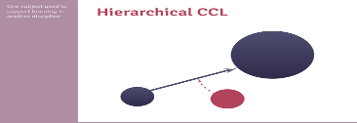
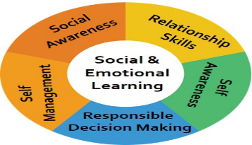
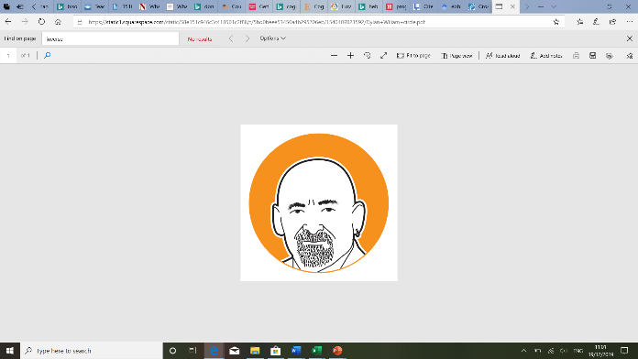
Tracking and AfL-
Barnes (2007) suggests the school is required to have a whole school policy which allow long-term tracking and assessment for learning. This can be created by individual appraisal, and promotes the teacher's professional judgement (Barnes, 2015). During this lesson I would be tracking information using Kinteract; an interactive tool in which parents and children can be involved in the process. Being able to track progress and understand where the child needs to go next in their learning is crucial. Christodoulou (2017, p.162) states “testing doesn’t just help measure understanding; it helps develop understanding”. An AfL approach looks at the learner's holistic engagement within the learning and assessment process, providing feedback which allows the learning to move forward; “Assessment for learning should recognise the full range of achievements of all learners” (Assessment Reform Group, 2002). The (QCA, 2008) supports the idea of practitioners looking at the whole child when evaluating the effectiveness of learning. This is enabled when using a variety of subjects, allowing the teacher the ability to see if learners can transfer their knowledge to different contexts.

Estyn and Donaldson - Estyn (2015) show good practice in Ty y Wern Primary School, who ensure they provide a broad curriculum, allowing children the ability to experience stimulating learning experiences. Fletcher-Wood (2018) suggests deep learning isn’t purely based on a plethora of knowledge but an organised mental model of learning. Donaldson (2015) has suggested the use of areas of learning in allowing teachers to provide close ties, building a web of learning.

Opportunistic Cross curricular learning – Lesson 1
A group of lessons will provide children with a wide depth of knowledge and understanding of their local area and knowledge of what happens in their town. These lessons will be aimed at Year 5. The first cross-curricular theoretical model I will be using is what Barnes (2015) calls an Opportunistic cross-curricular approach, which he suggests is the sharing of an important experience and connection between the child and the teacher. The teacher, or teaching assistant, listens carefully to children’s reactions, “observing changes in behaviour” (Barnes, 2015, p.273). Before the cross-curricular session, the class will have been on a trip to the local steel works where they learned about the process of creating steel, what materials is required, how much energy is needed to produce steel. On this trip the class had to come up with questions following a lesson on the production of steel and the history of our area. “Learners aged 7–14 should be given opportunities to develop and apply their knowledge and understanding of the cultural, economic, environmental, historical and linguistic characteristics of Wales” (WAG, 2008, p. 8); this lesson will link to the Chronological awareness, looking at dates of when the steelworks were created and other prominent days such as when the new blast furnaces were put in place. The class will use timelines to sequence events, and use appropriate key words to estimate, measure and describe the passage of time (Welsh Government, 2008, p.12). Pupils should develop their historical skills, knowledge and understanding through learning about a range of historical contexts. These should be based primarily on the local area (Welsh Assembly Government, 2008, p.12). Some children’s parents work in the steelworks and so their personal experience and knowledge helped the children understand some of the more complex nature of the steel making process following visits of steel workers, telling stories and helping children’s understanding and a visit to the site in Port Talbot. Ofsted (2010a) show that some schools use “wow” experiences in order to engage children emotionally, driving the child to want to understand more. In this series of lessons I will be using the experiences from the trip to understand the history of our local area; we will be looking to create an online interactive experience where children will recount experiences using children’s ideas on what method they want to use to present their findings, such as a podcast as a group, QR codes, or using pictures and videos taken at the Steelworks to create a Virtual reality experience or a YouTube vlog style experience as groups. These projects will be uploaded on to SeeSaw, where restricted access for parents and teachers and children is available. In maths the class will be using statistics of the costs of producing and selling steel. These numbers will be simplified for the year 5 class, using numbers up to 100,000 for the children at the levels 3 and 4, which can be differentiated for certain learners. They will work out problems with the data relating to how much steel needs to be produced. At Level 3, Learners organise their work, check results, and try different approaches through talking about and explaining their work (Welsh Assembly Government (WAG), 2008, p.13). In Level 4, “Learners develop their own strategies for solving problems, and present information and results systematically”, and will “search for a solution by trying out ideas of their own” (WAG, 2008, p.13). Using data skills, the class will extract and interpret “information from an increasing range of diagrams, timetables and graphs, use mean, median, mode and range to describe a data set” (WAG, 2008, p.11). With skills from the LNF, the class will interpret answers within the context of the problem and consider their answers, asking themselves if it is sensible (WAG, 2008). During the English lesson, the class will speak about the ecological problems the steel works has caused, presenting ideas in groups, and have a class discussion on the matters of pollution and the effect on our local area. The class will explain information and ideas, exploring and using ways to be convincing, such as use of vocabulary, gesture, visual aids. They will also develop their ability to “use a wide range of syntax structures, vocabulary and terminology in their talk, explore issues and themes through role play” (WAG, 2008, p.3), as well as “learning to listen to others, asking questions and responding to both the content and the speakers viewpoints, express opinions about topics and written texts and include some supporting reasons” (WAG, 2008, p.4). At Level 3 “Learners talk and listen confidently in different contexts, exploring and communicating ideas. In discussion, they show understanding of the main points” (WAG, 2008, p.14). At Level 4 “Learners talk and listen with confidence in an increasing range of contexts” (WAG,2008, p.14). Their talk is adapted to the purpose. The class will use LNF skills such as gather and organise information and ideas from different sources (WAG, 2008). Within the DCF framework, the class will be using VR cameras iPad’s uploading and saving files using it to present their findings. At Outcome 3, the class will modify and present a range of text, image, sound, animation and video selecting which is best for this project. They will also combine a range of multimedia components to produce an appropriate outcome (WAG, 2008). The class will generally be working towards DCF Outcome 3; they will create, collect and combine a range of text, image, sound, animation and video for this project about the steel works (WAG, 2008). Voogt and Roblin (2010) state that digital competencies are essential 21st century skills, which can be seen in a European context as the European Parliament has set out digital literacy as one of the 8 key competencies for lifelong learning. Alternatively, Yelland (2006) suggests that often technology is used through a curriculum that has been created before these new technologies had been created, therefore not allowing technology to be used to its full potential, and so can become problematic.

(Osiriseducational, 2019)
Hierarchical Cross curricular learning – Lesson 2
The second approach and lesson I have created is using a hierarchical cross-curricular approach to learning. This approach centres around learning from one subject; in this instance Art helps the development of other subjects (Barnes, 2015). In this lesson, the class will be looking at the work of local artist Mongo Gushi, whose style generally uses landscape pictures of the local area. This will allow the class the ability to connect with the art and create a relevance, which links to Curriculum Cymreig where children should be given opportunities to learn about their local area and use it to develop learning (Welsh Government, 2008). Using pictures from a Facebook page called Port Talbot Old and New, children will be able to see the history of the town and what it once looked like. They will use these images to create an art piece using their own interpretation of the picture, looking at the mood and the colours of to develop their understanding of the town. They will then be creating a piece of writing to show this understanding of the town and its history using the pictures. Within the English part of the lesson, the class should “Craft their writing by using the standard forms of English” (WAG, 2008, p. 12). The class will write an introduction “that establishes context, a series of appropriately ordered points and a suitable conclusion” (WAG, 2008, pp11). In art and design, learners develop first-hand a meaningful understanding of their immediate environment, culture and language. This allows the children “access to historical and contemporary Welsh art and design, enriching their creative activities” (WAG, 2008, P.8). In a mathematics context, the class will “identify the appropriate steps and information needed to complete the task or reach a solution” (WAG, 2008, p. 2). The class will also check their answers using inverse operations, showing their workings to check their answers (WAG, 2008). The class will create this artwork using software where they can edit the picture and add colours and develop specific parts of the picture they think requires more attention. The class will have opportunities to “investigate opportunities to select and record from: observation experience to investigate: the natural environment, the made environment using a variety of materials” (WAG, 2008, p.12). At DCF Outcome 3 the class will be able to use software tools to enhance outcomes for specific audiences (WAG, 2008). They will also be able use a range of software to produce and refine multimedia components. Using the art from Mongo Gushi, the class will produce an art piece using different components they have learned from the town, and the artist. This will be heavily influenced by the steelworks and culture of Port Talbot, using the unique styles and ideas of the town to create an individualistic piece. Hierarchical cross-curricular learning aims to achieve progress in one discipline by teaching aspects of another subject. The idea of using cross-curricular allows the learning to be flexible; teachers can adapt their practice according to children’s likes and dislikes, allowing more time for certain types of activities to learn. Barnes (2012) agrees, suggesting that this allows children to generate creative thinking. However, I know this approach needs to be carefully introduced by the teacher and carefully planned as the DfE (1999) shows there is no national guidance on this approach to teaching, suggesting more content is added without the expertise to match this. Barnes and Shirley agree, saying that many teachers do not experience cross-curricular approaches in training and often had limited experience when they were students. Barnes (2012) believes that assessing learning can be difficult due to the differing nature of subjects being introduced at the same time, suggesting that some children become confused. However, Rowley and Cooper (2009) suggest that cross-curricular learning assess the whole child, often showing learning in differing contexts.

Social emotional learning
Immordino-Yang and Damasio (2007) believe personal emotions direct their behaviour. However, they suggest there is not much time during the curriculum to use this approach effectively. Goodman and Gregg (2010) however suggest there has been a shift in policy making where policy makers have provided a focus on children’s emotional and social learning. Immodino-Yang and Faeth (2010); Bechara & Damasio (1997) stress the importance of emotional wellbeing in learning. Immordino-Yang and Damasio (2007) state that emotion is like a rudder, guiding the learning. Emotional wellbeing has a big effect on how children learn; it allows them the ability to process more information, preparing them for learning. Fredrickson (2009) and Dweck (2014) talk about the importance of positivity and the growth mindset, agreed by Cope and Whittaker (2012), who believe positivity and wellbeing allow children to find success. Barnes (2015) shows most cognitive psychologists point to a number of influences on children’s thinking and learning. He points out self-confidence, metacognition, heredity, peer examples and perceived relevance for learning as affecting ability for children to achieve. This means that there are many factors influencing the ability children have to take learning on. Barnes (2015); Entwistle (2000); Fisher (2008) show the large advantages of children having the ability to examine their own thought processes, while Sternburg’s (1997b, 2003) views on learning suggest that children require good memory, intelligence and analytical, creativity and practical ways of thinking, suggesting the need for children to engage in differing contexts of learning, helping develop their thinking development. Cognitive psychologists believe there is a great importance of creating meaning. Bruner (1996); Csikszentmihalyi (1997); Marton and Booth (1997) believe creating meaning from personalised language of learning is essential to allow this understanding to become engrained into children’s memory and therefore be useful. This point is agreed by Perkins (2009), who believes relevant context learning remains and is transferrable, where Barnes states “cross-curricular approaches provide fuller understanding of real world experiences” (Barnes, 2015, p.167).

(Oli Cav, 2019)
(rubicon, 2019)
(Osiriseducational, 2019)
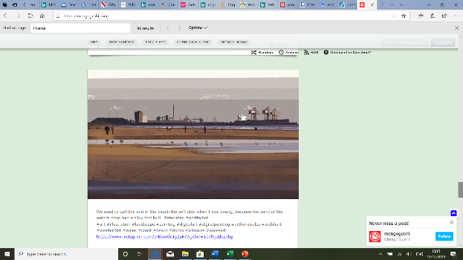
(Mongo Gushi, 2019)





