

The development of circular economy to support achieving NetZero
By
Graham Jones
2313935

Degree Apprenticeship in Logistics and Supply Chain Management
21st November 2024
Sustainability (ACMA4023)

Table of Contents
- Introduction…………………………………….……3
  - What is Sustainability?.............................3
  - What is a circular economy?....................3
  - What is NetZero?.....................................4
- Benefits of circular economies……………….……5
- Challenges of circular economies…………….…..5
- Case-study Tata Steel………………………….….6
  - Steelmaking with Electric Arc Furnace….6
  - Packaging material circular economy…...8
  - Conclusion…………………………………9
- Circular Economy review…………………………9
- References…………………………………………10

Introduction
Within this report we will be looking at how the development of a circular economy within businesses and companies can be used to work towards the aspect of sustainability reaching NetZero. Firstly understanding the concepts of sustainability, circular economies and NetZero, then moving onto case studies in Tata Steel UK.
What is sustainability?
Sustainability is currently the hottest topic in the business world, as companies look to promote the ways in which their products or services have reduced the businesses environmental footprint or conserved natural resources, but what is sustainability? The 1987 report Our common future (Also known as the Brundtland report) defines sustainability as development that meets the needs of the present without compromising the ability of future generations to meet their own needs. In simple terms it is the concept of being able to operate, create or process by using fewer natural resources for the benefit of future generations.
What is the circular economy?
Circular economy is the newest theory on making business and operations as sustainable as possible, the main premise of the theory is for companies to design out waste (Ellen MacArthur Foundation 2012) and maximize the re-utilization of materials (Ellen MacArthur Foundation 2015b). This can be achieved by reusing, recycling, repairing or rethinking our operating and processing models.
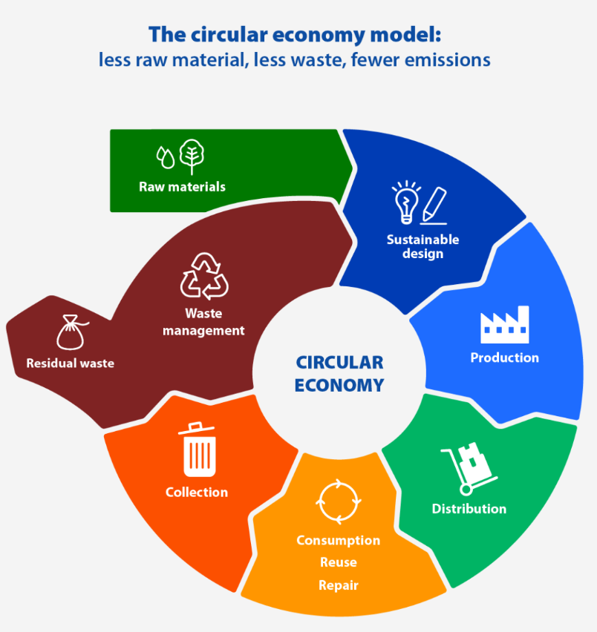
Fig 1 – Circular economy model
What is NetZero?
The concept of NetZero is the balancing of the amount of greenhouse gasses(GHG) that are currently entering the atmosphere through manufacturing production, transportation, energy production, etc by either reducing the amount created or by offsetting with projects which remove GHG’s from the atmosphere, examples of such projects are re-forestation, devising car-share schemes within the workplace or switching to renewable energy sources. The theory is that by achieving NetZero we will slow down the climate change of our planet and achieve the Paris agreement (2015) target of limiting global warming to 1.5°C, ensuring a better tomorrow for future generations.
Benefits of a Circular Economy
Whilst the benefit of a circular economy to the environment is obvious in the reduction of pollution, reduction in consumption of finite natural resources, slows down climate change and maintain and regenerate natural ecologies. The benefits to companies and businesses is less obvious, but are just as numerous; for example by find ways to recycle and re-use resources within production processes can reduce the cost of buying in new raw materials.
A study by the Ellen MacArthur foundation (2023) found that “When it comes to food and agriculture, regenerating nature is key to creating value. Designing food to come from regenerative farming systems can increase farmers’ profits and food output while reducing pollution, storing carbon in the ground, and helping biodiversity. This is achieved by cultivating healthy and highly productive soils in which to grow a wide variety of crops.”
Challenges of a Circular Economy
Whilst it seems logical for all businesses to implement circular economies within their business strategies there are many obstacles to overcome, according to the world resource institute (2018) the top five are:
- Meeting consumers expectations – The end users of the products we produce or manufacture have come accustomed to certain standards or costs for the products which they buy. By moving to a more circular economical way of production styling, designs and cost may change. Are the consumers of our goods willing to change with them or even completely abandon, for example, the convenience of plastic bags.
- Government regulations encourage waste – A common problem within the food industry are the laws and regulations that un-intentionally encourage wasteful behaviours by imposing best before or expiration dates on perishable goods, which can often be misunderstood by consumers.
- Lack of proper waste infrastructure – Most of the first world countries have well set-up and structured waste management in terms of recycling programmes. But the rest of the world may not be as advanced especially in developing countries which are trying to keep costs to a minimum to break into and compete within their markets.
- Recycling technologies not good enough – If we take plastics as an example there are many ways that material can be recycled but currently all methods take the input grade of material and re-process into a lower-grade of material, meaning that to produce the higher grade material is still requiring production using raw and natural materials.
- Wrong business models – A vast majority of companies and businesses are using business models and strategies to make quick profit in the short term, especially in developing countries, which is to make a product in the quickest and cheapest way to satisfy demand from consumers. Unfortunate this model, whilst good for the business requires more raw materials and less recycled / re-purposed material which can increase the cost and lead time of a product, as business models switch to a more long-term view more strategies will move to a circular economy model, but with these developing industries this will take time as they establish themselves.
Case study Tata Steel UK
Tata steel is the largest producer of steel in the UK, making five million tonnes of crude steel at the UK hub in Port Talbot and two million tonnes of finished steel products at the downstream operations centre in Shotton, Corby, Hartlepool, Llanwern and Trostre. As such Tata Steel UK is one of the largest CO2 producers in the UK at, for every tonne of steel produced it is estimated that 2567Kg of CO2 is also produced. This would mean that the 3.2million tonnes of steel produced annually by Tata Steel UK would generate 8.21million tonnes of CO2 or 2% of the UK total (Estimated at 406.2million tonnes). The company is committed to becoming NetZero by 2050, to do this they will be looking at reducing approximately five million tonnes of direct emissions by 2027 with the rest being off set by various projects to reduce in-direct emissions or remove green house gasses from the environment. Below we will look at two projects the first is the construction and switch steel making using an electric arc furnace at the UK hub in Port Talbot and the second is a local project at the Shotton downstream site recycling packaging material with customers and suppliers.
Steelmaking with Electric Arc Furnace
The largest sustainability project in the UK for decades has been launched when a joint venture between Tata Steel UK and the UK government agreed to invest £1.25Billion in the decommissioning the two old blast furnaces at Port Talbot with a brand new Electric Arc Furnace (EAF). This project will take three years to complete, but once fully operational it will reduce the direct emissions from steel making in Port Talbot by 50 million tonnes over 10 years. Steel making via an EAF requires no direct fuel fired energy to produce molten steel from raw natural resources, but instead is electrically fired from renewable energy sources, like wind farms off the South Wales coast. On top of the reduction in natural resources for fuelling the steel production, the furnace will source it’s material from the UK’s scrap metal stock pile recycling scrap iron and steel in re-graded material.
EAF steel production creates new steel with scrap steel being the main raw ingredient, reducing energy use and reliance on natural resources. Steel is 100% recyclable and can be used indefinitely, each piece of recycled steel saves one and a half times it’s weight in CO2. The UK has an abundance of steel scrap and with it’s magnetic properties it Is very easy to sort from general wastes meaning less goes into landfill. EAF’s are also efficient is recovering the zinc coating on steel too, which in turn can contribute to another circular economy. As steel is a vital component in modern society in construction, automotive, domestic appliances, etc recycling and reusing steel will play a vital role in sustaining future generations.
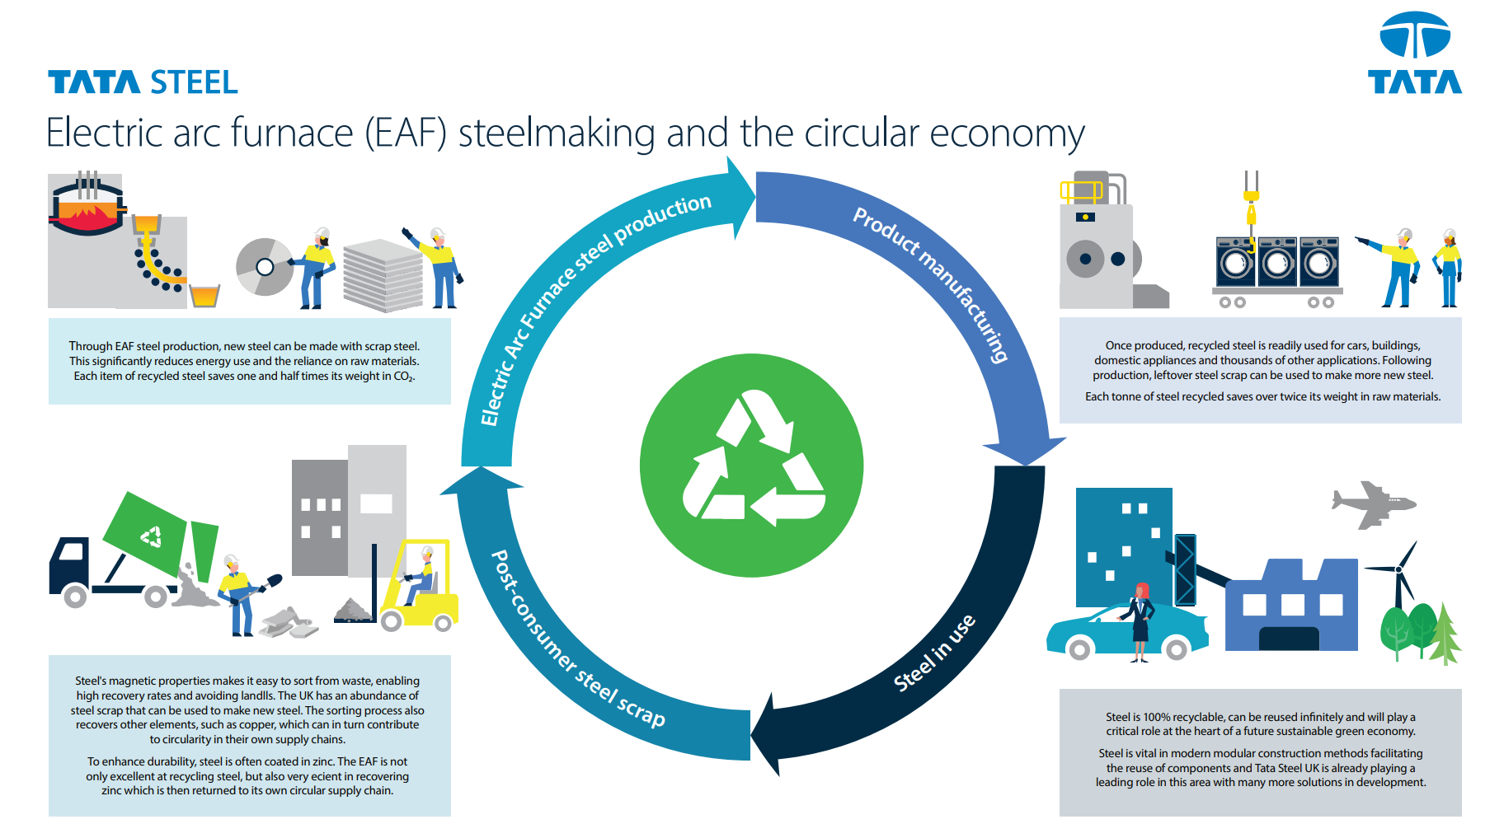
Fig2 – EAF steelmaking and the circular economy
EAF steelmaking takes scrap steel generated from consumers, in the shape of food cans, etc and manufacturers that produce steel products and melts down using a powerful electric arc between electrodes and raw materials. The energy used to power this process can be sourced from renewable sources, thus reducing the carbon footprint further. After this the steel making process continues as usual in continuous casting into slab form and then rolling in hot or cold reduced coil for processing at downstream processing centres. This steel will then find it’s way into various industries and products including construction, automotive, household appliances, etc meaning Tata steels customers will also be reducing the carbon footprint of their products all in line with the UK governments target of achieving NetZero.
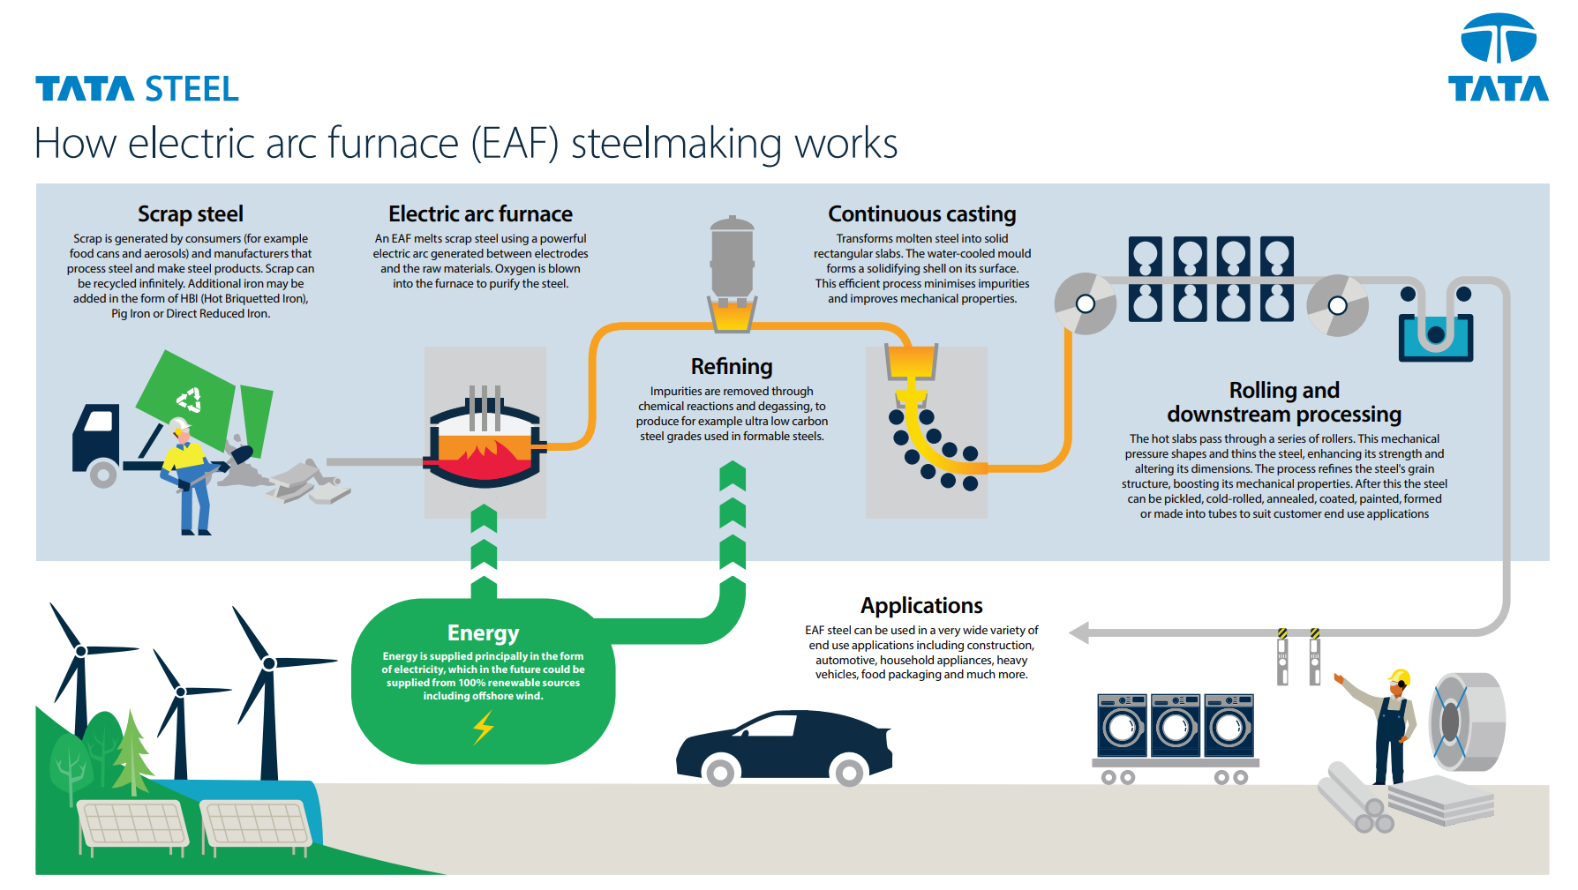
Fig3 – How EAF steelmaking works
Producing steel via an EAF reduces the CO2 produced to 326kg per tonne of steel meaning that the 3.2million tonnes of steel produced annually by Tata Steel UK would generate 1.04million tonnes of CO2, reducing the UK’s CO2 emissions by 1.75%.
Packaging material circular economy
On a smaller scale, the downstream hub of Tata Steel Colors based in Shotton, North Wales has a combined sustainability project with their supplier and customers around recycling and reusing packaging materials. The supplier produces all packaging materials; Cardboard cores, plastic edge protection and coil matts, using 100% recycled materials. Also the customers return all packaging material back to Tata steel colors to either be reused again or sent back to supplier to be recycled into their own circular economy for new packaging materials. Customers return their packaging on vehicles already at site delivering products as such not requiring any further transportation costs or have any increase on the environmental impact.
Current figures show that since the start of the project 75% of packaging material has been reused repeatedly and once the material has become to damaged to reuse there is 100% recyclable route for material to pass down. Which has reduced costs to business in purchasing new material for every product sent out.
Conclusion
In conclusion Tata Steel UK has many projects on going some large with massive reductions in the carbon footprint and many smaller projects that have small savings individually but cumulatively is coming together to build the circular economy of the business and help achieve the target of NetZero by 2030. As one of the largest contributors of green house gasses in the UK, this will in turn be a large step working towards the UK’s NetZero target as a whole.
Circular economy review
Circular economies should be the future model for all business going forward. Not only are they securing the future of product production by using less of our finite natural resources, but they are also benefiting the environment and planets ecological state. Reducing the speed and impact of climate change whilst also bringing about new businesses and prospects for future generations.

References
Ellen MacArthur Foundation. (2012). “Towards the Circular Economy Vol. 1: An Economic and Business Rationale for an Accelerated Transition.” http://www.ellenmacarthurfoundation.org/assets/downloads/publications/Ellen-MacArthur-Foundation-Towards-the-Circular-Economy-vol.1.pdf (Accessed 7th November 2024)
Ellen MacArthur Foundation. (2015). “Toward a Circular Economy: Business Rationale for an Accelerated Transition” http://www.ellenmacarthurfoundation.org/assets/downloads/TCE_Ellen-MacArthur-Foundation_9-Dec-2015.pdf (Accessed 7th November 2024)
Ellen MacArthur Foundation (2023). “How does the circular economy create value”. https://www.ellenmacarthurfoundation.org/how-does-the-circular-economy-create-value (Accessed 14th November 2024)
European parliament research service. (2003). “The circular economy model”. https://www.europarl.europa.eu/topics/en/article/20151201STO05603/circular-economy-definition-importance-and-benefits (Accessed 7th November 2024)
Stanislaus, M. (2018). “Barriers to a Circular Economy: 5 Reasons the World Wastes So Much Stuff”. https://www.wri.org/insights/barriers-circular-economy-5-reasons-world-wastes-so-much-stuff-and-why-its-not-just (Accessed 14th November 2024)
Tata Steel UK (2024). “Electric arc furnace (EAF) steelmaking and the circular economy”. https://www.tatasteeluk.com/green-steel-future (Accessed 14th November 2024).
Tata Steel UK (2024). “How Electric arc furnace (EAF) steelmaking works”. https://www.tatasteeluk.com/green-steel-future/media-and-resources (Accessed 14th November 2024)
Tata Steel UK (2024). “Tata steel sustainability report 2023/24”. Mumbai. Tata Steel limited.
World commission on environment and development. (1987). “Our common future” Oxford University press, USA.

