Assignment name: Individual Marketing Report
The impact of the Covid19 pandemic on the organization
Chosen company: Apple

Student ID:

Executive summary

COVID19 has major and significant negative impact for the global economy and businesses and this sets no other choices apart from analyses and reaction from the governments and the companies in order to set number of decisions and actions for trying to control the pandemic negative implications and to make sure there will be fast recovery of the damages and losses (Pousttchi,2021).
The UK government and all around the world institutions set support for the companies, employees, self-employees and this support the control over the losses and helping to the companies and people to go with minimum damages through the pandemic. The governments support with decisions for self-employed scheme, furlough scheme, company loans, mortgagefreezing and other measures in order to control the negative impact (Bach,2021).
Despite these measures the global economic shrink with 3% for the GDP and the forecasts for the 2021 is that this will even goes worst with 5% decreasing versus the 2019 and 2018 levels of the economic.

Contents
Executive summary 2
Introduction 4
Company brief 5
Impact of the covid19 over the world companies and economy 6
Impact of the covid19 over the Apple performance and operations 8
Apple SWOT 10
Apple PESTLE 12
Political factors 13
Economic factors 13
Social factors 13
Technological 14
Legal factors 14
Environmental factors 15
Recommendations 15
Conclusion 17
Reference list 18

Introduction

The COVID19 pandemic is the most serious challenge and disease with critical impact for every company around the globe. These effects lead to serious damages and losses to much business and even some of them closed down due to low sustainability and little financial resources for responding to the situation. The pandemic even hit the mobile services and in the below report there will be explanation, discussion and evaluation of the epidemic impact over Apple and the respond of the company for decreasing the loss (Ohkusa,2021).
When comes to decisions and serious actions there is always need for in advance proper and detailed analysis with using SWOT and PESTLE methods for evaluation of the internal and external factors so the company can create productive and effective decisions for improving the performance and net profit.
Figure 1

(Ohkusa,2021).

Company brief

Apple Computers, Inc. was established on April 1, 1976, by university dropouts Steve Jobs and Steve Wozniak, who decided to bring with them an aspiration of changing people's perceptions of computer system to the new firm. Apple's revenue grew from $7.8 million in 1978 to $117 million in 1980, the year the company has gone public.
Currently Apple is worldwide recognized brand for mobile devices, computers, mobile services and other electronic and software products. The company grows significantly due to the innovative ideas consistent way which ideas solving user’s challenges and issues globally and helping people to communicate more effective and productive way from all around the world (Vayena,2020).
Figure 2
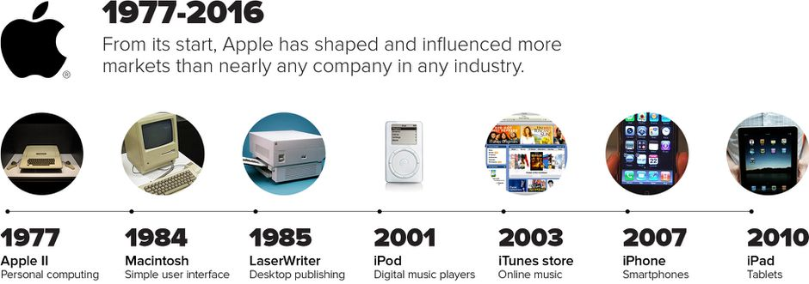
(Ohkusa,2021).

Impact of the covid19 over the world companies and economy

With the covid19 disease outbreak, the entire world transformed in a matter of a few months, and this transformation, which came with many heavy limitations, shifted actual work to 70% online. This had a huge impact on the overall internet technology and flexible workplace processes. Many businesses that began the process of having to move their online deals lost a wide range of clients, and it will take several years for any of them to make a full recovery (Ohkusa,2021).
The coronavirus (COVID-19) epidemic has indeed caused significant death and suffering as well as substantial economic interruption. Confinement initiatives in China have included quarantines and pervasive restrictions on labour migration and transport, actually results in unanticipated disruptions in factory restarts following the Lunar New Year holiday and significant reductions in very many service industry actions. These figures point to a significant drop in output while the outbreak's impacts linger. Following epidemics in other nations, such as Korea and Italy, confinement initiatives such as prevention measures and border shutdowns were implemented, albeit on a lesser level (Bach,2021).
The pandemic moves the whole business operations and decision into preventive and save side of the operations with focus over saving wages and reducing the investments, cost and expenses for every segment of the company. Opposite there are companies which analyzed the new environment and situation and they find the right way to instead losing customers and profit to transform and to discover new opportunities which will lead to more revenue and profit. Apple is one of this companies which always focus over the opportunities instead of looking over the challenges and issues and this so far since the 1977 year we can see have been always profitable for the company (Breslin,2021).
Globally we can see that many companies suffer and struggle to survive and they shutdown many stores which lead to huge high levels of unemployment illustrated over the figure 3 below:
Figure 3
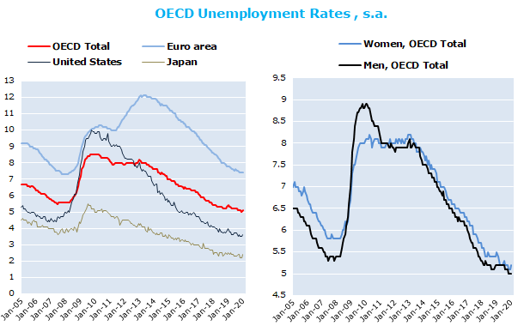
(Vayena,2020).

We can see significant decreasing of all reviewed points like United States, Euro area, Japan, Women and Men points of view and even worst we can see that the levels drop down under the decreasing of the 2005-2008 (Ohkusa,2021).
Despite the government actions with offering to the companies furlough scheme so they can retain the employees and this way to keep the employment levels under control this did not worked enough productive for saving the employees of the companies which decided to completely shut down and close their company (Monteiro,2020).

Impact of the covid19 over the Apple performance and operations

As we mentioned already and visible from the figure 4 below is visible that there is less negative impact from the covid19 over the Apple performance and the main reasons for this are:
- Immediately reaction and collaboration with the governments for track application over the mobile phones which app can contribute for the people safety and control over the covid19 spread to other people from specific area.
- Offering productive and effective apps for online company meetings and working remotely from your home with high focus over the quality and results with maximum safety for the users (Pousttchi,2021).
- Due to the pandemic many people over 45-50years old left in lockdown away from their family and Apple used this opportunity to create and improve the communication applications for making more user friendly for clients with limited awareness of internet and applications running (Breslin,2021).
- Apple also made donations for the respond to the covid19 which is actual long term investment and will lead in long term to consistent increasing of the loyal customers. Lastly this have been used by Coca Cola by giving free bottles to the soldiers why return at home from the great war and this in long term we can see lead to huge success of the company (Bach,2021).
- Apple even focus over the improving the online GP consultation with any people in need and emergency so this way the doctors can help to much more people who suffer from the covid19 pandemic.
- Apple moved all the present life activities into online meetings with closing all offices and moving all the services online. This is with the effort ones again to highlight that Apple is different company and is highly responsible for the people safety and wellbeing(Vayena,2020).

Figure 4
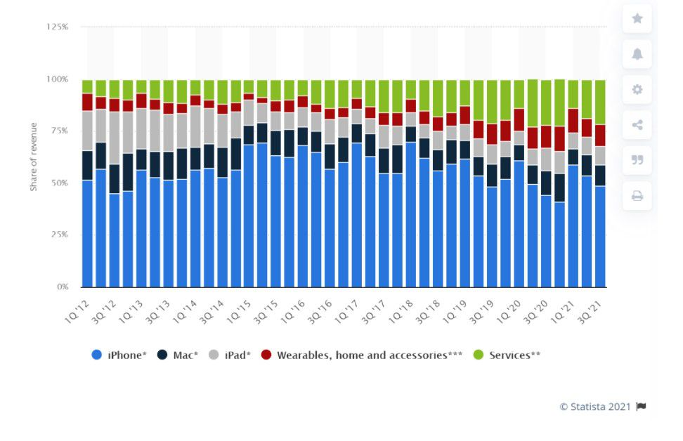
(Pousttchi,2021).

Apple SWOT

Strengths | Weaknesses
- Strong brand name, - high number of loyal clients, - proven results since 1977, - very good collaborations with the governments, - proven focus over improving the people life, - proven quality of the products and services international.  -For the eighth year in a row, Apple is consistently rated first.  - Whenever it relates to customized computer systems, Apple is among the most dependable companies. Figure 5 evaluating the success of the Apple growth. | - More focus over innovations. - More results linked to improved customer service. - improving the speed for solving the clients issues.  - High prices as products are classed as high luxury and medium class.  - Limited advertising, promotion as the company relay to the current client base.  - losing focus with expanding to new markets with video games, streaming where is already high brand names like Netflix and Disney.  - tracking clients data lead to trust issues and law challenges for the company.
Opportunities | Threats
- Increased customer demands  - Current covid19 challenges creates new opportunities for solving issues globally  - Opportunity for creating new apps and programs for supporting people health and safety(Bach,2021).  - With 92% retention rate Apple have high opportunities with such as high number of loyal clients.  - Retaining during the years high experienced and quality researches and IT specialists which contribute the company ideas and innovations.  - Opportunities for creating and focusing over eco-friendly products.  - Opportunities for more SMART wearing technologies like watches and end other tools for making customer life more easy (Breslin,2021). | - Competition activities and innovations like Samsung, Dell and Google (Pousttchi,2021).  - Brexit complications  - Extra taxation for the services  - Implications due the continued variants of the COVID19  - Supply chain challenge is other serious threats in front of the Apple productivity.  - Currently there is already many issues with counterfeit products which using the brand logo illegally(Ohkusa,2021).  - Negative social media review is increasing and the company needs to set actions for improving.  - China and other major countries threat is of increasing the taxes due to the covid19 increasing of the inflation (Vayena,2020).

Figure 5
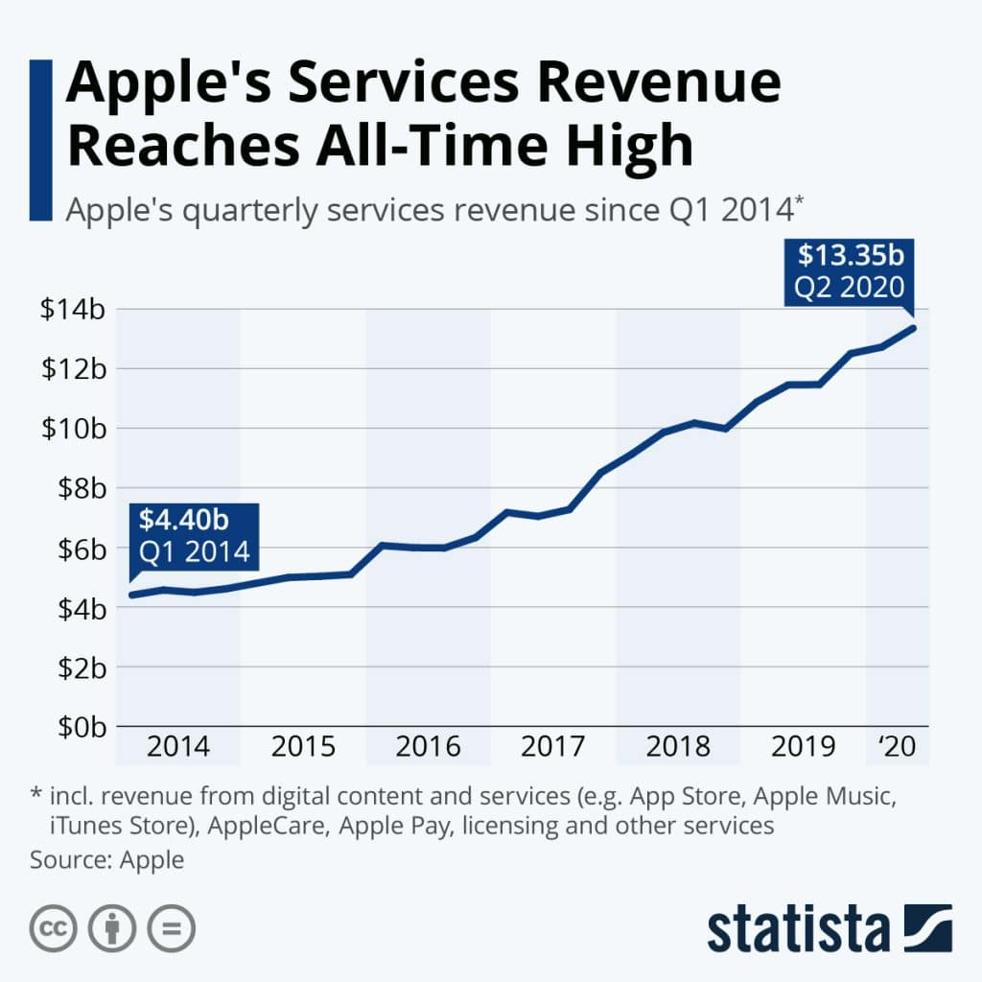
(Pousttchi,2021).

Apple PESTLE
Pestle analysis is other great method for ensuring that the company will maintain good consistent sustainability in short and long term as this method reviews all the important internal and external factors which impact the company performance and profit (Ohkusa,2021).
Figure 6 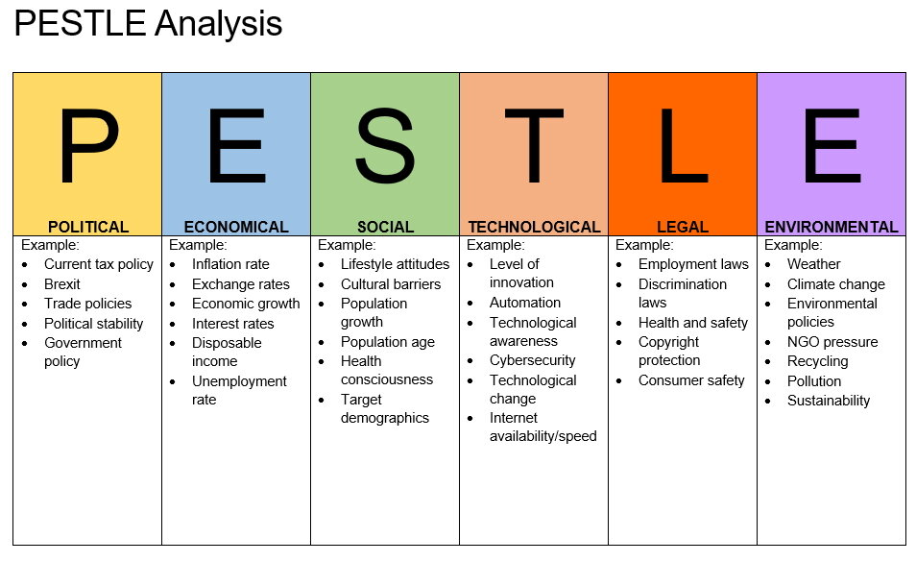
(Monteiro,2020).

Political factors

Here linked to the Apple factors we need to mention the government decisions for the mobile services, taxation, legal expectations and regulations, brexit and covid19 decisions and regulations which could impact the customer behavior and their purchase ability (Vayena,2020).

Economic factors

With the decreasing globally of the GDP with between the 3% and 5% versus last two years levels this will reflect in to serious increased inflation and the people ability to spend will decrease as they will prefer to save their incomes feeling the insecurity of the economic (Breslin,2021).

Social factors

Here we need to mention the new culture trends and changes of the population due to the migration of the young people. The moving abroad for many people will lead to population average age increasing and this will set challenges in front of the Apple.
There is also many lifestyle changes which impacting the consumer decisions and Apple need to take on time actions for improving in this direction, before is too late and the competitors take advantages (Ohkusa,2021).

Technological

Here the customer demand is high due to increased level of challenges and issues and this creates opportunities for Apple for finding the right solutions which can become very successful and profitable for the company.
One example is the Apple program named Liam is an iPhone recycling robot which break down to single parts the IPhone devices which supporting the wastage process and saving company cost and damages (Monteiro,2020).

Legal factors

Due to operating with large volume of data the Apple has issues with the Lawsuits claims due to different clients claims linked to their data and the company provided services. Some of the value of this legal claims is over millions of euro and pounds so we can measure what serious factor is this challenge for the company performance and profit (Bach,2021).
Here also we need to mention the discrimination and employment law which also lead to challenges due to the government regulations and legal expectations. Healthy and Safety is other issue which creates difficulties for the company when having branches all around the globe and need to comply with so many different expectations (Pousttchi,2021).

Environmental factors

Here are the global issues like climate changes, weather dramatically changes as both this are out of the Apple control. Environment could lead to decreased people ability to spend and this could significantly set challenges in front Apple.
The company need to be more responsible for saving the environment all across the world as this will increase the company popularity and success in long terms. The key success for this is to grab now the right moment and to use the environment challenges for increasing the brand loyalty and sustainability in long terms across the world (Breslin,2021).

Recommendations

There are high level of opportunities for success of new innovations and products in front of Apple, but it is very important that the company will add enough consistent focus over this so there will be consistent improvements (Pousttchi,2021).
Below there will be highlighted some of the main recommendations in front of the Apple company for achieving maximum performance and results:
- Increased collaboration with other world recognized innovative brands like Tesla and delivering different options and variants for supporting the people life and daily tasks.
- Expanding the music streams within the Asia and Africa as high opportunity for success.
- Self-control from one device or the client phone where he can have full control over his car, home electric devices, work related applications and many other which can improve the life effectiveness and productivity (Breslin,2021).
- As we can see Tesla has several issues and is not perfect when comes to self-driving systems and this is opportunity for Apple to improve and solve this issues on his own or with collaboration with other popular automobile brand.
- In near five years the electrical cars will become in very high demand due to the consistent increasing of the other diesel and fuel prices. This will lead the customers to look for other solutions and this is the electrical and hybrid cars. This future increase need to be used properly from Apple in advance from now in order to take maximum advantage from this situation and opportunity.
- Creating email app which could save companies and management time with generating responds in exact time of the day and the person can prepare the content and to have ready responds and answers to requests and most common issues. This will solve many time management issues which are currently experienced by many companies all around the world (Vayena,2020).
- Focus and implement improvements over the data security issues for the Apple users so this way can be increased the clients loyalty and company revenue.
- Implementing and offering more productive business message apps as currently many companies use whats app which is not secured and agreed application from the legal point of view. So there is opportunity for Apple to improve with implementing with the collaboration of the government legal proper and efficient application for more quick communications across the company members (Bach,2021).
- Other good recommendation and opportunity for Apple is the chance for implementing AI programs for better and efficient learning online and this can be done with very good collaboration with the universities and the educational bodies in each country around the world (Pousttchi,2021).
- The environment requires that there is need of auto saving option which can save the users time to save so many documents as this can be achieved automatic way with minimum time waste and effort.
- Main focus over the company need to be how to save the users the time spend for work and tasks and also how this can be achieved with user friendly easy to be navigated applications so the solution can be able to be used from high range of different age customers from 18 years old up to 80 years old (Monteiro,2020).

Conclusion

As we can see the automation of every process around the world is the future of the success and sustainability. Apple as innovative and creative company proved during the years that are able to find solutions at the right time and to implement at the right places. This company advantage needs to be properly maintained and used for consistent growth in the next difficult years (Ohkusa,2021).
From the above report and information we can see that Apple is able to turn most situations in opportunities and this need to be currently focus based over the SWOT and PESTLE analyses provided in the above report.
We can see from the information and discussion that now there is many opportunities and Apple need to take maximum advantages from them on time, before any main competitors decide to be first and to gain more market share and more loyal customers (Bach,2021).

Reference list
Almeida, F., Santos, J.D. and Monteiro, J.A., 2020.The challenges and opportunities in the digitalization of companies in a post-COVID-19 World.IEEE Engineering Management Review, 48(3), pp.97-103.
Bailey, K. and Breslin, D., 2021. The COVID‐19 Pandemic: What can we learn from past research in organizations and management?.International Journal of Management Reviews, 23(1), pp.3-6.
Gasser, U., Ienca, M., Scheibner, J., Sleigh, J. and Vayena, E., 2020. Digital tools against COVID-19: Framing the ethical challenges and how to address them. arXiv preprint arXiv:2004.10236.
Gasser, U., Ienca, M., Scheibner, J., Sleigh, J. and Vayena, E., 2020. Digital tools against COVID-19: Framing the ethical challenges and how to address them. arXiv preprint arXiv:2004.10236.
Gleiss, A., Kohlhagen, M. and Pousttchi, K., 2021.An apple a day–how the platform economy impacts value creation in the healthcare market.Electronic Markets, pp.1-28.
He, W., Zhang, Z.J. and Li, W., 2021.Information technology solutions, challenges, and suggestions for tackling the COVID-19 pandemic.International journal of information management, 57, p.102287.
Kurita, J., Sugishita, Y., Sugawara, T. and Ohkusa, Y., 2021. Evaluating Apple Inc Mobility Trend Data Related to the COVID-19 Outbreak in Japan: Statistical Analysis. JMIR public health and surveillance, 7(2), p.e20335.
Michael, K. and Abbas, R., 2020. Behind COVID-19 contact trace apps: The Google–Apple partnership. IEEE Consumer Electronics Magazine, 9(5), pp.71-76.
Oliver, N., Lepri, B., Sterly, H., Lambiotte, R., Deletaille, S., De Nadai, M., Letouzé, E., Salah, A.A., Benjamins, R., Cattuto, C. and Colizza, V., 2020.Mobile phone data for informing public health actions across the COVID-19 pandemic life cycle. Science advances, 6(23), p.eabc0764.
Pejić-Bach, M., 2021.Electronic commerce in the time of covid-19-perspectives and challenges. Journal of theoretical and applied electronic commerce research, 16(1), pp.i-i.
Thambusamy, R.X. and Bekiroğulları, Z., 2020. Virtual leadership in small businesses during the COVID-19 pandemic: Challenges and possibilities. The European Journal of Social &Behavioural Sciences.
Vanapalli, K.R., Sharma, H.B., Ranjan, V.P., Samal, B., Bhattacharya, J., Dubey, B.K. and Goel, S., 2021. Challenges and strategies for effective plastic waste management during and post COVID-19 pandemic. Science of The Total Environment, 750, p.141514.

