Researching and Analysing Data
Teleworking
By Resna Begum
Student Number: 1605337
Module Number: EMPL4012
Tutor: Sheraz Alam Malik Dr
University of Wales Trinity and
Saint David

Contents
Introduction 3
Telecommuting 3
What is the benefit of Telecommuting? 4
What are the drawbacks of Telecommuting? 5
The Pros and the Cons 5
Conclusion 7
References 7

Introduction
Telecommuting comes in few names such as remote working, teleworking and it means working outside from the office, as in working from home or e-commuting. This means they arrange a place to work, for example coffee shop. Employee might attend the office due to a meeting but that can be done by face timing.
For some, working from home would have been seen as not happening but today it is the future work. Where some companies may disagree with the term teleworking and some companies have accept the theme of teleworking.
Teleworking is possible due to advance technology without technology it wouldn’t been easy to work from home or anywhere else apart from an office.
The topic I will be doing is about working at home and the Pros and Cons.

Telecommuting
It has been said that working from home can’t deliver the speed or quality that it needs. Yahoo are trying to get their staff back at the office. This will be done by the chief Marissa Mayer from Yahoo because she herself went back to work weeks after giving birth. Around 11,500 yahoo employees were told that they need to go back to work in the office or leave the job. Where in another hand Richard Branson is calling the method backward step in this age where working from home can be done somewhere other than in an office. Yahoo has stopped their staff from Working at home and that cause anger to many employees.
There is fast broadband that can be used to allow workers to communicate by webcam that enables them to see each other for any important meeting and this can be used in tablets, laptop and smartphones.
Retailers might not be able to work from home but there is, so many work in offices that can be done from home then coming to an office to do it.
According to CBI, in the U.K there has been an increased people working at home. On a survey in 2011, 59% of employee proposing to teleworking. 24% of works are working some hours from home in US according to the Bureau of Labour Statistics.
The Telework Research Network mentions that 2.5% workforce only consider working from home their primary place for work.
Yahoo are not alone in conducting to not to work at home even Patrick Pichette Googles chief financial officer said when asked the question that how many people telecommute their answer was that only few do teleworking.
If you are not in the office this could be a disadvantage for not getting promoted because the employer can’t see you working if you are working at home. This can result in low pay rate than working in an office according to London Business School and the University of California. It can also be that the manager can be biased in favour to those they see working in the office. Though this might seem outdated to loads of people. Also working from home prevents that person socialising with others.
When Stephanie Shirly started her company F International in 1962, she stated the idea of working at home and this seem to be alienated to other companies. In the 1980s F International was teleworking, employing 800 home workers making nearly over £20 million in a year. It was also setting up national electronic mail network to link it at workers home computers to the company’s minimal headquarters.
There are some reasons why some employer does not want their employees working from home. These are:
- If they are not at work, then they are really not working- this is a concern for employers because it gives them the idea that employees will slack of more if they are working from home.
- The employee will be less productive
- If all employers employ people work from home, then its culture and collaboration will be lost

What is the benefit of Telecommuting?
It gives the employee to be flexible in their professional and personal life. It gives them the freedom of choosing their working hours and to choose the work location. Where employers worry about getting less productive, it is said if they work at home this can make them more productive because they won’t have distraction of an office space and it can benefit the company. Telecommuters might be more happier and may stay in the company for longer. It also saves money for the office expense.

What are the drawbacks of Telecommuting?
The drawbacks of telecommuting are that you have to self-motivate yourself and not get distracted and also find a place at home or out that will help you to do your work.

The Pros and the Cons
Though Yahoo and other companies prefer working in an office but there are also companies that do allow their staff to work from their homes. This is because of the recent advance technology that gives people the opportunity to work from home but there are some pros and cons that come with it.
These are:
Pros
- You are free to work on you own time
- There’s no one looking over your shoulder
- Able to look after your family and spend time with them
- No commute
Cons
- Not going office at 8 in the morning, you have to make yourself wake up and do some work
- No outside pressure to keep you busy
- Miss out on socialising with other employees
- Can take up the room and be messy
- Not know about any new project due to not being in the office
- Less communication with co-workers
- The manager wouldn’t know even if you do extra hours or how hard you been working
- No time management. May end up working until 1am

Though Marissa Mayer doesn’t want the employees to work from home there is another CEO Andy Mattes from Diebold wanted to look for employees that wanted to work remotely. In 2013 before Mattes joined the Diebold company they were only hiring people that live nearby. When Mattes joined the company, he saw this as a problem. He mentions that there are 75 top workers at Diebold and half are based in different cities.
When Yahoo called its employees back to work in 2013 in order to improve communication and collaboration. There was a lot of debate if employees should work in the office or from home. After 2 years it has been said that telecommuting has won. Many companies are allowing to work outside from the office to collaborate remotely and give high standard of productivity. Studies have shown that the employees working from home are more productive, this is because they are working more hours at home then in the office.
Working remotely has risen to 6% per year from 2000 to 2010 according to economic professor Nicholas Bloom from Stanford, who studied the Working from Home (WFH) and productivity in the Quarterly Journal of Economics.
According to Bloom’s research, working from home is still a small share. In 2010, 2.4% of workers are working remotely. In 2014, 67% workers were allowed to work from home occasionally. This has gone up since 2008 by 50% as the studies have found by the non-profit Families and Work Institute.
Figure 1 below shows how common it is working remotely:
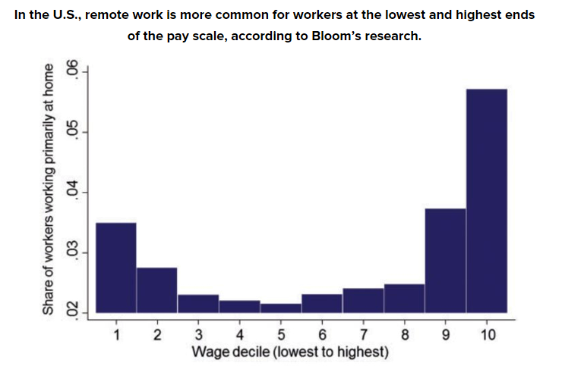
Working from home help the environment because employees will travel less. It can also help parent and older employees who want to count down on commute time and spend time with families.
Working from home can put less pressure but the employer and the employee must communicate and know what they have done from start to finish.

Conclusion
The conclusion I have come with this above data is that it may be ideal for some to work from home or anywhere else apart from the office because as I found out due to advance technology some work that are done in the office can also be done from home. But both working from home and working from an office have benefits and have their downside.
These are the two questions that is gathered from the report:
- Are the employees able to use these resources then why the workers can’t work from home and will it benefit them? As I have found in the report that those employee that work from home are more productive and its flexible for them that the employee stay longer at the company. Employers will benefit because they will save money for office expense and the employees have their freedom to choose their hours and spend time with their families.
- The disadvantage of teleworking? If the employees plan to work from home, then they will have to self-motivate but there is a chance they can get distracted by family members. The employers must keep track of their employees that are working from home by communicating otherwise the employee might lose track.

References
Doyle, A. (2017). Learn the Pros and Cons of Telecommuting. [online] The Balance. Available at: https://www.thebalance.com/what-is-telecommuting-2062113 [Accessed 27 Dec. 2017].
Peck, E. (2017). Proof That Working From Home Is Here To Stay: Even Yahoo Still Does It. [online] HuffPost UK. Available at: https://www.huffingtonpost.com/2015/03/18/the-future-is-happening-now-ok_n_6887998.html [Accessed 28 Dec. 2017].
Richardson, B. (2018). The Pros and Cons of Working from Home. [online] Monster Career Advice. Available at: https://www.monster.com/career-advice/article/pros-cons-of-working-from-home [Accessed 4 Jan. 2018].
Ryan, M. (2013). The myth of working from home. [online] BBC News. Available at: http://www.bbc.co.uk/news/magazine-21588760 [Accessed 31 Dec. 2017].
Sahadi, J. (2016). Telecommuting: 3 reasons your boss doesn't want you to work from home ... and why she's wrong. [online] CNNMoney. Available at: http://money.cnn.com/2016/06/21/pf/telecommuting-work-from-home/index.html [Accessed 27 Dec. 2017].
Shulman, A. (2013). Alexandra Shulman on working from home: it's not an adequate alternative. [online] the Guardian. Available at: https://www.theguardian.com/money/2013/mar/02/alexandra-shulman-working-from-home [Accessed 10 Jan. 2018].

