

Applied Professional Skills
Dewi Havard
HND Business Portfolio
1807482

Contents
- Activity 1 - Pages 3 & 4
- Activity 2 - Page 4, 5, 6 & 7
- Activity 3 – Pages 7 & 8
- Activity 4 – Pages 9 & 10
- References – Page 11
- Appendices - 12

Activity 1
A professional is someone who is part of specific group that is of a high standard which is above amateur level. A definition of a professional would be “The term professional refers to anyone who earns their living from performing an activity that requires a certain level of education, skill, or training. A professional a lot of the time bases their work around their profession and usually it is their main paid occupation.” (Wong, 2018)
To be a professional whether that is in a sport or work, there are principles that need to be followed. A few examples of these could be to lead by example, showing respect to everyone you work with, having good ethics, showing integrity, showing commitment to your work and also to work well as a team. These are only a few examples and there are much more but all of these traits show that the person works at a high standard and is dedicated to their job. (McQuerrey, 2019)
Other things that need to be looked at when looking at a professional’s role is whether they follow the codes of conduct. A code of conduct in a workplace is something that all workers should know and this is set by the manager or owner. The code of conduct should have rules on it about what they expect of everyone and also it can give guidance about what to do when coming up against problems. “Each business, each company, has its own culture and way of doing things. A code of conduct is a way for management to say what that culture should be - how employees should act and how they shouldn't act… An effective code has specific, clear guidelines that you want the company to live by.” (Sherman, 2017)
Everyone should follow the codes of conduct it doesn’t matter whether they are management or lower down support staff, these set of rules and guidance needs to be followed in order for the business to be successful. All staff must be aware of the code of conduct and should all have a copy. A good way to make sure everyone has a copy is to send it by email and also print them out and put them up for everyone to see.

Activity 2
Being a professional is about being able to work independently and take on responsibilities but also it is about being able to work as part of a team with good group dynamics. “Group dynamics refers to the attitudinal and behavioural characteristics of a group. Group dynamics concern how groups form, their structure and process, and how they function.” (Barnett, 2018)
To have good group dynamics everyone in the group must agree with each other and work together efficiently and coherently. This is not always the case though as there can be issues faced as a group to stop this happening. For example, the nature of the individuals in the group. Some people just simply aren’t good at working in groups and do not how to interact with other people in a respectful way so that no arguments are made. If there is a clash of personalities or opinion in a group this can become a major problem as this will affect the whole group and not just the people involved. Another way in which group dynamics can be affected is if there are problems with the group’s structure. When a group is formed, normally the people involved are assigned different roles by the leader or sometimes self-assigned as to the skills they are best at. Some people may not always agree with the leader and not want to do the task that they have been given whereas they should just get on with the task in hand. Linking with structure and the idea of having someone in charge, some people in the group might disagree with the fact that there is a leader of the group and therefore not everyone is on the same level. They might not like the idea of someone in a leadership role because they can then be told what to do or they might feel their opinion won’t be listened to.
In an organisation being able to work as a team is a very good skill for a professional to have. There are lots of occasions throughout your working life where you will have to work as a team so knowing how to do this in the best way possible is vitally important. Some people do prefer working alone but team working has so many benefits for example the sharing of ideas. When working alone it is only yourself and your own ideas you can think of whereas in a group there can be several people all inputting ideas for the organisation to get the best possible results. Another reason team working is a good idea is for the sharing of the work load. If you were to take on a big project on your own it can sometimes be overwhelming with the amount of work that needs to be done whereas if you are working with a group, the work load can be shared throughout the group evenly for a more relaxed and better standard of work.
When working in a team it is important that each person knows the role that they play and what they have to do within that role. Depending on how big the task is and how many people are in the team, each person could have a few things to do each or sometimes only 1 thing. At the beginning of any group work it is good for everyone to recognise the skills that they have individually so that they know what role they would be good at. A good way of doing this is by using Meredith Belbin’s theory on team work. Belbin’s theory is that there are nine clusters of behaviour which she called Belbin’s team roles, which were resource investigator, team worker, co-ordinator, plant, monitor evaluator, specialist, shaper, implementer and complete finisher. Belbin believed that to have a good team you need a mixture of abilities throughout these nine roles. (Jackson, 2018)
This is a fast and easy way for people to identify what role best describes them and it is also good because from here different roles can be given to each person depending on which of the nine qualities they chose. Also, this method is good because throughout the project if anyone wants to know what their other group members are doing they can easily look back and see.
While working within a group there will more than likely be things that don’t go your way or some people in the group may not see eye to eye but there are ways that these problems can be overcome. Conflict is normally looked upon as a bad thing but sometimes it can be a good thing as it can push the best ideas forward but mostly it causes upset and bad moral within the team. There are methods to overcome conflict for example one by Kenneth Thomas and Ralph Kilmann called the Thomas-Kilmann conflict resolution theory. The Thomas-Kilmann theory is there to show the options we have when handling conflict. “The first dimension, the vertical axis, is concerned with conflict responses based on our attempt to get what we want. Thomas and Kilmann call these the Assertiveness options. The other dimension, the horizontal axis, is concerned with responses based on helping others get what they want. Thomas and Kilmann call these the cooperativeness options. This creates 5 basic types of response.” (See 2a in appendices).
The five basic types of response are competing, accommodating, avoiding, compromising and collaborating. To resolve any conflict there needs to be the right amount of balance between assertiveness and cooperativeness to get the end result that is wanted which is collaboration. If there is too much assertiveness then it will end up in competition and if there is too much cooperation there will end up in accommodation which means giving in to the other person’s choice. (Manage Train Learn, 2016)
The group can look at the Thomas-Kilmann theory and decide that they are either going to competing, accommodating or collaborating.

Activity 3
Last year I was part of a group through my university that helped a charity in Swansea called Llys Nini. (Llys Nini, 2017) During this project there were times where I needed to take charge and also times where I had to think of ideas for the group. These is what I would call showing project management and problem solving techniques. At the beginning of a big project the amount of work can be overwhelming but there are steps that can be followed to break down what needs to be done. The five stages of project management are: project initiation, project planning, project execution, project monitoring and control and finally project closure.
These techniques are used to break down the workload into five simple steps so that the task is easier to understand. During the project we set ourselves goals to achieve which were to get 10 volunteers to help out in the charity shop in Swansea, to raise £100 for them and also to set up a Facebook page to raise awareness for the charity shop. With these goals we set milestones and dates of when they needed to be done by. We came up with the dates and all agreed with them but did not use anything to record these dates with. Although we didn’t use any method to write down our timeline, looking back a good method would have been to use a gantt chart. (See 3a)
The project was a big success in the end but along the way there were problems that as a group and individually needed to be sorted out. In the beginning we came up with a rough idea of what we wanted to do and we came up with ideas to raise money for the charity shops for example doing a sponsored dog walk etc and to help collect clothes to take to the charity shop but when we went and spoke to the owner of the shop she told us she didn’t want us to do either of those but she wanted as many volunteers as we could get. This was a problem as we had took a long time planning for the other ideas but as a group we came together and got rid of those plans and started on getting volunteers together. Another problem we came across was one of the members of the group was quite sick for a period of time so we had to take over their job of making the Facebook page which as a group we handled well. In the end my job was to set up the go fund me page to get some money for the charity shop but at the start I was put to the task of getting volunteers to sign up. I had to persuade and negotiate my way out of it because I was better at the technology side of things than the other member in the group and they were much better at getting people to sign up to volunteer.

Activity 4
In order to retain the skills that you already have you need to keep working on them and challenging yourself every day. Continuous professional development (CPD) is important so that you can retain your basic skills and knowledge so then you can move on to bigger and better things. It is also good because if you know your subject area inside and out you feel confident about the work you are doing and you can achieve a much higher standard of work as well. CPD is also important when looking back on what you have achieved. If you keep progressing and keep developing then looking back it is good to see how far you have come from the beginning to where you are at the top. For a way to find out how to approach your CPD you could use a CPD map. This shows you steps of what you need to do to develop. The 7 steps are:
- Identify: Understand where you've come from, where you are and where you want to be.
- Plan: Plan how you can get to where you want to be, with clear outcomes and milestone to track progress.
- Act: Act upon your plan, and be open to learning experiences.
- Reflect: Make the most of your day-to-day learning by routinely reflecting upon experience.
- Apply: Create opportunities where you can translate theory into practice and put your learning to work.
- Share: Share your learning in communities of practice to generate greater insight and benefit from the support of your community.
- Impact: Measure the overall impact your learning has had on the work you do.
(CIPD, 2019)
When looking at myself I feel that in order to develop I need to plan and act. I have chosen these because I don’t really set milestones or track progress properly. I need to act and write down when I want to achieve my goals and track whether I complete them or not.
To track my progress and to see how my progression is coming along I have made a professional development plan (PDP) (see 4a). A PDP is good because it is clear and easy to report on progress and also it is good for self-reflection. A PDP is also good because it keeps you motivated because you are tracking your work as you’re going and also it gives you a timeline of when you want to complete your goal. In my PDP I looked at how I want to track my milestones and how I want to track progress properly.

References
- Wong, F. (2018) Professional - Definition, Example, Types of Professionals. [Online] Corporate Finance Institute. Available at: https://corporatefinanceinstitute.com/resources/knowledge/other/professional/
[Accessed 22 Dec. 2019]
- McQuerrey, L. (2019) The Principle of Professionalism. [Online] Work.chron.com. Available at: https://work.chron.com/principle-professionalism-14174.html
[Accessed 22 Dec. 2019]
- Sherman, F. (2017) Code of Conduct in a Workplace. [online] Work.chron.com. Available at: https://work.chron.com/code-conduct-workplace-6237.html
[Accessed 22 Dec. 2019]
- Barnett, T. (2018) Group Dynamics - organization, levels, examples, type, company, Group development, Group types. [online] Referenceforbusiness.com. Available at: https://www.referenceforbusiness.com/management/Gr-Int/Group-Dynamics.html
[Accessed 28 Dec. 2019]
- Jackson, K. (2018) Belbin's Team Roles: How Understanding Team Roles Can Improve Team Performance. [online] Mindtools.com. Available at: https://www.mindtools.com/pages/article/newLDR_83.htm
[Accessed 29 Dec. 2019]
- Manage Train Learn (2016) The Thomas-Kilmann Model - Conflict Resolution. [online] Managetrainlearn.com. Available at: http://www.managetrainlearn.com/page/conflict-resolution-model
[Accessed 29 Dec. 2019]
- Llys Nini (2017) Charity Shops | RSPCA Llys Nini Animal Centre. [online] Rspca-llysnini.org.uk. Available at: http://www.rspca-llysnini.org.uk/charity-shops.php
[Accessed 3 Jan. 2020]
- CIPD (2019) CPD Cycle Stages | CIPD. [online] CIPD. Available at: https://www.cipd.co.uk/learn/cpd/cycle
[Accessed 4 Jan. 2020]
Appendices
2a)
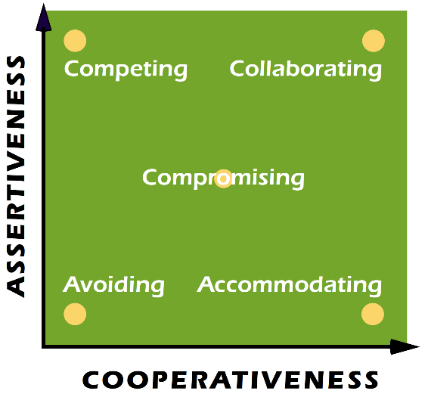

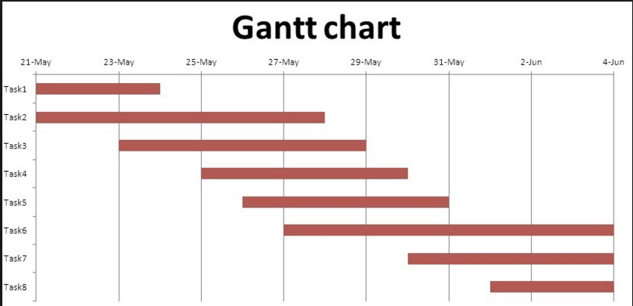
3a)

4a)


