
Online Portfolio
Anourah Sonahar
2220772
Submitted to: Professor Raheela shaikh
BMHP5015

Week 1: Task 1: Personal Brand
Task 1 Personal Brand
Building my personal brand is a practical way to move towards my ideal role. I see personal branding as the story other people talk about me when I am not in the room, shaped by my actions, my values, and my useful work. I want that story to be that I am reliable, ethical, and thoughtful, with steady judgement under pressure. It has been found out that a clear and consistent personal brand can make people be known and trusted, particularly on the Internet where first impressions can be generated almost instantly (Labrecque et al., 2011).
I will also create a simple site like personal blog on my name in order to have control on what will come up on the first page when you search my name. The location will contain short case notes, short plain English explainers, and some learning reflections. I will connect it to LinkedIn in order that individuals may view my recent work and get in touch with me. Personal branding is effective when it is authentic to the individual, but not a performance, so I will write in my voice and make it polite and human. Part of this plan is networking.
My frequency of participation on LinkedIn will be once or twice a week, leaving a comment of one paragraph where I am able to help. I will be present at a minimum of one event per month at the local level, introduce myself, and make a follow-up in two days, in the form of a short message. Minor, routine actions accumulate with time and make manifestation in a friendly manner. I will also give credit, refer to other people and include references, since giving credit translates to confidence and trust. My area of development is in the field of public speaking. In this case, I will become part of a local practise group and make three brief talks in the following term to expand here. I will practise using a phone recording to ensure that I can increase speed and clarity. The mission is to be remembered as cool, friendly, and effective, rather than bling. Strong brands are anchored in consistent behaviour and evidence of value, not slogans (Shepherd, 2005).

References
Labrecque, L. I., Markos, E., & Milne, G. R. (2011). Online personal branding. Journal of Interactive Marketing, 25(1), 37–50. https://doi.org/10.1016/j.intmar.2010.09.002
Shepherd, I. D. H. (2005). From cattle and coke to Charlie. Journal of Marketing Management, 21(5–6), 589–606. https://doi.org/10.1362/0267257054307381

Week 2: Activity 2: Case Study on Social Capital
Week 2 Activity 2 Case Study
1. What kind of support did the elderly residents receive from neighbours, local groups, and healthcare providers? (identify bonding, bridging and linking)
Neighbours offered close support like checking in, sharing meals, and lifts to appointments. That is bonding social capital because it is based on strong ties and trust. Local groups, such as a volunteer transport scheme and a charity that runs a weekly activity room, connect residents to wider circles. That is bridging social capital because it opens new contacts and ideas. The links with the GP practice, community nurse, and the council’s adult social care team are examples of linking social capital, because they connect residents to formal institutions with power and resources.
2. How would you know if this project is working?
I would look for simple signs first. Are more people attending the activity room over the next three months. Do people report feeling safer or less lonely. Are there fewer missed appointments. Health records can show practical changes, such as better blood pressure control or fewer falls. A short, repeat survey can check whether trust, confidence, and sense of belonging have improved, as social capital often supports wellbeing in later life.
3. What problems might this project face in the future?
The primary risks include exhaustion of volunteers, loss of financial support or alteration of the staff in the GP practise which undermines the connection. Incidents of transport failure may also occur when a minibus malfunctions or prices of fuel increase. When the health of people is lowered during winter time there may be a drop in attendance. The projects that are dependent on a handful of individuals are delicate thus succession planning is important.

4. What could be done to make this project even better?
We may train volunteer befrienders, construct a simple phone tree of cheque-ins and introduce a quarterly service fair, during which local services will have a table with which residents can pose questions. The practise pharmacist could also be invited to hold a clinic of medicines cheque and balance sessions with the falls team. Frequent feedback meetings allow the residents to influence the offer, making it up to date and equal.

Week 3: Task 2: Network Map and Rationale
Assignment 1 Task 2
Part 1 Network Map
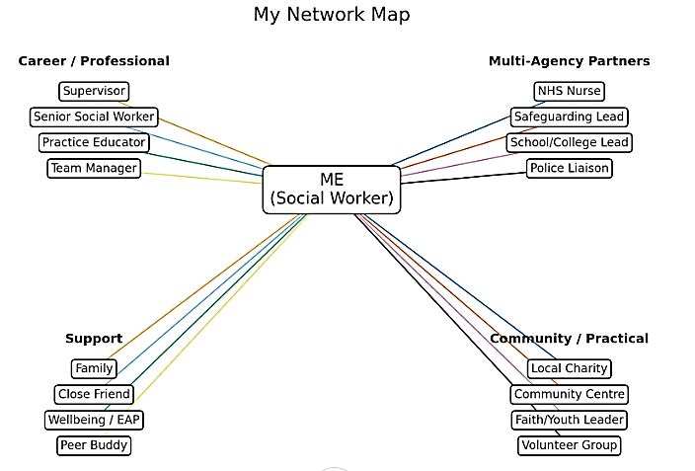
Part 2 Rationale
My network is a mix of people at work, partners, support, and the community. At work I have steady bonds with my supervisor, senior social worker, practice educator, and team manager. They guide my practice, help me think about risk, and keep me learning. I also work with partners such as the NHS nurse, safeguarding lead, school or college lead, and the police liaison. We share clear information and keep the child or adult at the centre. For support I lean on family, a close friend, the wellbeing/EAP service, and a peer buddy. In the community I link with local charities, the community centre, and faith or youth leaders for practical help.
My strengths are empathy, quick help, and strong bonding ties. I am proactive and good at building a network. I communicate well in writing and speaking, solve problems by analysing the situation, and keep tasks and information in good order. I work well in a team.
My main gap is bridging and linking. I need more links with housing, substance misuse, and SEND, and stronger ties with commissioners and senior clinicians. I can also improve at following others’ lead. To get better I will attend one multi-agency meeting each month, message two new partners for a short coffee chat, follow up within a week, and update this map each term.

Week 4: Case Study: Mr. Jones and Digital Exclusion
Week 4 Case Study 2
1. What barriers does Mr. Jones face in accessing healthcare?
He lives in a rural area, has poor or no broadband, and no device he is confident to use. He lacks digital skills and does not have easy transport. These are known barriers for many people and can lock them out of online services that are now common in the NHS.
2. How might his health be affected by his digital exclusion?
Delays in medication reviews and routine checks for diabetes and arthritis could lead to avoidable harm. It can also increase stress and isolation, which affect pain and sleep. Digital exclusion can widen health inequalities if non-digital routes are not kept open.
3. What practical steps could help Mr. Jones access healthcare?
Offer telephone bookings and paper letters as standard. Arrange community transport. Provide a simple step-by-step phone tutorial with a support worker if he wants to try online. A home visit for care planning could reduce travel and help with medicines. Public libraries and community hubs can be safe places to learn basic skills.
4. As future health and social care professionals, how can you help patients like Mr. Jones access healthcare services?
Ask about access needs without judgement. Give choices such as phone, face-to-face, or video. Use clear, short language. Check understanding. Record preferred contact method. Advocate for “digital and” not “digital only.” Work with local partners to run drop-in digital help sessions.

Week 5: Activity 2: Exploring My Identity: Group Discussion
Week 5: Exploring My Identity: Individual Reflection
Step 1: Who are you
I am a steady learner who likes to make complex ideas feel simple. I aim to become a trusted voice in social care. I am confident in writing and improving at speaking in front of a room.
Step 2: Identity Salience
At university I feel most like a developing professional. I try to test ideas, link theory to practice, and share notes that can help peers. At home I switch to a relaxed, caring self. I enjoy small routines with family that bring calm. The two sides support each other. Rest at home helps me stay composed at work.
Step 3: Identity Conflict
I once had a study commitment on the same evening as an important family visit. I chose the study event but planned a late meal with family after. I learned to talk early about clashes and to protect time for both study and relationships.
Step 4: Discussing with a Peer
In our chat we noticed how setting changes which identity is on top. We agreed that values are the anchor across settings. That insight fits with identity salience theory which says some identities become more central in certain contexts but the person seeks coherence over time (Stryker & Burke, 2000). It also echoes social identity theory, where belonging to groups shapes behaviour and feelings.
References
Stryker, S., & Burke, P. (2000). The past, present, and future of an identity theory. Social Psychology Quarterly, 63(4), 284–297. https://doi.org/10.2307/2695840
Week 5 activity 2 group discussion
1. What challenges did the patient face due to their intersectional identity
The adolescent was LGBTQ + and experienced poor experiences in previous care environments. This past made them secretive. Intersectionality assists in understanding how layers of identities and harms of the past can result in feelings of insecurity and not being listened to (Crenshaw, 1989).
2. How did different healthcare professionals approach the situation
The mental health worker attempted to establish rapport however narrow questions were asked in some instances. The social worker concentrated on stressor factors at home. Family views differed and at times drowned out the young person’s voice.
3. How did different professional roles collaborate to provide care? Were there any tensions or miscommunications
They shared updates but did not always align on goals, which caused confusion. Clear ownership of actions and a brief written plan would have reduced tension.
4. What could the healthcare professionals have done differently to provide more inclusive care? What role did intersectionality play in shaping the patient’s experience
They could have used open questions, offered choice of clinician, and checked pronouns and preferred name at the start. They could have normalised help-seeking and explained confidentiality. Intersectionality shaped the experience by joining age, identity, and prior trauma into a single sense of risk, so safety and trust needed to be designed in from the first contact (Crenshaw, 1989).
References
Crenshaw, K. (1989). Demarginalizing the intersection of race and sex. University of Chicago Legal Forum, 139–167. https://chicagounbound.uchicago.edu/uclf/vol1989/iss1/8
Week 5: Task: Letter to Younger Self
Task 5 Letter to yourself
Dear Younger Me,
You are quieter than you need to be. You care deeply and that is your strength. When you doubt yourself, pause, breathe, and name what matters. Learn a little about emotions and how the body reacts to stress. It will not make problems vanish, but you will feel steadier. Emotional skills can be learned and they will help you in study, work, and friendships (Goleman, 2006).
Keep a small notebook of wins. Write down what you did, what worked, and what you learned. When you feel unsure, read it. Practice speaking for sixty seconds about one idea. Record it on your phone. Notice one thing to improve each time. Growth is slow and that is fine. Effort plus reflection builds confidence.
Look after your sleep, food, and movement. Your brain is part of your body. Caring for it is not selfish. Set clear edges between study and rest. Ask for help earlier than you think. You do not have to carry everything alone.
I am proud of you. Keep going.
With care,
Your Future Self
References
Goleman, D. (2006). Emotional Intelligence (10th anniversary ed.). Bantam. https://danielgoleman.info/topics/emotional-intelligence

Week 5: Task: Cover Letter
Cover Letter
I now approach cover letters as a short, tailored story. First I study the advert and the person specification to highlight the essential and desirable criteria. I then choose two or three real examples that prove I can do the work. I use the STAR method to keep each example short and clear: I set the Situation, describe my Task, explain the Action, and finish with the Result and learning. The UK civil service uses the same approach, so it is a safe standard.
I open with why I want the role and how my values match the service. I keep paragraphs brief and use plain English. I show impact with outcomes, for example fewer missed appointments or faster responses. I close by thanking the panel and offering to provide references. I proofread once on screen and once out loud.
I update my CV to mirror the advert. Headings match the language of the employer so the link between job and evidence is easy to see. I include safeguarding training, equality commitments, and data handling, as these are key in health and social care. Advice from NHS Employers also stresses authenticity and clarity over jargon, which I follow.

Week 6: Activity 2: Vicarious Trauma Scenario
Week 6 Activity 2
Scenario 6: Mental Health Support Worker: Vicarious Trauma
Hearing trauma stories day after day is taking a toll on the worker. They feel heavy, find it hard to switch off, and sleep is worse. This is common and has a name. It is called secondary traumatic stress or vicarious trauma. The aim is not to harden the heart but to put in place habits and supports that keep the worker safe and effective.
First is supervision. A protected hour to reflect can reduce strain and improve care. Second is peer support, such as a debrief after tough shifts. Third is a short end-of-day ritual to mark the handover from work to home. A slow walk, a shower, or writing two lines in a reflection journal can help the brain file the day. Fourth is boundaries. It is caring to say no when the load is too high. The worker is one part of a team, not the whole system.
The evidence suggests that compassion satisfaction, which is the good feeling from helping, buffers against burnout. Checking this balance through a simple tool like the ProQOL scale can guide action. Services may be useful by administering caseloads, providing training on trauma-informed practise, and encouraging flexible rest.

Week 7: Activity 1: Leadership Scenario: Overtime Staffing
Week 7 Activity 1
Ask Staff for Overtime (Short-Term)
We decided to use a timed overtime in order to trim long lines and minimise pharmaceutical delays. Shifts will be divided equally, rest time will be monitored, and weekly reviews will be made. We shall also expressly indicate that it is a bridge to a better plan and not the plan itself. The long-term solutions that we are to consider are reassigning the tasks, more efficient use of pharmacy technicians, and booking.
Safe staffing advice reminds leaders to balance patient demand, skills mix of the staff and their wellbeing when rotas change. Fatigue risks patient safety, so breaks and recovery time are not optional. Short-term incentives like time off in lieu or a one-off thank you payment can recognise effort, while the People Promise asks us to look after each other and speak up if something is unsafe.

Week 5: Task 4: NHS Equality and Diversity Quiz
Task 4: Equality and Diversity Quiz
Quiz based on the NHS Equality, Diversity, and Inclusion Improvement Plan document.
1. What is the primary goal of the NHS Equality, Diversity, and Inclusion Improvement Plan?
To make the NHS fair and inclusive so every member of staff can thrive and patients receive equitable care, with measurable improvements in experience and outcomes.
2. How does the NHS EDI Improvement Plan propose to tackle the gender pay gap?
By transparent pay systems, fair promotion routes, and targeted action where gaps exist, along with regular reporting and accountability to boards.
3. What is meant by the term ‘intersectionality’ as used in the NHS EDI Improvement Plan?
It recognises that people can face overlapping forms of discrimination or disadvantage at the same time, so improvement work must consider combined effects rather than single labels.
4. Why is it important for the NHS to create a psychologically safe work environment?
So people can raise concerns and share ideas without fear, which improves learning, staff wellbeing, and patient safety.
5. How does the NHS EDI Improvement Plan suggest improving the experience of internationally recruited staff?
Through better induction, pastoral support, fair progression, and action on racism and exploitation, with oversight from leaders.
6. What role does leadership play in advancing EDI objectives according to the NHS Improvement Plan?
Leaders are responsible for setting expectations, modelling inclusive behaviour, allocating resources, and holding teams to account for results.
7. Identify one way the NHS EDI Improvement Plan aims to reduce health inequalities within the workforce?
By using high-quality data on protected characteristics to identify patterns in sickness, experience, and progression, and acting on them.
8. Why does the NHS EDI Improvement Plan emphasise the importance of collecting and analysing data on protected characteristics?
Because good data enables fair decisions, tracks progress, and shows where barriers remain, leading to targeted, effective action.
9. Explain how flexible working policies can contribute to equality and inclusion in the NHS workforce?
Flexible working helps staff balance caring responsibilities, disability, or study. It retains talent and reduces inequalities in access to good jobs.
10. What is one strategy mentioned in the NHS EDI Improvement Plan to combat bullying and harassment in the workplace?
Strengthening speak-up routes, acting quickly on reports, and training leaders to prevent and respond to poor behaviour.

Week 5: Task 3: Blog
Task 3 Blog
Telemedicine for Rural UK Communities
Introduction
Rural health services face a familiar mix of long distances, fewer clinics, and thin staffing. Remote care offers a practical way to close some of these gaps. The question is how to make it work for everyone, not just the already connected.
What telemedicine can do
Remote consultations save travel time and cost. For routine reviews, long-term condition checks, and follow-ups, phone or video can be faster for patients and teams. Evidence from the UK’s rapid switch to remote care shows strong acceptance when choice and clinical judgement guide the offer. Remote monitoring with simple devices can support blood pressure control and COPD care when supported by clear protocols (NHS England, 2024).
The limits and risks
Technology is not a cure-all. Some assessments require a physical exam. Poor connectivity, low digital confidence, and lack of private space can make remote care hard or unsafe. If services become “digital only,” those barriers can widen inequalities, especially for older adults, disabled people, and those on low incomes.
A fair approach for rural areas
Design for choice. Provide phone, video, and face-to-face, and allow people to be easily swapped. Partner with libraries and charities to run digital skills sessions. Give staff simple checklists to pick the right mode for the right person. Capture language needs and access preferences on the record. These steps align with current inclusive digital care guidance (NHS England, 2024).
Conclusion
Telemedicine can be a lifeline for rural communities when it is part of a blended, human service. With fair access to devices and data, support for skills, and a promise to keep non-digital routes open, no postcode needs to block care.
References
NHS England. (2024). Delivery plan for recovering access to primary care: update. https://www.england.nhs.uk/long-read/delivery-plan-for-recovering-access-to-primary-care-update

Week 8: Gantt Chart: Becoming a Social Worker
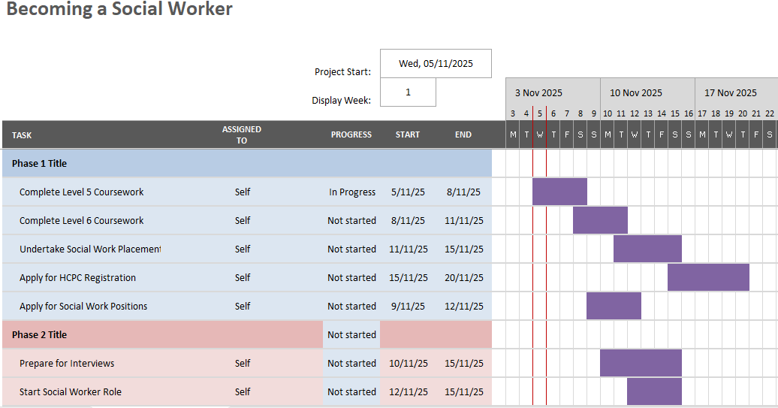

Week 8: Interview Preparation Timeline: “Start Social Worker Role” Planner
This timeline counts back three weeks from a target interview date at the end of the 12-week plan. I set a small action for most days so preparation never becomes a last-minute panic. I start by reading the advert and person specification, then map short STAR stories to each essential criterion. I review local authority strategies and regulator reports, because this helps me tailor answers to local priorities. I draft a 60-second pitch that links values to evidence. I practise answers to leadership, risk, and ethics questions, including how I handle unsafe practice and how I balance rights and risk.


