

Strategic Management & Sustainability-LCBB6004

Strategic Analysis of Tesco PLC

Lecturer: Dr. Hossein Shokri

Student name & ID:

Alina-Paula Manolache-2114609

Table of Contents
Introduction 3
Financial Performance 3
Identification of Key Strategies 4
Corporate Strategy-Ansoff Matrix 4
Organic Growth 4
Acquisitions and Diversification 5
Business Strategy- Porter’s Generic Strategies 5
Differentiation 5
Analysing Resources and Capabilities 6
Value Chain Analysis 6
VRIO Analysis 7
Evaluation of Strategy Implementation-The SAF Framework 7
Success Measures 8
Performance Analysis 8
Evaluation of Competitive Advantage 9
Brand Reputation 9
Economies Of Scale 9
Sustainability 9
Current Sustainability Practices 9
Sustainable Sourcing 10
Environmental Considerations 10
Consumer Expectations 10
Regulatory Compliance 11
Evaluation of Competitiveness 11
Conclusion 11
Appendix 12
SWOT Analysis 12
References 14

Introduction
Tesco PLC is one of the biggest retailers in the United Kingdom with a strong presence in the global market. The company is active in several sectors including groceries, general merchandise, and financial services (Tesco Plc, 2023). This report's purpose is to evaluate Tesco's strategy and critically analyze its strategic choices. The report's scope includes an analysis of Tesco’s corporate and business strategy, alignment of resources, and capabilities, evaluation of implementation of strategy, sustainability practices, and future strategic direction.
Company Background Tesco PLC, founded by Jack Cohen in 1919, has grown into a multinational retailer operating in many countries (Tesco Plc, 2023). The company provides a variety of services and products, such as fresh food, grocery, general merchandise, and clothing. Tesco targets a wide range of customers, emphasizing value, convenience, and quality.

Financial Performance
Tesco's financial performance has been strong over the years with revenue growth and profitability that have consistently increased. The business recorded revenues for the fiscal year that ended in February 2024 of GBP68,187 million, a 4.4% increase over FY2023. The operating margin of the business was 4.1% in FY2024 as rather than 2.2% in FY2023. The net margin for the corporation in FY2024 was 1.7%, as compared to 1.1% in FY2023 (MarketLine, 2024).
.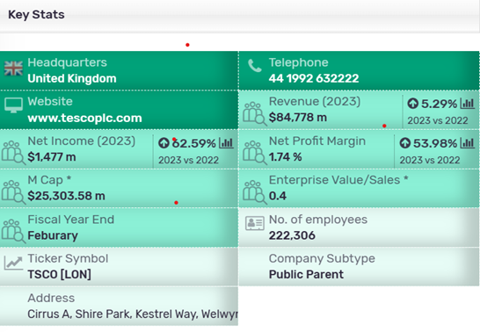Source: MarketLine Advantage, (2024)

Identification of Key Strategies

Corporate Strategy- Ansoff Matrix
Ansoff Matrix evaluates the organization’s possibilities from a broader strategic viewpoint than the standard market/product matrix. Thus, the market options matrix considers not only the possibility of launching new products and entering new markets, but also the possibility of withdrawing from existing markets and entering unrelated areas (Lynch, 2018).
Tesco’s corporate strategy combines growth, diversification, and internationalization. The company pursued organic growth and acquisitions such as the purchase of Booker Group by Tesco in 2018. Tesco has also expanded its business into new markets such as financial services, telecommunications, and other sectors. The company has also expanded internationally with operations in many countries throughout Europe and Asia (Tesco Plc, 2023).

Organic Growth
Organic growth means increasing profitability in key market with a focus on key products (Whittington, et.al.,2019).
Tesco’s organic growth strategy is focused on improving and expanding its stores. The company has made investments in modernizing and refurbishing its stores to improve the shopping experience of customers (Tesco Plc, 2023). Tesco also has a strong online presence with an established e-commerce platform, as well as a home delivery service. Organic growth initiatives by the company have strengthened its market position and increased customer loyalty.
Withal, market penetration is the process of increasing sales in existing markets (Whittington, et. al.,2019). Tesco can do this by increasing market share, encouraging its customers to purchase more, or attracting new clients within its existing markets. Market penetration strategies could include loyalty programs, targeted marketing campaigns, promotional activities, and other tactics (Tesco Plc, 2023).

Acquisitions and Diversification
To support its growth and diversity objectives, Tesco made several strategic purchases. Tesco expanded its presence in food wholesale and catering by acquiring Booker Group. The acquisition of Booker Group has allowed Tesco to use Booker's infrastructure and expertise to improve its offerings. Tesco's expansion into financial services through Tesco Bank has provided it with new revenue streams and cross-selling opportunities (Tesco Plc, 2023).

Business Strategy-Porter’s Generic Strategies
Porter’s Generic Strategies provide a framework for companies to determine their strategic positioning within an industry and make choices regarding how they compete (Allen, et. al.,2007).

Differentiation
A differentiation strategy requires uniqueness along some dimension that customers appreciate enough to allow a price premium (Whittington, et. al.,2019).
Tesco’s business strategy is based on differentiation. Tesco aims are to demonstrate value through price, quality, and sustainability, also to eliminate price as a barrier to purchase. Likewise, making nutritious, sustainable food affordable for all in collaboration with suppliers to create high-quality, sustainably derived products. Tesco also differentiates itself by the quality of its products, customer service, and in-store experiences. Tesco also has a wide range of products under its brand, which allows it to differentiate itself from other companies (Tesco Plc, 2023).
Tesco differentiates from its competitors in various ways, such as product quality, customer service, and the experience of shopping at Tesco. The company has invested heavily in its own-brand product range, which is often viewed as a high-quality alternative to national brands. (Tesco Plc, 2023). Tesco emphasizes excellent customer service with its well-trained employees and programs such as "Every Little Helps". Tesco's efforts to provide a convenient and pleasant in-store shopping experience through the store layout, product display, and other services further distinguish it from its competitors.

Analyzing Resources and Capabilities
An organization's competitive advantage and superior performance are explained by its specific resources and capabilities, resources are the assets which organization have, and capabilities are the way in which those assets are used (Whittington, et. al.,2019).
Tesco’s key resources are its extensive store network and efficient supply chain. It also has a strong brand reputation and a skilled workforce The capabilities of the company include its ability to manage and maintain a complex supply network, establish and maintain strong relationships, and use data and technology effectively to enhance operations and improve customer experience.
Tesco’s extensive store network provides the company with an excellent presence in the UK market. The company has over 3,700 outlets in the UK including supermarkets and convenience stores. Tesco can reach a wide customer base through this extensive network and provide convenient shopping options. Tesco’s store network has been strategically placed to maximize coverage and access (Tesco Plc, 2023).
Value Chain Analysis
When an organisation can adapt to environmental opportunities or threats and produces a good or service that makes customers happy, then its resources and capabilities are valuable (Whittington, et. al.,2019).
Tesco Plc. value chain is composed of Inbound Logistics, Operations, Outbound Logistics, Marketing & Sales, and Service (MarketLine Advantage, 2021).
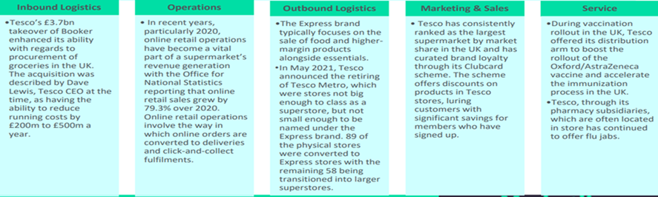
Tesco’s strategy of providing a large selection of products to customers is supported by its inbound logistics, which guarantee a consistent supply of products from suppliers. The company’s focus on technological advancement and operational efficiency guarantees smooth operations and cost control, which supports its competitive pricing approach. Tesco’s market position is strengthened by marketing and sales initiatives that improve customer engagement and retention, such as loyalty programs and tailored offers. Customers receive added value from Tesco’s customers service initiatives, both in-store and online, which improves their entire shopping experience (Tesco Plc, 2023).

VRIO Analysis- helps to determine how and to what extent a business or organization has resources and capabilities which are valuable, rare, inimitable and supported by the business (Whittington, et. al.,2019).
By using the VRIO framework, Tesco can assess its resources and capabilities:
- Tesco’s resources and abilities enable it to take advantage of opportunities and counter threats in the market.
- Tesco is unique in its ability to manage its supply chain and utilize data.
- Tesco is unique in its brand reputation and relationship with suppliers. It's hard for competitors to match.
- Tesco is well-organized and uses its resources and abilities to support its strategy effectively.
Tesco has a good balance between its resources and abilities, its current corporate and business strategy. This allows the company to be competitive in the market.

Evaluation of Strategy Implementation- The SAF framework
Suitability: Tesco’s strategies align well with the dynamic retail market. They have diversified into non-food sectors, expanded internationally, and focused on convenience formats. Withal, the company’s move into online grocery retailing demonstrates adaptability to changing consumer behavior and technological advancements.
Acceptability: Customers appreciate Tesco’s convenience offerings and loyalty programs, indicating acceptance of its strategies. Also, shareholders have supported Tesco’s strategies, as evidence by its stable financial performance and dividends.
Feasibility: Tesco’s strategies are feasible due to its financial strength and operational capabilities. Investment in infrastructure and technology support successful execution, especially in online retailing and supply chain optimization.

Success Measures
Tesco can evaluate the success of its strategy implementation using various measures such as financial performance and market share. Employee engagement, customer satisfaction, and employee retention are also important. Tesco's financial performance has been strong, with revenue growth and profitability that have been consistent (Tesco Plc, 2023). The company also managed to maintain a significant share of the UK grocery market despite fierce competition (Statista, 2021).

Performance Analysis
Tesco has had a positive performance, which indicates the successful implementation of its strategy. Its efforts to differentiate have also helped maintain customer loyalty. Tesco's investments in technology and data analytics also helped improve operational efficiency and the customer experience (Tesco Plc, 2023).
Tesco, however, has had to deal with challenges in some of its markets abroad, especially in the United States where the company left the market because it was unable to gain traction (MarketLine Advantage,2014). This shows the importance of tailoring strategies to market conditions and customer preferences in each country.

Evaluation of Competitive Advantage
Competitive advantage means that an organization has a distinctive and unique resource which competitors find difficult to imitate, and that is of value to customers (Whittington, et. al., 2019).
Tesco has established a competitive advantage in the UK grocery market through its successful implementation of the strategy. Its differentiation strategies have created a loyal clientele and helped maintain market share. Tesco has also been able to leverage its resources and scale to invest in innovative technologies and initiatives. This has further strengthened the company's competitive position.

Brand Reputation
Tesco’s strong brand is a source of competitive edge. The company is known for its high-quality products and customer service. Tesco is a brand that consumers are familiar with and trust, which drives customer loyalty and helps differentiate the company (Tesco Plc, 2023). Tesco's reputation as a brand is an asset that competitors find difficult to duplicate.

Economies Of Scale
Tesco’s large operations provide the company with significant scale economies, which is a source of competitive edge. The size of the company allows it to negotiate better terms with suppliers, improve cost efficiency in distribution and procurement, and spread fixed expenses over a greater sales volume. Tesco can maintain its low-cost position by leveraging economies of scale while investing in service and quality improvements (Tesco Plc, 2023). Tesco's ability to maintain a competitive edge in the market is heavily dependent on its scale.

Sustainability
Sustainable development not just refers to minimize environmental harm, but also, giving an importance to the product and service on the long-term, thus, successfully implement profitable strategies in a new market space (Whittington, et. al.,2019).

Current Sustainability Practices
Tesco implemented various sustainability techniques to reduce its impact on the environment and to contribute to social responsibility. The company has established targets to reduce greenhouse gases, increase renewable energy use, and minimize waste. (Tesco Plc, 2023). Tesco also focuses on sustainable sourcing. It works with suppliers to improve social and environmental standards in the supply chain.
Tesco has taken significant steps to reduce the environmental impact of its business. To reduce energy consumption, the company has invested heavily in energy-efficient technology, including LED lighting and refrigerator systems. Tesco also has implemented waste reduction measures, including reducing packaging and donating excess food to charity. Tesco has been able to reduce its environmental footprint by implementing these efforts (Tesco Plc, 2023).

Sustainable Sourcing
Tesco works closely with suppliers to ensure products are ethically and responsibly sourced (Tesco, 2023). Tesco has adopted various sustainability standards and certificates, such as those from the Marine Stewardship Council and Rainforest Alliance, to promote sustainable supply chain practices. Tesco's supply chain can be made more sustainable by sourcing sustainably. This will reduce the environmental impact of its business and improve the well-being of its workers and communities.

Environmental Considerations
Tesco’s sustainability efforts are driven by the increasing awareness of consumers of environmental issues, and their need to adhere to regulations. Tesco's environmental efforts can help it appeal to environmentally conscious consumers and set itself apart from its competitors (Tesco Plc, 2023). But implementing sustainable practices may also require large investments and increased costs, which could impact short-term profits.

Consumer Expectations
In recent years, consumer expectations have increased in terms of sustainability. Customers are increasingly looking for environmentally friendly products and businesses that practice responsible business practices. Tesco has responded by prioritizing sustainable practices in its strategies and communicating these efforts to its customers (Tesco 2023). Tesco's reputation can be enhanced by meeting the demands of consumers for sustainability.

Regulatory Compliance
Regulatory Compliance is an important aspect of Tesco's sustainability efforts. Governments and regulatory agencies have introduced more stringent environmental targets and regulations, like the UK's goal of achieving net-zero emissions by 2050. (Committee on Climate Change, 2019). Tesco's operations and supply chain must comply with these regulations to avoid penalties and to maintain its operating license. Tesco can maintain its competitive edge by complying with environmental regulations.

Evaluation of Competitiveness
Tesco’s sustainability practices can enhance its competitiveness over time. Tesco's commitment to social and environmental responsibility can help it improve its reputation and attract customers that value sustainable business practices. Investing in sustainable technologies and business processes can also lead to increased efficiency and cost savings over time (Tesco Plc, 2023).
The impact of sustainability on competition is also dependent on the actions taken by competitors and the market environment. Tesco may lose its competitive edge if competitors adopt sustainability practices that are similar or even more advanced.

Conclusion
Tesco PLC, in conclusion, has shown effective strategic choices and successfully implemented strategy, which has enabled it to maintain its strong competitive position in the UK grocery market. Corporate and business strategies that are aligned with the company's resources and capabilities have contributed to growth and profitability. Tesco's sustainable practices can enhance its competitiveness. However, the company needs to continue to innovate and adapt to market conditions.
Tesco must consider the strategic options that will drive growth and future competitiveness, such as product development, market expansion, diversification, and strategic partnerships. Tesco can create a competitive advantage by leveraging sustainability, such as the adoption of circular economic principles and sustainable agricultural practices.
Tesco's ability to achieve long-term business success is dependent on setting ambitious sustainability goals, working with stakeholders, investing heavily in innovation, and engaging its customers. To remain competitive and successful in the future, Tesco's ability to integrate sustainability into core strategies and operations is critical.

Appendices

SWOT Analysis
SWOT analyses can be used to identify possible strategic directions for Tesco.
- Strengths: Brand reputation, store network, supply chain efficiency, financial resources.
- Weaknesses include a dependence on the UK, difficulties in certain international markets, and vulnerability to economic downturns.
- Opportunities: Expansion into new product categories, further internationalization, and leveraging technology for growth.
- The threats are intense competition, changing consumer tastes, and economic insecurity.

Tesco's Strategic Options
Based on the SWOT Analysis, Tesco may consider the following options:
- Market development: Expand to new geographical markets, especially in emerging economies that have high growth potential. (Whittington, et. al., 2019).
- Product Development: Invest in new products and services such as healthier food or expanded financial services.
- Diversification: Explore new business segments to complement Tesco’s existing strengths (Whittington, et. al., 2019).
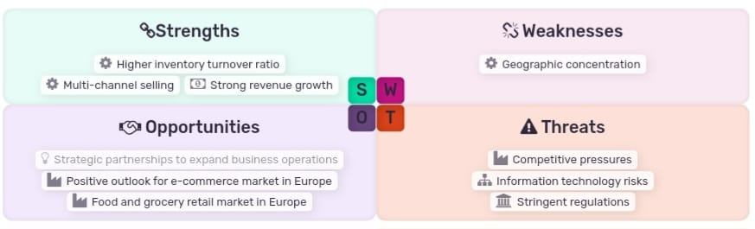Source: MarketLine, 2024

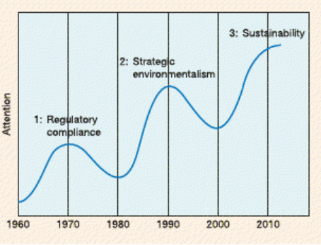
Source: Lynch, (2018)

References

- Whittington, R., Regnér, P., Angwin, D., Johnson, G. & Scholes, K. (2019). Exploring Strategy: Text and Cases (12th ed.). Pearson Education Limited. Available at: https://ebookcentral.proquest.com/lib/trinity/detail.action?pq-origsite=primo&docID=5987036#, Accessed on 12th April 2024.
- MarketLine Advantage (2024), Tesco Plc. Available at: https://advantage-marketline-com.ezproxy.uwtsd.ac.uk/search?q%5B%5D=Tesco+plc&IsSearchApi=true&exactword=1, Accessed on: 12th of April 2024.
- Tesco Plc (2023). Annual Report 2023. Available at: https://www.tescoplc.com/media/u1wlq2qf/tesco-plc-annual-report-2023.pdf, Accessed on 12th April 2024.
- Lynch, R. (2018), Strategic Management, Pearson Education, Limited, Harlow, United Kingdom. Available from: ProQuest eBook Central. Accessed on 19th April 2024.
- MarketLine Advantage (2021), Tesco Plc: Value Chain Analysis. Available at: https://advantage-marketline-com.ezproxy.uwtsd.ac.uk/Analysis/details/tesco-plc-value-chain-analysis-142480, Accessed on 19th of April 2024.
- MarketLine Advantage (2014), Tesco PLC’s US experience. How to lose £1bn: the Fresh & Easy way. Available at: https://advantage-marketline-com.ezproxy.uwtsd.ac.uk/Analysis/details/tesco-plc%E2%80%99s-us-experience-how-to-lose%C2%A31bn-the-fresh-easy-way-27463, Accessed on 19th of April 2024.
- Committee on Climate Change. (2019). Net Zero: The UK's contribution to stopping global warming. Available at: https://www.theccc.org.uk/publication/net-zero-the-uks-contribution-to-stopping-global-warming/, Accessed on: 12th of April 2024.
- Deloitte. (2021). Sustainability & Consumer Behavior 2021. Available at:https://www2.deloitte.com/uk/en/pages/consumer-business/articles/sustainable-consumer.html, Accessed on 12th April 2024.
- Kantar. (2023). Grocery Market Share - Great Britain. Available at: https://www.kantarworldpanel.com/en/grocery-market-share/great-britain, Accessed on 14th April 2024.
- Statista. (2021). Market share of grocery stores in Great Britain from January 2017 to May 2021. Available at: https://www.statista.com/statistics/280208/grocery-market-share-in-the-united-kingdom-uk/, Accessed on 12th April 2024.
- Tesco Plc (2023). About us. Tesco PLC. Available at: https://www.tescoplc.com/about/, Accessed on 12th April 2024.
- Zugay, B. and Zakaria, R., 2023. Ansoff Matrix. London: Sage Publications, Inc. Available at: <https://doi.org/10.4135/9781071924136> , Accessed on 14th Apr 2024.
- Allen, R., Helms, M., Takeda, M. and White, C., 2007. Porter's generic strategies: An exploratory study of their use in Japan. Journal of business strategies, 24(1), pp.69-90.
- MarketLine (2024), Tesco Plc. Company Summary, Available at: https://advantage-marketline-com.ezproxy.uwtsd.ac.uk/Company/Summary/tesco_plc , Accessed 14th of April 2024.
- Tesco Plc (2024). Sustainability Reports. Available at: https://www.tescoplc.com/sustainability-reports?activeTab=reports, Accessed 14th of April 2024.

