BSc Health and Social Care
Introduction To Physiology
BHMP5003_BIRM
Muhammad Humza Saeed
Nisha Sharma 2018069

Contents Page
Title Page …………………………………………………………………Pg1
Contents Page …………………………………………………………...Pg2
Introduction ………………………………………………………………..Pg3
Case Study ………………………………………………………………. Pg4 – P5
Assessment Report ………………………………………………………Pg6 – Pg9
Recommendation …………………………………………………………Pg10
Conclusion …………………………………………………………………Pg11 – Pg12
References …………………………………………………………………Pg13 – Pg15
Appendix ……………………………………………………………………Pg16

Introduction
What is the aim of a Health Assessment?
A health assessment is a structured, methodical evaluation of the human body that gathers both subjective and objective information to ascertain the patient's overall, physical, and mental health. This should include patient-centred methods of work to make sure professionals are aware of the requirements and viewpoints of the patient (King and Hoppe, 2013).
One tool used by professionals to learn about a patient's health status is the Health Assessment Questionnaire (HAQ), which was published in 1980. Gathering patient perspectives about their knowledge of the diagnosed disease was one of the first tools used in patient-centred ways of working (Pincus, Yazici and Bergman, 2007). By bridging the gap between patient and professional communication, establishing trust, and providing reassurance throughout the process, enables a clearer view from a professional perspective.
When evaluating individuals, professionals must be open and accountable in accordance with industry standards for decision-making. To accomplish this, the decision-making process itself must be precise and clear. Strengths, weaknesses, opportunities, and threats (SWOT) analysis should be used to collect the reliable data that healthcare administrators need while ensuring that the data is consistent with established policies and procedures (Dutta, 2018).

Case Study
Lola Chambers is a 14-year-old female began to complain of feeling dizzy experiencing black outs/ lengthy episodes of extreme tiredness and aching in joints for a period of 3 months.
A Health Assessment was completed with the patient. Questions were asked based around the current health status of the patient to identify and causes of the symptoms the patient has been experiencing.
Lola does not smoke nor drink alcohol; her blood pressure is within the average range for a young female. Lola has never had a stroke, history of her extended family was inquired to identify experience of any strokes or heart attacks. Lola has no known history of heart conditions within her family. A varied diet with chips and fries was selected when asked about her diet, Lola stated she eats more takeaway food then home cooked meals.
History
Lola has no known history, vital observations are:
- Weight: 11 stone 3 lbs
- Blood Pressure: 120/60
- Body Temperature: 35
- Respiratory Rate: 12 to 16 breaths per min
In the last two years, the only changes the patient has experienced is hormonal changes starting her menstrual cycle with no other health concerns.
In order to rule out any other causes of Lola's problems, the goal of this report is to investigate the source of her symptoms, with the aim of diagnosis and treatment.
Additional investigation is needed to see whether there may be any underlying issues.
According to Pasricha et al., 2021 when a blood sample is examined routine coeliac screening must also be recommended.
 (Hopkins, 2022)

A blood test indicated the patient’s Iron levels at 2 with average for a female being between 10-11 (Mesías, Seiquer and Navarro, 2013).
A Coeliac screening test also highlighted the patient testing positive for Coeliac Disease (CD).

Assessment Report
Based on the questions answered in the questionnaire, the next step to take is explore the function of Lola’s digestive system this is to rule out any abnormalities in the process of the system.
Digestive System
Processes of the digestive system start when we eat the food, as we chew our glands produce saliva softening food allowing it to pass through the esophagus into your stomach more easily.
There are two processes of the digestive system which is mechanical digestion and chemical digestion. Food gets broken down mechanically in order for successful chemical digestion.
In order to absorb nutrients, vitamins, and minerals through the chemical processing the digestive system must first break down the food in order for it to be absorbed. Our food choices and lifestyle can impair the digestive system's ability to function with certain food we eat (Sensoy, 2021). This can slow down the digestion process causing the stomach to feel bloated. The digestive system's most typical conditions include:
- Irritable Bowel Syndrome (IBS)
- Inflammatory Bowel Disease (IBD)
- Gastroesophageal Reflux Disease (GERD)
- Coeliac Disease
- Diverticulitis
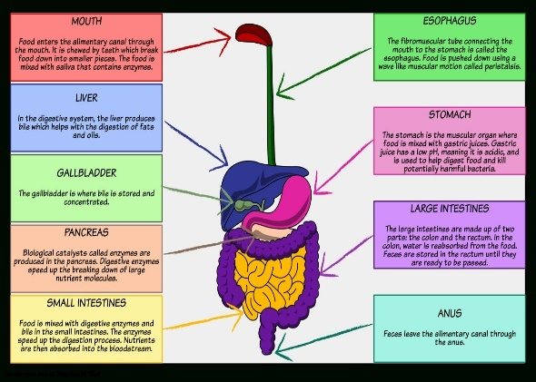
(Smith, 2022)
The three main functions of our digestive system include combining the food, transporting it through the digestive tract, and finally, using chemicals to break down the food into smaller molecules so that it may be absorbed into the small intestine and then into the blood stream.
Abnormal Digestive System
With the small intestine playing a major role in the process of food being digested, it is important to be mindful of the food we consume. Some foods contain protein gluten which can be harmful to the villi when consuming too much triggering an attack on your immune system (Connors et al., 2018).
Protein Gluten is found in:
- Grains
- Wheat
- Barley
- Rye
The villi, or hair-like structures that make up the lining of the small intestine can be disrupted by protein gluten (Leffler, Green and Fasano, 2015). Weakening the lining causing digestive disorders such as coeliac disease predominantly known in females (Catassi et el., 2022). As a result of the surface eroding away, our bodies will not be able to absorb the minerals and vitamins from the food we digest via the Villi.
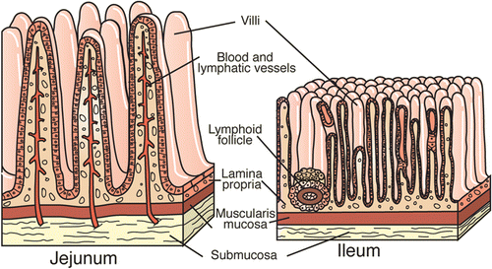
(Gelberg, 2014)
When we are not receiving crucial nutrients and minerals this can cause other complications such as Iron deficiency, malnutrition, lactose intolerance, cancer, neurological problems, loss of calcium and bone density (McGrogan et al., 2021).
Functioning Digestive System
One way to ensure you maintain a healthy digestive system is to consume a varied and balanced diet of fruit, vegetables, protein, carbohydrates, and plenty of water.
Your digestive system is made up of a group of organs that allow your body to absorb the vitamins and nutrients it needs from food. A healthy digestive system takes the vitamins and nutrients distributing them to vital organs via the bloodstream utilising it for energy, growth, and cell repair helping you feel healthier and energised. The process of the digestive system in order are as follows:
- Ingestion
- Propulsion
- Mechanical digestion
- Chemical Digestion
- Absorption
- Defecation
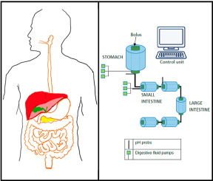
(Sensoy, 2022)
Coeliac Disease (CD) is known to be a common disease of the digestive system in children and adolescents. The condition is reversable with early intervention being sought and a care plan to guide best practice or guidance. As parents we allow responsibility and independency play a major part when transitioning into adulthood. Learning to live alone, learning how to cook and look after themselves without 24-hour supervision can sometimes result in the adolescent manifesting a poor diet which in some cases leads to coeliac disease (Ludvigsson et al., 2016).
Psychological disorders are more likely to develop in children with CD and may not necessarily get better with Gluten Free Diet (GFD) treatment. These disorders might develop before or after the CD diagnosis.
Lower GFD adherence has been connected to mental health comorbidities such depression, anxiety, panic attacks, suicide, and poor quality of life, which in turn raises the risk for health-related issues (Vuolle et al., 2022).
The small intestine is the most crucial component of the digestive system since it performs the majority of food digestion and absorption. Only the small intestine exposes food to various digestion enzymes.

Recommendation
A blood test for coeliac-specific antibodies together with a screening test will typically be able to identify most individuals who need a duodenal biopsy to confirm the diagnosis of Coeliac Disease.
Lola will be invited to see a Paediatrician to conduct further testing, a diagnosis should always be made by a Paediatrician.
As part of the care plan, which involves conducting a CD-focused clinical examination every one to two years, with patients' compliance following a gluten-free diet is supported by a Dietician/Nutritionist (Walker, Ludvigsson and Sanders, 2017).
Other than a strict gluten-free diet and advice from a nutritionist on how to manage your symptoms, there is no known treatment for coeliac disease. Since a gluten-free diet (GFD) necessitates considerable dietary habit changes, adhering to one can be challenging and requires new knowledge, abilities, and behaviours (Campagna et al., 2016).
Lola would need to be supported through the transitional stages of a gluten free diet with a professional and her support network. Lola is the first known case of coeliac disease in her family, making it more significant how important it is to ensure the family is supported adequately, for the family to support and guide their daughter.

Conclusion
The learning gained from completing this report has helped me identify that our diet and lifestyle can play a major part in how our digestive system and how other organs function. Exploring what happens when our digestive system is interrupted was most insightful when researching about the anatomy of the small intestine and how it plays a major role in the process. An untreated wall of the small intestine, results in the process no longer having the ability to absorb the nutrients and minerals we need in order to live a quality of life, and in some serious cases causes death caused by malnutrition. The regular function of the digestive system can be maintained by eating a diet high in fibre and full of fruits, vegetables, and whole grains.
Gibbs Reflective Cycle, a six-step approach tool designed to improve the capacity for critical analysis and reflection based on the contents of this report (Husebø, O'Regan and Nestel, 2015). The aim of this assessment is to create a personalised care plan for Lola and her family, who has been identified as having coeliac disease. The goal is to enhance her quality of life, and this health assessment places a strong emphasis on early intervention to prevent subsequent difficulties.

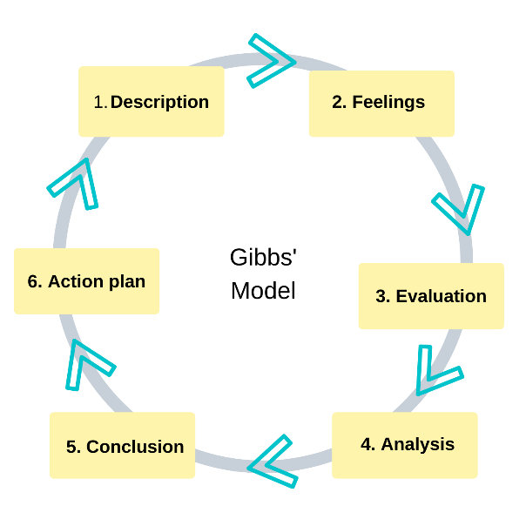 (Cycle, 2022)
Description
Benefits of the Health Assessment was discussed in the introduction. The tool's history has been presented to demonstrate its legitimacy and to share better ways of working with the ultimate purpose of acquiring raw data bridging the gap between patient and professional communication.
Feelings
In order to ensure that the patient's health condition was clear and accurate, questions were asked during the health assessment to examine the needs and perspectives of the individual.
Evaluation
The normal anatomy and physiology of the digestive system's structure and functionality was investigated. Conditions caused by the disruption of the digestive system was also explored in this section, sharing knowledge based around Coeliac disease.
Analysis
Questions concerning the patient's history and present health were asked in order to identify potential causes of the symptoms. It was suggested to conduct additional investigation using screening tools and blood tests to determine the cause.
Conclusion
Recommendation on lifestyle changes and plan of care was included in this section, diagnosis would need to be sought by a Paediatrician followed by support from a nutritionist/dietician. Gibbs cycle to reflect on the contents of this report.
Action Plan
Next steps to take were identified to support Lola and her family. Conclusion summarising my learning from exploring the digestive system and a condition of disrupted digestive system.

References
Campagna, G., Pesce, M., Tatangelo, R., Rizzuto, A., La Fratta, I. and Grilli, A., 2016. The progression of coeliac disease: its neurological and psychiatric implications. Nutrition Research Reviews, [online] 30(1), pp.25-35. Available at: <http://The progression of coeliac disease: its neurological and psychiatric implications G Campagna, M Pesce, R Tatangelo… - Nutrition research …, 201> [Accessed 30 July 2022].
Catassi, C., Verdu, E., Bai, J. and Lionetti, E., 2022. Coeliac disease. The Lancet, [online] 399(10344), pp.2413-2426. Available at: <https://www.sciencedirect.com/science/article/pii/S0140673622007942?casa_token=e6exkJVEiTkAAAAA:J7ohPn8cBWdleyMLZCPpO625btCEVBuolMTrgzxYo_cWAv9iuGxP3KgZOO0TGSK_Pp4vUBrYuF3C> [Accessed 30 July 2022].
Connors, L., O’Keefe, A., Rosenfield, L. and Kim, H., 2018. Non-IgE-mediated food hypersensitivity. Allergy, Asthma &amp; Clinical Immunology, [online] 14(S2). Available at: <https://aacijournal.biomedcentral.com/articles/10.1186/s13223-018-0285-2> [Accessed 30 July 2022].
Cycle, G., 2022. What is reflective writing?. [image] Available at: <https://library.nua.ac.uk/welcome-to-study-skills/reflective-writing/> [Accessed 30 July 2022].
Dutta, P., 2018. Human Health Risk Assessment Under Uncertain Environment and Its SWOT Analysis. The Open Public Health Journal, [online] 11(1), pp.72-92. Available at: <https://openpublichealthjournal.com/VOLUME/11/PAGE/72/FULLTEXT/> [Accessed 18 July 2022].
Gelberg, H., 2014. Comparative Anatomy, Physiology, and Mechanisms of Disease Production of the Esophagus, Stomach, and Small Intestine. Toxicologic Pathology, [online] 42(1), pp.54-66. Available at: <https://journals.sagepub.com/doi/full/10.1177/0192623313518113> [Accessed 30 July 2022].
Hopkins, J., 2022. Experts Recommend Fewer Lab Tests for Hospitalized Patients. [image] Available at: <https://www.hopkinsmedicine.org/news/media/releases/experts_recommend_fewer_lab_tests_for_hospitalized_patients> [Accessed 24 July 2022].
Husebø, S., O'Regan, S. and Nestel, D., 2015. Reflective Practice and Its Role in Simulation. Clinical Simulation in Nursing, [online] 11(8), pp.368-375. Available at: <https://doi.org/10.1016/j.ecns.2015.04.005> [Accessed 30 July 2022].
King, A. and Hoppe, R., 2013. “Best Practice” for Patient-Centered Communication: A Narrative Review. Journal of Graduate Medical Education, [online] 5(3), pp.385-393. Available at: <https://meridian.allenpress.com/jgme/article/5/3/385/34047/Best-Practice-for-Patient-Centered-Communication-A> [Accessed 30 July 2022].
Leffler, D., Green, P. and Fasano, A., 2015. Extraintestinal manifestations of coeliac disease. Nature Reviews Gastroenterology &amp; Hepatology, [online] 12(10), pp.561-571. Available at: <https://www.nature.com/articles/nrgastro.2015.131> [Accessed 25 July 2022].
Ludvigsson, J., Agreus, L., Ciacci, C., Crowe, S., Geller, M., Green, P., Hill, I., Hungin, A., Koletzko, S., Koltai, T., Lundin, K., Mearin, M., Murray, J., Reilly, N., Walker, M., Sanders, D., Shamir, R., Troncone, R. and Husby, S., 2016. Transition from childhood to adulthood in coeliac disease: the Prague consensus report. Gut, [online] 65(8), pp.1242-1251. Available at: <https://gut.bmj.com/content/65/8/1242.short> [Accessed 27 July 2022].
McGrogan, L., Mackinder, M., Stefanowicz, F., Aroutiounova, M., Catchpole, A., Wadsworth, J., Buchanan, E., Cardigan, T., Duncan, H., Hansen, R., Russell, R., Edwards, C., Talwar, D., McGrogan, P. and Gerasimidis, K., 2021. Micronutrient deficiencies in children with coeliac disease; a double-edged sword of both untreated disease and treatment with gluten-free diet. Clinical Nutrition, [online] 40(5), pp.2784-2790. Available at: <https://www.sciencedirect.com/science/article/pii/S026156142100145X?casa_token=pzfv7AMATIkAAAAA:C8dtgsbQI3FtOBtrsMKKC-8tTjh3y26Zk-rFUcXMJmjDBUZ-P0LZ4fjHSCHZRM0L_JCG9ExfpId6> [Accessed 30 July 2022].
Mesías, M., Seiquer, I. and Navarro, M., 2013. Iron Nutrition in Adolescence. Critical Reviews in Food Science and Nutrition, 53(11), pp.1226-1237.
Pasricha, S., Tye-Din, J., Muckenthaler, M. and Swinkels, D., 2021. Iron deficiency. The Lancet, 397(10270), pp.233-248.
Pincus, T., Yazici, Y. and Bergman, M., 2007. A practical guide to scoring a Multi-Dimensional Health Assessment Questionnaire (MDHAQ) and Routine Assessment of Patient Index Data (RAPID) scores in 10–20seconds for use in standard clinical care, without rulers, calculators, websites or computers. Best Practice &amp; Research Clinical Rheumatology, [online] 21(4), pp.755-787. Available at: <https://www.researchgate.net/profile/Martin-Bergman-4/publication/7494007_Development_of_a_Multi-dimensional_Health_Assessment_Questionnaire_MDHAQ_for_the_infrastructure_of_standard_clinical_care/links/00b4951bb3d2141393000000/Development-of-a-Multi-dimensional-Health-Assessment-Questionnaire-MDHAQ-for-the-infrastructure-of-standard-clinical-care.pdf> [Accessed 18 July 2022].
Sensoy, I., 2021. A review on the food digestion in the digestive tract and the used in vitro models. Current Research in Food Science, [online] 4, pp.308-319. Available at: <https://doi.org/10.1016/j.crfs.2021.04.004> [Accessed 18 July 2022].
Smith, O., 2022. Digestive System. [image] Available at: <https://www.mrgscience.com/uploads/2/0/7/9/20796234/digestive-system-diagram-digestive-system-storyboard-by-oliversmith_orig.jpg> [Accessed 23 July 2022].
Vuolle, S., Laurikka, P., Repo, M., Huhtala, H., Kaukinen, K., Kurppa, K. and Kivelä, L., 2022. Persistent symptoms are diverse and associated with health concerns and impaired quality of life in patients with paediatric coeliac disease diagnosis after transition to adulthood. BMJ Open Gastroenterology, [online] 9(1), p.e000914. Available at: <https://bmjopengastro.bmj.com/content/9/1/e000914.abstract> [Accessed 3 August 2022].
Walker, M., Ludvigsson, J. and Sanders, D., 2017. Coeliac disease: review of diagnosis and management. Medical Journal of Australia, [online] 207(4), pp.173-178. Available at: <https://doi.org/10.5694/mja16.00788> [Accessed 30 July 2022].

Appendix


