Assignment Title: Development of a manufacturing system simulation.
module code: M2X8523
module lecturer: Jaymie L. Phillips
module title: object ORIENTED programming
Student Number: Alexander Hall (P151746)
2018
Contents
Introduction 2
Background Theory and Coding 2
Classes 2-3
Objects 3-4
Patterns 4
Singleton 4
Inheritance 4
Overloading 5
Overriding 5
Composition 5
Aggregation 5-6
File Access/Stream 6
System design and UML models 6
Design Specifications 6-7
Structural: - 7
Class Diagram 7
Behavioural: - 8
Use-Case diagram 8-10
Sequence Diagram 10-12
References 13

Introduction
This assignment is used show a level of understanding of C++ programming language as well use the object-oriented programming techniques, these techniques will be outlined below and will be used to create a manufacturing and stocking system for a manufacturing business, also there will be design models that outline what the system does using UML (Unified Modelling language) diagrams.
The manufacturing business must have a system for manufacturing and selling a range of components, this includes a system should include features such as ordering raw materials, ordering new components, making user accounts for both individual customers and companies and should include a stocking system that can be used by the users mentioned above as well as being maintained by the manufacturing business itself.
The components that need manufacturing are resistors, capacitors, transistors, diodes and inductors.

Background Theory and Coding
This section is used to describe the various parts of Object oriented programming, it will also show the code that has been written for the system using the object-oriented programming techniques.

Classes
Classes are usually made up of a header (.h files) and a source files (.cpp files), both files have the same name, here is an example of a classes header and source files: -
Figure 2-Customer Class Source file
Figure 1-Customer Class header file

The class files are used to define data types (attributes) such as int, char, string or float, which normally go within the ‘private’ section of the class meaning they can only be used within the scope of the Class itself, this means the methods or functions usually go into the ‘public’ section of the class files, this way the functions can be used within the bigger program outside of the specified class files, meaning that the Class files are used overall as a type of blueprint to get data when an instance or object is instantiated .
Here are the images of the class files for the manufacturing business’s system filled with the data types, member functions and Macros: -
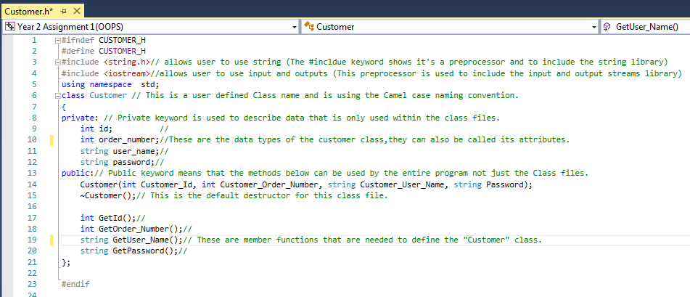
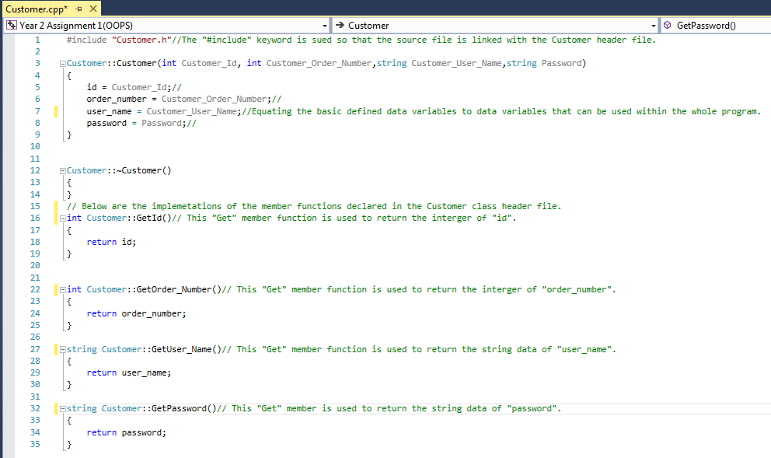
Figure 3-Customer header file filled with Attributes, Member Functions, Pre-processor’s and Macro's
Figure 4-The Customer Source file

Objects
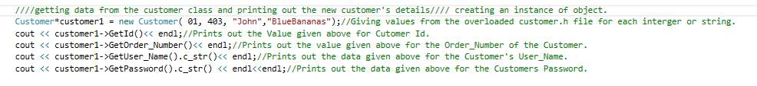
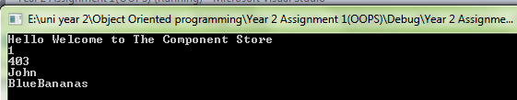
Objects are what are created when a class is used with a program needs to use a variety of data types at the same time to carry out a specific purpose, objects can also be called instances as you can use an object many different times, creating many difference instances depending what the object is being used for, here is an example of an object that was part of the manufacturing businesses program:-
Figure 5- Instantiation of a customer object
Figure 6-Output when the Customer object has been instantiated

Patterns
There are many three types of patterns within the subject of C++ object-oriented programming, which are creational, structural and behavioural patterns. The type that will be outlined below is the singleton Creational design pattern, these types of patterns are usually used within the creations of classes and objects and programs use these patterns to solve various problems that may appear during the creation of objects or make the creation of new objects simpler by the reuse of patterns.[1]

Singleton
The singleton pattern is a creational pattern that is used when only a singular instance of the singleton class is needed within a given program. it is also used when the class needs to be called-upon by the entire program, but the program only being able to call upon the one singular instance giving the program one place to access it when an object using the singleton class is instantiated. The singleton pattern is used as a class, where the only class has statically defined member functions and attributes.[2]

Inheritance
Inheritance within C++ programming is when a Specific ‘derived class’ such as the transistor class will use/gain some of the ‘base class’ such as the component classes data types, methods and functions here is an example of inheritance within the manufacturing businesses program: -
Figure 7-Inheritance of component class by the transistor class

Overloading
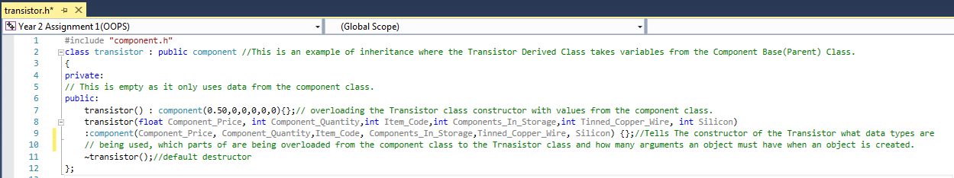
Constructor Overloading is the act of passing in specific data to a classes constructor which is seen as a type of class function, function overloading is used so that when an object is created within a given C++ program there is a reference of what data needs to be used and how many different arguments need to be called depending on the what data and how many arguments are needed by the object created. The constructor can been seen as being within the public part of the class and the constructor below within the transistor class header file is overloaded with data and the amount of arguments of the component base class:-
Figure 8 - Overloading the Transistor class's constructor with the data types and amount of arguments of the component class.

Overriding
Overriding can be part of inheritance, it happens when a child (derived) class has a function with the same name and amount of defined data types as its parent (Base) class, when the function is called by an instantiated object within the program, the child class’s function will override the function defined in the parent class.[3]
Figure 9- Overriding the default values of the capacitor given by the component class

Composition
Composition is used within C++ programming and is the practice of grouping classes together to make a parent class, it’s used when a relationship between classes is exclusively needed. It is done in the way that other subclasses end up being part of a parent class, this means that an object can be created from that parent class that must contain all parts of the other subclasses within it, but if any part the object or subclasses are destroyed then the parent class and all other parts are destroyed and the parent class would become useless and will then be unable to be used to create other objects.

Aggregation
Aggregation is where the parent class “can” contain other subclasses, but the relationship within aggregation is that the parent class may need to use the subclass’s data or functions, this way when an object is created it may use all of the data and functions, or some of the data and functions of subclass’s mentioned within the parent class, but if parts of the object that are given by the subclasses are destroyed the object can continue to function using the remaining parts of the parent class.

File Access/Stream
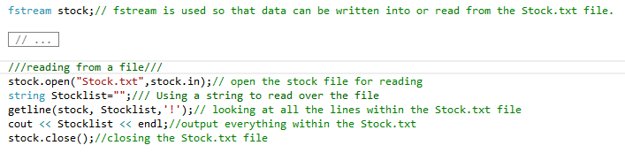
File streams and access are used within C++ to store data within external files, there are three key words when it comes to the accessing of files these keywords are ifstream for reading from a file, ofstream for when data needs to be written to a file or there is the easier option of using fstream which can make a stream for reading out of and writing into a file, here is an example of using fstream to write into a file and read out of a file within the manufacturing businesses system:-
Figure 10-Reading from the Stock.txt file using the fstream keyword
Figure 10-Writing to a Stock.txt File Using the fstream keyword

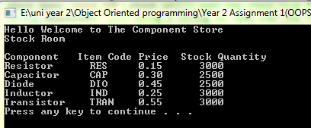
Figure 11-Output window showing the data from within the Stock.txt file

System design and UML models
This section is used to outline the designing of the component manufacturing system, it will include many UML (Unified Modelling Language) diagrams that show the systems structure and behaviour.

Design Specifications
This is just an initial list of specifications that the system should include: -
Allow user (whether it is a customer or company) to make an account.
Check user account details so that they can purchase components.
Show an interface for users so that Components can be bought.
Only allow users to buy specific quantities of Capacitors, Transistors and inductors.
Give users an output of their specified order (including the price of each component they have bought and the overall price of their order).
Include a piece of code that lets customers know that their order is to be delivered.
Allow the business’s employees to view the stock levels and amount of sales.
Manage stock levels (order new components or subcomponents when the business has run out of them
Include a visual output of a graph for the levels of the sales or levels of the stock for the business employees.
Include the use of external files to keep records of sales and stock levels.
Give deals to specific customers depending on specific promotions (20% off order to any user who buys 250 or more of any Components and 25% discount off next order if the user buys components more than 3 time within one week.)

Structural: -

Class Diagram
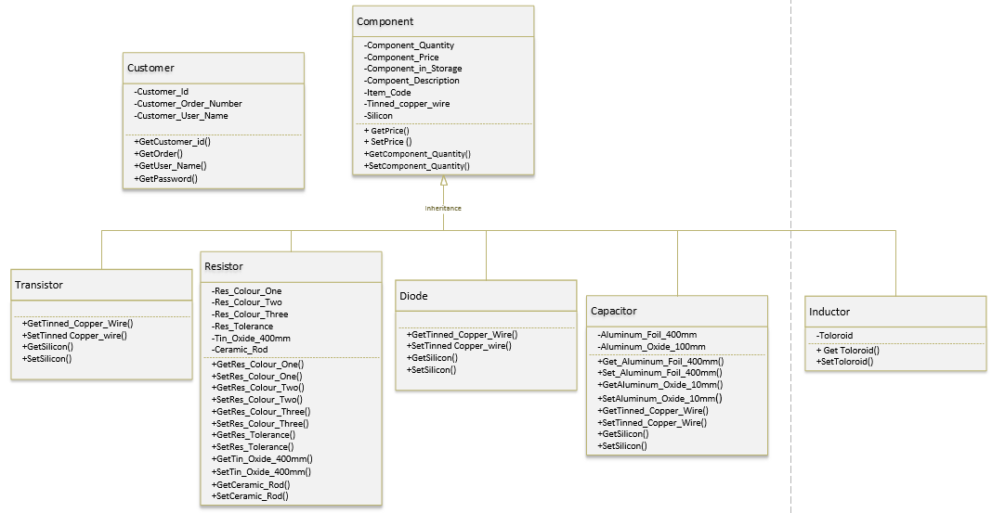
This diagram is used to show the relationships between classes, the diagram shown below is a basic representation of the classes within the manufacturing business’s system.
Diagram 1- Manufacturing business classes. (class diagram)

Behavioural: -

Use-Case diagram
Here are three use-case diagrams that describe the behaviour of user Account control, the Sales/Stock of the system and the re-stocking of components.
Diagram 2- User Account system use-Case diagram.
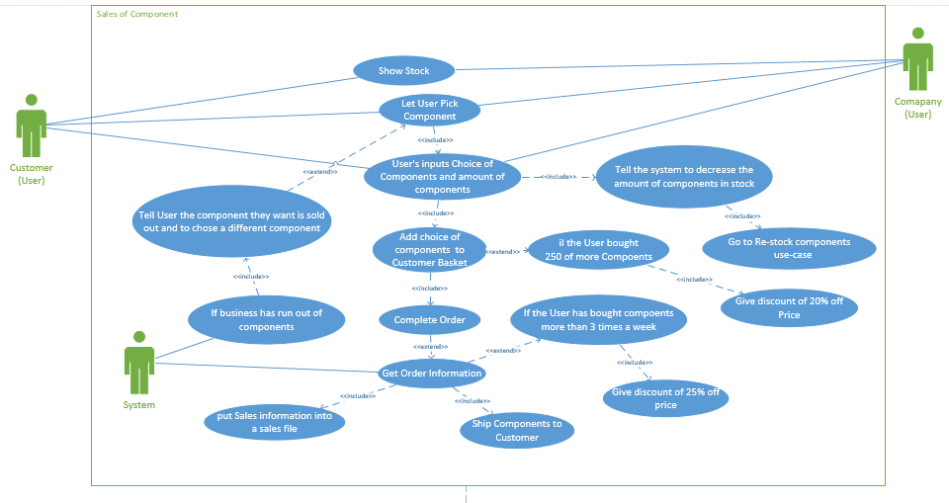
Diagram 3- Sales of component Use Case Diagram.

Diagram 4- Re-Stocking of Components Use-Case diagram

Sequence Diagram
A sequence diagram is used to show the flow of information within a given system and this is done with messages between users (actors) and various parts of the system.

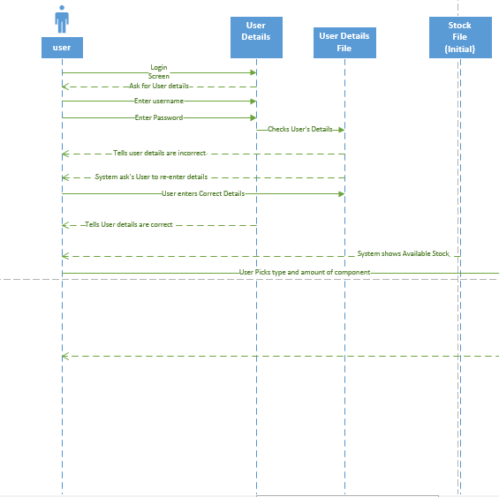

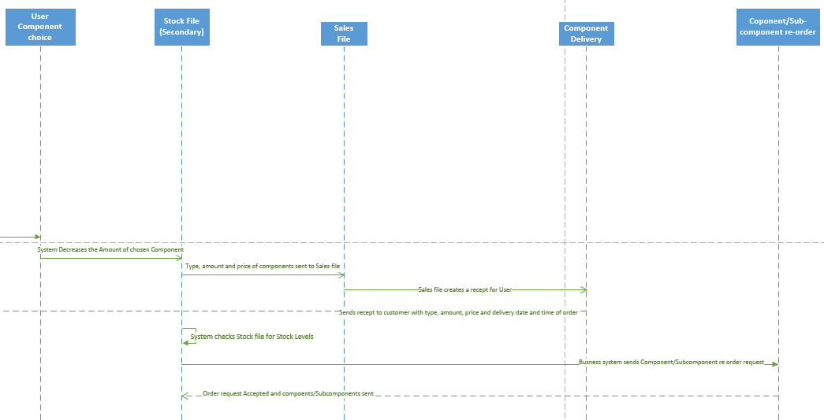
Diagram 5-System and user Interaction Sequence diagram.

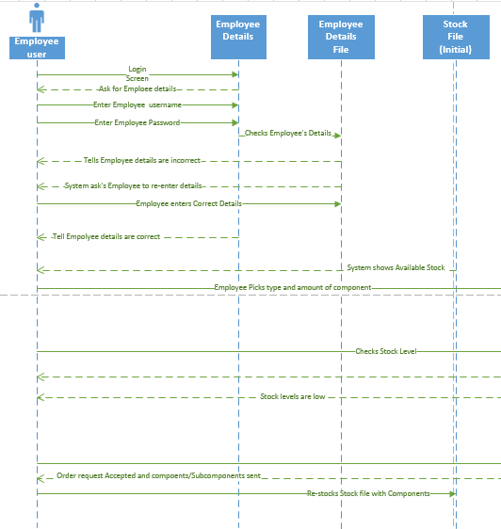

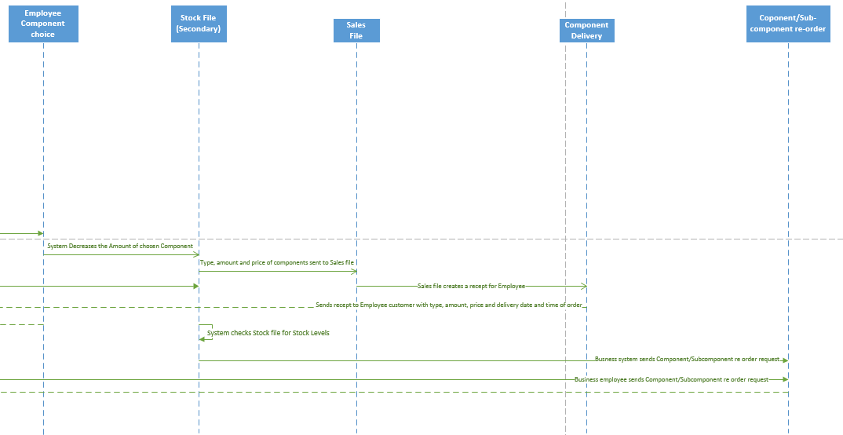
Diagram 6-Employee User and System Interaction Sequence Diagram.

References
[1] SourceMaking.com, “Creational Patterns.” [Online]. Available: https://sourcemaking.com/design_patterns/creational_patterns. [Accessed: 19-Mar-2018].
[2] W. B. Sanders and C. Cumaranatunge, “Singleton Pattern,” in ActionScript 3.0 Design Patterns: Object Oriented Programming Techniques, 1st ed., Steve weiss, Robyn G.Thomas, and Phillip Dangler, Eds. Sebastopol,CA: O’Reilly, 2007, pp. 101–102.
[3] Programiz.com, “C++ Function Overriding,” Programiz. [Online]. Available: https://www.programiz.com/cpp-programming/function-overriding. [Accessed: 19-Mar-2018].

