

Consort Equipment Products Ltd | Thornton Industrial Estate, Milford Haven, Pembrokeshire SA73 2RT, United Kingdom
Research methods
Designing a jig to test sub-assembly components

Author: Oliver Kucyj
Student number: 1910808
Course: B.Eng Electrical and Electronic Engineering
Module Code: ACDA5012
Lecturer: Dr David A Williams
Date: 30th April 2022

Table of Contents
1 Abstract 2
2 Introduction 3
2.1 Overview 3
2.2 Project Brief 3
3 Research and data collection 4
3.1 Research on AC and DC motors 4
3.2 Research on the battery system 5
3.3 Research on voltage regulation 5
3.4 Research on LCDs 5
3.5 Data Collection from Consort 6
4 Designing the test jig 7
4.1 Identifying what must be tested 7
4.2 Test jig functions and how they will be implemented 7
4.2.1 Testing the connector cables 7
4.2.2 Testing AC and DC motors 8
4.2.3 Testing digital temperature sensor and the NTC 8
4.2.4 Testing the RGB LEDs 8
4.2.5 Battery system 8
4.2.6 Dipswitch test select 8
4.3 System block diagram 9
5 Project Planning 11
5.1 Hardware required 11
5.2 Software required 11
5.3 Gannt chart 12
6 References 13
7 Appendix 15
Appendix A 15
Appendix B 16
Appendix C 17

1 Abstract
Throughout this paper a problem at Consort relating to component failures is investigated. A solution in the form of a test jig is identified. Research is carried out on how the components function and how they can be tested to provide a good understanding of the problem and solution before the design work is started. This research, along with data collected from Consort logbooks, is then used to design all features the test jig must contain and how it will test each component.

A system block diagram will then be created to demonstrate how the circuit will be constructed and highlight the logic being used. This design work will be used as the starting point for the design of the test jig which will be completed outside the scope of this assignment.

2 Introduction

2.1 Overview

The main objective of this project proposal is to identify a solution to an issue which is regularly encountered at Consort Equipment Products Ltd. Consort are an electric heating manufacturer based in Milford Haven. They manufacture a range of products including domesticated panel heaters, industrial fan heaters, radiant heaters, and air curtains. With modern government regulations in place such as Lot 20 [1], many heaters must have some form of electronic control to improve efficiency. On the more advanced/premium heaters, the internal electronics is rather complicated.

The issue with using complicated electronics in large scale production is the increased risk of the heaters failing since there are so many additional components. When heaters fail, the faults are usually discovered when carrying out the end of line test. When the heaters fail at this stage of production, the heater must be reopened, inspected, tested, repaired, and put back together. This is a time-consuming process which not only reduces the efficiency of the production line but also adds unnecessary stress to an already busy engineering department. This is the best-case scenario. Occasionally, minor faults can slip through the end of line test and cause issues for the customer.

2.2 Project Brief

This project proposal will investigate and present a method of resolving the issue discussed in section 1.1. This will aim to improve the efficiency of the production lines, minimize wasted components and to maximize customer satisfaction.

A proposed solution to the problem is to test all sub-assembly components before they are built into heaters. This will involve adding an extra step to the production process which will increase the production time needed to complete a built of heaters, so the advantage of using fully tested components will need to be compared to the disadvantage of adding an extra production step to ensure that efficiency is being improved and the company is benefiting.

The method of testing these components which will be investigated is the design of a portable test jig which can be used by production.

The research question for this project proposal is ‘What sub-assembly components require testing and how can they be tested using one PCB?’. The three main objectives which will be used to break this research question into sub-sections are listed below.

- Identify the components which must be tested and the corresponding faults.
- Identify how each component will be tested and how the results of the tests can be fed back to the user.
- Create a system block diagram highlighting how all sections of the circuit are linked together

All objectives were created with the SMART (Specific, Measurable, Achievable, Relevant and Time-Bound) analysis in mind. The objectives are all specific and have a measurable outcome to confirm it was achieved. They are all achievable and relevant to the project being proposed. They can all be completed within the timeframe specified for this project proposal.

The project will work along with the timeline set out in the Gannt chart shown in section 4.3.

3 Research and data collection
This section will contain the research and data collection for the project proposal. An epistemological action research approach will be used, and a mixture of primary and secondary data will be collected. The primary data will be collected from Consort fault reports and will consist of data on failed components to help identify what must be tested. This will mainly be quantitative data and will be entered into excel to represent the data graphically. The secondary data will be collected from reliable sources such as books on electronics, journals, conference papers, datasheets, and reputable websites.

The reliability of all sources will be determined using the CRAP (Currency, Reliability, Authority and Purpose) analysis system.

3.1 Research on AC and DC motors

The AC and DC motors used at Consort are controlled using PWM and tacho feedback in a closed loop circuit for improved speed control accuracy. This is not done via the supply connections for the motors. In the AC motor, the mains supply is electrically isolated from the PWM circuitry internally so there is no risk of damaging sensitive circuitry with the mains supply. The datasheet for the AC motor can be found in appendix A. The datasheet for the DC motor can be found in appendix B.

The basic principle used for controlling the AC motors is phase angle control using a triac. This is discussed here [2]. A triac will conduct bidirectionally once a signal is received at the gate and will stop conducting once zero crossing is detected. The PWM signal is connected to the gate. Figure 1 demonstrates how this works.

This control method adjusts the amount of power being supplied to the motor to match the PWM signal. A duty cycle of 50% will mean the motor only has power from the supply 50% of the time.
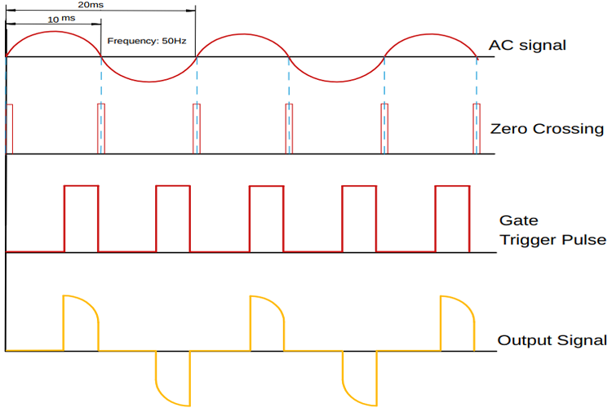
Figure 1 – Triac switching with PWM [3]

The PWM control works similarly in the DC motors, except a MOSFET controlled by the PWM is used to switch the power as demonstrated here [4]. This article also mentions the back EMF produced by the inductive element of the motor. This back EMF helps to prevent the motor from ‘stop starting’ as the power is switched by the PWM.

The feedback signal on both motors is generated by a tacho. Every time completes a full rotation a pulse signal is generated. The Rotations per minute (RPM) of the motor can be calculated by monitoring the number of pulses received.

These PWM control and feedback circuits are built internally to the motors so do not need to be implemented in the test jig. However, it is important to fully understand how the control circuits work before designing the test jig.

3.2 Research on the battery system

To make a portable test jig a battery-operated system must be used. Using standard, non-rechargeable batteries would be simple, however replacing batteries on a regular basic is costly and not environmentally friendly. A suitable solution is to use rechargeable batteries.

A popular battery choice for systems which are designed to be reliable are Li-ion. Whilst they are slightly more costly than alternatives, they have a high energy storage density and a low self-discharge, meaning the battery will not drain too much when the device is not in use [5, p. 688]. Since this test jig is going to be a one off and not mass produced, the cost is not important. Li-ion batteries usually have a working voltage range of 3-4.2V. They will drop lower than this, which could damage the battery. Many batteries have built-in protection to prevent this [6]. Based on this voltage rating, a 3.3V microchip should be used rather than a 5V one, otherwise 2 batteries would need to be connected in series to generate 5V.

To include a rechargeable battery, a recharge circuit is required. A suitable example of a rechargeable battery circuit is sold as a module by Adafruit [7]. This is suitable for Li-ion and Li-poly batteries and uses CC-CV (Constant current - Constant Voltage) charging. This uses a faster constant current charging method to begin with, before limiting the current and keeping the voltage constant as the battery approaches full charge. This helps to prevent damaging the battery and is a very common charging method [8].

3.3 Research on voltage regulation

As the battery discharges, the voltage will drop. Due to this, it must be regulated to ensure the test jig functions correctly under all conditions. The voltage regulator must maintain a fixed output voltage across the full voltage range of the battery. An example voltage regulator circuit which would be suitable for a Li-ion battery and a microcontroller is a buck-boost DC/DC converter circuit. An article written by M. Jordan [9] has more details on this. The circuit in the article maintains a 3.3V output with any input voltage ranging from 2.5V-4.2V.

3.4 Research on LCDs

The test jig will need to be connected to an LCD (Liquid Crystal Display) which will display information to the operator. It will need to display the component, which is being tested, and the result of the test.

LCDs display data using ASCII (American Standard Code for Information Interchange) [10]. Based on this an 8-bit number is required to transmit one letter. An 8-bit parallel LCD could be used so that the data can be transmitted with one clock pulse. A 4-bit LCD could be used to reduce the number of pins and wires required, helping to minimize cost and complexity. This would send the data in 2 clock pulses, slightly reducing performance [11].

A serial connection to the LCD could also be used. This would further reduce the number of connections between the LCD and microcontroller, however, it would further reduce the speed of the data transmission [12].

Software will need to be written to allow the microcontroller to communicate with the LCD. The references listed in the section above [10-12] contains information on writing code to do this together with some examples. These codes are written using an Arduino. However, it is likely that the final code for this test jig will be written in C+ language. Information on writing code in C can be found here [13, 14].

3.5 Data Collection from Consort

The data collected from Consort logbooks and fault reports has been used to create bar charts in excel. This makes the data easier to analyse. These graphs can be found in appendix C. They highlight the components which have caused problems at Consort over the previous 12 months and the faults which caused the problems.

4 Designing the test jig

4.1 Identifying what must be tested

Analysing the data from appendix C, the current transformers do not seem to be an issue. To further investigate, some colleagues from the engineering department and the production line were asked if they had seen faults with the current transformers previously. The answer from everyone was no. Based on this, the test jig does not need to test current transformers. All other components which are listed on the graph must be tested. A list of these components is below.
- 2-, 3-, 4- and 5-way JST connector cables
- 24V DC motor
- 230V AC motor
- Digital temperature sensors DS18S20
- NTC (Negative temperature coefficient) device
- RGB LEDs
The test jig must meet a range of criteria to solve this problem as efficiently as possible. The criteria are listed below.

- It must be low voltage DC
- It must be portable
- It must be user friendly
- It must test all components reliably
- It must be durable
- It must have a rechargeable battery system with a low battery indicator
- It must have an LCD display to inform the user of test results
- It must have an on/off switch to disconnect the battery
- It must have dipswitches to select a test
- It must have a push button to start a test

4.2 Test jig functions and how they will be implemented

This data shown in appendix C provides insight into what must be tested. This information can be used to specify the tests which must be carried out. These specifications are shown in this section. Since the jig is not being sold and uses low voltage only, there are no regulations which it must comply with.

4.2.1 Testing the connector cables

Apply a voltage to each wire and measure the output using analogue inputs on the microcontroller. A voltage divider must be used so that each wire has a different voltage. This will allow the microcontroller to ensure the correct voltage is received at each pin, ensuring the crimps provide a solid connection and that the wires are in the correct order.

The operator must visually inspect the wires for damage.

The LCD should display the name for the cable which has been tested on line one, and either ‘PASS’ or ‘FAIL’ on line two.

4.2.2 Testing AC and DC motors

The AC motor supply cable must be connected into a safe block. The DC motors supply cables must be connected to a 24V power supply.

The PWM and feedback wires must be connected to the test jig. The test jig should run the motor at 50% duty cycle and then 100% duty cycle. It must ensure the feedback signal matches the expected speed within a tolerance of +/-5%.

The operator must listen to the motors to ensure they are not making unwanted noise, such as rattling. The motor cables must be inspected for visual damage.

The LCD should display either ‘PASS’ or ‘FAIL’ depending on the test result. If the motor fails, it should display the required RPM and the RPM based on the feedback signal to help with fault diagnostic.

4.2.3 Testing digital temperature sensor and the NTC

Both temperature sensors will be tested the same way. They must be connected to the test jig. The microcontroller will compare the temperature value with an internal temperature measurement device.

The LCD will return either ‘PASS’ or ‘FAIL’ and display the measured temperature. The user should inspect the cable for physical damage.

The datasheet for the digital temperature sensor can be found here [15]. The datasheet for the NTC can be found here [16].

4.2.4 Testing the RGB LEDs

The LED must be connected to the test jig. The LED will power each LED individually for 3 seconds each.

The LCD will display which colour should be present. For example, when powering the red LED, the LCD will display ‘RED’. The operator must ensure each colour comes on when expected.

4.2.5 Battery system

The test jig will use the charging circuit and voltage regulators discussed in sections 2.2 and 2.3.

The battery voltage must be monitored by the microcontroller. Since the microcontroller cannot measure a voltage over its supply voltage (3.3V) a voltage divider must be used to ensure that even when fully charged the input voltage does not exceed 3.3V.

When the battery voltage drops to 3.3V the low battery voltage indicator must turn on. When this drops below 3V, the microcontroller must switch low power mode on and prevent the test jig from functioning. This is to protect the battery.

4.2.6 Dipswitch test select

To accurately test the components and feedback data to the operator, the microcontroller must know what is being tested. This will be done using dipswitches. The user will select a 4-bit code using the dipswitches to select the correct component. When the test starts, the LCD will display what is being tested.
4.3 System block diagram

The system block diagram is shown on page 10. This demonstrates how the circuit sections interconnect and communicate together. This is a useful way of starting a circuit design since it allows the circuit to be broken down into sub-categories and presents the circuit functionality in an easy to view format.
V_{bat}
V_{Reg}
V_{bus}
USB Charging Module
Buck Boost Converter
ON/OFF switch
USB Input

Voltage divider circuitry
Start test push button
Voltage divider circuit for battery monitoring
Li-ion Battery and fuse
Reference temperature sensor

NTC voltage divider circuitry
Dipswitch test select circuit
Microcontroller
JST connector blocks for 2-,3-, 4- and 5-way connector cables
NTC test output
RGB LED
PWM and feedback signals
AC motor with external mains supply
Low battery indicator
24VDC motor with external 24V supply
DS18S20 temp sensor
LCD display
PWM and feedback signals
Data lines to LCD

5 Project Planning

5.1 Hardware required

The hardware which will be used for this project is listed below.

- Breadboard for the prototype circuit designs
- PCB for the final circuit design
- Electronic components (Such as the microcontroller, ICs, resistors, capacitors etc)
- LCD
- Li-ion battery
- A box/case for the PCB and connector blocks to fit into
- Safe block and power supply for testing motors – motors will need to be tested near a mains socket to make this possible
- Programming cable to program the microcontroller
- Access to a computer

5.2 Software required

The software which will be required is listed below.

- Microsoft office package
- A circuit design package
- A PCB design package
- A package to write C+ software

There is also a requirement to have access to a range of academic resources. This will be done via the IEEE database, UWTSD library, Google, and Google scholar. These will be accessed using the internet.

5.3 Gannt chart

Figure 2 shows the Gantt chart which was created to help with the planning of this project. This has been updated as tasks have been completed. As shown, some tasks were finished on time some were finished behind schedule, and some were finished ahead of schedule. Some parts of the Gantt chart have not been completed yet as they are beyond the scope of this project proposal.


Figure 2 – Gantt Chart

6 References
[1] J. Lawless “What is Lot 20 & what does it mean?,” Best Heating, 2018. [Online] Available: https://www.bestheating.com/info/what-is-lot20-what-does-it-mean/#:~:text=In%20short%2C%20LOT20%20is%20recent,products%20that%20heat%20our%20homes [Accessed Apr. 14, 2022].

[2] S. Waghare, D. R. Tutakne, A. Deshmukh and M. Mardikar, "PWM controlled high power factor single phase Fan regulator," 2019 3rd International conference on Electronics, Communication and Aerospace Technology (ICECA), 2019, pp. 59-64, doi: 10.1109/ICECA.2019.8822156.

[3] D. Das, “AC Phase Angle Control For Light Dimmers and Motor Speed Control using 555 Timer and PWM signal,” Circuit Digest, 2020. [Online] Available: https://circuitdigest.com/microcontroller-projects/ac-phase-angle-control-for-light-dimmers-and-motor-speed-control-using-555-timer-and-pwm-control [Accessed Apr. 16, 2022].

[4] 4QD – Electric Motor Control, “Half Bridge,” 4QD. [Online] Available: https://www.4qd.co.uk/docs/half-bridge-tour-6/ [Accessed: Apr. 16, 2022].

[5] P. Horowitz and W. Hill, The art of electronics, Third edition. Cambridge: Cambridge University Press, 2015.

[6] D. Knight, “Lithium Ion Cell Protection,” Digi-Key, 2015. [Online] Available: https://www.digikey.com/en/maker/blogs/lithium-ion-cell-protection [Accessed: Apr. 18, 2022].

[7] Adafruit, “USB LiIon/LiPoly charger – v1.2,” Adafruit. [Online] Available: https://www.adafruit.com/product/259#technical-details [Accessed: Apr. 18, 2022].

[8] A. B. Khan and W. Choi, "Optimal Charge Pattern for the High-Performance Multistage Constant Current Charge Method for the Li-Ion Batteries," in IEEE Transactions on Energy Conversion, vol. 33, no. 3, pp. 1132-1140, Sept. 2018.

[9] M. Jordan, “It Just Got Easier to Convert Lithium-Ion Battery Voltage to 3.3V with this Efficient Single Inductor Synchronous Buck-Boost Regulator,” Analog Devices. [Online] Available: https://www.analog.com/en/technical-articles/it-just-got-easier-to-convert-lithium-ion-battery-voltage-to-33v.html [Accessed: Apr. 18, 2022].

[10] EG Projects, “How to Display Text on 16x2 Character LCD,” Engineers Garage. [Online] Available: https://www.engineersgarage.com/displaying-text-on-16x2-lcd/ [Accessed: Apr. 22, 2022].

[11] Last Minute Engineers, “Interfacing 16x2 Character LCD Module with Arduino,” Last Minute Engineers. [Online] Available: https://lastminuteengineers.com/arduino-1602-character-lcd-tutorial/ [Accessed: Apr. 22, 2022].

[12] Focus LCDs, “Serial vs. Parallel,” Focus LCDs. [Online] Available: https://focuslcds.com/serial-vs-parallel/ [Accessed: Apr. 22, 2022].

[13] L. George, “Interfacing LCD with PIC Microcontroller – Hi Tech C,” Electrosome, 2022. [Online] Available: https://electrosome.com/interfacing-lcd-with-pic-microcontroller-hi-tech-c/ [Accessed: Apr. 22, 2022].

[14] M. Bates, Programming 8-bit PIC microcontrollers in C with interactive hardware simulation, 1st ed. Amsterdam ;: Elsevier/Newnes, 2008.

[15] Maxim Integrated, “High-Precision 1-wire Digital Thermometer,” DS1820S datasheet. [Online] Available: https://datasheets.maximintegrated.com/en/ds/DS18S20.pdf [Accessed: Apr. 25, 2022].

[16] Vishay, “NTC Thermistors, Mini Epoxy PVC Insulated Leads,” NTCLE413 datasheet, 2017. [Online] Available: https://docs.rs-online.com/edfc/0900766b8167e618.pdf [Accessed: Apr. 25, 2022].

7 Appendix

Appendix A
Datasheet for the AC motor

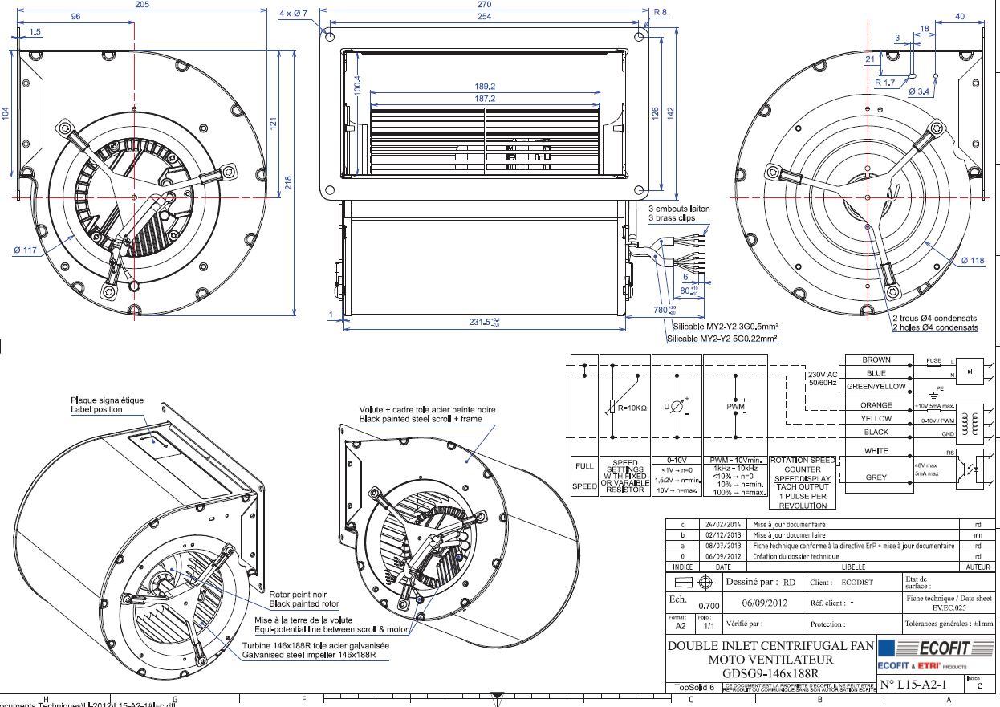

Appendix B
Datasheet for the DC motor

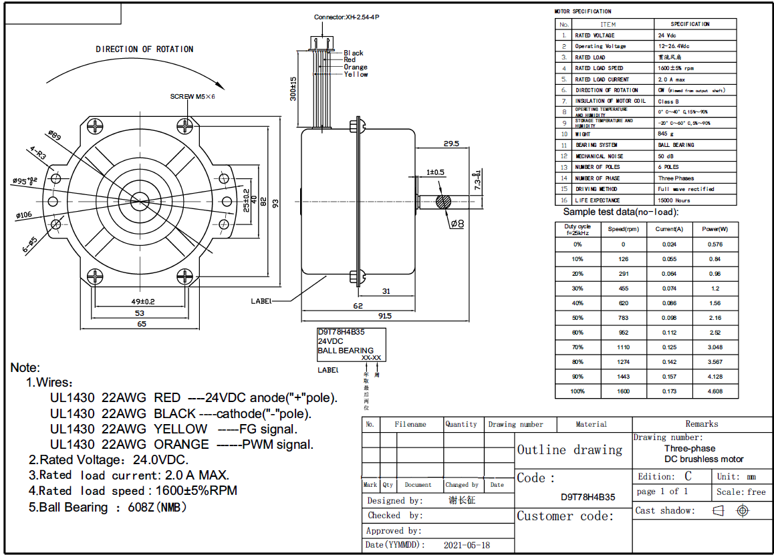

Appendix C

The graphs shown in this section were created using data from Consort logbooks. They highlight the components which commonly encounter faults and what the faults encountered are.







