Introduction to Web and Database

Assessment 2

HTML & CSS Web Development

Student: Jamile Barbosa Kashif
Student ID: 2514981
Module: ACCA4023
Lecturer: Dr. Fahad Ahmed
Date: 24 April 2026



Table of Contents

1. Introduction 2
2. Requirements 2
3. Implementation 2
3.1 Home Page (index.html) 2
3.2 About Page (about.html) 3
3.3 Gallery Page (gallery.html) 4
3.4 Contact Page (contact.html) 4
3.5 The CSS Stylesheet (style.css) 5
4. Validation 5
4.1 HTML Validation 5
4.2 CSS Validation 6
5. Evaluation 7
5.1 Usability 7
Website Evaluation — Usability 7
5.2 Accessibility 8
Evaluation Against WCAG 2.1 8
5.3 Search Engine Optimisation (SEO) 9
On-Page SEO Techniques Applied 9
5.4 Website Evaluation Summary 10
5.5 Website Comparison 10
6. References 11
7. Appendices 12
Appendix A — index.html 12
Appendix B — about.html 12
Appendix C — gallery.html 13
Appendix D — contact.html 14
Appendix E — style.css 15

1. Introduction
This report describes a four-page website that was designed and built for this assignment. The website is for a fictional interior designer called Paola Bracho, who is based in Cancún, Mexico. The site was hand-coded using HTML5 and CSS3, without the use of any design software or website builder. This report covers the purpose of the site, how it was built, the results of HTML and CSS validation, and an evaluation of how well the site performs in terms of usability, accessibility, and search engine optimisation (SEO).

2. Requirements
The website was created to serve as an online portfolio for Paola Bracho’s Interior Design Firm. Its main purpose is to allow potential clients to see examples of completed projects, read about the designer's background, and find contact details. The target audience is residential clients who are considering hiring an interior designer. These users need to be able to navigate the site without any technical knowledge, find information quickly, and get in touch with the studio easily. The website is made up of four pages:

- Home page (index.html) — introduces the studio, lists the services offered, and displays a large image of a project made by Paola.
- About page (about.html) — presents a short biography of the designer, her profile photo, and a summary of her qualifications and experience.
- Gallery page (gallery.html) — shows six photographs of completed interior design projects, each with a caption.
- Contact page (contact.html) — provides the phone number, email, Instagram profile name, and studio address.

All pages share the same header, navigation bar, and footer. A single external stylesheet (style.css) is linked to every page, which keeps the visual design consistent throughout the site.

3. Implementation
Each page uses the same HTML structure: a <header> at the top containing the designer's name and tagline, a <nav> with links to all four pages, a <main> section with the page-specific content, and a <footer> at the bottom. Semantic HTML5 elements such as <nav>, <figure>, <figcaption>, <ul>, and <strong> were used where appropriate, as these help to describe the purpose of content more clearly than generic <div> tags.

3.1 Home Page (index.html)
The home page contains a short welcome paragraph, a large featured image of a completed flat (class: landscape-pics, width: 680px, height: 400px), and a list of services such as residential interior design, kitchen and bathroom design, and nursery rooms.

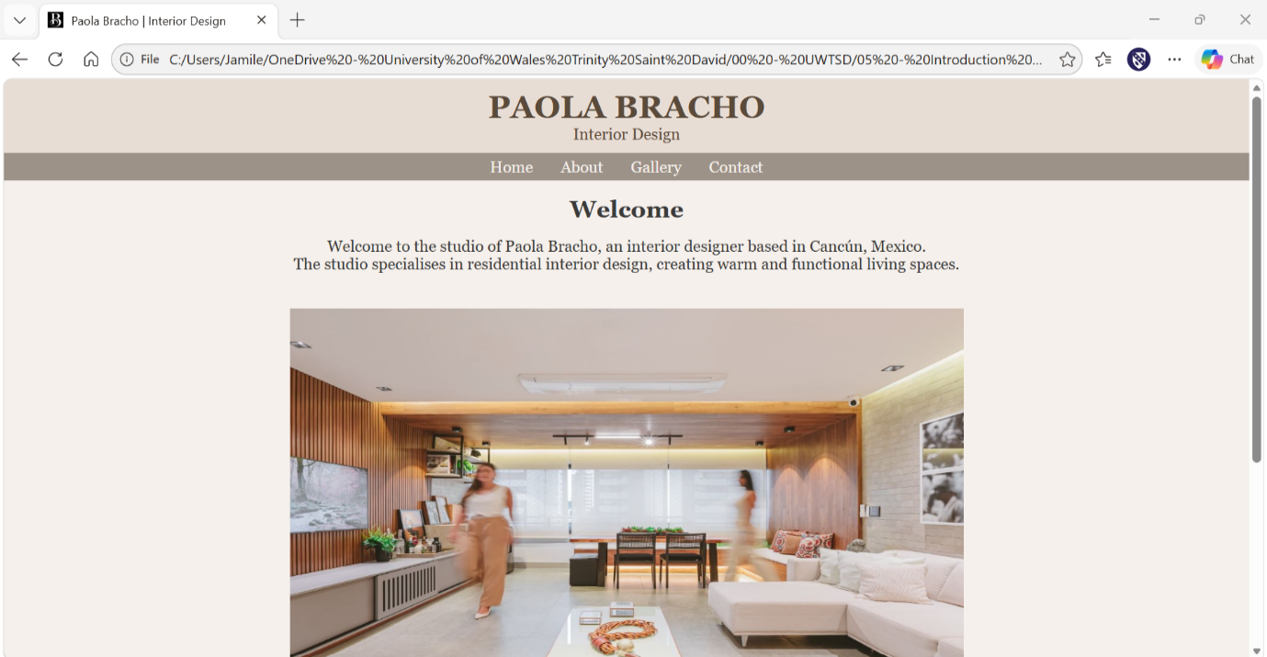
Figure 1: The home page displaying the welcome text, featured image, and list of services.

3.2 About Page (about.html)
The about page uses a flexbox layout (class: about-container) to place the profile photo and the biography paragraph side by side. The profile photo has class profile-pics (width: 265px) and the biography uses class bio-text (width: 300px, text-align: justify, line-height: 1.5). The justified text alignment was chosen because it gives a more polished, editorial feel which suits an interior design portfolio.

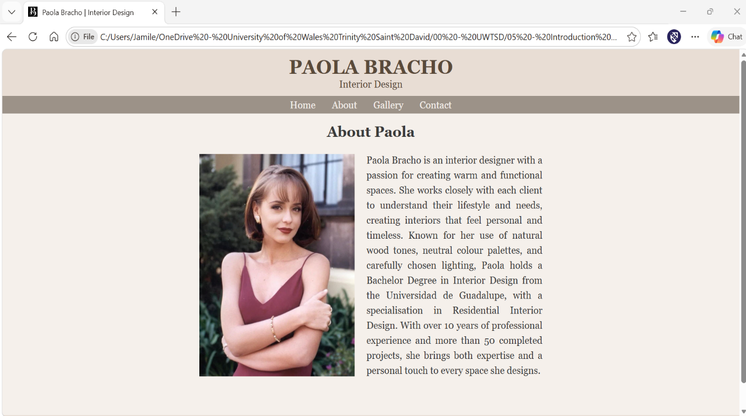
Figure 2: The about page showing the designer's profile photo and biography in a side-by-side flexbox layout.

3.3 Gallery Page (gallery.html)
The gallery page displays six project images, each inside a <figure> element with a <figcaption> describing the space. The CSS rule .gallery uses a three-column grid layout (grid-template-columns: repeat(3, 1fr)) with a total grid width of 820px and a gap of 30px between images. Each image is set to width: 100% and height: 270px, with object-fit: cover applied. This ensures all images fill the same dimensions without distortion, which is important because the original photos were shot in different aspect ratios.

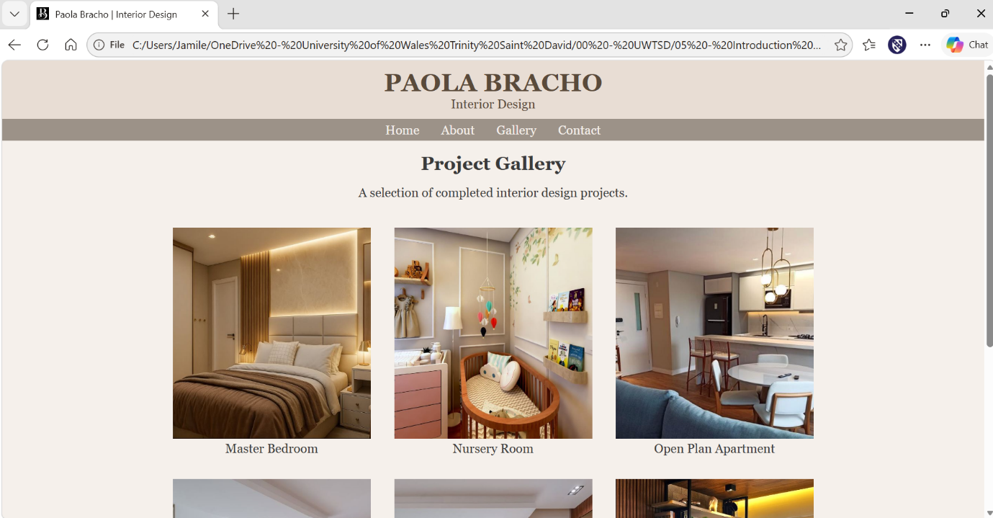
Figure 3: The gallery page displaying project images in a three-column CSS grid layout with captions.

3.4 Contact Page (contact.html)
The contact page lists the studio's phone number, email address, Instagram profile name, and physical address. Each piece of information is preceded by a <strong> label (e.g. Phone:, Email:) to help users scan the page quickly.

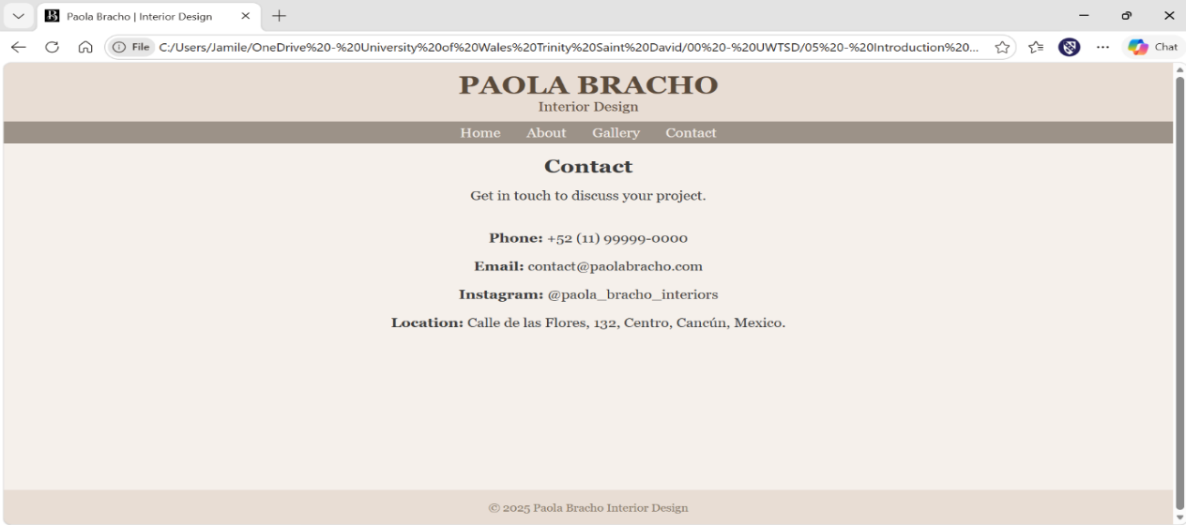
Figure 4: The contact page listing the studio's phone number, email, Instagram, and address.

3.5 The CSS Stylesheet (style.css)
A single external stylesheet was used for all four pages. The main design decisions were:
- Colour palette: background #f5f0eb (warm off-white), header and footer #e8ddd4 (muted beige), navigation bar #9c9288 (warm grey). These colours were chosen to match the neutral, natural aesthetic that is typical of interior design.
- Font: Georgia, serif. This font was chosen because it has a refined, editorial quality that suits a design portfolio better than a sans-serif.
- .landscape-pics sets the home page image to 680px wide and 400px tall.
- .profile-pics sets the about page portrait photo to 265px wide with margin spacing.
- .bio-text sets the biography paragraph to 300px wide with justified text and 1.5 line spacing.
- .gallery uses CSS Grid with three equal columns, a width of 820px, and a 30px gap.
- .gallery img sets all gallery images to 270px tall at full column width, with object-fit: cover for uniform display.
- The ul rule uses display: inline-block and text-align: left so that bullet lists appear centred on the page but with left-aligned text inside them.

4. Validation

4.1 HTML Validation
The home page (index.html) was validated using the W3C HTML Validator at http://validator.w3.org/. This tool checks whether the code follows the HTML5 standard correctly. One error was identified: the image source path in index.html referenced a filename with a space in it ("First page.jpg"). Spaces in file paths are not valid and can cause problems in some browsers. This was corrected by renaming the file to first_page.JPG and updating the src attribute to match. The validator also returned several informational notices about trailing slashes on void elements (e.g. <meta ... />) — these are not errors but are unnecessary in HTML5, so the self-closing slashes were removed from all pages. After these fixes, the validator returned no further errors.

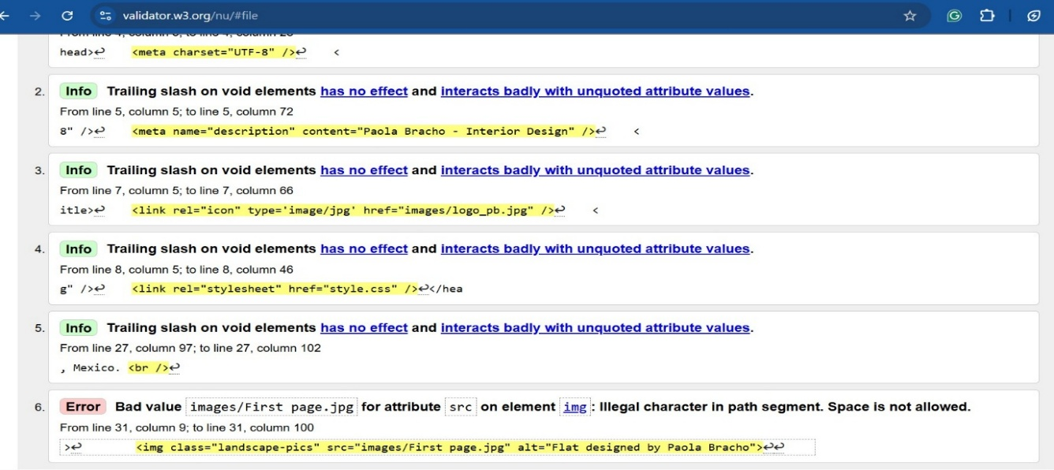
Figure 5: W3C HTML validation result for index.html before corrections, showing the filename space error and trailing slash notices
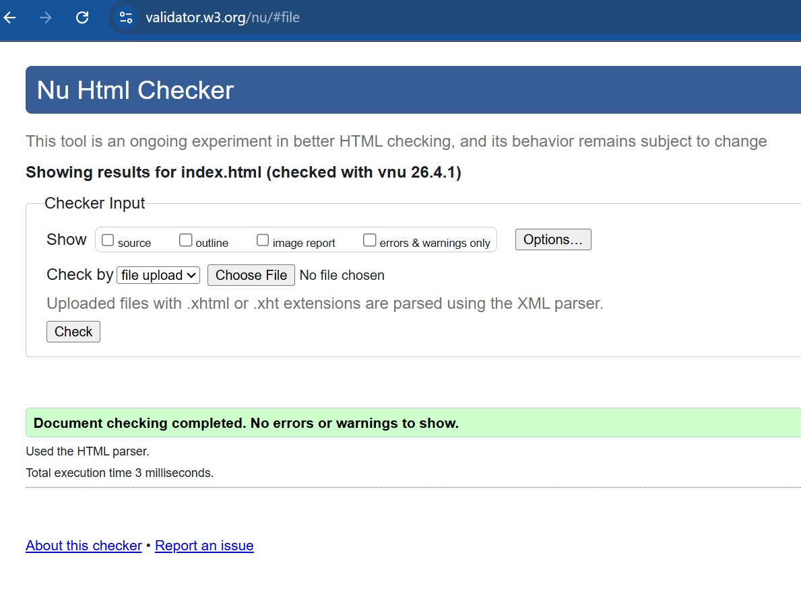Figure 6: W3C HTML validation result for index.html after corrections — no errors or warnings.

4.2 CSS Validation
The stylesheet (style.css) was validated using the W3C CSS Validator at http://jigsaw.w3.org/css-validator/. Two errors were found and corrected in an earlier version of the stylesheet. The first was the .profile-pics rule contained a margin property with missing units — the values were written as margin: 40 40px 20px 40 instead of margin: 40px 40px 20px 40px. In CSS, only the value 0 can be written without a unit; all other numeric values must include a unit such as px. This was corrected by adding px to the two values that were missing it. The second was a spelling mistake: "hight" instead of "height" in the .gallery img rule. Both errors were corrected and the final stylesheet passed validation with no errors.

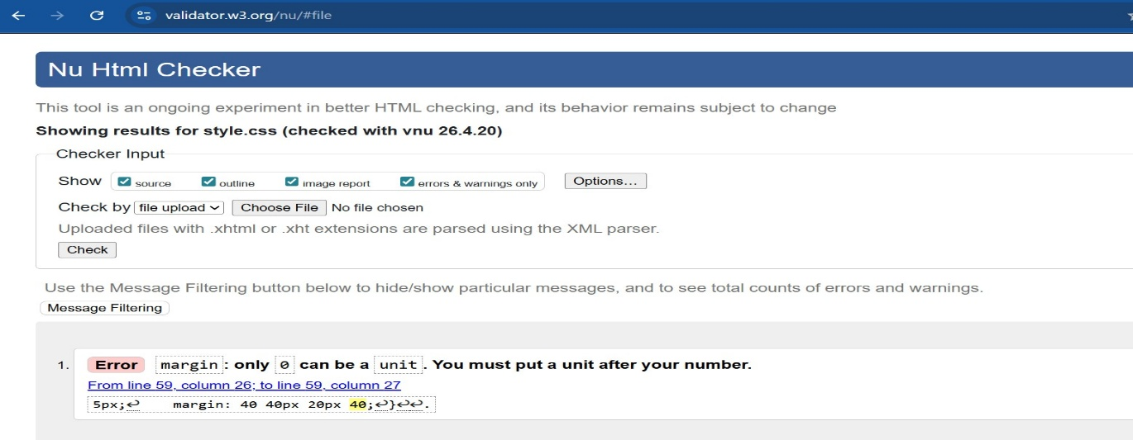
Figure 7: W3C CSS validation result for style.css showing the missing unit error in the .profile-pics margin property.

5. Evaluation

5.1 Usability
Usability refers to how easy and effective a website is to use — defined by ISO 9241-11 (2018) as the extent to which a product can be used to achieve specific goals with effectiveness, efficiency, and satisfaction. Nielsen (1994) identified ten usability heuristics still widely referenced today, including consistency and standards, visibility of system status, and aesthetic and minimalist design. These principles were applied throughout the site by maintaining the same layout and colour scheme on every page and keeping each page focused on a single purpose. This approach is supported by Flavian, Gurrea, and Orus (2009), whose study found that visual consistency and a harmonious colour palette significantly improved perceived usability, suggesting that a well-designed visual style can positively affect user experience even without advanced features. In practice, the website fulfils its main purpose effectively: navigation links work correctly throughout, content is relevant to the target audience, and key information as services, gallery, and contact details, are easy to locate.

5.2 Accessibility
Web accessibility is about making websites usable by people with a range of disabilities, including those who rely on screen readers, keyboard navigation, or high-contrast displays. The internationally recognised standard is the Web Content Accessibility Guidelines (WCAG) 2.1, published by the W3C (2018). It is built around four principles known as POUR: Perceivable, Operable, Understandable, and Robust. A study by Lazar, Olalere, and Wentz (2012) examined how accessible job application websites were for blind users who rely on screen readers. Their findings showed that missing alternative text on images and poor colour contrast were the most frequent barriers. These findings are directly relevant to this project, as they highlight two specific areas that were addressed in the design of the Paola Bracho website.

Evaluation Against WCAG 2.1
Perceivable: All images on the site include descriptive alt attributes. For example, the gallery images use descriptions such as "Master bedroom with warm lighting" and "Nursery room with wooden cot". The profile photo uses alt="Paola Bracho, Interior Designer". This means screen reader users receive a meaningful description of every image. The text colour (#3a3a3a) on the background (#f5f0eb) should provide adequate contrast, confirmed using contrastchecker.com.
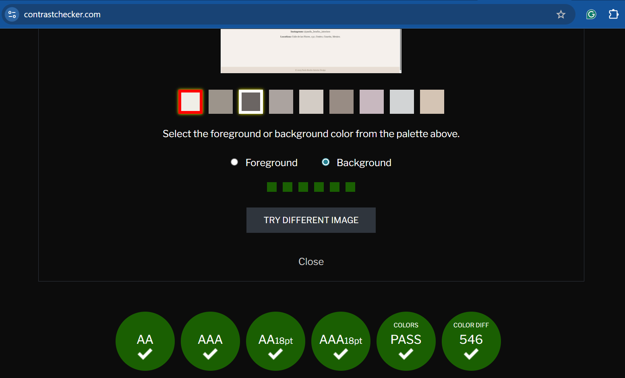
Figure 8: Contrast check result from contrastchecker.com — the website's text and background colours pass all WCAG 2.1 contrast levels (AA, AAA, and large text variants).

Operable: All navigation links are standard <a> elements, which are fully keyboard-accessible using the Tab key. There is no auto-playing media or time-limited content on the site.
Understandable: All four pages have lang="en" set in the <html> element, which tells screen readers the language of the page. The content uses straightforward language appropriate for the target audience.
Robust: Semantic HTML5 elements are used throughout, including <header>, <nav>, <main>, <footer>, <figure>, and <figcaption>. These elements help assistive technologies interpret the structure of the page correctly.

5.3 Search Engine Optimisation (SEO)
SEO refers to the practice of making a website more visible in search engine results pages such as Google. On-page SEO involves elements written directly in the HTML code, such as page titles, meta descriptions, heading structure, and image alt text. Off-page SEO relates to external factors such as backlinks from other sites [7]. A study by Baye, De los Santos, and Wildenbeest (2016) found that on-page improvements, particularly in page titles and meta descriptions, led to measurable increases in click-through rates from search results. This indicates that even simple SEO measures can have a practical effect on how often a website is visited.

On-Page SEO Techniques Applied
Meta description: All four pages include a <meta name="description"> tag with the value "Paola Bracho - Interior Design". This text appears below the page title in search results and gives users a preview of the page content. In a more developed site, each page would have a unique, keyword-rich description.
Page title: Every page uses the title element "Paola Bracho | Interior Design". Search engines display this as the main clickable heading in results, so it is important that it is descriptive and relevant.
Heading hierarchy: Each page uses a single <h1> in the header and <h2> elements to mark-up sections within the main content. This logical structure helps search engines understand the relative importance of different parts of the page.
Image alt text: All images include descriptive alt attributes, which serve both accessibility and SEO purposes. Search engines use alt text to understand and index image content.
Semantic HTML: Elements such as <nav>, <main>, and <footer> provide structural signals to search engine crawlers about the role of different content areas on the page.

5.4 Website Evaluation Summary
Overall, the website achieves its main goal of presenting an interior designer's portfolio in a professional and accessible way. The colour scheme is appropriate to the context, the navigation is simple and consistent, and the gallery page effectively displays the completed projects at a uniform size. The use of semantic HTML throughout is a positive feature for both accessibility and SEO.

5.5 Website Comparison
Two live interior design studio websites were compared: Kinnersley Kent Design (kkd.co.uk) and 1508 London (1508london.com). Both serve a similar professional residential interior design audience to Paola Bracho.

Area | Kinnersley Kent Design (kkd.co.uk) | 1508 London (1508london.com)
Usability | Clean, structured layout with fixed navigation bar. Text is easy to read, and pages have a logical flow. | Uses large full-screen images creating strong visual impact but navigation menu can be difficult to locate on first visit.
Accessibility (WAVE) | Small number of contrast warnings but generally well-structured with good use of alt text. | More significant issues including several images without alt text — a direct failure of WCAG 2.1 Perceivable principle.
SEO | Descriptive, page-specific title tags and meta descriptions. Clear heading hierarchy throughout. | More visually led with fewer text-based SEO elements, which may reduce visibility for specific search terms.
Mobile Friendliness | Fully responsive layout that adapts to mobile and tablet screen sizes. | Fully responsive layout that adapts to mobile and tablet screen sizes.
Conclusion | Stronger overall — balances good visual design with solid technical performance across usability, accessibility, and SEO. | Prioritises aesthetics over technical quality and falls short on accessibility in particular.

Paola Bracho’s website compares reasonably well on accessibility and basic SEO against both sites but would need responsive design and more detailed per-page meta content to reach a similar standard to KKD.

6. References
[1] C. Flavian, R. Gurrea, and C. Orus, "The role played by perceived usability, satisfaction and consumer trust on website loyalty," Information & Management, vol. 43, no. 1, pp. 1-14, 2006.

[2] J. Lazar, A. Olalere, and J. Wentz, "Investigating the accessibility and usability of job application web sites for blind users," Journal of Usability Studies, vol. 7, no. 2, pp. 68-87, 2012.

[3] M. R. Baye, B. De los Santos, and M. R. Wildenbeest, "Search engine optimization: What drives organic traffic to retail sites?" Journal of Economics & Management Strategy, vol. 25, no. 1, pp. 6-31, 2016.

[4] J. Nielsen, Usability Engineering. San Francisco: Morgan Kaufmann, 1994.

[5] ISO, "ISO 9241-11:2018 Ergonomics of human-system interaction — Part 11: Usability: Definitions and concepts," International Organisation for Standardisation, Geneva, 2018.

[6] W3C, "Web Content Accessibility Guidelines (WCAG) 2.1," World Wide Web Consortium, 2018. [Online]. Available: https://www.w3.org/TR/WCAG21/. [Accessed: 20 Apr. 2026].

[7] R. Fishkin and Moz, The Art of SEO, 3rd ed. Sebastopol, CA: O'Reilly Media, 2015.

7. Appendices

Appendix A — index.html
<!DOCTYPE html>
<html lang="en">
<head>
<meta charset="UTF-8">
<meta name="description" content="Paola Bracho - Interior Design">
<title>Paola Bracho | Interior Design</title>
<link rel="icon" type='image/jpg' href="images/logo_pb.jpg">
<link rel="stylesheet" href="style.css">
</head>

<body>

<header>
<h1>PAOLA BRACHO</h1>
<p>Interior Design</p>
</header>

<nav>
<a href="index.html">Home</a>
<a href="about.html">About</a>
<a href="gallery.html">Gallery</a>
<a href="contact.html">Contact</a>
</nav>

<main>
<h2>Welcome</h2>
<p>Welcome to the studio of Paola Bracho, an interior designer based in Cancún, Mexico. <br>
The studio specialises in residential interior design, creating warm and functional living spaces.</p>
<br>
<br>
<img class="landscape-pics" src="images/first_page.jpg" alt="Flat designed by Paola Bracho">

<h2>Services</h2>

<ul>
<li>Residential interior design</li>
<li>Space planning and layout</li>
<li>Kitchen and bathroom design</li>
<li>Nursery and children’s rooms</li>
<li>Furniture selection and lighting</li>
</ul>

</main>

<footer>
<p>&copy; 2025 Paola Bracho Interior Design</p>
</footer>

</body>
</html>

Appendix B — about.html
<!DOCTYPE html>
<html lang="en">
<head>
<meta charset="UTF-8">
<meta name="description" content="Paola Bracho - Interior Design">
<title>Paola Bracho | Interior Design</title>
<link rel="icon" type='image/jpg' href="images/logo_pb.jpg">
<link rel="stylesheet" href="style.css">
</head>

<body>

<header>
<h1>PAOLA BRACHO</h1>
<p>Interior Design</p>
</header>

<nav>
<a href="index.html">Home</a>
<a href="about.html">About</a>
<a href="gallery.html">Gallery</a>
<a href="contact.html">Contact</a>
</nav>

<main>
<h2>About Paola</h2>

<div class="about-container">
<img class="profile-pics" src="images/paola_bracho.jpg" alt="Paola Bracho, Interior Designer">
<p class="bio-text">Paola Bracho is an interior designer with a passion for creating warm and functional spaces. She works closely with each client to understand their lifestyle and needs, creating interiors that feel personal and timeless. Known for her use of natural wood tones, neutral colour palettes, and carefully chosen lighting, Paola holds a bachelor’s degree in interior design from the Universidad de Guadalupe, with a specialisation in Residential Interior Design. With over 10 years of professional experience and more than 50 completed projects, she brings both expertise and a personal touch to every space she designs.
</div>

</main>

<footer>
<p>&copy; 2025 Paola Bracho Interior Design</p>
</footer>

</body>
</html>

Appendix C — gallery.html
<!DOCTYPE html>
<html lang="en">
<head>
<meta charset="UTF-8">
<meta name="description" content="Paola Bracho - Interior Design">
<title>Paola Bracho | Interior Design</title>
<link rel="icon" type='image/jpg' href="images/logo_pb.jpg">
<link rel="stylesheet" href="style.css">
</head>
<body>
<header>
<h1>PAOLA BRACHO</h1>
<p>Interior Design</p>
</header>

<nav>
<a href="index.html">Home</a>
<a href="about.html">About</a>
<a href="gallery.html">Gallery</a>
<a href="contact.html">Contact</a>
</nav>

<main>
<h2>Project Gallery</h2>

<p>A selection of completed interior design projects.</p>
<br>
<br>

<div class="gallery">
<figure>
<img src="images/bedroom.jpg" alt="Master bedroom with warm lighting">
<figcaption>Master Bedroom</figcaption>
</figure>

<figure>
<img src="images/baby_bedroom.jpg" alt="Nursery room with wooden cot">
<figcaption>Nursery Room</figcaption>
</figure>

<figure>
<img src="images/flat.jpg" alt="Open plan apartment living area">
<figcaption>Open Plan Apartment</figcaption>
</figure>

<figure>
<img src="images/kitchen.jpg" alt="Minimalist kitchen with island">
<figcaption>Kitchen Design</figcaption>
</figure>

<figure>
<img src="images/kitchen2.jpg" alt="Kitchen bar area with shelves">
<figcaption>Kitchen Bar Area</figcaption>
</figure>

<figure>
<img src="images/balcony.jpg" alt="Balcony with plants and shelving">
<figcaption>Balcony</figcaption>
</figure>
</div>

</main>

<footer>
<p>&copy; 2025 Paola Bracho Interior Design</p>
</footer>

</body>
</html>

Appendix D — contact.html
<!DOCTYPE html>
<html lang="en">
<head>
<meta charset="UTF-8">
<meta name="description" content="Paola Bracho - Interior Design">
<title>Paola Bracho | Interior Design</title>
<link rel="icon" type='image/jpg' href="images/logo_pb.jpg">
<link rel="stylesheet" href="style.css">
</head>
<body>
<header>
<h1>PAOLA BRACHO</h1>
<p>Interior Design</p>
</header>

<nav>
<a href="index.html">Home</a>
<a href="about.html">About</a>
<a href="gallery.html">Gallery</a>
<a href="contact.html">Contact</a>
</nav>

<main>
<h2>Contact</h2>

<p>Get in touch to discuss your project.</p> <br> <br>

<p><strong>Phone:</strong> +52 (11) 99999-0000</p> <br>
<p><strong>Email:</strong> contact@paolabracho.com</p> <br>
<p><strong>Instagram:</strong> @paola_bracho_interiors</p> <br>
<p><strong>Location:</strong> Calle de las Flores, 132, Centro, Cancún, Mexico.</p>
<br>
<br>
<br>
<br>
<br>
<br>
<br>
<br>
</main>

<footer>
<p>&copy; 2025 Paola Bracho Interior Design</p>
</footer>

</body>
</html>

Appendix E — style.css
* {
margin: 0;
}

body {
background-color: #f5f0eb;
font-family: Georgia, serif;
color: #3a3a3a;
text-align: center;
}

header {
background-color: #e8ddd4;
padding: 10px;
color: #5a4a3a;
}

nav {
background-color: #9c9288;
padding: 5px;
}

nav a {
color: #f5f0eb;
margin: 0 12px;
text-decoration: none;
}

a:hover {
text-decoration: underline;
}

h2 {
margin: 15px 0 15px 0;
}

.bio-text {
width: 300px;
margin: 0 0 0 0;
text-align: justify;
line-height: 1.5;
}

.about-container {
display: flex;
align-items: center;
justify-content: center;
gap: 20px;
margin: 20px auto;
}

.landscape-pics {
width: 680px;
height: 400px
}

.profile-pics {
width: 265px;
margin: 20px 0px 20px 20px;
}

.gallery {
display: grid;
grid-template-columns: repeat(3, 1fr);
gap: 30px;
width: 820px;
margin: 0 auto;
}

.gallery img {
width: 100%;
height: 270px;
object-fit: cover;
}

ul {
margin-top: -10px;
display: inline-block;
text-align: left;

}
footer {
background-color: #e8ddd4;
padding: 15px;
margin-top: 60px;
font-size: 13px;
color: #8a7a6a;

