Adventure and ethics

As filmmakers we have a great responsibility to our audience, we must understand the potential consequences of what we show on screen.
Storytelling lies at the heart of everything we do as filmmakers, and I believe it is not only our job but also our responsibility to tell the stories that need to be told as we advance into an era of great uncertainty and misinformation.

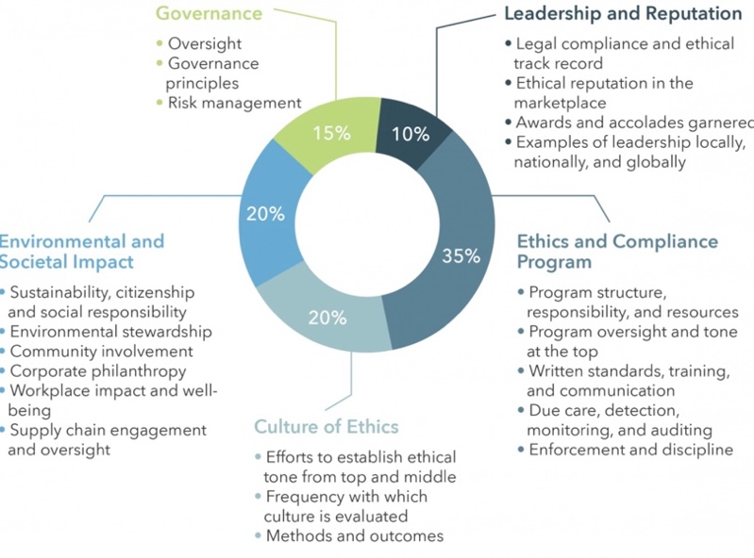
⁷

Ethical filmmaking is no doubt a hot topic of debate but what does it really mean? “The heart of documentary ethics lies in balancing creative storytelling with a filmmaker's responsibility to the wider world.” – Sebastian Solberg¹
Let’s break that up into two different sections, firstly, what is creative storytelling in the context of documentary or adventure filmmaking and how does it impact the creative decisions we must make throughout the production process.
“Story is where the realm of the subjective and objective meet” – Robert Mc Kee². And here in lies the complexity, is it up to us as filmmakers to create a story? To define its path? or are we merely the instrument through which it is told. There is great debate in the film industry regarding censorship and its place in documentary filmmaking ( see https://philosophy.institute/ethics/ethical-movie-production-screening/ ³) but I believe in this area of film is not up to us to mould the story to fit a narrative or agenda but to allow the story to take shape through the truth of the subject even if that truth is uncomfortable lest it become propaganda. Yes, we must consider the long-term effects our film has on society and be prepared to defend the choices we make but if something is true, if it has been portrayed with empathy, compassion and understanding, can it ever be considered unethical? well that is up to you the reader, the audience to decide.
There seem to be many different opinions of what that responsibility actually entails however most agree on these few points
. Truth
. Transparency
. Privacy
. Accountability
. Representation
. Sensitivity
By factoring in these values to every aspect of our creative process I believe we are able to fulfill these responsibilities and create a genuine understanding with our audiences.⁴
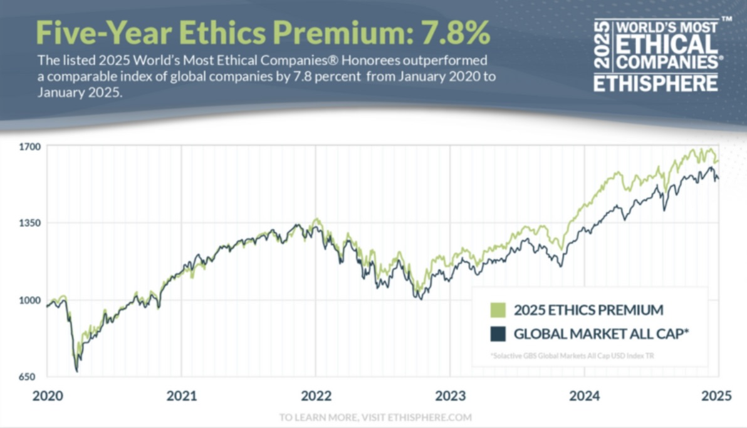
⁸
https://ethisphere.com/the-five-year-ethics-premium-shows-how-integrity-pays-off/⁵
Studies also show that over a long range forecast ethical companies have a greater increase in profit margin especially over the last few years as people become more aware of corporation’s impact on the planet and the environment in which they operate, socially, environmentally and economically.
The consequences of ignoring these responsibilities are become clearer and clearer every day, misinformation is rampant in society now even more so with the capabilities of AI growing exponentially. One only need look at how one AI generated video backed up by false evidence resulted in 32 deaths by I.C.E agents in the United States. https://www.theguardian.com/us-news/ng-interactive/2026/jan/04/ice-2025-deaths-timeline⁶
Ethical and factual integrity have never been more important than they are today, there are hundreds of stories that are waiting to be told and it is up to us to tell them with honesty, courage and the hope that the impact they have on society will inspire positive change, that people will accept truth no matter how difficult it is to hear and if they do not then it is up to bear the weight of that responsibility and strive to do better with every film we make for every audience we touch in every way that we can.

1 - Sebastian Solberg on The complete guide to ethical filmmaking https://www.docfilmacademy.com/blog/the-complete-guide-to-ethical-storytelling
2 - Story by Robert Mc Kee 1997 McKee, R. (1999). Story : substance, structure, style, and the principles of screenwriting([Paperback ed.]). Methuen.
3 - Ethics in Screen Production – Philosophy Institute https://philosophy.institute/ethics/ethical-movie-production-screening/
4 - Responsible Filmmaking - https://www.youtube.com/watch?v=hBnDUpwsPsQ&t=57s Deirdre Boyle, Associate Professor of Media Studies, the New School in NY. Video: 43 seconds.
5 – How integrity pays off https://ethisphere.com/the-five-year-ethics-premium-shows-how-integrity-pays-off/ by Erica Salmon Byrne 2025
6 – 2025 was I.C.E’s deadliest year in over a decade https://www.theguardian.com/us-news/ng-interactive/2026/jan/04/ice-2025-deaths-timeline by Maanvi Singh, Coral Murphy Marcos and Charlotte Simmonds
7 - https://climate.sustainability-directory.com/term/ethical-filmmaking-principles/
8 - Kathryn Kyte on The world’s most ethical companies https://sidewalkhustle.com/the-worlds-most-ethical-companies/

Is micro adventure escapism and what’s the actual problem of an escapist ideology
After doing lots of research on micro-adventure for a previous project I noticed a common theme began to immerge throughout the texts that I read. They a discuss the need to get away from the stresses of modern society and experience adventure on whatever scale that may be.
While I myself have committed to an adventurous lifestyle I have begun to think about the deeper implications of this mentality, what is wrong with so many of our lives that we spend almost all of our time hoping to run away from it.
This topic is especially personal to me, I recently had a conversation in which I was asked what in life I was going to put energy towards next but the question I heard was different to the one asked, I heard where am I going to run to next to escape having to confront myself, my problems even my very way of thinking. Why should I always be running towards something, is it not enough to stop and appreciate where I am now, and if it isn’t they why?
So instead perhaps of committing to an adventurous lifestyle should I in fact be committing to an adventurous mentality?
My point was proved when I googled micro-adventure and escapism and was confronted with a dozen articles on tourist escapes, weekend getaways and tips for everyday escapism and again asked the question what is so wrong with our everyday that all we want to do is get away from it?

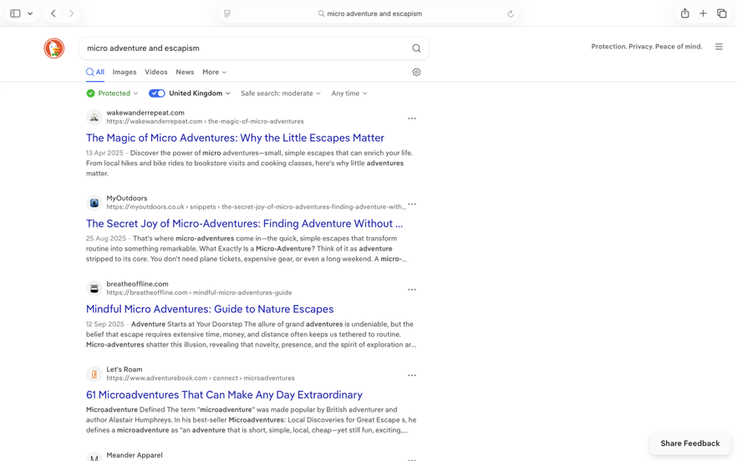

For the answer to that question, I had to delve deeper into the psychology of modern human consciousness, well I tried, the first academic text I clicked on about the epidemic of escapism was written by AI, if AI writing articles on human consciousness doesn’t tell you everything that’s wrong with the world I don’t what will but anyways, consciousness…..

Consciousness and later, subconsciousness was studied extensively by Sigmund Freud and his theory further developed by Jacques Lacan (https://plato.stanford.edu/entries/lacan/) ¹ which discusses the development of selfhood from infantry.²
In this theory Lacan talks about the ideals that are assigned to us at birth and that we strive towards for much of our adult life, is it possible that the desire to run towards something that is always slightly out of reach is an inescapable aspect of existence or did we get lost somewhere along the way?
And such as Belinda Kirk says is adventure engrained into our very being or is just another thing to strive towards, another answer to a question we don’t even realize we are asking.

The UK Adventure Tourism Market shows exponential growth in popularity, investment and capitol
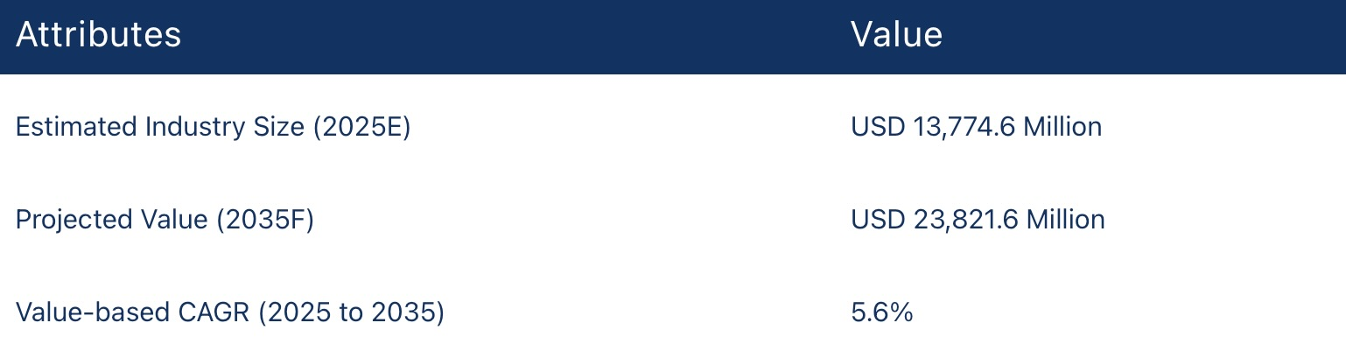
https://www.futuremarketinsights.com/reports/united-kingdom-adventure-tourism-market³
As these statistics increase so does social and economic poverty, mental health issues, homelessness and natural disasters. Is it coincidence or is it just that the problems we are running away from becoming bigger and bigger.
I could philosophize for pages seeking the answer that no human has or ever could find but instead I want to come to some kind of conclusion, a tangible reality for you and for me to reflect on in our daily lives.
Society is designed for us to focus on anything but ourselves, work, money, material possession, even adventure, these desires pushed onto us by the media along with the very definition of success fuel modern capitalism (see article below for the definition of success to include getting ahead on your insurance for 2026!) https://www.independent.co.uk/life-style/strive-for-success-2026-beyond-b2889582.html⁴
I don’t know about you, but this makes me question what the world doesn’t want us to find, if all of these things are in fact distractions then what are we being distracted from?
Could it be something as simple as, ourselves…...?

By taking active accountability for ourselves and our lives we limit the need to escape towards micro adventure or anything else and accountability starts with awareness.
So, if the desire to strive towards something is in fact an undeniable part of what it means to be human then let us strive towards awareness.

1 – Jaques Lacan https://plato.stanford.edu/entries/lacan/ Stanford encyclopaedia of philosophy 2013
2 – Lacan: The mirror stage https://www.english.hawaii.edu/criticalink/lacan/ The University of Hawaii
3 – Uk adventure tourism market outlook https://www.futuremarketinsights.com/reports/united-kingdom-adventure-tourism-market 2025-2035
4 – Strive for success in 2026 and beyond https://www.independent.co.uk/life-style/strive-for-success-2026-beyond-b2889582.html The Independent 2026

BIBLIOGRAPHY

Lacan, J., & Miller, J.-A. (2008). The ethics of psychoanalysis, 1959-1960 : the seminar of Jacques Lacan, book VII. Routledge.
Osimo, S. A., Pizarro, R., Spanlang, B., & Slater, M. (2015). Conversations between self and self as Sigmund Freud—A virtual body ownership paradigm for self counselling. Scientific Reports, 5(1), Article 13899. https://doi.org/10.1038/srep13899
Ogden, M. G. (2023). An uncanny dialogue: Lev Shestov’s philosophy as the ‘great art’ of not seeing and Sigmund Freud’s psychoanalytic investigations of the unconscious mind. Journal of European Studies, 53(2), 119–131. https://doi.org/10.1177/00472441231172061

An academic conspiracy
This one might be bordering on controversy rather than something with actual academic substance but oh well I can’t be perfect (maybe exceptional) ALL the time.
I was making fried eggs today and was carefully setting aside the eggshells and teabags for composting and started wondering if climate change is actually all a big hoax, the president is eating babies but never mind because I’m saving the planet with my composting.
See https://www.justice.gov/epstein ¹
This thought paired with the documentary Life On Our Planet narrated by Morgan Freeman and directed by Stephan Speilberg https://www.imdb.com/title/tt23181388/ ² gave me the overall feeling that we as humans are rather egotistical for pitying mother nature and thinking we are performing some great heroic deed by taking the green dye out of 7up bottles, when all the evidence quite clearly points to the fact that earth is quite capable of wiping the disease that is mankind from the planet whenever takes its fancy (around every 100 million years or so) https://www.worldatlas.com/articles/the-timeline-of-the-mass-extinction-events-on-earth.html³

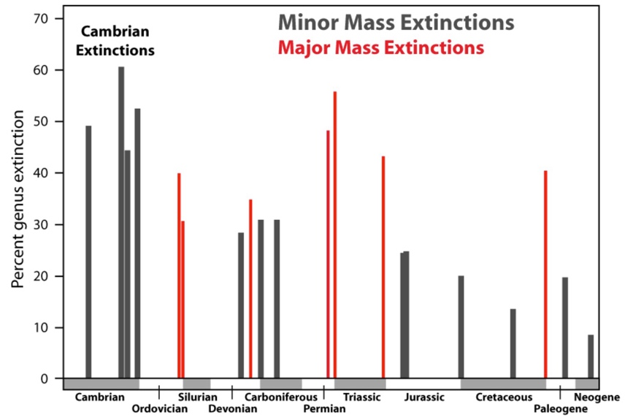

It is clear that since the very inception of life itself Earth’s climate has fluctuated as has its CO2 levels, due to volcanic activity, asteroids and even plankton, although according to EARTH.ORG, records containing robust evidence only date back around 800000 years the general sensis is that climate fluctuations were taking place long before that.
https://earth.org/data_visualization/a-brief-history-of-co2/⁴
And so, is thinking that we can prevent such a historically devasting yet natural part of earth’s cycle and evolution not a perfect example of human delusion?
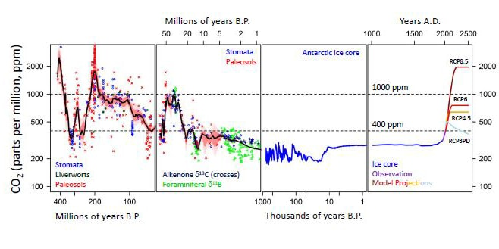

Now don’t get me wrong I don’t think this is an excuse to frivolously pollute our planet. By all means composting for the win however, I do think that the problem at the heart of climate change isn’t plastic, CO2 or single use props but instead a distinct lack of empathy for life itself, plants, animals and even the soil beneath our feet.

The importance of empathy for climate action ~ by Nick Barnes February 2024 https://impact.ed.ac.uk/inspiring-minds/empathy-for-climate-action/⁵

This article touches on the point and there are a lot of good things about it however, it is also a testament to the decline of human empathy that acknowledging its mere existence warrants an interview marvelling at the political ingenuity of it all.

Following the law on littering and buying electric cars means nothing and will do absolutely nothing to mitigate the damage caused to our planet without understanding why we are doing so, only once we understand that, can we evolve with our planet rather than against it.

We must develop a real consideration and awareness for all life-forms and gain actual insight into the consequences of our actions, a complete shift in mind-set that expands our consciousness towards empathy for all living beings, will I believe do far more than mindlessly following the law on recycling and caving in to trends that promote “a greener future”.

1.9 TRILLION USD was generated in finance under the banner of climate change and yet C02 levels and the global surface temperature continue to rise faster than ever. https://www.climatepolicyinitiative.org/press-release/global-climate-finance-hits-1-9-trillion-bridging-the-climate-investment-gap-remains-within-reach/⁶

If there was ever a time to be critical of the progress made by governments in regard to climate change it would be now, it’s clear that money isn’t fixing the problem so it is up to us to ask ourselves, what will?

“You cannot eat money” ~ The Lorax

1 - U.S Department of Justice Epstein library https://www.justice.gov/epstein 2026

2 – Life On Our Planet https://www.imdb.com/title/tt23181388/ 2023

3 – The timeline of mass extinction events on Earth https://www.worldatlas.com/articles/the-timeline-of-the-mass-extinction-events-on-earth.html World Atlas by Megan Deak 2023
4 – A graphical history of Co2 levels over time https://earth.org/data_visualization/a-brief-history-of-co2/ Earth.ORG by Owen Mulhurn 2025

5 – The importance of empathy for climate action https://impact.ed.ac.uk/inspiring-minds/empathy-for-climate-action/ The University of Edinburg by Nick Barnes 2024

6 - Global climate finance hits $1.9 trillion—bridging the climate investment gap remains within reach https://www.climatepolicyinitiative.org/press-release/global-climate-finance-hits-1-9-trillion-bridging-the-climate-investment-gap-remains-within-reach/ Climate Policy Initiative, Barbara Buchner 2025

BIBLIOGAPHY

Apaolaza, V., Hartmann, P., Rincón, V., & Paredes, M. R. (2025). Climate Action Through a Feminist Lens: The Role of Gender Inequality Awareness, Nature Empathy, and Climate Change Concern. Journal of Business Ethics. https://doi.org/10.1007/s10551-025-06171-x
Hamann, K., Junge, E., Blumenschein, P., Dasch, S., Wernke, A., & Bleh, J. (2025). The Psychology of Collective Climate Action : Building Climate Courage. (1st ed.). Taylor & Francis Group.
Richard S.J. Tol. (2022). CLIMATE CHANGE. Copenhagen Consensus Center.

