

TESLA HOME GRID: EXPANDING SUSTAINABLE INNOVATION INTO SMART ENERGY ECOSYSTEMS

Student Name | Kumakamba Punga
Student Number | 2226848
Lecturer | Dr. Taonga Kaonga Sobere-Snithers




TABLE OF CONTENTS
ELEMENT 1: BRAND EXTENTION POSTER 3 ELEMENT 2: SEGMENTATION, TARGETING, DIFFERENTIATION AND POSITIONING ANALYSIS 4 ELEMENT 3: MARKETING MIX 7 ELEMENT 4: REFLEXTION 11 OVERALL CONCUSION 13 REFERENCES 14

ELEMENT 1: BRAND EXTENTION POSTER
tesla home grid expanding sustainable innovation into smart energy ecosystems 111.pdf
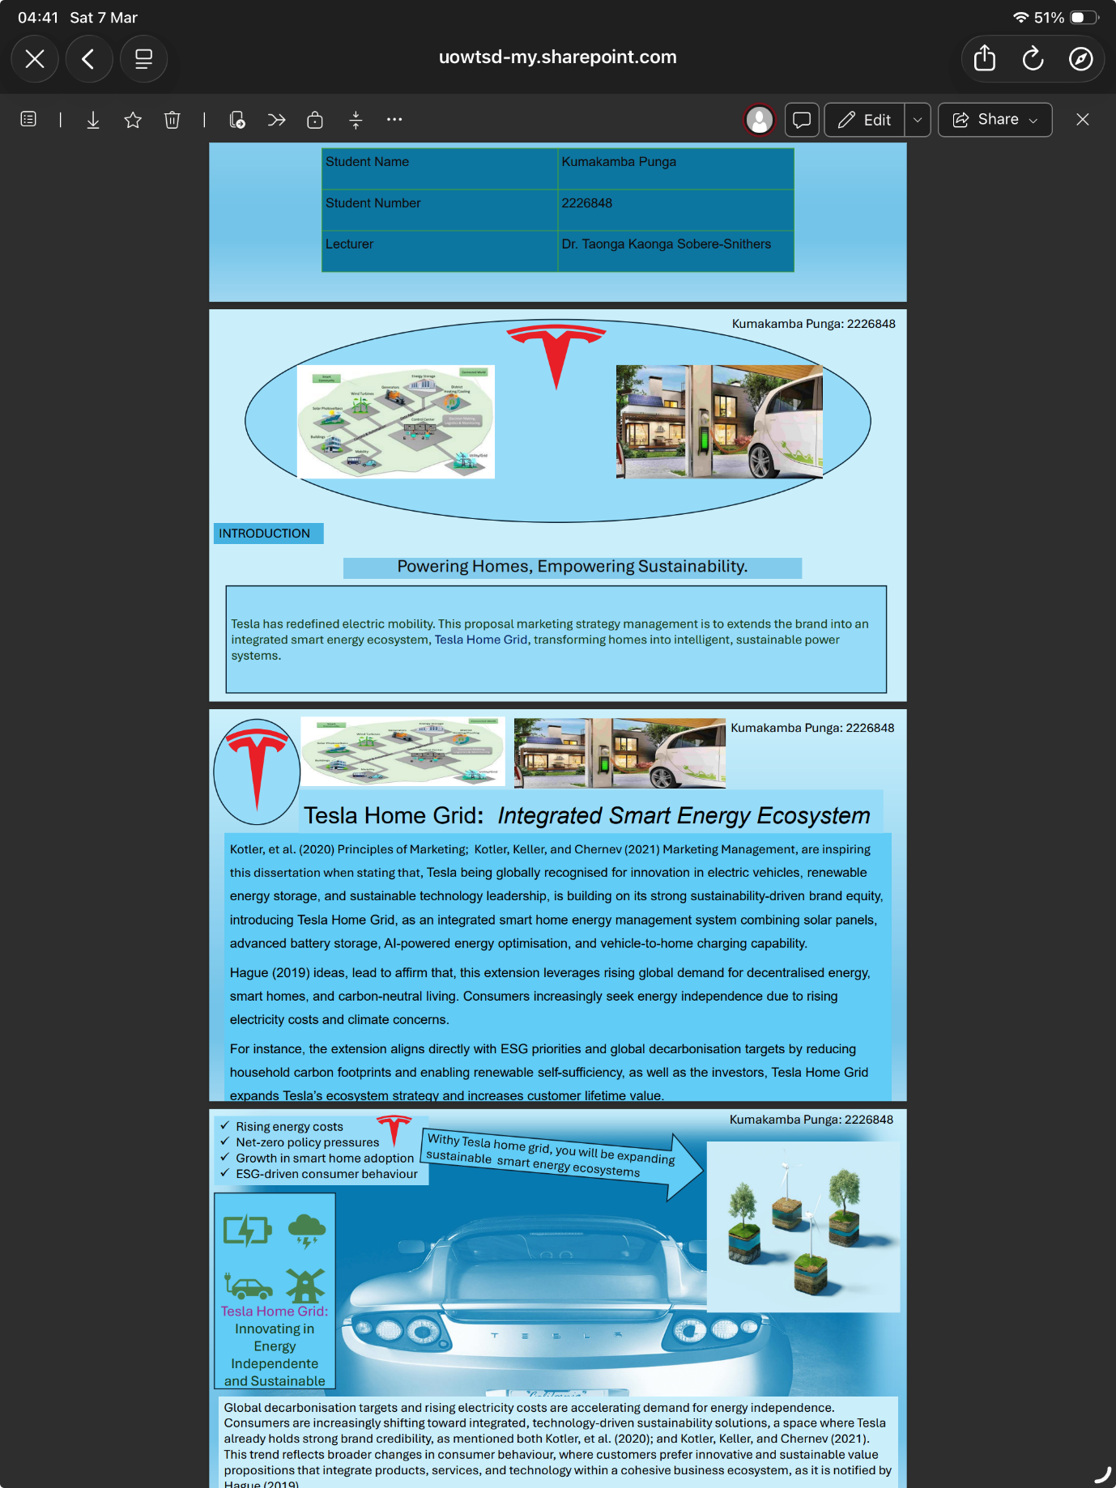

ELEMENT 2: SEGMENTATION, TARGETING, DIFFERENTIATION AND POSITIONING (STDP) ANALYSIS
The development of Tesla Home Grid represents a strategic brand extension designed to expand the sustainability ecosystem of Tesla into the residential energy market. To successfully introduce this innovation, a comprehensive Segmentation, Targeting, Differentiation and Positioning (STDP) analysis is required. STDP is a fundamental marketing framework used to identify attractive markets, opportunities, develop competitive advantages, and position offerings effectively within competitive markets (Kotler, et al.2020; Hooley et al., 2024).

- Market Segmentation
According to Kotler et al. (2020), market segmentation referring to the process of dividing a heterogeneous market into distinct groups of consumers with similar needs, characteristics, or purchasing behaviour, Tesla Home Grid segmentation is eligible to be analysed through geographic, demographic, psychographic, and behavioural variables.
Geographic segmentation identifying regions where renewable energy adoption is rapidly growing due to environmental regulations, energy costs, and sustainability policies, are reflected through countries such as the United States, the United Kingdom, Germany, et., which are considered attractive markets because they demonstrate strong policy support for renewable energy and smart energy infrastructure.
Demographic segmentation focuses on income homeowners aged between 30 and 60 who possess the financial capacity to invest in smart energy technologies. These consumers typically belong to professional or entrepreneurial occupations and often seek long-term investments that combine economic and environmental benefits.
Psychographic segmentation reflects consumers’ lifestyles, values, and attitudes toward sustainability and technological innovation, which environmentally conscious individuals who prioritise low-carbon living and sustainable lifestyles are more likely to adopt renewable energy technologies such as Tesla Home Grid. According to Hooley et al. (2024), psychographic segmentation is particularly relevant in markets where consumers’ environmental values influence purchasing decisions.
Behavioural segmentation focuses on consumers’ attitudes toward innovation and energy consumption patterns that early adopters of electric vehicles, smart home technologies, and renewable energy systems will represent a key behavioural segment, considering these consumers typically demonstrate strong interest in energy independence, digital innovation, and long-term efficiency improvements (Ho, 2019).

- Target Market
Based on the segmentation analysis, the primary target market for Tesla Home Grid consists of affluent, technologically sophisticated homeowners who value sustainability and energy independence. This group includes existing Tesla electric vehicle owners as well as environmentally conscious consumers interested in smart home technologies.
Targeting this segment allows Tesla to leverage existing customer relationships and strengthen its ecosystem strategy. According to Anderson and Kerr (2002), organisations that enhance long-term value by building strong customer relationships and delivering integrated solutions to meet the evolving consumer needs, in occurrence Tesla Home Grid aligning with this principle by integrating transportation, energy storage, and home energy management within a single ecosystem.

- Differentiation Strategy
Differentiation is essential for achieving competitive advantage in dynamic technology markets (Hooley et al., 2024). They differentiate themself from competitors through several strategic features.
First, technological integration which represents a major differentiator, aloud Tesla to combine solar generation, battery storage, vehicle-to-home energy transfer, and artificial intelligence-driven energy optimisation within a unified ecosystem.
Second, Tesla benefiting from a strong brand reputation for innovation and sustainability, has established itself as a global leader in electric mobility and renewable energy technologies.
Third, Tesla’s data-driven software ecosystem enables continuous improvement through software updates, predictive energy analytics, and real-time system monitoring, his digital capability allows the company to deliver more efficient and intelligent energy management solutions compared to traditional energy providers.

- Positioning Strategy
For Kotler et al. (2021), positioning refers to the way a brand is perceived by consumers relative to competing. Offerings Tesla Home Grid to be positioned as a premium smart energy ecosystem that enables households to achieve energy independence while supporting the transition to sustainable energy systems, highlights three key value propositions:
  - Intelligent energy management through AI-driven optimisation.
  - Sustainable living through renewable energy integration.
  - And energy independence from traditional utility providers.
This strategy aligns with broader sustainability and digital transformation trends in the global energy market. From a strategic perspective, it also supports Tesla’s long-term mission of accelerating the transition toward sustainable energy (Whittington et al., 2023). This aligns with Kotler et al. (2021), describing how firms expand and manage their brands to grow market presence and value. As for the main strategies including, line extension (new variations within the same product category), brand extension (using an existing brand to enter a new product category), multibrands (introducing additional brands within the same category), and new brands (creating entirely new brands for new markets), That Tesla Home Grid’s strategies help firms leverage brand equity, target different segments, and support long-term competitive growth.

ELEMENT 3: MARKETING MIX (7ps)

To successfully introduce Tesla Home Grid, a comprehensive marketing mix strategy as required, is referring to the set of controllable marketing tools used by the firm in accordance with any organisation in need to achieve their marketing objectives in target markets indicated by Kotler et al. (2020). Given the technological and service-based nature of the offering, the 7Ps framework provides a suitable strategic approach for aligning product development with customer value creation and competitive positioning align with Hooley et al. (2024). This aligns with Ghicajanu (2021) who analysed the competitive environment’s five forces model developed by Porter in 1979, evaluating the strength and importance of each varies from market to market, relevant when analysing the conditions under which a business operates.

- Product
The core product as an integrated smart home energy management system consisting of solar panels, battery storage systems, artificial intelligence-driven energy optimisation software, and vehicle-to-home charging capabilities developed by Tesla, offering a system with several key benefits, including improved household energy independence, lower electricity costs, reduced carbon emissions, and advanced smart home integration. Such innovations reflect the growing importance of digital technologies in shaping modern consumer solutions and enabling connected energy ecosystems (Ho, 2019). This aligns with Chaffey (2011) who has focuses his study on digital strategy and online consumer engagement, explaining how organisations use digital technologies, platforms, and data-driven marketing to create connected customer experiences and technology-enabled service ecosystems. Obviously, beyond the core product, Tesla Home Grid also includes an augmented product offering, such as professional installation services, system monitoring through the Tesla mobile application, regular software updates, and dedicated customer support services. Integrating these services enhances the overall customer experience and strengthens value creation within technology-driven business models that demonstrated De Silva (2021).

- Price
As Tesla Home Grid is expected to adopt a premium pricing strategy, reflecting its technological sophistication, sustainability benefits, and strong brand positioning, premium pricing is consistent with the firm’s broader brand identity, which emphasises innovation, high performance, and sustainability leadership.
However, to increase market accessibility, Tesla is implementing flexible pricing models such as financing plans, leasing options, and subscription-based energy services. These models reduce the initial financial barriers associated with renewable energy technologies while encouraging long-term customer relationships. According to Anderson and Kerr (2002), building long-term customer relationships through value-driven service models is a key component of effective customer relationship management strategies.
Furthermore, pricing strategies must reflect both perceived customer value and competitive positioning within the renewable energy market (Hooley et al., 2024). By offering flexible pricing solutions, Tesla is broadening market adoption while maintaining its premium brand positioning.

- Place (Distribution)
Tesla’s distribution strategy combines direct digital channels and physical infrastructure to maximise accessibility and customer engagement.
The primary distribution channels include Tesla’s official website, company showrooms, and authorised installation partners responsible for system deployment, approach allowing the firm to maintain greater control over brand experience and customer relationships.
Direct distribution channels also enable Tesla as any other organisation to gather valuable customer data and improve strategic decision-making. According to Kotler et al. (2021), direct distribution enhances customer experience by allowing companies to interact directly with consumers and deliver more personalised services, which align with Mumtaz Awan (2024) who examined the dynamics in CRM due to cutting-edge technologies and human-centric approaches that redefine businesses’ engagement with their customer.
In addition, strategic partnerships with renewable energy installers and smart home technology providers may further expand distribution capabilities and accelerate market penetration.

- Promotion
Promotion will focus on communicating the environmental, technological, and economic benefits of Tesla Home Grid’ effective marketing communication strategies, essential for building brand awareness and influencing consumer adoption of innovative technologies that is mentioning Kotler et al. (2020), include:
- Digital marketing campaigns across social media platforms.
- customer testimonials and real-life case studies demonstrating energy savings.
- partnerships with environmental organisations.
- sustainability-focused advertising emphasising carbon reduction.
Tesla’s strong global brand reputation and active digital community amplifying promotional efforts in the digital era, organisations increasingly rely on connected consumer engagement strategies to influence purchasing decisions and strengthen brand loyalty as stated Ho (2019).

- People
Employees and technical specialists who are playing a crucial role in delivering the Tesla Home Grid experience, are skilled engineers, technicians, and installation professionals ensuring the reliability, safety, and efficiency of the energy system, as in the way to De Silva (2021) addressed the effective organisational processes and skilled personnel are essential for delivering integrated service solutions in technology-driven business environments. Tesla Home Grid’s highly trained employees therefore contribute directly to customer satisfaction and operational performance.
Moreover, the company’s knowledgeable staff are providing expert advice and technical guidance to customers, which strengthens trust and reinforces Tesla’s reputation for innovation and quality.

- Process
Efficient service processes are necessary to ensure smooth installation, operation, and maintenance of Tesla Home Grid systems.
Tesla is streamlining the customer journey through digital tools such as online configuration platforms, automated installation scheduling systems, and AI-driven energy management software to simplify system adoption and to improve operational efficiency.
The firm’ strategic management literature emphasises that efficient operational processes are critical for maintaining competitive advantage in technologically complex industries (Whittington et al., 2023), by optimising service processes of Tesla’s enhancing both operational performance and customer satisfaction.

- Physical Evidence
As Kotler et al. (2020) physical evidence refers to the tangible elements that support the service experience and reinforce brand credibility, for Tesla Home Grid’s physical evidence includes solar panel installations, battery storage units, Tesla-branded equipment, and the digital interface provided through the Tesla mobile application, these visible elements provide reassurance to customers and demonstrate the reliability and sophistication of the technology that that company’s energy infrastructure within households also reinforces the brand’s commitment to sustainable innovation and strengthens consumer trust in the system.

ELEMENT 4: REFLECTIOM
This study was undertaken at the University of Wales Trinity Saint David (UWTSD) as part of a Brand Development Portfolio module. It examines strategic brand extension within the technology sector and focusing on the proposed development of Tesla’s “Tesla Home Grid,” an integrated smart energy ecosystem designated to extend the brand beyond electric vehicles into sustainable residential energy solutions.
The primary of this study was to critically evaluate how marketing theory can inform real-world strategic decision-making in dynamic, sustainability-driven markets. To achieve this, established marketing frameworks were applied, including Element 2 - Segmentation, Targeting, Differentiation and Positioning (STDP) and Element 3 - the Marketing Mix (7Ps). These frameworks were used to assess the market viability, competitive positioning, and strategic fit of the proposed brand extension.
In fact, the experience on the accomplishment of my learning journey as related to Marketing Management – LCLB7024; however, the study reflects on the integration of theory and practice, highlighting both the analytical process and personal learning development under my module leader (Dr. Taonga Kaonga Sobere-Snithers), that comes the dialectic combination of knowledge, challenges, LinkedIn skills learned, and that output, just like in accordance with Sicora (2025), citing Gibbs’ Reflective Cycle’s six-stage framework guiding structured as description, feelings, evaluation, analysis, conclusion, and action planning to deepen learning, improve practice, and support professional growth through systematic self-assessment.
Therefore, developing the Tesla Home Grid brand extension project provided valuable insights into strategic marketing planning and sustainable innovation management, the project required integrating theoretical marketing frameworks with practical business analysis, which significantly enhanced my understanding of brand strategy and market development.
One of the most important lessons from this project was the importance of aligning brand extensions with the core competencies and identity of the parent brand. Analysing the innovation ecosystem of Tesla demonstrated that Tesla Home Grid represents a logical extension of the company’s broader sustainability mission. As learn from this year module, successful brand extensions must leverage existing brand equity while maintaining strategic coherence with the organisation’s core capabilities. Taonga Kaonga, S. (2026) Marketing Management (LCMB7024).
Another key learning outcome involved applying the Segmentation, Targeting, Differentiation, and Positioning (STDP) framework. Through this analytical process, I gained a deeper understanding of how organisations identify attractive market opportunities and develop targeted value propositions. Strategic marketing literature emphasises that effective segmentation and positioning are essential for achieving competitive advantage within dynamic markets (Hooley et al., 2024).
The development of the marketing mix further strengthened my strategic thinking skills. Designing product, pricing, distribution, and promotional strategies required careful alignment with Tesla’s premium brand positioning. This stage highlighted the importance of integrating customer value, innovation, and sustainability within modern business models (Ho, 2019).
Preparing to deliver the poster presentation also improved my communication and analytical abilities.
Furthermore, engaging with LinkedIn skills learning during the year encouraged critical reflection on the strengths and limitations of the module. Strategic management theory highlights the importance of reflective learning and continuous improvement in developing effective business solutions as align Whittington et al., (2023).
From a personal development perspective, this project strengthened several transferable skills, including academic research, strategic analysis, problem-solving, and professional communication. These competencies are particularly valuable for careers in marketing management, innovation management, project management, and sustainability strategy management.
Looking forward, I recognise several opportunities to improve my approach in similar projects. For example, incorporating primary research methods such as surveys or interviews could provide deeper insights into consumer behaviour and market demand. Additionally, integrating other modules from this term of the year such as Financial Management and Human Capital Management could strengthen the strategic evaluation of innovative business concepts.
OVERALL CONCLUSION
This portfolio demonstrates how strategic marketing frameworks support the development of Tesla’s Home Grid brand extension. By applying segmentation, positioning, and the marketing mix, the project shows how integrated renewable energy solutions can create customer value, strengthen competitive advantage, and support sustainable innovation within the emerging smart energy ecosystem.
Overall, this project demonstrated how strategic brand extensions can contribute not only to organisational growth but also to broader they sustainability objectives, in one hand, and in the other hand, the growth and development of the individual staff.

REFERENCES
Anderson, K. and Kerr, C. (2002) Customer relationship management. 1st edn. New York: McGraw-Hill.

Awan, T.M. (2024) Customer relationship management: Contemporary concepts and strategies. IntechOpen. Available at: https://doi.org/10.5772/intechopen.111023.

Chaffey, D. (2011) E-business and e-commerce management: Strategy, implementation and practice. 5th edn. Harlow: Pearson/Financial Times Prentice Hall.

De Silva, T. (2021) Integrating business management processes: Volume 2: Support and assurance processes. London: Routledge.

Ghicajanu, M. (2021) ‘Competitive analysis of the business with the Michael Porter model’, Annals of the University of Petroşani. Economics, 21(1), pp. 169–178.

Ho, R.C. (2019) Strategies and tools for managing connected consumers. Hershey, PA: IGI Global.

Hooley, G.J. et al. (2024) Marketing strategy and competitive positioning. 8th edn.

Kotler, P., Armstrong, G., Harris, L. and Piercy, N. (2020) Principles of marketing. 8th European edn. Harlow: Pearson.

Kotler, P., Keller, K. and Chernev, A. (2021) Marketing management. 16th edn.

Sicora, A. (2025) ‘Cultivating joy and mindfulness in social work: Enhancing well-being and resilience through positive reflection and practice’, Social Sciences, 14(3), p. 152. Available at: https://doi.org/10.3390/socsci14030152.

Taonga Kaonga (2026) Marketing Management, LCMB7024 module materials. University of Wales Trinity Saint David.

Whittington, R., Regnér, P., Angwin, D., Johnson, G. and Scholes, K. (2023) Exploring strategy: Text and cases. 13th edn. Harlow: Pearson.

