Individual Business Model Canvas with entrepreneurial reflection using appropriate academic models - Sustainable Urban Oasis
Assessment 1
Sumaiya Begum Tanni
2211676
Module code: BMIH5001
Ben Chong

Wordcount: 1998

Part 1: Essay
Introduction
In the dynamic hospitality sector, it is crucial to develop a strategic plan that caters to the requirements of contemporary tourists while considering the increasing emphasis on sustainability (Torr, 2014). The essay introduces the concept of "Sustainable Urban Oasis", a novel and environmentally conscious notion for a hospitality enterprise. To elucidate and justify the various components of this concept, one can employ the Business Model Canvas (BMC) to highlight its distinctive selling propositions and strategies for outperforming competitors. The outcomes of the personal entrepreneurial/managerial assessments completed in class will also be discussed in this part.
Value Proposition
The notion of value serves as the cornerstone upon which the concept of sustainability in Urban Oasis is built. The company asserts that its clients will enjoy a unique and environmentally aware experience during their whole stay with the company (Timmons, Adams and Spinelli, 2015). This includes the use of organic food that is cooked with materials that are sourced from the local area, lodgings that are ecologically sustainable, and engaging experiences that are aimed to increase people's awareness of environmental concerns. The mission of the organisation is to attract travellers who are concerned about the environment and are looking for greater experiences by placing an emphasis on sustainability. Looking at the local suppliers and rivals is necessary in order to provide evidence in support of this argument. From the perspective of Sustainable Urban Oasis, it is of the highest significance to give priority to the purchasing of commodities from local farmers and businesses. Because of this, the effect that transportation has on the environment will be reduced (Scarborough and Cornwall, 2019). Through the establishment of partnerships with regional vendors, the organisation strives to reduce the negative effects that it has on both the community and the environment.
Customer Segments
It is recommended that in order to improve the offering of the organisation, particular customer segments be the primary focus of attention. Individuals who are environmentally concerned, people who are passionate about the environment, and people who are looking for an experience that is both meaningful and interesting will all be attracted to Sustainable Urban Oasis. In order to achieve its goal of cultivating a loyal customer base that would enthusiastically support the firm's efforts to be environmentally conscientious, the company intends to prioritise meeting the needs of this specific market group. It is possible that the company may concentrate its marketing efforts on a certain population of customers who are environmentally concerned (Rickman, 2012). This will be accomplished by doing research to establish the preferences and online behaviour of this particular demographic.
Channels
The way in which Sustainable Urban Oasis interacts with its customers has a substantial impact on the company's capacity to provide the value that it has promised. For the purpose of successfully targeting its audience and promoting its ecologically responsible ideas, the firm will use digital marketing and social media in addition to the traditional ways of booking. Increasing brand recognition and establishing credibility are two goals that the firm intends to accomplish by investigating the possibility of collaborating with travel bloggers and influencers who are ecologically sensitive (Nicholas, 2021). The effectiveness of these websites is shown by the fact that they are used in modern hotel marketing methods that provide favourable outcomes. By using Instagram and other social media platforms to promote their unique products and environmentally responsible efforts, resorts and hotels have the ability to successfully increase their audience and cultivate a community of people who share their values and are in agreement with their ideals.
Customer Relationships
It is only possible for Sustainable Urban Oasis to flourish if it is able to create and maintain strong relationships with its clientele. As a result of the company's focus on open and individualised communication, guests will be constantly informed about the environmentally friendly policies that have been implemented as well as the good impact that their stay will have on the environment (Nerys Fuller-Love, 2020). It will be done through reward schemes, feedback systems, and regular letters to make customers feel like they belong and to get them to come back for more trips. The Ritz-Carlton prides itself on giving guests unforgettable experiences, which can be seen in the way they tailor their service to each guest. This may serve as inspiration If Sustainable Urban Oasis stresses how important it is to protect the earth, they can learn from their mistakes as well.
Revenue Streams
To secure the financial stability of Sustainable Urban Oasis, the firm will seek to diversify its revenue streams Furthermore, apart from the usual procedures for reserving rooms, the organisation will explore the potential of establishing connections with local craftsmen and producers of environmentally sustainable goods (Mariotti and Glackin, 2019). Visitors will have the opportunity to purchase unique things that are produced in an environmentally friendly way during their stay at the institution Collaborating with environmental groups to provide workshops and events has the potential to create extra income while still maintaining the principles of sustainability (Ndubisi and Nwankwo, 2013) Hotel sector businesses that have effectively diversified their sources of income might possibly strengthen this strategy by increasing their ability to withstand economic fluctuations.
Key Resources
For Sustainable Urban Oasis to work, it needs a dedicated group of people, infrastructure that is good for the environment, and supply lines that can last To make sure the company stays true to its ideals in everything it does, it needs to use green energy sources, build with salvaged and upcycled materials, and give its employees a lot of training on how to be environmentally friendly (Mariotti and Glackin, 2015). Contemporary hotels and resorts that have used eco-friendly methods in their operations and building materials can be found to back up the choices (M Szycher, 2015) This could include buildings that have been certified by Leadership in Energy and Environmental Design (LEED), the use of technology that saves energy, and less trash.
Key Activities
Sustainable Urban Oasis will conduct its principal operational activities in ensuring the preservation and enhancement of sustainable practices In pursuit of this aim, periodic environmental assessments may be conducted, personnel may be instructed on ecologically responsible business management practices, and endeavours may be made to forge alliances with regional suppliers The group will also plan events and activities that are meant to help clients learn more about environmental problems (Lars Tvede and Mads Faurholt, 2018) Because of the success of health and sustainability-focused hotels like "Six Senses" and their dedication to constant improvement, Sustainable Urban Oasis might get ideas from these types of businesses.
Key Partnerships
Sustainable Urban Oasis needs to build smart partnerships in order to reach its sustainable goals In addition, they will explore the potential for establishing collaborations with local environmental groups, providers of eco-friendly products, and enterprises that uphold similar principles By leveraging these connections, businesses have the capacity to enhance their standing and actively contribute to the betterment of the community (Kiyosaki, Fleming and Kiyosaki, 2019) This strategy is supported by examples of hotels, resorts, and local businesses working together to give visitors experiences that they will never forget and to contribute to the economy of the local community.
Cost Structure
Using the marketing money that Sustainable Urban Oasis has allocated, the spread of information about the extraordinary offer will be made easier. Both the initial investment in environmentally friendly infrastructure and the ongoing costs involved with running a sustainable business will be taken into consideration when determining the proposed budget. Despite the fact that it will result in higher initial costs, the corporation's long-term objective is to realise cost savings by lowering the amount of trash produced, the amount of energy used, and the level of customer loyalty (Katz and Green, 2014). There are certain businesses that have successfully struck a favourable balance between the initial investment in sustainability and the future cost savings, as well as the enhanced value of their brand over time. This pricing plan is sensible since these businesses have reached this equilibrium.
The Sustainable Urban Oasis is a novel and environmentally conscious choice for holidaymakers. This is a comprehensive business plan that integrates sustainability principles into all aspects of the hotel sector. The Business Model Canvas effectively showcases the distinctive attributes of this concept by utilizing contemporary illustrations (Jones, 2013). The objective of Sustainable Urban Oasis is to revolutionize the approach to sustainable hospitality by satisfying the preferences of environmentally aware guests, employing efficient communication techniques, and establishing robust collaborations.
Conclusion
To summarise, the Sustainable Urban Oasis idea not only offers an appealing framework for sustainable hospitality but also embodies a balanced fusion of my entrepreneurial and management traits. The Business Model Canvas provides a thorough plan, backed by current examples and statistics, to establish a higher benchmark in sustainable travel experiences (Baron, 2014). The reflective study establishes a connection between my inclination towards taking risks and being inventive, and the theories related to entrepreneurship, highlighting a flexible and adaptable character. In the future, I am dedicated to expanding my knowledge via academic research and hands-on experiences, guaranteeing a versatile and efficient approach to business. Sustainable Urban Oasis is positioned as a revolutionary force in the changing field of sustainable hospitality.

Part 2 Reflective Essay
Introduction
After analysing my entrepreneurial motives and traits in light of my in-class personal entrepreneurial/managerial exam scores, I discovered congruence with many important academic models and frameworks. An organised method for delving into this reflection is the Gibbs Reflective Cycle.
Description
The findings of my test suggested a strong propensity for risk-taking and a predilection for new methodologies. I have a proactive nature and get pleasure from investigating new chances. This aligns with the entrepreneurial characteristic hypothesis, which posits that people with a greater propensity for risk-taking and a proactive mentality are more inclined to participate in entrepreneurial endeavours (Fiet, 2022).
Feelings
Given my inherent proclivity for risk and creativity, I am filled with enthusiasm and a strong desire to delve into entrepreneurial endeavours. This corresponds to the affective domain of entrepreneurship, which highlights the emotional and motivational factors that propel people towards engaging in entrepreneurial endeavours (Casson, 2020).
Evaluation
Based on the entrepreneurial motivation framework developed by Shapero and Sokol, my tendency towards innovation falls inside the "Innovativeness" component, while my comfort with taking risks fits with the "Risk-Taking Propensity" dimension (Burns, 2022). This assessment affirms that my motivations are very compatible with entrepreneurial pursuits.
Analysis
Upon self-reflection on my management inclinations, I saw a harmonious blend of strategic cognition and operational effectiveness in the test outcomes. This aligns with Mintzberg's concept of management responsibilities, which emphasises that an effective manager must possess a combination of strategic foresight and practical operational skills (Barringer, 2013). This dual capability might be advantageous in entrepreneurial environments where both strategic planning and efficient execution are essential.
Conclusion
My congruence of features with entrepreneurial attributes and management jobs indicates a flexible profile capable of adapting to the changing demands of entrepreneurship. By acknowledging this synergy, I have a clear understanding of the areas where I can use my talents and identify areas that have growth potential.
Action Plan
In the future, I will go further into academic literature on entrepreneurial management to improve my comprehension of how entrepreneurial characteristics connect with efficient managerial strategies. Furthermore, I will actively participate in practical learning opportunities, such as internships or projects, in order to put into practice and enhance my entrepreneurial and management abilities.
Conclusion
To summarise, the Gibbs reflective cycle demonstrates that my goals and qualities as an entrepreneur and manager are in line with well-established academic frameworks (Baron and Hmieleski, 2018). This alignment acts as a cornerstone for my entrepreneurial development, directing me towards capitalising on my strengths and pinpointing opportunities for improvement. As I begin my journey as an entrepreneur, I will continuously improve and use these qualities, understanding that the dynamic interaction between taking risks, being innovative, and having strong management skills is crucial for achieving success in the always changing field of entrepreneurship.

References
Baron, R.A. (2014). Essentials of entrepreneurship : evidence and practice. Cheltenham, Uk ; Northampton, Ma: Edward Elgar Pub.
Baron, R.A. and Hmieleski, K.M. (2018). Essentials of entrepreneurship : changing the world, one idea at a time. Cheltenham, UK: Edward Elgar Publishing.
Barringer, B.R. (2013). Launching a business : the first 100 days. New York, Ny: Business Expert Press.
Burns, P. (2022). Entrepreneurship and small business. Basingstoke England ; New York: Palgrave.
Casson, M. (2020). Entrepreneurship : theory, networks, history. Cheltenham: Edward Elgar.
Fiet, J.O. (2022). The Theoretical World of Entrepreneurship. Edward Elgar Publishing.
Jones, G. (2013). Entrepreneurship and Multinationals. Edward Elgar Publishing.
Katz, J.A. and Green, R.P. (2014). Entrepreneurial small business. New York, Ny: Mcgraw-Hill Irwin.
Kiyosaki, R.T., Fleming, J. and Kiyosaki, K. (2019). The business of the 21st century. Two Rivers Distribution.
Lars Tvede and Mads Faurholt (2018). Entrepreneur : building your business from start to success. Chichester, West Sussex, United Kingdom: John Wiley & Sons.
M Szycher (2015). The guide to entrepreneurship : how to create wealth for your company and stakeholders. Boca Raton, Fl: Crc Press, Taylor & Francis Group, An Informa Business.
Mariotti, S. and Glackin, C. (2015). Entrepreneurship + Liveplan, 6-month Access Starting and Operating a Small Business. Pearson College Div.
Mariotti, S. and Glackin, C. (2019). Entrepreneurship : starting & operating a small business. New York: Pearson Education.
Ndubisi, N.O. and Nwankwo, S. (2013). Enterprise development in SMEs and entrepreneurial firms : dynamic processes. Hershey, Pa.: IGI Global (701 E. Chocolate Avenue, Hershey, Pennsylvania, 17033, USA).
Nerys Fuller-Love (2020). The Absolute Essentials of Entrepreneurship. Routledge.
Nicholas, M. (2021). 8 SUPERPOWERS OF SUCCESSFUL ENTREPRENEURS : from zero to hero. S.L.: Business Expert Press.
Rickman, C.D. (2012). The Small Business Start-Up Workbook : a step-by-step guide to starting the business you’ve dreamed of. Oxford: How To Books.
Scarborough, N.M. and Cornwall, J.R. (2019). Essentials of Entrepreneurship and Small Business management. 9th ed. Upper Saddle River: Pearson.
Timmons, J., Adams, R. and Spinelli, S. (2015). New Venture Creation: Entrepreneurship for the 21st Century. McGraw-Hill Higher Education.
Torr, M.A. (2014). The small business start-up workbook : a step-by-step guide to successful small business ownership. Carlsbad, Ca: Blackbull Learning.

Appendix
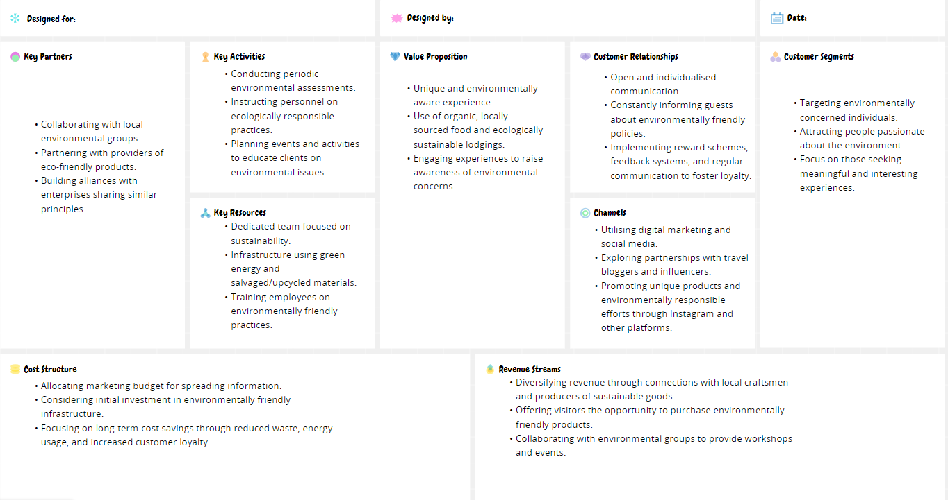
BMC

