Module Title: Problem Solving and Decision Making

Module Code: LCLM 4004

Assessment:
Component 2 Report

Case-study:
Green Haven Florists
Table of Contents

Introduction 2
Suggested Two Alternative Solutions 2
Solution A – Digital Transformation and E-Commerce Upgrade 2
Solution B – Customer Retention and Local Engagement Strategy 3
Justification for Selected Solution (via Grid Analysis) 3
Grid Analysis Overview 3
Evaluation Outcome and Justification 4
Risk Analysis of the Selected Solution 4
Identified Risks 4
Risk Evaluation 5
Plan to Implement the Selected Solution 5
Implementation Phases 5
Change Management and Monitoring 6
Means of Measuring Effectiveness of Implementation 6
Key Findings 7
References 8
Appendix 1: Grid Analysis Table 10
Appendix 2: Risk Analysis Table 11
Appendix 3: Implementation Plan 12
Appendix 4: The Key Performance Indicator (KPI) 13

Introduction
Green Haven Florists is a small independent and eco-friendly floral enterprise located in Norwich, England. The firm was founded in 2016 and its position was based on customised floral compositions and environmentally friendly packaging as the consumers of the UK were becoming increasingly environmentally aware. Nevertheless, the business has been recording a significant reduction over the last twelve months, of about 30 per cent in in-store sales. This recession has been accompanied by increasing operational expenses, the growing competition posed by online florists, as well as customer behaviour towards the digital shopping platforms. Rahman (2019) defines problem-solving in the twenty-first century as an important managerial skill that entails critical, creative, and adaptive thinking to generate viable solutions in dynamic situations. The 5W2H framework offered a systematic exploration of the what, why, who, where, when, how, and how much (Brosnan, 2025) was used to perform a structured diagnosis with the help of the 5 Whys framework used to trace the underlying causes (Hancock, 2022).

Suggested Two Alternative Solutions

Solution A – Digital Transformation and E-Commerce Upgrade
The proposed solution the first one is a thorough digital transformation that aims at creating an interactive online shopping site and online presence. This would involve search-engine optimisation, mobile compatibility, and easy online ordering and a delivery scheduling locally. An overlapping investment into social-media marketing and paid advertising like Google Ads would make the shop visible to more customers and especially younger audience who do their purchases online. The utilisation of the digital analytics and the new machine-learning resources can aid in identifying the customer trends and predictive demand modelling (Shethiya, 2024). The initiative fits the technological and social aspects of the PESTLE framework, indicating the need to keep up with the dynamic consumer technology and preferences (Hayden, 2025). Digitisation of the digital infrastructure of Green Haven would contribute to better accessibility of operations, competitiveness and minimising reliance on footfall.

Solution B – Customer Retention and Local Engagement Strategy
The second alternative revolves around enhancing customer loyalty and relations with the society via subscription and reward programmes, eco-consciousness and local sponsorships with other sustainable companies. Subsidiary plans (monthly bouquet subscriptions), corporate offers, and training sessions might further strengthen the interest of the customers as well as leverage the green nature of the firm. Using the principles of Total Quality Management (TQM), the business would focus on the regularity of the service quality, the integration of customer feedback and continuous improvement (Oakland, 2014). TQM builds a trust and follows the brand image of giving personal attention in the long term.

Justification for Selected Solution (via Grid Analysis)

Grid Analysis Overview
It was based on a Quantitative comparison of the two alternatives, which was done using a Grid Analysis or decision matrix. The tool offers a logical system to assess complicated alternatives by giving preference of weighted criteria and grading every solution in terms of it (Saugel et al., 2018). Such systematic comparison minimises subjectivity in business decision-making and allows making evidence-based judgement (Pennings and Hollenstein, 2020).
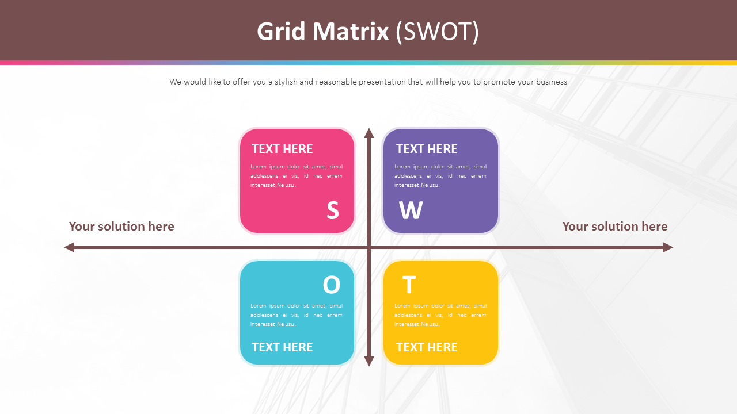
Figure 1: Grid Matrix (Saugel et al., 2018).
The main assessment criteria were: cost effectiveness, ease of implementation, access to customers, potential of innovation and long-term sustainability. All the criteria were rated based on strategic significance and graded out of 1-5. The elaborate grid can be found in Appendix 1.

Evaluation Outcome and Justification
It was revealed that Solution A - Digital Transformation scored significantly higher on the overall. It showed better growth, scalability and competitive placement in the digital retail environment. Solution B was incremental on loyalty and brand engagement, but it could not be considered a transformative solution that would turn around the drop in revenue.
The choice consequently lays emphasis on long term adaptation as compared to short term stability. The systems that are being created with the aid of technology produce smarter and data-driven decisions that allow responding to changing market conditions swiftly, as Shethiya (2024) notes. Therefore, Solution A will be the best solution to the realisation of sustainable performance and future-proofing Green Haven Florists in the changing UK economy.

Risk Analysis of the Selected Solution

Identified Risks
A total process of digital transformation presents a number of risks. In the first place, technical issues might be encountered during the process of web resource development, such as integration, and possible unavailability. Second, it might be hindered by financial limits because of the costs of software and professional fees, as well as training. Third, the success of the project can be limited by the resistance of employees to the digital adoption, especially in case of the lack of technological skills. Lastly, online operations are exposed to cybersecurity threats that are very dangerous to customer information and reputation of business.

Risk Evaluation
The likelihood-impact matrix (Appendix 2) was created with the aim of allocating a score (1-5) to the risks in terms of probability and impact. Financial exposure (5 × 4 = 20) and technical disruption (4 × 4 = 16) were found to be the most critical risks. The mitigation strategies involve stage by stage implementation, outsourcing of IT consultancy and installment payments. Resistance would be minimised through staff training programmes as it would increase confidence in new systems.
Oakland (2014) argues that operational risks can be prevented and controlled by using structured quality management practices whereby proactive monitoring and corrective action are implemented. Furthermore, Rahman (2019) concludes that problem-solving requires constant review and adjustment to allow organisations to use challenges as a chance. Continuing with mixed in-store and online operation throughout rollout would further reduce the possible business disruption.

Plan to Implement the Selected Solution

Implementation Phases
Solution A implementation would be carried out in several stages to make sure it is systematic. The first step is a needs assessment, which aims at defining particular digital needs and finding a reliable web-development partner. The second step will require about three months and will involve the design, testing, and the launch of a responsive e-commerce platform that has secure payment and customer-tracking features.
Then, the employees will receive digital-skills training, which will involve online customer-service procedures, order processing, and data protection. The fourth step will be about the implementation of social-media marketing and performance-tracking tools to achieve brand awareness and customer acquisition. Lastly, feedback comments by customers will be tracked in the course of time so that they can be improved in real time. The owners are in charge of oversight and external experts of technical implementation.

Change Management and Monitoring
To continue with service excellence and brand reliability, the Total Quality Management ideas will be introduced into the process of change (Oakland, 2014). Periodical check-ups will monitor their progress towards set standards of the Grid Analysis, including access to customers and managing cost (Saugel et al., 2018).
All marketing strategies, in line with the UK legislation of data-protection and consumer-rights, should be done in a way that will guarantee a clear line of communication and accountable data management (Hayden, 2025). Development of employee engagement and appreciation of small successes will bring about enthusiasm and slow down resistance. The quality of constant improvement, which is the focus of both TQM and problem-solving theory (Rahman, 2019) will ensure Green Haven Florists is kept in the changing digital economy.

Means of Measuring Effectiveness of Implementation
The digital transformation is crucial in evaluating success in order to know whether the transformation attains its aims. The most important Key Performance Indicators (KPIs) will be the growth of the site traffic, the online conversion rate, the customer satisfaction levels, the recovery of the revenues, and the retention rates. As an example, a minimum of 50 per cent growth in traffic is likely to occur in six months, and a 5 per cent conversion level by the third quarter of 2026 will indicate a high level of digital adoption. Financial recovery will be signaled by customer satisfaction goal of 85 per cent and 30 per cent increase in revenue by the end of the fiscal year.
These metrics will have to be modeled to facilitate each measure and the SMART framework will be used to frame each measure (Specific, Measurable, Attainable, Relevant and Time-Bound) to guide each objective (Doran, 1981). This makes sure that the goals are attainable and well linked to the performance of the business. The main goal of the project is to make online orders via the e-commerce system, and the revenues should grow within a year.
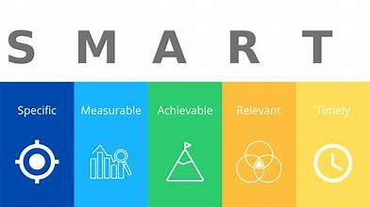
Figure 2: SMART framework (Rahman, 2019)

Key Findings
It is concluded that the recent deterioration of the performance of Green Haven Florists can be achieved mainly due to the technological and strategic gap, which is intensified by the pressure of inflation and the alteration of the consumer behaviour in the UK. The digital transformation is among the suggested strategies that can offer the most efficient and sustainable approach to the reversal of revenue loss and competitiveness in the long term. The Grid Analysis proved the excellence of this strategy regarding the potential of innovation and reaching customers, whereas the Risk Analysis revealed that significant challenges can be addressed with the help of the gradual implementation and the quality-management systems. This initiative will be based on the commitment of leadership, training of the staff and the systematic performance evaluation to success. The current problem solving is based on adaptive decision-making and environmental consciousness. With the help of the idea of continuous improvement, green Haven Florists can reorient its work to the demands of the modern UK market.

References
Brosnan, K. (2025) What is 5W2H and Why It Matters in Manufacturing Excellence -
David Hayden (2025) PESTLE analysis, CIPD. Available at: https://www.cipd.org/en/knowledge/factsheets/pestle-analysis-factsheet/ (Accessed: 4th November 2025).
Fabriq, Fabriq. Available at: https://fabriq.tech/en/2025/07/30/what-is-5w2h-and-why-it-matters-in-manufacturing-excellence/ (Accessed: 4th November 2025).
Heath, C. and Heath, D. (2014) Decisive: how to make better decisions in life and work. London: Rh Books.
Jonathan Hancock (2022) 5 Whys, www.mindtools.com. Available at: https://www.mindtools.com/a3mi00v/5-whys (Accessed: 4th November 2025).
Oakland, J.S. (2014) Total quality management and operational excellence: text with cases. New York: Routledge.
Pennings, H.J. and Hollenstein, T., 2020. Teacher-student interactions and teacher interpersonal styles: A state space grid analysis. The Journal of Experimental Education, 88(3), pp.382-406.
Rahman, M.M., 2019. 21st century skill'problem solving': Defining the concept. Rahman, MM (2019). 21st Century Skill “Problem Solving”: Defining the Concept. Asian Journal of Interdisciplinary Research, 2(1), pp.64-74.
Saugel, B., Grothe, O. and Nicklas, J.Y., 2018. Error grid analysis for arterial pressure method comparison studies. Anesthesia & Analgesia, 126(4), pp.1177-1185.
Shethiya, A.S., 2024. Smarter Systems: Applying Machine Learning to Complex, Real-Time Problem Solving. Integrated Journal of Science and Technology, 1(1).
Stankevich, A., 2017. Explaining the consumer decision-making process: Critical literature review. Journal of international business research and marketing, 2(6).

Appendix

Appendix 1: Grid Analysis Table
Criteria | Weighting (1–5) | Solution A: Digital Transformation | Weighted Score A | Solution B: Customer Retention | Weighted Score B
Cost Effectiveness | 3 | 4 | 12 | 3 | 9
Implementation Ease | 2 | 3 | 6 | 4 | 8
Customer Reach | 4 | 5 | 20 | 3 | 12
Innovation Potential | 3 | 5 | 15 | 3 | 9
Long-Term Sustainability | 4 | 5 | 20 | 4 | 16
Total Weighted Score |  |  | 73 |  | 54

Appendix 2: Risk Analysis Table
What Could Cause a Risk? | Likelihood (1–5) | Impact (1–5) | Risk Factor (L × I) | Preventive / Mitigation Actions | Contingency / Corrective Actions
1. Website development issues (technical errors or downtime). | 4 | 4 | 16 | Conduct phased testing and engage experienced web developers. | Maintain hybrid operations until full system stability achieved.
2. Budget overruns due to unexpected technology costs. | 5 | 4 | 20 | Secure fixed-price contracts and phased payment milestones. | Reallocate short-term reserves; defer secondary features.
3. Staff resistance or skill gaps in using digital tools. | 3 | 3 | 9 | Provide comprehensive staff training and incentives. | Recruit temporary support staff for transition period.
4. Cybersecurity threats or data breaches. | 3 | 5 | 15 | Install secure SSL encryption, antivirus, and regular audits. | Implement data recovery plan and notify customers promptly.
5. Customer dissatisfaction during transition period. | 2 | 4 | 8 | Communicate transparently about service upgrades. | Offer goodwill discounts or loyalty rewards to affected customers.

Appendix 3: Implementation Plan
Initiative (What) | Timeframe (When) | Lead Role (Who) | Status
1. Run a digital capability audit and choose a website build partner. | Month 1 | Owners (Liam & Priya) | Not yet begun
2. Architect, implement, and QA a responsive design online store. and a secure checkout flow. | Months 2–4 | External Web Developer | Queued
3. Upskill staff on digital customer care, order-tracking workflows, and core data-security practices. | Months 3–5 | Owners & IT Trainer | In progress
4. Launch the site and activate co-ordinated social campaigns. (Instagram, Facebook) and Google. Ads. | Month 5 | Marketing Consultant | Scheduled
5. Gather user feedback analyze performance continuously. Measures, and improve procedures. iteratively. | Ongoing (Month 6 onward) | Owners & Staff | In progress

Appendix 4: The Key Performance Indicator (KPI)
Purpose:
To define the main performance measure and demonstrate how it meets the SMART (Specific, Measurable, Attainable, Relevant, Time-Bound) criteria.
The Key Performance Indicator is:
“Increase online sales revenue by 30% within twelve months of implementing the new e-commerce platform.”
Criterion | Explanation
Specific | Focuses on online sales through the newly launched e-commerce website.
Measurable | Tracked through monthly digital analytics and sales reports showing percentage increase.
Attainable | Target is realistic given increased market reach via SEO and online marketing campaigns.
Relevant | Directly addresses the business’s main challenge of declining in-store sales.
Time-Bound | To be achieved within twelve months post-implementation.

