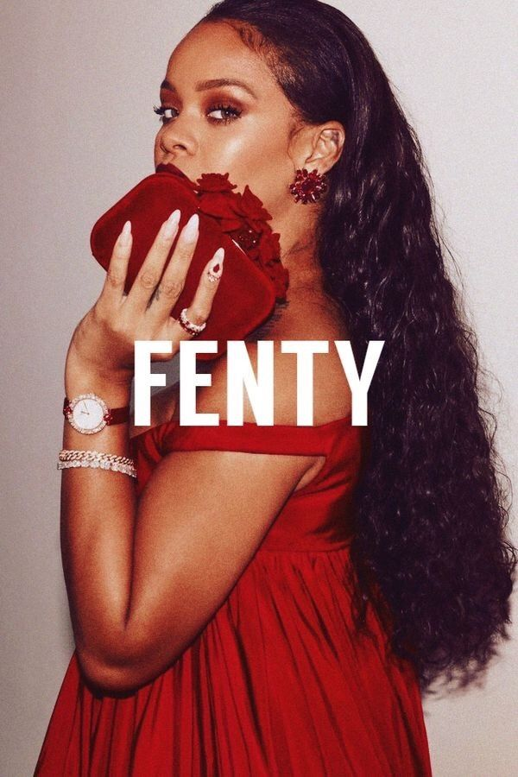 | Definition of an entrepreneur  Tia Thomas (1706468)

Executive Summary

This report will explore and discuss the many definitions that are used to describe an entrepreneur, these definitions will then be taken in to consideration and further applied alongside the motivational theories to justify that the entrepreneur of choice is in fact entrepreneurial. For this report, a study of Robyn ‘Rihanna’ Fenty will be used as the entrepreneur example, an overview of herself and her entrepreneurial efforts will be discussed and further analysed to establish whether she has entrepreneurial qualities. It was found that the term entrepreneurship does not have one focal definition that can apply to all as the term is considered multifaceted and can be subjective to the circumstances. The short overview of Rihanna and her entrepreneurial efforts gave the opportunity to see that during her time as a business woman she has shown that she possesses several qualities typically found with entrepreneurs such as the ability to be innovative and make creative decisions. From this the conclusion was made that Rihanna is an entrepreneur in her own right as she sees the opportunities within markets that she is able to develop and capitalise from.

Table of Contents
Executive Summary 1
1.1. Introduction 3
2.1. What is an entrepreneur 3
2.2 Defining Entrepreneurship 3
3.1. About the entrepreneur 4
3.2. Who is ‘Rihanna’ 4
3.3. Fenty Beauty 5
3.4. Charity Work 5
4.1. Motivational Theories 5
Conclusion 7
References 9

Introduction

The Global Entrepreneurship Monitor released a study in 2017 that states that there are said to be over 582 million people worldwide who are beginning to start up or are currently running their own businesses. (The Hill, 2017) Not all of those people are trying to accomplish the same business goals, however they may all be defined as entrepreneurs in different ways. Barringer & Ireland (2008) discuss entrepreneurship and how it derives from the French term ‘entre’ which means between and ‘prendre’ which to take risks, therefore implying that the term is to describe those who take risks. However, it is argued that entrepreneurship is considered to be more of a multifaced term that can be difficult to define. The purpose of this report is to research and develop a better understanding of the phrase over multiple definitions and theories. An in-depth analysis in to the definition of an entrepreneur will be carried out by reviewing multiple definitions and discussing them in contradiction of each other. An overview of Robyn ‘Rihanna’ Fenty will be discussed with further discussion of motivational theories of an entrepreneur that will be then considered with examples of Rihanna expressing these theories. These examples will be analysed to determine whether she is able to be defined as an entrepreneur.

2.1. What is an entrepreneur

2.2 Defining Entrepreneurship

It can be difficult when trying to define an entrepreneur as there are many different interpretations of what the term could mean. The aim of this discussion is to develop a general understanding of how diverse the functions of an entrepreneur can be. Lowe and Marriott citing Casson (2006) state that entrepreneurship is a ‘multifaceted activity’ as if there is no one specific definition for the term. Cunningham and Lischeron (1991) also have a similar stance as they discuss the idea that entrepreneurs are not one definition and can be categorised in to six school of thoughts each with different beliefs, skills and behaviours. This idea can be better understood when researching the phrase. For example, many people believe that entrepreneurs are born with specific skills such as creativity and the ability to be innovative that allow them to perform well as an entrepreneur. This argument has been expressed as the ability to find gaps within the existing markets and then using the current research to create a new innovative product and thus capitalising from the idea. (Spilling, 1996 as cited in Yeoman, 2004). The theory of entrepreneurs being innovators is also an idea discussed by Hannapi while citing Schumpeter (2015), he believes innovative entrepreneurs can also be considered inventors as he believed that the introduction of new or improved existing products that alter the existing markets is what can define an entrepreneur. For many, it is thought that this intuitive, creative way of thinking is what allows others to become entrepreneurs. However, others believe that entrepreneurship is itself a teachable skill that can be taught to anyone, not only those who possess certain qualities. Wickham (2004) is cited by Lowe and Marriott (2006) stating ‘entrepreneurs are managers making entrepreneurial decisions’, further discussion suggests that this statement implies that entrepreneurs can in fact be made if any managerial figure is granted permission to be more creative with decision making in the workplace. This idea also reinforces the thought that entrepreneurship is largely based off of creative decision making, as initially discussed. If these ideas of innovation and creativity were to represent an entrepreneur, it would position them in Cunningham and Lischeron’s Classical School, this school suggests that entrepreneurship is more about the doing process instead of the owning.
However, some do believe that a person may be labelled an entrepreneur more simply from owning or being handed a business. Carland et al. discuss this matter further and cite Schumpeter stating that entrepreneurs however are distinct from business owners.

3.1. About the entrepreneur

3.2. Who is ‘Rihanna’
Robyn ‘Rihanna’ Fenty is a 30-year-old woman from Barbados, labelled as a businesswoman, philanthropist and singer. Robyn Fenty, better known as Rihanna is most recognised for her music as an international popstar, she grew up in a ‘slightly less than average’ area and was said to have had a slightly difficult childhood with her father having problems with alcohol, drugs and being physically abusive to her mother which then ultimately lead to her parent’s divorce. From this, she turned to singing to escape the problems at home (The Guardian, 2009). The singer was only 16 when she became famous but has since won numerous awards and has been dubbed the ‘best-selling digital artist of all time’. However more recently she has been working on developing her charities and businesses in the fashion and beauty industry.

3.3. Fenty Beauty
In the past, Rihanna has collaborated with brands such as Puma, Armani and River Island by developing lines and in some cases, staying with Puma as head designer (Rihanna Now, 2018). However, in 2017, Rihanna released her own beauty project, a makeup brand called Fenty Beauty. From launch, the brand has been dubbed a game changer in the beauty industry. The line immediately set out with intentions to be as inclusive as possible by selling 40 different foundation shades, to which 10 more shades have been added, from extremely pale to extremely dark with an assortment of undertones in between. The marketing also cohesive with the brands inclusive message used a wide diversity of models of colour, sizes and genders. Fenty Beauty has been a huge success earning $72 million in the first month. Since this launch, many other make up brands have listened to the customers’ demands and followed the footsteps of Fenty Beauty, they have made changes to their products and more specifically their foundation ranges to be more inclusive of all skin colours. The brand has set the standard for competitors as it keeps evolving and developing new products that are challenging the brands, including products such as male makeup packages.

3.4. Charity Work
Rihanna has also made an effort in developing multiple charities, 2006 saw the start of the Believe Foundation, a charity created to help terminally ill children and in 2012 she also founded the Clara Lionel Foundation which was developed in honour of her grandparents. This charity was created to give back to her birthplace of Barbados (Vogue, 2018), to which over $10 million has been utilised to better the community by providing project grants and educational programmes (Fenty Beauty, 2018). For these philanthropic efforts, Rihanna was awarded the Harvard Foundation’s Peter J Gomes Humanitarian Award from Harvard University (Harvard Gazette, 2017).

4.1. Motivational Theories

There are many different reasons why a person may want to become an entrepreneur, Shepherd and Patzelt (2018) discuss the motivational theories of an entrepreneur in great depth and argue that an entrepreneur’s motivation is usually related to the particular opportunity that the person has recognised. For example, the reason may be that a person does not wish to work for another company or person any longer, they wish to work independently and have the opportunity to do so, thus desire for independence may be the main motivator Shane et al. (2003).

When discussing McClelland’s (1961) idea of key competencies and applying Rihanna to the concepts she fits a selection of the criteria such as proactivity, achievement orientation and commitment to others. She provides examples of being a proactive due to her identification of a gap in the market for providing a wider assortment of foundation shades. This problem has been apparent in the beauty industry for years, yet no one had acted upon it. However, she was able to use initiative, take the opportunity to become a market leader and be a company that is able to develop products that competitors follow.
Achievement orientation discusses the ability to see and act on opportunities. As previously stated, she acted upon the opportunity to develop something inclusive and different from what is already offered. Finally, she has a strong commitment to others. She states in an interview that she does not make makeup for herself, she makes it for her friends and her consumers of whom she also considers her ‘friends’. She states how she will try a product on herself and also another person, then if the product does not work for another person then tweaks need to me made.
The discussion also covers social factors, Rihanna shows a social behavioural approach to entrepreneurship with her charity the Clara Lionel Foundation. This, as previously stated, is a charity to give back to her home community of Barbados.
The economic theories Knight (1921) discusses, include factors such as calculated risks. An example of this show by Rihanna was that she took a risk by releasing 40 shades of foundation at the initial launch. Competitor brands do not usually create so many as doing this means higher production costs as there are many different combinations of pigment required to compose the individual colours. However, Rihanna recognised the lack of representation for much darker skin tones and developed shades deep enough to cater for those people. This risk has ultimately paid off and has forced the industry to be more inclusive to keep up with the popularity of Fenty products.

Conclusion

To conclude this report, it was found that the title of an ‘entrepreneur’ is a somewhat difficult subject to narrowly define as there are many different ways of interpreting the topic depending on the person or business. However, from the research gathered it is understood that an entrepreneur can at times be defined as a person who possesses certain qualities; such as creativity and the ability to be innovative. The person could also possibly be starting their own business or may have even be passed a family business. These examples only touch the surface of defining entrepreneurship and are both very different aspects of the term, to which they may define one entrepreneur but not the other. When analysing Robyn ‘Rihanna‘ Fenty, it could be argued that she is an entrepreneur in her own right as she is a passionate businesswoman that has developed an innovative beauty brand and found ways to broaden her business concepts through finding gaps in the market. These qualities are found in multiple entrepreneur definitions such as the idea from Schumpeter (1959) stating entrepreneurs innovate products, and Spilling (1996) also like-minded saying entrepreneurs have the ability to find that gap in the market. Ultimately, Fenty beauty changed the way that other beauty businesses create their products.

Bibliography

Billboard. (2017) 5 Reasons Why Rihanna's Fenty Beauty Was Named One of TIME's Best Inventions of 2017. [Online] Available at: https://www.billboard.com/articles/news/lifestyle/8046279/rihanna-fenty-beauty-time-best-inventions-2017. [Accessed 30 December 2018].

Biography. (2018) Rihanna Biography. [Online] Available at: https://www.biography.com/people/rihanna-201257. [Accessed 22 December 2018].

British Library. (2018) What Is the Definition of An Entrepreneur? [Online] Available at: https://www.bl.uk/business-and-ip-centre/articles/what-is-the-definition-of-an-entrepreneur. [Accessed 30 December 2018].

Clara Lionel Foundation. (2016) New Impact Snapshot Highlights CLF’s Key Milestones. [Online] Available at: https://claralionelfoundation.org/news/new-impact-snapshot-highlights-clfs-key-milestones/. [Accessed 19 December 2018].

Global Entrepreneurship Monitor. (2018) Report. [Online] Available at: https://www.gemconsortium.org/report. [Accessed 30 December 2018].

References

Barringer, B. R. & Ireland, R.D. (2008) Entrepreneurship: Successfully Launching New Ventures, 2nd Ed., Prentice Hall: New Jersey, USA

Carland, J.W., Hoy, F., Boulton, W.R. & Carland, J.A.C. (1984) ‘Differentiating Entrepreneurs from Small Business Owners: A Conceptualization’, Academy of Management Review, Vol: 9, Iss: 2, pp. 354–359

Cunningham, J.B. & Lischeron, J. (1991). "Defining Entrepreneurship", Journal of Small Business Management, Vol. 29, Iss. 1, pp. 45.

Fenty Beauty. (2019) CLARA LIONEL FOUNDATION. [ONLINE] Available at: https://www.fentybeauty.com/clara-lionel-foundation. [Accessed 26 December 2018].

Lowe, R. & Marriott, S. (2006) Enterprise entrepreneurship and innovation : concepts, contexts and commercialization Oxford; Burlington, MA: Elsevier Butterworth-Heinemann.

Rihanna Now. (2018). Bio. [Online] Available at: http://www.rihannanow.com/bio/. [Accessed 23 December 2018].

Hanappi, H. (2015) Schumpeter and Goodwin. Journal of Evolutionary Economics. [Online] Vol: 25 Iss: 1, pp. 277-291. Available at: https://search-proquest-com.ezproxy.uwtsd.ac.uk/docview/1680165819?rfr_id=info%3Axri%2Fsid%3Aprimo [Accessed January 1 2019]

Knight, F.H. (1921) Risk, Uncertainty and Profit. New York: Harper.

Shane, S., Locke, E. A. & Collins, C. J. (2012) Entrepreneurial Motivation. Human Resource Management Review. [Online]. Vol: 13 Iss: 2, pp. 257-279. Available at: https://digitalcommons.ilr.cornell.edu/cgi/viewcontent.cgi?article=1840&context=articles [Accessed 2 January 2019].

Shepherd, D.A. & Patzelt, H. (2018) Entrepreneurial Cognition: Exploring the Mindset of Entrepreneurs. Palgrave Macmillan

The Guardian. (2009) Rihanna: 'That's a part of my life I want to throw away'. [Online] Available at: https://news.harvard.edu/gazette/story/2017/02/rihanna-named-humanitarian-of-year/. [Accessed 26 December 2018].

The Harvard Gazette. (2017) Rihanna named Humanitarian of Year. [Online] Available at: https://news.harvard.edu/gazette/story/2017/02/rihanna-named-humanitarian-of-year/. [Accessed 23 December 2018].

The Hill. (2017) The 582 million entrepreneurs in the world are not created equal. [Online] Available at: https://thehill.com/blogs/pundits-blog/economy-budget/323586-the-worlds-582-million-entrepreneurs-are-not-created-equal. [Accessed 19 December 2018].

McClelland, D.C. (1961) The Achieving Society University. New York: MacMillan

Vogue. (2018) Rihanna, singer and beauty entrepreneur. [Online] Available at: https://www.vogue.com.au/gamechangers/beauty-and-health/rihanna-singer-and-beauty-entrepreneur/news-story/e1408d469fe5a4e8c194b0ff261e85b6. [Accessed 26 December 2018].

Yeoman, I. (2004). Festival and Events Management: An International Arts and Culture Perspective, Oxford; London: Elsevier Butterworth-Heinemann.

