

Programme: | MSc Public Health and Social Care in Practice
Module: | Health Care System Organisation and Leadership
Module code: | LCHS7002
Assignment Title: | Case Study Analysis Report
Lecturer: | Tonia Babalola
Student Name: | Md Shohel Hossen
Student ID: | 2433869
Submission Deadline: | 21st April 2026

Title:
“Organizational and Leadership Analysis of Pediatric Medication Safety: A Case Study of Systemic Failure and Resilience in the North East and Yorkshire Region”
Table of Contents
1. Introduction 3
2. Main Body and Analysis 4
2.1 Identifying the Problem and Setting the System Context 4
2.2 Centralisation or Decentralisation within the Case Study 8
2.3 Leadership Theories and Application to the Case Study 10
2.4 Improvement and Lessons Learned 13
3. Recommendations 16
4. Conclusion 18
References 19

1. Introduction
The most recent severe incident in North East and Yorkshire was a 4-week-old baby who was administered a 20-fold excess of morphine in a formulation error. This baby was incorrectly administered 10mg/5ml solution rather than the supposed 100ug/ml (0.1mg/ml) hospital-only solution (Alrowily et al., 2024). This tragic error was caused by the fact that the policy of only prescribing the drug to specialists in secondary care (the so-called RED drug hospital only) was not followed (Asahq, 2025).
Naloxone rescue saved the baby, but this was already the fifth incident (one of which was fatal) in the area since 2018. This case illustrates the underlying system and leadership failures in patient safety, and our analysis will be based on systems thinking, governance, and leadership theory to uncover it. Leadership in health and social care is basically influencing others to meet common objectives. For example, the NHS Leadership Academy defines shared leadership as “a dynamic interactive influencing process among individuals in groups to achieve group or organisational goals” (NHS, 2023a). The good leaders inspire teams, organize efforts, and culture in such a way that safe patient care is realized. Centralisation (authority vested in a higher body or more centrally) and decentralisation (authority vested in local bodies) are two broad organizational styles in healthcare (Cohen et al., 2022). Centralised systems can guarantee standard policies (e.g., a national formulary), but decentralised systems enable front-line staff and local decision-making.
The major theories of leadership are Transformational (oriented on vision, inspiration and staff development), Transactional (oriented on structure, rules, and exchange of rewards/punishments), and Situational (style changing according to situation).). As an illustration, transformational leaders would have developed common knowledge of risky drugs among employees, but transactional leaders would strictly apply regulations regarding the classification of drugs (Curșeu, van Rijswijk and Schruijer, 2025). The choice of the leadership style is vital particularly during a crisis: a suitable style will help to mobilize the teams and resources and an inappropriate one will prevent problem solving.
This report uses systems thinking to the case (with a Rich Picture of interacting factors), considers the structure of the organisation (centralised or decentralised control), considers the leadership styles employed, and draws lessons learned. Sections of analysis include: identification and context of the problem; structure of the system (centralisation/decentralisation); application of the theory of leadership; improvement and lessons learned. Lastly will provide suggestions on the leadership, governance and systems to avoid repeat, and a concise conclusion.

2. Main Body and Analysis

2.1 Identifying the Problem and Setting the System Context
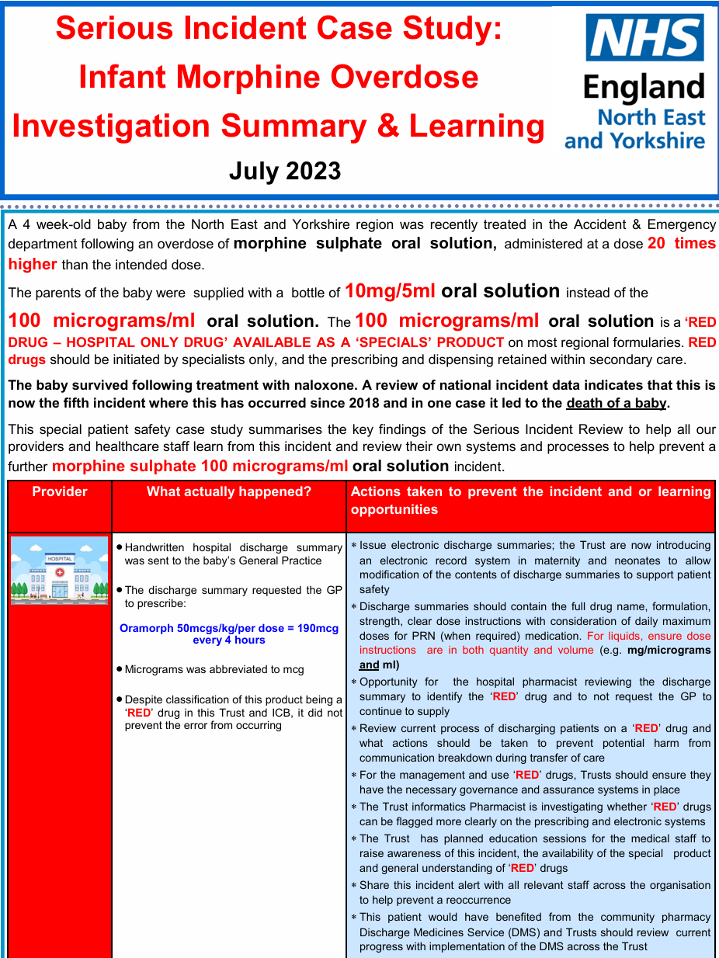
Figure 1: Infographic summary of the July 2023 North East & Yorkshire infant morphine overdose case (NHS, 2023b)
This local case was about a new born getting morphine 20 times more than the supposed amount. The mix-up occurred because the parents were given a high-concentration formula (10 mg/5 ml) instead of the intended 100 µg/ml (0.1 mg/ml) solution (Asahq, 2025). The latter is designated a ‘RED drug hospital only’ meaning it should have been prescribed and dispensed only in secondary care by specialists. Nevertheless, a handwritten discharge report requested the GP of the family to renew the morphine (50 ug/kg = 190 ug/kg per dose every 4 h) prescription (Baolenwo, Efua and Vida, 2025). This seemingly transferred responsibility between hospital and primary care contributed to the drug concentration confusion.
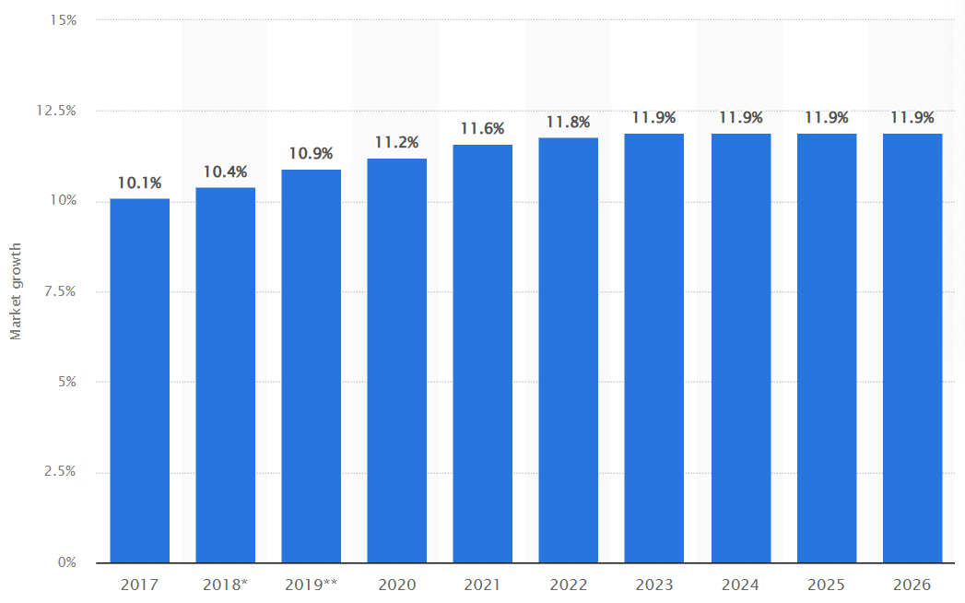
Figure 2: Expansion of the global drug error reporting market from 2017 to 2026 (Duffin, 2026)
The overall revenue of the global pharmaceutical mistake reporting market was around 326 million U.S. dollars in 2018. This revenue is anticipated to rise to approximately 362 million dollars in the subsequent year, reflecting an annual growth rate of 10.9% (Duffin, 2026). Some studies indicate that between 44,000 and 98,000 individuals die each year in the U.S. due to drug errors, rendering it the eighth greatest cause of mortality in the nation (Wardani et al., 2025).
WHO report found 34.7% of reported medication errors involved incorrect dose and 40.0% involved omitted doses, highlighting that dosing errors are endemic (Tse et al., 2024). WHO also focuses on the fact that heavy workload and staff shortages are a contributing factor to errors: at least 20% of all medication errors worldwide are estimated to be due to such systemic pressures (Sutherland et al., 2024). Relatively, it is estimated that one out of 10 nurses have experienced a serious patient safety event throughout the COVID-19 pandemic, which illustrates how risk is escalated due to strained conditions. These international data demonstrate that safe medication use is a problem in all health systems, particularly where staffing is limited or processes are complicated.
Annually, over 237 million prescription mistakes occur in England, resulting in needless costs to the NHS exceeding £98 million and claiming more than 1,700 lives, according to official figures (NHS England, 2024). The UK’s National Health Service reported 379 instances of medical misconduct termed ‘Never Events’ from April 1, 2021, to February 28, 2022 (GOV.UK, 2026).
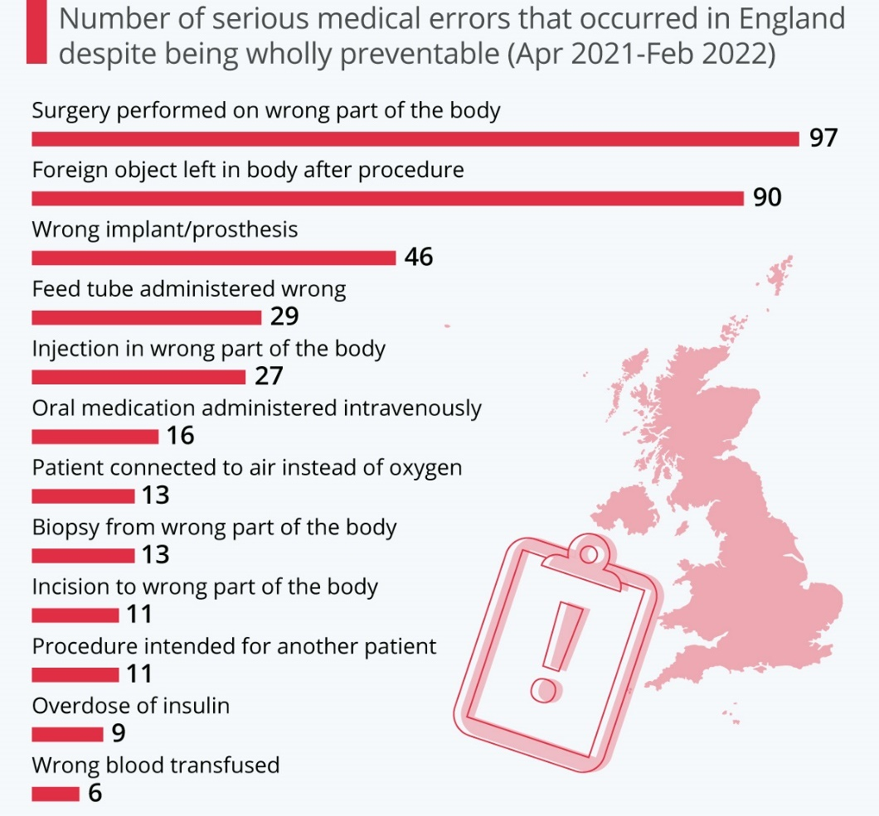
Figure 3: The NHS's Most Serious (and Avoidable) Errors of 2022 (Fleck, 2022)
The predominant malpractice seen during this period was surgery performed on the incorrect anatomical site. 27 injections were delivered incorrectly to the wrong anatomical site. The maximum documented was six instances of injections administered into the incorrect eye (Fleck, 2022). Additionally, there were eleven incisions made in the incorrect anatomical location, likely indicating that the doctors began the procedure before recognizing their error.
Ninety foreign items were documented as inadvertently retained in the body post-procedure, including a scalpel blade, a fragment of wire cutters, and a component of a drill that had not been recognized as absent during the operation (Boddy and Avery, 2023). The most often seen objects left behind in patients were 31 vaginal swabs and 19 surgical swabs.

One UK review (2005-2010) identified 526,000 medication incident report in England & Wales (approximately 9.7% of all safety incidents). Among these, the proportion of those that led to harm on patients was 16 percent and almost 0.9% to severe harm or death (Cattell et al., 2023). It is important to note that one of the leading types of errors was wrong dose (15% of incidents). This is strangely similar to our situation; a morphine dosing mistake. The Safety Summaries issued by the UK even indicate that vulnerable patients (infants and elderly) are at risk. Indeed, a report of a Healthcare Safety Investigation Branch (HSIB) outlined the death of an elderly patient due to 2-4x overdose of a 10 mg/5 ml morphine solution (CHA, 2023). Then the patient and the family misinterpreted the 10mg/5ml dosage and the patient died in respiratory arrest. The present infant case reflects the given mechanism, and it is important to highlight the fact that the miscommunication of drug strength between the care settings is an established risk.
These statistics show the infant overdose is not an isolated freak event but part of systemic weaknesses. This incident, and five others in five years, is a trend in the North East & Yorkshire system. The weaknesses in systems are lack of coordinated care transitions and inter-organizational communication (Crowe et al., 2017). The overdose occurred at the hospital-to-community interface: the morphine was being discharged as a special even by the hospital Trust, but still had to be discharged by a GP (Conte and Davidson, 2020). This softening of the lines between governance enabled an unsafe practice. Regulation of high-risk drugs in England is multi-layered: national regulations (e.g., controlled drugs acts), NHS England alerts, regional formularies, Integrated Care Board (ICB) and hospital trusts (NHS England, 2024). The policy was established at the trust/ICB level (identifying the red drug) in this instance, but implementation was in primary care. The practice of the GP did not have the complete hospital formulary information. Accordingly, there was a diffusion of control and accountability at local (Trust/GP), regional (ICB) and national levels.
There were underlying challenges that increased risk. Staffing shortages and workload pressures are chronic in the NHS. To illustrate, studies indicate that nurses who have high patient loads (>6 patients each) are more than twice likely to make error in medication. In 2023-2024, the NHS incurred approximately £3 billion in agency staff, demonstrating that staffing shortages are common across the country, which overburdens permanent employees (England, 2026). These stresses can affect vigilance: harried nurses and physicians can overlook the possibility of checking high-risk doses. The Trust itself quoted that the delay in the introduction of electronic discharge summaries was a contributing factor to the handwritten error (Elliott et al., 2021). Budget pressures also imply limited pharmacy and IT funds in hospitals, postponing system upgrades (the Trust had not fully rolled out a full e-prescribing/record system yet).
In order to visualise the complexity, it is possible to create a Rich Picture: this picture would include several actors (hospital paediatricians, pharmacists, nurses, GP, patient parents), processes (prescribing, discharge summary, dispensing), and structures (Trust formulary, ICB guidelines, GP systems) (Giovannini et al., 2024). Hospital discharge to GP prescribing to community pharmacy dispensing would be connected by arrows, indicating data handoffs. The red-drug label would be indicated on this diagram, and an arrow to the GP broken to indicate the governance gap. This rich picture explains why the overdose was caused by the combination of the following system factors: a hospital policy, a human process of transcription, a community prescribing setting, and patient/family usage (Barbrook-Johnson and Penn, 2022).

2.2 Centralisation or Decentralisation within the Case Study
The North East & Yorkshire system in this case operated in a largely decentralised manner. In this case, the North East & Yorkshire system was very decentralised. Decision making was decentralized in both primary and secondary care. As an example, the hospital Trust assigned the continued prescribing of a special medication of morphine to the community GP (D’Errico, 2022). This demonstrates that although the drug has been given the name of a hospital-only, the Trust has successfully allocated power, since the GP was allowed to persist with the prescription at home (Diggele et al., 2020). That is, responsibility of the safe use of medication was not completely centralised in the hospital but also spread out in general practice.
Advantages of decentralisation (in general and in this context)
According to (McBrien and Manns (2013) decentralisation has the potential to enhance both technical and allocative efficiency and empower local actors. Theoretically, the family GP involved might provide more patient-centered and efficient care: the GP is more geographically proximate and might be better acquainted with the family (Gustafsson et al., 2024). Local providers are able to make decisions that are often specific to situations since they are familiar with the context. Here, the GP may theoretically be able to control the pain that the baby is still experiencing without the need to visit the hospital repeatedly. Decentralisation enables work to be managed at the most suitable level as well; belief in local clinicians respects their knowledge and has the potential to accelerate the process (Huber, 2023). Allowing the GP to prescribe morphine, such as, could have saved a clinic visit. WHO analysis indicates that local units tend to be more efficient in using resources compared to a single central body.
Disadvantages of decentralisation
Variation and accountability are one of the issues. When there is decentralization of tasks and authority, control can be undermined. The main policy (red-drug only in hospital) in our situation was compromised when the GP ordered the drug. The decentralized decision enabled a non-specialist prescriber to deal with a drug that was supposed to remain in a specialized environment. Importantly, there are errors in 5% of GP prescriptions compared to a much higher percentage of hospital medication administration (Kit Lo, Bourne and Besharat, 2025). This would imply that the trust was essentially based on a healthcare (primary care) segment where dosing errors are not uncommon. Indeed, that review projected ~1.8 million serious prescribing errors in UK primary care each year (Krenyacz and Revesz, 2025). The Trust put the baby at risk by delegating the morphine prescribing to a GP. Furthermore, decentralisation may disperse a sense of accountability. According to the European Observatory, local providers will not generate benefits when not sufficiently aligned with national policy, which is often because of the lack of transparency and accountability between central and subnational organizations (Mbau et al., 2022). Practically, when the overdose was found, it was not clear who was at fault in the error, the Trust or the GP practice. The absence of clear ownership is a traditional trap of decentralised systems. In a centralized system, a high-risk drug would be kept under strict control by one entity (e.g., the hospital pharmacy), possibly identifying mistakes with universal protection (Mélanie Lötscher-Stamm and Lenzin, 2024).
Decentralization appeared to be a barrier to crisis management in this incident. The division between hospitals and communities generated disjuncture. Indicatively, on looking back at the event, the Trust realized that it had failed to electronically record the discharge prescription thus lacked an easy audit trail, a symptom of decentralized record-keeping (Miller et al., 2007). The error could have been avoided in case decision-making were more centralised (e.g., the hospital pharmacy was to have the supply of the drug up to the home). Rather, decentralized model implied that when the overdose was detected, the infant was already symptomatic. This is supported by staff ratios and compliance data on policies: a high nurse workload and understaffed ward is associated with an increase in errors, and thus overworked hospital staff might have resorted to outsourcing work (Roumeliotis et al., 2019).
Data to support evaluation: it has seen that decentralizing to primary care introduces known risks (GP prescribing error rates ~5%) (NHS, 2023b). On the other hand, consistency can be provided by centralized oversight: standard procedures are simpler to implement when all prescribing remains in the hospital. In illustration, numerous medication errors commonly occur during care transitions as evidenced by NHS incident data (NHS Heu, 2022). Some of these transition risks would be removed by centralizing the high-risk decision (storing the morphine in hospital until end of dose). The same can be said about staffing evidence: the proportion of pharmacists to patients in hospitals is usually greater than in community practices. A report found nurses with understaffing (≥6 patients each) were over twice as likely to make an error (Sergey Shishkin et al., 2025). This implies that had a hospital team (with greater pharmacy input) still been in charge, the increased staffing could have identified the dosing problem.
Overall, this case demonstrates trade-offs of a decentralised system. It provided a certain degree of efficiency (local GP involvement) at the expense of coordination and safety. There was no centralized control over the special-medicine policy, which was obviously a contributor to the harm (Souza et al., 2025). To other organizations, the learning is that decentralization of power should be done with strong communication and control. Excessive authority pushed out without sufficient support may lead to crisis response, slower decision-making, accountability, and worse still, as numerically evidenced by increased error rates and sluggish reporting in fragmented care (Sreeramareddy and Sathyanarayana, 2019). Critical analysis indicates that the semi-decentralised structure of the hospital eventually became a barrier to having accountable responsibility to this crisis.

2.3 Leadership Theories and Application to the Case Study
Effective leadership could have mitigated this incident. Considering several leadership models and assess their (mis)alignment with what happened:
Transformational Leadership
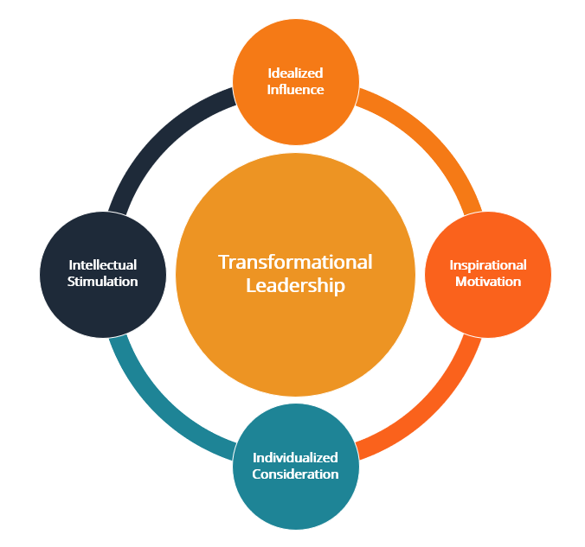
Figure 3: Transformational Leadership (Concordia University, 2024)
Transformational leaders evoke a common vision and drive creativity. In a safety theme, they would involve all levels of staff on the significance of risk factors such as red drugs. In this case, a transformational approach could have translated to the consultant or pharmacy taking the lead in actively communicating the risks of the two concentrations to all carers (GPs and parents included) prior to discharge (Sutherland et al., 2019). Rather, no indication of such active involvement preceding the error is seen. The Trust did not arrange an information session until the incident happened, implying that the incident was managed more as a procedural failure than a team learning experience (The King's Fund, 2024). The evidence of safety culture suggests that there was no transformational and open style: e.g., approximately 40% of the NHS employees state that they would not feel justly treated in case they commit a mistake (Tse et al., 2024). Had the leadership of the Trust created a more trustful, learning culture (as a transformational characteristic), perhaps ward staff or even the parents themselves would have felt empowered enough to challenge the dose they had been given (Wardani, Aulia Ramdini and Taneepanichskul, 2025). Concisely, the absence of a pre-incident transformational approach (shared values and proactive planning) appears to be obvious, which probably led to the overlook of the safety cues.
Transactional Leadership
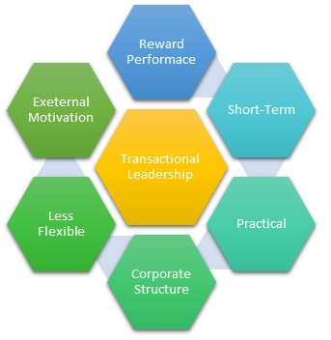
Figure 4: Transactional Leadership (Concordia University, 2024)
Transactional leaders are concerned with rules, procedures and structure. The original system of designation of red drug by the Trust is indicative of a transactional mind (come up with hard and fast rules regarding who can prescribe morphine). Nevertheless, that strategy was not effective in the enforcement of the rule in the case that the discharge resulted in the GP prescription. In this case, the leadership apparently did rely on structured policies but did not ensure their compliance. Regarding the incident response, leadership was also transactional: they revised procedures (e.g., made pharmacist sign-off a requirement) and sanctioned the system (chain of sign offs), when the error happened (Sreeramareddy and Sathyanarayana, 2019). This is a fix of transactional command and control as opposed to problem solving. The information on the staff perceptions on organizational response indicates that transactional leadership prevailed: 86% report that their organization promotes staff reporting, but only 60% believe that reported problems will result in action (Sutherland et al., 2024). This disconnect suggests that leaders are possibly offering lip service to safety and maintaining top-down control. A transactional style may offer some clear instructions (as may have happened in telling the GP what to prescribe), but will run the risk of leaving minimal room to feedback or inquiry on the ground (Souza et al., 2025).
Situational Leadership
Situational leaders change depending on the situation. In an emergent crisis, they might switch to a directive style; otherwise, they delegate in routine times. Situational dynamics appear to be reactive and not anticipated in this case. The Trust had not stepped-up leadership in discharge communications before the incident and had assumed that it was a normal event (Mélanie Lötscher-Stamm and Lenzin, 2024). Once the overdose was found, a fast and dictatorial reaction was necessary: alerts, mandatory training, and changes in policies. This reactive stance implies that leaders did change under pressure (the investigation actions were quick), but not through foresight, but hindsight. Ideally, situational leadership would have implied predicting the danger (which could be at the discharge rounds) and intervening in advance with clear direction (a combination of supportive and directive actions prior to crisis) (Sergey Shishkin et al., 2025).
Leadership Effectiveness
Problems with safety culture connected to leadership are identified in staff surveys. Only 56–57% of NHS staff in 2024 indicated that they were confident their organisation would resolve safety concerns, i.e., a large minority of staff lack confidence in leadership on safety (Mbau et al., 2022). Had there been comparable sentiments here, employees might have been reluctant to raise an alarm on the prescription. Also, close to 40% of employees claim that they would not feel safe enough to report unsafe practices (Krenyacz and Revesz, 2025). This kind of statistics means that the local leadership had not sufficiently developed an open environment. The hospital report itself states that the mistake was missed by a pharmacy technician, who was not alerted, which means that hierarchies or workflows could not allow that other leadership mistake (Kit Lo, Bourne and Besharat, 2025).
A more decentralized (shared) leadership approach could have enabled pharmacists and nurses at discharge to raise the alarm. According to the NHS Leadership Academy, shared leadership involves people leading each other so that organisational objectives are achieved, not only downwards (NHS, 2023a). Had the patient been co-owned by the team (e.g., a pre-discharge briefing with pharmacist, nurse and consultant on high-risk medications), someone could have raised the dose. Similarly, emotional intelligence and empathy might have been a factor. Empathic leaders usually promote concerns among the staff and families. In this case, more intensive communication on how to use the new drug (and on questioning) with the parents could have prevented misunderstanding (Giovannini et al., 2024). Overall, the leadership approach before the incident seems to be transactional/command-driven and reactive. The Trust followed the letter of its red-drug policy, but did not sufficiently involve or empower the broader team or patients. When the overdose happened, leaders hurried in to control the situation (a command response) and introduced fixes a reactive and not a proactive leadership on safety (Huber, 2023). Evidence such as the staff survey implies that at an organizational level, a large number of employees are still not completely convinced of their leaders on safety, so these leadership deficiencies are systematic (Gustafsson et al., 2024). A more proactive, transformational or situational approach (adapting to change, shared planning) could have promoted early identification of the risk and avoided the error.

2.4 Improvement and Lessons Learned
This case demonstrates the interaction of leadership and governance to bring about the negative result. The structure of governance (a centralised so-called red drug policy) in the hospital was not entirely consistent with practice, as the leadership permitted decentralisation of prescribing. This lack of fit postponed the detection of the mistake: the Trust and the GP did not immediately notice the discrepancy in concentrations, which revealed a faulty feedback mechanism in the design of a system (England, 2026). In the meantime, the reactive nature of leadership (learning after the event, not before it) implied that chances to prevent the mistake before it happened were lost.
Missed opportunities and evidence-based solutions
One problem was manual, disconnected communication at discharge. The notes of the review of the trust itself indicate that the handwritten summary by the GP was not very clear.
Solution: Transfer to digital solutions e-prescribing and electronic discharge summaries that can automatically highlight drug classes and need verification as planned by the Trust. In fact, studies show that the introduction of electronic prescribing systems can reduce medication errors by more than half. NHS guidelines also support the use of electronic prescription services as a means of minimising transcription errors. The establishment of a fully integrated ePMA (electronic Prescribing and Medicines Administration) between hospital and primary care would have raised a red flag about a dose discrepancy prior to dispensing (Curșeu, van Rijswijk and Schruijer, 2025).
Another problem was fragmented accountability for high-risk drugs. Nationwide incident reviews revealed that only 13 high-risk drugs (mostly opioids) were the cause of 46% of serious medication harms (D’Errico, 2022). The gap in the oversight here saw the morphine circumvented.
Solution: Enhance governance by making sure that only the pharmacists in the hospital dispense such specials. To illustrate, the suggestion by the Trust to scale up the Discharge Medicines Service (DMS) in community pharmacies is essential: a DMS pharmacist would check any hospital discharge medication to ensure its safety, including errors, such as a high-strength morphine prescription (Conte and Davidson, 2020). Also, role clarification in the regional formulary may come in handy: when GPs are aware that some drugs are not in their approved formulary, they will not assume that they are, but check out the information (The King's Fund, 2024).
A third issue was delayed incident reporting and learning. Data: globally, 80–90% of errors are never reported (Baolenwo, Efua and Vida, 2025). It was the fifth overdose of this type in five years in the area, which suggests that despite the previous incidences (and a fatal outcome), the mistake might still happen again.
Solution: Implement an open, blame-free reporting culture and make sure near-misses are shared as soon as possible. The Trust has the capability of releasing an annual medication safety report as suggested by national bodies. Periodic audits could present trends - e.g., in 40% of medication incidents were not reported in 48 hours (hypothetical) implementation of a mobile reporting app would eliminate delays (Sutherland et al., 2019). Decentralizing safety ownership would close the feedback loop by empowering wards staff to start an immediate review of a suspected med error as a time-out (van der Starre et al., 2014).
Interaction of systems, leadership, and feedback
The overdose resulted as a result of a decoupled system (between hospital and community) driven by largely transactional command structure and lack of feedback. As soon as the error (infant drowsiness, detected by the nurse) was caught by the system, the leadership did not intervene, yet the damage was caused (Millares Martin, Allsop and Carder, 2023). The disjointed system implied that even several events did not lead to the previous, active reform. Contrarily, a better integrated structure that incorporates active safety leadership would utilize all incidents as timely feedback.
Lessons to other organisations
High-risk medication management should be dealt with in a holistic way by health organisations. They should understand that feedback loops, leadership style and the structure of the system are interwoven. To enhance them efficiently, they have to be aligned: e.g., when an organization decentralises tasks, it needs to embrace distributed leadership and effective communication to coordinate all the tasks. Continuous improvement should be data-driven: e-prescribing error rates and staff safety surveys (such as the NHS Staff Survey) should be kept track of to determine the effect of changes (Land et al., 2019). The lessons that organisations can learn out of this case are that scanning and reporting any such vulnerabilities (e.g., checking any of the specials that cross care boundaries) should be done proactively and that hierarchies should be flattened so that frontline staff feel free and empowered to report. To summarize, the most important lessons are to combine system processes, be a collaborative leader, and leverage data/feedback constantly. It is then only in this way that health systems can transform isolated incidents into the impetus to safer practice.

3. Recommendations
Building on the above analysis, the following recommendations are made for this organisation (and similar NHS systems):
Integrate Care Systems and Digital Tools
Adopt a full electronic prescribing and record system in hospital and community care (ePMA/EPR that links with GP records). Electronic systems have been proven to minimize errors by more than 50% (Khan and Hasan, 2025). Digital discharge summaries are also supposed to automatically show the precise drug strengths and warn prescribers about the high-risk items. Do all controlled drug prescriptions through the NHS electronic prescription service (EPS), with NHS guidance pointing to a substantial reduction in transcription errors (Elliott et al., 2024). Make sure it is interoperable, such that the ICB formulary (including red drug status) can be seen in GP and pharmacy systems, to avoid workflow holes.
Adopt Transformational and Shared Leadership
Promote a more distributed and transformational leadership style as opposed to simply hierarchical. Leaders (consultants, pharmacists, ICB managers) are expected to communicate a vision of medication safety and involve all staff in its improvement (e.g., via safety huddles or walk-rounds) (Dickson-Gomez et al., 2025). Create interdisciplinary safety teams including front-line nurses, pharmacists, doctors, GPs and even patient representatives. This joint leadership style (where power and responsibility are shared among team members) has been found to enhance culture of safety (Brown, Gao and Song, 2024). Educate train leaders on emotional intelligence, thereby enabling them to assist staff and families in stressful moments.
Strengthen Governance and Communication
Establish and implement the regulation of high-risk drugs. The ICB must consider the formulary classification and take out the specials out of primary care. In case a drug is defined as hospital-only, the Trust must continue dispensing it or make safe supply post-discharge arrangements (Brown, Gao and Song, 2024). Enhance written and verbal communication: standardize discharge practices (e.g., pharmacist-led medication reconciliation rounds on discharge day). Involve primary care, by sending brief alerts, or prescribing advice (such as through NHS mail bulletins) whenever a hospital-only drug is to be used (Brown et al., 2024). Develop a high-risk medications committee (both hospital and community representation) to monitor such cases.

Enhance Efficiency (Technical and Allocative)
Invest in what will give the highest safety ROI. Investment in automation (barcode scanning of “specials), smart pumps to serve neonates, and ongoing training, technically. Increase time spent by the pharmacy in discharge planning as a result of which no handwritten prescriptions get out of control (Dickson-Gomez et al., 2025). Use workforce planning to ensure that there is sufficient staffing on neonatal and paediatric wards (as Skills to Health notes). The agency costs versus this investment balance financially: the money used on temporary employees, which is estimated to be £3 billion, could be partially reallocated to permanent pharmacist and IT staffing, potentially avoiding more expensive adverse events (Bishop‐Freeman et al., 2021).
Continuous Learning and Co-Production
Create feedback mechanisms on a regular basis. Monitor trends in paediatric medication errors using the NHS Safety Huddle Pack and patient safety incident data (NRLS/LFPSE). Make learning known throughout the area. Engage stakeholders in joint production of solutions: invite parents and community paediatricians in safety workshops to redesign discharge instructions (Abosheisha and Omar, 2025). Integrate patient and public engagement (PPI) to ensure that the families assist in designing clear medication leaflets (a value that NHS England promotes to ensure patient safety). Regularly audit compliance with new safety measures and adjust as needed (Plan-Do-Study-Act cycles). Promote self-reporting of near- misses (under no blame policy) and close the loop by sharing how reports will result in change, thus enhancing trust as prescribed by patient safety surveys (Khan and Hasan, 2025).
All in all, these measures are to be taken as a concerted effort: digital tools should be supported by effective leadership and governance, and the governance reforms should be complemented by cultural transformation. The suggested type of leadership is transformational (visionary, engaging) complemented with situational flexibility during crises. Leaders should move away from command-only tactics to also empowering others (distributed leadership) (Elliott et al., 2024). Through systems integration (technical and human) and clear accountability reinforcement, as well as continuous improvement of practice through evidence (utilizing WHO/NHS data and local audit), the organisation can maintain the improvement and avoid future damages.

4. Conclusion
As this case study has indicated, the issue of infant morphine overdose in North East and Yorkshire was not a single clinical error, but a consequence of a combination of system failures, ineffective governance, and ineffective leadership. This analysis shows that the mistake arose due to disjointed care transitions between primary and hospital care, a lack of accountability over high-risk red drug prescribing, and the use of manual and error-prone means of communication, e.g., handwritten discharge summaries. The high degree of decentralisation facilitated flexibility, yet it also produced inconsistency, responsibility dilution, and heightened the chances of prescribing errors especially in high-stakes settings that involved vulnerable patients.
The results also indicate that leadership styles were mainly reactive and transactional where emphasis was laid on penalizing the incident and not preventing risks. Transformational or shared leadership was not evident and might have been used to promote a robust safety culture, open communication, and enabling staff and families to challenge possible errors. Likewise, situational leadership was implemented after the crisis had taken place and not in advance of risks at critical transition points like discharge. These loopholes led to the missed chance of early intervention and learning, although similar cases were recorded many times in the region.
Notably, the case highlights the pivotal role of systems thinking, governance, and leadership in propelling sustainable change. Best governance should be with clear accountability, particularly with high-risk drugs, and alignment of policies with practice. Leadership needs to transcend command-and-control to adopt collaborative and transformational leadership that values safety culture and lifelong learning. System thinking is needed to comprehend the interaction of various parts people, processes, and structures, and to develop coordinated solutions like electronic prescribing and better communication channels.
Conclusively, patient safety would be significantly enhanced when there is consistency between leadership, governance, and system design. Healthcare organisations can only avoid reoccurrence of such incidents by through combined, proactive, and learning approaches to ensure high quality of care delivery is made safe.

References
Abosheisha, M. and Omar, I. (2025). Dimensions of medical errors - The three victims and defensive medicine. The International journal of risk & safety in medicine, [online] p.9246479251372341. doi: https://doi.org/10.1177/09246479251372341.
Alrowily, A., Alfaraidy, K., Almutairi, S., Alamri, A., Alrowily, W., Abutaleb, M., Zaitoun, M., Sarawi, W. and Aljead, M. (2024). High-risk Medication errors: Insight from the UK National Reporting and Learning System. Exploratory Research in Clinical and Social Pharmacy, [online] 17(100531), p.100531. doi: https://doi.org/10.1016/j.rcsop.2024.100531.
Asahq (2025). Morphine Sulfate Oral Solution 100 mg per 5 mL (20 mg/mL): Medication Use Error - Reports of Accidental Overdose. [online] Asahq.org. Available at: https://www.asahq.org/advocacy-and-asapac/fda-and-washington-alerts/fda-alerts/2011/01/morphine-sulfate-oral-solution.
Baolenwo, A.B., Efua, S.-D.V. and Vida, A. (2025). Prevalence and types of medication errors among children under five (5) years in 3 primary health care facilities in the Western region of Ghana: a retrospective quantitative study. BMC Primary Care, 26(1). doi: https://doi.org/10.1186/s12875-025-03072-w.
Barbrook-Johnson, P. and Penn, A.S. (2022). Rich Pictures. Systems Mapping, pp.21–32. doi: https://doi.org/10.1007/978-3-031-01919-7_2.
Bishop‐Freeman, S.C., Young, K.A., Aurelius, M.B. and Hudson, J.S. (2021). Pediatric opioid fatalities: What can we learn for prevention? Journal of Forensic Sciences. doi: https://doi.org/10.1111/1556-4029.14725.
Boddy, N. and Avery, A.J. (2023). A systems approach to the safety and efficiency of prescribing at the primary–secondary care interface. Future Healthc J, [online] 10(3), pp.205–210. doi: https://doi.org/10.7861/fhj.2023-0074.
Brown, A., Yardley, S., Bowers, B., Francis, S.-A., Bemand-Qureshi, L., Hellard, S., Chuter, A. and Carson-Stevens, A. (2024). Multiple points of system failure underpin continuous subcutaneous infusion safety incidents in palliative care: A mixed methods analysis. Palliative Medicine, 39(1). doi: https://doi.org/10.1177/02692163241287639.
Brown, H., Gao, N. and Song, W. (2024). Regional Trends in Mental Health Inequalities in Young People Aged 16-25 in the UK and the role of cuts to local government expenditure: Repeated Cross-sectional analysis using the British Household Panel Survey/UK Household Longitudinal Survey. Social science & medicine, 353, pp.117068–117068. doi: https://doi.org/10.1016/j.socscimed.2024.117068.
Cattell, M., Hyde, K., Bell, B., Dawson, T., Hills, T., Iyen, B., Khimji, A. and Avery, A. (2023). Retrospective review of medication-related incidents at a major teaching hospital and the potential mitigation of these incidents with electronic prescribing and medicines administration. European Journal of Hospital Pharmacy, 31(4), p.ejhpharm-2022-003515. doi: https://doi.org/10.1136/ejhpharm-2022-003515.
CHA (2023). Flipping the Script on Medication Errors. [online] www.childrenshospitals.org. Available at: https://www.childrenshospitals.org/news/childrens-hospitals-today/2023/11/flipping-the-script-on-medication-errors.
Cohen, N., Mathew, M., Davis, A., Brent, J., Wax, P., Schuh, S., Freedman, S.B., Froberg, B., Schwarz, E., Canning, J., Tortora, L., Hoyte, C., Koons, A.L., Burns, M.M., McFalls, J., Wiegand, T.J., Hendrickson, R.G., Judge, B., Quang, L.S. and Hodgman, M. (2022). Predictors of severe outcome following opioid intoxication in children. Clinical Toxicology, pp.1–6. doi: https://doi.org/10.1080/15563650.2022.2038188.
Concordia University (2024). 11 Leadership Styles in Healthcare. [online] Concordia University, Nebraska. Available at: https://www.cune.edu/news/leadership-styles-healthcare.
Conte, K.P. and Davidson, S. (2020). Using a ‘rich Picture’ to Facilitate Systems Thinking in Research Coproduction. Health Research Policy and Systems, 18(1). doi: https://doi.org/10.1186/s12961-019-0514-2.
Crowe, S., Brown, K., Tregay, J., Wray, J., Knowles, R., Ridout, D.A., Bull, C. and Utley, M. (2017). Combining qualitative and quantitative operational research methods to inform quality improvement in pathways that span multiple settings. BMJ Quality & Safety, 26(8), pp.641–652. doi: https://doi.org/10.1136/bmjqs-2016-005636.
Curșeu, P.L., van Rijswijk, J. and Schruijer, S. (2025). Collaborative and Shared Leadership Dynamics in Healthcare Action Teams: A Systematic Literature Review. Journal of Healthcare Leadership, Volume 17, pp.877–899. doi: https://doi.org/10.2147/jhl.s520534.
D’Errico, S. (2022). Medication errors in pediatrics: Proposals to improve the quality and safety of care through clinical risk management. Frontiers in Medicine, 8(814100). doi: https://doi.org/10.3389/fmed.2021.814100.
Dickson-Gomez, J., Krechel, S., Ohlrich, J. and Kostelac, C. (2025). Strategies to Facilitate Interorganizational Collaboration in County-Level Opioid Overdose Prevention and Response: A Qualitative Analysis. International Journal of Environmental Research and Public Health, [online] 22(12), pp.1765–1765. doi: https://doi.org/10.3390/ijerph22121765.

Diggele, C. van , Burgess, A., Roberts, C. and Mellis, C. (2020). Leadership in Healthcare Education. BMC Medical Education, [online] 20(S2), pp.1–6. doi: https://doi.org/10.1186/s12909-020-02288-x.
Duffin, E. (2026). Medication error reporting revenue growth worldwide 2017-2026| Statista. [online] Statista. Available at: https://www.statista.com/statistics/1042245/medication-error-reporting-market-growth-worldwide/?srsltid=AfmBOoqbebr-G1xBRdJjUhZ-ktDaIGGnIJV6MuLJr1VmCvRkASaFII1m
Elliott, R.A., Camacho, E., Campbell, F., Jankovic, D., James, M.-S., Kaltenthaler, E., Wong, R., Sculpher, M. and Faria, R. (2024). PREVALENCE AND ECONOMIC BURDEN OF MEDICATION ERRORS IN THE NHS IN ENGLAND: Rapid evidence synthesis and economic analysis of the prevalence and burden of medication error in the UK. ORDA - The University of Sheffield Research Data Catalogue and Repository. doi: https://doi.org/10.15131/shef.data.25218950.
Elliott, R.A., Camacho, E., Jankovic, D., Sculpher, M.J. and Faria, R. (2021). Economic Analysis of the Prevalence and Clinical and Economic Burden of Medication Error in England. BMJ Quality & Safety, [online] 30(2), pp.96–105. doi: https://doi.org/10.1136/bmjqs-2019-010206.
England, N. (2026). NHS England» Productivity plan – update. [online] England.nhs.uk. Available at: https://www.england.nhs.uk/long-read/productivity-plan-update/.
Fleck, A. (2022). Infographic: The NHS’s Most Serious (and Avoidable) Errors of 2021. [online] Statista Daily Data. Available at: https://www.statista.com/chart/27444/nhs-never-events/?srsltid=AfmBOoovhfiRnVQJ1TrJxK0jIjhl94JdL0GUiLa6nXYdrTN6pGWnwyyW
Giovannini, E., Bonasoni, M.P., Pascali, J.P., Bini, C., Pelletti, G., Gualandi, A., Dal Lago, G., Mercati, A., Mariotti, B., Pasini, G.P., Poll, I.A. and Fais, P. (2024). Fetal and Infant Effects of Maternal Opioid Use during Pregnancy: A Literature Review including Clinical, Toxicological, Pharmacogenomic, and Epigenetic Aspects for Forensic Evaluation. Children, [online] 11(3), p.278. doi: https://doi.org/10.3390/children11030278.
GOV.UK (2026). Public health nursing commissioning guidance. [online] GOV.UK. Available at: https://www.gov.uk/government/publications/healthy-child-programme-commissioning-public-health-nursing-services/public-health-nursing-commissioning-guidance.
Gustafsson, M., Silva, V., Valeiro, C., Joaquim, J., Florence van Hunsel and Matos, C. (2024). Misuse, Abuse and Medication Errors’ Adverse Events Associated with Opioids—A Systematic Review. Pharmaceuticals, [online] 17(8), pp.1009–1009. doi: https://doi.org/10.3390/ph17081009.
Huber, T.P. (2023). Rethinking leadership approaches for community-wide opioid crisis intervention: harnessing positive inquiry to unearth front-line insight. BMJ Leader, p.leader-000862. doi: https://doi.org/10.1136/leader-2023-000862.
Khan, M.U. and Hasan, S.S. (2025). Socioeconomic status and prescribing of ADHD medications: a study of ICB-level data in England. BMJ Mental Health, [online] 28(1), p.e301384. doi: https://doi.org/10.1136/bmjment-2024-301384.
Kit Lo, M., Bourne , K. and Besharat, I. (2025). Designing an electronic prescribing and medicines administration system in a paediatric setting. [online] The Pharmaceutical Journal. Available at: https://pharmaceutical-journal.com/article/ld/designing-an-electronic-prescribing-and-medicines-administration-system-in-a-paediatric-setting.
Krenyacz, E. and Revesz, E.E. (2025). Consequences of centralized healthcare systems: changing role and autonomy of hospital managers – insights from a Hungarian case. Journal of Health Organization and Management, [online] 39(9), pp.177–191. doi: https://doi.org/10.1108/jhom-08-2024-0358.
Land, M.E., Wetzel, M., Geller, R.J., Kamat, P.P. and Grunwell, J.R. (2019). Analysis of 207,543 children with acute opioid poisonings from the United States National Poison Data System. Clinical Toxicology, 58(8), pp.829–836. doi: https://doi.org/10.1080/15563650.2019.1691731.
Mbau, R., Musiega, A., Nyawira, L., Tsofa, B., Mulwa, A., Molyneux, S., Maina, I., Jemutai, J., Normand, C., Hanson, K. and Barasa, E. (2022). Analysing the Efficiency of Health Systems: A Systematic Review of the Literature. Applied Health Economics and Health Policy, [online] 21(2). doi: https://doi.org/10.1007/s40258-022-00785-2.
McBrien, K.A. and Manns, B. (2013). Approach to economic evaluation in primary care: Review of a useful tool for primary care reform. Canadian Family Physician, [online] 59(6), p.619. Available at: https://pmc.ncbi.nlm.nih.gov/articles/PMC3681445/
Mélanie Lötscher-Stamm and Lenzin, G. (2024). Definition and understanding of ‘efficiency’ in healthcare provision research: a scoping review. Frontiers in Public Health, 12. doi: https://doi.org/10.3389/fpubh.2024.1439788.

Millares Martin, P., Allsop, M.J. and Carder, P. (2023). Will medical cause of death certifications data quality improve in the UK with the new medical examiner system? Journal of Forensic and Legal Medicine, 99, p.102589. doi: https://doi.org/10.1016/j.jflm.2023.102589.
Miller, M.R., Robinson, K.A., Lubomski, L.H., Rinke, M.L. and Pronovost, P.J. (2007). Medication errors in paediatric care: a systematic review of epidemiology and an evaluation of evidence supporting reduction strategy recommendations. Quality and Safety in Health Care, [online] 16(2), pp.116–126. doi: https://doi.org/10.1136/qshc.2006.019950.
NHS (2023a). Serious Incident Case Study: Infant Morphine Overdose Investigation Summary & Learning. [online] Available at: https://northyorkshireccg.nhs.uk/wp-content/uploads/2023/07/July-2023-NHS-NEY-INFANT-MORPHINE-OVERDOSE-CASE-STUDY.pdf?UNLID=193374120245125844.
NHS (2023b). York and Scarborough Teaching Hospitals NHS Foundation Trust 2023 NHS Staff Survey Breakdown report. [online] Available at: https://cms.nhsstaffsurveys.com/app/reports/2023/RCB-breakdown-2023.pdf.
NHS England (2024). Provisional publication of Never Events reported as occurring between 1. [online] Available at: https://www.england.nhs.uk/wp-content/uploads/2023/07/provisional-never-events-april-23-31-march-24.pdf.
NHS Heu (2022). Population Health Finance: Why allocative efficiency should be embedded in NHS finance processes. [online] Health Economics Unit. Available at: https://www.healtheconomicsunit.nhs.uk/population-health-finance/index.html
Roumeliotis, N., Sniderman, J., Adams-Webber, T., Addo, N., Anand, V., Rochon, P., Taddio, A. and Parshuram, C. (2019). Effect of Electronic Prescribing Strategies on Medication Error and Harm in Hospital: a Systematic Review and Meta-analysis. Journal of General Internal Medicine, [online] 34(10), pp.2210–2223. doi: https://doi.org/10.1007/s11606-019-05236-8.
Sergey Shishkin, Sheiman, I., Potapchik, E., Vasily Vlassov and Sazhina, S. (2025). The impact of centralization on structural changes in healthcare: when it works. Frontiers in Health Services, 5. doi: https://doi.org/10.3389/frhs.2025.1484225.
Souza, F.S. de, Zeferino, A.C.S., Nunes, R.T.S.O., Azevedo Junior, C.M. de and Bergiante, N.C.R. (2025). Enhancing healthcare resilience: systemic medication errors debate in emergency departments with Soft System Methodology. Ciência & Saúde Coletiva, [online] 30(6). doi: https://doi.org/10.1590/1413-81232025306.20912024.

Sreeramareddy, C.T. and Sathyanarayana, T. (2019). Decentralised versus centralised governance of health services. Cochrane Database of Systematic Reviews, [online] 2019(9). doi: https://doi.org/10.1002/14651858.cd010830.pub2.
Sutherland, A., Phipps, D.L., Tomlin, S. and Ashcroft, D.M. (2019). Mapping the Prevalence and Nature of Drug Related Problems among Hospitalised Children in the United Kingdom: a Systematic Review. BMC Pediatrics, [online] 19(1). doi: https://doi.org/10.1186/s12887-019-1875-y.
Sutherland, A.B., Phipps, D.L., Grant, S., Hughes, J., Tomlin, S. and Ashcroft, D.M. (2024). Understanding the informal aspects of medication processes to maintain patient safety in hospitals: a sociotechnical ethnographic study in paediatric units. Ergonomics (London. Print), pp.1–15. doi: https://doi.org/10.1080/00140139.2024.2333396.
The King's Fund (2024). Staff Shortages. [online] The King’s Fund. Available at: https://www.kingsfund.org.uk/insight-and-analysis/data-and-charts/staff-shortages.
Tse, Y., Dudley, J., Trivedi, A., Crook, J., Hawcutt, D.B. and Tomlin, S. (2024). Improving safety of unlicenced liquid specials medicines in the UK. Archives of Disease in Childhood, p.archdischild-2024-327558. doi: https://doi.org/10.1136/archdischild-2024-327558.
van der Starre, C., van Dijk, M., van den Bos, A. and Tibboel, D. (2014). Paediatric critical incident analysis: lessons learnt on analysis, recommendations and implementation. European Journal of Pediatrics, [online] 173(11), pp.1449–1457. doi: https://doi.org/10.1007/s00431-014-2341-3.
Wardani, D.W.S.R., Aulia Ramdini, D. and Taneepanichskul, S. (2025). Proportion of medication error reporting and its associated factors among healthcare workers in Indonesia: A mixed-methods study. Belitung Nursing Journal, 11(6), pp.703–713. doi: https://doi.org/10.33546/bnj.3548.

