Introduction To programming
  - Lottery Number Generation and Management

  - Nicholas Evans
1704662 – M4X01508

Contents

Introduction 2
Requirements 2
Flowchart 3
Why use a loop? 4
Testing 4
User Documentation 7
Technical Documentation 9
Conclusion 12
References 13

Introduction

The purpose of this report is to explain how a first-time user of Visual Studio created a random number generator to work as a lottery draw program which is simple to use.
The task itself seemed simple enough but putting it into practice became frustratingly confusing very quickly. The program in question, like all other coding software, uses a certain ‘language’ that the program can understand. Unlike the English language, the ‘language’ used in Visual Studio are varied from abbreviations to symbols which depending on how and where along the code they are used, offers very different results.

Requirements

The task that was given was to create a lottery program that will generate random set of numbers which doesn’t duplicate, meaning the number 4 will only appear once in the set, and rearrange them into ascending order.
Here is a MoSCoW chart to explain in simpler detail on how best to organise the task at hand.

Must Have | Should Have
Numbers ranging 1 – 59 | Option to generate numbers again
6 random numbers | Display random and ascended ordered numbers
No duplicate of numbers
Arrange numbers in ascending order

Could Have | Won’t Have
Option to print numbers | Reveal if the player has won
Personalise Program using players name | Account creation

Flowchart

Here is a flowchart to help show persons uneducated to the coding language of Visual Studio the workings of and how the code in question works in easy to see steps.
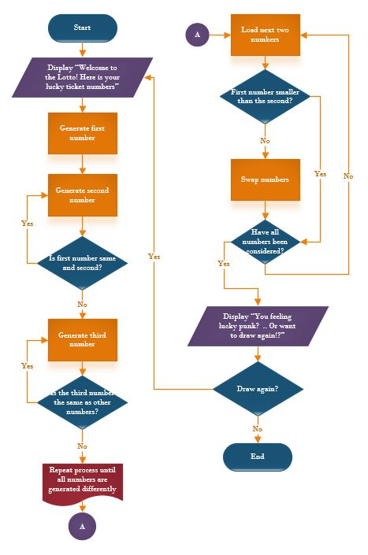

Why use a loop?

The use of loops when inserted correctly can allow the programmer to bypass the need of repeating the same lines of code. The need for this is to help shorten the lines of code necessary to get the preferred outcome and also allows the programmer to repeat that section an unknown number of times until a specific condition is met [1]. As presented in the Technical Documentation, Without the use of loops in coding, the code itself becomes unnecessarily long and repetitive.
There are two types of commonly used loops, but what’s the difference between them?
For loop is used to repeat a section of code a known number of times.
While loop is used to repeat a section of code an unknown number of times until a specific condition is met.

Testing

Due to the nature of the task, it is expected to come across a fair few instances of confusion due to code not working the way it’s expected. This is of course problematic, especially if the faulty or misplaced code is not easily located. The easiest solution to this is to conduct frequent tests to each section just to minimise the mistakes and broken codes.
The examples below show how these tests were conducted and the reason why.

Test 1 - Normal
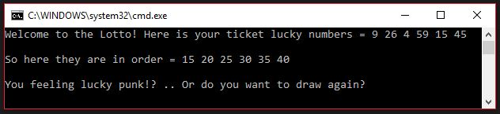
Testing to see if the program can rearrange any numbers given into ascending order.
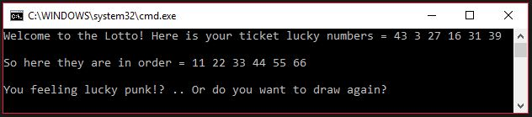

Result: Even though the program would still generate random numbers, it didn’t stop the program rearranging the numbers hardcoded into it into ascending order.

Test 2 – Break
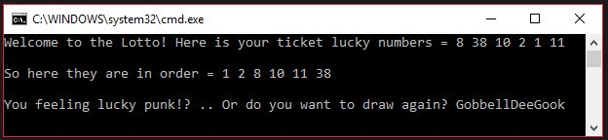
If the user typed any answer accept either ‘Y’ or ‘N’ into the box, would the program break?
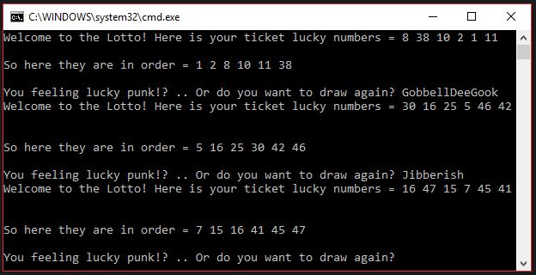

Result: Due to allowing the program up to 100 letters for an answer, the program will carry on straight into a new window of numbers. This prevents accidental mistypes from crashing the code. Only way to exit the program via typing in an answer is to type either NO, No, no, N, n. Reason for this is to cover all anticipated replies by any specific individual typing style.

Test 3 – Randomize
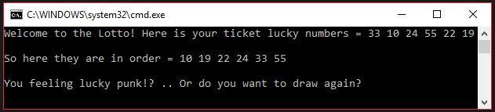
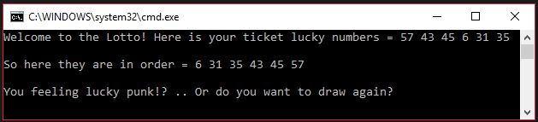
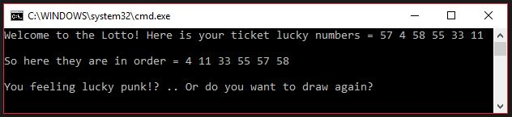
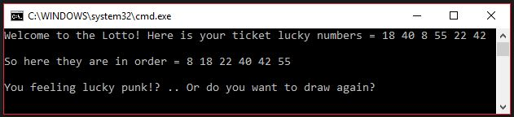
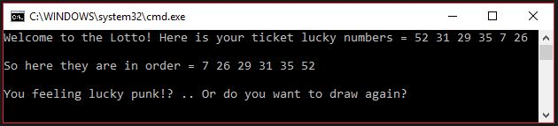
Multiple tests to check if the numbers generated are random and if there are any duplicates.

Result: There are some numbers that appear more often than others, but it is concluded that this was merely chance as the program successfully generated a new set of numbers each time it’s requested to do so. Even whilst doing so, the program still relocates each number in ascending order.

User Documentation



Step 1 - To start the program, please press CTRL key [2], then whilst that key is being pressed, press the F5 key [3]. Remember the program will not start if they are pressed simultaneously.

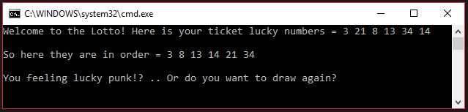
Step 2 - Once the program starts, it will immediately display randomly generated lottery numbers and rearranges them in ascending order for convenience.

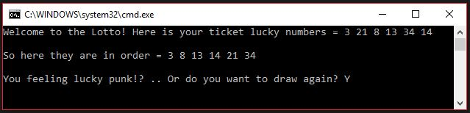
Step 3 - As displayed above, the program will also offer the option to generate different numbers if unhappy with the numbers originally given. To ask the program to generate new numbers, simply type either ‘Y’ or ‘Yes’ then press the ENTER key.
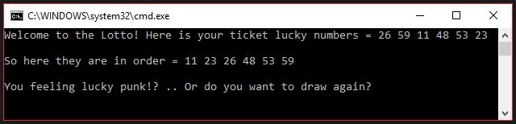

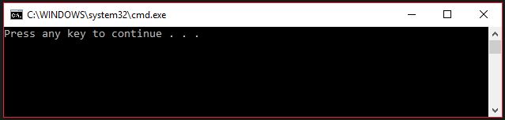
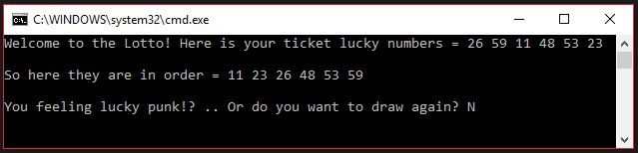
Step 4 - To close the program down safely, simply type either ‘N’ or ‘No’ in the same place as before. This will close the program down and display another window. To exit this window, Press the ENTER key once more to close the program down fully.

Technical Documentation

The list below shows the coding used to design the program in question.

#include <stdio.h>
#include <stdlib.h>
#include <time.h>
#include <string>
#include <Windows.h>

using namespace std;
void main()
{
int i; // Counter for loop
int myrand1, myrand2, myrand3, myrand4, myrand5, myrand6; // To hold random numbers
int low = 1; // Bottom of range for random number generator
int high = 59; // Top of range for random number generator
int temp;
bool quit = false;
char text[100];
string answer;

while (quit == false)
{
srand(time(NULL));
printf("Welcome to the Lotto! Here is your ticket lucky numbers = ");
myrand1 = rand() % (high - low + 1) + low; //first number

printf("%d ", myrand1);

myrand2 = rand() % (high - low + 1) + low; //second number

while (myrand1 == myrand2)
{
myrand2 = rand() % (high - low + 1) + low; //if duplicate, regenerate
}
printf("%d ", myrand2);

myrand3 = rand() % (high - low + 1) + low;

while (myrand3 == myrand2 || myrand3 == myrand1)
{
myrand3 = rand() % (high - low + 1) + low;
}
printf("%d ", myrand3);

myrand4 = rand() % (high - low + 1) + low;

while (myrand4 == myrand3 || myrand4 == myrand2 || myrand4 == myrand1)
{
myrand4 = rand() % (high - low + 1) + low;
}
printf("%d ", myrand4);

myrand5 = rand() % (high - low + 1) + low;

while (myrand5 == myrand4 || myrand5 == myrand3 || myrand5 == myrand2 || myrand5 == myrand1)
{
myrand5 = rand() % (high - low + 1) + low;
}
printf("%d ", myrand5);

myrand6 = rand() % (high - low + 1) + low;

while (myrand6 == myrand5 || myrand6 == myrand4 || myrand6 == myrand3 || myrand6 == myrand2 || myrand6 == myrand1)
{
myrand6 = rand() % (high - low + 1) + low;
}
printf("%d\n\n", myrand6);

if (myrand1 > myrand2) // First number lower than second
{
temp = myrand1;
myrand1 = myrand2;
myrand2 = temp;
}

if (myrand1 > myrand3) // First number lower than third
{
temp = myrand1;
myrand1 = myrand3;
myrand3 = temp;
}

if (myrand1 > myrand4)
{
temp = myrand1;
myrand1 = myrand4;
myrand4 = temp;
}

if (myrand1 > myrand5)
{
temp = myrand1;
myrand1 = myrand5;
myrand5 = temp;
}

if (myrand1 > myrand6)
{
temp = myrand1;
myrand1 = myrand6;
myrand6 = temp;
}

if (myrand2 > myrand3)
{
temp = myrand2;
myrand2 = myrand3;
myrand3 = temp;
}

if (myrand2 > myrand4)
{
temp = myrand2;
myrand2 = myrand4;
myrand4 = temp;
}

if (myrand2 > myrand5)
{
temp = myrand2;
myrand2 = myrand5;
myrand5 = temp;
}

if (myrand2 > myrand6)
{
temp = myrand2;
myrand2 = myrand6;
myrand6 = temp;
}

if (myrand3 > myrand4)
{
temp = myrand3;
myrand3 = myrand4;
myrand4 = temp;
}

if (myrand3 > myrand5)
{
temp = myrand3;
myrand3 = myrand5;
myrand5 = temp;
}

if (myrand3 > myrand6)
{
temp = myrand3;
myrand3 = myrand6;
myrand6 = temp;
}

if (myrand4 > myrand5)
{
temp = myrand4;
myrand4 = myrand5;
myrand5 = temp;
}

if (myrand4 > myrand6)
{
temp = myrand4;
myrand4 = myrand6;
myrand6 = temp;
}

if (myrand5 > myrand6)
{
temp = myrand5;
myrand5 = myrand6;
myrand6 = temp;
}

printf("So here they are in order = ");
printf("%d ", myrand1);
printf("%d ", myrand2);
printf("%d ", myrand3);
printf("%d ", myrand4);
printf("%d ", myrand5);
printf("%d ", myrand6);
printf("\n\nYou feeling lucky punk!? .. Or do you want to draw again? ");
scanf("%99s", text);
answer = text;

if (answer == "NO" || answer == "No" || answer == "no" || answer == "N" || answer == "n")
{
quit = true;
}
system("cls");
}
}

Conclusion

As a first-time user of not just using Visual Studio, but coding as a whole, It’s not hard to see why so many people fall in love with the process of it all, there’s always a certain satisfaction of creating something new and watching it take shape right before your eyes, and coding offers that to you in droves! if your happy to put in the work. Browsing online forums proves just how passionate people are when it comes to coding, the ability to create almost anything digitally is an exciting prospect and a powerful incentive.
There are a few negatives though, due to the coding itself needing specific wording and abbreviations, you must first learn the ‘language’ of that program, which then differs depending on which program you’re using! This in itself can either simply put off by the prospect or even impossible for others. A small mistyped symbol, letter, number or space can completely break the entire code, and finding the small mistake can take a frustratingly long time.
I myself can be placed on both ends of the spectrum here which gives me a good overall hindsight of what coding can do and offer. Even though I find the whole process daunting at times, I would very much like to learn more at what coding can offer and try to push myself in understanding the process as much as possible.

References

[1] | "www.cs.utah.edu," [Online]. Available: https://www.cs.utah.edu/~germain/PPS/Topics/while_loops.html. [Accessed 23 April 2018].
[2] | "www.colourbox.com," [Online]. Available: https://www.colourbox.com/image/control-key-on-a-black-laptop-keyboard-image-3446721. [Accessed 23 April 2018].
[3] | "www.istockphoto.com," [Online]. Available: https://www.istockphoto.com/pt/fotos/tecla-f5?excludenudity=true&sort=mostpopular&mediatype=photography&phrase=tecla%20f5. [Accessed 23 April 2018].

