

Report: Energy in a flywheel
Name: Greig Western
Student Number: 1804348
Subject Tutor: Abigail Summerfield
Module Number: M4X00385
University of Wales Trinity St David
School of Engineering
Course: Motorsport Engineering (BEng)

Contents
Introduction 3
Experimental Procedure 4
Results 9
Analysis 11
Conclusion 12
Evaluation 13
Further Work 14
Bibliography 15

Introduction

A flywheel is an energy storage device, it converts potential energy to kinetic energy by using the potential energy in the form of load on the flywheel to overcome the moment of inertia, as the moment of inertia is overcome the flywheel accelerates rotationally creating kinetic energy. This report will investigate the correlation between incrementally increasing the potential energy on a flywheel and the kinetic energy created from this additional load. One would expect, due to the laws of physics dictating that energy can be neither created nor destroyed (The conservation of energy (Explain that Stuff, 2019)), that the large majority of Potential Energy applied to the flywheel in the guise of load at a height, will be converted to Kinetic Energy, in the manner of angular velocity of the flywheel, with minimal losses to both air resistance and friction.

Experimental Procedure

The equipment used for this experiment was the ‘Potential and Kinetic Energy Kit ES9’, a stop watch and a stop watch app on a phone. The kit consists of:
1x metal rule
1x pulley block
1x flywheel
3x screws
1x mass platform with hook end
50x 10g weights
1x string
1x stopwatch
1x back panel
2x legs


Fig.1 (TecQuipment, 2019)

The kit is constructed as per Fig. 2, the block and flywheel are attached to the top of the apparatus and the string with the variable loads are connected to the opposite end of the shaft from the flywheel. The magnetic ruler is used to measure the height of the start and end position of each oscillation of the loads. The initial height and mass applied will give the potential energy according to the formula PE=mgh.
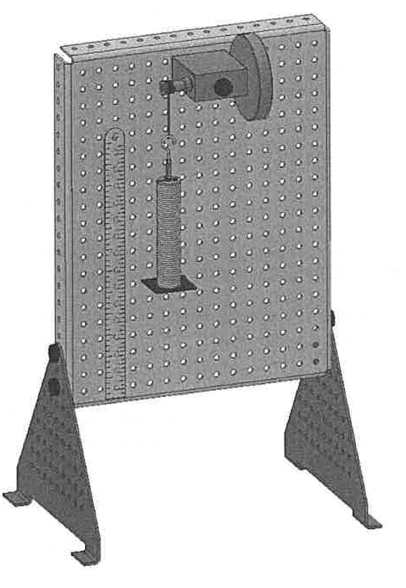
Fig. 2 (Moodle.uwtsd.ac.uk, 2019)
The initial height was taken from the bottom of the weights to the deck, at a height of 280mm. (Fig. 3)

Fig. 3 (Moodle.uwtsd.ac.uk, 2019)

Fig. 4 shows the last load (500g) applied before the flywheel was wound to the top. This clearly shows that there is a gap between the table top and the bottom of the load.


Fig. 4

The load was then wound to the 280mm specified distance from the bottom of the oscillation before being released and timed (Fig. 5). The kit comes with a number of weights. The first results were recorded for 100g (0.1kg), this process was repeated another 2 times to give 3 results, so that any anomalous figures could be seen more easily. This process was repeated for each additional 100g added, up to and including a maximum 500g mass.

Fig. 5
The oscillations were timed using both a stopwatch and a phone with stop watch function (Fig. 6), the times were then recorded as an average between the 2 times on each occasion. Each weight added to the load was timed on 3 occasions to try and rule out user error of the equipment by highlighting any anomalies.

Fig. 6

Results

The results recorded and calculated are in Table. 1. Note that there are 3 readings for h2 at each added mass. This was done to reduce discrepancies due to user error of the equipment. Moment of Inertia given is the sum of the flywheel and the pulley in the bearing block as per the nominal values given in the assessment worksheet. This equals 0.0004696 kgm^2, whereas the result from using the difference in maximum and minimum y axis values divided by the difference between maximum and minimum x axis values comes to a moment of Inertia of 0.000752 kgm^2.
Mass (m) | Potential Energy (mgh) | Time to fall and rise (Tt) |  |  | Average time to fall and rise | h1 | h2 |  |  | Average h2 | Weight | Potential Energy loss adjusted | Falling time (Tf) | Acceleration (a) | Velocity (v) | Angular velocity | (mg-ma)r | a/r | Kinetic Energy | Potential Energy Loss | Moment of inertia
kg | J | s |  |  | s | m | m |  |  | m | mg | J | s | m/s^2 | m/s | rad/s |  |  | J | J
0.1 | 0.27 | 4.40 | 4.30 | 4.25 | 4.32 | 0.28 | 0.24 | 0.24 | 0.24 | 0.24 | 0.98 | 0.02 | 2.32 | 0.05 | 0.12 | 18.61 | 0.00634 | 8.0245 | 0.21 | 0.04 | 0.000752
0.2 | 0.55 | 3.20 | 3.00 | 2.90 | 3.03 | 0.28 | 0.25 | 0.25 | 0.25 | 0.25 | 1.96 | 0.03 | 1.61 | 0.11 | 0.17 | 26.74 | 0.01261 | 16.5638 | 0.44 | 0.07 | 0.000752
0.3 | 0.82 | 2.50 | 2.50 | 2.40 | 2.47 | 0.28 | 0.25 | 0.25 | 0.26 | 0.25 | 2.94 | 0.04 | 1.29 | 0.17 | 0.22 | 33.36 | 0.01880 | 25.7829 | 0.68 | 0.08 | 0.000752
0.4 | 1.10 | 2.20 | 2.10 | 2.30 | 2.20 | 0.28 | 0.24 | 0.25 | 0.25 | 0.25 | 3.92 | 0.07 | 1.17 | 0.21 | 0.24 | 37.01 | 0.02497 | 31.7283 | 0.84 | 0.12 | 0.000752
0.5 | 1.37 | 1.90 | 1.90 | 1.90 | 1.90 | 0.28 | 0.24 | 0.24 | 0.24 | 0.24 | 4.91 | 0.10 | 1.02 | 0.27 | 0.27 | 42.23 | 0.03101 | 41.3140 | 1.09 | 0.19 | 0.000752

Table. 1

Graph. 1 shows the correlation between (mg-ma)r and a/r and when the gradient is calculated by: change in y/change in x, we get a value of I (moment of inertia. The change in x or y is determined by subtracting the minimum value of each axis from the maximum value of each axis, so in this case it is (0.03101-0.00634)/(41.3140-8.0245), this gives a value of I at 0.000752 kgm^2.

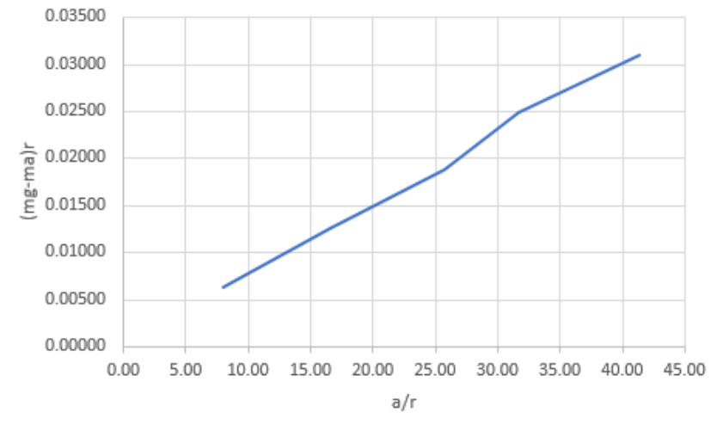
Graph. 1

Analysis

There is direct correlation between (mg-ma)r and a/r, the graph shows very nearly a straight line, the anomaly can be put down to human error in timing. This implies that as the potential energy is increased, the kinetic energy increases in direct response. The gradient is: 0.000752 kgm^2, this is quite different to the nominal values given for the moment of inertia (I) in the assessment specification, which came to 0.0004696 kgm^2 after adding up the nominal values for the flywheel and shaft pulley with string. These values do not compare well, the values given nominally are 1.6 times lower than the calculated value. The author of the nominated values has been contacted by the lecturer for further information, but for this report, the calculated values will be used.
As more mass is added to the flywheel, hence more potential energy, the time to fall reduces, this would indicate that more kinetic energy is being produced as a result, this is backed up by the increased acceleration and angular velocity of the flywheel along with the increased upwards distance travelled by the weights after the weights get to the bottom of the oscillation.
When looking at the overall time for an oscillation vs the falling time, the total time is nearly twice the falling time, suggesting that minus any friction and air resistance, the Energy on the downward movement is very similar to that of the Energy in the upward movement.
These statements are borne out by the potential energy and kinetic energy columns in Table 1. With the energies calculated being very similar, which would suggest loss through friction and resistance. The lower weight values suggest that the potential energy is 1.28 times the kinetic energy whereas the higher values are closer to 1.25 times the kinetic energy produced, showing that although friction has increased due to the increased load, the additional mass overcomes any increase in friction making it less of an issue as the load is increased.

Conclusion
In conclusion, according to the laws of the conservation of energy, energy can be neither created or lost, it can only be converted from one type to another, therefore, as the mass is released and falls its potential energy reduces. As the equation PE=mgh is reliant on the height of the mass, this energy is then mostly converted into kinetic energy in a directly proportional manner. The findings of this experiment are that there are minimal losses due to friction in bearings or from air resistance in the system, but that the theory is in fact correct, as shown by the near 45-degree gradient shown in Graph. 1. Hence, the more potential energy you introduce to the flywheel through mass, the more kinetic energy is produced in linear distance travelled on the up stroke of the weights.

Evaluation

Whilst the experiment went smoothly overall, there were some issues with parallax error (different view points from different members of the teams’ eye levels), timing due to the start and finish times being called out by one member to another, thus creating another delay between real time and the times recorded by the stop watch. There was also a certain amount of pendulum motion occurring to the weights when the flywheel was released, adding additional distance travelled by the apparatus. All of these issues combined could have caused the blip in the results (Graph. 1).

Further Work

If this experiment were to be done again without constraints on equipment or budget then certain areas would have to be addressed, as follows:
- Timing inaccuracies due to hand held stop watches being started and stopped via audible commands.
In an ideal world this experiment would be done using more exact timing and measuring equipment, a laser or optical window could be used to start the timing.
2 Measurement of distance travelled inaccuracies due to parallax errors.
A high-speed camera could be used to measure the speed and distance travelled by the loads on the string.
3 The inaccuracy of starting point on the flywheel and releasing of the flywheel due to being released manually by hand.
An integrated system using automatic release on the flywheel so that the release and timing could be started simultaneously.
4 Potential difference between 10g weights due to manufacturing defects.
The loads could be verified by calibrated weights.
5 Loss of kinetic energy due to outside factors such as air resistance to the flywheel and friction on the bearings
The experiment could be carried out in a vacuum so that air resistance could be eliminated, leaving only bearing friction. This could be reduced, but not eliminated, by using low friction bearings such as those made by Coo Space (Popular Mechanics, 2019).
To go even further the flywheel could be mounted on superconducting magnets as some of the most advanced flywheels in the world do. (Explain that Stuff, 2019)
6 The Inaccuracy of timing and distance due to kinetic energy being used to cause a pendulum effect of the load.
The pendulum effect could be reduced with low friction guides on either side of the weights, such as polished glass, forcing them to take a certain path.

Bibliography

Explain that Stuff. (2019). The law of conservation of energy: A simple introduction. [online] Available at: https://www.explainthatstuff.com/conservation-of-energy.html [Accessed 12 Dec. 2019].
TecQuipment. (2019). Potential and Kinetic Energy Kit ES9 | Engineering Science | TecQuipment. [online] Available at: https://www.tecquipment.com/potential-kinetic-energy-kit [Accessed 11 Dec. 2019].
Moodle.uwtsd.ac.uk. (2019). UWTSD Moodle 2019/20: Log in to the site. [online] Available at: https://moodle.uwtsd.ac.uk/pluginfile.php/324439/mod_resource/content/1/M4X00385_SEM1_CW_2019_2020.pdf [Accessed 11 Dec. 2019].
Popular Mechanics. (2019). These Greaseless Bearings Can Spin Virtually Forever. [online] Available at: https://www.popularmechanics.com/technology/gear/a15603/super-efficient-greaseless-bearings/ [Accessed 11 Dec. 2019].
Explain that Stuff. (2019). How do flywheels store energy?. [online] Available at: https://www.explainthatstuff.com/flywheels.html [Accessed 12 Dec. 2019].

