

Module name: Introduction to Physiology
Module code: BMHP5023
Lecturer name: Lou Wells (Weekday G1)
Assessment: Component 1: Written Assignment

Student Name: Berthe M Mutombo
Student ID: 2427851

Table of Contents
1. Introduction 3
2. Blood Sugar Regulation 4
3. Cellular Metabolism 4
4. Recording and Tracking of Blood Sugar levels 6
5. Lifestyle-based Recommendations 7
5.1 Diet 7
5.2 Physical Activity 7
5.3 Smoking Cessation 7
5.4 Mental Health and Alcohol 8
6. Conclusion 8
References 9

1. Introduction
Diabetes mellitus is a chronic disease that is manifested by the inability of the body to maintain the level of glucose in the blood. The inability to maintain homeostatic regulation is caused by either inadequate production of insulin internally or the reduced biological response of insulin secreted by the pancreas (World Health Organisation, 2023). Two main types are identified: Type 1 diabetes, where beta cells are destroyed by autoimmune means, and Type 2 diabetes mellitus (T2DM), which is the most common type (approximately 90% of all cases) (Diabetes UK, 2023). T2DM is develops gradually and is also strongly related to lifestyle. The determinants of risk that have been identified include obesity, sedentary behaviour, unbalanced dieting, tobacco use, older age, family history, and ethnic backgrounds, especially South Asian and Black African (NICE, 2022). The current report outlines the physiological processes of how glucose homeostasis is normally regulated and explains how cells use glucose as a energy source, as well as provides an overview of the therapeutic interventions based on monitoring and lifestyle changes.

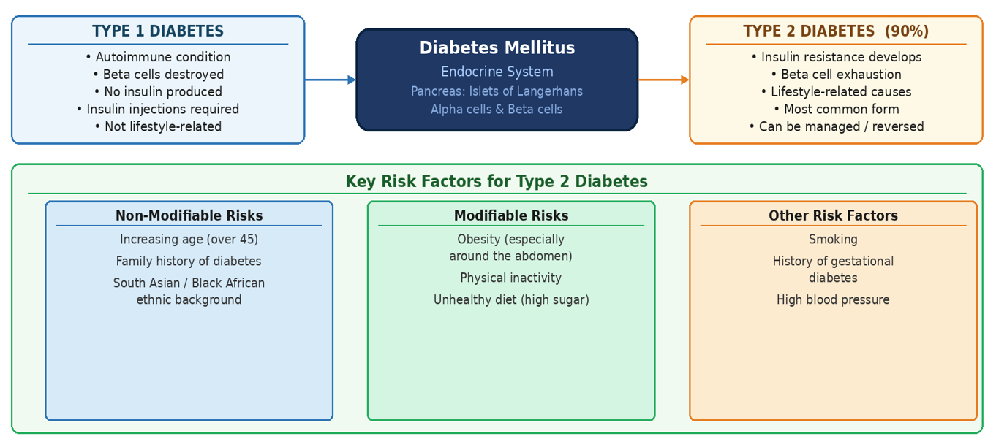
Figure 1: Overview of Diabetes Types and Risk Factors
Source: (NICE, 2022).

2. Blood Sugar Regulation
Body systems continuously keep blood glucose at a close physiological level, which is 3.9 -5.6 mmol/L in the fasting state (NICE, 2022). The two hormones produced in the pancreatic endocrine gland play the primary role in the orchestration of homeostatic balanced. The beta -cells and the alpha cells, which are the secretory cells in the pancreas, are grouped in clusters called the islets of Langerhans (Marieb and Hoehn, 2019).
When a meal rich in carbohydrates is consumed, polysaccharides are hydrolyzed into a single saccharide glucose that is then absorbed into the bloodstream causing a postprandial rise in blood glucose. The beta -cells respond to this by releasing insulin into the bloodstream. Insulin works as a key, allowing the movement of glucose out of the vascular into the target tissues, e.g., skeletal muscle and adipose tissue to provide cellular energy. Excessive glucose is simultaneously converted into glycogen by the liver by glycogenesis. The uptake of glucose into the cell reverses the plasma glucose levels to the level of the baseline, and it is an example of a negative feedback loop, where the organism senses an imbalance and the body initiates a mechanism to correct it (Tortora and Derrickson, 2017).
In cases of low glucose levels lower than physiologically acceptable like that between meals or during body activity, alpha cells release glucagon. This hormone activates Hepatic glycogenolysis that causes the release of stored glucose in the blood. Moreover, the liver is capable of producing new glucose molecules through gluconeogenesis by using non-carbohydrate precursors, including amino acids, and thus creates a dual control system with insulin and glucagon working together to maintain the glucose balance (Marieb and Hoehn, 2019).
This regulation network is impaired in T2DM. The cells become insulin-unresponsive, which is known as insulin resistance. The pancreas starts by increasing the amount of insulin secreted but over time, when the demand is constant, the beta cells become exhausted leading to the eventual reduction in insulin secretion. As a result, hyperglycaemia remains, causing damage to the vessels and nerve cells that result in such complications as kidney failure, visual loss, and peripheral neuropathies (DeFronzo et al., 2015).

3. Cellular Metabolism
Every cell in the human organism is in need of sufficient amount of energy to conduct the physiological processes. Cellular respiration Aerobic is the dominant path way through which cells obtain this energy and involves the use of glucose and oxygen to produce adenosine triphosphate (ATP) which is the major form of energy used by biological systems. This cascade of metabolic events consists of three major steps (Marieb and Hoehn, 2019).
The first phase, glycolysis, occurs in the cytosol, that is, one molecule of glucose is broken down into two molecules of pyruvate. This catabolic reaction results in an insignificant amount of ATP (two molecules) and is oxygen-independent.
The next step, which is also known as Krebs or citric acid cycle, takes place in the mitochondrial matrix, the organelle that is known as the powerhouse of the cell. Pyruvate is converted to acetyl-CoA, and it is then used in a series of enzymatic reactions. The products of these reactions include the release of carbon dioxide (CO 2) as a metabolic waste product and at the same time the reduction equivalents are transferred to carrier molecules that are NADH and FADH 2 (Tortora and Derrickson, 2017).

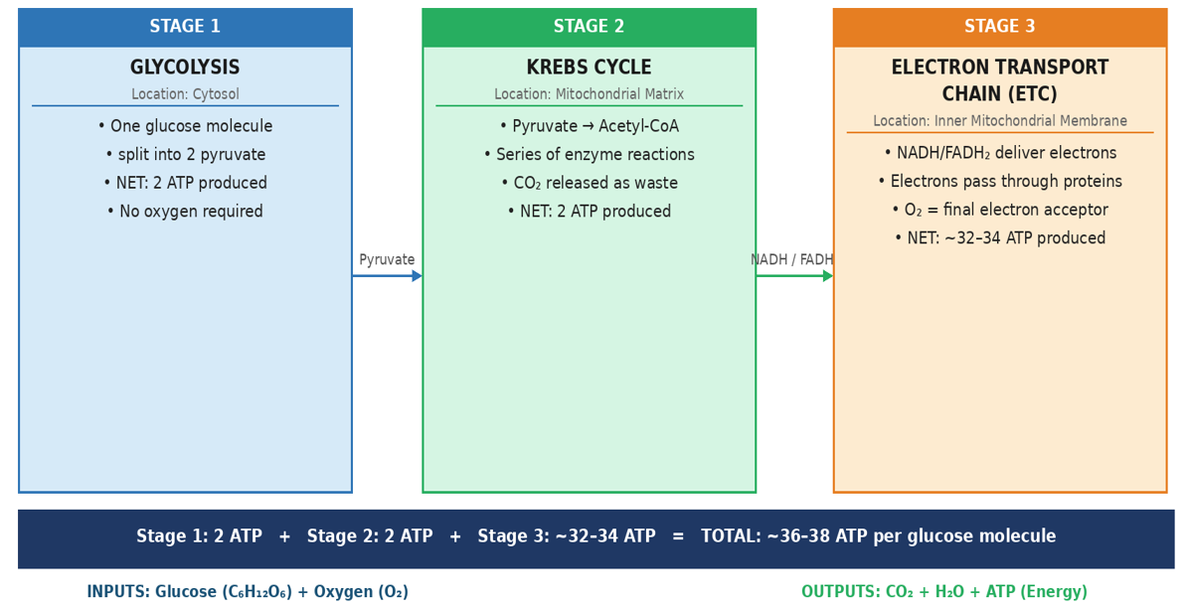
Figure 3: Stages of Aerobic Cellular Respiration
The last step, the electron transport chain (ETC) which is also present in the mitochondria consists of the transfer of the electrons by NADH and FADH2 through a series of protein complexes. This electron flow is the force behind the generation of a significant amount of ATP - about 32 to 34 molecules per glucose fuel. Oxygen is the terminal electron acceptor in this system which is reduced by the combination of electrons and protons to produce water. The stoichiometry of the process may be written as net stoichiometry:
Glucose + Oxygen Carbon Dioxide + Water + ATP (energy).
The persistently high levels of blood glucose in patients that experience type 2 diabetes mellitus (T2DM) cause cellular damage, especially the mitochondrial structures. This reduces the efficiency of the ATP production and that is why after hyperglycaemia patients are usually characterised by deep fatigue (Wilcox, 2005).

4. Recording and Tracking of Blood Sugar levels
The routine and regular monitoring of blood glucose levels is one of the pillars of safe disease management to the individuals with a diagnosis of type 2 diabetes mellitus (T2DM). In the absence of this information, clinical practitioners and patients cannot determine whether glycaemic levels are in a physiologically acceptable range, measure the effectiveness of a therapeutic intervention, or assess the effect of lifestyle interventions (NICE, 2022).
Self-monitoring of blood glucose (SMBG) and continuous glucose monitoring (CGM) are the most frequently used modalities in monitoring plasma glucose. SMBG involves the use of a handheld glucometer to receive a small amount of blood, usually by means of a fingertip prick, and produce a fast reading. The patients are recommended to measure themselves at different times during the day, such as pre and two hours after a meal, and to record the outcomes in a diary or a mobile application. This type of longitudinal recording allows determining the glycaemic patterns over the circadian cycle, which allows one to identify dietary stimuli leading to post-prandial hyper-glycaemia or chronic morning elevation, which can be used to discuss it with medical professionals (Haak et al., 2017).
The introduction of CGM technology, including the FreeStyle Libre, provides a small, arm-mounted, sensor, which measures interstitial glucose every few minutes, both in the diurnal and nocturnal period and eliminating the necessity of frequent capillary sampling. There is empirical evidence that CGM use causes a decrease in the average glucose levels and a drop in time a patient with T2DM spends within the critical levels (Haak et al., 2017).
The second necessary test is glycated haemoglobin (HbA1c) test that is conducted in a primary care environment. HbA1c is a model that gives the combined measure of the mean plasma glucose in the last two to three months by measuring the percentage of haemoglobin molecules bound by glucose. In most patients with T2DM, the treatment goal is an HbA1c level of 48mmol/mol (6.5% or below) (NICE, 2022).
Keeping a thorough record of glucose monitoring can also help a patient recognise patterns, including how certain foods or stress affect glycaemic excursions. Such data can enable changes in dietary consumption and physical exercise. In addition, it can be used by the clinical team in identifying the need to adjust pharmacological interventions.
There is a high risk associated with failure to do regular monitoring. Hypoglycaemia is a plasma glucose level that is below 4mmol/L which may trigger symptoms such as dizziness, confusion and even unconsciousness, especially in people taking insulin or blood sugar spikes (Cryer et al., 2003). On the other hand, the unidentified persistent hyperglycaemia continues to cause vascular endothelium and peripheral nerve damage, which eventually leads to serious long-term complications.

5. Lifestyle-based Recommendations
The most critical and effective approach to the treatment of type 2 diabetes mellitus (T2DM) and the slowdown of its development is lifestyle changes. The recommended suggestions are ones based on the current research and national clinical guidelines.

5.1 Diet
The nutritional makeup has a direct effect on the glycaemic control. The clinicians are to advise patients to reduce intake of food rich in free sugars and refined carbohydrates, which include white bread, confectionery, and sugared beverages because they promote rapid postprandial glucose excursions. Replacing these with food products which have a lower glycaemic index such as whole grains, legumes, and non-starchy vegetables, will create a more balanced glycaemic pattern.
The evidence regarding a Mediterranean pattern of diet that includes a lot of vegetables, extra-virgin olive oil, oily fish, nuts, and legumes is quite strong in terms of its glycaemic control advantages, as well as protective effect against cardiovascular risks in people with T2DM (Esposito et al., 2015). Moreover, it has been shown that a small weight loss of 5-10% of body mass, increases the insulin sensitivity considerably (Franz et al., 2015). In the direct trial, it was shown that the structured low-calorie diet programme allowed the treatment of around 50 per cent of participants with the T2DM remission in one-year time (Lean et al., 2019). The patients are encouraged to eat regularly, have breakfast and use portion control.

5.2 Physical Activity
Physical exercise improves the use of insulin. In the condition of skeletal muscle activity, the absorption of glucose does not require the presence of insulin, decreasing glucose concentrations in the bloodstream. According to NICE (2022), moderate-intensity exercise applied at least 150 minutes per week, such as brisk walking, cycling, or swimming, and strength training 2 times per week is recommended. Even short after-prandial walks have been depicted to smooth glucose spikes. Those people who are not used to regular exercise must start slowly increasing in length and intensity. The use of pedometers or smartphone apps can result in compliance (Colberg et al., 2016).

5.3 Smoking Cessation
Smoking is one of the key harmful conditions of people with diabetes that enhance insulin resistance and raise blood sugar levels. It also has a marked and significant impact on the risk of cardiovascular disease, nephropathy, and vascular complications, pathologies that are already widely spread in the population of T2DM. It is important to persuade patients to stop smoking and refer them to NHS Stop Smoking Services where they can receive professional help. Empirical research shows that smoking cessation enhances glycaemic regulation and reduces the probability of diabetes-associated complications (DeFronzo et al., 2015).

5.4 Mental Health and Alcohol
Having a chronic illness like diabetes may be psychologically heavy and most of the patients develop mood disturbances or depression. There is a long-standing documented relationship between symptoms of depression and poor diabetes management because depressed patients are less likely to respond to diet, exercise, or pharmacotherapy (Holt et al., 2014). Nurses in practise should regularly evaluate the emotional wellbeing including making relevant referrals to psychosocial interventions or diabetes self-management education programmes like DESMOND where needed.
With regards to alcohol use, the patients should be informed to take not more than 14 units of alcohol per week. High dosage of alcohol may trigger intense hypoglycaemia among patients on glucose-lowering medications. One should never consume without filling the stomach (NICE, 2022).

6. Conclusion
The report has proved that T2DM is a complex but manageable disease condition. A highly balanced hormonal axis of insulin and glucagon is known to regulate endogenous glycaemic regulation. In T2DM, insulin resistance interferes with such equilibrium, and resulting in the chronically high level of blood glucose. On the cellular level, glucose and oxygen are critical in the production of ATP, glucose regulation deficiency makes this vital process impossible. Safe self-management will not be possible without routine blood glucose monitoring through SMBG and HbA1c. Lifestyle interventions, including dietary optimization, physical activity, smoking cessation and psychosocial well-being, have strong empirical evidence and have the potential to significantly improve clinical outcomes. As practice nurses, patient education and understanding of how to manage diseases is also central to preventing severe complications and improving the quality of life.

References
Colberg, S.R., Sigal, R.J., Yardley, J.E., Riddell, M.C., Dunstan, D.W., Dempsey, P.C., Horton, E.S., Castorino, K. and Tate, D.F. (2016) ‘Physical activity/exercise and diabetes: a position statement of the American Diabetes Association’, Diabetes Care, 39(11), pp. 2065–2079.
Cryer, P.E., Davis, S.N. and Shamoon, H. (2003) ‘Hypoglycemia in diabetes’, Diabetes Care, 26(6), pp. 1902–1912.
DeFronzo, R.A., Ferrannini, E., Groop, L., Henry, R.R., Herman, W.H., Holst, J.J., Hu, F.B., Kahn, C.R., Raz, I., Shulman, G.I., Simonson, D.C., Testa, M.A. and Weiss, R. (2015) ‘Type 2 diabetes mellitus’, Nature Reviews Disease Primers, 1, p. 15019.
Diabetes UK (2023) Diabetes: facts and stats. Available at: https://www.diabetes.org.uk/professionals/position-statements-reports/statistics (Accessed: 4 April 2026).
Esposito, K., Maiorino, M.I., Bellastella, G., Chiodini, P., Panagiotakos, D. and Giugliano, D. (2015) ‘A journey into a Mediterranean diet and type 2 diabetes: a systematic review with meta-analyses’, BMJ Open, 5(8), p. e008222.
Franz, M.J., Boucher, J.L., Rutten-Ramos, S. and VanWormer, J.J. (2015) ‘Lifestyle weight-loss intervention outcomes in overweight and obese adults with type 2 diabetes: a systematic review and meta-analysis of randomized clinical trials’, Journal of the Academy of Nutrition and Dietetics, 115(9), pp. 1447–1463.
Haak, T., Hanaire, H., Ajjan, R., Hermanns, N., Riveline, J.P. and Rayman, G. (2017) ‘Flash glucose-sensing technology as a replacement for blood glucose monitoring for the management of insulin-treated type 2 diabetes: a multicenter, open-label randomized controlled trial’, Diabetes Therapy, 8(1), pp. 55–73.
Holt, R.I.G., De Groot, M. and Golden, S.H. (2014) ‘Diabetes and depression’, Current Diabetes Reports, 14(6), p. 491.
Lean, M.E.J., Leslie, W.S., Barnes, A.C., Brosnahan, N., Thom, G., McCombie, L., Peters, C., Zhyzhneuskaya, S., Al-Mrabeh, A., Hollingsworth, K.G. and Rodrigues, A.M. (2019) ‘Durability of a primary care-led weight-management intervention for remission of type 2 diabetes: 2-year results of the DiRECT open-label, cluster-randomised trial’, The Lancet Diabetes & Endocrinology, 7(5), pp. 344–355.
Marieb, E.N. and Hoehn, K. (2019) Human anatomy and physiology. 11th edn. Harlow: Pearson.
NICE (2022) Type 2 diabetes in adults: management. NICE guideline NG28. Available at: https://www.nice.org.uk/guidance/ng28 (Accessed: 4 April 2026).
Tortora, G.J. and Derrickson, B.H. (2017) Principles of anatomy and physiology. 15th edn. Hoboken, NJ: Wiley.
Wilcox, G. (2005) ‘Insulin and insulin resistance’, The Clinical Biochemist Reviews, 26(2), pp. 19–39.
World Health Organization (2023) Diabetes. Available at: https://www.who.int/news-room/fact-sheets/detail/diabetes (Accessed: 4 April 2026).

