

An exploration into the impact of verbal descriptions and visual cues on memory of illness contaminated objects.

P1700014

Dissertation in Psychology: March 2020

University of Wales Trinity Saint David

Dissertation submitted in partial fulfilment of the requirements for the degree in Bachelor of Arts (hons) in Counselling Studies and Psychology.

DECLARATION

This work has not previously been accepted in substance for any degrees and is not being concurrently submitted in candidature for any degrees.

Signed ………………R.Harding………………………………………………. (candidate)
Date …………………26.03.2020……………………………………………….

STATEMENT 1:
This dissertation is being submitted in partial fulfilment of the requirements for the degree of Bachelor of Arts (hons) in Counselling Studies and Psychology.
Signed ……………R.Harding…………………………………………………. (candidate)
Date ……………………26.03.2020…………………………………………….

STATEMENT 2:
This dissertation is the result of my own independent work/investigation, except where otherwise stated. Other sources are acknowledged by giving explicit references. A reference list is appended.

Signed ……………R.Harding……………………………………. (candidate)
Date …………………26.03.2020……………………………………………….

STATEMENT 3:
I hereby give consent for my dissertation, if accepted, to be available for photocopying and for inter-library loan, and for the title and summary to be made available to outside organisations.

Signed ………………R.Harding………………………………………. (candidate)
Date …………………26.03.2020……………………………………………….
Acknowledgements
First and foremost, I would like to show my appreciation and say a big thank you to my academic supervisor Dr Kate Williams, who has given me guidance and support throughout this journey. The journey in completing my dissertation, albeit enjoyable at times, has been incredibly overwhelming and, often, stressful. Dr Kate Williams has shown me patience and, most importantly, been there every step of the way, providing encouragement, support and excellent feedback. This was particularly evident when I was filled with fear and apprehension when faced with statistics and analysis, during which period Dr Kate Williams rapidly responded to my panic-stricken emails and kept me on track with the utmost professionalism throughout. It has all been immensely appreciated.
I want to thank all those of the psychology and counselling department at University of Wales Trinity Saint David for all their support, guidance and patience, not only through this journey, but for my whole university experience. They have provided me with the knowledge and skills I required, not only for this project, but going forward with my professional career. So, once again, thank you.
Finally, I would like to say a special thank you to Amy Mellin for pushing me every single step of the way, showing me immense emotional support and helping me keep on track when I required it the most. A special thank you also goes to Verity Hollands, who pushed me to come to university. For, also, proofreading my work, listening to my constant worrying and moaning, for frequently reminding me that the word ‘can’t’ is not an academic word, and for showing me that I am capable by instilling confidence in me.

Table of Contents
Declaration…………………………………………………………………………… 2
Acknowledgements……………………………………………………………………3
Abstract………………………………………………………………………...……...6
Chapter 1 – Literature Review…………………………………………………………7
Chapter 2 – Methods
2.1 Participants………………………………………………………………...20
2.2 Design……………………………………………………………………...20
2.3 Materials…………………………………………………………………...21
2.4 Procedure…………………………………………………………………..22
Chapter 3 – Results
Figure 1 – Table Showing Descriptive Statistics……………………………...26
Figure 2 – Line Graph Showing Main Interaction Effect……………………..28
Chapter 4 – Discussion ………………………………………………………………..29
References……………………………………………………………………………..39
Appendix A – Stimuli…………………………………………………………...……..43
Appendix B – Proposal Form………………………………………………………….63
Appendix C – Application for Ethical Approval Form………………………………..81
Appendix D – Instructions for Computer Based Activity……………………………..103
Appendix E – Information Sheet………………………………………………………104
Appendix F – Consent Form………………………………………………………….105
Appendix G – Study Debrief Sheet……………………………………………...……106

Abstract
The study within this paper aims to explore whether visual cues or verbal descriptions have greater impact on memory, for items that have been touched by illness contaminated and healthy individuals. This was done by exploring which contaminated objects were better remembered by the participant through a computer-based experiment. A 2 x 2 within subject ANOVA analysis was conducted to analyse the interaction effect. Participants included 40 Psychology students (10 male, 29 female and 1 other) (age range = 18 to 57, M = 30.2, SD = 10.44) recruited through an Experiment Management System. The results generated from the analysis found no significance between illness contamination and healthy contact objects F (1,39) = p = .15. No significance between pictorial and verbal presentation format F (1,39) = p = .20. However, a significant interaction was found between contact type and format F (1,39) = p = .00. Overall, the results indicate participants remembered illness contaminated items better than healthy items. Illness contaminated items presented through verbal description format were better than the other three conditions. The results also indicate an interaction effect was found between illness contaminated items denoted through a verbal description format. The results suggest that further research is required to investigate to gain a full understanding of the causality of the interaction effect.

Chapter One: Review of Literature
It is undoubtable that memory is a fundamental process in everyday life and an indispensable human function, although the mechanisms of memory remains one of the greatest mysteries (Poo et al., 2016). It is critical, therefore, that research is conducted in all aspects of this process to gain a full and informed understanding of how cognitive processes function (Brewin & Langley., 2019), with each cognitive task being paramount for the survival and development of individuals. Memory is also paramount to who we are today, it allows us to recognise people, allows us to make sense of the world by recalling our memories of past events, and it also forms the backdrop of what we believe in (Eysenck & Keane, 2015).
Theorists have concluded that memories are made through encoding of information, stored within memory systems and retrieved when needed by recovering information stored (Butler, 2018). This process can be categorised into short term and long-term memory. Short term memory has been suggested to retain information for merely a few seconds, whereas long-term memory systems can retain information for many years, however it is important to acknowledge that this varies on an individual basis (Eyseneck & Keane, 2015). The term ‘memory’ can be broken down into different types of memories, such as semantic memory, which is an individual’s general knowledge about the world, and episodic memories, based upon memories of specific events in an individual’s life (Butler, 2018).
However, the concept of short-term memory has been questioned by Baddeley and Hitch (1974) who suggested a subsequent model, the ‘working memory model’, which involves more than just basic storage, but also incorporates dealing with more complex tasks and holding information. Baddeley and Hitch (1974) suggested that the working memory consist of three main systems; the central executive, which is the system used for the attention span and tasks
which are cognitively demanding, the phonological loop, which is responsible for the processing of and storing of information, such as words and speech based information and the visual spatial sketchpad, responsible for the temporary storage of visual and spatial information (Baddeley & Hitch, 1974). A fourth component was added years later, which suggested that an episodic buffer was used to temporarily store information that combined both visual information as well as auditory information (Baddeley, 2000). This system allows us to intake information and process it, allowing us to retain and recall information, although the working memory has a limited amount of capacity in comparison to long term memory.
However, for some individual’s retrieval of information can sometimes be difficult, and often quite distressing. Although it has been suggested that the retrieval of information is the most important part of the memory process (Butler, 2018). ‘Forgetting’ has been a focal point of research and discussed at length surrounding the topic of memory (Eysneck & Keane, 2015; Lofus & Lofus, 2018; Jenkins & Hamiliton, 2018). ‘Forgetting’ is the failure to retrieve information from within the memory system. Many explanations have been put forward as to why forgetting occurs, one of which being decay, which is the gradual loss of the memory which occurs particularly within the hippocampus (Teichert & Gurnsey, 2019). Age has also been suggested as a possibility, alongside proactive and retroactive interference, which involves disruption of a memory by previous learning or disruption of the processing during the retention period (Eysneck & Keane, 2015). Older theories have also been highlighted, such as repression, where a person purposely represses information. The information may be causing emotional pain, causing the individual to intentionally repress the information (Baog, 2018; Englehard, McNally, & Van Schie, 2019).
The memory system requires many cognitive processes to occur in order to form, consolidate and retrieve information. Individuals must process information taken from the environment via the senses, for example visual, verbal and auditory. that can be processed, stored, and retrieved. Therefore, our memories can be composed for many different elements. Individuals use verbal descriptions throughout their everyday life; it is one of the ways in which human beings communicate, express their knowledge, and recall past experiences (Belouaer, Brosset, & Claramunt, 2016; Mickes, 2016). Verbal descriptions are used within the teaching profession and in legal systems; indicating the vast importance of verbal descriptions. However, it is apparent that much of the research within verbal description and memory has been conducted within the legal system, and therefore it could be argued that there is a lack of research and the impact of verbal descriptions in everyday life. Although, the research available does highlight the importance of verbal descriptions and on memory to communicate past events through verbal descriptions (Wilson, Seale-Carlisle, & Mickes, 2018).
A recent online study conducted by Wilson, Seale-Carlisle, and Mickes, (2018) investigated the effects of verbal descriptions on performance in line-ups, where 780 undergraduate students were asked to watch a video of a bank robbery for 44 seconds, then to identify the suspect from a six suspect line-up after a short delay. The participants were separated into either a verbal condition group or a control group. The participants in verbal condition group, had to describe from memory the suspect, whereas the participants in the control group had to choose the suspect from images displayed. The study consisted of five separate experiments. Within experiments one to four, participants had to give verbal descriptions. The participants in the verbal condition group, had to provide descriptions after encoding in experiments one and three, the results did not differ. However, in experiments two and four, where the participants within the verbal condition had a distractor task and had to recall from memory, the results differed, and correct identification was much lower. This could indicate that the processes used within verbal description and memory are impaired after a delay. Within experiment five, participants were shown verbal descriptions of the suspects. The participants had to read one description of the suspect before being shown an eight-image line up. Participants had to identify the suspect based on the description they had read. Participants who had read the description and were then immediately presented with the eight-image line up were significantly better at correctly identifying the suspect than those in the group with a distractor task. This suggests that verbal descriptions plays a role within memory, impairing recall.
However, it is important to consider the study was conducted on undergraduate students for course credits. This could have impacted the results, as some of the participants could have been limited for time, due to the distractor task being 20 minutes long, and therefore, rushing answers or not giving a full account of true data; calling in to question the reliability of the results. The study also only included six suspects in experiments one to four, as opposed to the eight suspects included in experiment five. This could increase the probability of the participant guessing the suspect out of a smaller number. Therefore, a suggestion for this experiment could be to use a larger number of suspects within the line-up, which could potentially encourage participants to think and withdraw information from memory.
It is apparent that the research surrounding the topic area of verbal descriptions is mostly experimental cognitive laboratory studies focused on behaviours, where participants provide general verbal descriptions, i.e. recalling numbers or colours rather than real life application (Markman, 2018).
Another key issue to consider is the importance of visual information has been suggested a fundamental within cognitive processes (Lew, 2016; Mance, & Vogel, 2013). It aids individuals to obtain information from the outside world to allow cognitive processes to make memories. This ability can be explained by the Visual Working Memory Model (Kong & Fougnie, 2019; Gayet, Paffen, & Stichel, 2018). The Visual Working Memory Model suggests that an individual is able to prioritise an object by enhancing its representation within
memory (Dube & Al-Aidroos, 2019). The Visual Working Memory Model proposes that allowing an object to be prioritised during encoding, which occurs during initial contact, enhances the ability for precision and recall. This is due to the flexibility of the Visual Working Memory (Lorenc, Dreenivasan, Nee, Vanenbroucke, & Esposito, 2018) which enhances its representation quality, allowing for bias attention during recall which is effective in matching during recall (Adaval, Saluja, & Jiang, 2018).
A recent study by Brewin and Langley (2019) was conducted to explore the impact of verbal cues or visual cues. The study included forty participants, who viewed 30 negative and positive scenes, from ‘very pleasant’ to ‘very unpleasant’. Participants where then provided with a distractor task, where 30 seconds of classical music was played. Participants were asked to report when a new instrument was played. This was designed purposely to ensure participants did not have the opportunity to rehearse the previously seen scenes. Participants were then given reminders of the previously seen images. Either through small descriptions or a small portion of the pictures, for ten seconds. Participants had to report in as much detail as possible, solely from memory. Participants were then asked to report whether the memory had been prompted by a cue and documents the vividness of the memory. Participants were asked to keep a document in a diary at seven o’clock in the evening, for seven days after the experiment. Participants received a text message as a reminder. Participants were also instructed to note any random occurring memory they may have had and include what the image was and describe the vividness of the image using the scale provided. The results suggested that all participants had experienced visual memories of stimuli from experiment. However, the ‘very unpleasant’ scenes presented through visual cues were better remembered in terms of accuracy by participants. The findings also suggested that the ‘very unpleasant’ scene presented through visual cues resulted in fewer incorrect images being remembered. Whilst it must be noted that there was not a significant difference between the verbal description and visual cue recall, nevertheless there was a difference in accurate recall. However, as some of this data was collected from diary entries on undergraduate students, the argument of the accuracy and reliability of this data could be raised. Could it be argued that some participants had forgotten or been under pressure for time and merely documented a result? It could also be a possibility that the dairies were not filled out each day as participants might have lost interest, instead being filled out when due back to the investigator because they were receiving course credits. An important point to note is that the lack of real-life application within this study must also be acknowledged.
Despite the support and the evidence provided (Brewin & Langley, 2019), and the importance surrounding the Visual Memory Model, it must be considered that not everyone processes information in the same way (Kim & Klassen, 2018). An example of this could be that individuals have their preferred learning styles. Some individuals better remember through visual cues rather than verbal cues. Clarke, Flaherty, and Yankey, (2006), conducted a study using two separate groups of participants. The first group consisted of 34 participants, labelled as the ‘traditional class’, who were presented with teaching materials of core textbooks, handouts and copies of the PowerPoint presentation. The second group consisted of 35 participants, labelled as the ‘visual summary class’, who were provided with extra visual summaries added to the topic discussion alongside the traditional material. Both groups were given the same instructor, and the same topics and content were discussed. The results indicated that exam performance increased for those individuals in the group provided with the visual summaries. The findings suggested that approximately 40% of college students are visual learners. This indicates that the other students, approximately 60%, have a different learning style, i.e. practical learner or auditory learners. This study is, however, outdated and several years old, which could be a limitation to the study as many advances in research practices and technology have been developed and it must acknowledged that learning styles themselves have gained major disrepute and far more student engaging techniques have been adopted (Fitriya, 2019). It does, however, reference older literature and research which also highlighted that not all individuals use the same processes to process information.
Due to the inconsistencies as to which mental processes and functions play a role in the memory system, it has been difficult for an agreement to be made in terms of which best explains the full function and capacity of visual working memory (Pearson & Keogh, 2019). A suggestion for this could be that it is greatly assumed that individuals remember and recall information in the same way using the same processes. This, however, is not always the case. While some people are perceived to have good memories, others require aids or cues to remember information such as birthdays, special occasions or some daily tasks. Aids may include diaries, calendars or, in more recent times, technology or personal devices. These aids are used to trigger memories from the long-term memory system (Lanzi, Wallace, & Bourgeois, 2019). Although current research conducted by Lanzi, Wallace, and Bourgeois (2019) provides evidence that memory aids are used, the research was conducted on participants living with mild cognitive impairment, who live independently but require some assistance. The research does, however, suggest that individuals do not recall information the same way, or by using the same processes. The assumption that individuals remember and recall in the same way using the same process was also challenged by Koppenol-Gonzalez, Bouwmeester, and Vermunt (2018), who ran a study longitudinal study on 30 children, who made up three categories verbal, visual and low performance groups. This study was a follow up of a previous study that Koppenol-Gonzalez et al. (2014). The results from the recent study concluded a large variation in the development of verbal and visual short-term memory process, this indicates a difference in development and includes individual differences.
Given the limitations of the visual working memory model, in relation to the uncertainties of the processes and functions which play vital roles within memory. A meta-analysis was conducted by Vakil, Greenstein, Weiss, and Shtein (2019) on memory impairment on episodic memory following moderate-to-severe traumatic brain injury. This study found that verbal memory and verbal recall were mostly impacted by the effects of the traumatic brain injury. This supports the claim that visual cues could, in fact, be better remembered within memory in comparison with verbal descriptions (Lyeth et al., 1990; Vakil, Greenstein, Weiss, & Shtein, 2019). However, there are limitations to some of the studies included within the meta-analysis. Some of the studies included did not control some of the variables, including the educational level of participants. It could be argued that some participants included had an advantage given their education. These factors could have impacted the results. Another limitation that could be raised is the difference in time scale from injury within the participants, suggesting that some participants may have had longer in rehabilitation treatment, and therefore that their recovery was more advanced than others. These limitations question the reliability of the studies in relation to the accuracy of results, given the vast difference in participants.
The support and evidence that visual cues have a greater impact on memory, inspired Swanson (2017) to conduct a study to investigate age related changes within the verbal and visual working memory systems. The study included five complex working memory tasks. The participants’ age ranged between 6 and 66 and compared their performances between verbal and visual working memory. Swanson (2017) found that performance on visual-spatial working memory declined at a faster rate than verbal working memory. This could indicate the importance of verbal working memory, which plays a vital role within the memory process. However, much of the research surrounding the importance of the verbal descriptions and the impact it has on memory has been conducted in relation to the justice system and face recognition, and not on everyday objects or situations. The vast difference within the research could be a suggestion as to why it may appear that visual cues may have a greater impact on memory ability.
Much of the current research already available suggests that visual cues have a greater impact on memory, allowing information to be better remembered. However, it seems more research on visual cues has been conducted in comparison to verbal descriptions, therefore this may be a significant limitation to contemporary schools of thought, and perhaps a key area of future research required.
It is clear that memory plays a crucial role within all aspects of everyday life. However, the purpose of this paper is to take a further and more detailed look into the impact of verbal descriptions and visual cues on memory alongside other mechanisms that to play a vital role in survival. It has been proposed that humans not only have a biological immune system, that aids with survival and reproduction, but also a disease avoidance system, which has likely evolved and adapted over time, known as the Behavioural Immune System (Fernandes, Pandeirada, Soares, & Nairne, 2017; Schaller, Murray, & Bangerter, 2015; Bonin, Thiebaut, Witt, & Meot, 2019).
The Behavioural Immune System theory proposes that human beings have a motivational system that has evolved to adopt social behaviours which provide individuals with protection that minimises the risk of coming into contact with infections or any potential sources, such as pathogens that the individual feels could cause the individual harm (Schaller, Murray, & Bangerter, 2015; Ackerman, Hill, & Murray, 2018; Culpepper, Havlicek, Leongomez, & Roberts, 2018, Bonin et al., 2019).
The Behavioural Immune System has been suggested to be triggered by the emotion of disgust, which is then interlinked with psychological, cognitive and behavioural mechanisms that then occur, causing an individual to activate disease avoidance behaviours (Culpepper et al., 2018; Chapman, Johannes, Poppenk, Moscovitch, & Anderson, 2013; Bonin et al., 2019). Firstly, the individual will recognise the cues for the potential risk within the environment. The cues recognised will trigger cognitive and negative emotional responses i.e. disgust (Lieberman & Carlton, 2014), and the individual will display disease avoidance behaviours i.e. avoiding contact (Schaller & Park, 2011). These three processes coordinating with each other allows the behavioural immune system to be become sophisticated and as effective as possible in creating a defence mechanism (Schaller, Murray, & Bangerter, 2015).
The Behavioural Immune System, which relies on cognitive processes as well as behavioural systems, enables individuals to avoid coming into contact with potential risks that could cause them harm through behaviours (Schaller, 2015). It has been suggested that individuals can identify differences between healthy people and sick people based on subtle differences such as physical appearance or bodily odours. The differences identified are often enough to trigger the individual to avoid contact with the sick individual (Schaller, 2020).
Similarly, avoidance systems have also been found in animal species. Some species have been found to avoid contaminated drinking water and land. Animals have also been found to actively protect themselves through grooming and hygiene behaviours (Brambilla, Von Hardenber, Kristo, Bassano, & Bogliani, 2013; Eckstein & Hart, 2000). This indicates that it is not just human beings who have a behavioural immune system. It is important to note, however, that the knowledge surrounding cognitive processes that are involved within the Behavioural Immune System is still limited, indicating that more research is required.
An explanation as to why and how humans have evolved and adapted the Behavioural Immune System is that, over time, many advances within clinical research have been discovered. This has allowed wider knowledge and awareness surrounding parasites, pathogens and potential risks that pose a threat (Altmann, 2019). This information has become readily available over the years, undoubtedly as a result of advances in technology and research. With access to an extensive amount of information through the internet, allowing individuals to make educated informed decisions on objects and situations to avoid contact (Karft et al., 2018). This could be an explanation as to how and why individuals have adapted their ways in thinking and approaches towards pathogens and potential risk that may cause an individual harm. However, despite the wealth of research that has been undertaken in this area, the cognitive processes that occur as part of the Behavioural Immune System continues to be a strong line of interest within contemporary research.
A recent study conducted by Fernandes et al. (2017), suggested that memory played a vital role in the Behavioural Immune System. Fernandes et al. (2017) study investigated the cognitive processes of the system, and specifically investigated the role of human memory within the processes of the Behavioural Immune System. The study was composed of four different experiments. Within the study participants were shown pictures of objects that had come into contact with either healthy or sick individuals, either through visual cues or verbal description. In experiments 1a and 1b each object was linked to verbal descriptions about the person initiating contact. In experiments two and three visual cues were provided using faces to initiate contact. After the encoding phase was completed, participants were then given a distractor task for two minutes. The distractor task consisted of single digitals being displayed on the screen for two seconds each. Once this was completed the participants then had a surprise free recall memory test, where each participant had to write down as many of the objects as they could possibly remember. Participants were given ten minutes to complete this task. Throughout all four of the experiments, the objects touched by sick people were better remembered than the objects that had come into contact with healthy people.
The findings do suggest that memory could potentially play a vital part within the Behavioural Immune System, in three of the experiments the data confirmed and provided strong support that objects described to have come into contact with a contaminated person were better remembered than an object being touched by a healthy person. It is also important to note that the study was run in two different countries, which provides robustness of the research. This also limits the role of cultural influences suggesting that the behavioural immune system is active throughout humanity. The main focus of the study was on adaptive memory in relation to contamination, and therefore does not provide a clear and more detailed explanation as to why and how visual cues or verbal descriptions had a greater impact on memory and recall. It is also important to highlight that these studies conducted by Fernandes et al. (2017) were not examined together as part of the same testing period, and only examined the effects of pictorially and verbally presented information in four different experiments. This limitation suggests further research is required to gain a better understanding of some of the processes involved.
Although there is empirical research already available surrounding the topic of the Behavioural Immune System, much of the present research provides supporting evidence that memory does play a vital role within the system (Schaller & Park, 2011; Fernandes et al., 2017 & Schaller et al., 2015; Bonin et al., 2019). Therefore, the focus and purpose of this study will be to examine whether visual cues or verbal descriptions have a greater impact on memory and the behavioural immune system. It must be highlighted that little research surrounding the mechanisms or processes that play a part within the Behavioural Immune System has been conducted within the same testing period. Therefore, the purpose of the present paper is to explore how verbal descriptions and visual cues impact memory. Although this is a laboratory-based study, it allows for the applied element and real-world application to be brought into the laboratory environment. This adds to existing research by encompassing real world aspects i.e. object contamination.
Therefore, this present research activity is to explore the impact of presentation format (picture/written description) and object contact type (illness contamination/healthy contact) on memory. The research activity will aim to explore three research questions; Does object contact presented through a visual pictorial format leads to better memory, than object contact presented through a verbal description format? Are illness contaminated items better remembered than healthy contact items? And finally, does object memory depend on the interaction between presentation format (pictorial/verbal) and contact type (illness/healthy)?

Chapter Two: Method Section
2.1 Participants
A total of 40 participants were recruited through to participate in the study through the Experiment Management System in exchange of course credits. The participants were level four, five and six students studying one of the psychology programmes at the University of Wales Trinity Saint David, SA1 campus Swansea. The participants included (29 Females, 10 Males and 1 Other). The age range was 18 – 57 (Mean = 30.02, Standard Deviation = 10.44). There were eligibility requirements for this study, Normal or corrected-to-normal vision participants must have been capable of viewing images and descriptions depicting common illnesses/infections. If participants felt they may have had difficulty reading the information at a quick pace, they were advised not to sign up.
2.2 Design
The research design of this study was a 2 X 2 within subjects’ experimental design, with a total of four conditions. The design of the study included two independent variables and one dependent variable. The first independent variable within the study was the type of person making contact with the object in the pictures displayed to participants, with two levels – either healthy contact or illness/infection contact. The second independent variable within the study was the means in which the cues as to the health of the person making contact with the object were provided; again with two levels either verbal description or a visual picture. Both independent variables were within- subjects variables, as all participants viewed images within all four condition trails. The dependent variable was the total amount of accurate objects remembered in all four conditions. The analysis conducted for this experiment was a one-way within-subject analysis of variance (ANOVA), in order to establish a main effect of contact type, a main effect of cue type, and interaction between these variables on memory accuracy for objects presented in the study phase.
2.3 Materials
A computer-based experiment was created on a programme called Super Lab, where a total of 40 image trails were presented individually on a computer screen to participants. The pictures of the objects used within the study were sourced from the massive memory database http://cvcl.mit.edu/mm, and were chosen as they depicted common everyday items that we come into contact and use in our everyday lives. Each trail was presented on the screen for eight seconds. Ten of the trails included a picture of an object and simultaneously presented picture of a healthy person initiating contact, with an object. For example, a picture of a young girl, along with a picture of a camera with the caption ‘this female, who enjoys outdoor activities, tries to capture every moment’. A further ten trials were shown to participants depicting illness contact, these included items such as a child holding a tissue to their nose along with a picture of a balloon with a caption ‘this child held this balloon during a party. These were the visual cue contact trials. A further ten trials were shown, which included verbal descriptions and a picture of the object, suggesting that a healthy person had come into contact with the object. These included items such as a pair of eye protection googles with the caption ‘a 29-year-old glass technician wore this protective equipment when working’. Finally, a further ten trials were shown containing verbal descriptions including a picture of the object, suggesting the object had been touched by an unhealthy person with a common illness or infection. This included items such as a soldier boot along with the caption ‘These boots were worn by a soldier with a verruca’. A 1,100 piece jigsaw of two cats was used during the distractor task for five minutes. For the memory task of the experiment, a further 40 pictures of objects were added to those previously seen and presented again to the participants (Appendix A) totalling 80 trials which were then presented.
2.4 Procedure
During this experiment all university and BPS ethical requirements were obtained and followed during each stage (Appendix B & C). Participants could only be identified by a unique number on arrival, and data collected remained fully anonymous. Given the nature of the topic of the study, all ethical considerations were fully considered and minimised at all stages of the study.
Limitation that came to the attention of the experimenter were, during the pilot phase, some participants either forgot or became unsure of the instructions that were presented before the testing phase of the study, in relation to the keys they should press to denote whether the object was old or new. As a result of this feedback, a hardcopy of the instructions (Appendix D) were made for participants and put on the desk to remind participants, if required, of the correct keys on the keyboard to press in order to respond. This was done to ensure responses were correct. If a participant had forgotten or became unsure of which key to press in order to give the correct response, this could have had an impact on the results of the study, meaning the results from the study were unreliable.
Participants chose whether or not to take part in the study through the university’s EMS, in exchange of two credits. Participants chose a timeslot convenient to them. Before the participants could sign up, an advisory was placed on the EMS explaining that some of the stimuli included graphic content of common illness/infections, which could potentially be distressing, and if participants felt that this would be a topic area that would upset them, it was advised that participants did not sign up to the study. This was to ensure that all ethical considerations and requirements were met. The advisory notice on the EMS also included an explanation that the sentences and images were going to be presented at a quick pace, and if the participant felt that this would be an issue for them, then again it was advised that participants did not sign up.
The participants were identified by the experimenter through a unique number upon arrival at the university laboratory. The participant was then welcomed into the room and took a seat in front of the computer desk, where they were presented with an information sheet (Appendix E). The information sheet reminded the participant of the nature of the topic, again explaining that the stimuli about to be presented to them contained graphic images and content of common illness/infections, to ensure all ethical considerations were adhered to. The information sheet also stated that the participant had the right to withdraw at any point without penalty if they felt the stimuli within the study may cause discomfort or distress, and that any questions should be directed towards the researcher prior to the task. Once the information sheet was read, and the participant was happy to continue, the participant was then presented with and asked to read and sign the consent form (Appendix F) before data collection began. The participant was then presented with and asked to complete a demographic sheet in order to collect information on their age and gender.
The participant was then directed to the computer to begin the experiment, before the researcher left the lab room. The participant was presented with instructions stating that a series of trials depicting various pictures and sentences would be shown. Each trial was shown for eight seconds in the centre of the screen and in a randomised sequence. Participants were required to simply to view the images and read the sentences. Each picture was shown for ten seconds. There were ten pictures depicting whether the item had come into contact with a healthy individual, and ten pictures depicting whether the item had been contaminated by a ill individual. These were to determine the visual cues. A further ten images were shown containing verbal descriptions, including a picture of the object, suggesting that a healthy person had come into contact with the item. Finally, a further ten pictures were shown containing verbal descriptions, including a picture of the object, suggesting the item had been contaminated by illness.
Once completed, further instructions were shown on the screen, explaining that this phase of the experiment was completed, and that the participant would now take part in a five-minute jigsaw task. The participant was advised to call the experimenter when the study phase was complete. The experimenter the re-entered the lab and gave the participant the distractor task. The researcher timed the task for exactly five minutes per participant. Once the five minutes had elapsed the researcher entered the room and redirected the participant back to the computer screen to complete the final phase of the experiment. The participant was presented with further instructions on the screen, denoting which keys to press on the keyboard in order to respond. The researcher also presented the participant with a hardcopy of the instructions (Appendix D).
The participant was shown a series of 80 objects, 40 of which the participant had previously seen during the study phase, and 40 new objects. Each object was presented in the centre of the screen for five seconds in a randomised sequence. The participant used the keyboard to respond to whether or not they believed the picture of the object had been previously seen, using Q key to denote that the picture of the object had previously been seen in the study phase and P key to denote that a new picture of an object was being presented. The recording of the responses was done through the Superlab programme. Once the participant had completed the testing phase, a comment to inform the participant that the study had ended, and thank the participant for their time, appeared on the screen. The researcher then re-entered the lab room for the final time and asked the participant if they had any questions/feedback they wished to share. The participant was then presented with a fully informed debrief sheet including details of the purpose of the study, and the researcher’s and academic supervisor’s contact details (Appendix G) and thanked for their participation by the researcher. The researcher then led the participant out of the lab room.

Chapter Three: Results
Once all data collection had been completed, each participant’s raw data was cleaned, screened and transferred individually into an Excel document. The data was then separated and placed into sections; healthy pictorial, healthy verbal, illness contamination pictorial, illness contamination verbal and new. A final component was created for the total score of objects remembered. Data was then used to produce percentages detailing the accuracy of the scores. The data was then transferred into a pivot table, which gave a total accuracy of scores for the number of each objects remembered per condition. Once the Excel document had been completed, all cleaned and screened data was then put into a Statistical Package for the Social Sciences (SPSS) for analysis, with the statistical level of significance set at p < 0.05.
The table below shows means and Standard deviation for the number of correctly recognised objects; illness contamination contact items presented pictorially, illness contamination contact items presented through verbal descriptions, healthy contact items presented through a pictorial format and healthy contact items presented through verbal descriptions.

Contact Type | Pictorial | Verbal
Illness Contamination | 68.25  (20.74) | 79.00  (17.21)
Healthy | 79.00  (18.91) | 74.75  (14.49)
Figure 1: Table showing the mean scores and standard deviations for the number of accurately remembered items in all four conditions.
A 2 x 2 within-subject Analysis of Variance (ANOVA) was performed to explore the following research questions. Does object contact presented through a visual pictorial format lead to better memory of those objects than object contact presented through a verbal description format? The second question was, are illness contamination contact items better remembered in comparison to healthy contact items? The final research question was does object memory depend on the interaction between presentation format (pictorial/verbal) and contact type (illness contamination/healthy)?. Once the analysis was performed the assumptions were checked and all assumptions were met.
The results obtained from the analysis in the four experimental conditions found that the main effect between illness contamination and healthy contact objects was not statistically significant F(1,39) = 2.06, p = .15, partial ƞ² = .05. Also, the main effect of pictorial and verbal presentation format was found to be not statistically significant F(1,39) = 1.68, p = .20, partial ƞ² = .04. However, there was a statistically significant interaction between contact type and format F(1,39) = 11.93, p = .00, partial ƞ² = .23.
The line graph below gives a clear indication of the interaction effect between the four conditions. The main interaction effect is clearly identified, which occurred when illness contamination contact items were presented through verbal description format.
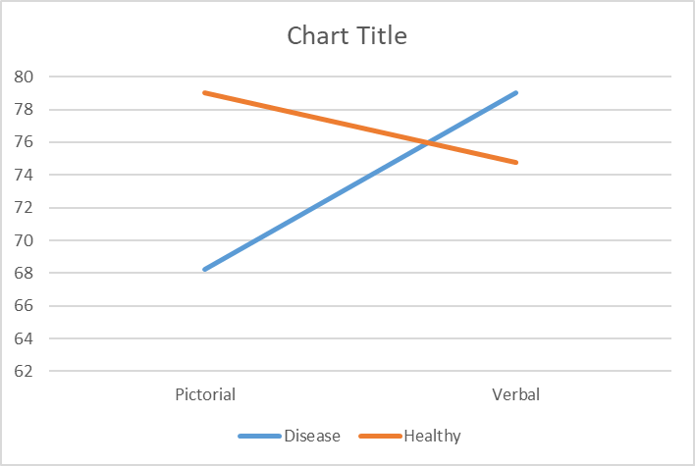 Figure 2. A line graph showing the main interaction effect of all four conditions.
Therefore, from the results obtained, it is clear that participants remembered illness contamination objects presented verbally better than the other three conditions. Interestingly, however, healthy objects presented through pictorial cues were slightly better remembered by participants than healthy objects presented through verbal descriptions. The results also indicate that contaminated objects presented pictorially were least remembered by participants. Therefore, the results suggest that object contact presented through a verbal description format lead to better memory recall. Moreover, the findings also provide support for existing literature, which states that contaminated contact objects lead to better memory recall.

Chapter Four: Discussion
The primary goal of this research was to explore three areas of interest; does object contact presented through a visual pictorial format lead to better memory than object contact presented through a verbal description format? Are illness contamination items better remembered than healthy object contact items? And, finally, the research investigated the main interaction effect between presentation format (pictorial/verbal) and contact type (illness contamination/healthy)? The findings within this research are consistent with existing literature, suggesting that illness contamination contact objects are better remembered in comparison to healthy contact objects. Interestingly, the results suggest a stark contrast within the total number of objects remembered; illness contamination objects did lead to the better recall. This was only through verbal description format, however, while illness contamination objects presented through pictorial format had the worst recall of objects remembered. Within the pictorial of both healthy and illness contaminated items presented during the research, there was a marginal difference. The analysis completed on the data concluded a significant main interaction effect between illness contaminated objects when presented through a verbal description format.
The present data is largely consistent with, and provides additional support to, existing literature which states that objects described as being touched by an unhealthy person or negative stimuli led to better memory, which has been previously suggested by Fernandes, Pandeirada, Soares, & Nairne, (2017). Fernandes et al. (2017) had previously explored objects that had come into contact with a potential source of contamination and found similar evidence to this present research activity. However, this present study differed as it attempts to explore both presentation format (pictorial/verbal) and the effects of contamination in the same testing period. However, better memory recall on illness contaminated objects was only seen on contact denoted through a verbal description format.
The present data is somewhat consistent with Bonin, Thiebaut, Witt, and Meot, (2019), who ran a series of five experiments during the research. The results within the present paper provided further evidence of the effects contamination has on memory, interestingly this was only found within three of the experiments. Bonin et al. (2019) found that contemporary contamination situations and scenarios were better remembered, for example, people becoming unwell during a trip abroad. This present paper somewhat supports this. The stimuli objects used within this study were everyday or contemporary objects such as a baby beaker, camera and items of clothing. These items are modern and everyday use items.
However, the current findings from within this research activity provides a contrast to the research of Brewin and Langley (2019). Brewin and Langley (2019) found that fewer incorrect images of the ‘very unpleasant’ scenes were recalled, suggesting that visual cues of negative stimuli leads to a better memory. However, a significance was not found during the results. The results from within the present research, in contrast, found that a verbal description format leads to better memory. It is important to note, however, that the research studies largely differ. It must be highlighted that there was a distinct lack of real-life application within Brewin and Langley (2019), in comparison with the present study.
The results of illness contaminated objects leading to better memory could be explained in terms of the Behavioural Immune System, an adaptive disease avoidance system (Fernandes et al., 2017; Schaller et al., 2015). The Behavioural Immune System triggers behavioural and cognitive responses, allowing an individual to actively avoid contaminated or potentially contaminated surface or objects, which may pose a threat to that individual. An individual’s behavioural immune system would benefit from enhanced memory recall, not only to avoid potential contamination to decrease threat, but to know to avoid the object, or make educated assumptions on situations in the future.
Previous literature suggests that presenting information in a visual format leads to better memory of that information compared to information presented verbally or in text, (Adaual et al., 2018; Dube & Al-Aidroos, 2019; Kong & Fougnie, 2019; Gayet, Paffen & Stichel, 2018; Lorenc, Dreenivasan, Nee, Vanenbroucke & Esposito, 2018). It has been suggested that this is due to the flexibility of visual working memory, which enables cognitive processes to prioritise and enhance representation to allow recall precision (Dube & Al-Aidroos, 2019). The findings from this research do somewhat support this, indicating a marginal difference between the two healthy conditions (pictorial/verbal). Healthy object contact presented pictorially was slightly better recalled than verbally presented information, which does seem to provide some support for presentation in visual format leading to better recall.
Unfortunately, this was not the case for the illness contamination sub-conditions, which revealed significantly better memory for verbally presented illness contaminated objects compared to pictorially presented illness contaminated objects. Therefore, this could be considered as a contradiction to the suggestion that pictorially presented information is always recalled better than verbally presented information, as this was not the outcome when examining the interaction effect between all four conditions. An explanation for this could be an element linking to individual differences. That is, when participants read the descriptions relating to the illness contaminated objects, they used their own experiences and interpretations for how that contact would take place. It is possible that participants conjured their own mental representations about the contact presented through the verbal format, which may have been more extreme visually than the pictorially presented contact objects in the study. Therefore, in accordance with Craik and Lockhart (1972) levels of processing framework, some tasks may require deeper levels of processing, which potentially enhances the long-term memory recall of objects (Craik & Lockhart, 1972). This could suggest that there is a possibility that creating one’s own mental visual representation of an object requires deeper levels of encoding. This representation will be based on their previous experiences of objects. This, perhaps, then becomes a more elaborate form of rehearsing. In terms of this present research, this could raise the argument that an individual is creating their own visual memory from the verbal description themselves, creating a more personal relevance to the object and causing a more elaborate form of rehearsing, in turn enhancing memory.
For example, Brewin (2014) found that recall of negative stimuli could be caused by participants using sensory imagery they had previously come into contact with. This suggests that some participants could have interpreted the verbal descriptions of contamination as much worse in comparison with contact denoted pictorially, based on previous experiences.
The level of individual differences of verbal and visual processes in short term memory is also highlighted in research conducted by Koppenol-Gonzalez et al. (2018). The previous evidence provided by Brewin (2014) and Koppenol-Gonzalez et al. (2018) both highlight that individual differences and interpretation should be taken into consideration when looking at the results. This, along with the findings of Swanson (2017), which state that performance on visual-spatial working memory declined at a much faster rate than verbal working memory, could be an explanation as to why. A combination of both factors of illness contaminated objects and the faster decline in visual-spatial working memory could have led to better memory recall of illness contamination contact objects presented through verbal descriptions.
Interestingly, an important factor to highlight is that one of the key components of the Behavioural Immune System is the emotion of disgust (Fernandez et al., 2017; Schaller & Park, 2011; Bonin et al. 2019). It is possible, therefore, that this component may have been an influencer within this study. Disgust is triggered when an individual is faced with potential risk of infection or illness. As it triggers this response it, in turn, seems to aid with memory. Taking into consideration that emotions play a strong role within the Behavioural Immune System and memory, could it be suggested that illness contaminated objects presented through a pictorial format are repressed and purposely forgotten by participants, perhaps to conceal a current emotion such as disgust, or to regulate emotions in order to protect themselves through a motivational psychological behaviour (Patel & Patel, 2019)? This may be a reason why the illness contaminated objects presented through a pictorial format lead to worse memory recall.
As previously noted, it is possible that other factors could have played a role here. It is possible that the results could be explained by enhanced attention. Evidence has already suggested that more attention is paid to contaminated or emotion-arousing stimuli such as fear or disgust (Chapman et al., 2013; Van Hoof et al., 2013).With this in mind, the verbal description stimuli caught, and required the participant to hold and engage more with the verbal description stimuli, meaning more attention was required. Therefore, given that more attention was required, it may have subsequently influenced memory processes. This could suggest that, in this case, it would enhance memory recall (Cowan, 1998).
The role of emotions could have further implications here. Although this study focused primarily on contamination and the stimuli was chosen carefully and ethically thought out, it cannot be assumed that these factors eliminated the roles of other emotions. The emotion of disgust can also induce the emotion of fear. Although this fear is more related to physical threat than anything, the emotion of fear does also have an impact on episodic memory (Chapman et al., 2013). However, it is still unclear and further lines of investigation are still required to determine, whether fear is incorporated within the Behavioural Immune System processes, or if it is a separate emotion that is subsequently triggered when presented with contaminated objects.
Therefore, could it be proposed that, in terms of explaining the interaction effect, a combination of different factors play a role here, and that, at this point in time, it is fair to say that this area of interest requires further development. However, it is important to note here, that there seems to be a stark difference in research available on visual cues in comparison to verbal descriptions. This may be a limitation to contemporary schools of thought and may have impacted the initial assumption that visual cues have a greater impact on memory. Perhaps, in terms of future research, this is an area which should be considered.
Therefore, going forward, this study requires development. The study included two levels, with a total of four conditions, investigating not only what condition was remembered better, but also an interaction effect, with all participants presented with the same stimuli. A 2 x 2 within-subject analysis was used, which, based on the design of the study, was the appropriate analysis to be used. Although the sample size was a respectable amount, giving clear findings and an interaction effect, in future, if the study was to be run again, a larger number of participants would provide a more robust finding. Another limitation that was faced when running this study was the recruitment method. The Experiment Management System was used for a number of reasons, including those of an ethical nature. This gave participants the option to take part in the study, due to the nature of the study and the stimuli used. This could have, however, impacted the amount of people that were recruited. The number of participants recruited for the present study was marginally lower than previous research (Fernandes et al., 2017; Bonin et al., 2019). Despite the fact that the current research allowed for real world application to brought into a laboratory-based environment, the research was only conducted on one group of people; undergraduate psychology students. Limiting the study to Psychology students could have had an indirect impact on the results. Psychology students may have recognised that it was a memory test, given the nature of their course, purposely remembering items and specifically recalling them. This would question the reliability and generalisation of the results. Therefore, would it be a suggestion to use a mixed sample size of the general public, or to run the study on a between subject basis as opposed to within. As this study explored one group of people, it would be interesting to test on different groups of people from within society. Would those working within the health and social sector, who are subject to illness and infection daily, have the same reaction or avoidance system? Would those individuals remember them less because they are not shocked, or feel the need to suppress the emotions of fear or disgust as they are almost conditioned to it?
If the study was to be replicated, recruiting participants from the general public could be considered. This would also give the study diversity and range throughout participants, and not just include psychology students. This would allow more reliability of results if generalised, and could be achieved by making the study available online. Although, it is important to note, that this could highlight ethical considerations, due to the nature of the study. However, it would be possible to provide a disclaimer at the start of the study to allow participants the option to continue.
One suggestion that would be beneficial in strengthening future research would be to replace the testing phase. Instead, this could be replaced with a free recall test. In the current study, participants had to respond to whether they had previously seen the picture during the testing phase or not using the keyboard. It is important to note here, that a free recall test was not originally used in this research activity, because this study required a robust amount of data to generate an interaction effect result. If a free recall test was originally in place, this would run the risk of not enough data generated for the analysis of the interaction effect, given the number of participants. However, going forward, a free recall test would eliminate the risk of participants guessing and simply pressing keys rather than engaging with the study fully; providing inaccurate answers and, ultimately, having an impact on results. A free recall test will also void participants disengagement due to finding the study too long, given the length of the experimental phase and the distractor task. This will also eliminate participants from being reminded of what they had seen. Providing a free recall test would allow participants to recall solely from memory. This would strengthen the reliability of the results generated, gaining an accurate account of what is being recalled. A free recall test has already been used in a previous study by Bonin et al. (2019). The study’s main aim was to provide evidence of the recurring problem of avoiding contamination, and to provide evidence that better remembered items were those which cause potential threat. The results found supporting evidence that contaminated objects and the potential to cause contamination to objects were better recalled.
Providing a free recall test, where participants have to list and name the objects they remember seeing, could potentially strengthen the study design for future research. However, it is important to note here that this could cause some potential issues, as some participants may call objects similar names but potentially mean something else, for example, a chair. This could suggest a range of chairs. Therefore, it is crucial that stimuli are selected carefully, ensuring that all objects included must be from separate groups of items. This would ensure the researcher clearly understood and could not mistake any data collected. Moreover, this would eliminate the risk of recognition, again providing a more accurate result of true memory. Although free recall tests have been done in previous studies (e.g., Fernandes et al., 2017; Bonin et al., 2019) this present study differs, as it focuses on object contact and presentation format in the same testing period. and would test purely which items were remembered. It is possible to examine the presentation format in the same testing period, however, providing enough data is gathered.
Previous studies which explored disjunction of attention and memory in the processing of physical disfigurement conducted by Ackerman et al. (2009) found that participants seem to remember the location of disfigured faces well, but remembered faces with no disfigurements better than the disfigured faces. In terms of future research, to ensure this is eliminated, it would be beneficial that the background of each stimuli is plain, for example, a white background. This would guarantee that any further influencing factors would be eradicated. Although the stimuli in this present research was chosen carefully, not all of the images were on white backgrounds; some of the images presented to the individuals do have a background image to them, which could have had an impact on participants’ recognition and therefore impacted the results.
Given the current situation in which the world finds itself, in the midst of the COVID-19 pandemic. Research surrounding contamination, people’s behaviours and the Behavioural Immune Systems, seems more relevant than ever. Allowing for real world application and implications to be applied to the present research. An example of this would be the current situation in Britain. The manner in which information about the infection and the guidelines in which the public are to follow are conveyed through the media. These include television, radio, adverts and radio, being communicated at the most part, through verbal descriptions. This is enabling people to make decisions about what and where to avoid in order to stay safe and reduce the transmission. In terms of the current results, this would suggest that people are able to remember and recall information and guidelines about the infection better, over a longer time period.
Despite the limitations within the present study, this research does allow for real world application, and highlights some contradictory findings to existing research. The results also provide further support that memory performs better in context of contamination. The results also indicate presentation through a verbal description format and illness contaminated contact objects, which could cause potential threat to an individual, had the greatest impact on memory, formulating the best interaction effect. It is not possible to determine at this point, however, that other influencing factors, such as emotions, attention or limitations within the study, did not play a role here. Despite this, the study does present interesting findings. It is fair to conclude that, in light of current research, further research is required to gain a full understanding of the causality.

Reference list
Ackerman, J. M., Becker, D. V., Mortensen, C. R., Sasaki, T., Neuberg, S. L., & Kenrick, D. T. (2009). A pox on the mind: Disjunction of attention and memory in the processing of physical disfigurement. Journal of Experimental Social Psychology, 45, 478-485.
Adaval, R., Saluja, G., & Jiang, Y. (2018). Seeing and thinking in pictures: A review of visual information processing. Consumer Psychology Review, 2(1), 50-69.
Altmann, D. M. (2019). Vaccine Immunology: What Do Clinicians Need to Know?. In Poland, G. A. (Eds.). London: Elsevier
Baddeley, A. D. & Hitch, G. (1974). Working Memory. Psychology of Learning and Motivation, 8, 47-89. https://doi.org/10.1016/S0079-7421(08)60452-1.
Baddeley, A. D. (2000). The episodic buffer: A new component of working memory?. Trends in Cognitive Sciences, 4(11), 417-423. https://doi.org/10.1016/S1364-6613(00)01538-2
Belouaer, L., Brosset, D., & Claramunt, C. (2016). From verbal route descriptions to sketch maps in natural environments. ACM Sigspatial. 13. doi:10.1145/2996913.2997003
Boag, S. (2018). Freudian repression, the Unconscious, and the Dynamics of Inhibition. London: Routledge.
Bonin, P., Thiebaut, G., Witt, A., & Meot, A. (2019). Contamination is “good” for you memory! Further evidence for the adaptive view of memory. Evolutionary Psychological Science, 5, 300-316.
Bramilla, A., Von Hardenberg, A., Krsito, O., Bassano, B., & Bogliani, G. (2013). Don’t spit in the soup: Faecal avoidance in foraging wild alpine ibex, Capra ibex. Animal Behaviour, 86, 153-158. https://dx.doi.org/10.1016/j..anbehav.2013.05.006
Brewin, C. R. & Langley, K. M. R. (2019). Imagery retrieval may explain why recall of negative scenes contains more accurate detail. Memory & Cognition, 47(3), 420-427. https://doi.org/10.3758/s13421-018-0876-7
Burton, C. Z., Vella, L., & Twamley, E. W. (2019). Prospective memory, level of disability, and return to work in severe mental illness, The Clinical Neuropsychologist. 33(3), 594-605. https://doi.org/10.1080/13854046.2018.1436725
Butler, A. (2018). "General Psychology (Fall 2018)". Retrieved from https://scholar.valpo.edu/psych_oer/2
Chapman, H.A., Johannes, K., Poppenk, J. L., Moscovitch, M., & Anderson, A. K. (2013). Evidence for the differential salience of disgust and fear in episodic memory. Journal of Experimental Psychology: General, 142, 1100-1112. doi: 10.37/a0030503
Clarke, I., Flaherty, T. B., & Yankey, M. (2006). Teaching the visual Learner: The use of visual summaries in marketing education. Journal of Marketing Education. 28(3), 218-226. https://doi.org/10.1177%2F0273475306291466
Cowan, N. (1998). Attention and memory: An integrated Framework. Oxford: Oxford University Press.
Craik, F. I. M., & Lockhart, R. S. (1972). Levels of processing: A framework for memory research. Journal of Verbal Learning and Verbal Behaviour, 11(6), 671-684.
Culpepper, P. D., Havlicek, J., Leongomez, J. D. & Roberts, S. C. (2018). Visually Activating Pathogen Disgust: A new Instrument for Studying the Behavioural Immune System. Frontiers in Psychology, https://doi.org/10.3389/fpsyg.2018.01397
Dube, B., & Al-Aidroos, N. (2019). Distinct prioritization of visual working memory representations for search and for recall. Attention, perception, & psychophysics, 81(5), 1253-1261. https://doi.org/10.3758/s13414-018-01664-6
Eckstein, R. A., & Hart, B. L. (2000). Grooming and control of fleas in cats. Applied Animal Behaviour Sciences, 68, 141-150. https://dx.doi.org.10/1016/so186-1591(00)00095-2
Engelhard, I. M., McNally, R. J., & Van Schie, K. (2019). Retreving and Modifying Traumatic Memories: Recent Research Relevant to Three Controversies. Current Directions in Psychological Science, 28(1), 91-96. https://doi.org/10.1177%2F0963721418807728
Eysneck, M. W. & Keane, M. T. (2015). Cognitive Psychology. A student’s Handbook. London: Psychology Press.
Fernandes, N. L., Pandeirada, J. N. S., Soares, S. C., & Nairne, J. S. (2017). Adaptive memory: The mnemonic value of contamination. Evolution and Human Behaviour, 38(4), 451-460. https://doi.org/10.1016/j.evolhumbehav.2017.04.003
Gayet, S., Paffen, C. L. E., & Stigchel, S. V. D. (2018). Visual Working Memory Recruits Sensory Processing Areas. Trends in Cognitive Sciences, 22(3), 189.
Jenkins, L. & Hamilton, C. (2018). The Importance of Retrieval Context in Visual Working Memory. Clinical and Experimental Psychology, 4, 3. doi: 10.4172/2471-2701.1000196
Kensinger, E. A. (2009). Remembering the details: Effects of emotion. Emotion Review, 1, 99–113. https://doi.org/10.1177/1754073908100432
Kim, L. E. & Klassen, R. M. (2018). Teachers’ cognitive processing of complex school-based scenarios: Differences across experience levels. Teaching and Teacher Education. 73, 215-226. https://doi.org/10.1016/j.tate.2018.04.006
Kong, G. & Fougnie, D. (2019). Visual Search within working memory. Journal of Experimental Psychology: General, 148(10), ,1688-1700. https://psycnet.apa.org/doi/10.1037/xge0000555
Koppenol-Gonzalez, G. V., Bouwmeester, S. & Vermunt, J. K. (2018). Accounting for individual differences in the development of verbal and visual short term memory processes in children. Learning and Individual Differences, 66, 29-37. https://doi.org/10.1016/j.lindif.2018.01.007
Kraft, S.A., Cho, M.K., Gillespie K., Halley, M., Varsava, N., Ormond, K. E … Soo-Jin Lee, S. (2018) Beyond Consent: Building Trusting Relationships with Diverse Populations in Precision Medicine Research, The American Journal of Bioethics, 18:4, 3-20. doi:10.1080/15265161.2018.1431322
Lanzi, A., Wallace, S. E., & Bourgeois, M. (2019). Group external memory aid treatment for mild cognitive impairment. Aphasiology, 33(3), 320-336. https://doi.org/10.1080/02687038.2018.1466104
Lew, S. M. (2016). Special issue on visual information retrieval, International Journal of Multimedia Information Retrieval. 5, 1-2. https://doi.org/10.1007/s13735-016-0094-7
Loftus, G. R. & Loftus, E. F. (2018). Human Memory the processing of information. New Jersey: Lawrence Erlbaum Associates, Inc., Publishers
Lorenc, E. S., Sreenivasan, K. K., Nee, D. E., Vandenbroucke, A. R. E., & D’Esposito, M. (2018). Flexible Coding of Visual Working Memory Representations during Distraction. Journal of Neuroscience, 38(23), 5267-5276. https://doi.org/10.1523.JNEUROSCI.3061-17.2018.
Lyeth, B. G., Jenkins, L. W., Hamm, R. J., Dixon, C. E., Phillips, L. L., Clifton, G. L., Young, H. F. & Hayes, R. L. (1990). Prolonged memory impairment in the absence of hippocampal cell death following traumatic brain injury in the rat. Brain Research, 526(2), 249-258. https://doi.org/10.1016/0006-8993(90)91229-A
Mance, I. & Vogel, E. K. (2013). Visual working memory Advanced Review. Wires Cognitive Science. 2(4), doi:10.1002/wcs.1219
Markman, A. B. (2018). Combining the strengths of naturalistic and laboratory decision-making research to create integrative theories of choice. Journal of Applied Research in Memory and Cognition. 7(1), 1-10. https://doi.org/10.1016/j.jarmac.2017.11.005
Mickes, L. (2016). The Effects of Verbal Descriptions on Eyewitness Memory: Implications for the Real-World. Journal of Applied Research in Memory and Cognition. 5(3), 270-276. https://doi-org.ezproxy.uwtsd.ac.uk/10.1016/j.jarmac.2016.07.003
Parson, J. & Keogh, R. (2019). Redefining Visual Working Memory: A Cognitive-Strategy, Brain-Region Approach. Current Directions in Psychological Science. https://doi.org/10.1177%2F0963721419835210
Patel, J. & Patel, P. (2019). Consequences of Repression of Emotion: Physical Health, Mental health and General Well Being. International Journal of Psychotherapy Practice and Research, 1(3). doi: 10.14302/issn.2574-612x.ijpr-18.2564
Poo, M., Pignatelli, M., Ryan, J. T., Tonegawa, S,. Bonhoeffer, T., Martin. K. C., Rudenko, A., Tsai, L., Tsien, R. W., Fishell, G., Mullins, C., Goncalves, T., Shtrahman, M., Johnston, S. T., Gage, F. H., Dan, Y., Long, J., Buzsaki, G., & Stevens, C. (2016). What is memory? The Present State of Engram. BMC Biology, 14, 40. https://doi.org/10.1186/s12915-016-0261-6
Schaller, M. (2015). The Behavioural Immune System, Part 2 Survival. Retrieved from https://onlinelibrary.wiley.com/doi/abs/10.1002/9781119125563.evpsych107
Schaller, M., & Park, J. H. (2011). The Behavioural Immune System (and why it matters). Current Directions in psychological Science, 20, 99-103.
Schaller, M., Murray, D. R., & Bangerter, A. (2015). Implications of the Behavioural Immune System for Social Behaviour and Human Health in the Modern World. The Royal Society Publishing, https://doi.org.10.1098/rstb.2014.0105
Swanson, H. L. (2017). Verbal and Visual-Spatial Working Memory: What Develops Over a Life Span?. Developmental Psychology, 53(5), 971-995. https://psycnet.apa.org/doi/10.1037/dev0000291
Teichert, T. & Gurnsey, K. (2019). Formation and Decay of Auditory Short-Term Memory in the Macaque Monkey. Journal of Neurophysiology. https://doi.org/10.1152/jn.00821.2018
Vakil, E., Greenstein, Y., Weiss, I. & Shtein, S. (2019). The Effects of Moderate-to- Severe Traumatic Brain Injury on Episodic Memory: A Meta-Analysis. Neuropsychology Review, 29(3), 270-287. https://doi.org/10.1007/s11065-019-09413-8
Van Hoof, J.C., Devue, C., Vieweg, P. E., & Theeuwes, J. (2013). Disgust and not Fear Evoking Images Hold our Attention. Acta Psychology, 143, 1-6.
Wilson, B. M., Seale-Carlisle, T. M., & Mickes, L. (2018). The Effects of Verbal Descriptions on Performance in Line-ups and Show-ups. Journal of Experiments Psychology: General, 147(1), 113-124. https://psycnet.apa.org/doi/10.1037/xge0000354

Appendices
Appendix A
Healthy – Verbal
1)
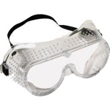
- A 29 year old glass technician wore this protective equipment when working.

2)
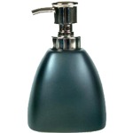
- A nurse practitioner used this soap dispenser after tending to a patient.
3)

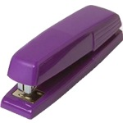
- A school girl who enjoys netball used this to staple her project together.

4)
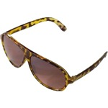
- A 45 year old lawyer wore these when driving on a sunny day.
5)

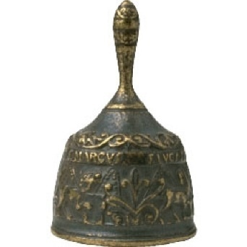
- A tall, blonde school teacher rung this bell at the end of break.

6)

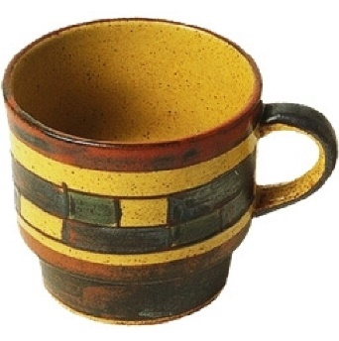
- This mug was used by a 69 year old female who enjoys reading and knitting.

7)
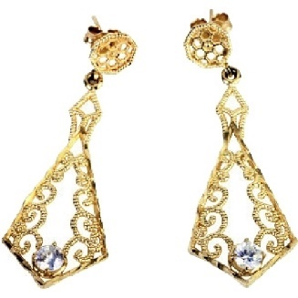
- These brand new earrings have just been purchased by a husband for his wife.
8)
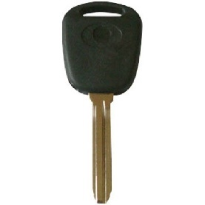
- This car key has been used by a 17 year old boy who has recently passed his driving test.
9)
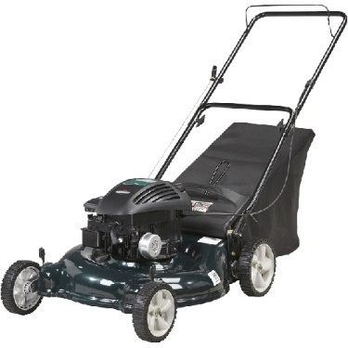
- An elderly gentleman has used this to cut the lawn in his back garden.
10)

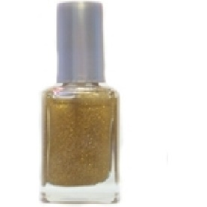
- The nail polish was used by a nail technician on a young female client.

Unhealthy – verbal
1)
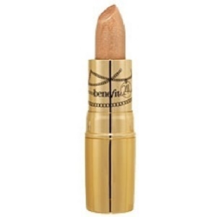
- A 25 year old model who has a cold sore used this lipstick.
2)
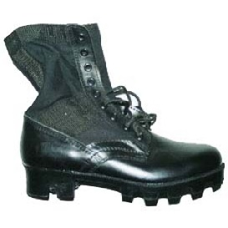
- These boots were worn by a solider with a verruca.
3)
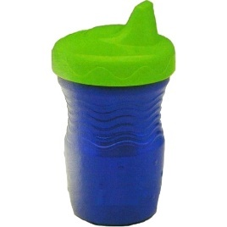
- This cup was used by a 3 year old with a runny nose.
4)
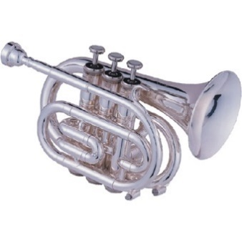
- This trumpet was used by a 12 year old boy who had just returned back to school from having time off due to the sickness bug.

5)
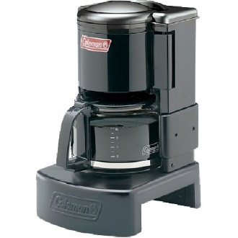
- This was used by a barrista who has ezcema on her face and arms.

6)
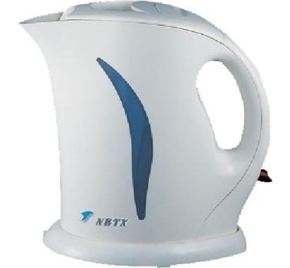
- A 33 year old mother who is currently suffering from the flu used this to make coffee.
7)
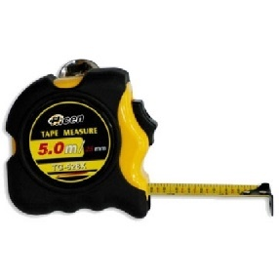
- This was used by a carpenter who has an infected wound from a previous work accident.
8)
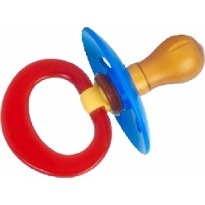
- This dummy was given to a child with chicken pox

9)
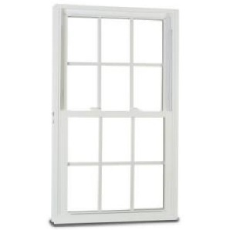
- This window was opened by a 37 year old lady who had not washed her hands after using the toilet.
10)
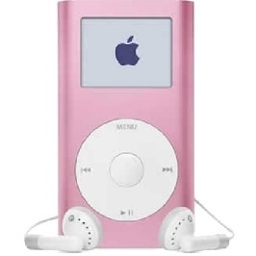
- This headset was worn by a 10 year old girl with an ear infection.
Unhealthy - visual
1)
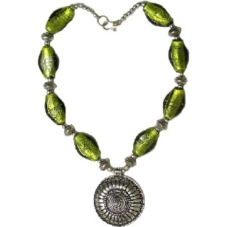This necklace was worn by this female to an evening meal 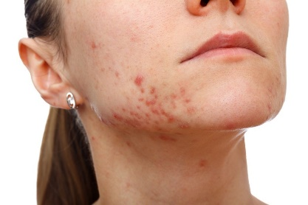

2)
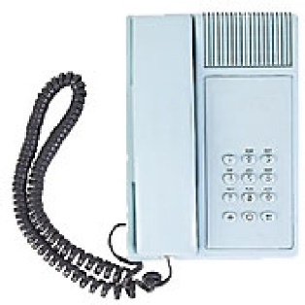 This phone was used by this female to contact her work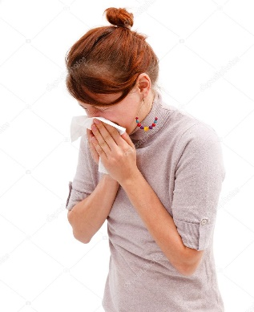
3)
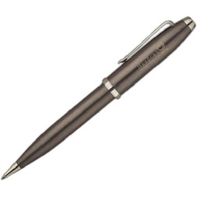 This pen was used by a young girl with a lesion on her finger 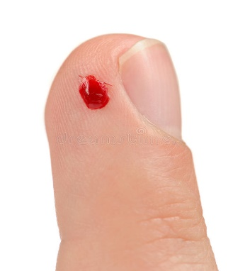

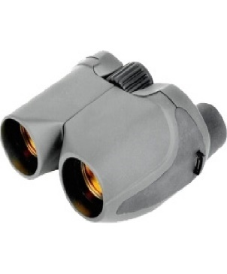
4)

These binoculars were used by a child with this on her eye 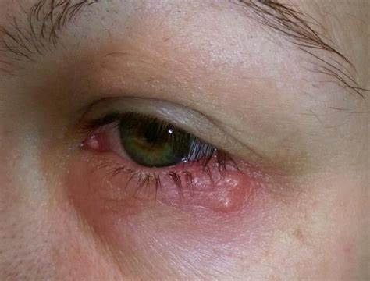

5)
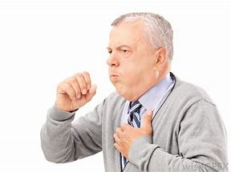
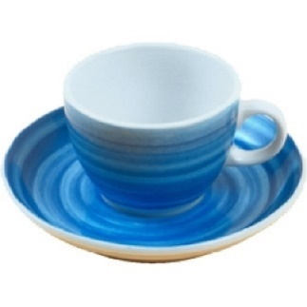 This cup and saucer was used by this male.

6)
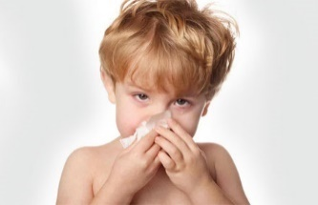 this child held this balloon during a party 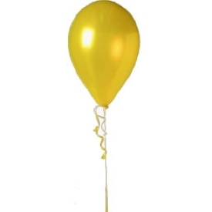

7)
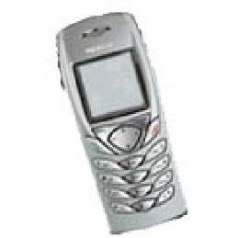 This mobile was used by this young female 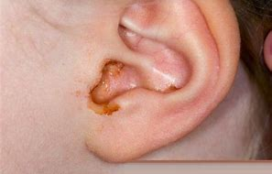

8)
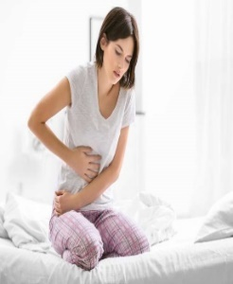
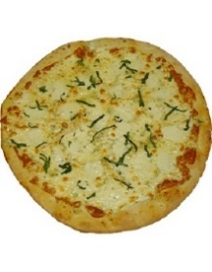
This pizza was prepared by this young girl just a few hours before she fell ill

9)
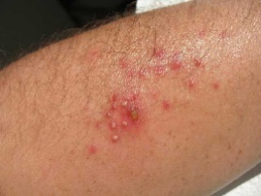
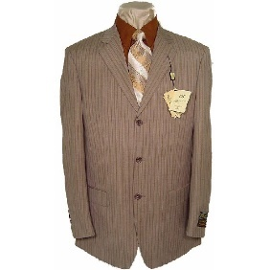 This was worn by a gentleman with a skin condition

10)
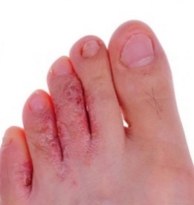
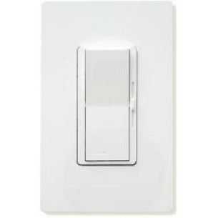
This switch was pressed by a gentleman with a skin infection on his feet

Healthy – visual
1)
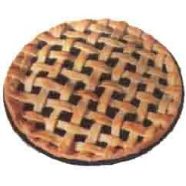


This female chef prepared this pie

2)
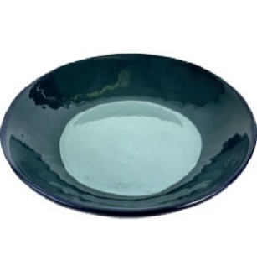This plate was used by a female who enjoyed a manicure 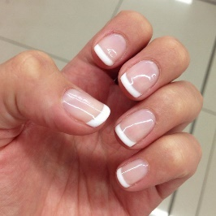
3)
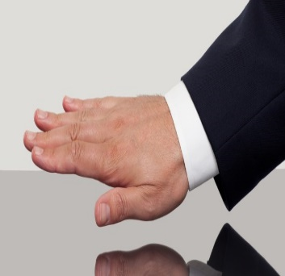 This gentleman drank this during a party 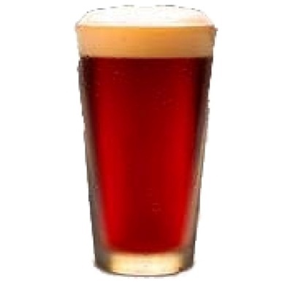

4)
 This female, who enjoys outdoor activities, tries to capture every moment. 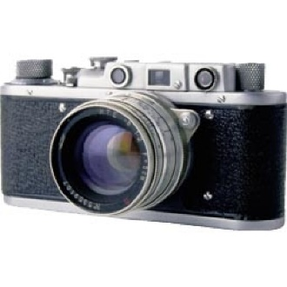

5)
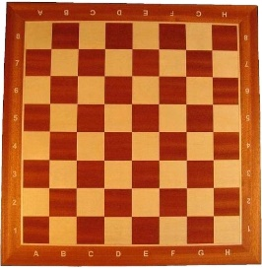
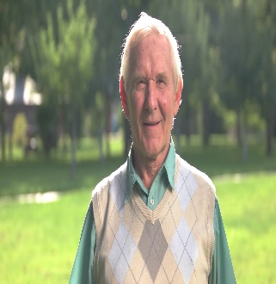
This male enjoys trying to teach his grandchildren how to play chess.

6)
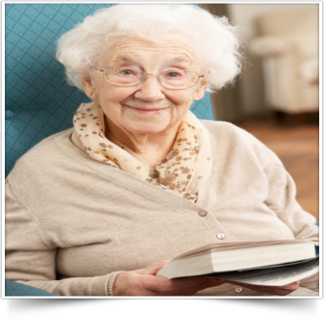
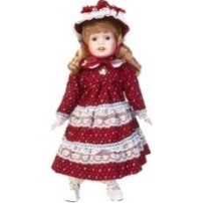 This doll belongs to this female

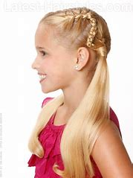
7)
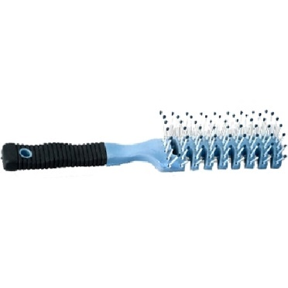This is this little girl’s favourite brush to use

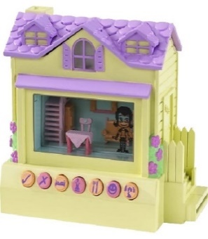
8)
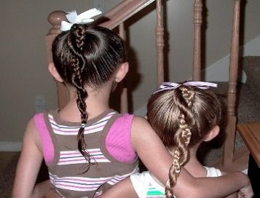
These children enjoy playing with this together on weekends

9)
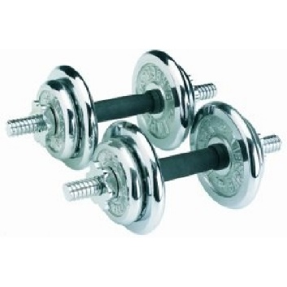 This equipment is used four times a week by this male 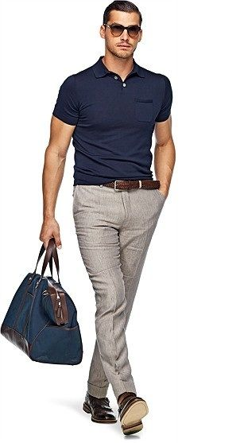
10)
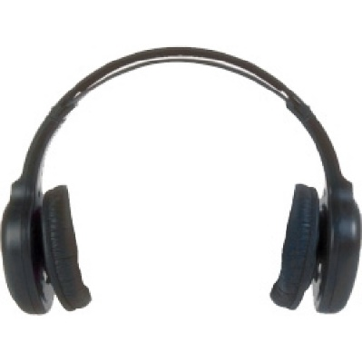These headphones are used during piano practice by this female 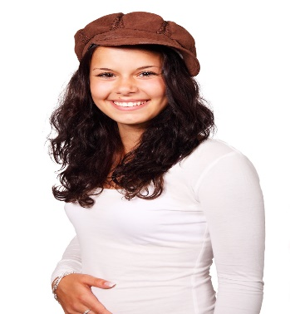
40 images for testing phase

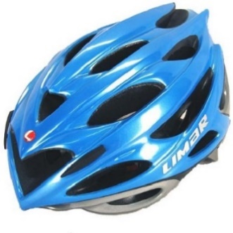

2)

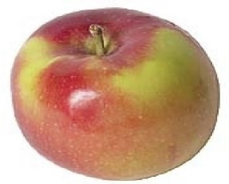
3)
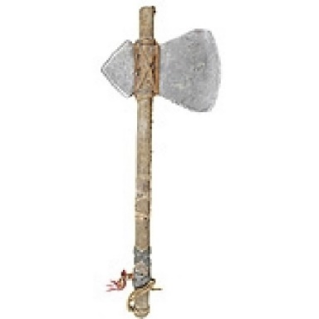
4)
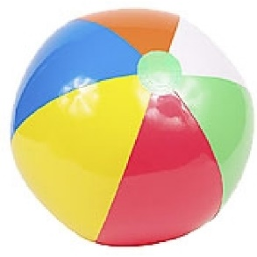
5)
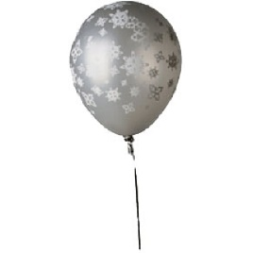
6)
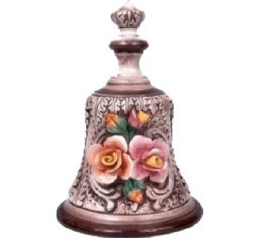

7)
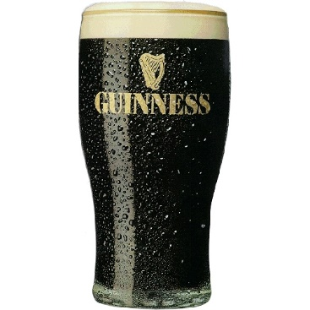
8)
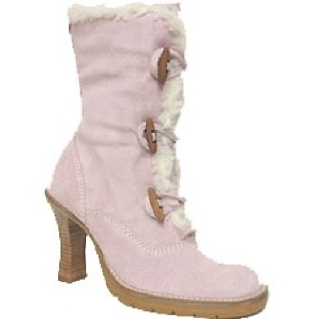
9)
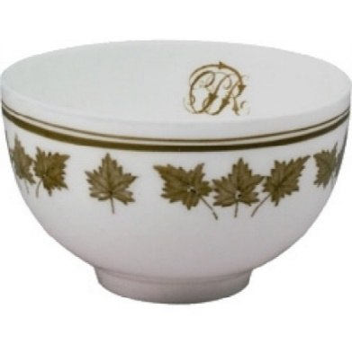
10)
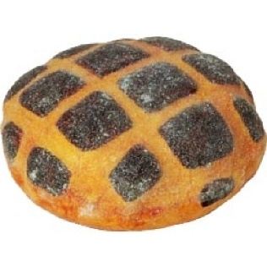

11)
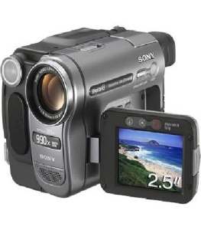
12)
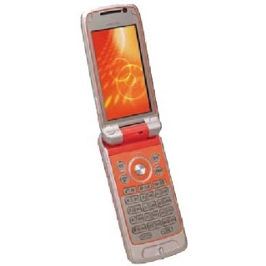
13)
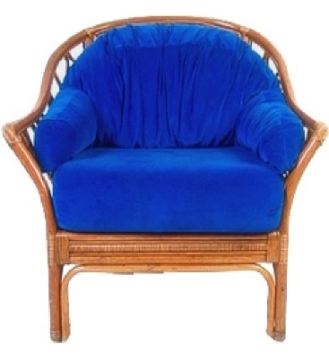

14)
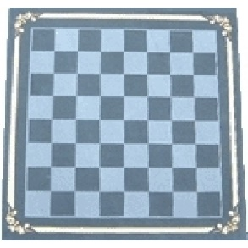
15)
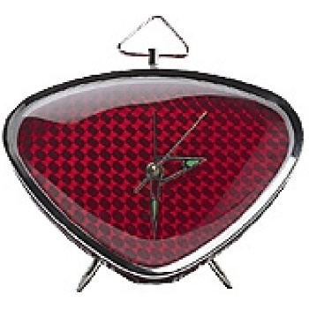
16)
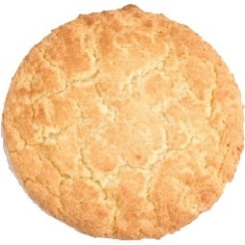
17)
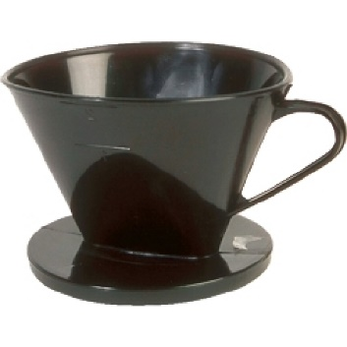
18)
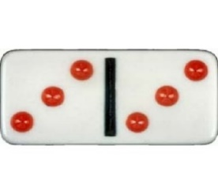
19)
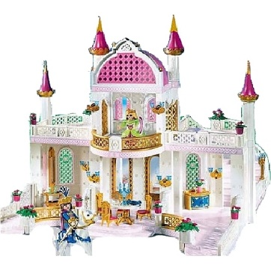
20)
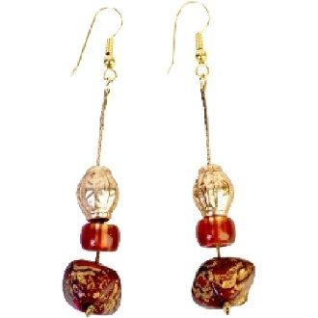

21)
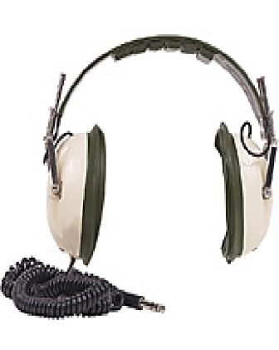
22)
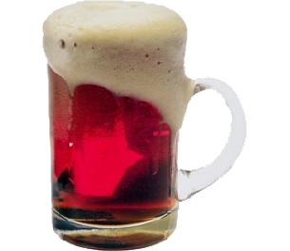
23)
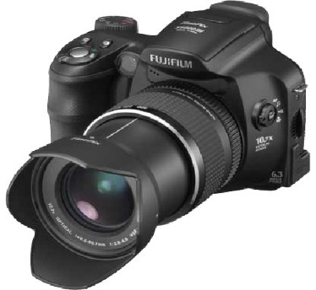
24)
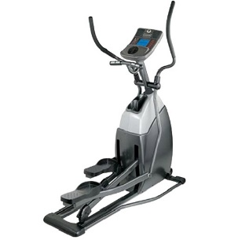
25)

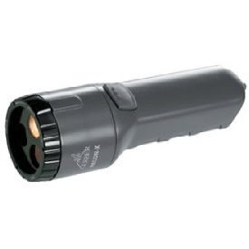
26)
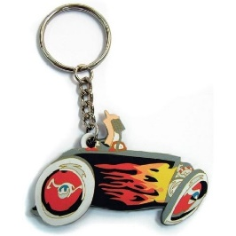
27)
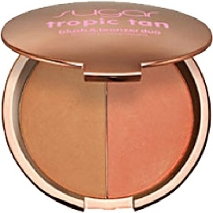
28)
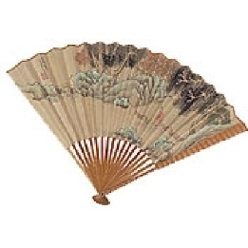
29)


30)
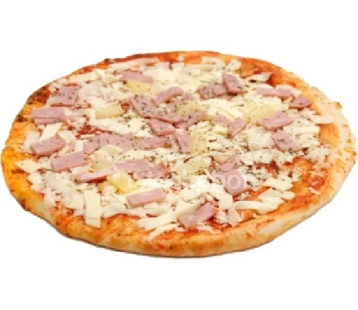

31)
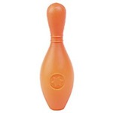
32)
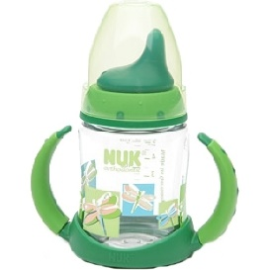
33)
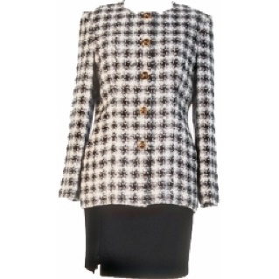
34)
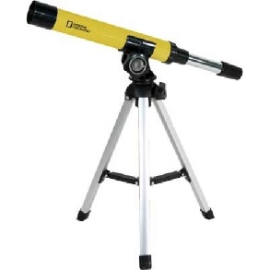
35)
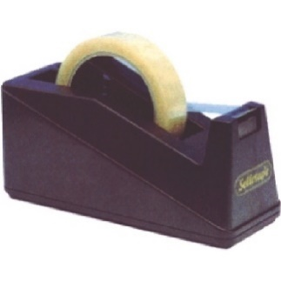

36)
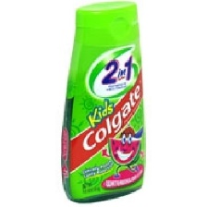
37)
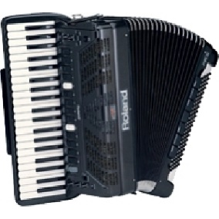
38)
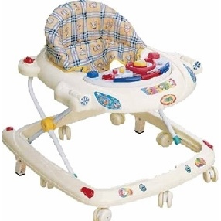
39)

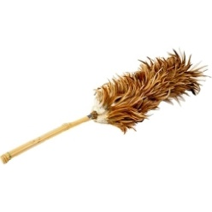
40)
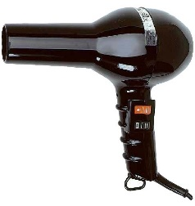

Appendix B – Proposal form

Dissertation proposal 2019-2020

Student Name | Rebecca Harding
Dissertation Supervisor | Dr Kate Williams
Date submitted | 10th October 2019

Title of Research (this must reflect the essence of your proposed research question, study design and study population and should be more specific than the broad topic area provided in the dissertation topics selection book).

The impact of verbal descriptions and visual cues on memory for disease contaminated objects.

Please state your main research question(s) and hypothesis/hypotheses

Does object contact presented through a visual pictorial format lead to better memory of those objects than object contact presented through a verbal description format?

Are disease contact items better remembered compared to non-disease contact items?

Does object memory depend on the interaction between presentation format (pictorial/verbal) and contact type (disease/healthy)?

The following hypotheses are proposed as part of this research:

Objects presented pictorially will be better remembered than verbally described objects, due to prioritisation in visual working memory, which enhances recall precision.

Disease contaminated objects will be better remembered due to the disease avoidance system – the behavioural immune system, enhancing their representation in memory.

As there are four separate conditions within this study; pictorial healthy, pictorial diseased, verbal healthy and verbal diseased, this could lead to a different interaction and combination effect. Although, it is likely that objects from the verbal healthy condition will be remembered the least, and objects from the pictorial diseased condition are likely to be remembered the best.
However, it is possible that, objects from the verbal healthy condition could be remembered better. This is due to suppression of the objects from the diseased conditions and enhancement of the healthy conditions. Although it is unclear at this stage if the combination and interaction between the four will have an impact.

What empirical evidence supports your research question? (Please provide a 1500 word review of relevant psychological literature and theory and a minimum of eight references). If you have already drafted a review of literature please attach it to the end of this document – you do not need to complete this section if so).

…Please find attached at the end of this form.

Please describe your participant group (including anticipated number of participants required) and any specific inclusion/exclusion criteria.

The participants will be university students studying one of the Psychology degree programmes at UWTSD. There will be no inclusion or exclusion criteria. However, all participants will be over the age of 18. The participants will be recruited through the EMS used at the University of Wales Trinity Saint David in exchange for course credit. Based on similar previous studies the participant numbers varied from 60 – 120. For this research the aim is approximately 80 – 100 participants, as this will give a good, robust amount of data to work with.

Please provide brief details of the anticipated design (e.g., between, within, mixed, regression, focus groups, interviews, experimental, questionnaires) and main procedure for your study (it should be clear from this how you are actually planning to carry out your study, and what will be happening to your participants).

The design of this study will be a 2x2 within subjects experimental design, with a total of four conditions.
The design will contain two independent variables, the first independent variable will be the type of person touching the object, with two levels – either healthy or diseased and the second independent variable will be mode of denoting the person touching the object, again with two levels - either a verbal description or a visual picture.
The dependent variable will be the total amount of accurate objects remembered in all four conditions.
The experiment will be programmed using SuperLab to present the stimuli and record participant responses.

The participant will be shown a total of 40 objects displayed individually as visual pictures on the computer screen. Each picture and corresponding description will be presented for ten seconds. The objects will be sourced from the Massive Memory Database http://cvcl.mit.edu/mm/..
Ten of the object pictures will contain a verbal description denoting diseased contact with the object, a further ten object pictures will contain a verbal description denoting non – diseased contact.
The visual description pictures will include ten pictures indicating non – diseased contact and a further ten pictures indicating diseased contact with the object. The order in which the object pictures within each of the four conditions is displayed will be counterbalanced.

Once the participant has been shown the 40 object pictures, the participant will then complete a jigsaw, as a distractor for five minutes.
For the memory task of the experiment the participant will be shown a total of 80 pictures, 40 of those will be the pictures that were shown previously and 40 new object pictures. Each picture during the memory recall phase will be shown for five seconds. The participant will see these in a randomised sequence. The participant will have to respond whether they have seen the picture previously. The participants will respond during the memory task using the keyboard, by pressing the corresponding keys Q and P to whether they believe that the picture presented is an old picture from the experimental phase or not.
Key Q will be used to denote that the picture has previously been seen and key P, will be used to denote a new picture. This then will be changed to counterbalance and the other half of participants will use Key P to denote that the picture presented is one previously seen and Key Q is a new picture.
This will determine whether a diseased contact object is remembered better than non-diseased contact objects and whether pictorially presented information is remembered better than verbal description.

What measures are you planning to use for data collection and how will this data be used in the analysis in order to answer your research question? (Be as specific as possible here – what type of data will you be obtaining, what specific topics/measures/scales/instruments will you be using and what will you do with this data?)

The type of data that will be obtained will be numerical data, which will come from the memory task of the study. Participants will have a total accuracy score for the number of objects they correctly identified from the study phase. The data will be then be analysed using a 2 x 2 within subject ANOVA, using SPSS. This will provide…….

o Main effect of object contact presentation type (verbal/pictorial)
o Main effect of type of contact (healthy or diseased)
o Interaction

The results will then be interpreted using the appropriate measure and written up in a report format.

What are the main ethical issues that you will need to address in this study? (Please note all students will need to complete the full ethics form prior to final approval for data collection being given).

Firstly, in order to follow ethical guidelines, full consent must be obtained from the participant.
Secondly, participants’ data will be anonymous, and this will be explained during the start of the study when obtaining consent.
One potential ethical issue that could occur is, given the nature of the topic, the study may prove distressing for some individuals. In order to limited the amount of potential distress to the participant, much thought and care was given when choosing the stimuli. Stimuli was chosen not to include pictures or verbal descriptions that were to gruesome/distressing but still enough detail to capture the essence of the presence of disease.
It must be taken into consideration and was when choosing the stimuli, that some individuals do not like the nature of the topic as they are squeamish, for example, as one BPS ethical guideline is to minimise the risk of any psychological distress that could be caused.
As participants will be recruited using the University’s EMS a disclaimer will be written at the start explaining the nature of the topic with an advisory statement stating that, if an individual finds the nature of the topic distressing, they should not sign up or partake in the study.
This will also be explained during the consent period of the study where the researcher will again explain the nature of the topic, and also explain if at any one point during the study the participant becomes distressed or doesn’t feel they can continue, then to stop and leave the lab immediately without penalty. If this does occur the researcher will contact their academic supervisor immediately. In the event the academic supervisor is not available, the Lab manager may be contacted, or the student research may take the participant to student services.
Once the participant has completed the experiment, the research student will provide the participant with the opportunity to raise any issues, concerns or questions they may have. The participant will then be provided with a debrief sheet which will include an explanation of the study and its aims. It will also contain the student researchers and the academic supervisors contact details on.

Student Name (Please print clearly) ________Rebecca Harding__________

Student Signature ___________R.Harding______________Date_____10/10/19____

Proposal Outcome |  | Supervisor to tick one only
Satisfactory proposal (all final materials have been approved by the supervisor; proceed to submitting the ethics form to the discipline research ethics committee). |  | X
Minor revisions (some areas require clarification before submitting ethics to the discipline research ethics committee - see below for required actions)

Unsatisfactory (proposal lacks significant detail and must be resubmitted to supervisor within seven days following feedback - see below for required actions)

Unsatisfactory - proposal is considered unethical/unworkable in practice. New proposal to be developed following feedback from supervisor (see below)

Proposal is satisfactory but requires full consideration by the Faculty research ethics committee due to the nature of the study

Supervisory team additional comments/feedback:

Action required:

Date of comments/feedback :



Supervisor’s Signature: ___________________________ Date: _23.10.19____

Draft Literature Review

It is undoubtable that memory is a fundamental process in everyday life and an indispensable human function. It is critical, therefore, that research is conducted in all aspects of this process to gain a full and informed understanding of how cognitive processes function (Brewin & Langley, 2019), with each of these tasks being paramount for the survival and development of an individual. However, the purpose of this paper is to take a further and more detailed look into the impact of verbal descriptions and visual cues on memory for disease contaminated objects.
It has been proposed that humans not only have a biological immune system, that aids with survival and reproduction, but also contain a disease avoidance system, which has likely evolved and adapted over time, known as the Behavioural Immune System (Fernandes, Pandeirada, Soares, & Nairne, 2017 & Schaller, Murray, & Bangerter, 2015).
The Behavioural Immune System theory proposed that human beings have a motivational system that has evolved and adopted social behaviours which provide individuals with protection that minimises the risk of coming into contact, with infections, or any potential sources such as pathogens that could cause the individual harm. (Schaller, Murray & Bangerter, 2015; Ackerman, Hill & Murray, 2018).
The Behavioural Immune System consists of psychological mechanisms that occur. Firstly, the individual will recognise the cues for the potential risk within the environment. The cues recognised will trigger cognitive and negative emotional responses i.e disgust (Lieberman & Carlton, 2014), the individual will display disease avoidance behaviours i.e avoiding contact (Schaller & Park, 2011). With these three processes coordinating with each other, it allows for the behavioural immune system to be become sophisticated and effective as possible, in creating a defence mechanism (Schaller, Murray & Bangerter, 2015). The Behavioural Immune System, which relies on cognitive processes as well as behavioural systems, enables individuals to avoid coming into contact with potential risks that could cause them harm through behaviours (Schaller, 2015). It has been suggested that individuals can identify differences between healthy people and sick people based on subtle difference such as physical appearance or bodily odours. The differences identified are often enough to trigger the individual to avoid contact with the sick individual (Schaller, 2020).
Similarly, avoidance systems have also been found in animal species. Some species have been found to avoid contaminated drinking water and land. Animals have also been found to be actively protecting themselves through grooming and hygiene behaviours (Brambilla, Von Hardenber, Kristo, Bassano & Bogliani, 2013; Eckstein & Hart, 2000). This indicates that it is not just human beings who have a behavioural immune system. It is important to note, however, that the knowledge surrounding cognitive processes that are involved within the Behavioural Immune System is still limited, indicating that more research is require.
An explanation as to why and how humans have evolved and adapted the Behavioural Immune System is that, over time, many advances within clinical research have been discovered. These discoveries have been informed by through research. This has allowed wider knowledge and awareness surrounding parasites, pathogens and potential risks that pose a threat (Altmann, 2019). This knowledge and information has become readily available to individuals over the years, undoubtedly also as a result of advances in technology, and further research allowing individuals to make educated assumptions and informed decisions on objects and situations to avoid making contact with (Karft et al, 2018). This could be an explanation as to how and why individuals have adapted their ways in thinking and approaches towards pathogens and potential risk that may cause an individual harm. However, despite the wealth of research that has been undertaken in this area, the cognitive processes that occur as part of the Behavioural Immune System continues to be a strong line of interest within contemporary research.
A recent study conducted by Fernandes et al. (2017), suggested that memory played a vital role in the Behavioural Immune System. Fernandes et al’s. (2017) study investigated the cognitive processes of the system, and specifically investigated the role of human memory within the processes of the Behavioural Immune System. The study was composed of four different experiments. Within the study participants were shown pictures of objects that had come into contact with either healthy or sick individuals, either through visual cues or verbal description. In experiment 1a and 1b each object was linked to verbal descriptions about the person initiating contact. In experiment 2 and 3 visual cues using faces to initiate contact. After the encoding phase was completed, participants were then given a distractor task for two minutes. The distractor task consisted of single digitals being displayed on the screen for two seconds each. Once the experiment was completed the participants then had a surprise free recall memory task, where each participant had to write down as many of the objects as they could possibly remember. Participants were given ten minutes to complete this task. Throughout all four of the experiments, the objects touched by sick people were better remembered than the objects that had come into contact with healthy people. The findings do suggest that memory could potentially play a vital part within the Behavioural Immune System, in three of the experiments the data confirmed and provided strong support that objects described to have come into contact with a contaminated person were better remembered than an object being touched by a healthy person. It is also important to note that the study was run in two different countries which provides robustness of the research. This also limits the role of cultural influences suggesting that the behavioural immune system is active throughout humanity. The main focus of the study was on adaptive memory in relation to contamination, and therefore does not provide a clear and more detailed explanation as to why and how visual cues or verbal descriptions had a greater impact on memory and recall. It is also important to highlight that current research conducted by Fernandes et al, (2017), were not examined together as part of the same testing period and only examined the effects of pictorially and verbally presented information in four different experiments. This limitation suggests further research is required to gain a full explanation and a clear understanding of some of the processes involved.
Although there is empirical research already available surrounding the topic of the Behavioural Immune System, much of the present research provides supporting evidence that memory does, in fact, play a vital role within the system, (Schaller & Park, 2011; Fernandes, Pandeirada, Soares, & Nairne, 2017 & Schaller, Murray, & Bangerter, 2015). Therefore, the focus and purpose of this study will be to explore and examine whether visual cues or verbal descriptions have a greater impact on the memory and behavioural immune system. It is also important to note that current research conducted by Fernandes et al, (2017), were not examined together as part of the same testing period and only examined the effects of pictorially and verbally presented information in four different experiments. Therefore it was highlighted that little research, surrounding the mechanisms or processes that play a part within the Behavioural Immune System within the same testing period.
People use verbal descriptions throughout their everyday life; it is one of the ways in which human beings communicate, express their knowledge, and recall past experiences and events (Belouaer, Brosset & Claramunt, 2016; Mickes, 2016). Verbal descriptions are used within the teaching profession and in legal systems; indicating the vast importance of verbal descriptions. However, it is apparent that much of the research surrounding verbal description and memory has been conducted surrounding the legal system, and therefore it could be argued that there is a lack of research surrounding the impact of verbal descriptions in everyday life. Although, this does indicate the importance of verbal descriptions and the way in which individuals rely on memory to communicate past events through verbal descriptions (Wilson, Seale-carlisle & Mickes, 2018). However, a recent online study conducted by Wilson, Seale-Carlisle and Mickes, (2018) which investigated the effects of verbal descriptions on performance in line-ups, asked 780 undergraduate students to watch a short 44 seconds video on a bank robbery and then identify the suspect from a line-up of six suspects after a short delay. The participants were separated into either the verbal condition group or the controlled group. Within the verbal condition group, participants had to describe from memory the suspect, whereas the participants in the control group had to choose the suspect from images displayed. The study consisted of five separate experiments. Within experiment one to four, participants had to give verbal descriptions. For the participants in the verbal condition group, who provided descriptions after encoding in experiments one and three, the results did not differ. However, in experiments two and four, where the participants within the verbal condition had a distractor task and had to recall from memory, the results differed and identification of the suspect was much lower. This could indicate that the processes used within verbal description and memory are impaired after a delay. Within experiment five, participants were shown verbal descriptions of the suspects. The participants then had to read one description of the suspect before being shown an eight image line up. The participants had to identify the suspect based on the description they had read. The participants who had read the description and were then immediately presented with the eight-image line up had a significantly higher rate of correctly identifying the suspect than those in the group with a distractor task. This suggests that verbal descriptions have a low impact on memory, which impaired recall.
However, it is important to consider that the study was conducted on undergraduate students for course credits. This could have impacted the results, as some of the participants could have been limited for time, due to the distractor task being 20 minutes long, and therefore the participants may have given rushed answers; not giving a full account of true data and calling in to question the reliability of the results. The study also only included six suspects in experiments one to four, as opposed to the eight suspects included in experiment five, from which participants had to choose. This could increase the probability of the participant guessing the suspect out of a smaller number. Therefore, a suggestion for this experiment could be to use a larger number of suspects within the line-up, which could potentially encourage participants to think and withdraw information from memory.
It is apparent that the research surrounding the topic area of verbal descriptions is mostly experimental cognitive laboratory studies focused on behaviours, where participants provide general verbal descriptions, i.e. recalling numbers or colours rather than real life application (Markman, 2018). The current study adds to this by developing verbal description research to encompass real world aspects i.e. object contamination. Another aspect that this present study will be examining is the impact visual cues have on memory, exploring whether visual cues are better remembered than verbal descriptions. As previous literature suggests, it has been found that negative stimuli has been better remembered in comparison to positive stimuli presented to participants during experiments (Kensinger, 2009), which is in accordance with Brewin (2014), who suggested that the recall of negative stimuli could be caused by participants using sensory imagery they had previously come into contact with.
Visual information is fundamental within many cognitive processes used in everyday activities (Mance & Vogel, 2013), which could be a suggestion as to why and how individuals are capable of remembering and recalling potential harm in order to avoid contact. This ability could be explained by the Visual Working Memory Model (Kong & Fougnie, 2019; Gayet, Paffen & Stichel, 2018). The Visual Working Memory Model suggests that an individual is able to prioritise an object by enhancing its representation within memory (Dube & Al-Aidroos, 2019). The Visual Working Memory Model proposes that allowing an object to be prioritised during encoding which occurs during initial contact, enhances the ability for precision and recall. This is due to the flexible coding of the Visual Working Memory (Lorenc, Dreenivasan, Nee, Vanenbroucke & Esposito, 2018).
A study conducted by Brewin and Langley, (2019) investigated whether verbal cues or visual cues lead to better recall. The study included 40 undergraduate students who received course credits in order to take part. All of the participants viewed the same amount of negative and positive scenes, totalling a number of 30 scenes ranging from ‘very pleasant’ to ‘very unpleasant’. Participants then had a distractor task, in which they listened to 30 seconds of classic music and were asked to record when a new instrument was played. This was designed purposely to ensure participants did not have the opportunity to practice the previous scenes they had seen. Participants were then shown reminders of previously seen pictures. These reminders included either small descriptions or a small portion of the pictures, on a neutral background, and were shown to the participants for ten seconds. Participants then had to report as much detail as possible, solely from memory, that they could from the corresponding picture. Participants were then asked to report whether the memory had been prompted by the cue they had received, and to report how vivid the memory was. Participants were also asked to keep a diary for seven days after the experiment, and to record into it at the same time every day; which was 7pm. Participants received a text message each day as a reminder. Participants were also instructed to note any random occurring memory they may have had of the stimuli form the experiment. Participants were to include what the image was, and describe the vividness of the image, using the vividness scale given during the study. The findings suggested that all participants had experienced visual memories of the images they had encountered at some point within the experiment after the study. The results suggested that the average was 16.18 images per participant. However, the negative scenes presented through visual cues were better remembered in terms of accuracy by participants. The findings also suggested that the negative scene presented through visual cue resulted in fewer incorrect images being remembered. Whilst it must be noted that there was not a significant difference between the verbal description and the visual cue recall, nevertheless there was a difference in accurate recall. However, based on the suggestion that some of this data was collected from diary entries on undergraduate students, the argument of the accuracy and reliability of this data could be raised. Could it be possible that some of the entries were completely accurate, given that the diary entry was due the same time each day, despite the text message reminder they would have received? Could the participants have forgotten or been under pressure for time that day and just placed an inaccurate account, or very limited information for one or more of the days? It could also be a possibility that the dairies were not filled out each day, and, instead merely filled in the day they were due back to the investigator. It is, perhaps, possible that the participant might have lost interest within the study and only filled it in at last minute because they were receiving course credits they needed. The lack of real-life application within this study must also be acknowledged.
Despite the support and the evidence provided (Brewin & Langley, 2019), and importance surrounding the Visual Memory Model, it must be considered that not everyone processes information in the same way (Kim & Klassen, 2018) An example of this could be that individuals have their preferred learning styles. Some individuals prefer and better remember through visual cues rather than verbal cues. Clarke, Flaherty and Yankey, (2006), conducted a study using two separate groups of participants. The first group consisted of 34 participants, which were labelled as the ‘traditional class’, who were presented with teaching materials of core textbooks, handouts and copies of the PowerPoint presentation. The second group consisted of 35 participants, which were labelled as the ‘visual summary class’, who were provided with extra visual summaries added to the topic discussion alongside the traditional material. Both groups were given the same instructor, and the same topics and content were discussed. The results indicated that exam performance increased for those individuals in the group provided with the visual summaries. The findings suggested that approximately 40% of college students are visual learners. This indicates that the other students, approximately 60%, have a different learning style, i.e. practical learner or auditory learners. Although this study is outdated and several years old, which could be a limitation to the study as many advances in research practices and technology have been developed and it must acknowledged that learning styles themselves have become a major disrepute and far more student engaging techniques have been adopted (Fitriya, 2019). It does, however, reference older literature and research which also highlighted that not all individuals use the same processes to process information.
Due to the inconsistencies as to which mental processes and functions within the brain play a role in the system, it has been difficult for an agreement to be made in terms of which best explains the full function and capacity of visual working memory (Pearson & Keogh, 2019). A suggestion for this could be that it is greatly assumed that individuals remember and recall information in the same way using the same processes. This, however, is not the case, as concluded from research and studies conducted on brain damage and injury individuals. Many studies and extensive research have been conducted throughout the years which contradicts the statement that individuals remember and recall information the same way. However, given the limitations of the visual working memory, a meta-analysis was conducted by by Vakil, Greenstein, Weiss and Shtein (2019) on memory impairment following moderate-to-severe traumatic brain injury on episodic memory, found that verbal memory and verbal recall were mostly impacted by the effects of the traumatic brain injury. This supports the claim that visual cues could, in fact, be better remembered within memory in comparison with verbal descriptions. (Lyeth, Jenkins, Hamm, Dixon, Phillips, Clifton, … Hayes, 1990; Vakil, Greenstein, Weiss & Shtein, 2019). However, there are limitations to some of the studies included within the meta-analysis. Some of the studies included did not control some of the variables including the educational level of the participant and the time scale form injury.
The support and provided evidence that visual cues have a greater impact on memory, inspired a study conducted in 2017. Swanson (2017) conducted the study to investigate age related changes within the two working memory systems. The study included five complex working memory tasks. The participants’ age ranged between 6 and 66 and compared their performances between verbal and visual working memory. The findings by Swanson found that performance on visual-spatial working memory declined at a faster rate than verbal working memory. This could indicate the importance of verbal working memory, which plays a vital role within the memory process, and could have a great impact on the behavioural immune system. It is important to note, however, that much of the research surrounding the importance of the verbal descriptions and the impact it has on memory has been done around the justice system and face recognition and not on everyday objects or situations. The vast difference within the research could be a suggestion as to why it may appear that visual cues may have a greater impact within memory.
Therefore, it is undoubtable, as suggested within current research, that memory plays a vital role within the behavioural immune system. Much of the current research already available suggests that visual cues have a greater impact on memory, allowing information to be better remembered. However, it seems more research on visual cues has been done in comparison to verbal descriptions, therefore this may be a significant limitation to contemporary schools of thought, and perhaps a key area of future research required. Therefore, the purpose of the present paper is to explore how verbal descriptions and visual cues impact memory, and which has a deeper lasting effect on the memory allowing the object to be better remembered. Although this is a laboratory-based study, it allows for the applied element and for real world application to be brought into the laboratory environment, which will add to and enrich existing research.

Reference List

Ackerman, J. M., Hill, S. E., & Murray, D. R. (2018). The behavioural immune system: current concerns and future directions. Social and Personality Psychology Compass. 12(2). https://doi.org/10.1111/spc3.12371

Altmann, D. M. (2019). Vaccine Immunology: What Do Clinicians Need to Know?. In Poland, G. A. (Eds.). Vaccinations (pp. 131-137). London: Elsevier

Belouaer, L., Brosset, D. & Claramunt, C. (2016). From verbal route descriptions to sketch maps in natural environments. ACM Sigspatial. 13. doi:10.1145/2996913.2997003

Bramilla, A., Von Hardenberg, A., Krsito, O., Bassano, B., & Bogliani, G. (2013). Don’t spit in the soup: Faecal avoidance in foraging wild alpine ibex, Capra ibex. Animal Behaviour, 86, 153-158. https://dx.doi.org/10.1016/j.anbehav.2013.05.006

Brewin, C. R. & Langley, K. M. R. (2019). Imagery retrieval may explain why recall of negative scenes contains more accurate detail. Memory & Cognition, 47(3), 420-427. https://doi.org/10.3758/s13421-018-0876-7

Clarke, I., Flaherty, T. B., & Yankey, M. (2006). Teaching the visual Learner: The use of visual summaries in marketing education. Journal of Marketing Education. 28(3), 218-226. https://doi.org/10.1177%2F0273475306291466

Dube, B., & Al-Aidroos, N. (2019). Distinct prioritization of visual working memory representations for search and for recall. Attention, perception, & psychophysics, 81(5), 1253-1261. https://doi.org/10.3758/s13414-018-01664-6

Eckstein, R. A., & Hart, B. L. (2000). Grooming and control of fleas in cats. Applied Animal Behaviour Sciences, 68, 141-150. https://dx.doi.org.10/1016/so186-1591(00)00095-2

Fernandes, N. L., Pandeirada, J. N. S., Soares, S. C., & Nairne, J. S. (2017). Adaptive memory: The mnemonic value of contamination. Evolution and Human Behaviour, 38(4), 451-460. https://doi.org/10.1016/j.evolhumbehav.2017.04.003

Fitriya, S. N. (2019). An Evaluation of the Preference-Based Teaching Approach for children with Dyslexia and Challenging Behaviours. Asia Pacific Journal of Developmental Differences, 6(2), 152-185.

Gayet, S., Paffen, C. L. E., & Stigchel, S. V. D. (2018). Visual Working Memory Recruits Sensory Processing Areas. Trends in Cognitive Sciences. 22(3), 189.

Kensinger, E. A. (2009). Remembering the details: Effects of emotion. Emotion Review, 1, 99–113. https://doi.org/10.1177/1754073908100432

Kim, L. E. & Klassen, R. M. (2018). Teachers’ cognitive processing of complex school-based scenarios: Differences across experience levels. Teaching and Teacher Education. 73, 215-226. https://doi.org/10.1016/j.tate.2018.04.006

Kong, G. & Fougnie, D. (2019). Visual Search within working memory. Journal of Experimental Psychology: General. 148(10), ,1688-1700. https://psycnet.apa.org/doi/10.1037/xge0000555

Kraft, S.A., Cho, M.K., Gillespie K., Halley, M., Varsava, N., Ormond, K. E … Soo-Jin Lee, S. (2018) Beyond Consent: Building Trusting Relationships with Diverse Populations in Precision Medicine Research, The American Journal of Bioethics, 18:4, 3-20. doi:10.1080/15265161.2018.1431322

Lieberman, D., & Carlton, P. (2014). Are the behavioural immune system and the pathogen disgust identical?. Journal of Social, Evolutionary, and Cultural Psychology, 8(4), 244-250. http://dx.doi.org.ezproxy.uwtsd.ac.uk/10.1037/ebs0000018

Lorenc, E. S., Sreenivasan, K. K., Nee, D. E., Vandenbroucke, A. R. E., & D’Esposito, M. (2018). Flexible Coding of Visual Working Memory Representations during Distraction. Journal of Neuroscience, 38(23), 5267-5276. https://doi.org/10.1523.JNEUROSCI.3061-17.2018.

Lyeth, B. G., Jenkins, L. W., Hamm, R. J., Dixon, C. E., Phillips, L. L., Clifton, G. L., Young, H. F. & Hayes, R. L. (1990). Prolonged memory impairment in the absence of hippocampal cell death following traumatic brain injury in the rat. Brain Research. 526(2), 249-258. https://doi.org/10.1016/0006-8993(90)91229-A

Mance, I. & Vogel, E. K. (2013). Visual working memory Advanced Review. Wires Cognitive Science. 2(4), doi:10.1002/wcs.1219

Markman, A. B. (2018). Combining the strengths of naturalistic and laboratory decision-making research to create integrative theories of choice. Journal of Applied Research in Memory and Cognition. 7(1), 1-10. https://doi.org/10.1016/j.jarmac.2017.11.005

Mickes, L. (2016). The Effects of Verbal Descriptions on Eyewitness Memory: Implications for the Real-World. Journal of Applied Research in Memory and Cognition. 5(3), 270-276. https://doi-org.ezproxy.uwtsd.ac.uk/10.1016/j.jarmac.2016.07.003

Parson, J. & Keogh, R. (2019). Redefining Visual Working Memory: A Cognitive-Strategy, Brain-Region Approach. Current Directions in Psychological Science. https://doi.org/10.1177%2F0963721419835210

Schaller, M. (2015). The Behavioural Immune System, Part 2 Survival. Retrieved from https://onlinelibrary.wiley.com/doi/abs/10.1002/9781119125563.evpsych107

Schaller, M. (2020). Evolutionary psychology meets socio-ecological psychology: the motivational psychologies of disease avoidance and parental care. Current Opinion in Psychology. 32, 6-11. https://doi-org.ezproxy.uwtsd.ac.uk/10.1016/j.copsyc.2019.06.020

Schaller, M., & Park, H. J. (2011). The Behavioural Immune System (and Why it Matters). Current Directions in Psychological Science, 20(2), 99-103. https://doi.org/10.1177%2F0963721411402596

Schaller, M., & Park, J. H. (2011). The behavioural immune system (and why it matters). Current Directions in psychological Science, 20, 99-103.

Schaller, M., Murray, D. R., & Bangerter, A. (2015). Implications of the behavioural immune system for social behaviour and human health in the modern world. The Royal Society Publishing. https://doi.org.10.1098/rstb.2014.0105

Swanson, H. L. (2017). Verbal and visual-spatial working memory: What develops over a life span?. Developmental Psychology, 53(5), 971-995. https://psycnet.apa.org/doi/10.1037/dev0000291

Vakil, E., Greenstein, Y., Weiss, I. & Shtein, S. (2019). The effects of moderate-to- severe traumatic brain injury on episodic memory: A meta-analysis. Neuropsychology review, 29(3), 270-287. https://doi.org/10.1007/s11065-019-09413-8

Wilson, B. M., Seale-Carlisle, T. M., & Mickes, L. (2018). The Effects of Verbal Descriptions on Performance in Lineups and Showups. Journal of Experiments Psychology: General. 147(1), 113-124. https://psycnet.apa.org/doi/10.1037/xge0000354

Appendix C – Application for ethical approval

PG2 / E1 FORM

APPLICATION FOR ETHICAL APPROVAL

In order for research to result in benefit and minimise risk of harm, it must be conducted ethically. A researcher may not be covered by the University’s insurance if ethical approval has not been obtained prior to commencement.

The University follows the OECD Frascati manual definition of research activity: “creative work undertaken on a systematic basis in order to increase the stock of knowledge, including knowledge of man, culture and society, and the use of this stock of knowledge to devise new applications”. As such this covers activities undertaken by members of staff, postgraduate research students, and both taught postgraduate and undergraduate students working on dissertations/projects.

The individual undertaking the research activity is known as the “principal researcher”.

Ethical approval is not required for routine audits, performance reviews, quality assurance studies, testing within normal educational requirements, and literary or artistic criticism.

Please read the notes for guidance before completing ALL sections of the form.

This form must be completed and approved prior to undertaking any research activity. Please see Checklist for details of process for different categories of application.

Delete the Guidance Notes at the end of the form BEFORE submitting your application

SECTION A: About You (Principal Researcher)
Full Name: |  | Rebecca Harding
Tick all boxes which apply: |  | Member of staff: | ☐ | Honorary research fellow: | ☐
Undergraduate Student | ☒ | Taught Postgraduate Student | ☐ | Postgraduate Research Student | ☐

Faculty/School/Centre: | Academic discipline of Psychology and Counselling
Campus: | SA1 Campus
E-mail address: | 1700014@student.uwtsd.ac.uk
Contact Telephone Number: | 07532763108
For students:
Student Number: | 1700014
Programme of Study: | BA psychology and counselling studies
Director of Studies/Supervisor: | Dr Kate Williams

SECTION B: Approval for Research Activity
Has the research activity received approval in principle?  (please check the Guidance Notes as to the appropriate approval process for different levels of research by different categories of individual) |  | YES | ☒ | NO | ☐
 |  |  |  | Date
If Yes, please indicate source of approval (and date where known): Approval in principle must be obtained from the relevant source prior to seeking ethical approval | Research Degrees Committee |  | ☐
 | Faculty Research Committee |  | ☐
 | Other (write in) Dr Kate Williams (Supervisor) |  | ☒ | 23/10/2019

SECTION C: Internal and External Ethical Guidance Materials
Please list the core ethical guidance documents that have been referred to during the completion of this form (including any discipline-specific codes of research ethics, and also any specific ethical guidance relating to the proposed methodology). Please tick to confirm that your research proposal adheres to these codes and guidelines.
UWTSD Research Ethics & Integrity Code of Practice | ☒
UWTSD Research Data Management Policy | ☒
BPS Code of Human Research Ethics | ☒
BPS Code of Ethics and Conduct | ☒

SECTION D: External Collaborative Research Activity
Does the research activity involve collaborators outside of the University? |  | YES | ☐ | NO | ☒
If Yes, please provide the name of the external organisation and name and contact details for the main contact person and confirmation this person has consented to their personal data being shared.as part of this collaboration.
Institution
Contact person name
Contact person e-mail address

Has this individual consented to sharing their details on this form? |  | YES | ☐ | NO |  |  | ☒
Are you in receipt of a KESS scholarship? |  | YES | ☐ | NO |  |  | ☒
Is your research externally funded |  | YES | ☐ | NO |  |  | ☒
Are you specifically employed to undertake this research in either a paid or voluntary capacity? | Voluntary | YES | ☐ | NO |  | ☒
 | Employed | YES | ☐ | NO |  | ☒
Is the research being undertaken within an existing UWTSD Athrofa Professional Learning Partnership (APLP) | If YES then the permission question below does not need to be answered. | YES | ☐ | NO |  |  | ☒
Permission to undertake the research has been provided by the partner organisation | (If YES attach copy)  If NO the application cannot continue | YES | ☐ | NO |  |  | ☒

Where research activity is carried out in collaboration with an external organisation
Does this organisation have its own ethics approval system? | YES | ☐ | NO | ☒
If Yes, please attach a copy of any final approval (or interim approval) from the organisation

SECTION E: Details of Research Activity
Indicative title: | The impact of verbal descriptions and visual cues on memory for disease contaminated objects.
Proposed start date: | November 2019 | Proposed end date: | July 2020
Introduction to the Research (maximum 300 words)
Ensure that you write for a Non-Specialist Audience when outlining your response to the three points below:
- Purpose of Research Activity
- Proposed Research Question
- Aims of Research Activity
- Objectives of Research Activity
Demonstrate, briefly, how Existing Research has informed the proposed activity and explain
- What the research activity will add to the body of knowledge
- How it addresses an area of importance.
Purpose of Research Activity
The purpose of this research activity is to determine whether visual cues or verbal descriptions have greater impact on memory for objects that have been touched by diseased and non-diseased individuals. This will be done by exploring which contaminated objects were better remembered by the participant, through a computer-based recall test of pictures previously shown to them during the experimental phase of the study.

In accordance with previous research diseased contact items are better remembered in comparison with non-diseased contact items (Fernandes, Paneirada, Soares & Nairne, 2017). This is due to the suggestion that humanity has developed a behavioural survival technique which has adapted over years, known as the behavioural immune system. The behavioural immune system suggests that individuals identify the risk and purposefully avoid making contact with a contaminated object.
However, little research has been conducted on object contact presented through a visual cue or verbal description format and the impact this has on memory. Research suggests that visual cues have a greater impact on memory in comparison to verbal descriptions (Brewin & Langley, (2019). This is due to visual working memory having an influence on this. One suggestion put forward could be that the visual working memory has the ability to be flexible and its ability to prioritize which has a positive influence on an individual’s ability to recall (Dube & Al-Aidroos, 2019).

(this box should expand as you type)
Research Question

Does object contact presented through a visual pictorial format lead to better memory of those objects than object contact presented through a verbal description format?

Are disease contact items better remembered compared to non-disease contact items?

Does object memory depend on the interaction between presentation format (pictorial/verbal) and contact type (disease/healthy)?

(this box should expand as you type)
Aims of Research Activity

The aim of this research is to investigate the impact of presentation format (picture/written description) and object contact type (disease contamination/non-disease contact) on memory for objects.

(this box should expand as you type)
Objectives of Research Activity

Therefore, this research activity will investigate the difference between verbally presented descriptions of object contact information and visual pictorial cues to inform object contact information, to determine which has the greatest impact on memory recall for pictures of objects

(this box should expand as you type)
Proposed methods (maximum 600 words)
Provide a brief summary of all the methods that may be used in the research activity, making it clear what specific techniques may be used. If methods other than those listed in this section are deemed appropriate later, additional ethical approval for those methods will be needed.
The design of this study will be a 2x2 within subjects experimental design, with a total of four conditions. The design will contain two independent variables, the first independent variable will be the type of person touching the object, with two levels – either healthy or diseased and the second independent variable will be mode of denoting the person touching the object, again with two levels - either a verbal description or a visual picture. The dependent variable will be the total amount of accurate objects remembered in all four conditions.

Participants will choose whether or not to part take in the study through the University’s EMS. Participants will choose a timeslot convenient to them. The study will take place in the psychology laboratories. The participant will arrive and be shown into the lab room, where the student researcher will give a brief explanation of the nature of the study, also explaining that the participant has the right to withdraw at any point during the experiment without penalty. If the participant wishes to continue, the participant will then sign an informed consent form before data collection begins. The participant will then be handed a demographic sheet to fill in, once completed the participant will be directed to the computer to begin the experiment. The study will be conducted through a programme called Superlab. The participant will be presented instructions explaining that the participant will now be shown a series of 40 pictures. These pictures have been sourced from the massive memory database http://cvcl.mit.edu/mm/... Each picture will be shown for 10 seconds.
There will be ten pictures depicting whether the object has been touched by a healthy person, and ten pictures depicting whether the object has been touched by a diseased person. These will determine the visual cues. A further ten images will be shown containing verbal descriptions, including a picture of the object, suggesting that a healthy person has come into contact with the object. Finally, a further ten will be shown containing verbal descriptions, including a picture of the object, suggesting the object has been touched by a diseased person. Once this stage is complete the research student will then enter the lab room and give the participant a distractor task, for this purpose it will a jigsaw. The participant will do this task for 5 minutes.
The participant will then be directed back to the computer by the research student to complete the final phase, the memory task of the experiment. The participant will be shown a total of 80 pictures, 40 of which the participant had previously seen during the experimental phase, and 40 new pictures. Each picture will be present on the screen for five seconds.
The pictures will be shown in a randomised sequence. The participant will use the keyboard to respond to whether they have seen the picture previously. The participant will respond using the keyboard, using keys Q and P to whether they believe they have seen the picture during the experimental phase or not.
The Key Q will be used to denote that the picture has previously been seen, and Key P will denote a new picture. This will then be changed and reversed to counterbalance and the other half of the participants will key Q to denote a new picture and key P to denote a picture previously seen. The recording of the responses will be done through the Superlab programme.

This will determine whether contaminated objects are better remembered in comparison to non-contaminated objects. This will also determine whether pictorial presented information is better remembered in comparison to verbal description presented information.

Once the participant has completed the memory task, the research student will enter the room this will give the participant an opportunity to raise any questions or concerns the participant may have. The student researcher will the provide the participant with a debrief sheet. This will give an explanation of what the research was about, and also the student research and the academic supervisors contact details on.

(this box should expand as you type)

Location of research activity
Identify all locations where research activity will take place.
An individual Psychology laboratory, at the University of Wales Trinity Saint David SA1 Swansea campus.
(this box should expand as you type)
Research activity outside of the UK
If research activity will take place overseas, you are responsible for ensuring that local ethical considerations are complied with and that the relevant permissions are sought. Specify any local guidelines (e.g. from local professional associations/learned societies/universities) that exist and whether these involve any ethical stipulations beyond those usual in the UK (provide details of any licenses or permissions required). Also specify whether there are any specific ethical issues raised by the local context in which the research activity is taking place, for example, particular cultural and/or legal sensitivities or vulnerabilities of participants.
(this box should expand as you type)
Use of documentation not in the public domain: Are any documents NOT publicly available? | NO | ☒
 | YES | ☐
If Yes, please provide details here of how you will gain access to specific documentation that is not in the public domain and that this is in accordance with prevailing data protection law of the country in question and England and Wales.

(this box should expand as you type)

SECTION F: Scope of Research Activity
Will the research activity include: | YES | NO
Use of a questionnaire or similar research instrument? | ☐ | ☒
Use of interviews? | ☐ | ☒
Use of diaries? | ☐ | ☒
Participant observation with their knowledge? | ☐ | ☒
Participant observation without their knowledge? | ☐ | ☒
Use of video or audio recording? | ☐ | ☒
Access to personal or confidential information without the participants’ specific consent? | ☐ | ☒
Administration of any questions, test stimuli, presentation that may be experienced as physically, mentally or emotionally harmful / offensive? | ☒ | ☐
Performance of any acts which may cause embarrassment or affect self-esteem? | ☐ | ☒
Investigation of participants involved in illegal activities? | ☐ | ☒
Use of procedures that involve deception? | ☐ | ☒
Administration of any substance, agent or placebo? | ☐ | ☒
Working with live vertebrate animals? | ☐ | ☒
Other primary data collection methods, please explain in this box  For example, ‘focus groups’. Please indicate the type of data collection method(s) in this box and tick the accompany box. | ☒ | ☐
Details of any other primary data collection method:  For the memory task phase of the experiment, participants will be asked to respond using the keyboard on a programme used throughout the experiment called Superlab.  The participants will have to respond to the stimuli presented on the screen to whether the image on the screen is one that the participant seen during the experiment phase or if the image on the screen is a new picture.  The participants will be instructed to use the keys P and Q and Q will be used to denote if the image has previously been seen and key P will be used to denote if the image is a new picture. This will be then be reversed to counterbalance, meaning key Q will be used to denote a new image and key P will be used to denote if the image has previously been seen during the experimental phase of the experiment.  The recordings of the responses will be saved through the Superlab programme.  (this box should expand as you type) | ☒ | ☐
If NO to every question, then the research activity is (ethically) low risk and may be exempt from some of the following sections (please refer to Guidance Notes).

If YES to any question, then no research activity should be undertaken until full ethical approval has been obtained.

SECTION G: Intended Participants
Who are the intended participants: | YES | NO
Students or staff at the University? | ☒ | ☐
Adults (over the age of 18 and competent to give consent)? | ☒ | ☐
Vulnerable adults? | ☐ | ☒
Children and Young People under the age of 8? (Consent from Parent, Carer or Guardian will be required) | ☐ | ☒
Prisoners? | ☐ | ☒
Young offenders? | ☐ | ☒
Those who could be considered to have a particularly dependent relationship with the investigator or a gatekeeper? | ☐ | ☒
People engaged in illegal activities? | ☐ | ☒
Others (please identify specifically any group who may be unable to give consent) please indicate here and tick the appropriate box. | ☐ | ☒
Other – please indicate here:  (this box should expand as you type) | ☐ | ☒

Participant numbers and source
Provide an estimate of the expected number of participants. How will you identify participants and how will they be recruited?
How many participants are expected? | An estimated number of participants will be approximately between 80 and 100 participants, this number of participants will allow for a robust data analysis.  (this box should expand as you type)
Who will the participants be? | The participants used during this research activity will be university students studying one of the Psychology degree programmes at UWTSD.  (this box should expand as you type)
How will you identify the participants? | The Participants will be recruited through the EMS used by the University and can only be identified by a unique number. Students can sign up to take part in the research as part of their course in exchange for credits.  (this box should expand as you type)

Information for participants: | YES | NO | N/A
Will you describe the main research procedures to participants in advance, so that they are informed about what to expect? | ☒ | ☐ | ☐
Will you tell participants that their participation is voluntary? | ☒ | ☐ | ☐
Will you obtain written consent for participation? | ☒ | ☐ | ☐
Will you explain to participants that refusal to participate in the research will not affect their treatment or education (if relevant)? | ☒ | ☐ | ☐
If the research is observational, will you ask participants for their consent to being observed? | ☐ | ☐ | ☒
Will you tell participants that they may withdraw from the research at any time and for any reason? | ☒ | ☐ | ☐
With questionnaires, will you give participants the option of omitting questions they do not want to answer? | ☐ | ☐ | ☒
Will you tell participants that their data will be treated with full confidentiality and that, if published, it will not be identifiable as theirs? | ☒ | ☐ | ☐
Will you debrief participants at the end of their participation, in a way appropriate to the type of research undertaken? | ☒ | ☐ | ☐
If NO to any of above questions, please give an explanation
(this box should expand as you type)

Information for participants: | YES | NO | N/A
Will participants be paid? | ☐ | ☒ | ☐
Is specialist electrical or other equipment to be used with participants? | ☐ | ☒ | ☐
Are there any financial or other interests to the investigator or University arising from this study? | ☐ | ☒ | ☐
Will the research activity involve deliberately misleading participants in any way, or the partial or full concealment of the specific study aims? | ☐ | ☒ | ☐
If YES to any question, please provide full details
(this box should expand as you type)

SECTION H: Anticipated Risks

Outline any anticipated risks that may adversely affect any of the participants, the researchers and/or the University, and the steps that will be taken to address them.

If you have completed a full risk assessment (for example as required by a laboratory, or external research collaborator) you may append that to this form.
Full risk assessment completed and appended? |  | Yes | ☐
 |  | No | ☒
Risks to participants
For example: emotional distress, financial disclosure, physical harm, transfer of personal data, sensitive organisational information
Risk to Participant:  1.One risk to participants is that some participants may find the nature of the topic and potentially the stimuli used slightly distressing or sensitive, especially if they find illness or the risk of an individual becoming ill upsetting or distressing.  2.As some of the stimuli could be sensitive, which includes younger individuals and also older individuals indicating that they are unwell, for example, runny nose, an upset stomach and some skin disorders. It could be a possibility that some participants may become distressed or feel uncomfortable when seeing these images during the research activity  3. Another identified risk to participants is the transfer of the data.  Participants will only be identified by a unique number and not their names. Consent form will be completed but cannot be traced back to the data the individual completed.  The research student will need to transfer data from the main computer to another in order to analyse the data.  (this box should expand as you type) | How will you mitigate the Risk to Participant  1.Firstly, before the participant signs up to do the study a disclaimer will be displayed, advising the participant that some of the stimuli is sensitive and potentially distressing and which will also include an advisory notice stating if the participant is highly sensitive to some of the issues in the study then it not advised they sign up to complete the study.  2.The disclaimer will also include that some of the stimuli in the study does include children, younger people, and older individuals. Participants will also be reminded of the sensitivity surrounding the topic, with the option to withdraw and not complete the study without any penalty at the start of the study while gaining consent from the participant.  3.To minimise the risk all data collected will not be named and remain fully anonymous and only be accessed by the research student.  The research student will need to transfer data from the computer used in the Laboratory to another in order to analyse the data. This may occur because of limited time in the laboratory, as other research students may have been allocated time slots.  This will be done by a password protected memory stick. The memory stick will be stored in a locked cabinet and once the data has been transferred the data will then be removed from the memory stick.  The data will be stored on a password protected folder saved the University’s network, this is to ensure data are not lost and are kept free from corruption.  (this box should expand as you type)
If research activity may include sensitive, embarrassing or upsetting topics (e.g. sexual activity, drug use) or issues likely to disclose information requiring further action (e.g. criminal activity), give details of the procedures to deal with these issues, including any support/advice (e.g. helpline numbers) to be offered to participants. Note that where applicable, consent procedures should make it clear that if something potentially or actually illegal is discovered in the course of a project, it may need to be disclosed to the proper authorities
The study will involve depicting pictures and verbal descriptions of diseased individuals.
An example of the stimuli involves a young child with a cold virus holding a balloon.

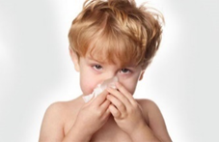

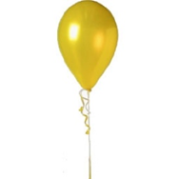
Another example of the stimuli is a picture of a soldiers boot with the verbal description of “These boots were worn by a solider with a verruca”

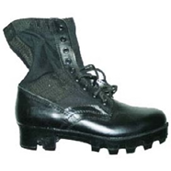

To ensure to minimise the risk to participants the stimuli chosen within the study has been carefully chosen, this is to ensure that the stimuli is not too offensive, and the risk to the participant becoming distressed is minimised.
Participants will also be presented with a brief advisory disclaimer in the box provided on the EMS before signing up to the study, explaining the nature of the topic and an advisory note explaining if the participant is highly sensitive to the nature of the topic it is advisory not to participate.
Participants will also be given a verbal explanation and reminded of the nature of the topic on arrival and the choice of not participating without penalty before written consent is given.
The research student will also explain to the participant that if at any point they wish to withdraw during the study, they may do so, without penalty. If this does occur or a participant becomes distressed at any point during the study or once the study has finished, the research student will contact their academic supervisor immediately. However, in the event of the academic supervisor being unavailable, the student researcher may contact the lab manager or remind participants about the option of seeking further support from student services.
Once the study is complete the participant will be a given the opportunity to speak to the researcher if they wish to do so, this will allow the participant the opportunity to raise any concerns they may have. This time also allows the research student to double check that the participant is happy to allow their data to be used and that the participant is in the same frame of mind in which they entered the research activity in. The research student will then provide the participant with a de-brief sheet which includes information about the study and the contact details of the researcher and their academic supervisor.
(this box should expand as you type)
Risks to investigator
For example: personal safety, physical harm, emotional distress, risk of accusation of harm/impropriety, conflict of interest
Risk to Investigator:  A risk to the research student could potentially be their personal safety and emotional distress which could be caused by a participant.  It could be possible that the research student could feel guilt or other emotional distress caused to them if a participant did become emotionally distressed or felt uncomfortable during any point of the research activity.  Another risk to the research student could be, accusation by the participant aimed at the research student during the research activity, if a participant did become distressed or felt that the research activity caused them any discomfort.  (this box should expand as you type) | How will you mitigate the Risk to Investigator:  To minimise the risk to the student researcher it is crucial that the participant fully understands the nature of the topic, then gain informed consent from the participant. Good communication skills by the student researcher is vital for this, so the participant can make an informed decision to whether they feel the study is appropriate for them. This limits the risk of the participant becoming emotionally distressed or feeling anger or upset towards the research student.  However, in the event of this happening, the research student will contact their academic supervisor immediately. However in the event of the academic supervisor being unavailable, the research student may contact the lab manager.  All participants will be appropriately debriefed at the end of the study.  The researcher will also minimise this by adhering to the UWTSD and BPS ethics guidance for appropriate study conduct.  (this box should expand as you type)
University/institutional risks
For example: adverse publicity, financial loss, data protection
Risk to University:  A potential risk to the university could be that if the research student is not fully compliant in how they conduct their researcher activity, transfer of data or maintain respect towards the participant and the university which includes any materials or equipment used.  Failure to do so, may result in adverse publicity, failure to comply with Data Protection Act and potentially financial loss to the university.  (this box should expand as you type) | How will you mitigate the Risk to University:  Firstly, the research student will gain full approval from the Psychology department.  The research student must always maintain and adhere to the BPS code of human research ethics and the University’s research integrity and the University’s code of practice.  The research student must always maintain a respectful manner throughout the process and work with the upmost professionalism.  The research student must ensure they always adhere to the Data Protection Act 2018 when handling, transferring, analysing and reporting all data.  (this box should expand as you type)

Disclosure and Barring Service
If the research activity involves children or vulnerable adults, a Disclosure and Barring Service (DBS) certificate must be obtained before any contact with such participants. | YES | NO | N/A
Does your research require you to hold a current DBS Certificate? | ☐ | ☐ | ☒

SECTION I: Feedback, Consent and Confidentiality
Feedback
What de-briefing and feedback will be provided to participants, how will this be done and when?
Feedback will be provided immediately at the end of the study via a written debrief form, which will explain the purpose and background to the study. The participant will also be provided with an opportunity to ask any further questions before leaving the lab room.
Due to the nature of some of the pictures in the study, the researcher will also ensure to check that the participant is okay when leaving study.
If the participant wishes to stop the research activity at any point, they can do so. At this point they will be debriefed by the research student.

(this box should expand as you type)
Informed consent
Describe the arrangements to inform potential participants, before providing consent, of what is involved in participating. Describe the arrangements for participants to provide full consent before data collection begins. If gaining consent in this way is inappropriate, explain how consent will be obtained and recorded in accordance with prevailing data protection legislation.
Participants will be briefed of the nature of experiment. This is due to the nature of the topic and the sensitivity surrounding the stimuli.
The participant will then be provided with an informed consent sheet, which they will have to sign to give their full consent before any data collection is started.
The informed consent sheet will again explain the nature of the topic and the aim of the experiment. It will also provide the participant with the choice to continue with the experiment at this point. The informed consent sheet will also inform participants of their rights to withdraw from the study at any point during the experiment without penalty.

(this box should expand as you type)
Confidentiality / Anonymity
Set out how anonymity of participants and confidentiality will be ensured in any outputs. If anonymity is not being offered, explain why this is the case.
Participants will sign up to the study through the University EMS, and each participant will have a unique number. Once they have signed up the student researcher will only be given the unique number in which to identify the participant. By unique ID numbers this will result in only anonymised data being made available for the analysis of the data.

The informed consent sheet that will contain participant names will kept securely with the researcher in a locked cabinet at their home until a time where they can be submitted to the secure storage at the UWTSD SA1 lab. The consent forms will not be stored with the collected data.

However, all participants will be informed that the data collected during this experiment will be used in a final year undergraduate dissertation project. It will also be made clear to the participant that the data collected will not be traced back to the participant at any point.

(this box should expand as you type)

SECTION J: Data Protection and Storage
In completing this section refer to the University’s Research Data Management Policy and the extensive resources on the University’s Research Data Management web pages (http://uwtsd.ac.uk/library/research-data-management/).
Does the research activity involve personal data (as defined by the General Data Protection Regulation 2016 “GDPR” and the Data Protection Act 2018 “DPA”)? | YES | NO
“Personal data” means any information relating to an identified or identifiable natural person (‘data subject’). An identifiable natural person is one who can be identified, directly or indirectly, in particular by reference to an identifier such as a name, an identification number, location data, an online identifier or to one or more factors specific to the physical, physiological, genetic, mental, economic, cultural or social identity of that natural person. |  | ☐
If YES, provide a description of the data and explain why this data needs to be collected:
Consent forms will contain participant names. Age and gender will also be collected. No other collected data will contain any identifiable information.

(this box should expand as you type)
Does it involve special category data (as defined by the GDPR)? | YES | NO
“Special category data” means sensitive personal data consisting of information as to the data subjects’ –  (a) racial or ethnic origin,  (b) political opinions,  (c ) religious beliefs or other beliefs of a similar nature,  (d) membership of a trade union (within the meaning of the Trade Union and Labour Relations (Consolidation) Act 1992),  (e) physical or mental health or condition,  (f) sexual life,  (g) genetics,  (h) biometric data (as used for ID purposes), | ☐
If YES, provide a description of the special category data and explain why this data needs to be collected:
(this box should expand as you type)
Will the research activity involve storing personal data and/or special category data on one of the following: | YES | NO
Manual files (i.e. in paper form)? | ☒ | ☐
University computers? | ☐ | ☒
Private company computers? | ☐ | ☒
Home or other personal computers? | ☐ | ☒
Laptop computers/ CDs/ Portable disk-drives/ memory sticks? | ☐ | ☒
“Cloud” storage or websites? | ☐ | ☒
Other – specify: | ☐ | ☒
For all stored data, explain the measures in place to ensure the security of the data collected, data confidentiality, including details of password protection, encryption, anonymisation and pseudonymisation:
Consent forms will be collected in paper forms. The forms will be stored in a locked draw that only the student researcher will have access to. These will also be stored separate to data.

The Demographic information sheets will also be completely anonymised as the participant does not put their names on it. The demographical information sheets will be kept separate from the consent forms and will also be stored in locked draws, which only the student researcher will have access to.

Data collected from the Superlab programme will be stored on the university network under the students university account, which is password protected. At this point, the data will already be anonymous, as no names will be associated with the recall memory scores. Data will be transferred securely from the lab computer via a password protected memory stick to the students personal laptop in order to run data analysis. The student researchers laptop will also be password protected and the data on the memory stick will be deleted.
(this box should expand as you type)
All Data Storage
Will the research activity involve any of the following activities: | YES | NO
Electronic transfer of data in any form? | ☒ | ☐
Sharing of data with others at the University? | ☐ | ☒
Sharing of data with other organisations? | ☐ | ☒
Export of data outside the European Union or importing of data from outside the UK? | ☐ | ☒
Use of personal addresses, postcodes, faxes, emails or telephone numbers? | ☐ | ☒
Publication of data that might allow identification of individuals? | ☐ | ☒
Use of data management system? | ☐ | ☒
Data archiving? | ☐ | ☒
If YES to any question, please provide full details, explaining how this will be conducted in accordance with the GDPR and DPA (and/or any international equivalent):
All electronic data that will need to be transferred from the lab computer used during the experiment will be done and stored under password protection. This will ensure that access to the data is controlled.

(this box should expand as you type)
List all who will have access to the data generated by the research activity:
The research student
The academic supervisor – Dr Kate Williams
(this box should expand as you type)
List who will have control of, and act as custodian(s) for, data generated by the research activity:
The research student
The academic supervisor – Dr Kate Williams

(this box should expand as you type)
Give details of data storage arrangements, including security measures in place to protect the data, where data will be stored, how long for, and in what form. Will data be archived – if so how and if not why not.
The data that will need to be transferred will be done by using a password protected memory stick, which will be kept in a locked cabinet only accessible to the researcher. This will ensure that the data is not lost. The paper consent form will be stored separate from other data generated during the experiment. This will also ensure that the data collected can not be used to attempt to be traced back to the participant. By keeping the memory stick within a locked cabinet, it also limits the access to the memory stick. Once the data has been transferred, the data on the memory stick will be deleted.

Data will be stored until the end of the dissertation process and in line with the data protection act 2018.

(this box should expand as you type)
Please indicate if your data will be stored in the UWTSD Research Data Repository (see https://researchdata.uwtsd.ac.uk/ ). If so please explain. (Most relevant to academic staff)
(this box should expand as you type)
Confirm that you have read the UWTSD guidance on data management (see https://www.uwtsd.ac.uk/library/research-data-management/) | YES | ☒
 | NO | ☐
Confirm that you are aware that you need to keep all data until after your research has completed or the end of your funding | YES | ☒
 | NO | ☐

SECTION K: Declaration
The information which I have provided is correct and complete to the best of my knowledge. I have attempted to identify any risks and issues related to the research activity and acknowledge my obligations and the rights of the participants.

In submitting this application I hereby confirm that I undertake to ensure that the above named research activity will meet the University’s Research Ethics and Integrity Code of Practice
Signature of applicant: | RHarding | Date:

For STUDENT Submissions:
Director of Studies/Supervisor: | Dr Kate Williams | Date: 23/10/2019
Signature: |  | Date: 23/10/2019

For STAFF Submissions:
Head of School/Assistant Dean: |  | Date:
Signature: |  | Date:

Checklist: Please complete the checklist below to ensure that you have completed the form according to the guidelines and attached any required documentation:
☒ | I have read the guidance notes supplied before completing the form.
☒ | I have completed ALL RELEVANT sections of the form in full.
☒ | I confirm that the research activity has received approval in principle
☐ | I have attached a copy of final/interim approval from external organisation (where appropriate)
☐ | I have attached a full risk assessment (and have NOT completed Section H of this form) (where appropriate) ONLY TICK IF YOU HAVE ATTACHED A FULL RISK ASSESSMENT
☒ | I understand that it is my responsibility to ensure that the above named research activity will meet the University’s Research Ethics and Integrity Code of Practice.
☒ | I understand that before commencing data collection all documents aimed at respondents (including information sheets, consent forms, questionnaires, interview schedules etc.) must be confirmed by the DoS/Supervisor, module tutor or Head of School.
☒ | I have deleted the guidance notes before submitting the PG2 for consideration

Reference List

Brewin, C. R. & Langley, K. M. R. (2019). Imagery retrieval may explain why recall of negative scenes contains more accurate detail. Memory & Cognition, 47(3), 420-427. https://doi.org/10.3758/s13421-018-0876-7
Dube, B., & Al-Aidroos, N. (2019). Distinct prioritization of visual working memory representations for search and for recall. Attention, perception, & psychophysics, 81(5), 1253-1261. https://doi.org/10.3758/s13414-018-01664-6
Fernandes, N. L., Pandeirada, J. N. S., Soares, S. C., & Nairne, J. S. (2017). Adaptive memory: The mnemonic value of contamination. Evolution and Human Behavior, 38(4), 451-460. https://doi.org/10.1016/j.evolhumbehav.2017.04.003

Appendix D

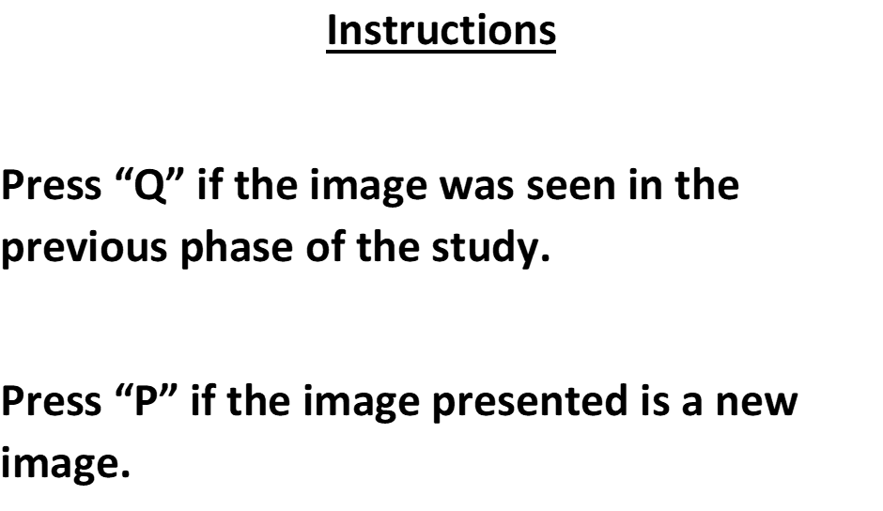

Appendix E

Appendix F

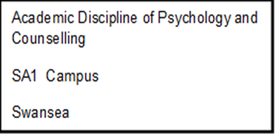


Study Consent Form

I understand that this research study is being carried out by a 3rd year Psychology Student for the purpose of a dissertation assessment, and that taking part in this study will involve viewing a series of pictures of objects with either visual or verbal descriptions regarding the contact with those objects, completing a jigsaw, and then completing a memory test. I understand that this study will take place on the computer.

This study will take approximately 25 minutes to complete.

I understand that participation in this study is entirely voluntary and I am free to withdraw at any time without giving a reason or penalty. I am aware that if I have concerns about the study, I can discuss these concerns with the researcher at any point during or after the study.
I understand that the information provided by me will be held confidentially, with a code assigned in place of my name. The data collected will be stored indefinitely in accordance with the Data Protection Act.
I also understand that at the end of the study I will be provided with a full debrief form and the opportunity to discuss any issues or concerns with the researcher, and that I will be provided with the contact details of the academic supervisor for this study should I have any further questions.

I, ___________________________________( NAME) consent to participate in the study conducted by Rebecca Harding, School of Psychology, University of Wales Trinity Saint David, Swansea under the supervision of Dr Kate Williams.

Participant Signature:________________________________________________

Date:___________________

Name and signature of researcher taking consent

Appendix G



Study Debrief Sheet

The impact of verbal descriptions and visual cues on memory for disease contaminated objects.

Thank you for your participation in the study.

During the study, the pictures of the objects presented in the study phase were accompanied by either a visual depiction or verbal description of contact type with the object. This contact was either from a healthy person or a disease/contaminated person. The aim of this study was to explore the impact of verbal descriptions and visual cues on memory for disease contaminated objects. The purpose of the study was to examine which format would lead to better memory for the objects presented in the study phase.

If you wish to withdraw your data from the study, you must tell the researchers now. After this point, all your data will be anonymised and we will not be able to trace it back to you.

If taking part in this study has raised any questions or concerns, please speak to the researcher on
Rebecca Harding – 1700014@student.uwtsd.ac.uk or if you wish to contact the academic supervisor Dr Kate Williams on Kate.Williams@uwtsd.ac.uk

Thank you once again for taking time to participate in this study.

Rebecca Harding

BA Honours Psychology and Counselling Studies

University of Wales Trinity Saint David, Swansea

