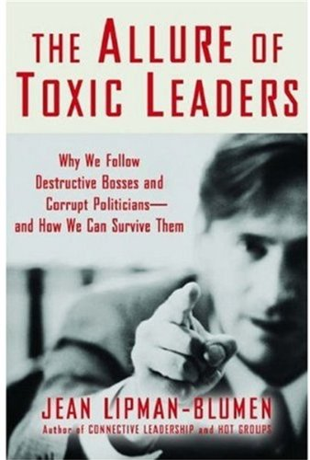
Steve Griffiths (2016) Why do we follow toxic leaders? South Wales Business Review, Vol. 6, No 1.
The concept of the toxic leader is well rehearsed, after Lipman-Blumen (2005) evaluated how such leaders emerge and thrive, but also how organisations can identify and neutralise their negative influence. At recent seminars and events linked to the Leading Wales Awards 2016, held at Swansea Business School led by Executive Chair, Barbara Chigey, audiences have been invited to nominate their choices of current and historical strong leaders. Many admirable examples pervade, however quite a few still opt for Adolf Hitler, Mussolini, Stalin and other notorious dictators “who at least ran the trains on time”. While even this claim may be challenged by historians, toxic leaders, as their name denotes, tend to exhibit qualities and traits which are destructive to their organisations, actually making them less effective and at the very least worse off, as a result of their activities. In recent years, the concept has been utilised by several industries and sectors, to explain poor performance and disastrous impacts on organisations and the wider society. This runs from the Enron scandals, to a special concern in public services, and especially the military (US Army War College, 2014), to explain often lethal outcomes of their delivery.
Toxic leaders are the antithesis of more inclusive transformational leadership models or Servant Leadership (Greenleaf,1977). Often characterised by ‘aggressive narcissism’ (Goldman, 2009), toxic leaders are motivated by self-interest to the exclusion of the organisation. They may display superficial charm, but use their cunning to manipulate, deceive, bully and control. Lipman-Blumen does not classify toxicity as simply mismanagement but something more pernicious, dysfunctional and destructive. Yet the intriguing thing is we often value our toxic leaders. As she says, ”my toxic leader is your heroic saviour”. Without loyal followers who tend to stay the course, toxic leaders cannot operate. Therefore they seem to appeal to a deep need in many of us to be strongly led. They offer to satisfy many levels of Maslow’s hierarchy of needs, making decisions for us, removing anxiety, allowing us to be part of the “chosen group”, safe in an unpredictable world and promising results. Her thesis states that this offering is more a grand illusion than noble vision, since it is usually unattainable, leading to negative outcomes and misdirection from goals set. To establish their place at the top, they often promise impossible targets, as Jeffrey Silling announced soaring stock prices, just before the Enron collapse.
We followers rationalise our loyalty, by buying the myth, obeying the unreasonable demands and fearing the alternatives. “Lions led by donkeys’ to continue the military application? The solutions might be organisational, where leaders are offered finite periods of office, to ensure transition to new influences, more open management and communication styles, peer and subordinate review and audit, and systems to welcome internal criticism. For the critical follower, doing research on decision making incidents, collaborating with others in the organisation and avoiding individual confrontations may be a way to limit toxicity. More drastically some form of whistleblowing might ultimately have reduced some of the serious consequences in our health, education, military and business scandals. David Sloan Wilson, reviewed in a previous edition of the SWBR, offers an evolutionary perspective where humans may be the only animal to be able to avoid toxic leaders, especially in small organisations and communities, through collective decision making, however even he admits that in large bureaucracies, the “institutional cancer” of toxic leadership is a feature in our economies. He also analyses the military implications which he believes have resulted in death and serious injury not only to the enemies and civilians in war zones, but also to US military personnel in high suicide and bullying rates.
Positively the authors in identifying toxic characteristics, tools of manipulation and solutions, offer hope against this poisonous element of modern organisations.
(600 words)
Bibliography
Goldman, A. (2009) Transforming toxic leaders, London: Kogan Page
Greenleaf, R.K. (1977) Servant leadership: A journey into the nature of legitimate poer and greatness, New York: Paulist
Lipman-Blumen, J. (2005) The allure of toxic leaders, Oxford: OUP
US Army War College (2014) The effect of toxic leadership, Washington DC.: CreateSpace Independent Publishing Platform

Steve Griffiths
Assistant Dean
Faculty of Business and Management
UWTSD
Addendum Feb 2023
Need to follow up…………


