
University of Wales Trinity Saint David
School of Engineering

Stress Analysis & Dynamics

Designing an overhead gantry crane
ACMA5010

Darren J Thomas
1905425
23/04/2021

Abstract
This task is to calculate and suggest a suitable beam for the design of an under running single girder gantry crane. The following report will highlight why equation $Ymax=\frac{{WL}^{3}}{48EI}$ has been used and the results. There were some assumptions that were made to enable the solution to be calculated and these are identified.

It was also essential that a safety monitoring system was implemented. This report will highlight the history and types of strain gauges available and what system will be implemented and why.

This report found how critical it is to understand the second moment if area when designing a gantry crane. This enabled us to ensure the correct beam will withstand the stresses during operation. It also highlights the use of safety monitoring devices to ensure safe working conditions

Table of Contents
1 Introduction 5
2 Minimum second moment of area 6
2.1 Equation & Solution 6
2.2 Suitable beam section. 8
2.3 Assumptions 8
3 Safety Monitoring 9
3.1 History of strain gauges 9
3.2 Strain gauges 10
3.2.1 Characteristics of strain gauges 11
3.2.2 Types of Strain Gauges 11
3.3 Strain gauge selection 14
3.4 Strain gauge interpretation. 15
4 Conclusion 16
5 References 17

Table of Figures
Figure 1 Single Girder Underhung Crane, (Acculift, 2010-2021) 5
Figure 2 Simply supported beam with concentrated point load between the supports (LAING O'ROURKE, n.d.) 6
Figure 3 Universal Beams (UB) sizes (British Steel, 2018) 8
Figure 4 The Huggenberger tensiometer with its double lever mechanism. 9
Figure 5 Some disadvantages of the late Strain measuring gauges (Hoffmann, 2012) 9
Figure 6 E.E. Simmons's force measuring device. The force impulse to be measured acts in the axial direction 10
Figure 7 Characteristics of strain gauges 11
Figure 8 Tee Rosette, Rectangular Rosette, and Delta Rosette 11
Figure 9 Quarter Bridge Type I and Type II Strain Gauge 12
Figure 10 Half Bridge Type I and Type II Strain Gauge 12
Figure 11 Full Bridge Type I and Type II Strain Gauge 13
Figure 12 Full Bridge Type III Axial Strain, Bending Strain, and Circuit Diagram 13
Figure 13 Overview of wireless monitoring system 14
Figure 14 Sensor locations 14
Figure 15 Wheatstone bridge 15

Introduction
The requirement is to create an ‘under running single girder gantry crane’ shown below, made from Steel (E=210GPa). The bridge drive wheel and the bridge idler wheel are such that the crane’s movement is limited when stationary, but allows the end truck to rotate around the longest axis of the. When lifting a 5000kg mass the deflection where the hoist connects to the bridge girder must be limited to 10mm to ensure safe movement of the crane during operation. This report will show the investigation carried out to suggest what beam is required and the safety monitoring system that will be used.

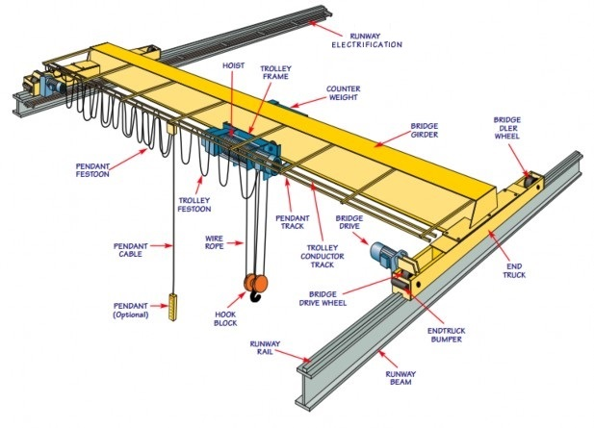
Figure 1 Single Girder Underhung Crane, (Acculift, 2010-2021)
Chapter two of this report will identify the equation and solution to Calculate the minimum second moment of area required for the bridge girder and from these calculations propose a suitable beam section. Due to the information that has been given, chapter 2.3 will explain what assumptions have been made to enable us to gain the solution and suggest an appropriate beam selection.

Chapter three discusses the history of strain gauges and explains some of the common types of strain gauge. Understanding these different types allow us to use the appropriate strain gauge which will be simple to install and cheap to purchase. Although strain gauges can be made for individual situations, there is a vast amount of designs on the market that almost every solution is catered for.

Minimum second moment of area
The second moment of area (or second moment of inertia) belongs to a two-dimensional basic profile which bends under loading. The area moment of inertia has measurements of length to the fourth power (Weisstein, 1999 - 2021).

Equation & Solution
Before obtaining the materials for the under running single girder gantry crane we need to calculate what Steel (E=210GPa) will be suitable.
The equation that has been chosen is:
$$Ymax=\frac{{WL}^{3}}{48EI}$$

Equation 1 Simply supported beam with concentrated load w at the centre (E.J.Hearn, 1985)
This equation has been chosen due to the assumption that the load will be lifted from a hook at the centre of the beam.
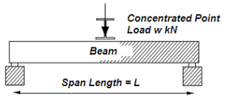
Figure 2 Simply supported beam with concentrated point load between the supports (LAING O'ROURKE, n.d.)

The equation will be used to calculate the minimum second moment of area required for the bridge girder. We know some requirements but assumed the length of eight metres.

- W = 5000Kg (converted to Newtons - 5000 $×$ 9.81 = 49050N)
- L = 8M (The length of the proposed girder)
- Y = Maximum deflection (10mm = 0.01M)

The equation is rearranged below to find EI,
$$EI=\frac{{WL}^{3}}{48ymax}$$

The figures are put into the equation, shown below:
$$EI=\frac{{49050 × 8}^{3}}{48 × 0.01}$$
$$EI=\frac{25113600}{0.48}$$
$=52320000$

The equation is rearranged again to enable ‘I’ (area moment of inertia) to be calculated. The material to be used is Steel (E=210GPa).
$$I=\frac{52320000}{210 { × 10}^{9}}$$
$$=0.000249143$$

The above answer is in mm, therefor multiplied by ${10}^{8}$ to get ${cm}^{4}$
$$0.000249143 { × 10}^{8}$$
$$=24914.28571{cm}^{4}$$

Suitable beam section.
Now we have the minimum second moment of area, we can use the Universal Beams section table to identify the beam that will be used (British Steel, 2018).
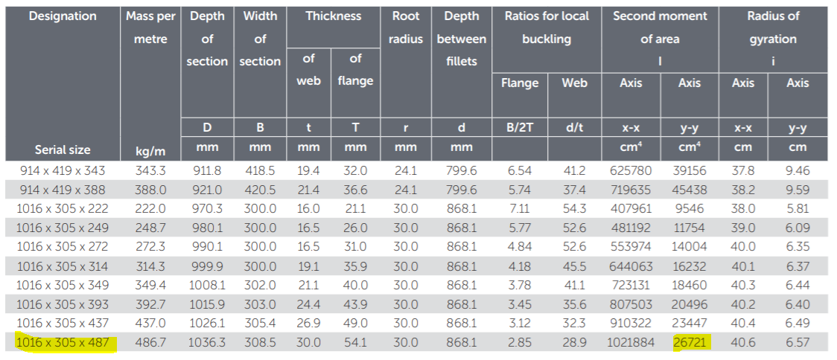
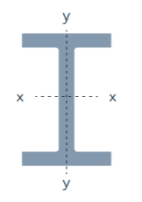
Figure 3 Universal Beams (UB) sizes (British Steel, 2018)
Our calculated minimum second moment of area is $24914.28571{cm}^{4}$. The closest beam to withstand this force is the ‘I’ beam with dimensions 1016mm x 305mm x 487mm (highlighted above) with the second moment of area at 26721${cm}^{4}$ and will therefore be chosen for this proposal.
It is essential to choose the beam that has a greater second moment of area so if the forces are exceeded during operation the beam will not fail.

Assumptions
Assumptions were required to enable the proposal to be designed. These were:

- The beam for the under running single girder gantry crane will be 8M in length,
- The load will be picked up by a hook from the centre of the beam,
- Constant operating temperature,
- The gantry will be permanently fixed to the floor (not mobile),

Safety Monitoring
To ensure the safety of the equipment it is essential to monitor the strain on the gantry at any given time. To carry out this safety monitoring, strain gauges will be used.
There are a variety of strain gauges on the market, therefore it is vital to understand what is the best strain gauge for the task. It is important to select the correct device to reduce the potential failure of the device. (Hoffmann, 2012).

History of strain gauges
Mechanical stresses are difficult to establish during operation. The X-ray could be used but is restricted on its use due to safety and how bulky the equipment is.
A sensible approach to understand the stresses on a material was discovered in 1678 by the English scientist Robert Hooke (1635 – 1703). He discovered a connection relating to the material stress and the subsequent distortion (strain).
Below is a diagram of the Huggenberger tensiometer with its double lever mechanism. It was a large piece of engineering but allowed the measurement of strain on a material.
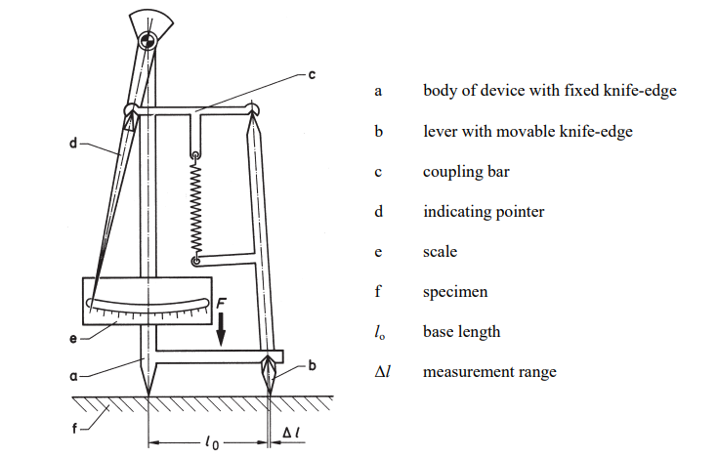
Figure 4 The Huggenberger tensiometer with its double lever mechanism.

These types of methods were the only way to carry out strain measurements for a long period. Regardless of how clever the equipment was designed, they had many disadvantages:

- only static processes can be observed,
- strong clamping forces are needed to prevent the devices from slipping under vibration,
- the test sample must be fixed with respect to the observer,
- the size of the devices places restrictions on their use for small test samples and in
- some cases such measurements are impossible, - the relatively long measurement base only gives correct results for uniform conditions
- of strain and so closely situated stress concentrations cannot be measured,
- the local conditions may be untenable for the observer,
- automatic recording of the measurements is not possible.
Figure 5 Some disadvantages of the late Strain measuring gauges (Hoffmann, 2012)

Charles Wheatstone had invented the ‘Bridge Circuit’ around 1843. It was only in the 1930’s that it was recognised for the use in strain gauges. This invention affects the resistance when there is a change in the material due to forces acting on it, bending for example.
William Thomson (1824-1905, Lord Kelvin after 1892) wrote a paper in 1856 stating that the current methods were not possible to be used on thin material.
Arthur Claude Ruge (1905 – 2000) tried an experiment using thin resistance wire, shaped it into a ‘zigzag’, on a piece of thin paper and connected the ends with larger gauge wire. He then attached this device to a beam and applied a bending force and evaluated the recordings with their current device. He noticed there was a close relationship to the measurements through the complete range. Due to these findings, the use of the “electrical resistance strain gage with bonded grid” was born. It is this design that is used today.

Figure 6 below shows the ‘Simmons's force measuring device’.

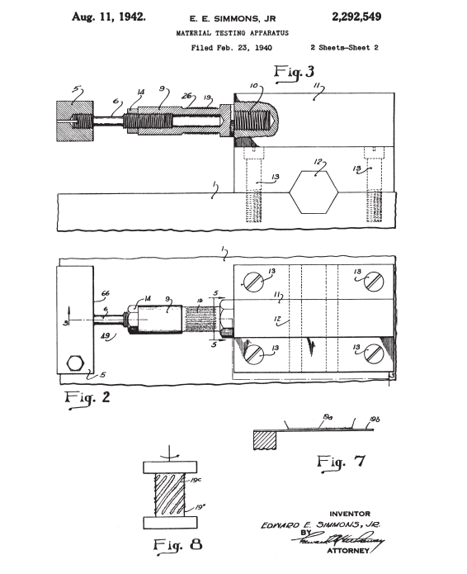
The force impulse to be measured acts in the axial direction. range, both with positive and with negative, i.e. compressive, strain, including good zero-point stability. So, the “electrical resistance strain gage with bonded grid” was invented. The shape used in those very first tests was the same as that normally used today.
Figure 6 E.E. Simmons's force measuring device. The force impulse to be measured acts in the axial direction

Strain gauges
A Strain gauge is a device where the resistance alters when an external force (bending) is applied; It converts force, pressure, tension, weight, etc., into a difference in electrical resistance that can then be measured. External forces, when applied to a stationary object, results in stress.
Stress is described as the object's internal resisting forces, and strain is defined as the displacement and deformation that occur (OMEGA engineering inc., 200.-2021).

Characteristics of strain gauges
Some features of strain gauges are described below:

- Very accurate with little effect from temperature changes (If temperature changes the readings a thermistor can be used to prevent this).
- Due to the electrical signal, they can communicate from a range of distances away from the source.
- Strain Gauges have a long life and easy to maintain.
- The production of strain gauges is straightforward due to the minimum number of components and simple design.
- These gauges can be used for long periods but require extra precautions during installation.
- All gauges produced by Encardio-Rite are hermetically sealed and made up of stainless steel thus, waterproof.
- They are fully protected against handling and installation damage.
- Strain gauges can be controlled remotely ( Encardio-Rite, July 3, 2019).

Figure 7 Characteristics of strain gauges

Types of Strain Gauges
There are various types of strain gauges, below describes these.

LY Linear Strain Gauges
LY linear strain gauges evaluate strain in one path only.

Strain Gauge Rosettes
The styles of strain gauge rosettes are membrane rosette, tee rosette, rectangular rosette, and delta rosette (Fig 8).

Membrane Rosette Strain Gauges
Membrane rosette strain gauges measure translation, velocity, pressure, and force, and measures the ‘elastic’ strain of materials under dynamic and static loads. These gauges are used in railroad car manufacturing, mechanical engineering and other industries (Fig 8).
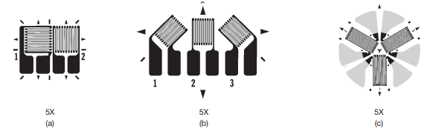
- Tee rosettes are two-element rosette gauges. The Tee rosette have two grids mutually perpendicular.
- Rectangular rosettes also recognised as a ‘three-element’ rectangular rosette gauge which comprises of three lattices
- The delta rosette is also recognised as a ‘three-element’ delta rosette gauge

Figure 8 Tee Rosette, Rectangular Rosette, and Delta Rosette

Quarter Bridge, Half Bridge, and Full-Bridge Strain Gauges

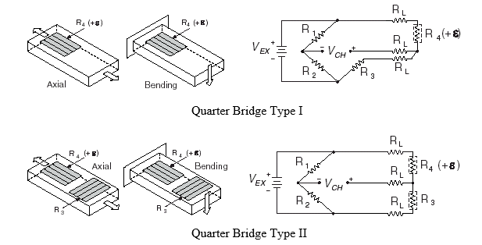
- Type I quarter bridges measures deflection (moment) or axial strain. The moment strain is expressed as a ratio of ‘bending stress’ and ‘young’s modulus of elasticity’. The type-I quarter bridge, the gauge is attached in the direction of the deformation
- Type II quarter bridge also measures deflection (moment) or axial strain. Where R1 and R2 (half-bridge completion resistors); R3 (quarter bridge temperature sensing element) and R4 (an active strain-gauge element which measures tensile strain).
Figure 9 Quarter Bridge Type I and Type II Strain Gauge

Half-Bridge Type Strain Gauges
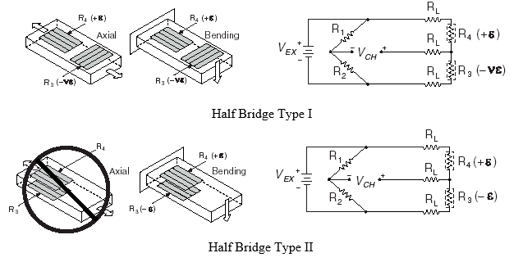

- Half bridge type I Measures bending or axial strain. In type I R1 and R2 (half-bridge completion resistors); R3 (it measures compression from Poisson effect); and R4 (it measures tensile strain).
- Half bridge type II. In type II R1 and R2 (half-bridge completion resistors); R3 (compressive strain); R3 (measures tensile strain). R3 (measures tensile strain).
Figure 10 Half Bridge Type I and Type II Strain Gauge

Full-Bridge Type Strain Gauges
Full-bridge type I, II and III gives data about full-bridge gauge relationships and described below.
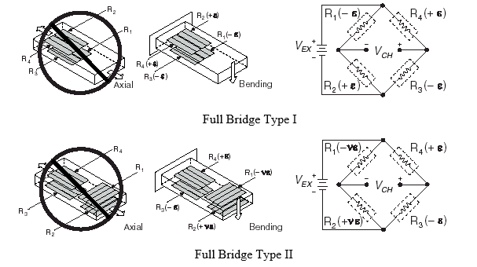
- Type I and II measures bending strain only. In type I R1 and R3 (measures compressive strain); R2 and R4 (measures tensile strain).
- Type II R1 (measures compressive Poisson effect); R2 (measures tensile Poisson effect); R3 (measures compressive strain); and R4 (measure tensile strain)
Figure 11 Full Bridge Type I and Type II Strain Gauge

Full Bridge Type III
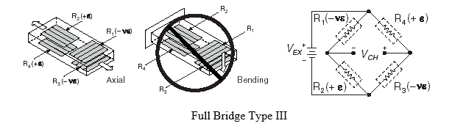
- Type III full-bridge measures axial strain only. R1 and R3 (measures compressive Poisson effect); R2 and R4 (measures tensile strain).
- The total elements in type III are four. Two-gauge elements are fitted in axial strain direction (one fitted on top and the other on the bottom) the other two elements act as a Poisson gauge, (ElProCus – Electronic Projects for Engineering Students, 2013 - 2021).
Figure 12 Full Bridge Type III Axial Strain, Bending Strain, and Circuit Diagram

Strain gauge selection
There are many types of strain gauges available. This allows numerous applications achievable. To enable the correct selection, investigation is required to understand what is required. Consideration during the investigation is needed to determine physical size, resistance sensitivity, temperature, strain limits and cost (E.J.Hearn, 1997).
The strain gauges that will be used for this task are the Half bridge type II. They will be connected to a wireless system on the gantry with them all connected to a central control box.

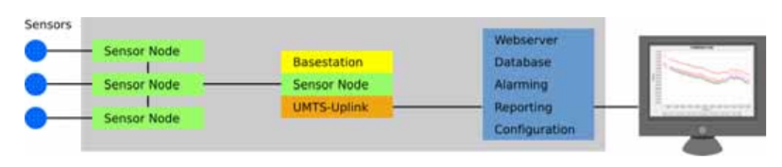
Figure 13 Overview of wireless monitoring system
The below figure identifies the location of the gauges. They will be attached to the beam by bonding them to the structure with resin. This will ensure they will adhere to the beam and will be waterproof.
R3
R2
R1
R7&8

base station
R6
R4
R5

The beam will consist of 8 nodes and the root node connected to the base station. The location of the strain gauges is shown above. Six gauges R1 to R6, attached longitudinal, two gauges R7 & 8 attached to the ‘floor’ of the beam.
Figure 14 Sensor locations

Strain gauge interpretation.
Strain gauge measurements operate on very small resistances. To ensure an accurate reading, strain gauges are formed in the bridge configuration and use a Wheatstone bridge (Fig 15).
- The Wheatstone bridge comprises of four resistive members with a voltage that is directed across the bridge. The output voltage will be equal. Under this situation the bridge is equalised/balanced. A change in resistance will cause a non-zero output (National Instruments, 1998). Bridge output is separate to the resistance of the strain gauge, but is directly proportional to the bridge voltage. The greater the resistance allows greater bridge volts to be affected.
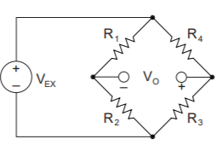
- For example, a strain of 1000 micro-strain applied to a single active gauge, with a bridge excitation of 4 volts gives an output of approx. 2 millivolts. A resolution of one micro-strain or 2 micro-volts is frequently required (R, 1984).
Figure 15 Wheatstone bridge

Conclusion
This task is to create an ‘under running single girder gantry crane’ made from Steel. It was required to calculate and recommend a suitable beam to support a 5000kg mass, but the deflection where the hoist connects to the bridge girder is limited to 10mm to ensure safe movement of the crane during operation.

Through this task it was determined to use the equation:

$$Ymax=\frac{{WL}^{3}}{48EI}$$

This was chosen because the load will be lifted from a hook at the centre of the beam. This equation required rearranging and to assume the length of the beam used in the design. The solution to the equation allowed us to select the correct beam for the task.

This task also stated the crane must have strain gauge safety monitors fitted. It was required to understand this requirement to enable the correct solution. It was decided to use the ‘Half bridge type II’. They will be connected to a wireless system on the gantry and all connected to a central control box. This allowed data to be read ‘live’, which would allow the operator to monitor the strain on the gantry while carrying out his/her operation.

Through the research of this report it has shown that there are many types of strain gauges available. Many could be used for the same job with the same results. However, it is essential that investigation prior to installing these gauges is carried out thoroughly to ensure that the system functions for the requirement. Some applications are short term and others for long term and therefore there may be specific devices for this requirement. Cost must be understood as it is pointless spending too much if the requirement is short term.

Together with the strain gauges it is also advantageous to use brittle lacquers as a visual where stresses and strains can cause cracks to this layer to show where these stresses are before potential failure (ELLIS, 2012).

References
Encardio-Rite, July 3, 2019. Strain Gauge: Principle, Types, Features and Applications. [Online]
Available at: https://encardio.medium.com/strain-gauge-principle-types-features-and-applications-357f6fed86a5
[Accessed 16 April 2021].
Acculift, 2010-2021. Acculift - Dedicated to lifting your business. [Online]
Available at: https://acculift.com/lifting-systems/overhead-cranes/
[Accessed 16 April 2021].
British Steel, 2018. Sections, Universal Beams (UB). Scunthorpe: British Steel.
E.J.Hearn, 1985. Mechanics of Materials. 2nd ed. Exeter: A. Wheaton& C0. Ltd.
E.J.Hearn, 1997. Mechanics of Materials 2. 3 ed. Oxford: Butterworth Heinmann.
ELLIS, A. V. D. F. a. G., 2012. Brittle Lacquers as an Aid to Stress Analysis. ARC Aerospace Research Central, 1(1), p. 1.
ElProCus – Electronic Projects for Engineering Students, 2013 - 2021. Types of Strain Gauge : Characteristics & Its Applications. [Online]
Available at: https://www.elprocus.com/types-of-strain-gauge/
[Accessed 16 April 2021].
Hoffmann, K., 2012. An Introduction to Stress Analysis and Transducer Design using Strain Gauges. HBM Test and Measurement, 1(1), p. 261.
LAING O'ROURKE, n.d. The Mathematics of Simple Beam Deflection. [Online]
Available at: https://www.raeng.org.uk/publications/other/15-beam-deflection
[Accessed 19 April 2021].
National Instruments, 1998. Strain Gauge Measurement – A Tutorial. [Online]
Available at: http://elektron.pol.lublin.pl/elekp/ap_notes/NI_AN078_Strain_Gauge_Meas.pdf
[Accessed 22 April 2021].
OMEGA engineering inc., 200.-2021. Strain Gauge Introduction to Strain gauges. [Online]
Available at: https://www.omega.co.uk/prodinfo/straingauges.html
[Accessed 22 April 2021].
R, S. G. a. L. C., 1984. DEFENCE SCIENCE AND TECHNOLOGY ORGANISATION AERONAUTICAL RESEARCH LABORATORIES. In: D. I. S. Branch, ed. Structures Technical Memorandum 378. Melbourne: Aeronautical Research Laboratories, p. 31.
Weisstein, E. W., 1999 - 2021. Area Moment of Inertia. [Online]
Available at: https://mathworld.wolfram.com/AreaMomentofInertia.html
[Accessed 22 April 2021].

