
Labour market
Professor: Gladius Kulothungan
Internal Verifier: Dr John-Paul Okeke
Student /ID: Akashdeep/2223250 | 4/24/23 | HRM (LCMB7000

Table of Contents
1 INTRODUCTION 3
2 LABOUR MARKET 4
2.1 EMPLOYMENT 4
2.2 UNEMPLOYMENT 6
3 Current state of labor market in the UK 7
4 PESTEL ANALYSIS 8
5 THE EMERGING CHANGES IN THE HR STRATEGIES 10
5.1 POST COVID 11
5.2 POST BREXIT 12
6 RECOMMENDATION 14
7 CONCLUSION: 15
8 REFERENCES 16

INTRODUCTION
The labor market in the United Kingdom has experienced significant changes in recent years due to various factors, including the impact of the Covid-19 pandemic and the country's withdrawal from the European Union (Brexit). These changes have had a profound effect on human resourcing strategies of organizations operating in the UK. In this report, we will analyze the current state of the labor market in the UK including employment, unemployment, developing and developed countries, based on data from the Office for National Statistics (ONS).
We will also explore the emerging changes in human resourcing strategies in the post-Covid, post-Brexit external environment, and how organizations have adapted to these challenges. In the early months of the pandemic, the UK's gross domestic product (GDP) witnessed a sharp decline of approximately 20%, although there was some partial recovery during the summer months. However, in early 2021, the economy was once again impacted by persistently high levels of COVID-19 cases, resulting in the need for another national lockdown. As per the latest available data on GDP from February 2021, the economy was 7.8% lower than the pre-pandemic levels of February 2020, and 3.1% below the initial recovery peak of October 2020, despite a modest recovery compared to the previous month (Office for National Statistics (ONS), 2022.

LABOUR MARKET
Labor market statistics encompass a wide range of indicators that shed light on various aspects of work and employment, offering valuable insights into the state of the economy. These statistics are not just about numbers, but also about the people who participate in the labour force, the nature of their work, their earnings and benefits, and their work patterns (Leaker, 2023). They provide a comprehensive picture of the dynamics and characteristics of the labour market, offering valuable information for policymakers, researchers, and stakeholders to understand and analyze the world of work. Another significant change brought about by Brexit is the new points-based immigration system, which prioritizes skilled workers and requires employers to meet certain criteria to hire workers from outside the UK (Leaker, 2023). This has increased the administrative burden for businesses and introduced additional costs and complexities in recruiting international talent.

EMPLOYMENT
After experiencing a steady increase since early 2012, the employment rate in the UK declined at the onset of the COVID-19 pandemic. Nonetheless, there has been a gradual rebound since the conclusion of 2020, resulting in a rise in employment rate within the most recent quarter. For detailed information on employment rates, please refer to our Guide to labour market statistics methodology.
Despite a decrease in the count of full-time employees over the past three months, the figure remains higher than pre-pandemic levels. Conversely, part-time employees had been on a decline since early 2022 but observed an uptick in the last three-month period. Similarly, self-employed workers also faced a decline during the initial year of the pandemic. Nevertheless, as shown in Figure 1, there has been an increase in both full-time and part-time self-employed workers during the most recent three-month period, resulting in the number of part-time self-employed workers now surpassing pre-pandemic levels. The UK has a diverse labor market, with employment concentrated in various sectors. The services sector, including finance, education, health, and retail, is a significant source of employment, accounting for a substantial portion of the country's workforce. The manufacturing and construction sectors also play a significant role in the labor market, although they have faced challenges in recent years
Figure 1 The rise in workforce participation during the most recent quarter was primarily influenced by individuals working part-time or as self-employed.
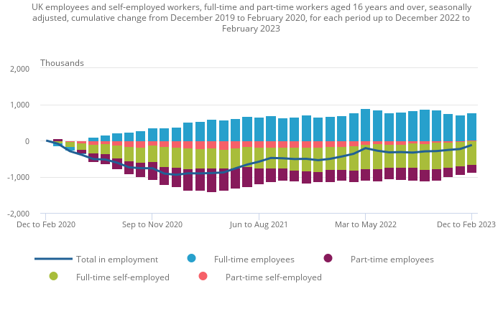
Source: Labor Force Office for National Statistics

UNEMPLOYMENT
The unemployment rate in the UK had been steadily declining since late 2013 until the onset of the COVID-19 pandemic. However, it increased until the end of 2020, but has now returned to levels seen prior to the pandemic. Nevertheless, the unemployment rate has increased during the latest three-month period.
While the employment rate in the UK has been relatively stable, the unemployment rate has shown more volatility. The ONS defines unemployment as individuals who are without a job, actively seeking work, and available to start work within a specified period. The unemployment rate in the UK has varied over time, with a low of 3.8% in early 2020 before rising to a peak of 5.1% in early 2021 due to the impact of the Covid-19 pandemic.
It's worth noting that the impact of unemployment can vary across different regions and demographic groups. For example, certain regions may have higher unemployment rates compared to others, and certain demographic groups, such as young people and individuals from minority backgrounds, may face higher unemployment rates than the general population.
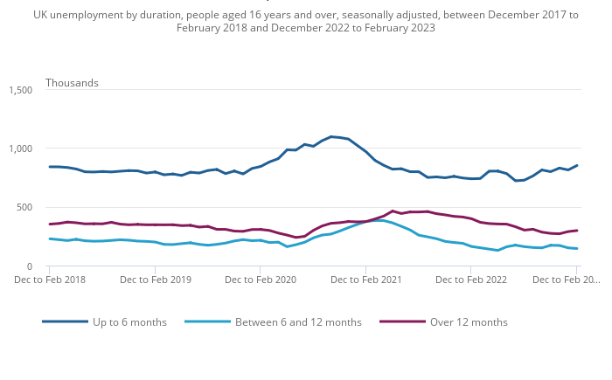
Figure 2 the rise in unemployment can be attributed to individuals who have been jobless for a duration of up to six months.
Source: Labor Force from the Office for National Statistics

Current state of labor market in the UK
The employment rate in the UK was estimated at 75.8% from December 2022 to February 2023, which was 0.2 percentage points higher compared to September to November 2022. The increase in employment was mainly driven by part-time employees and self-employed workers.
The most recent approximation for payrolled workers in March 2023 showed a monthly increase of 31,000 compared to the revised figures from February 2023, totaling 30.0 million. The unemployment rate for December 2022 to February 2023 increased by 0.1 percentage points to 3.8% compared to the previous quarter, with the increase primarily driven by individuals unemployed for up to six months. The economic inactivity rate decreased by 0.4 percentage points to 21.1% from December 2022 to February 2023. The decrease in economic inactivity was largely attributed to individuals aged 16 to 24 years, and the main reason for the decrease was students becoming more active in the economy. In January to March 2023, the estimated number of job vacancies fell by 47,000 compared to the previous quarter, totaling 1,105,000. This marks the ninth consecutive period of declining vacancies, which reflects uncertainty across various industries, as economic pressures are cited as a factor hindering recruitment by survey respondents.
In recent months, the disparity in growth rates between the private and public sectors has narrowed. When adjusted for inflation, both total and regular pay growth declined on a yearly basis from December 2022 to February 2023, with total pay falling by 3.0% and regular pay by 2.3%. The last time a larger drop in real total pay was observed was in February to April 2009, when it declined by 4.5%, marking one of the steepest declines in growth since comparable records began in 2001. Additionally, in February 2023, there were 348,000 working days lost due to labor disputes, up from 210,000 in January 2023, with over three-fifths of the strikes occurring in the education sector.

PESTEL ANALYSIS
- Political Factors: The political landscape in the UK has been shaped by the Brexit process, with the country formally leaving the European Union (EU) on January 31, 2020. The ensuing changes in immigration policies and labor laws have had significant implications for the labor market. The UK has implemented a points-based immigration system, which prioritizes skilled workers and imposes stricter immigration requirements. This has led to challenges in recruiting and retaining foreign talent, particularly in industries such as healthcare and hospitality, which heavily rely on migrant workers.
- Economic Factors: The UK economy has been significantly impacted by the Covid-19 pandemic. According to the ONS, the UK experienced a sharp decline in economic activity in 2020, with GDP contracting by 9.9% - the largest annual fall on record. This has resulted in widespread job losses and increased unemployment rates, particularly in sectors such as hospitality, retail, and travel. The pandemic has also led to reduced hiring, increased job insecurity, and changes in work patterns, including remote and flexible working arrangements.
- Social Factors: Social factors, such as demographic changes, societal values, and cultural shifts, also influence the labor market in the UK. The aging population, changing workforce demographics, and evolving employee expectations are reshaping the dynamics of the labor market. The ONS data shows that the UK population is aging, with a higher proportion of older workers in the workforce. This has implications for retirement patterns, labor force participation, and the need for age-friendly workplaces. There is also a growing emphasis on diversity, equity, and inclusion (DEI) in the workplace, with increased awareness and demand for fair and inclusive employment practices.
- Technological Factors: Advancements in technology have transformed the labor market, with automation, artificial intelligence (AI), and digitalization impacting the demand for skills and changing the nature of work. The ONS data shows that technology adoption has accelerated during the Covid-19 pandemic, with increased reliance on remote working, online platforms, and digital communication tools. This has implications for job roles, skill requirements, and the need for reskilling and up skilling to adapt to the changing technological landscape.
- Environmental Factors: Environmental factors, such as climate change and sustainability, are also influencing the labor market in the UK. There is a growing awareness of the need to address environmental challenges, and organizations are increasingly adopting sustainable practices and green initiatives. This has implications for job creation and skills development in industries such as renewable energy, clean technology, and environmental conservation.
- Legal Factors: Legal factors, including employment laws, regulations, and labor market policies, shape the labor market environment in the UK. The ONS data indicates that there have been changes in employment laws and regulations as a result of Brexit, including new rules on immigration, work permits, and employment contracts. Organizations need to stay compliant with these legal changes, which may impact their recruitment, retention, and employment practices.

THE EMERGING CHANGES IN THE HR STRATEGIES
The COVID-19 pandemic has significantly disrupted the international market, including the labor market in the UK. The unprecedented challenges posed by the pandemic have forced businesses to adapt and implement new strategies to navigate the post-COVID external environment. The CIPD and ONS have been closely monitoring the impact of the pandemic on the labor market and have provided valuable insights into the emerging strategies that are shaping the future of work in the UK. This report will delve into the key emerging strategies in the post-COVID, post-Brexit external environment, with a focus on their implications for the UK labor market, drawing on insights from CIPD and ONS.

POST COVID
Remote and Flexible Work: According to CIPD, remote work has had a significant impact on the labor market, with about 70% of organizations in the UK implementing remote work during the pandemic (CIPD, 2021). This has implications for job design, employment contracts, and employee well-being. While remote work has allowed businesses to continue operations, it has also presented challenges such as managing remote teams, maintaining employee engagement and motivation, and addressing issues related to work-life balance (CIPD, 2021).
- Wellbeing and Mental Health: According to CIPD, employee wellbeing has become a top priority for organizations during the pandemic, with many businesses offering support services, flexible working arrangements, and mental health resources to their employees (CIPD, 2021). This has implications for employee engagement, productivity, and retention. Businesses need to continue prioritizing employee wellbeing and mental health as they navigate the post-COVID external environment to ensure a healthy and engaged workforce.
- Diversity, Equity, and Inclusion (DEI): According to CIPD, businesses are increasingly recognizing the importance of DEI in creating an inclusive and resilient workforce (CIPD, 2021). Many organizations have implemented policies and practices to promote diversity, equity, and inclusion in their workplaces, such as inclusive recruitment processes, diversity training, and flexible working arrangements. This has implications for talent acquisition, retention, and overall organizational performance. Ensuring that diversity, equity, and inclusion are embedded in organizational culture and practices is crucial for businesses to thrive in the post-COVID external environment.
- Hybrid Work Models: As businesses look towards the future of work in the post-COVID external environment, many are considering hybrid work models, which combine remote work and in-person work. Hybrid work models allow businesses to strike a balance between the benefits of remote work, such as flexibility and cost savings, and the benefits of in-person work, such as collaboration and innovation.

POST BREXIT
As the UK navigates the post-Brexit landscape, businesses have had to adapt and implement new strategies to address the challenges and opportunities presented by the changing regulatory and trade landscape. In this report, we will explore the emerging strategies in the post-Brexit external environment in the UK, with reference to the CIPD and the ONS.
- Compliance with Regulations and Trade Policies: Post-Brexit, businesses in the UK have had to navigate new regulations and trade policies. Compliance with these regulations and policies has become a critical strategy for businesses to avoid disruptions in their operations and trade. According to ONS, businesses in the UK are closely monitoring and adapting to changes in regulations, customs requirements, and trade agreements to ensure that they are compliant and can continue to trade smoothly (ONS, 2021). This includes investing in trade compliance tools and technologies, engaging with regulatory bodies and trade associations, and training their employees on the new requirements. Compliance with regulations and trade policies is essential for businesses to maintain their access to markets and avoid potential legal and financial risks in the post-Brexit environment.
- Collaboration and Partnerships: Businesses in the UK are forming alliances, joint ventures, and partnerships with other businesses, trade associations, and governments to navigate the post-Brexit landscape (CIPD, 2021). This includes collaborating on research and development, pooling resources for trade promotion, and sharing best practices for regulatory compliance. Collaboration and partnerships can help businesses access new markets, share risks, and enhance their capabilities in the post-Brexit environment.
- Innovation and Digital Transformation: According to CIPD, businesses in the UK are investing in research and development, adopting automation and artificial intelligence, and embracing digital platforms and technologies to drive innovation and digital transformation (CIPD, 2021). This includes adopting e-commerce, digital marketing, and data analytics to expand their reach, optimize their operations, and enhance their competitiveness in the global market. Innovation and digital transformation can enable businesses to adapt to the changing external environment, create new opportunities, and enhance their overall performance.
- Supply Chain Resilience: The post-Brexit external environment has raised concerns about supply chain disruptions and uncertainties. Businesses have had to reevaluate their supply chain strategies and enhance their resilience to mitigate potential risks. According to CIPD, businesses in the UK are exploring ways to diversify their supply chain sources, establish contingency plans, and enhance their supply chain visibility and transparency (CIPD, 2021). This includes reevaluating their sourcing strategies, exploring local suppliers, and leveraging digital technologies for supply chain management. Supply chain resilience has become a critical strategy for businesses to ensure that they can continue to operate smoothly and meet customer demands in the post-Brexit environment

RECOMMENDATION
Based on the present circumstances of the labor market in the UK and the emerging strategies in the post-COVID, post-Brexit environment, the following recommendations can be made for organizations:
- Foster Diversity, Equity, and Inclusion: Organizations should create an inclusive work culture that promotes diversity and equity, and implement strategies to attract, retain, and develop a diverse workforce. This includes promoting diversity in leadership positions, addressing pay gaps, and creating inclusive policies and practices that promote diversity, equity, and inclusion at all levels of the organization.
- Adapt Talent Acquisition and Retention Strategies: Organizations should review their talent acquisition and retention strategies in light of changes in immigration policies following Brexit. This may include exploring alternative sources of talent, reskilling existing employees, and leveraging technology for remote working and collaboration.
- Embrace Flexible Working Arrangements: Organizations should continue to embrace flexible working arrangements, including remote work, compressed work weeks, and flexible hours, as a key strategy to enhance employee engagement, improve work-life balance, and promote productivity. This may require investing in technology and infrastructure to support remote working, and reviewing policies and procedures to ensure compliance with legal and regulatory requirements.
- Collaborate with External Partners: Organizations should collaborate with external partners, such as industry associations, government agencies, and educational institutions, to address workforce challenges in the post-COVID, post-Brexit environment. This may include partnering with educational institutions for skill development programs, participating in industry-wide initiatives to address skills shortages, and engaging with government agencies to influence policies related to immigration, labor market regulations and diversity.

CONCLUSION:
The current state of the labor market in the UK is shaped by various factors, including the impact of the COVID-19 pandemic, political changes resulting from Brexit, economic challenges, social shifts, technological advancements, environmental concerns, and legal changes. .The COVID-19 pandemic has brought significant disruptions to the global economy and the labor market in the UK. Businesses have had to adapt and implement new strategies to navigate the post-COVID external environment. Remote and flexible work, wellbeing and mental health, diversity, equity, and inclusion (DEI), and hybrid work models have emerged as key strategies for businesses to address the challenges posed by the pandemic, it is recommended that businesses prioritize employee wellbeing, DEI, and flexible work arrangements, while also focusing on compliance with regulations and trade policies, collaboration and partnerships, innovation and digital transformation, and supply chain resilience. Businesses should also invest in training and development programs to upskill and reskill their workforce to adapt to the changing demands of the post-COVID and post-Brexit environment. Continuous monitoring of the external environment, engagement with regulatory bodies and trade associations, and proactive planning and preparation for potential disruptions will be crucial for businesses to thrive in the evolving labor market in the UK.

REFERENCES

Chartered Institute of Personnel and Development (CIPD). (2021). COVID-19: HR and Workplace Response. Retrieved from https://www.cipd.co.uk/knowledge/fundamentals/emp-law/employees/COVID-19-workplace-response
Chartered Institute of Personnel and Development (CIPD). (2021). Brexit: Preparing for Change. Retrieved from https://www.cipd.co.uk/knowledge/fundamentals/emp-law/brexit-preparing-for-change
Chartered Institute of Personnel and Development (CIPD). (2021). HR's Role in a Changing World. Retrieved from https://www.cipd.co.uk/knowledge/strategy/hr/role-changing-world
Office for National Statistics (ONS). (2021). UK Business: Activity, Size and Location. Retrieved from https://www.ons.gov.uk/businessindustryandtrade/business/activitysizeandlocation

International Labour Organization (ILO) (2020). Women and Men in the Informal Economy: A Statistical Picture (Third Edition). Available at: https://www.ilo.org/w

Leaker, D. (2023, April 17). Labour market overview, UK: April 2023. Labour market overview, UK - Office for National Statistics. Retrieved April 23, 2023, from https://www.ons.gov.uk/employmentandlabourmarket/peopleinwork/employmentandemployeetypes/bulletins/uklabourmarket/april2023

