Hotel Handbook for Intercultural Competence

Module: Foreign Language and Intercultural Awareness
Module No: BMIH5003
Lecturer: Mike Davies
Student Name: Monica Mihaela Nica
Student Number: 2012860

Table of Contents
Introduction 2
Discussion 3
Cross-cultural Theory 5
Hotel’s Departments and Functions According to their Culture; 6
Conclusion 7
References 8

Introduction
The market of hospitality and tourism is achieving height rapidly and diversifies the market globally. The industry doesn’t just focus upon the employees or services but the consumers too (Jandt, 2016). Market consisting varying sectors including hotels, travel agencies, hotels as well as airlines that has a great importance within financial growth of country (Frew & White). Hotels can achieve sustainability of economy through creating jobs for citizens, generating salaries via paid taxes from foreigners and also local citizens who visit the hotel, promoting cultural development as well as improving a nation’s local infrastructure. However, the cultural diversity is a major issue which has been seen globally. The environment of us explains behaviour of us. Individuals adapt particular communication styles, talking habits as well as varying dressing styles which depend upon the social interaction. Tourists or guests from different countries visit hotels which has different gestures, body languages and culture. The cultural diversity between staff and guests is the most challenging task for any hotel management (Bramwell, 2004). It is highly needed to be skilled managers and leaders for effectively managing the problems of cultural diversity (Mackay, 2011).
In this report, the cultural diversity within hospitality industry has been discussed and with the use of cross-cultural theories, how the cultural diversity challenges can be managed. The theories must be implemented by the hotel management for improvement and providing efficient services to the visitors according to their cultures (Cooper & Hall, 2005). Knowing foreign languages and applying theories of cross-cultural are the main processes which can improve the hospitality system. To understand the dynamics of cross-cultural issues in hospitality industry and how to overcome these issues, the chosen hotel is in the UK named as Holiday Inn Express which is a leading brand in hotels of the UK and is highly famous because of which many guests stay there coming from different countries.

Discussion
The cultural diversity issues in the hospitality industry are common as the department attends customers from various countries. Similarly, Holidays Inn Express (HIE) has cultural diversity issues as the guests came from Japan and having very different way of talking, however, as English is a universal language, Japanese also speaks it but they have very different accent, way of talking, gestures and body language. These cultural differences can be managed by a competent manager and staff. The management must acquire different cross-cultural theories and models to identify how they can achieve success in dealing and interacting with international guests. Most common challenges of cultural diversity are communication issues with foreign visitors and discrimination issues among staff and visitors (Cooper & Wahab, 2007).
- Communication issues: effective communication between staff and customers is very necessary to achieve as the dealing and all operations of management depends upon communication effectively.
- Language issue: is the main barrier which will occur in dealing and interacting with the Japanese visitors. However, different communication styles will also cause cultural barrier.
- Discrimination issues: involve discriminating the visitors from local visitors such as delivering service to other local visitors first and then treating international visitors.
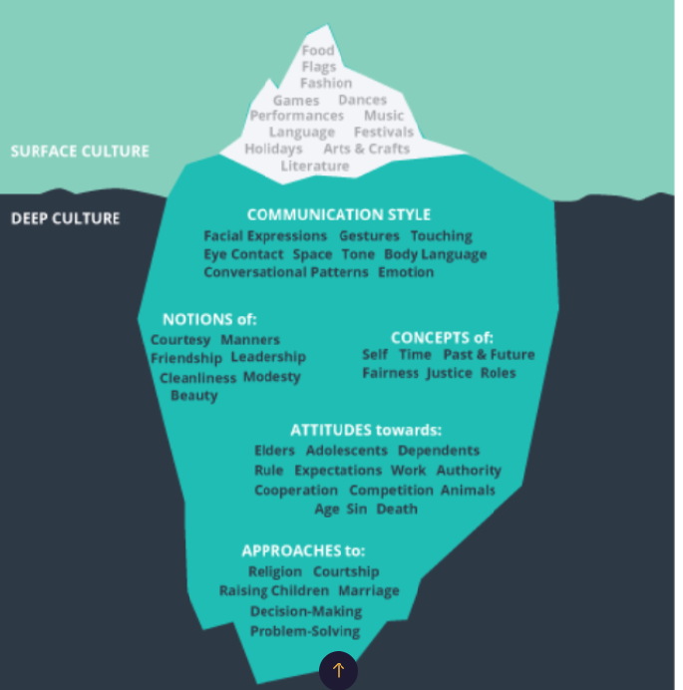
Fig 1: A Culture Iceberg
Following are the components which comes under culture. It is consisting standardized values, belief systems, traditions as well as learned behaviours, attitudes as well as ideas through five aspects which are given below:
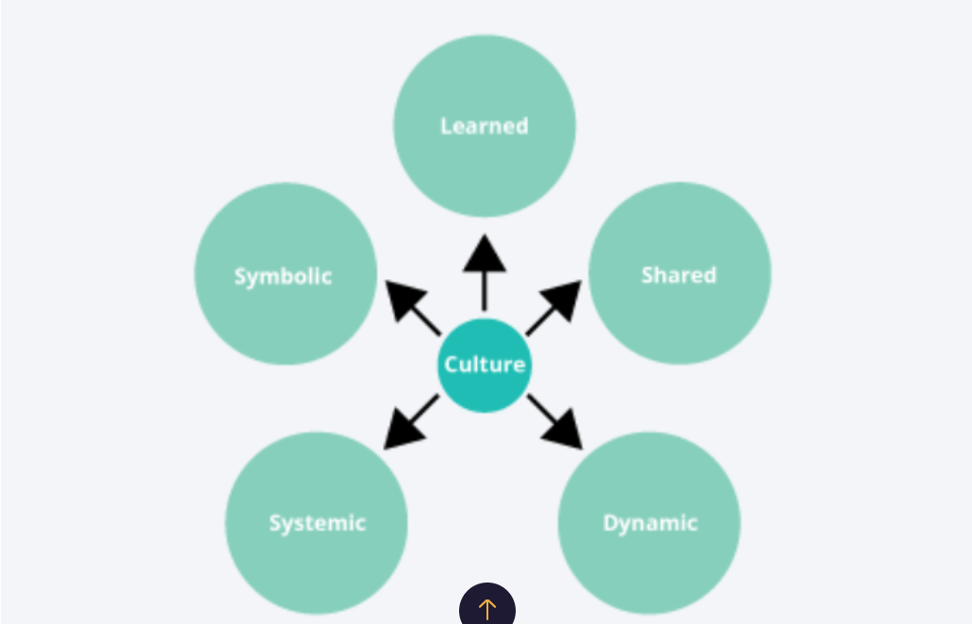
Fig 2: Culture can be learned, shared, dynamic, systematic and symbolic.

Cross-cultural Theory
According to Dr. Milton Bennett, higher a person practices cultural differences, highly this individual will become more competent worker throughout cultures (Mackay, 2011). The individuals who are competent in management of cross-cultural problems, is capable of adjusting and adapting to various environments. Theory of Bennet consist of 6 stages related to the development of intercultural competence by workers. Initial phase is called as denial phase in which workers aren’t capable of interacting with cross-cultured guests (Moran, 2018).
Commonly, individual refuses for interacting and behaving in an aggressive way. The second stage is called defense stage in which the workers discriminate themselves from others as superior. In this stage, they usually criticize others and even defend their culture. Third stage is named as minimization phase in which people have a belief that there are common values every culture has. Individuals strive for minimizing cultural variations. The 4th stage is called acceptance in which people have curiosity regarding the cultural norms of others. It is the stage in which people understand that all cultures are not the same. Lastly, the adaptation phase occurs in which people initiate adapting other culture (Cooper & Wahab, 2007). Individuals start changing their communication style or they can change their communication style when needed.
This model related to cross-cultural management explains the whole adapting of other culture by any individual. This theory is applied by the HIE hotel management for understanding different cultures and adapting them for better service providing according to the culture of guests (Moran, 2018). Japanese guests visiting to the UK would most likely stay in a hotel whilst hotel must have cross-cultural issues as the people coming from Japan will have different lifestyle, way of communication as well as different food taste, for which, implementation of this model is required to teach staff and management to acquire other cultural strategies and language to stay high in the market and good services providing.

Hotel’s Departments and Functions According to their Culture;
- Front office department: Communication style must be according to their culture.
- Housekeeping department: services must be on-time and on priority.
- Food and Beverages Service department: menu should be according to Japanese culture.
- Human Resource Department (HR): communicating the visitors effectively about the services and costs of visiting in hotel.

Conclusion
In Japan culture, it is considered that intangibles including the service must be free as they are also known as great service providers which means that they don’t have the culture of giving tip to service providers (Sato & Parry, 2015). They have the concept that respecting, being patient and friendliness should be the key features of service provider. Thirdly, Japan culture considers the service providers as empathetic towards the complain of visitors and do their best to achieve customer satisfaction. Moreover, Japanese has a concept of inequality among hotel management and consumer, which means that they have a concept that visitors are favouring them by visiting their place and getting service from them (Sato & Parry, 2015). Thus, according to these cultural concepts and beliefs of Japanese, the hotel management has to change its operations to achieve international customer satisfaction and diminishes cultural diversity.

References
Bramwell, B. (2004) Coastal Mass Tourism, Clevedon: Channel View.
Cooper, C. and Hall, C. M. (2005) Oceania: A Tourism Handbook, Clevedon: Channel View.
Cooper, C. and Wahab, S., (eds.) (2007) Tourism in the Age of Globalisation. London: Routledge.
Frew, E. & White, L. (eds) Tourism and National Identities: an international perspective, Routledge
Jandt, F (2016) An Introduction to Intercultural Communication, 8th edition, Sage: San Bernadino
Mackay, H. (2011) Understanding Contemporary Wales, University of Wales Press Moran RT et al. Managing Cultural Differences, 2007, Elsevier, Oxford
Moran, R. (2018) Managing Cultural Differences, 10th edition, Routledge:Abingdon
Samovar, L.(2009) Communication Between Cultures, Wadsworth, London
Timm, A. (2011) Intercultural Problems in the Tourism Industry, GRIN Verlag
Wall, G. and Mathieson, A. (2006) Tourism: Change, Impacts and Opportunities, Harlow: Pearson.
Sato, Y. and Parry, M.E., 2015. The influence of the Japanese tea ceremony on Japanese restaurant hospitality. Journal of Consumer Marketing.

