University of Wales Trinity Saint David


Title: Marketing Environment Analysis- Tesla-Pioneer organization & Ford-Follower
Student Name: Zahraa Araf
Student ID: 2211190
Module: Marketing Management
Module Code: LCMB70024
Name of Lecturer: Ejike Udeogu (Birmingham)
Internal verifier: Vasilios Tavlaridis
Hoang Dang Nguyen
Date: 24 October 2025

Tesla
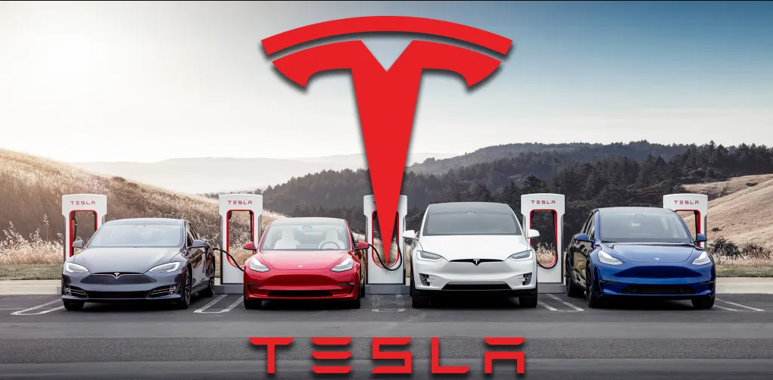
Ford
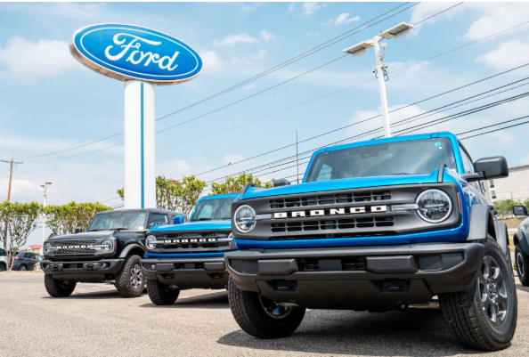

Contents
1.0 Introduction 1
1.Marketing Environmental Analysis for Pioneers and Followers- The case of Tesla and Ford 1
1.1 The Technological Actor: A Double-Edged Sword of Innovation. 1
1.1.1 Opportunities and Threats for Pioneers 1
1.1.2 Opportunities and Threats for Followers 2
1.2 The Economic Actor: The Shifting Sands of Affordability and Investment 3
1.2.1 Opportunities and Threats for Pioneers 3
1.2.2 Opportunities and Threats for Followers 3
1.3 Conclusion 4
2. Strategic response to Macro-environmental factors 4
2.1 Introduction 4
2.2 Strategic Responses to Technological Change 4
2.3 Strategic Responses to Economic Volatility 6
2.4 Critical Conclusion: The Evolving Nature of Competitive Responses 7
References 9

1.0 Introduction
Using illustrative examples such as Tesla (a quintessential pioneer) and Ford (a major follower with its Mustang Mach-E and other models), this critical analysis will discuss the asymmetric impacts of environmental turbulence on these distinct strategic positions. This analysis will critically discuss how shifts in two macro-environmental forces Technological and Economic factors, can create a complex and shifting landscape of opportunities and threats of pioneering and follower organisations in the UK electric vehicle (EV) industry. This study will discuss the effects of environmental turbulence on these unique strategic positioning by using illustrative examples like Tesla (a quintessential pioneer) and Ford (a leading follower with its Mustang Mach-E and other models).

1.Marketing Environmental Analysis for Pioneers and Followers- The case of Tesla and Ford

1.1 The Technological Actor: A Double-Edged Sword of Innovation.
The technological change is, perhaps, the strongest force in the EV industry that constantly redefines the boundaries and competitive rules. For pioneers, technology is the core of their existence, and but it also presents a perpetual threat.

1.1.1 Opportunities and Threats for Pioneers
According to Han (2021), for a pioneer like Tesla, technological leadership is its main competitive advantage and an important opportunity. The first to market enabled Tesla to create some of its own unique technologies (including its own vertically integrated battery and software systems), create an extensive network of Superchargers across the UK, and create a strong brand image that is associated with EV innovation (Tesla, 2024). This initial technological commitment created high barriers to enter the market and also made brand loyalty to be very strong. In line with the research on micro-influencers, albeit at a corporate level, early adopters and brand advocates are strong marketing tools that increase the message of a pioneer on organic grounds (Gomez-Galan, 2024). The cult-like following of Tesla is a direct consequence of its technological innovativeness story.
However, such dependence on technology is a great threat. The high rate of innovation implies that the technology that was pioneered by a company can become obsolete in a very short time. The pioneer role of Tesla in battery range is being gradually undermined by its competitors who leverage their vast R&D resources. For example, car makers like Hyundai-Kia are now producing vehicles with competitive or higher speed of charging and range (Shen et al., n.d.). The risk and cost of designing new infrastructure and technology is also an enormous risk that the pioneer undertakes. Originally neglected by fans, Tesla invested an immense amount of money in its network of Superchargers in the UK. Standardisation is however the biggest threat in terms of technology. The governments of the UK and EU are now insisting on a common charging standard (e.g. CCS) (CMA, 2021) which, again, undermines the competitive moat maintained by Tesla with its proprietary connector and they have to open up their network to competition, converting an asset to a commoditised utility.

1.1.2 Opportunities and Threats for Followers
The technological environment is full of potential to followers like Ford (Rademaker, T., Klingenberg, I. and Süß, S., 2025). They can engage in “to sit and wait’ approach without having to spend as much money as the pioneer does in R&D and market-education efforts. They will then be able to enter the market with second-mover advantage by using their established manufacturing capability and supply chain relationships to enhance the blue print of the pioneer. As an example, the quality of the manufacturing of the car and the acceleration of the Ford Mustang Mach-E received positive reviews, whereas early Tesla cars were sometimes criticized on these fronts.
Maximal technological threat to followers is the risk of being left behind (Monye et al., 2023). An innovative leader who is a consistent innovator is able to establish an emotional moving target which is hard to follow. Software upgrades continuously uploaded by Tesla over-the-air lead to a never-ending product as it is continually advanced, and new features are added to the car even long after being purchased (Tesla, 2025). This negates the traditional automotive model where there are yearly facelifts and generational updates, a model that followers such as Ford are built upon. Also, because of the early brand establishment made by the pioneer it may be hard to make followers get consumer mindshare. Although most of the traditional automakers are making great EVs, they face the challenge of overcoming the image that they are lagging in the EV race, which was created as a direct result of the strong technological story of the pioneer.

1.2 The Economic Actor: The Shifting Sands of Affordability and Investment
Economic environment, that is, factors such as inflation, interest rates, consumer purchasing power, etc have a significant effect on the affordability, costs of production, and flexibility of both the pioneers and followers in the UK EV market

1.2.1 Opportunities and Threats for Pioneers
When the economy is favourable, a pioneer such as Tesla is in a position to enjoy its premium positioning. Due to the fact that the first mover in the use of a technology is often less price sensitive (Singh, V., Singh, J. and Singh, N., 2025), the innovator can set higher prices and attain higher profit margins to finance additional innovation. This forms a vicious circle of investment and development. Moreover, at times when the economy is doing well and interest rate is low, capital is accessible to expansion. Tesla can use its high market valuation to finance its building of a Giga factory in Berlin to serve the European and UK markets, as this would guarantee its supply chain, lowering its logistics expenses. On the other hand, economic decline is an existential threat to innovator. When inflation increases and interest rates are rising as in the case of UK economic environment, then consumer discretionary spending is reduced (Hodge, A., 2024). EVs and other high value products tend to be the initial ones to be reduced in a household. This instantly jeopardizes the sales volume of Tesla. Pioneers are also vulnerable to credit constraints and increased cost of borrowed money since they are often not yet profitable or are retrenching their profits heavily.

1.2.2 Opportunities and Threats for Followers
Followers like Ford have a high level of economic resiliency, which is a large opportunity during turbulent times (Tang & Musa, 2011). Their diversification of products through differentiated products such as profitable internal combustion engine (ICE) cars will help them offset the loss or lower margins in their nascent electric vehicle (EV) business segments. This gives it a financial cushion a pure-play EV pioneer (Teece, 2018). During an economic recession, Ford has the resources to rely on its sales of commercial vehicles and well-known ICEs to sustain cash flow, but will continue to make a cautious, long-term investment in its EV conversion. This is one of the major competitive advantages of the financial stability. Economic threat to the followers is two-fold. First, the enormous cost of capital investments in re-equipping plants, creating new EV platforms, and attaining battery supply is tremendous. It becomes expensive in an economy that is characterized by high interest rates; it slows their competitive response and gives the first mover more space. Second, the followers are susceptible to intense price battles. The price wars can be started when pioneers realize economies of scale and cost of production decreases.

1.3 Conclusion
For pioneers like Tesla, technological leadership provides the brand identity and the first-mover advantages but comes with the perpetual threat of obsolescence and immense burden of infrastructure costs. To the followers like Ford, the economic stability of the diversified portfolio presents essential tenacity, but it is offset by the danger of the expensive technological catch-up and brutal price competition.

2. Strategic response to Macro-environmental factors

2.1 Introduction
Building on the analysis of the macro-environment where the critical question becomes how organisations are able to respond strategically to these external forces in order to remain competitive. Competitive landscape of both leaders and followers in the UK EV industry will remain competitive (Reiss, T.N., 2025) and essentially unpredictable through the constant interplay between technological innovation and the economic instability and will require flexibility and strategic acuity on all sides of the interaction. This evaluation critically examines how leading players like Tesla (pioneer) and Ford (follower) deploy distinct strategic responses to navigate this complex landscape.

2.2 Strategic Responses to Technological Change
The technological advancement is the most critical battleground, and the approaches used demonstrate the major differences in the ways pioneers and followers utilize their strong points and address their weak points.

2.2.1 Pioneer Strategy: Ecosystem Lock-in and Continuous Innovation
Innovators such as Tesla know that a technological advantage does not last long (Liu, Z., 2023). Their strategic reaction is mainly to establish an intensely bound up ecosystem that renders it difficult and expensive to move to a rival hence customer lockage.
Proprietary Charging Network as a Strategic Asset: Tesla’s most potent response was the early and aggressive deployment of its proprietary Supercharger network. By 2023, Tesla had more than 140 Supercharge locations throughout the UK (CAR Magazine, 2025), and this figure represents quite a substantial portion of the reliable rapid-charging network in the country (Zap-Map, 2023). This plan went straight to the technological giant problem of range anxiety and developed a strong unique selling point (USP). Yet, as a strategic move under some critical conditions answering to the pressure of the market and at the same time the opportunity of new revenue flows, there was a transition in 2024, where Tesla started to open this network to other EV brands in the UK. This move leverages its technology base to be a utility provider to its own competitors and transforms an emblem of a closed strategy to a new, high-margin source of revenue. A Tesla statement confirmed this strategy, noting it would "encourage more drivers to go electric" while unlocking value from its network (Tesla, 2023).
Software-Defined Vehicle and Over-the-Air (OTA) Updates: To counter the threat of followers catching up on hardware, Tesla has pivoted to a software-centric model. Its vehicles are also created to evolve over the years through OTA updates, a strategy that has created its current fleet technologically modern. An example of software upgrade is a 2023 upgrade, which improved the performance of the car and included a Disney plus app-which a car belonging to a follower would not have without this feature (Tesla, 2025). To counter the threat of followers catching up on hardware, Tesla has pivoted to a software-centric model.

2.2.2 Follower Strategy: Technological Leapfrogging and Strategic Partnerships
Followers like Ford are unable to compete in terms of the breadth of the ecosystem at the beginning. Instead, they retaliate by concentrating on better product development in particular areas and use alliances to hasten their progress.
Targeted Superiority and Platform Sharing: The followers do not engage in a direct attack against all layers of technology of the pioneer. Rather, they identify and control certain performance measures. Ford shook the snow with Mustang Mach-E and specifically emphasized driving dynamics and build quality, which Tesla was perceived to be weak (Ford, 2025).
Forming Strategic Alliances to Close the Gap: The cost and time involved in coming up with proprietary technology is enormous, and in this regard, followers are active in forming alliances. The most significant strategic response Ford ever had was that it joined forces with Volkswagen to use its MEB electric platform to produce its cars in Europe (Groß, 2022). By not spending years on development and billions of dollars to develop a competitive EV, Ford was able to jump into the market with a competitive EV. According to the words of the then-Ford Europe President Stuart Rowley, this collaboration enabled them to provide customers with a second all-electric vehicle, fast (Ford Europe, 2023). This collaborative model is a direct strategic response to the high technological barriers to entry erected by the pioneer.

2.3 Strategic Responses to Economic Volatility
Both pioneers and followers are challenged by economic pressures on their financial strength and to be strategic and must make hard decisions in pricing and investment

2.3.1 Pioneer Strategy: Vertical Integration and Agile Pricing
Pioneers with little diversified revenue flow must develop economic resilience by operation strategy and intensive and information-driven marketing strategies.
Vertical Integration as a Cost-Control Mechanism: The ultimate long-term response of Tesla to economic threats (e.g., inflation, supply chain disruption) is its very high level of vertical integration (Tesla, 2021). Tesla hedges supplier on the cost of products and prices in cases of shortages by controlling manufacture of its batteries, seat, and software. This was a necessary tactic at the time of the global supply chain crisis, as Tesla was able to keep producing cars when other traditional car manufacturers were going through serious challenges. Gigafactory Berlin was a calculated step to localise the production in the European market to lower the logistics costs and currency risk directly offsetting the economic risks of trade fluctuations around the world.
Dynamic and Aggressive Pricing: Tesla has been using an aggressive and highly dynamic pricing strategy in the midst of the increasing interest rates and declining consumer spending. In 2023, Tesla began reducing the price of its models, decreasing the price of the Model Y and the Model 3 by up to PS4,000 in the UK (BBC, 2023). This was done due to the economic risk of a diminishing demand. Tesla had an opportunity to wage a price war and exert great pressure on its followers who were not yet profitable on its EV lines, by using its profit margins, which were leading in the industry (Tesla reported over 15% per vehicle at the time). It is a classic pioneer strategy, of squeezing competitors in a recession with cost leadership acquired through scale and integration.

2.3.2 Follower Strategy: Portfolio Diversification and Strategic Segmentation
Followers leverage their established business models as a shield, allowing them to respond to economic pressures with a more measured, segmented approach.
Cross-Subsidisation and Phased Transitions: Ford’s primary strategic response to economic volatility is its diversified portfolio. The significant profits generated from its global sales of ICE vehicles, particularly the Ranger pickup and Transit van, are used to fund the costly EV transition. Ford can maintain losses in its Model e (EV) division, which reported a $4.7 billion loss for the entire year 2023, while still investing in future growth thanks to this cross-subsidization (Ford Motor Company, 2024). This financial cushion gives the follower the ability to withstand protracted economic headwinds, something pure-play EV pioneers do not have.
Differentiated Branding and Market Segmentation: Instead of competing solely on price, followers use targeted marketing to defend and grow their market share. Ford has strategically segmented its EV offerings. The Mustang Mach-E is positioned as a performance SUV, using the well-known Mustang name to support its high price. On the other hand, the UK's most popular automobile class, the mass-market B-SUV category, is the target market for the future Ford Puma EV. Ford reduces the possibility that a recession will impact any one group of consumers by introducing cars in a variety of markets. This multi-pronged approach allows them to respond to economic threats not with across-the-board price cuts, but with a diversified product offensive that caters to different purchasing power levels.

2.4 Critical Conclusion: The Evolving Nature of Competitive Responses
The strategic responses of pioneers and followers are not static; they are in a constant state of evolution and convergence. With its proposed £25,000 model and the availability of its private network, Tesla, the quintessential pioneer, is gradually embracing follower-like tactics. Conversely, Ford is being forced to adopt pioneer-like agility, restructuring its organization to accelerate innovation and compete in a software-defined future.
The competitiveness of each strategic position ultimately hinges on execution within the macro-environment. A pioneer's strategy of ecosystem lock-in is powerful, but it can be undermined by regulatory pressure for standardization. Cross-subsidization is a robust strategy for followers, but it relies on old ICE companies' sustained profitability in a market that is becoming more and more anti-fossil fuel. As the UK market evolves—with EV sales growing to account for 16.5% of the total new car market in 2023 (SMMT, 2024)—the lines between pioneer and follower will continue to blur. The winners will be those organizations, regardless of their initial market entry status, that can most adeptly orchestrate a portfolio of strategies to turn macro-environmental threats into sustainable competitive advantages.
.

References
- CMA (2021). Final Report. [online] GOV.UK. Available at: https://www.gov.uk/government/publications/electric-vehicle-charging-market-study-final-report/final-report.
- CAR Magazine. (2025). Tesla Superchargers: everything you need to know. [online] Available at: https://www.carmagazine.co.uk/electric/charging-network/tesla-supercharger/.
- Groß, A. (2022). Volkswagen and Ford Expand Collaboration on MEB Electric Platform. [online] Volkswagen Group. Available at: https://www.volkswagen-group.com/en/press-releases/volkswagen-and-ford-expand-collaboration-on-meb-electric-platform-16817.
- Gómez-Galán, J. (2024). A Comprehensive Overview of Micro-Influencer Marketing: Decoding the Current Landscape, Impacts and Trends. [online] ResearchGate. Available at: https://www.researchgate.net/publication/379063876_A_Comprehensive_Overview_of_Micro-Influencer_Marketing_Decoding_the_Current_Landscape_Impacts_and_Trends [Accessed 15 October 2025].
- Edwards, J. (2024). Zapmap. [online] www.zap-map.com. Available at: https://www.zap-map.com/ev-stats/how-many-charging-points.
- Ford Europe (2023). Ford reveals new Explorer EV for the European market. Available at https://www.cnbc.com/2023/03/21/ford-explorer-ev-europe.html
- Ford Motor Company (2024). Ford Motor Company - Reports & Filings. [online] Ford.com. Available at: https://shareholder.ford.com/financials/default.aspx.
- Han, J. (2021). How Does Tesla Motors Achieve Competitive Advantage in the Global Automobile Industry? Journal of Next-generation Convergence Information Services Technology, 10(5), pp.573–582. doi:https://doi.org/10.29056/jncist.2021.10.09.
- Hodge, A., 2024. Public Spending Pressures in the UK. IMF Selected Issues Paper (SIP/2024/029), Washington, DC.
- https://www.ford.com/. (2025). Mustang Mach-E® Performance, Speed & Handling | Ford EV News. [online] Available at: https://www.ford.com/electric/ev-news/innovation/mustang-mach-e-performance-deep-dive/ [Accessed 23 Oct. 2025].
- Idrees, M., Kashif, M. and Parveen, F., 2025. Uncovering the Political, Economic and Social Aspects of Militancy in Pakistan. Bulletin of Business and Economics (BBE), 14(1), pp.55-59.
- Li, P. and Wu, B., 2025. Pioneer or follower? The sequence of introducing self-operated logistics on platform under consideration of preannouncement. Asia Pacific Journal of Marketing and Logistics, pp.1-26.
- Liu, Z., 2023. The relationship between innovation and strategy. In SHS Web of Conferences (Vol. 178, p. 03018). EDP Sciences.
- Monye, S.I., Afolalu, S.A., Lawal, S.L., Ojo Augustine Oluwatoyin, Ajenifuja Oluwafemi Adeyemi, Emmanuel Ikechukwu Ughapu and Abayomi Adegbenjo (2023). Impact of Industry (4.O) in Automobile Industry. E3S web of conferences, 430, pp.01222–01222. doi:https://doi.org/10.1051/e3sconf/202343001222.
- Oi, M. (2024). Tesla: EV giant cuts prices in major markets as sales fall. [online] www.bbc.com. Available at: https://www.bbc.com/news/articles/c1d4g8jz57yo.
- Oxford College of Marketing (2014). The Impact of Micro and Macro Environment Factors on Marketing. [online] Oxford College of Marketing Blog. Available at: https://blog.oxfordcollegeofmarketing.com/2014/11/04/the-impact-of-micro-and-macro-environment-factors-on-marketing/ [Accessed 15 October 2025].
- Reiss, T.N., 2025. Compulsory Strategic Leadership in the Upcoming Decade.
- Rademaker, T., Klingenberg, I. and Süß, S., 2025. Leadership and technostress: a systematic literature review. Management Review Quarterly, 75(1), pp.429-494.
- Rietveld, R. (2024). ‘The Double-Edged Sword of Algorithmic Management: A Test of the Effect on Gig Worker Proactivity’. Journal of Management. [online] Available at: https://pmc.ncbi.nlm.nih.gov/articles/PMC12239928/ [Accessed 15 October 2025].
- SMMT (2025). Electric Vehicle (EV) Data | UK Electric Car Registration Statistics | SMMT. [online] SMMT. Available at: https://www.smmt.co.uk/vehicle-data/electric-vehicle-registrations/.
- Szymanski, D.M., Troy, L.C. and Bharadwaj, S.G. (1995). ‘Order of Entry and Business Performance: An Empirical Synthesis and Reexamination’. Journal of Marketing, 59(4), pp.17-33.
- Singh, V., Singh, J. and Singh, N., 2025. Fuelling Organisational Capabilities for Sustainable Innovation Disruption: Performing to Be a Pioneer. Business Strategy and the Environment.
- Shen, C., Fadhil, I., Yang, Z., Bui, A., Negri, M. and Searle, S. (n.d.). Who is leading the transition to electric vehicles? [online] Available at: https://theicct.org/wp-content/uploads/2025/06/ID-371-%E2%80%93-GAR-2024-2025_report_final.pdf.
- Tesla (2024). Software Updates. [online] www.tesla.com. Available at: https://www.tesla.com/support/software-updates.
- Tang, O., & Musa, S. N. (2011). Identifying risk issues and research advancements in supply chain risk management. International Journal of Production Economics, 133(1), 25-34.
- Tesla (2024). Artificial Intelligence & Autopilot. [online] Tesla. Available at: https://www.tesla.com/AI.
- Vasilachi, A. (2015). Pioneers and followers. [online] Academia.edu. Available at: https://www.academia.edu/15181349/Pioneers_and_followers [Accessed 15 October 2025].

