12th January 2018
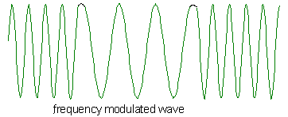
A Comparison of Digital Modulation Methods and Error Detection and Correction Techniques

P151664 Derek Lockhart
M2X8518 Prof Ian Wells
Digital Signal Processing and Communications

Contents | Page
Abstract | 2
Introduction | 2
Theory | 2
Method | 4
Results | 13
Conclusion | 18
References | 20
Tables | 21

1. Abstract
An investigation into designs and properties of digital modulation techniques, their operation within a range of noise levels and the ability of FEC techniques to mitigate noise corruption
2. Introduction
This paper will critically compare the performances of different digital keying techniques namely Amplitude Shift Keying (ASK), frequency Shift Keying (FSK) and Phase Shift Keying (PSK). These keying techniques will be simulated using the MATLAB Simulink software package, and their performance measured and compared both with and without the presence of Additive Gaussian White Noise (AWGN). The performance of the different keying techniques will again be compared after the data has been altered by use of different Forward Error Correction (FEC).
3. Theory
3.1 Simulink
Simulink is an emulation package used within the MATLAB software. Among other possibilities, it allows block level emulation of communications systems. It is used in this paper as the emulation software[1].
3.2 Amplitude Shift Keying
ASK is one a form of digital modulation, it is analogous to analogue amplitude modulation. In this instance it is implemented as simplistic on-off keying (OOK) where the sinusoid is in effect enabled by arrival of a logic one data bit and likewise disabled by the arrival of a logic zero data bit[2].
3.3 Frequency Shift Keying
FSK is an improvement of the ASK modulation technique, in such that it allows the production of a sinusoidal output for both logic one and logic zero data bits, this change should improve the discrimination of the receiver, however it also necessitates a more complicated demodulation system[3].
3.4 Phase Shift Keying
PSK is a further improved system of digital modulation over the FSK system. Wherein instead of the arrival of a logics one or zero data bits altering the frequency of the sinusoid output, instead it can alter the phase of the sinusoidal. In this implementation, Binary Phase Shift Keying (BPSK) shall be used, this involves only two phase conditions, allowing the transmission of one of a possible two binary conditions. This is the simplest implementation of phase shift keying and not very common, Quadrature Phase Shift Keying (QPSK) is one of the most common, which, as its name suggests, involves a total of four phase conditions allowing the transmission of one of four possible binary conditions[4].
3.5 Additive White Gaussian Noise
AWGN is used within information theory to model noise in a communications system[5]. In this case the model is used to simulate the noise added to the channel during transmission through a medium[6].
3.6 Forward Error Correction
Forward Error Correction is used to improve the quality of data transmission[7] by using specific coding techniques to identify and correct data errors picked up during transmission. In this paper we shall be using Hamming Code and the CRC-16 version of Cyclic Redundancy Checking.

4. Method
4.1 ASK
A model of ASK digital modulation has been simulated in the Simulink emulation software and is shown below in Figure 1.
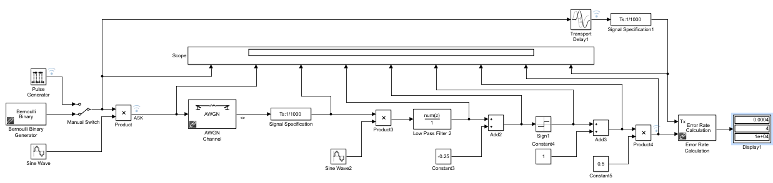
Figure 1 Simulation of Amplitude Shift Keying
The circuit can be seen in effect to be two halves. The modulation section is the creation of the ASK signal, it is produced by the product of sinusoid with the data signal source. The demodulation section is the same method in reverse, the product of the received signal and a new sinusoid demodulates the signal. The remainder of the demodulation section is pure signal processing to return the noisy signal to its original state.
In this model a hypothetical nine input oscilloscope has been used to sample the process, the samples taken are shown below in Figure 2.
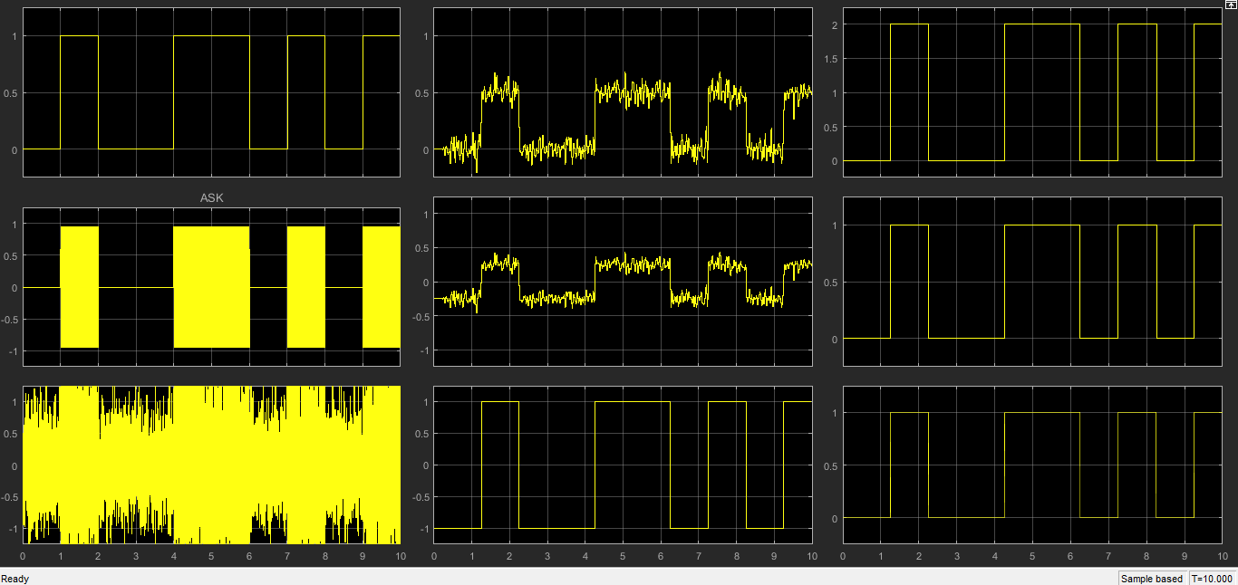
Figure 2 Samples of ASK process
Trace A in Figure 2 shows the output of the Bernoulli generator. The Bernoulli generator produces random data bits with a defined probability, in this case 0.5, which equates to an equal probability of a logic’1’ or logic ‘0’ being produced[8]. This generator is emulating the data source.
Trace B shows the product of the Bernoulli generator combined with a 100 Hz sinusoid. This is an example of simple on off keying, where the carrier is simply turned on and off, this simplifies the receivers task, such that the receiver must simply discriminate when the carrier is either on or off[9].
Trace C shows the modulated ASK signal after being subjected to AWGN, in this example a significant amount of noise was added though not enough to interfere with the recovery of the origonal signal.
Trace D shows the result of the first stages of modulation, the first stage is the most important, heterodyning the received signal with a duplicate of the origonal sinusoid to produce the lower frequency data signal plus high frequency noise. This noise can be mostly removed with the low pass filter.
With the noise mostly removed the signal can be recognised visually, to allow it to be discriminated logically we need the signal to be effectivly bipolar, therefore we carry out a mathematical ‘add’ function of a negative value to create trace E, before logically senseing its value to create trace F.
Further mathmatical functions are carried out to return the signal to its origonal state, shown in figure H. It can be seen to be identical to the origonal transmitted signal shown in figure I.
A range of signal levels were subsequently passed through the system to ascertain the performance of this ASK implementation.

4.2 FSK
A model of FSK digital modulation has been simulated in the Simulink emulation software and is shown below in Figure 3.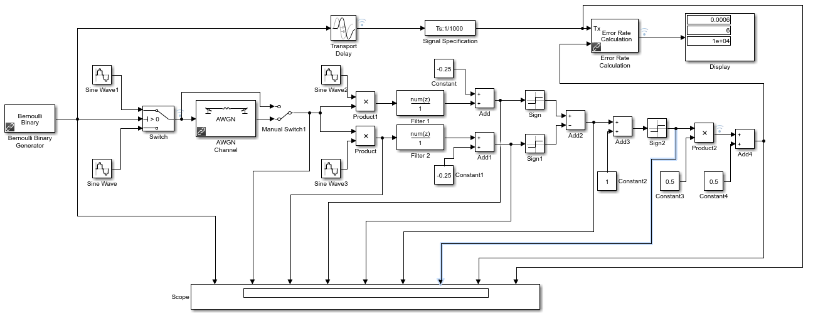
Figure 3 Simulation of Frequency Shift Keying
The circuit used is essentially very similar to the ASK circuit used previously, where it is in effect two ASK circuits working in parallel. The modulation is a logical switch that selects one of two sinusoids based on the data input. The demodulation section is also the equivalent of two ASK circuits, each demodulating one of the sinusoids before being combined mathematically.
Using the same methodology as used in the ASK simulation to obtain signal examples through the circuit, as shown in Figure 4.
Figure 4 Samples of FSK process
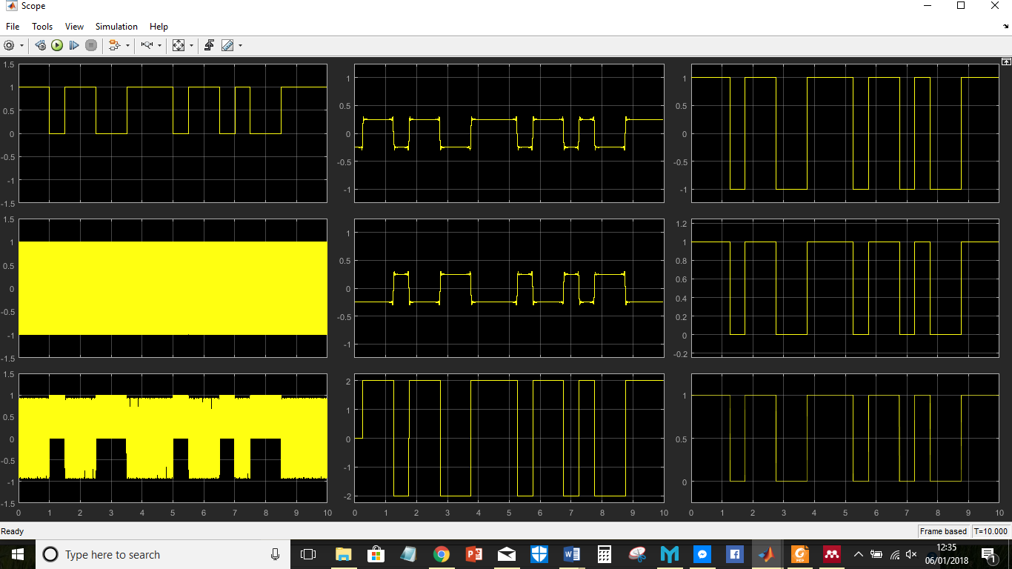
The traces shown in Figure 4 show the FSK process in similar fashion to those in Figure 2. Due to scaling the FSK modulated signal in Trace B is not clear, the FSK signal can be seen clearly in Figure 5. It should be noted that Traces D &E show a ringing anomaly known as the Gibbs Phenomenon, this is defined by Rim et al [10] as the cause of information distortion by the ringing overshoot at a change of state.
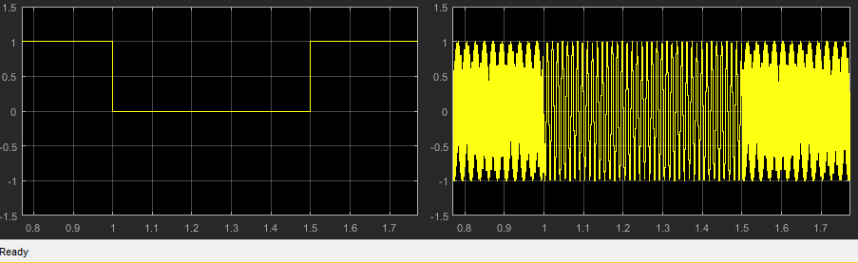
Figure 5 FSK Samples showing frequency changes
A range of signal levels were subsequently passed through the system to ascertain the performance of this FSK implementation.
4.3 Phase Shift Keying
A model of PSK digital modulation has been simulated in the Simulink emulation software and is shown below in Figure 6. This model uses only 2 phases to modulate the signal and is therefore referred to as Bipolar Phase Shift Keying (BPSK).
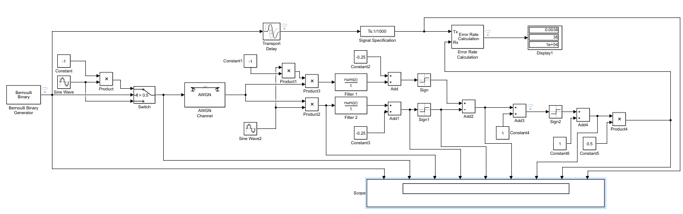
Figure 6 Simulation of Phase Shift Keying
As before the PSK circuit used is a development of the previously used circuits. The modulation is provided by a logical switch selecting from two antiphase sinusoids based on data input. The demodulation section is only different from the ASK circuit in the replacement of the two sinusoid frequencies with two antiphase sinusoids of the same frequency.
Using the same methodology as used in previous simulations to obtain signal examples through the circuit, as shown in Figure 7.
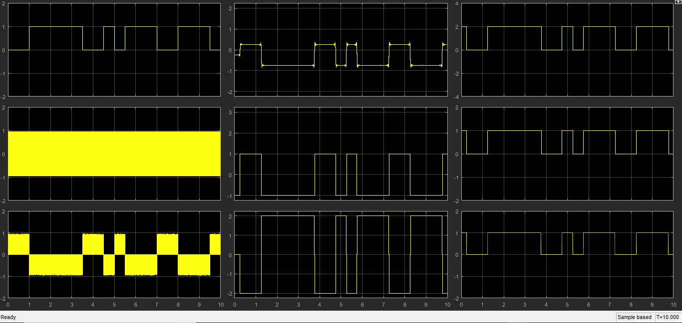
Figure 7 Samples of PSK process
Due to scaling the FSK modulated signal in Trace B is not clear, the FSK signal can be seen clearly in Figure 8. Traces D again shows the evidence of Gibbs Phenomenon ringing.

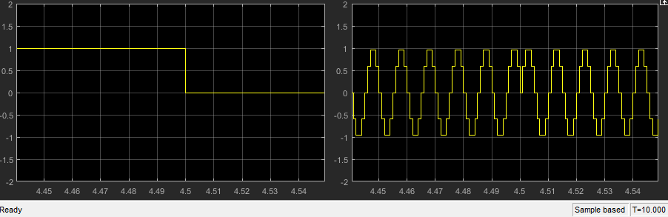
Figure 8 PSK Samples showing phase change
A range of signal levels were subsequently passed through the system to ascertain the performance of this BPSK implementation.
4.4 AWGN
Additive White Gaussian noise is a mode from information theory that is added to the modulated data signal as it transfers through a medium[5]. Gaussian noise is a normal distribution in probability theory that defines variation from the norm. In the case of Gaussian noise it means that the likelihood of large noise transition are less than smaller transitions and that the noise itself will be wideband in nature[11]. The AWGN signal block was used to vary the noise signal to assess the performance of each circuit. The noise injected was measured using its Signal to Noise Ratio (SNR). SNR is an expression of wanted signal power to unwanted noise power, as it is a ratio it is dimensionless[12]. In this instance, the power of the AWGN subjected to the signal is expressed logarithmically in decibels (dB) with reference to 1 Watt of signal power, giving the relationship the expression dBW.
4.5 FEC
Forward Error Correction is a method of reducing errors in a received data stream, Haykin [13] explains FEC as the mathematical expansion of transmitted code to allow the inclusion of redundant code that will allow the receiving station to detect and correct errors picked up during transmission.
Two methods of FEC have been used to show the advantages of FEC in these circuit examples. Unfortunately, it proves problematic in the extreme to incorporate FEC in the circuits used to this point. Therefore, it was found to be prudent to use analogous Simulink blocks to test the theory of FEC advantages.
4.5.1 Hamming Code
Hamming Code is an error detection and correction code, in this implementation a (7,4) code is used such that for every 4 bits of data there would be 3 parity bits added to create the 7 it word. Hamming code in the (7,4) implementation can correct any single bit error or detecting two error bits. The parity bits are calculated such that each parity bit will be created from 3 of the 4 data bits.
Owunwanne [14] explains Hamming distance as the minimum number of edits that would be required to alter one data block into another, and is used to define the minimum number of errors that a system will not detect.
e.g. The data block 10110001 can be changed to 10110101 by changing a single bit. Therefore, its hamming distance is 1.
In terms of FEC the Hamming Distance can be used to define the ability of a code to correct errors.
4.5.2 CRC
Parker [15], explains the Cyclic Redundancy Check as a method for producing an error check code using Exclusive-OR (XOR) Logic gates in a method similar to a parity check though greatly expanded for larger data block sizes. CRC can be used over a range of data block sizes, the larger the block then the larger the polynomial required. The CRC checksum is calculated from the repeated use of the polynomial XOR’d with the data, this checksum is then appended to the original data and transmitted as a single codeword. The same polynomial is used at the decoding end the check for errors. Detected errors would normally incite a resend request. The number of errors that can be detected by CRC depend of the hamming distance[16].
In this case CRC-16 was the code used, which uses the polynomial x¹⁶+x¹⁵+x²+1, (1100000000000011)[17].
4.6 ASK with FEC
To test the capabilities of FEC techniques with ASK the circuit shown in Figure 9 was designed. Again due to the difficulties encountered with Simulink and alternative was used, in this case Pulse Amplitude Modulation (PAM) was used, PAM is a completely different modulation technique, it is used in analogue modulation, however since it produces pulses where their size with respect to zero volts is critical, it may provide a resonable analogy.
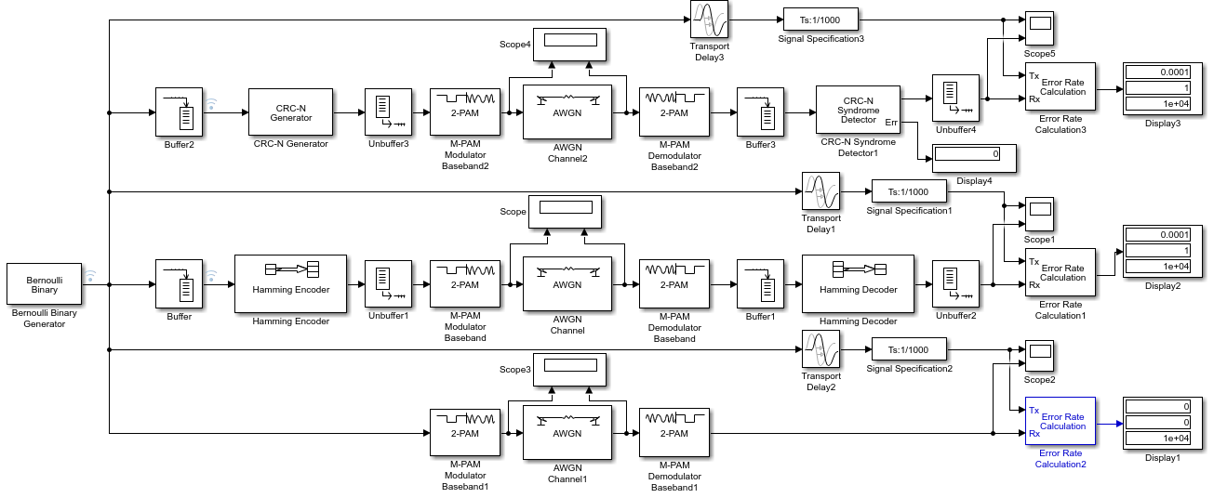
Figure 9. ASK alternative and FEC.
The results of this test can be seen in Table 1.
4.5.2 FSK with FEC
To test the capabilities of FEC techniques with FSK the circuit shown in Figure 10 was designed. Due to Simulink difficulties 4-FSK Modulators were used, these provide a waveform similar to the DTMF (Dual Tone Multiple Frequency) technique used in telephone dialling, (as seen in Figure 11) and could provide a reasonable anaolgy.
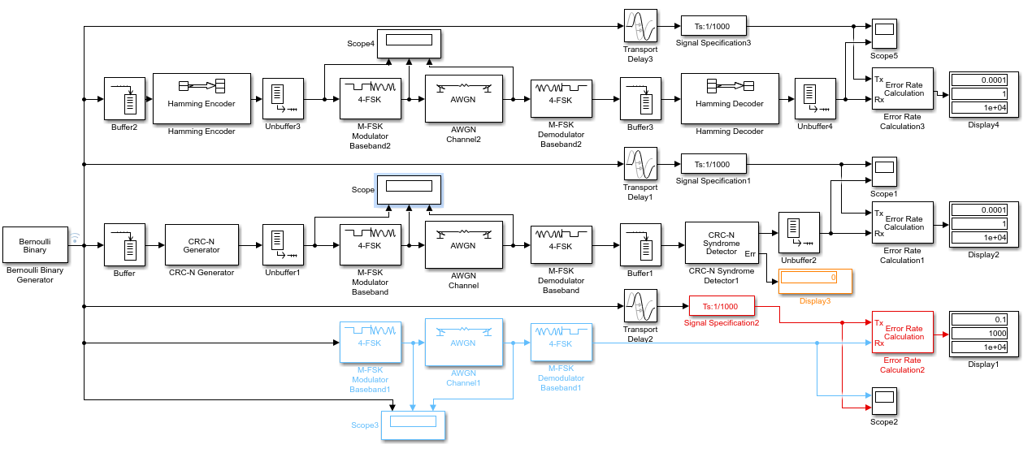
Figure 10. FSK alternative and FEC.
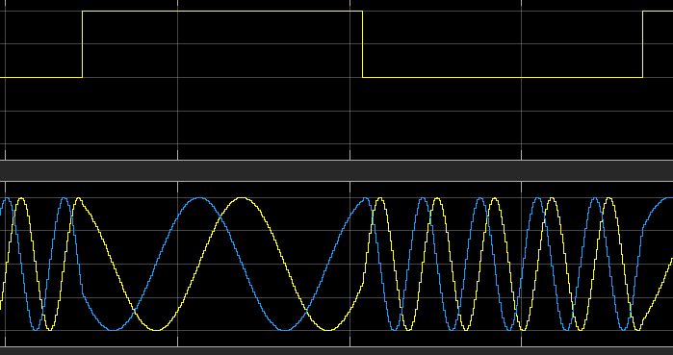
Figure 11 4-FSK waveforms
The results of this test can be seen in Table 1.
3.5.2 PSK
To test the capabilities of FEC techniques with PSK the circuit shown in Figure 10 was designed. Due to Simulink difficulties BPSK Baseband Modulators were used, this is the least similar of the three replacement circuits despite the similarities of name.
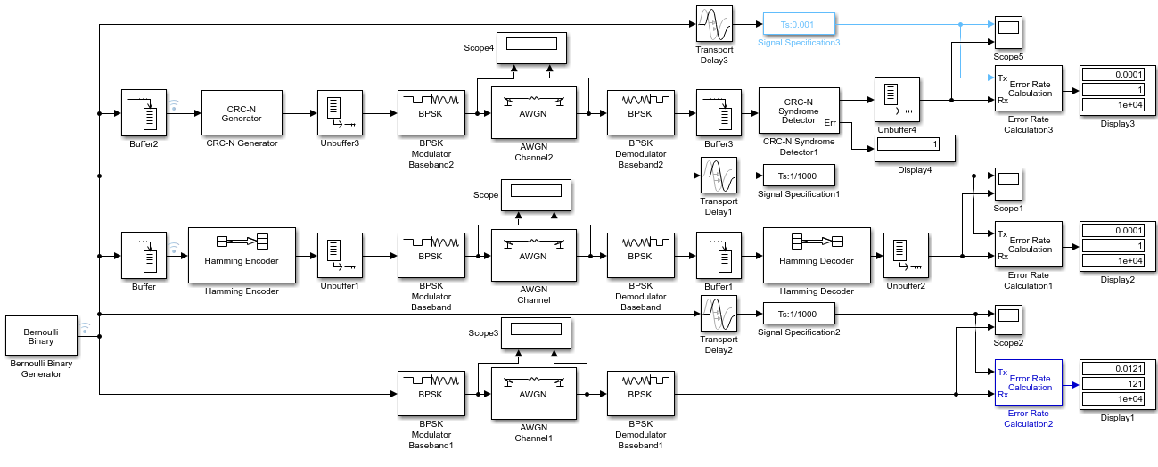
Figure 12 BPSK alternative with FEC.
The results of this test can be seen in Table 1.

4. Results
4.1 ASK / FSK / PSK
The results from Table 1 have been plotted and shown in Figure 12. These results show a distinct divergence of the three modulation techniques. The ASK shows the greatest reaction to the change in SNR, whereas BPSK shows the least. This would appear to be an approximate 2-3 dB advantage that is gained using BPSK over ASK, with a distinctly less though still notable advantage when using FSK.

Figure 13 SNR v BER of Digital Modulation Techniques
4.2 Digital Modulation with FEC
4.2.1 ASK
Due to issues with Sinulink, to asses the advantages of FEC with Digital Modulation techniques we must first do a comparison of the ASK model with the replacement that will be used for FEC. The previous test was repeated using the PAM simulink block, the results can be found in Table 1 and due to the found results the testing range was extended to -60dB as found in Table 2, all results are plotted below in Figure 14. It can be seen that both models have the same profile though offset by 30dB. This 30dB offset could be adjusted for using signal or noise power but in this case will only be noted.

Figure 14 Comparison of ASK v PAM
4.2.2 FSK
The results of the comparison of the FSK model with the replacement that will be used for FEC can be found in Table 1 and are plotted below in Figure 15. The replacement 4-FSK circuit has a different profile to the assignment FSK design, the 4-FSK module has approximately a 12dB improvement though with a far steeper degradation, this will probably be due to the better engineered design of using multiple frequencies.

Figure 15 Comparison of FSK v 4FSK

4.2.3 PSK
The results of the comparison of the PSK model with the replacement that will be used for FEC can be found in Table 1 and are plotted below in Figure 16. The BPSK replacement circuit has a similar profile to the assignment design although with a 5 -10 dB advantage. This difference will only be noted.

Figure 16 Comparison of PSK v PSK Baseband Block
4.3 ASK with FEC
The comparison of FEC and Non-FEC modulation with an ASK replacement can be seen in Table 1 and is shown below in Figure 17. It can be seen Non-FEC becomes susceptible to noise before the FEC techniques, any advantage is lost after 5dB and neither Hamming nor CRC shows a clear lead due to variations.

Figure 17 Comparison of FEC and Non-FEC ASK Techniques
4.4 FSK with FEC
The comparison of FEC and Non-FEC modulation with an FSK replacement can be seen in Table 1 and is shown below in Figure 18. It can be seen Non-FEC becomes susceptible to noise 6-8 dB before the Hamming technique, after that any advantage is lost. CRC begins to fail at -14dB, the same point as the Hamming Code, though the CRC has a more graceful degradation.

Figure 18 Comparison of FEC and Non-FEC FSK Techniques
4.5 PSK with FEC
The comparison of FEC and Non-FEC modulation with an PSK replacement can be seen in Table 1 and is shown below in Figure 19. It can be seen Non-FEC becomes susceptible to noise 1-2 dB before the FEC, this pattern remains throughout the degradation curve. Neither of the two FEC techniques shows a distinct advantage initially, thought CRC again shows a better degradation.

Figure 19 Comparison of FEC and Non-FEC PSK Techniques

5. Conclusions
5.1 Digital Modulation Methods
The ASK circuit designed works well and shows no errors until the noise reaches parity with the signal strength. Due to its simplicity of design the ASK model makes for inexpensive hardware, especially at the receiver. This simplicity also allows the ASK design to be adapted for a wide range of applications from Morse Code to fibre optic. Its simplicity also means the ASK is susceptible to noise, as its decoding strategy is dependent on detecting the amplitude of the signal, noise masking this amplitude will produce errors. The FSK circuit also works well, its constant amplitude allows it to be reasonably immune to noise transitions. Due to the multiple frequency operation it will require a higher bandwidth medium to carry it, this will only increase as more frequencies are added to the strategy. This more complicated hardware implementation will increase costs. The BPSK technique performed the best in this test, despite variances in the profile, at no point did BPSK perform worse than FSK and in general showed a 2+ dB advantage. BPSK also uses a single frequency, albeit with phase transitions, therefore its bandwidth use is efficient and offers the option to increase the phase discrimination to increase the data rate. However, this implementation and others have complex hardware that increases costs.

5.2 Forward Error Correction
The Hamming and CRC methods of FEC used here both show an improvement over any Non-FEC modulation Technique. The 7,4 implementation of Hamming Code carries overheads of around 43%, these overheads limit the amount of useful data that can be transmitted, this cost however is mitigated by the codes Hamming distance of 3, allowing it to detect up to 2 errors and correct a single error without any retransmission. The CRC-16 code used in this case has a hamming distance of 8, however it carries an overhead burden of 57% but can only detect errors and then request a retransmission, in certain circumstances CRC can correct errors, though this is not always the case. It must also be said that the 16-bit CRC used in this test is overkill for such a small dataset and a much smaller CRC would have been more appropriate. The appropriate level of CRC to use could have been better defined by use of the Shannon Limit which defines the efficiency of FEC for given noise levels in a medium.

6.0 References
[1] F. Musio et al., “PEMFC system simulation in MATLAB-Simulink® environment,” Int. J. Hydrogen Energy, vol. 36, no. 13, pp. 8045–8052, Jul. 2011.
[2] Z. Xia et al., “Novel AM/FM/ASK/FSK/PSK/QAM Signal Generator Based on a Digitally Programmable CDTA,” Circuits Syst Signal Process, vol. 34, pp. 1635–1653, 2015.
[3] Y. Qiu and C.-K. Chan, “Characterization of an optical frequency-shift-keying transmitter based on carrier-suppressed phase modulation,” Opt. Fiber Technol., vol. 19, no. 3, pp. 227–230, Jun. 2013.
[4] A. Kartci, R. Sotner, J. Jerabek, N. Herencsar, and J. Petrzela, “Phase shift keying modulator design employing electronically controllable all-pass sections,” Analog Integr. Circuits Signal Process., vol. 89, no. 3, pp. 781–800, Dec. 2016.
[5] S. S. Haykin, Digital communication systems. Wiley, 2014.
[6] A. Farhadi, “Sub-optimal control over AWGN communication network,” Eur. J. Control, vol. 37, pp. 27–33, Sep. 2017.
[7] Hewitt, E. ; Thesling, and William H, “Use forward error correction to improve data communications,” Electron. Des. Aug, vol. 21, no. 17, 2000.
[8] A. Khrennikov, “p-Adic behaviour of Bernoulli probabilities,” Stat. Probab. Lett., vol. 37, no. 4, pp. 375–379, Mar. 1998.
[9] L. Ohlsson and L.-E. Wernersson, “A 15-Gb/s Wireless ON-OFF Keying Link,” IEEE Access, vol. 2, pp. 1307–1313, 2014.
[10] K. S. Rim and B. I. Yun, “Gibbs phenomenon removal by adding Heaviside functions,” Adv. Comput. Math., vol. 38, no. 4, pp. 683–699, May 2013.
[11] A. Quinquis, Digital signal processing using MATLAB. ISTE, 2008.
[12] D. Johnson, “Signal-to-noise ratio,” Scholarpedia, vol. 1, no. 12, p. 2088, 2006.
[13] S. S. Haykin, Digital communication systems. Wiley, 2014.
[14] D. N. Owunwanne, “Analysis Of The Effectiveness Of Error Detection In Data Transmission Using Polynomial Code Method - ProQuest,” International Journal of Management and Information Systems; , 2010. [Online]. Available: https://search-proquest-com.ezproxy.uwtsd.ac.uk/docview/365929564?accountid=130472&rfr_id=info%3Axri%2Fsid%3Aprimo. [Accessed: 12-Jan-2018].
[15] M. Parker, Digital signal processing : everything you need to know to get started. Newnes/Elsevier, 2010.
[16] V. Chea, M. Vargas Martin, and R. Liscano, “Hamming Distance as a Metric for the Detection of Side Channel in 802.11 Wireless Communications,” 2015.
[17] Mathworks, “Generate CRC bits according to CRC method and append to input data frames - Simulink - MathWorks United Kingdom,” Mathworks, 2018. [Online]. Available: https://uk.mathworks.com/help/comm/ref/crcngenerator.html. [Accessed: 09-Jan-2018].

7.0 Annexes
Table 1 BER at various SNR

Table 2 BER at various SNR for ASK Extended

