
Programme: Master of Business Administration
Module Code and Title: LCMB7035 Dissertation
Dissertation Proposal
Research Title:
“Evaluating the Impact of Perceived Content Marketing Quality on Customer Trust and Brand Engagement in the UK Fashion Sector: Evidence from Zara”

Student Name: Jamila Begum
Student ID: 2503076

Supervisor: Supervisor Shahrukh Irfan

Table of Contents
1. Introduction 3
1.1 Background to the Study 3
1.2 Research Problem and Rationale 3
1.3 Research Aim, Objectives and Questions 4
Research Aim 4
Research Objectives 4
Research Questions 4
2. Literature Review 5
2.1 Content Marketing Quality, Trust and Brand Engagement 5
2.2 Theoretical Framework 6
Stimulus-Organism-Response Theory 6
2.3 Research Gap 7
2.4 Conceptual Framework and Hypotheses 8
3. Methodology 10
3.1 Research Philosophy 10
3.2 Research Approach 10
3.3 Research Design and Strategy 11
3.4 Population and Sampling 11
3.5 Data Collection Instrument 12
3.6 Data Analysis Procedure 13
3.7 Ethical Considerations 13
4. Expected Findings 13
5. Limitations 13
6. Timeframe 14
7. Conclusion 16
8. References 17

1. Introduction

1.1 Background to the Study
Over the last few years, fashion retail has moved over to digital communication, and brands are increasingly turning to digital content as a means of communicating with consumers (Bowden and Mirzaei, 2021). Zara is a prime example of this trend, as Inditex reported digital sales of 10.7 billion euros in 2025 and the number of followers on its social media has surpassed 62 million on Instagram (Inditex, 2026), while Statista (2025) shows that fashion e-commerce in the United Kingdom accounts for a significant portion of retail spending. Even with this visibility, the pathway of how content quality strengthens customer relations through trust remains untested and not well understood (Hollebeek and Macky, 2019), as few studies examine how content quality builds trust to drive engagement (Dolan et al., 2019).

1.2 Research Problem and Rationale
Zara has been spending a lot of resources and budget on online marketing and promotion via its website, the app, Instagram and TikTok, with Inditex reporting an online sales figure of 10.7 billion euros in 2025 and more than 62 million followers on Instagram (Inditex, 2026). However, with all this activity, it's not clear if shoppers are reading the content or skimming it, as visibility doesn't always mean a trusted brand relationship. This is important because most content marketing budgets are based on metrics like reach and impressions, but they don't mean that the content is credible, authentic, or worth engaging with on a deeper level with customers. If managers don't know if the quality of content creates "trust" and whether that "trust" is what leads to engagement, they may end up creating content that performs well on vanity metrics but doesn't help them create lasting customer relationships. However, elsewhere, Alrwashdeh (2025), Ali et al. (2025) confirm that social media activity has an impact on trust and loyalty outcomes; neither of these studies, however, focuses specifically on UK audiences, which results in no testing of these specific audiences by Zara, as confirmed by Cheung, Pires and Rosenberger (2020). Thus, this investigation is required to clarify what content attributes really foster trust and not just exposure.

1.3 Research Aim, Objectives and Questions

Research Aim
The research aim is to evaluate how perceived content marketing quality influences customer trust and brand engagement among Zara customers in the United Kingdom, guided by the objectives and questions below.

Research Objectives
- To examine the effect of perceived content marketing quality on customer trust towards Zara in the United Kingdom.
- To assess the effect of perceived content marketing quality on brand engagement with Zara.
- To investigate the effect of customer trust on brand engagement with Zara.

Research Questions
- How does perceived content marketing quality influence customer trust towards Zara among United Kingdom customers?
- How does perceived content marketing quality influence brand engagement with Zara among United Kingdom customers?
- How does customer trust influence brand engagement with Zara among United Kingdom customers?

2. Literature Review

2.1 Content Marketing Quality, Trust and Brand Engagement
Digital content marketing refers to relevant and valuable brand-related content designed to foster engagement, trust and relationships rather than directly persuading customers to purchase (Hollebeek and Macky, 2019). Some studies do indicate that properties like informativeness, credibility and entertainment value are positive attributes for trust (Lou and Xie, 2021). Kim, Leung and McKneely (2023) identified that brand trust is a mediator between the relationship between Instagram-derived social capital and purchase intention, but the study only included small fashion brands instead of a global fashion retailer like Zara. Similar results were found by Husain, Ahmad and Khan (2022), who showed that social media marketing activities increase brand trust among luxury consumers and by Haudi et al. (2022) who showed that marketing activities build brand equity through brand trust, but both measure composite social media marketing activities, which might reduce the validity of their causal claims. The study by Low, Goh and Lim (2025) extends this research by demonstrating that source credibility, not post frequency, is the key factor in fostering brand loyalty toward a fast fashion brand. In contrast, Samarah et al. (2022) also conclude that interactivity and involvement, through the lens of trust, stimulate engagement and loyalty, but their cross-industry sample dampens out the dynamics specific to fashion. The findings of these studies suggest that content quality is associated with trust, and there is some conflict as to what factors are important to content quality and how it should be viewed as a model, namely, antecedent, mediator or parallel construct.
The concept of brand engagement is defined as a multidimensional phenomenon that includes the cognitive, emotional and behavioral aspects of consumer-brand interaction (Cheung, Pires and Rosenberger, 2020; Krowinska and Dineva, 2025). Bowden and Mirzaei (2021) posit that digital content marketing serves as the “hub of engagement” of the retail communication channels when the content is seen as authentic. In the context of fashion, Naeem and Ozuem (2021) conclude that the formation of trust comes before engaging in interaction, and Bonilla-Quijada et al. (2024), and Molina-Prados, Munoz-Leiva and Prados-Pena (2022) confirm that the creation of visual and interactive content on Instagram leads to interaction, but that this is not enough to isolate trust as an explicit mediator, which is a common methodological drawback in this literature. Ruiz-Vinals, Pretel Jimenez and Del Olmo Arriaga (2024) followed this study with a direct analysis of Zara's content profile to find that this same evidence extends to TikTok, though their descriptive analysis does not include testing the assumed causal pathway of trust. Kim, Jin and Jo (2025) provide some corrective with their finding that video storytelling has an engagement effect on small fashion businesses through brand trust, but haven't yet tested it with a big international retailer like Zara. In addition, Leckie, Dwivedi and Johnson (2022) and Osei-Frimpong, McLean and Famiyeh (2020) confirm that brand trust is a stable antecedent of engagement, which supports the rationale for the test of trust as a mediating variable instead of a direct unmediated relationship.

2.2 Theoretical Framework

Stimulus-Organism-Response Theory
The main theory used is Stimulus Organism Response theory. Mehrabian and Russell (1974) suggested that the external stimuli influence one's internal psychological state, which in turn impacts on behavioural reactions. Later this framework was endorsed by Jacoby (2002) for its consumer behaviour value. The stimulus is the perceived quality of the content marketing of the brand, in this study, Zara, the organism is customer trust and the response is brand engagement. This framework is suitable for the study as it provides a psychological mechanism that digital content may be able to affect engagement.
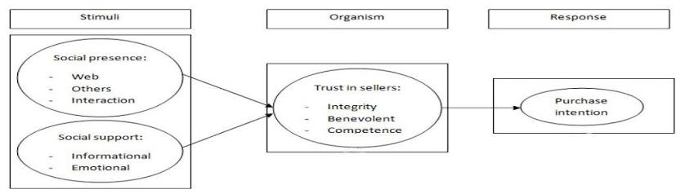
Figure 1: Stimulus-Organism-Response framework applied to digital trust formation. Source: adapted by the researcher from Mehrabian and Russell (1974).
Commitment-Trust Theory of Relationship Marketing
According to Morgan and Hunt (1994), the key ingredients of effective relationship marketing are trust and commitment, and trust is a key relational variable that decreases uncertainty and promotes cooperative behavior. This theory is applicable because the current study does not only focus on whether or not customers see Zara's content, but whether or not that content builds a trusted relationship that can maintain customer engagement in the long-term. As shown in figure 2, trust is linked to relationship commitment, which in turn is linked to outcomes including cooperation and the lower tendency to leave. Nevertheless, Morgan and Hunt's (1994) original model focuses on inter-organisational business-to-business relationships, and this study explores the applicability of the model to individual consumer-brand relationships by adapting the dimensions of trust in a digital content marketing context.
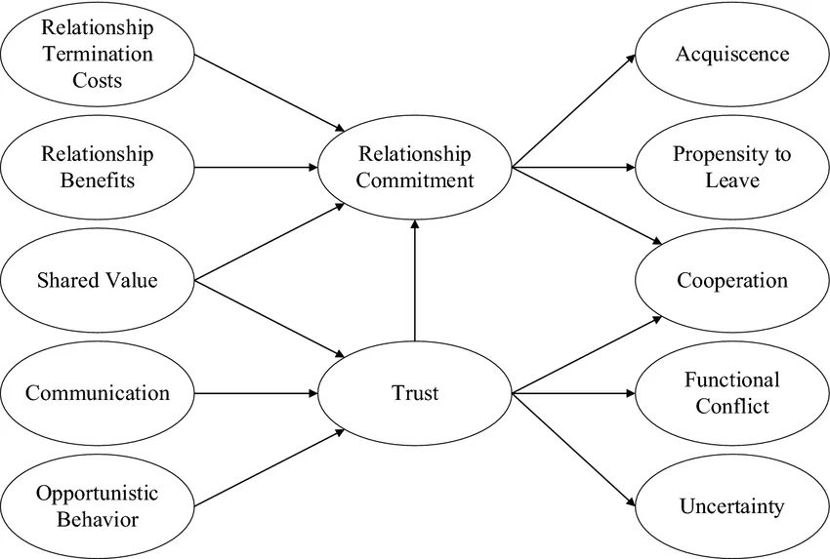
Figure 2: Commitment-Trust model of relationship marketing. Source: adapted by the researcher from Morgan and Hunt (1994).

2.3 Research Gap
Despite extensive literature on social media marketing and engagement, a precise gap remains rather than a complete absence of research. A contextual gap exists because digital content marketing studies are frequently conducted outside the United Kingdom, meaning focused evidence concerning United Kingdom fashion customers and Zara specifically remains limited; Naeem and Ozuem (2021) demonstrate the importance of engagement within fashion-brand relationships broadly, Ruiz-Vinals, Pretel Jimenez and Del Olmo Arriaga (2024) examine Zara directly but only through a TikTok content-profile lens, and Alrwashdeh (2025) confirms similar dynamics within a Jordanian rather than United Kingdom market. A theoretical gap is evident because many studies examine effects of content marketing on engagement without clearly modelling trust as the connecting mechanism; Dolan et al. (2019) omit trust as a mediator, Park and Ha (2021) conflate content quality with exposure frequency, and Cheung et al. (2021) treat trust only implicitly. A measurement gap also exists, since content marketing is frequently conflated with broader social media activity rather than isolated as perceived content quality; Li, Larimo and Leonidou (2021) conceptualise social media marketing strategy broadly, while Bonilla-Quijada et al. (2024) and Molina-Prados, Munoz-Leiva and Prados-Pena (2022) measure engagement without isolating content quality itself. A practical gap persists because managers require evidence on whether content quality builds trust and engagement rather than evidence limited to reach alone, as highlighted by Fetais et al. (2023), Low, Goh and Lim (2025), and McKinsey and The Business of Fashion (2025).

2.4 Conceptual Framework and Hypotheses
The conceptual framework extends the theoretical discussion above by defining perceived content marketing quality as the independent variable, customer trust as the mediating variable, and brand engagement as the dependent variable, with age, gender, purchase frequency and content exposure frequency as the control variables. This framework is presented in Figure 3, and it depicts that content quality has four dimensions: informativeness, relevance, credibility and authenticity, while trust has four dimensions: reliability, honesty, confidence and dependability and engagement has three dimensions: cognitive, emotional and behavioural, which corresponds with Hollebeek Glynn and Brodie's (2014) conceptualisation of consumer brand engagement.
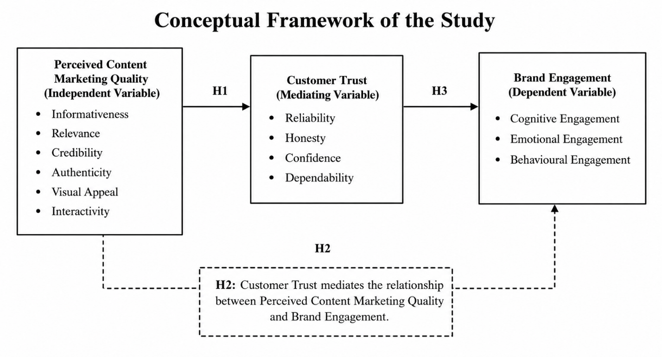
Figure 3: Conceptual framework of the study. Source: developed by the researcher
Three hypotheses are proposed accordingly, summarised in Table 1 below, which sets out each hypothesis code, statement and hypothesised path within the conceptual model.
Table 1: Hypotheses and hypothesised paths of the study.
Code | Hypothesis Statement
H1 | Perceived content marketing quality has a positive and significant effect on customer trust towards Zara.
H2 | Perceived content marketing quality has a positive and significant effect on brand engagement with Zara.
H3 | Customer trust has a positive and significant effect on brand engagement with Zara.

3. Methodology
This research is based on the research onion framework proposed by Saunders, Lewis and Thornhill (2019), which is a systematic approach for selecting and justifying the methodological choices, from research philosophy to data collection and analysis. It is adopted in this study to ensure that the chosen research methods are logically aligned with the research aim, objectives and hypotheses.

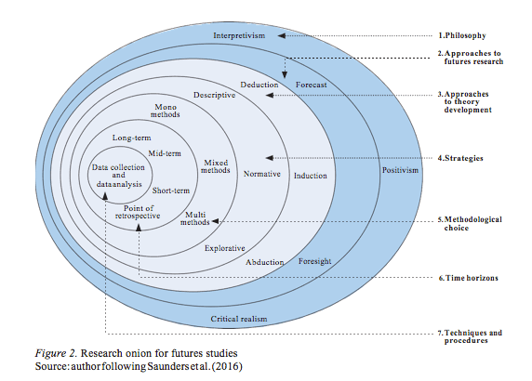
Figure 4: Research onion framework: adapted by the researcher from Saunders, Lewis and Thornhill (2019).

3.1 Research Philosophy
The research philosophy of this study is positivist because it involves a set of measurable variables, structured survey data and statistical hypothesis testing (Bryman and Bell, 2015).

3.2 Research Approach
A deductive approach is used because the hypotheses are formulated directly from the Stimulus-Organism-Response framework and the Commitment-Trust theory, and do not emerge inductively from the data. This is fitting since the study does not develop any new theory, rather it tests the given relationships between content quality, trust and engagement (Collis and Hussey, 2014).

3.3 Research Design and Strategy
Research Type: Primary Research: Primary research is a method which uses original data that is collected by the researcher for specific research questions or problems (Saunders, Lewis and Thornhill, 2019). In this study primary research techniques are used to gather primary data from the participants of the study that is the customers of Zara in the United Kingdom, in order to ensure that the perceptions of the customers with respect to the quality of content marketing, their trust in the brand and their engagement with the brand directly relate to the objectives and hypotheses of the proposed research.
Research design: Quantitative Analysis: Quantitative research is quantitative data which is measured numerically and is examined with statistical analysis in order to analyse relationships (Bryman and Bell, 2015). The approach is suitable because the study examines the assumed relationships between perceived quality of content marketing, customer trust and brand engagement based on structured questionnaire data and statistical methods.
Research Strategy: Survey: A survey strategy is a process that involves gathering information in a standardized format from a specific population using a standardized questionnaire (Pajo, 2018). It is appropriate for this study because it allows for the collection of data from customers of UK Zara and allows for consistent data for correlation analysis, multiple regression and mediation analysis tests of the proposed hypotheses.
Time Horizon: Cross-Sectional: In a cross-sectional design, data is gathered at one specific time in the study, as opposed to a long period of time (Saunders, Lewis and Thornhill, 2019). The approach is suitable because the study investigates the present perception of the digital content of Zara by its customers and checks the relationships between the study variables during the time frame of the dissertation.

3.4 Population and Sampling
Population: The target population comprises United Kingdom based customers aged eighteen or above who have purchased from or browsed Zara products within the past twelve months, and who have interacted with Zara's digital content through Instagram, TikTok, the website, app, email or YouTube.
Sampling: The sampling method used is purposive convenience sampling as a complete sampling frame is not available and therefore probability sampling cannot be truly said to be used (Saunders, Lewis and Thornhill, 2019).
Sample Size: The sample size is targeted between 100 and 150 respondents.

3.5 Data Collection Method
Questionnaire Administration: The research, Data will be gathered using self-administered online questionnaire using Google Forms. The questionnaire is a suitable method to use as it allows for easy access of the United Kingdom Zara customers, anonymity of the participants and the responses can be recorded electronically for statistical analysis afterward (Saunders, Lewis and Thornhill, 2019).
Questionnaire Structure: There will be four parts to the questionnaire. Section A will be screening questions to ensure all respondents are residents of the UK aged 18 years or over and have bought from, or had contact with, Zara's digital content within the last 12 months. Section B will gather information about the respondents' demographic and behavioural characteristics such as age, gender, how often they buy the Zara brand and if they have come into contact with Zara's digital content. Perceived content marketing quality will be measured in Section C in terms of six dimensions: relevance, informativeness, credibility, authenticity, visual appeal and interactivity. In Section D, the level of trust (reliability, honesty and confidence) and engagement (cognitive, emotional and behavioural) will be measured from the perspective of the customers.
Question Types and Measurement Scale: The questionnaire will consist of questions that are spaced between 1 (strongly disagree) and 5 (strongly agree) with multiple choice, dichotomous (Yes/No) and 5-point Likert scale questions. Items of measurement will be taken from validated scales in the earlier studies to ensure content validity and consistency with the study objectives (Bryman and Bell, 2015).

3.6 Data Analysis Procedure
Data will be analysed using SPSS and Excel. Demographic frequency tables are used as the starting point for the analysis. The mean, standard deviation, minimum and maximum values will then be reported for each construct as descriptive statistics. Cronbach's alpha will be used to test the reliability of the instrument, and will be considered acceptable when the value is greater than 0.70 for the scales that have been established. Pearson correlation analyses will be used to determine the relationships between variables. Multiple regression will be used to test the relationships between the variables directly. To determine whether customer trust accounts for the link between perceived quality of customer content marketing and brand engagement, mediation analysis will be conducted.

3.7 Ethical Considerations
Ethical approval is sought prior to any data collection, in accordance with University of Wales Trinity Saint David requirements. All participation is voluntary, anonymous and based on informed consent and no primary data is collected prior to approval. All documentation is held securely in the University OneDrive account, viewable only by the researcher, supervisor and moderation staff relevant to the research (Yin, 2018).

4. Expected Findings
The study will likely conclude that the quality of perceived content marketing has a positive effect on customers' level of trust. Such an expectation is supported by Hollebeek and Macky (2019), who associate digital content marketing with trust and engagement. It is also supported by Low, Goh and Lim, 2025 in which they prove the importance of credibility in fast fashion brand loyalty. The study will also determine that the quality of content marketing has a positive relationship with brand engagement, when perceived.

5. Limitations
In the research, there are a number of limitations expected. The main drawback of a purposive convenience sample is that it does not allow for generalisation as it is not random (Saunders, Lewis and Thornhill, 2019). Cross sectional design will measure perceptions at a single point in time and cannot make a definite causal conclusion. There are several drawbacks to complex mediation modeling with a small sample size, and social desirability bias may make responses to Likert items unreliable, though can be minimized through the thoughtful design of questionnaires and pilot testing.

6. Timeframe
The dissertation will take 16th weeks to complete. Table 2 gives the Gantt chart that shows the literature consolidation, ethical approval, piloting of the questionnaire, data collection, data statistical analysis, and writing. Table 2 is the Gantt chart for the 16th week dissertation schedule.
Table 2: Gantt chart of the 16th week dissertation timeline

Source: Developed by the researcher.

7. Conclusion
This proposal aims to conduct a targeted quantitative research into the relationship between perceived quality of content marketing and the level of customer trust and brand engagement in the UK fashion industry, with Zara as the case organisation. The study is academically relevant as it is not just about the general perceptions of social media marketing but goes to a more defined mechanism. It examines whether customer trust is a mediating factor between customer perceptions of content quality and customer engagement. It is expected that the study will give practical suggestions for Zara and other fashion brands.

8. References
Ali, F., Suveatwatanakul, C., Nanu, L., Ali, M. and Terrah, A. (2025) 'Social media marketing and brand loyalty: exploring interrelationships through symmetrical and asymmetrical modeling', Spanish Journal of Marketing - ESIC, 29(1), pp. 114-135. Available at: https://doi.org/10.1108/SJME-08-2023-0219 (Accessed: 27 June 2026).
Alrwashdeh, M. (2025) 'How do social media marketing activities enhance online purchase intention among Jordanian consumers? The role of brand trust and brand engagement', Innovative Marketing, 21(2), pp. 291-302. Available at: https://doi.org/10.21511/im.21(2).2025.23 (Accessed: 30 June 2026).
Bonilla-Quijada, M., Del-Olmo-Arriaga, J.L., Andreu-Domingo, D. and Ripoll-i-Alcon, J. (2024) 'Fast fashion consumer engagement on Instagram: a case study', Cogent Business & Management, 11(1), Article 2322111. Available at: https://doi.org/10.1080/23311975.2024.2322111 (Accessed: 29 June 2026).
Bowden, J. and Mirzaei, A. (2021) 'Consumer engagement within retail communication channels: an examination of online brand communities and digital content marketing initiatives', European Journal of Marketing, 55(5), pp. 1411-1439. Available at: https://doi.org/10.1108/EJM-01-2018-0007 (Accessed: 28 June 2026).
Bryman, A. and Bell, E. (2015) Business Research Methods. Oxford: Oxford University Press.
Cheung, M.L., Pires, G. and Rosenberger, P.J. III (2020) 'The influence of perceived social media marketing elements on consumer-brand engagement and brand knowledge', Asia Pacific Journal of Marketing and Logistics, 32(3), pp. 695-720. Available at: https://doi.org/10.1108/APJML-04-2019-0262 (Accessed: 27 June 2026).
Cheung, M.L., Pires, G., Rosenberger, P.J., Leung, W.K.S. and Chang, M.K. (2021) 'The role of social media elements in driving co-creation and engagement', Asia Pacific Journal of Marketing and Logistics, 33(10), pp. 1994-2018. Available at: https://doi.org/10.1108/APJML-03-2020-0176 (Accessed: 26 June 2026).
Collis, J. and Hussey, R. (2014) Business Research: a practical guide for undergraduate and postgraduate students. Basingstoke: Palgrave Macmillan.
Dolan, R., Conduit, J., Frethey-Bentham, C., Fahy, J. and Goodman, S. (2019) 'Social media engagement behavior: A framework for engaging customers through social media content', European Journal of Marketing, 53(10), pp. 2213-2243. Available at: https://doi.org/10.1108/EJM-03-2017-0182 (Accessed: 25 June 2026).
Fetais, A.H., Algharabat, R.S., Aljafari, A. and Rana, N.P. (2023) 'Do social media marketing activities improve brand loyalty? An empirical study on luxury fashion brands', Information Systems Frontiers, 25(2), pp. 795-817. Available at: https://doi.org/10.1007/s10796-022-10264-7 (Accessed: 24 June 2026).
Haudi, H., Handayani, W., Musnaini, M., Suyoto, Y.T., Prasetio, T., Pitaloka, E., Wijoyo, H., Yonata, H., Koho, I.R. and Cahyono, Y. (2022) 'The effect of social media marketing on brand trust, brand equity and brand loyalty', International Journal of Data and Network Science, 6(3), pp. 961-972. Available at: https://doi.org/10.5267/j.ijdns.2022.1.015 (Accessed: 30 June 2026).
Hollebeek, L.D. and Macky, K. (2019) 'Digital content marketing's role in fostering consumer engagement, trust, and value: Framework, fundamental propositions, and implications', Journal of Interactive Marketing, 45, pp. 27-41. Available at: https://doi.org/10.1016/j.intmar.2018.07.003 (Accessed: 29 June 2026).
Hollebeek, L.D., Glynn, M.S. and Brodie, R.J. (2014) 'Consumer brand engagement in social media: Conceptualization, scale development and validation', Journal of Interactive Marketing, 28(2), pp. 149-165. Available at: https://doi.org/10.1016/j.intmar.2013.12.002 (Accessed: 29 June 2026).
Husain, R., Ahmad, A. and Khan, B.M. (2022) 'The impact of brand equity, status consumption, and social media marketing activities on luxury brand purchase intentions: The mediating role of brand trust', Cogent Business & Management, 9(1), Article 2034234. Available at: https://doi.org/10.1080/23311975.2022.2034234 (Accessed: 28 June 2026).
Inditex (2026) FY2025 Results. Arteixo: Industria de Diseno Textil, S.A. Available at: https://www.inditex.com/itxcomweb/ad/en/press/news-detail/b870d5ec-6b7e-491d-b38e-340cd69036df/fy2025-results (Accessed: 30 June 2026).
Jacoby, J. (2002) 'Stimulus-Organism-Response reconsidered: An evolutionary step in modeling (consumer) behavior', Journal of Consumer Psychology, 12(1), pp. 51-57. Available at: https://doi.org/10.1207/S15327663JCP1201_05 (Accessed: 30 June 2026).
Kim, G., Jin, B.E. and Jo, H. (2025) 'Effective video storytelling for small fashion businesses: the mediating role of brand trust', Journal of Fashion Marketing and Management, 29(2), pp. 327-352. Available at: https://doi.org/10.1108/JFMM-08-2023-0203 (Accessed: 29 June 2026).
Kim, J., Leung, X.Y. and McKneely, B. (2023) 'The effects of Instagram social capital, brand identification and brand trust on purchase intention for small fashion brands: the generational differences', Journal of Fashion Marketing and Management, 27(6), pp. 988-1008. Available at: https://doi.org/10.1108/JFMM-05-2021-0126 (Accessed: 27 June 2026).
Krowinska, A. and Dineva, D. (2025) 'The role and forms of social media branded content driving active customer engagement behaviours', Journal of Marketing Management, 41(9-10), pp. 1030-1060. Available at: https://doi.org/10.1080/0267257X.2025.2544808 (Accessed: 30 June 2026).
Leckie, C., Dwivedi, A. and Johnson, L.W. (2022) 'Examining drivers and outcomes of social media brand engagement', Asia Pacific Journal of Marketing and Logistics, 34(2), pp. 350-367. Available at: https://doi.org/10.1108/APJML-07-2020-0488 (Accessed: 26 June 2026).
Li, F., Larimo, J. and Leonidou, L.C. (2021) 'Social media marketing strategy: Definition, conceptualization, taxonomy, validation, and future agenda', Journal of the Academy of Marketing Science, 49, pp. 51-70. Available at: https://doi.org/10.1007/s11747-020-00733-3 (Accessed: 25 June 2026).
Lou, C. and Xie, Q. (2021) 'Something social, something entertaining? How digital content marketing augments consumer experience and brand loyalty', International Journal of Advertising, 40(3), pp. 376-402. Available at: https://doi.org/10.1080/02650487.2020.1788311 (Accessed: 24 June 2026).
Low, F.C.S., Goh, Y.-N. and Lim, C.N. (2025) 'Assessing the impact of source credibility on fast fashion brand loyalty', Journal of Fashion Marketing and Management, 29(4), pp. 568-584. Available at: https://doi.org/10.1108/JFMM-08-2023-0199 (Accessed: 28 June 2026).
McKinsey & Company and The Business of Fashion (2025) The State of Fashion 2026: When the Rules Change. London/New York: McKinsey & Company and The Business of Fashion. Available at: https://www.mckinsey.com/industries/retail/our-insights/state-of-fashion (Accessed: 28 June 2026).
Mehrabian, A. and Russell, J.A. (1974) An Approach to Environmental Psychology. Cambridge, MA: MIT Press. ISBN: 978-0262130905.
Molina-Prados, A., Munoz-Leiva, F. and Prados-Pena, M.B. (2022) 'The role of customer brand engagement in the use of Instagram as a shop window for fashion-industry social commerce', Journal of Fashion Marketing and Management, 26(3), pp. 495-515. Available at: https://doi.org/10.1108/JFMM-12-2020-0275 (Accessed: 30 June 2026).
Morgan, R.M. and Hunt, S.D. (1994) 'The commitment-trust theory of relationship marketing', Journal of Marketing, 58(3), pp. 20-38. Available at: https://doi.org/10.1177/002224299405800302 (Accessed: 30 June 2026).
Naeem, M. and Ozuem, W. (2021) 'Understanding the social consumer fashion brand engagement journey: insights about reputed fashion brands', Journal of Brand Management, 28(5), pp. 510-525. Available at: https://doi.org/10.1057/s41262-021-00239-5 (Accessed: 29 June 2026).
Osei-Frimpong, K., McLean, G. and Famiyeh, S. (2020) 'Social media brand engagement practices: Examining the role of consumer brand knowledge, social pressure, social relatedness, and brand trust', Information Technology & People, 33(4), pp. 1235-1254. Available at: https://doi.org/10.1108/ITP-05-2018-0220 (Accessed: 28 June 2026).
Pajo, B. (2018) Introduction to Research Methods: a hands-on approach. Los Angeles: SAGE.
Park, J.S. and Ha, S. (2021) 'From information experiences to consumer engagement on brand's social media accounts', Fashion and Textiles, 8, Article 21. Available at: https://doi.org/10.1186/s40691-021-00246-9 (Accessed: 27 June 2026).
Polonsky, M.J. and Waller, D.S. (2015) Designing and Managing a Research project: a Business Student's Guide. London: SAGE.
Ruiz-Vinals, C., Pretel Jimenez, M. and Del Olmo Arriaga, J.L. (2024) 'The impact of TikTok on the generation of engagement for fashion brands: A profile analysis of Zara', VISUAL Review, 16(4), pp. 167-181. Available at: https://doi.org/10.62161/revvisual.v16.5289 (Accessed: 26 June 2026).
Samarah, T., Bayram, P., Aljuhmani, H.Y. and Elrehail, H. (2022) 'The role of brand interactivity and involvement in driving social media consumer brand engagement and brand loyalty: The mediating effect of brand trust', Journal of Research in Interactive Marketing, 16(4), pp. 648-664. Available at: https://doi.org/10.1108/JRIM-03-2021-0072 (Accessed: 25 June 2026).
Saunders, M.N.K., Lewis, P. and Thornhill, A. (2019) Research Methods for Business Students. 8th edn. Harlow: Pearson Education.
Statista (2025) Fashion e-commerce in the United Kingdom (UK). Hamburg: Statista. Available at: https://www.statista.com/topics/8759/fashion-e-commerce-in-the-united-kingdom/ (Accessed: 27 June 2026).
Yin, R.K. (2018) Case Study Research and Applications: Design and Methods. 6th edn. Thousand Oaks, CA: SAGE Publications.

